**GOVERNMENT COLLEGE OF ENGINEERING ERODE**



B.E Electronics and Communication Engineering

TAMILNADU MARGINAL WORKERS

**Name of the Students: University Register no:**

**Team Leader:**

Karthick Raj . M 731121106021

**Team Members:**

Aatham Anari . B 731121106001

Selvaragavan . K 731121106042

Senthamil Selvan . V 731121106043

Gowtham . R 731121106016

Under the mentor of

**Dr.M.Sathiyakala**

**Department of Information Technology(IT)**

**Department of Electronics and Communication Engineerin**

Government College of Engineering

Erode ,PO ,near Vasavi College,TamilNadu-638316,Affiliated to Anna University ,Chennai.

**PROJECT DESCRIPTION:**

Data Source – The data for data analytics with cognos is based on the Census 2011 Data for districts in Tamil Nadu has been downloaded from the link which has been provided by Nan Mudhalvan and IBM .

The raw data is first being downloaded and then data cleaning operation being performed to get the data on which Advanced Data analytics can be performed.

In the first analysis [i.e. in the fig.1] ,we have the detailed analytics to visualize the literacy rate and unemployment rate of each state under consideration. Now in this analysis we will be going in detail of the male working population and try to visualize each type of employment the working population is involved in. Based on the analysis we will try and give some findings which can be helpful in taking strategic decisions.

**Analysis:**

 As per data from [https://tn.data.gov.in/resource/marginal-workers-classified-age-industrial-category-and-sex-scheduled-caste-2011-tamil](https://tn.data.gov.in/resource/marginal-workers-classified-age-industrial-category-and-sex-scheduled-caste-2011-tamil%20 ), the classification of the working population is based on the part time workers. Part time working population is called Marginal Working Population.

The Marginal Working population do not work through the entire year but works on the seasonal basis or on a particular periods of year only. Marginal workers were those who worked any time at all in the year preceding the enumeration but did not work for a major part of the year, i.e., those who worked for less than 183 days (or six months).

**DATA VISUALIZATION OF TOTAL MARGINAL WORKERS IN TAMILNADU:**

Analysis of the marginal workers in Tamil Nadu has been visualized and can be viewed using the following link and it can viewed as in image[Fig:1]: <https://us3.ca.analytics.ibm.com/bi/?perspective=dashboard&pathRef=.my_folders%2FPIECHART-MALE%2BANALYSIS&action=view&mode=dashboard&subView=model0000018b40fdb107_00000000>

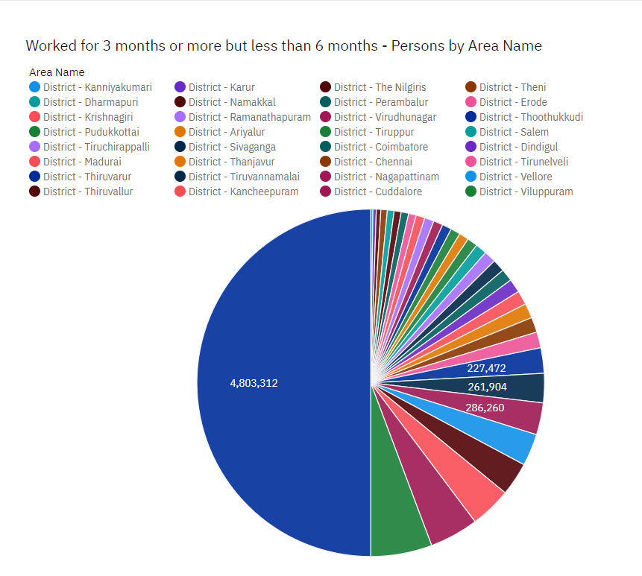

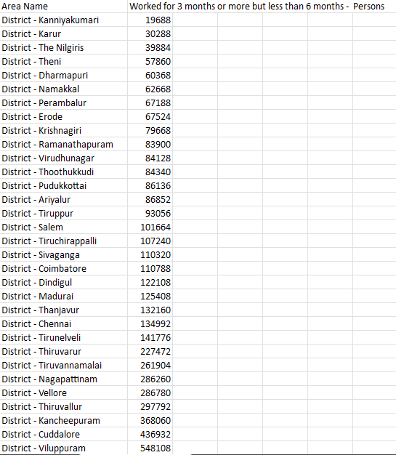

Fig :1

**FINDINGS:**

* Viluppuram[260,252] has the most marginal working population among the states in Tamil Nadu.
* Kanyakumari[11,544] has the least count in marginal workers among the states in Tamil Nadu.

The marginal working population is further classified in to the following:

**Cultivators:**A person was considered as cultivator if he or she was engaged either as employer, single worker or family worker in cultivation of land owned or held from government of held from private persons or institutions for payment in money, kind or share of crop. Cultivation included supervision or direction of cultivation. A person who had given out his/her land to another person or persons for cultivation or money, kind or share of crop and who did not even supervise or direct cultivation of land was not treated as cultivator.

The visualization of this data can be viewed by the following link and can also be viewed as image[Fig:2]:

<https://us3.ca.analytics.ibm.com/bi/?perspective=dashboard&pathRef=.my_folders%2FBARVIEW-CULTIVATORS&action=view&mode=dashboard&subView=model0000018b40fdb107_00000000>

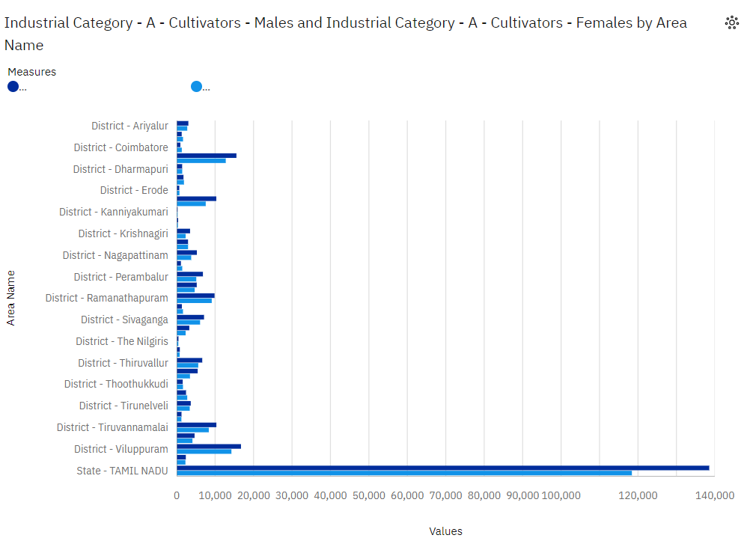

**Findings:**

* Viluppuram [16,600] has the most female cultivators among the states in Tamil Nadu.
* Viluppuram[14,240] has the least female cultivators among the states in Tamil Nadu.
* Kanyakumari[240] has the most male cultivators among the states in Tamil Nadu.
* Kanyakumari[188] has the least male cultivators among the states in

Tamil Nadu.

**Agricultural Labors:**A person who worked in another person's land for wages in cash, kind or share was regarded as an agricultural laborer. Such a person had no risk in cultivation but merely worked in another person's land for wages. An agricultural laborer had no right of lease or contract on land on which he worked.

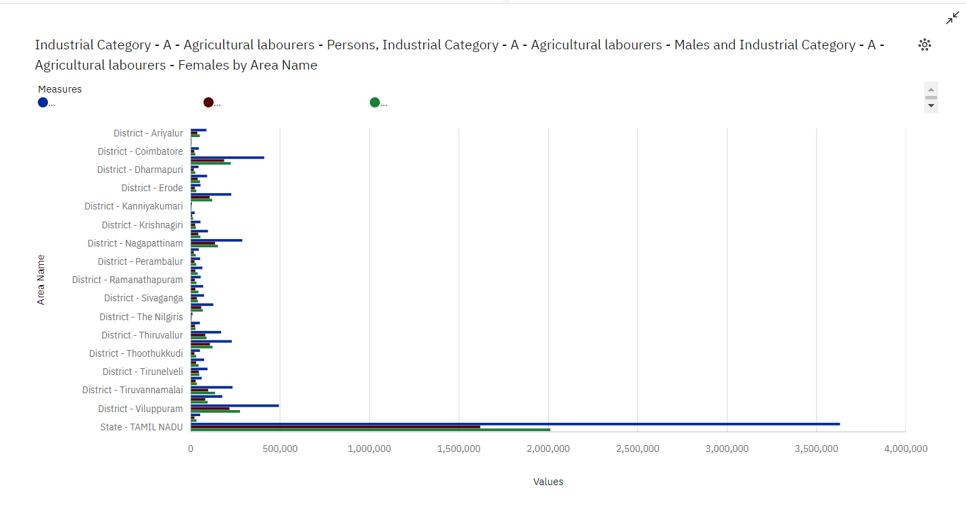

**Findings:**

* Viluppuram[2,76,244] has the most female agricultural workers among the states in Tamil Nadu.
* Chennai[1,224] has the least female agricultural workers among the states in Tamil Nadu.
* Viluppuram[2,16,972]has the most male cultivators agricultural workers among the states in Tamil Nadu.
* Chennai[2,052]has the least male cultivators agricultural workers among the states in

Tamil Nadu.

**INDUSTRIAL CATEGORIES-A[Plantation,livestock,forestry,hunting,fishing and hunting activities]:**

Plantations are farms specializing in cash crops, usually mainly planting a single crop, with perhaps ancillary areas for vegetables for eating and so on. Livestock are the domesticated animals raised in an agricultural setting in order to provide labour and produce diversified products for consumption

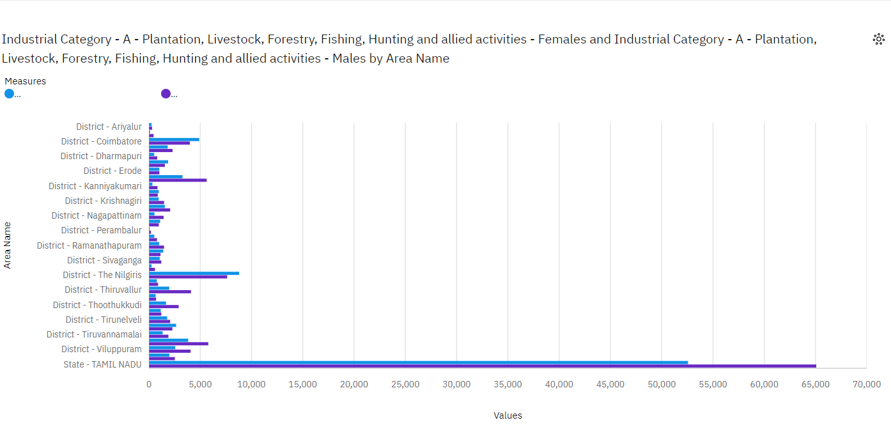

**Findings:**

* Nilgiri [8800]has the most female agricultural workers among the states in Tamil Nadu.
* Perambalur [64]has the least female cultivators agricultural workers among the states in Tamil Nadu.
* Nilgiri [7,624]has the most male cultivators agricultural workers among the states in Tamil Nadu.
* Perambalur [192]has the least male cultivators agricultural workers among the states in Tamil Nadu.

**INDUSTRIAL CATEGORIES-B [Mining and Quarrying]:**

Mining is the process of extracting buried material below the earth surface. Quarrying refers to extracting materials directly from the surface. In mining and quarrying, water is used and gets polluted in a range of activities, including mineral processing, dust suppression, and slurry transport.

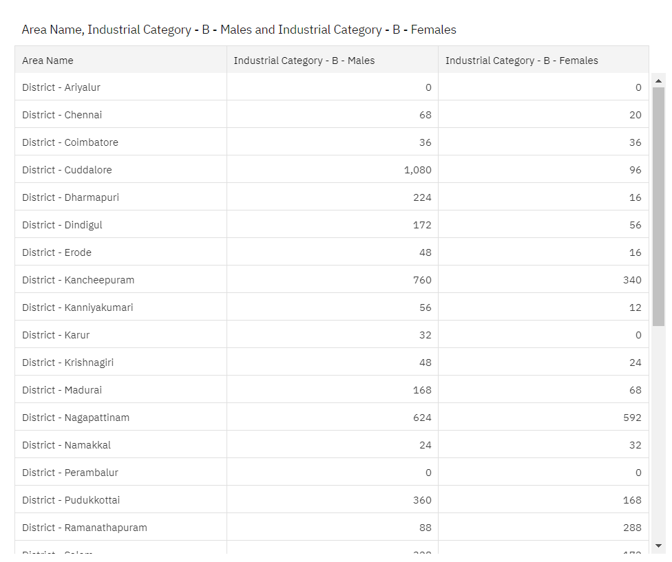

**Findings:**

* Kancheepuram has the most female workers in industrial category-B among the states in Tamil Nadu
* Kaur has the least female workers industrial category-B among the states in Tamil Nadu.
* Cuddalore has the most male workers in industrial category-B among the states in Tamil Nadu.
* Ariyalur has the least male workers in industrial category-B among the states in Tamil Nadu.

**INDUSTRIAL CATEGORIES-C [Manufacturing]:**

A manufacturing job involves the creation of new products either from raw materials or by assembling different components through physical, chemical or mechanical means. Manufacturing can exist on a large scale for items such as phones, cars, computers and food and beverages.

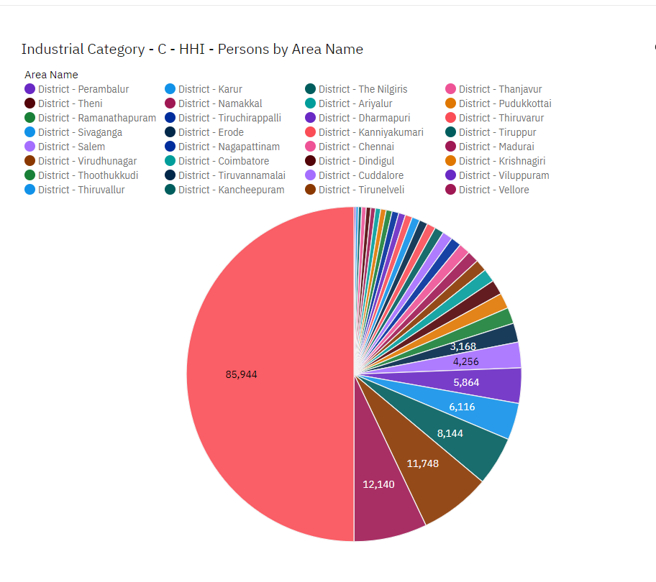

**Findings:**

* Vellore has the most population in industrial category -C.
* Perambalur has the least population in industrial category -C

**INDUSTRIAL CATEGORIES-D and E :[Electricity ,Gas, Steam and air conditioning]:**

HVACR technicians install, maintain, and repair heating, cooling, and refrigeration systems. Heating, air conditioning, and refrigeration mechanics and installers—often called HVACR technicians—work on heating, ventilation, cooling, and refrigeration systems that control the temperature and air quality in buildings.

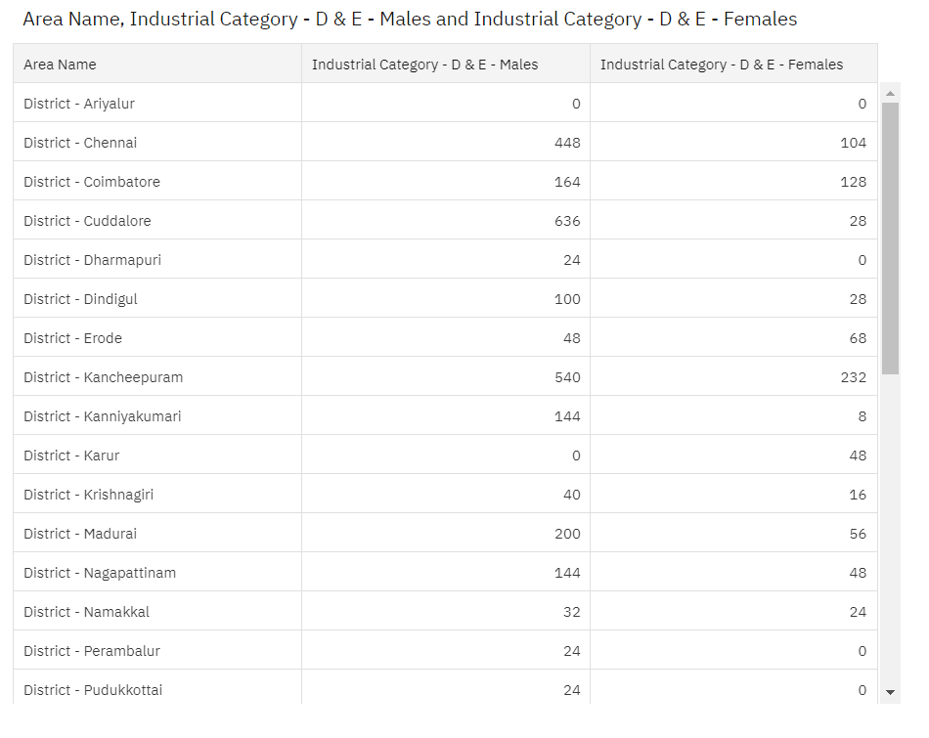

**Findings:**

* Cuddalore has the most population in industrial category – D&E.
* Ariyalur has the least population in industrial category – D

**INDUSTRIAL CATEGORIES-F[Construction]:**

A construction worker is someone who is employed as part of a construction crew and will perform many tasks that often involve physical labour on construction sites. However, there are plenty of roles that don't involve being on a construction site.

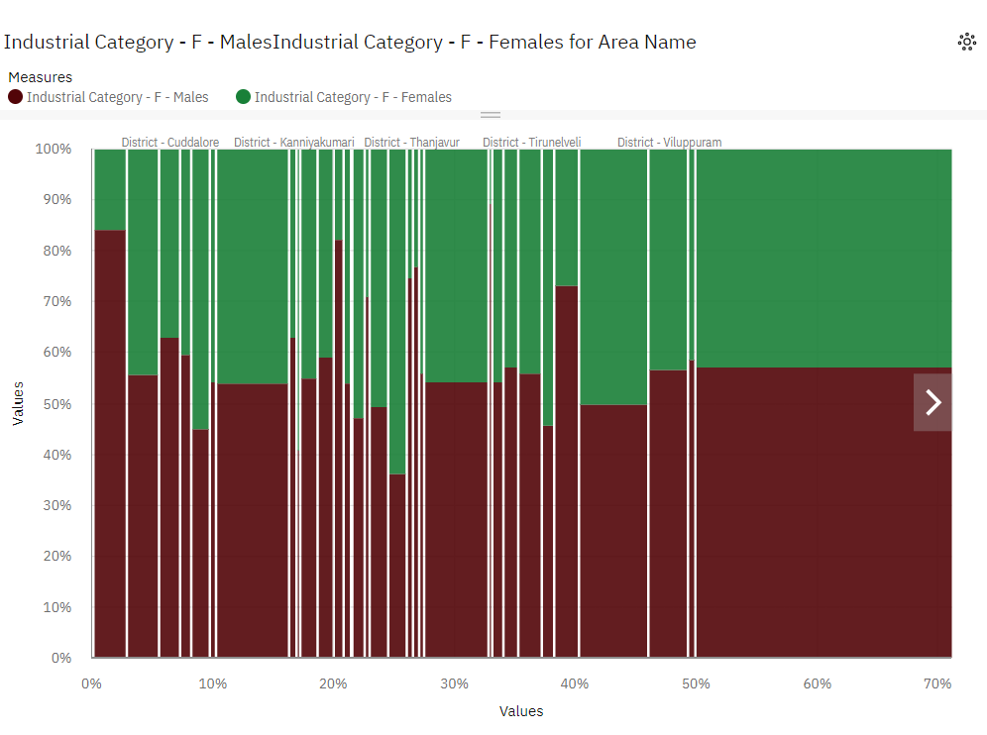

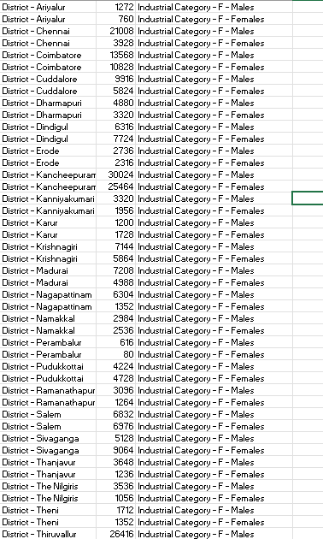

FINDINGS :

* Kancheepuram has the most female workers in industrial category-F among the states in Tamil Nadu
* Perambalur has the least female workers industrial category-F among the states in Tamil Nadu.
* Kancheepuram has the most male workers in industrial category-F among the states in Tamil Nadu.
* Perambalur has the least male workers in industrial category-F among the states in Tamil Nadu.

**CONCLUSION:**

 These analysis shows that Agriculture being dominating the nature of employment of the population in Viluppuram. The towns where agriculture is not showing up population’s percentage is increasing in Marginal Work. This means that there has to be some way to motivate agriculture in these towns to so as to engage the population employed throughout the year.