Initial State:
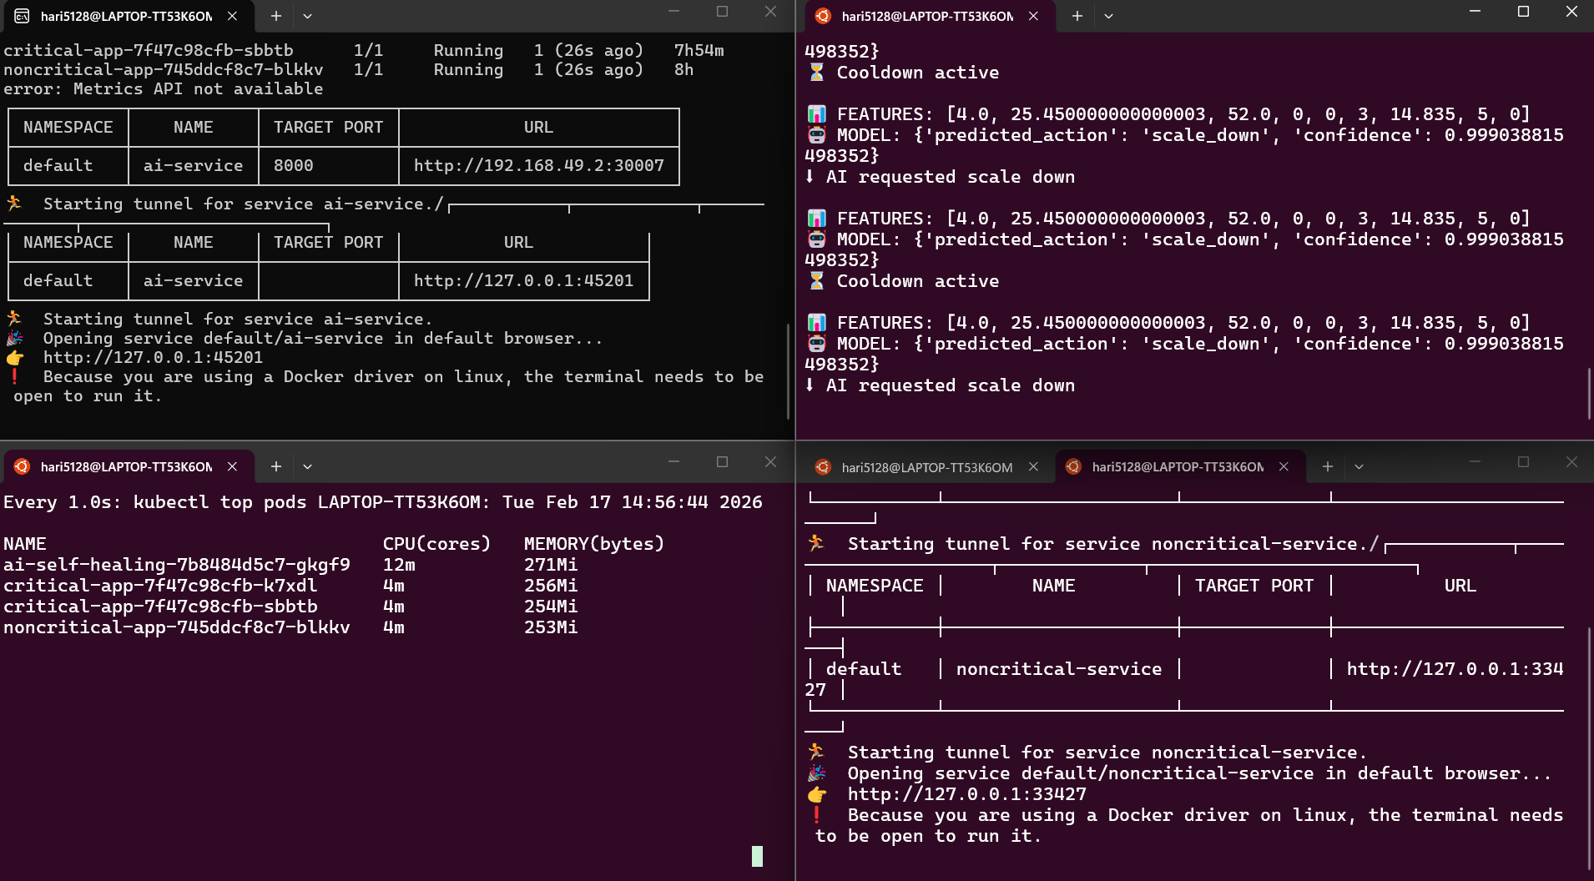
After giving load to critical service(Scaling critical service):
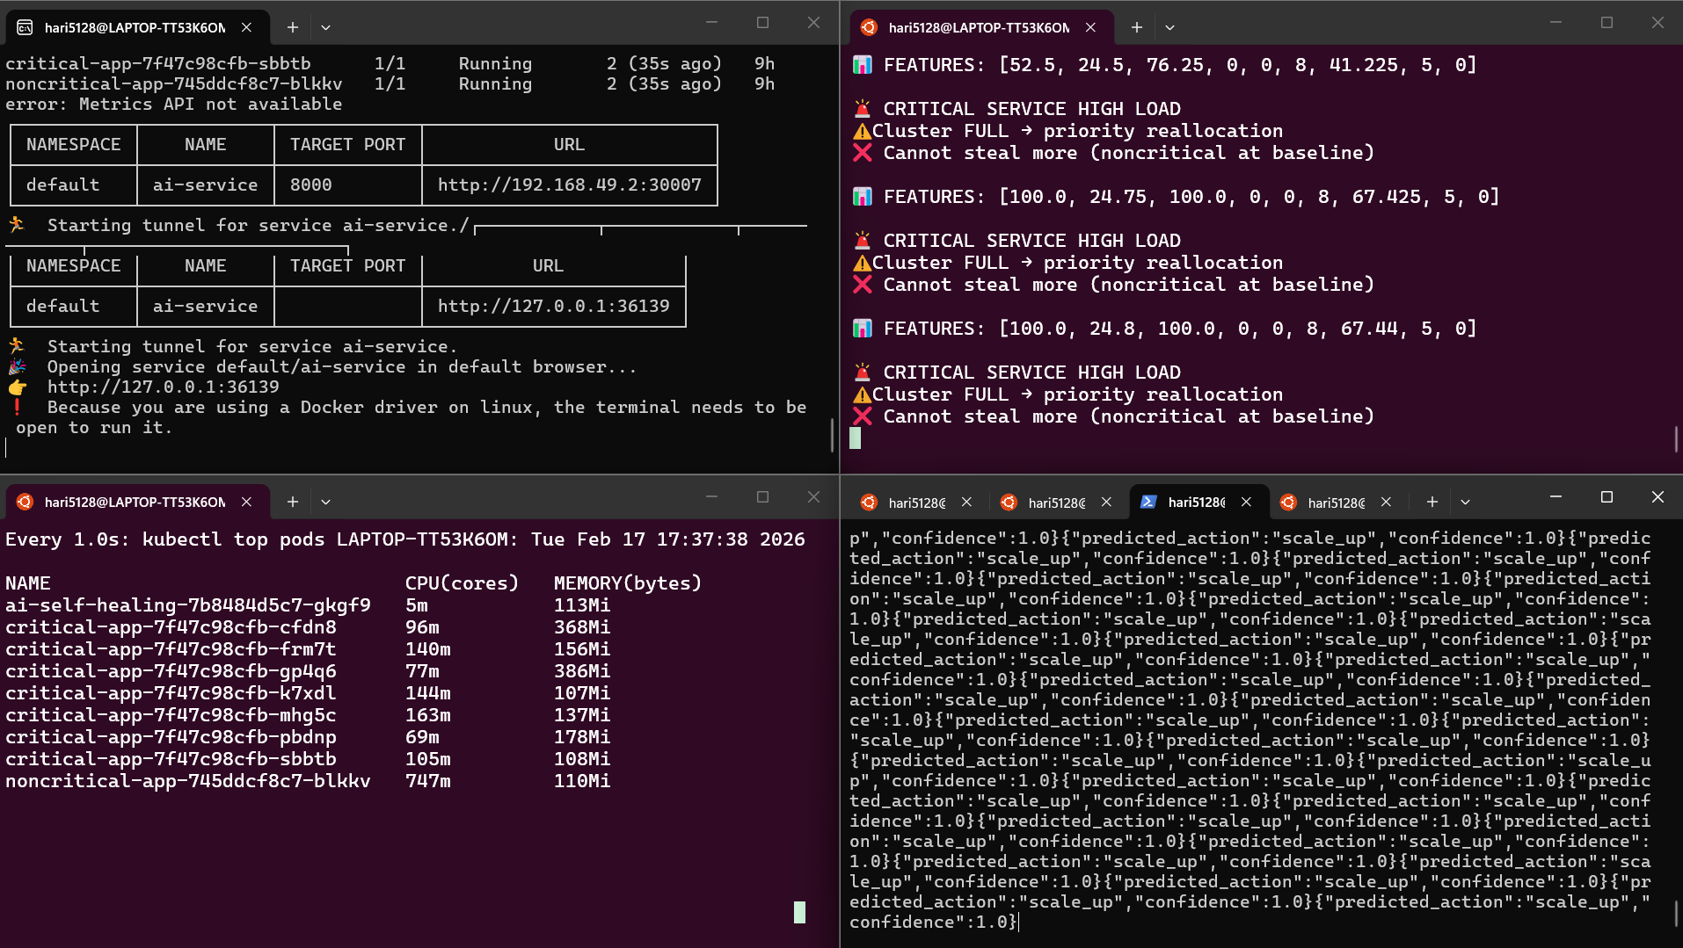
After removing load from critical service(Scaling down):
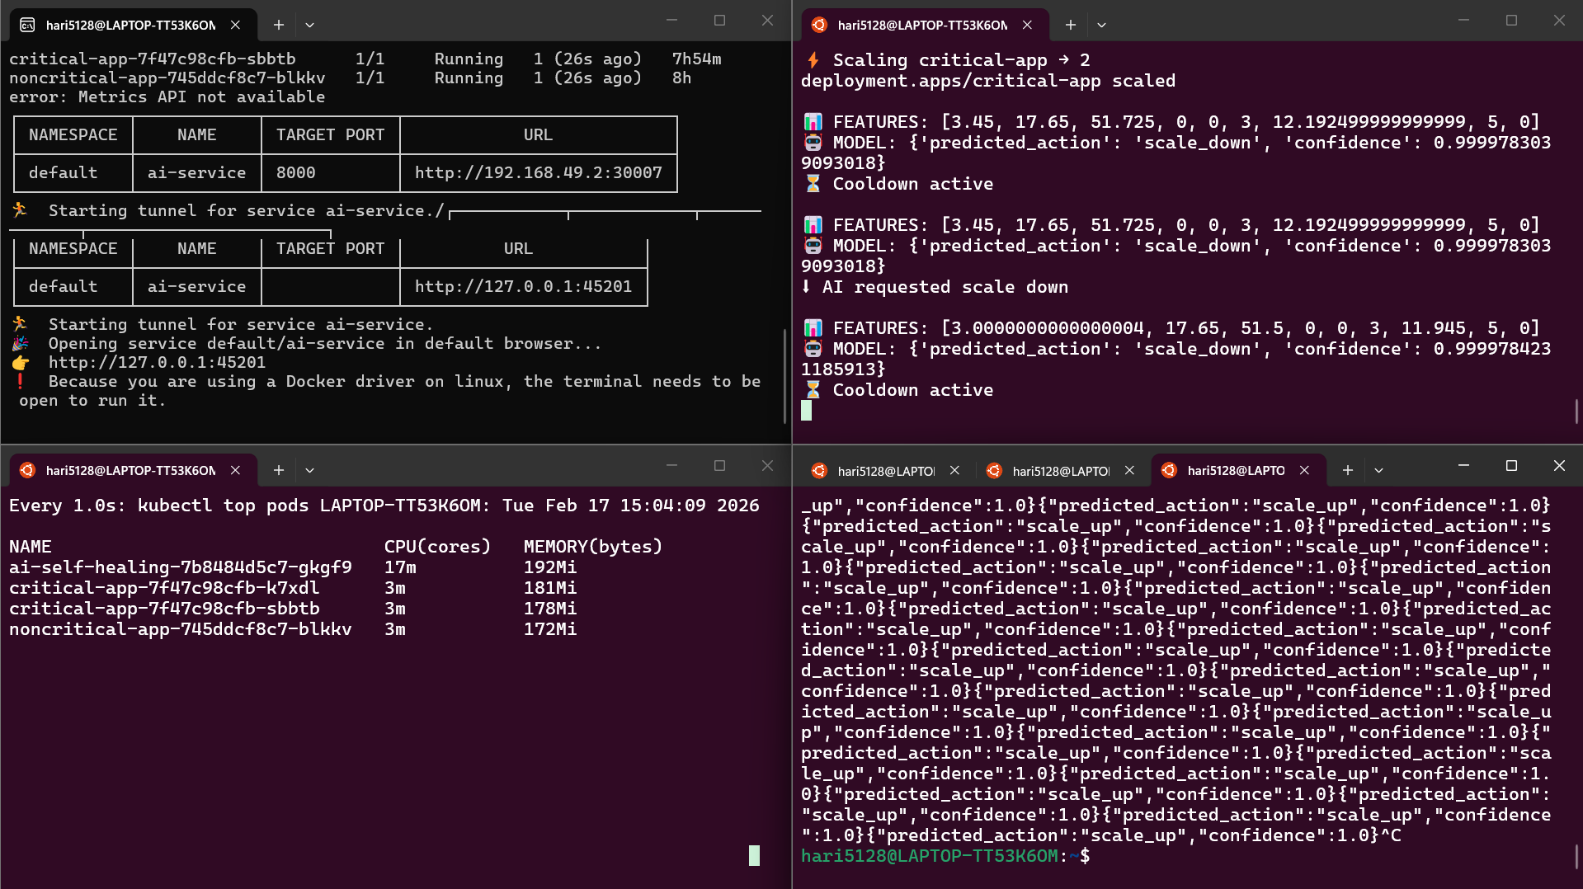
After giving load to non critical service(Scaling non critical service):
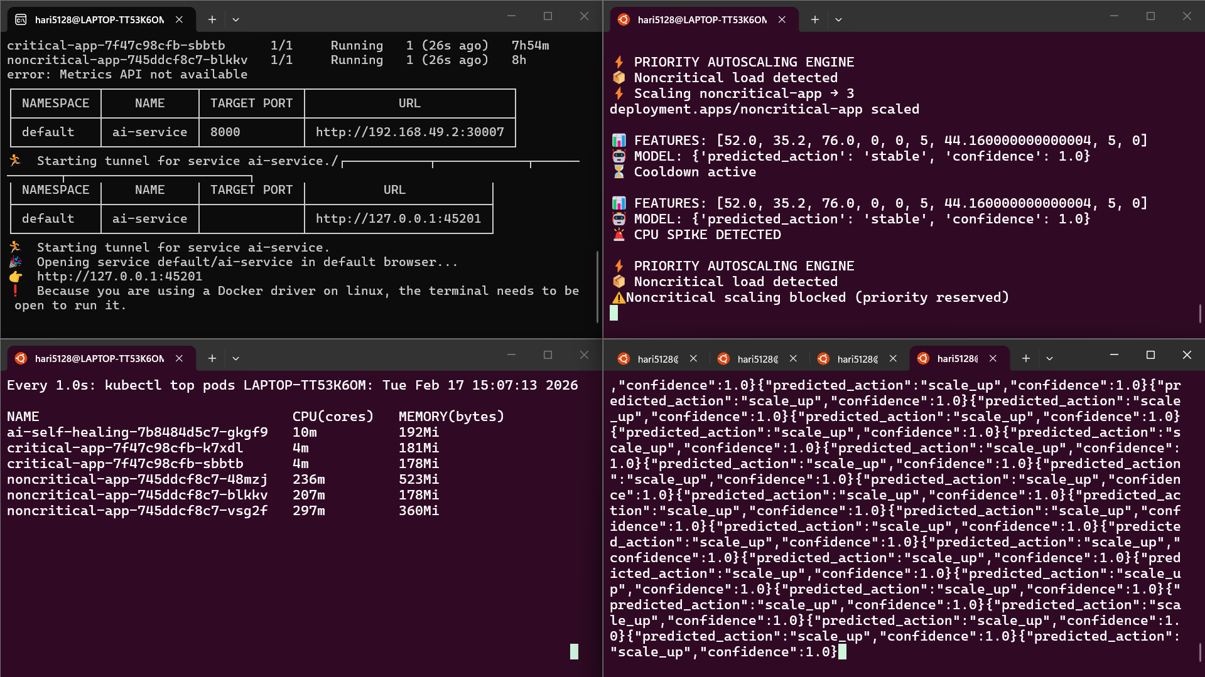
After removing load from non critical service(scale down):
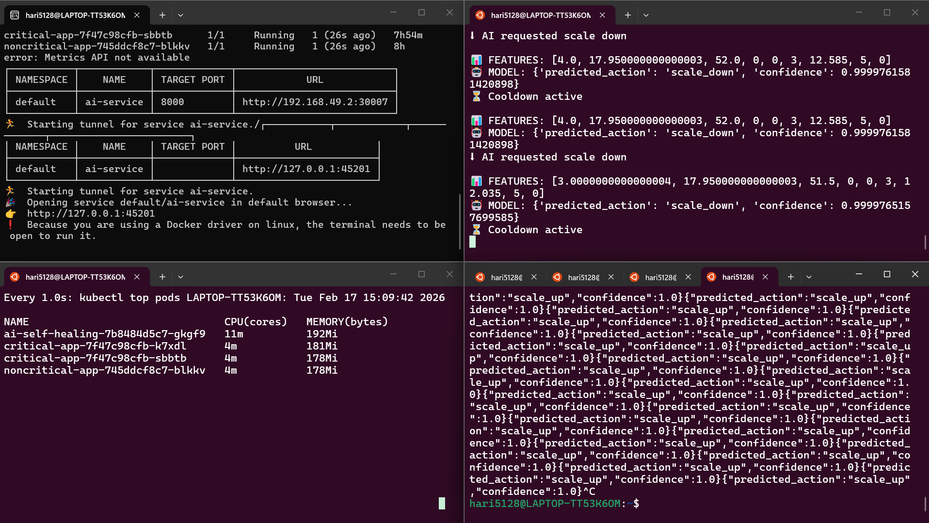
After scaling both non critical and critical service at the same time:
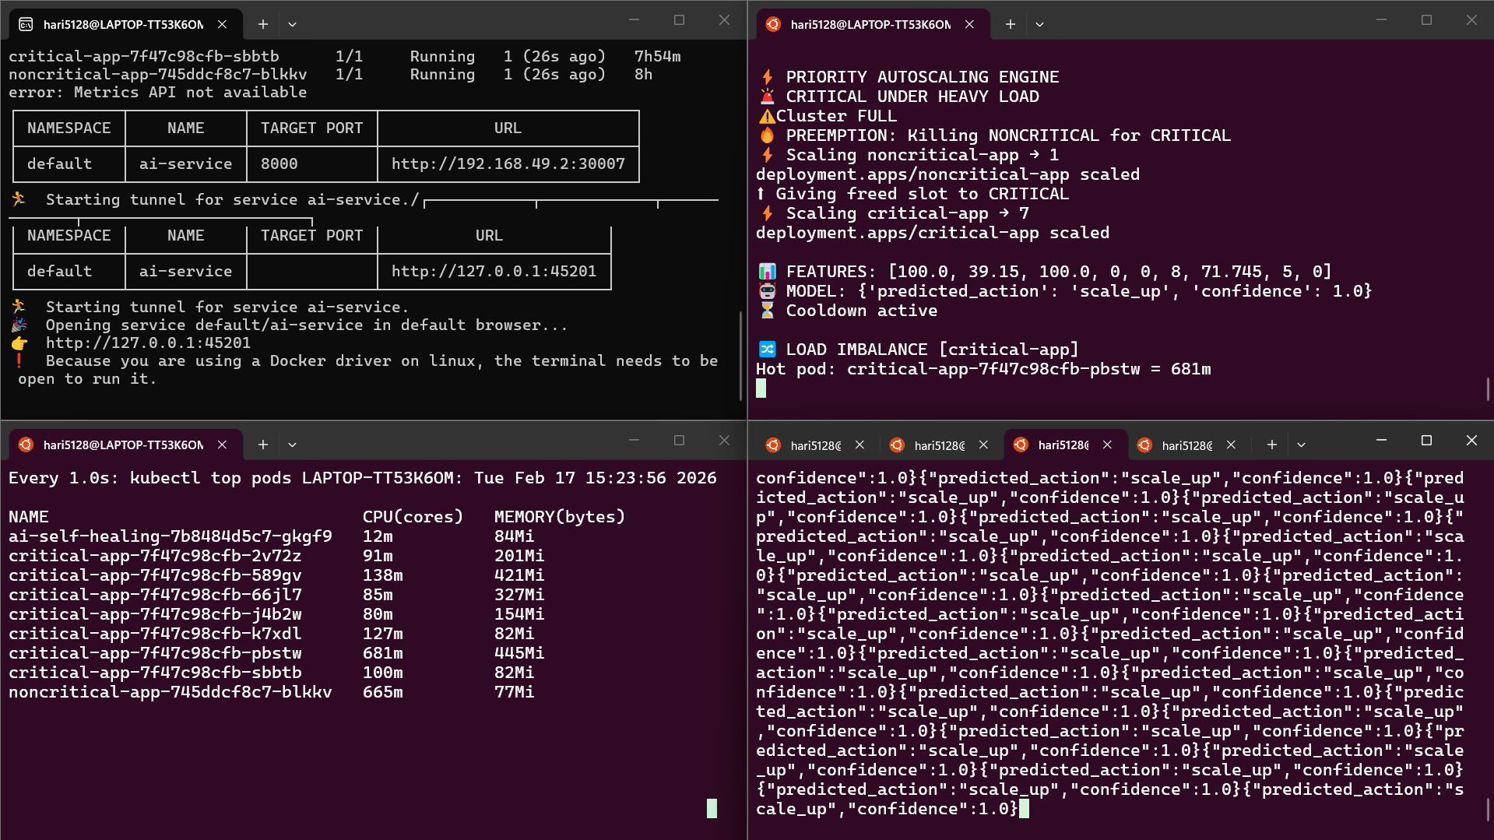

After cancelling only critical (critical scales down while non critical scales up):
