**SERVER:**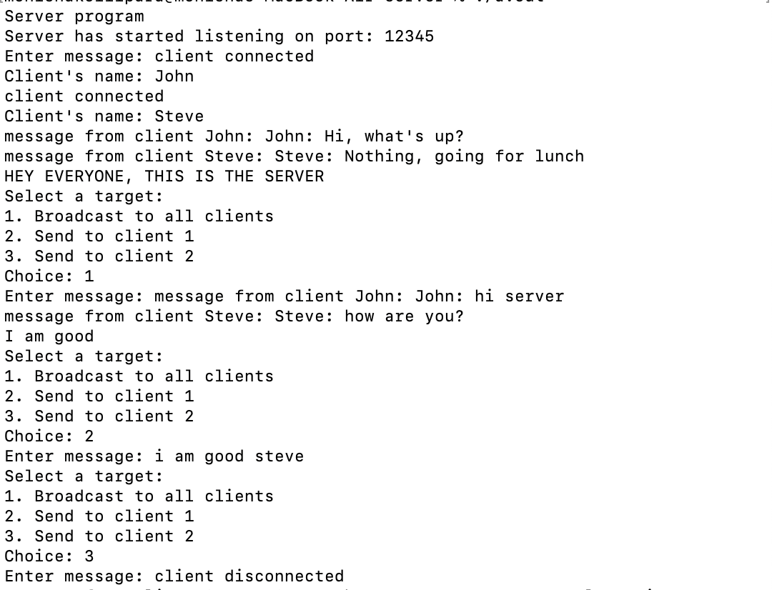

**CLIENT:**

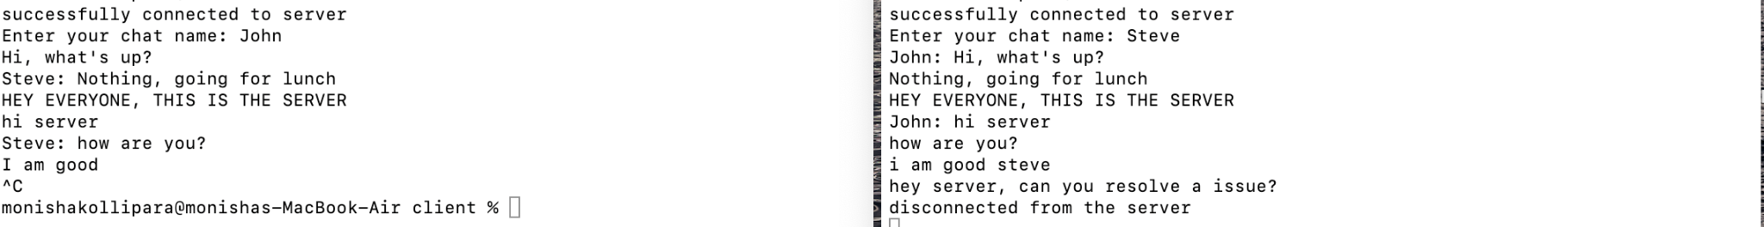

CLIENT 1 CLIENT 2

