**UML ASSIGNMENT OUTPUT:**

1.UML CLASS DIAGRAM:

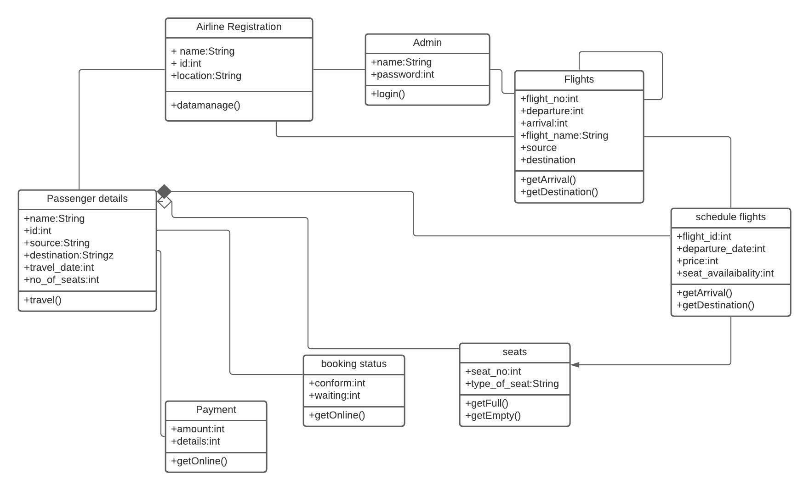

2.UML CLASS DIAGRAM:

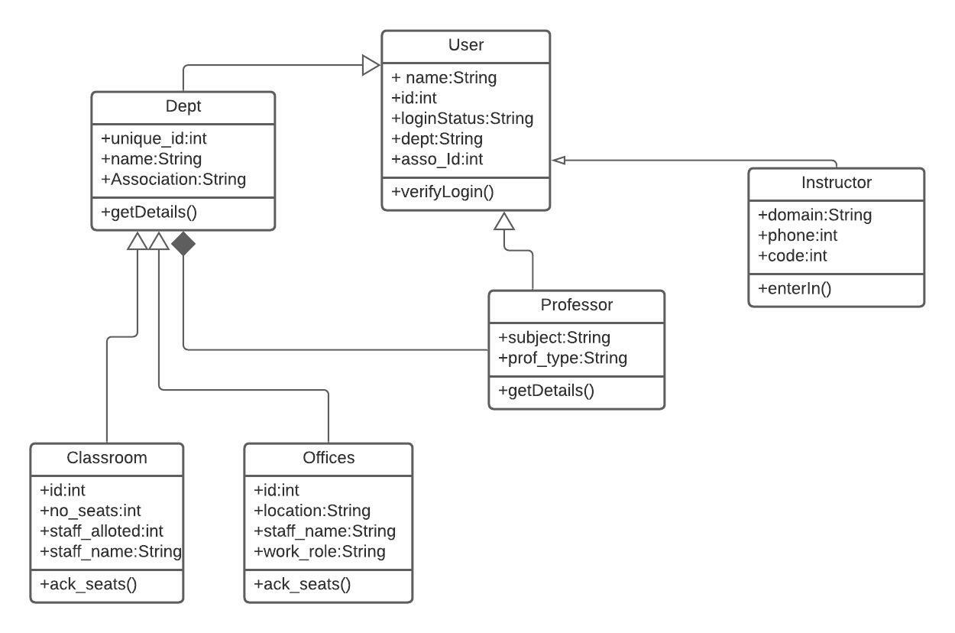

3.ACTIVITY DIAGRAM:

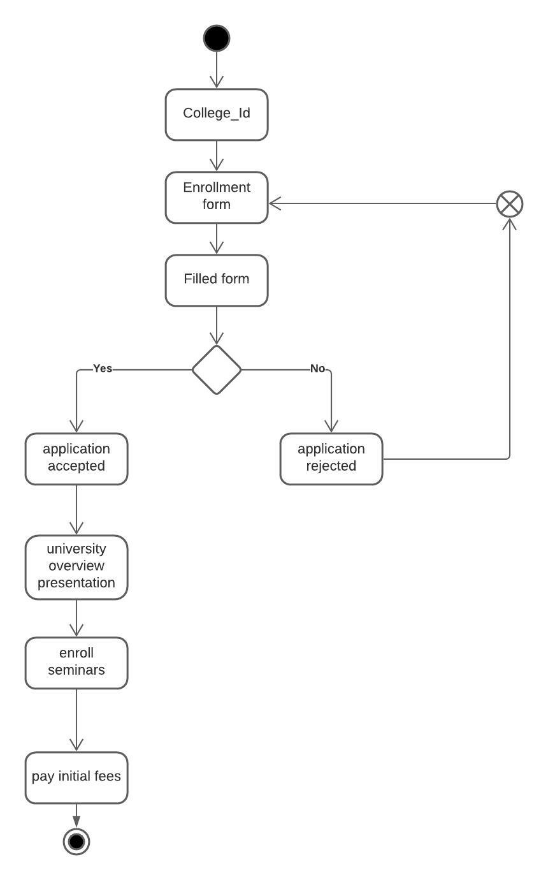

4.sequence diagram:

