Task7

1. New repository created.

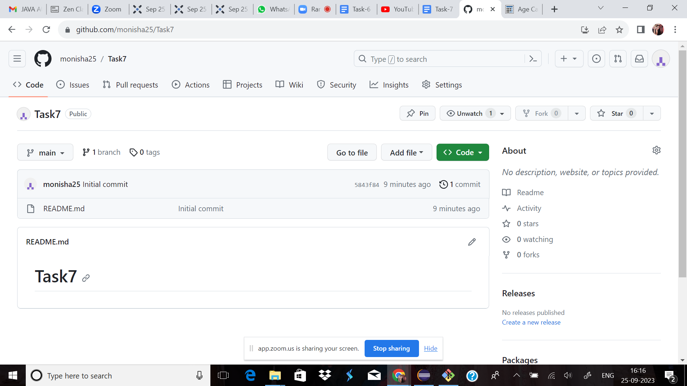

2.Use init comment

init is to create processes from script stored in the file /etc/inittab which is a configuration file which is to be used by initialization system

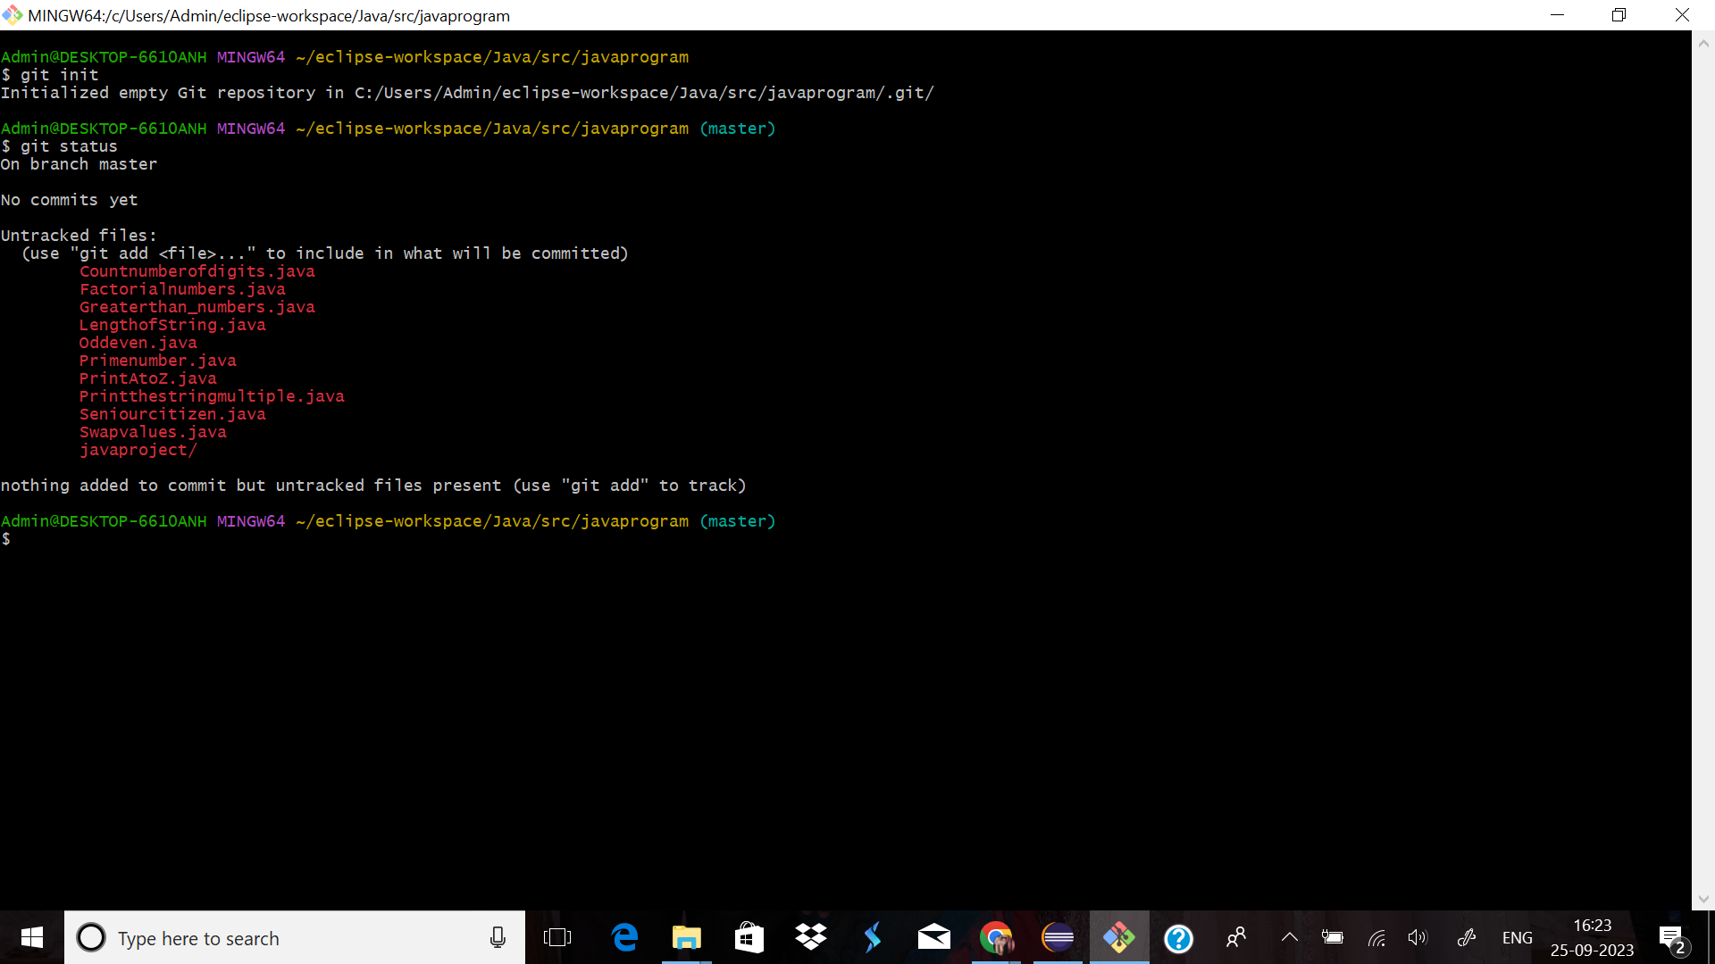

3.observed .git

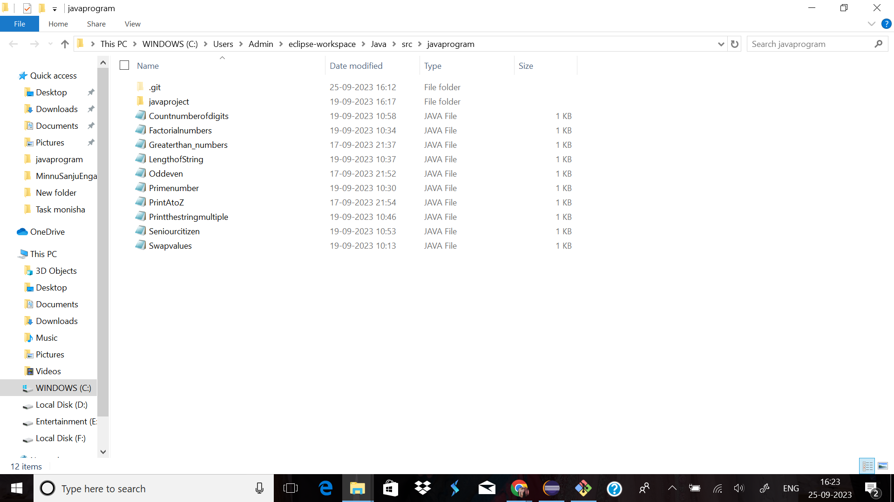

4. README file created

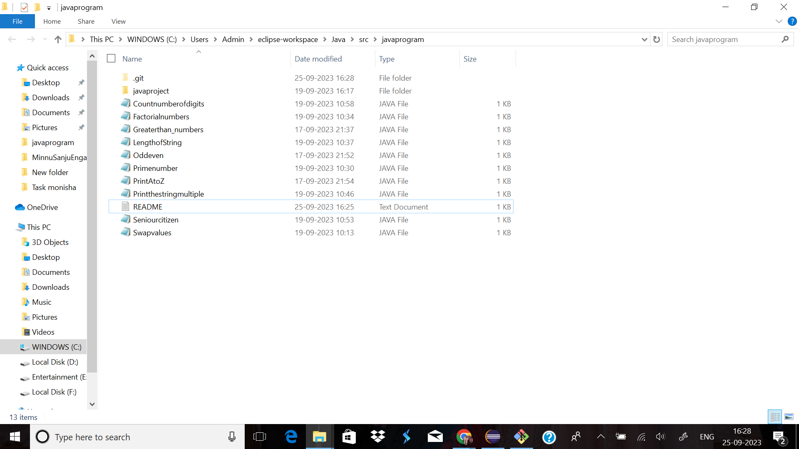

5.README text file Observed in untracked file

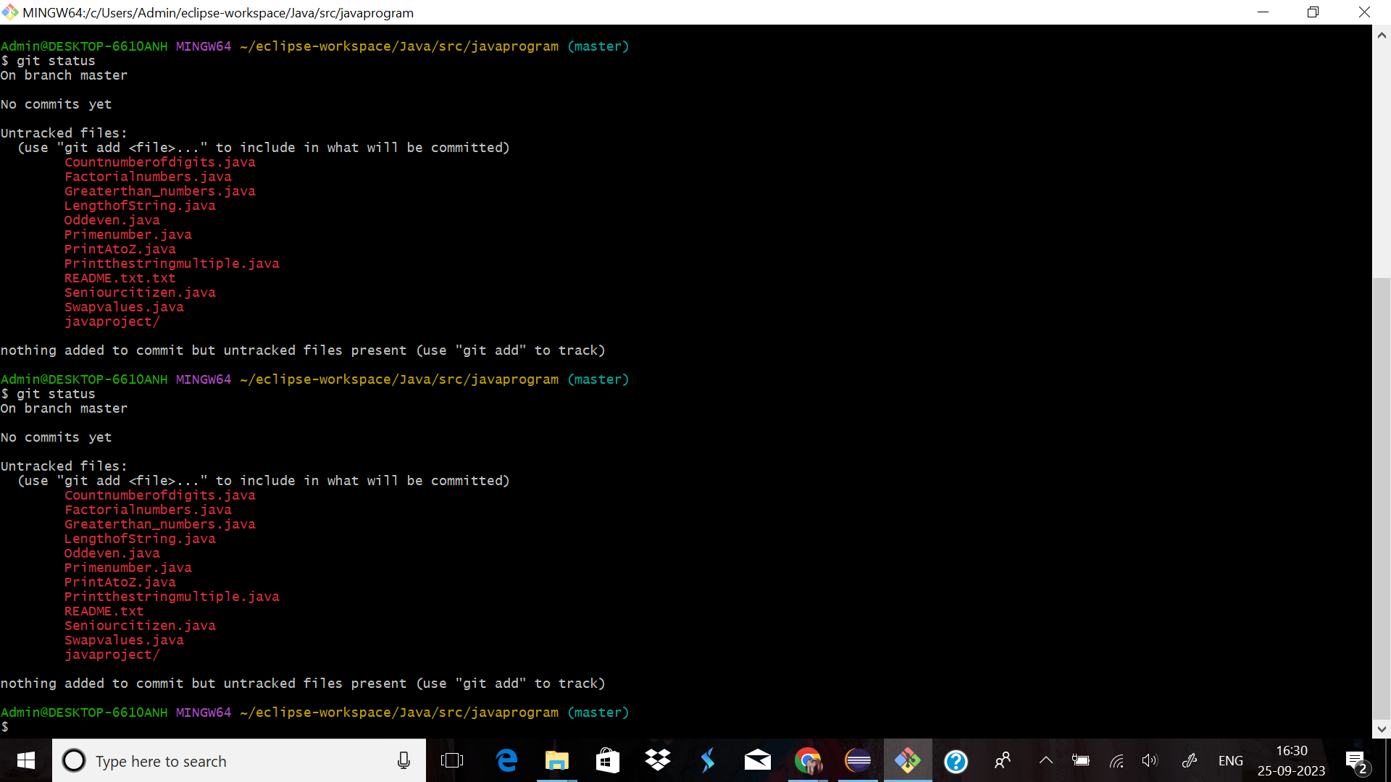

6.Using add command

add is a command that allows you to stage individual files, or all files in the project directory at once, preparing them to be staged.

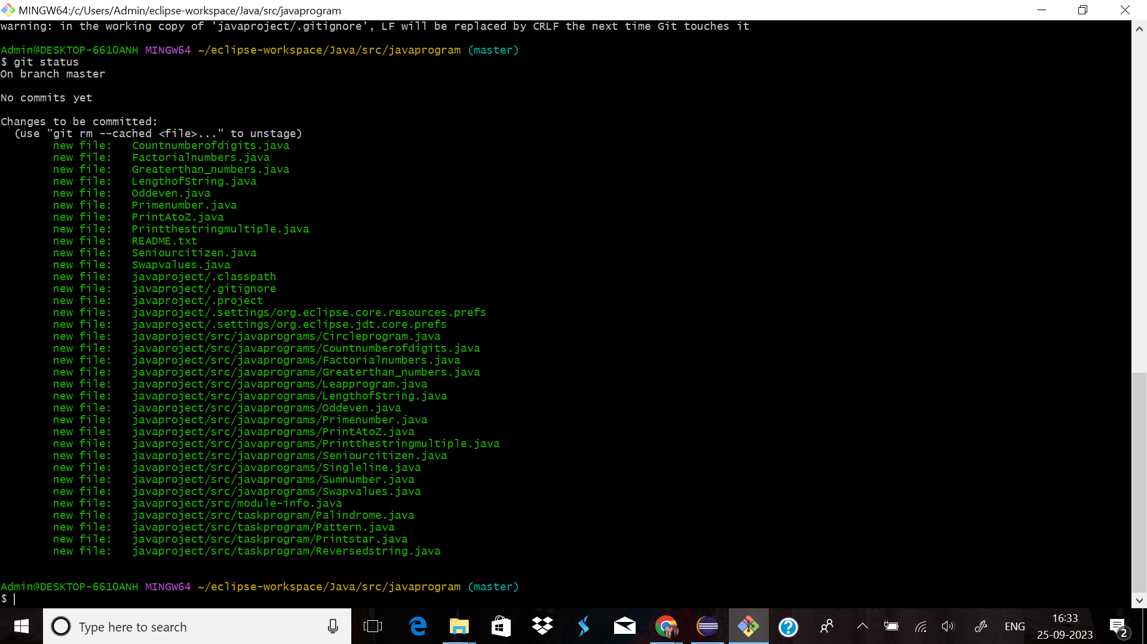

7.Using commit command

The git commit command captures a snapshot of the project's currently staged changes.

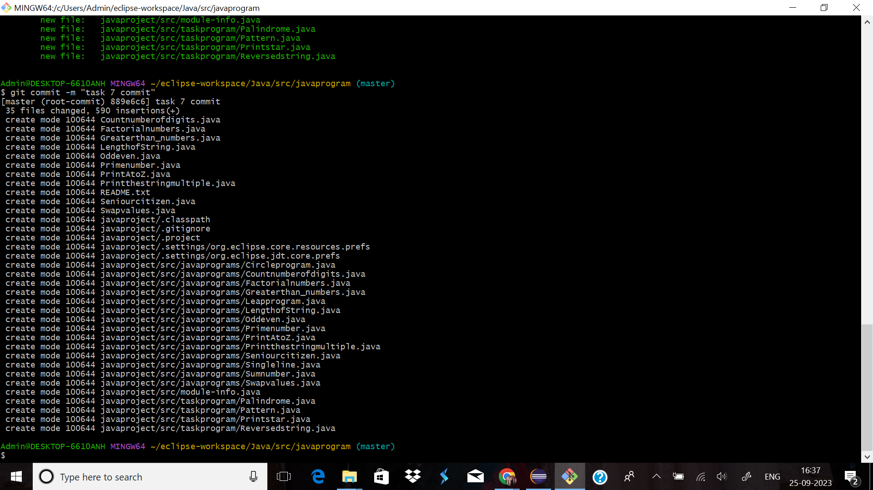

8.Add Two files inside the src folder

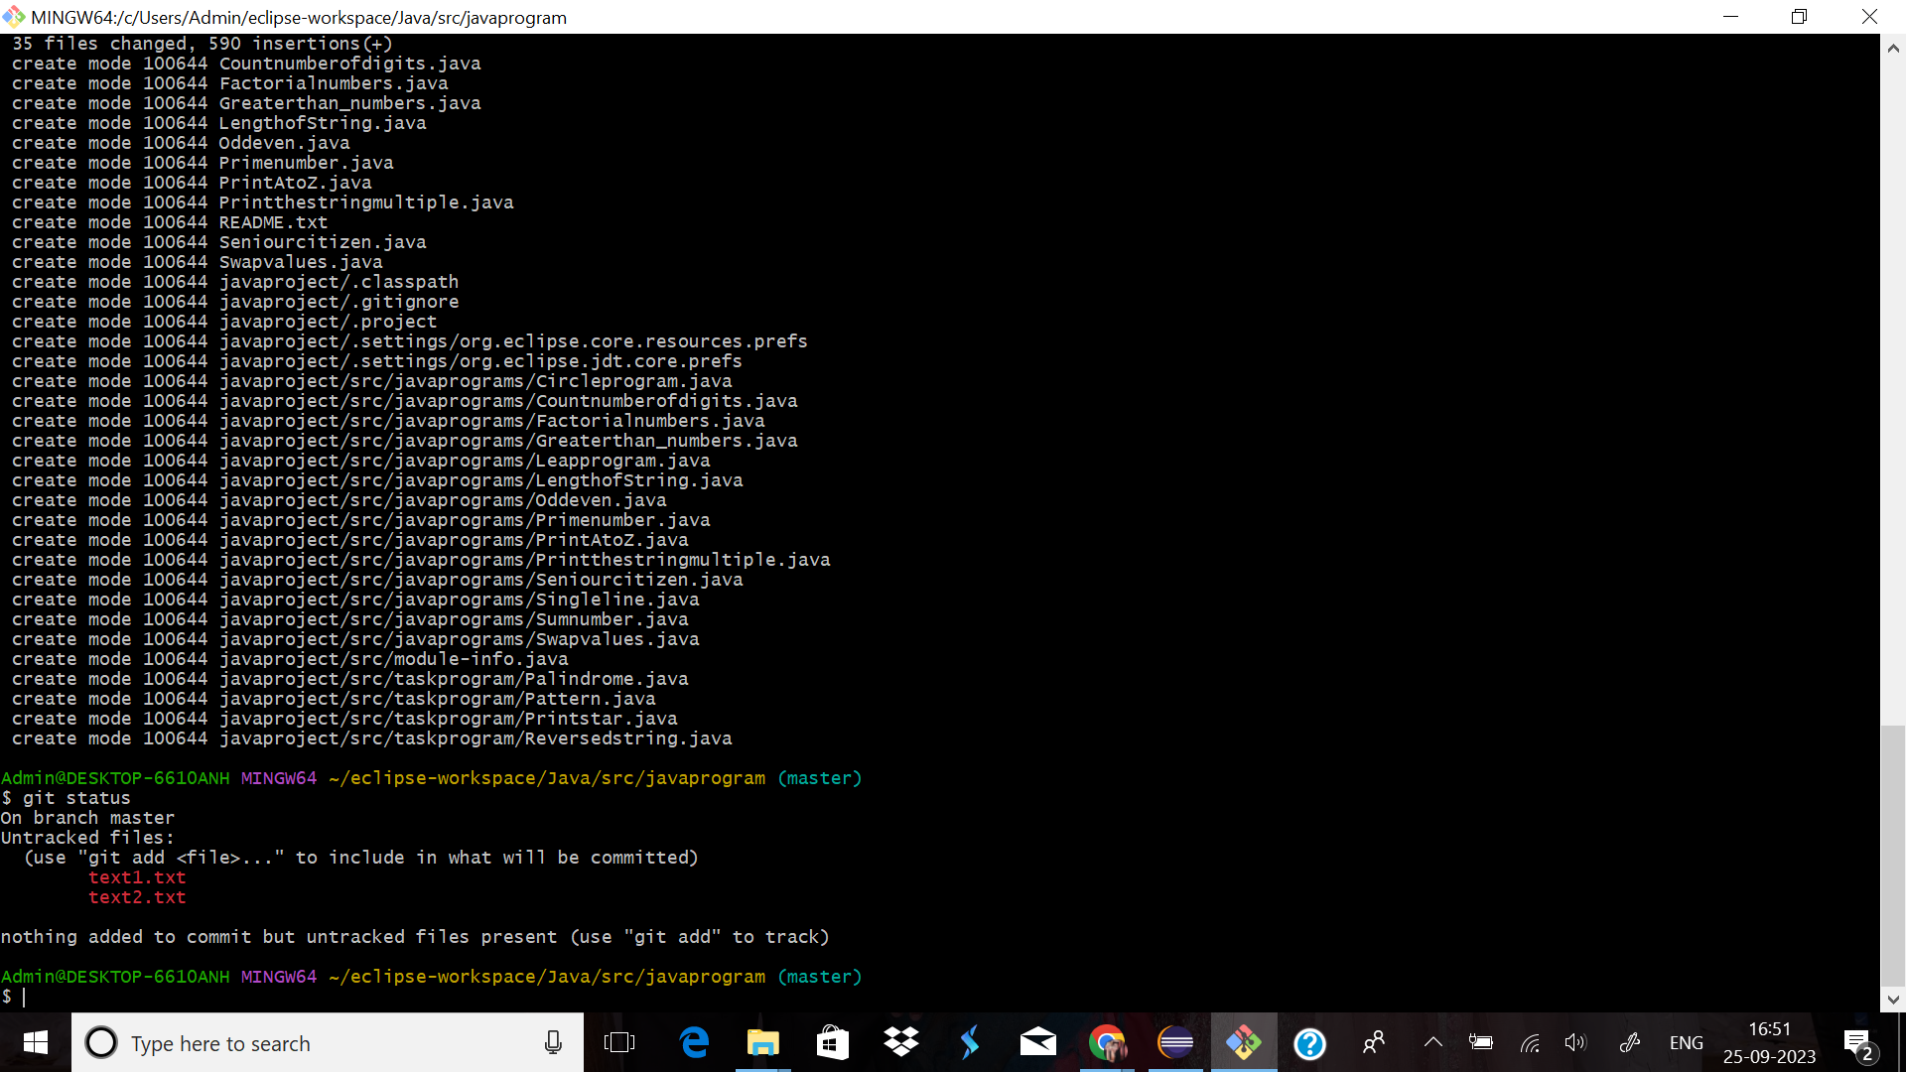

9.Using add command and commit

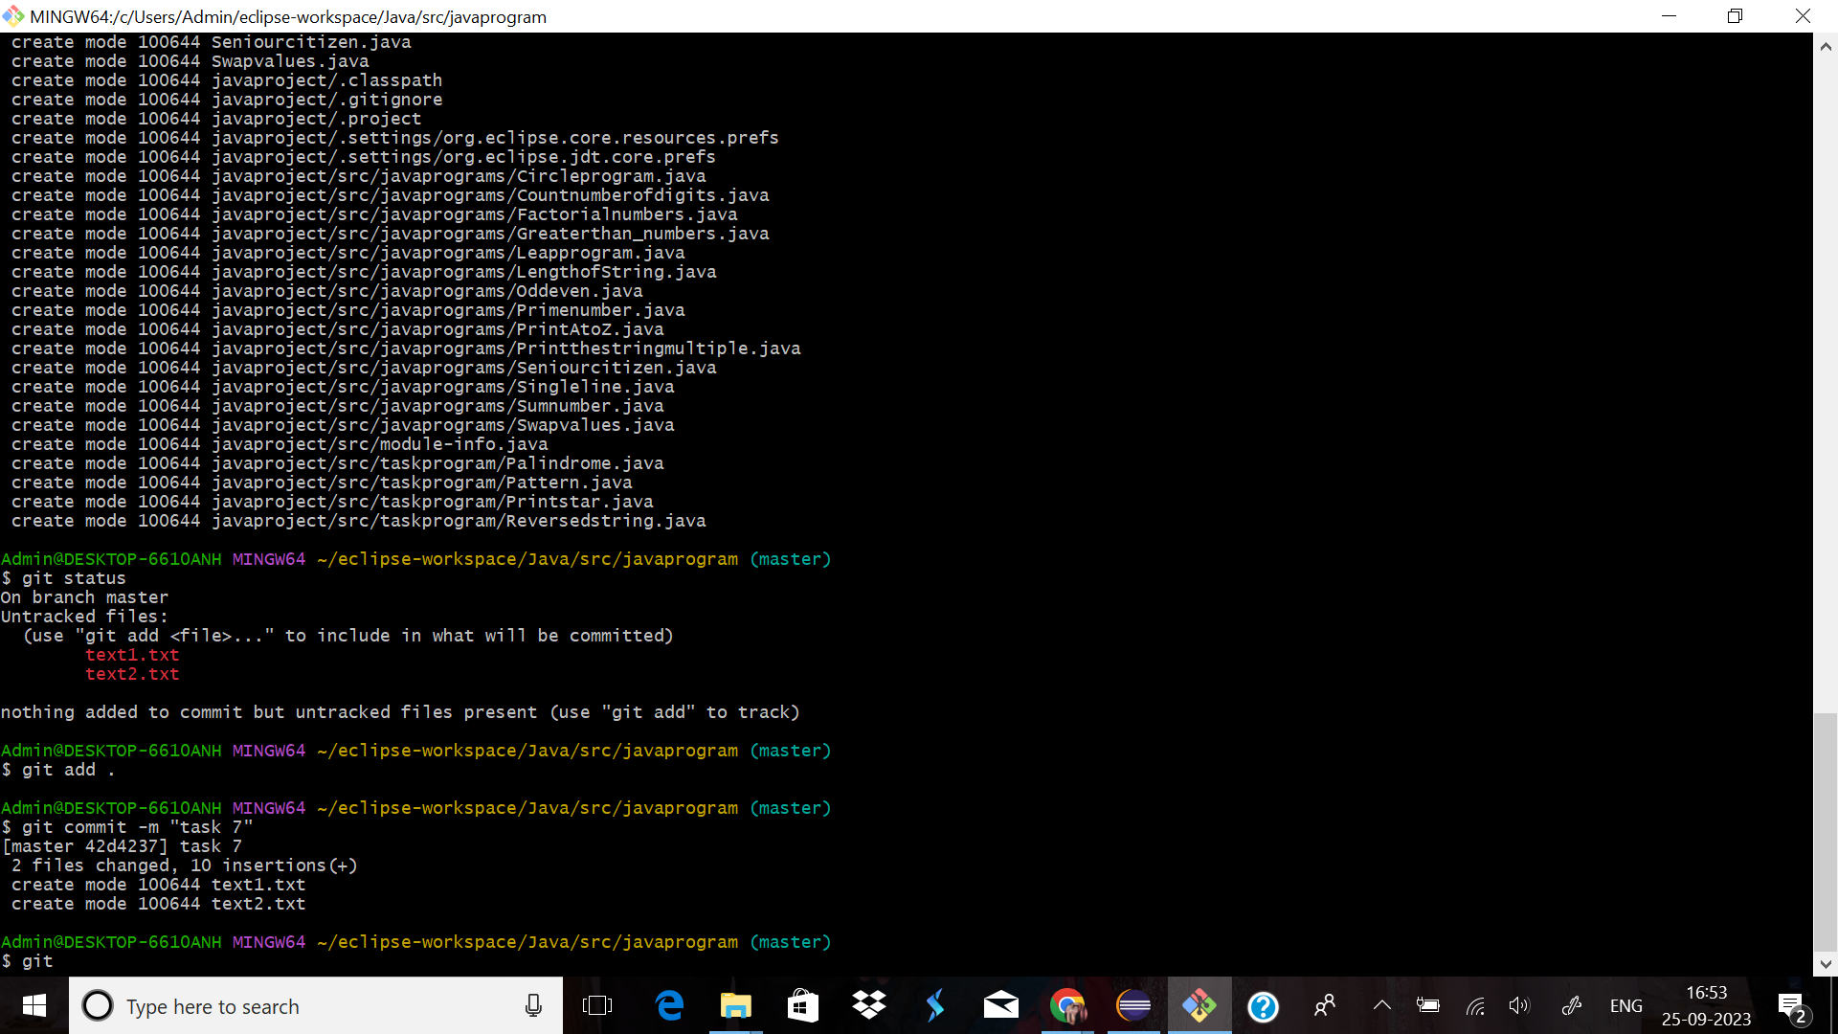

10.One file has been Modified and Using diff command to view the changes.

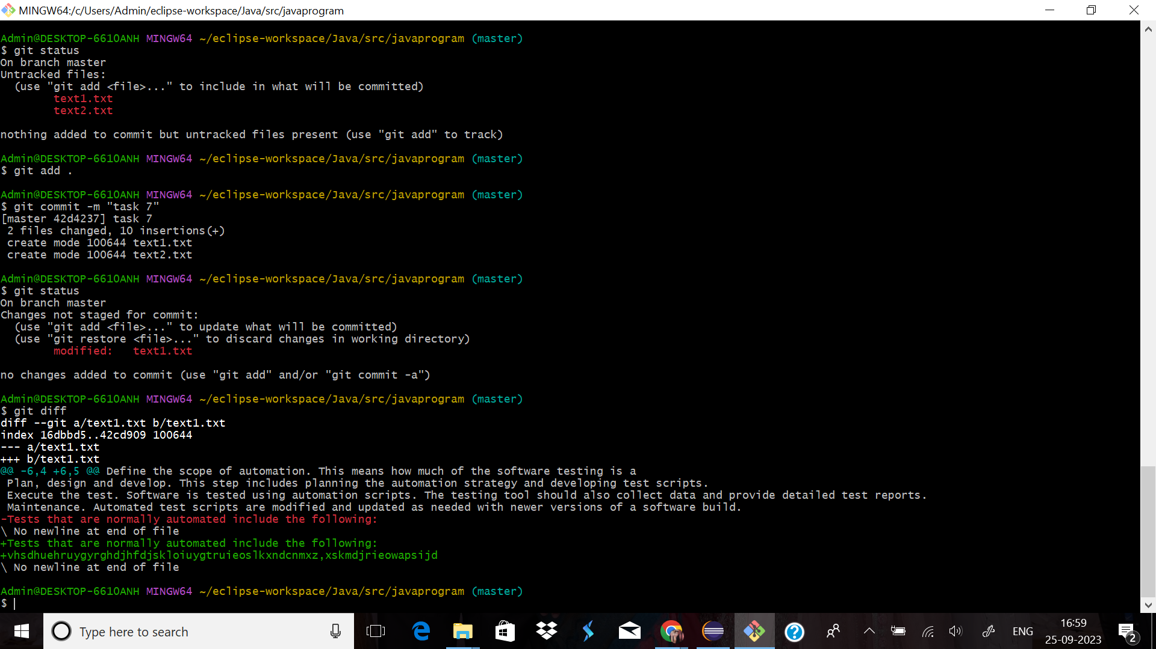

11. Using add command and see the difference.

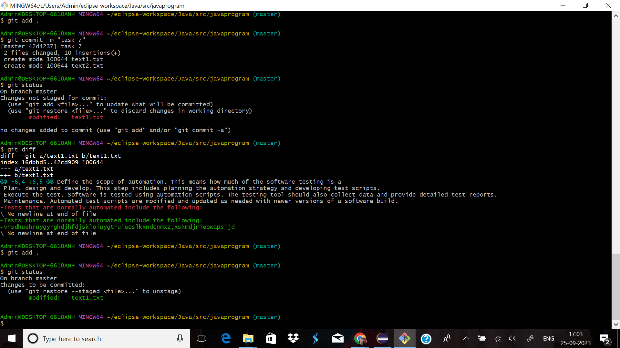

12.With out committing,made another changes in same file and observe the changes and finally done the commit.

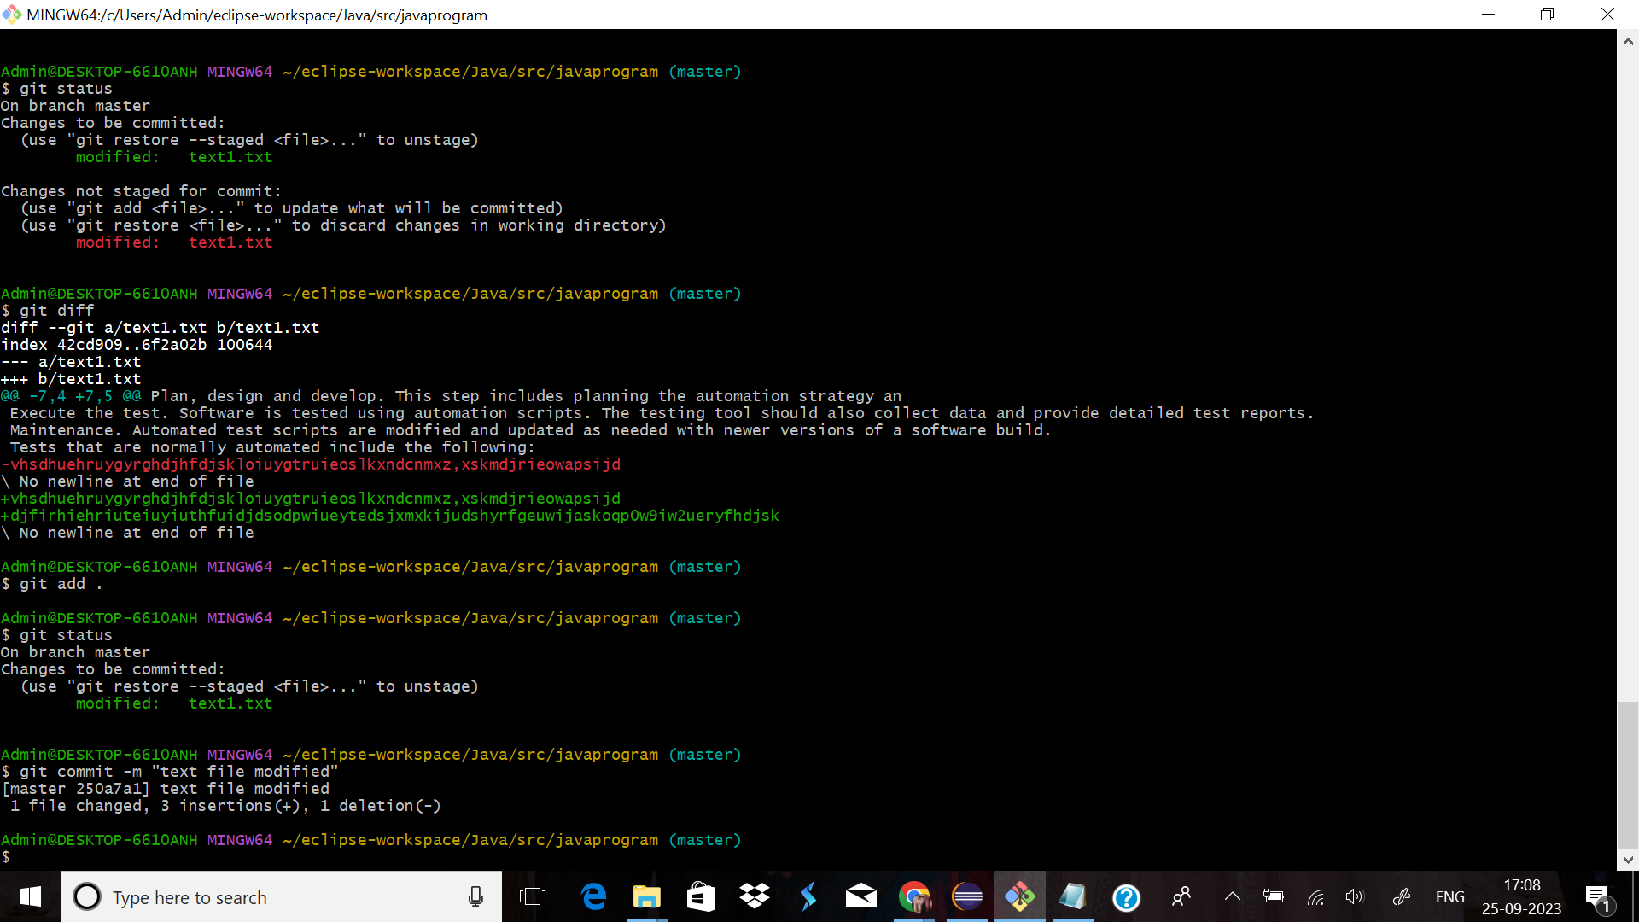

13. Using log command

The git log command is Git's basic tool for exploring a repository's history.

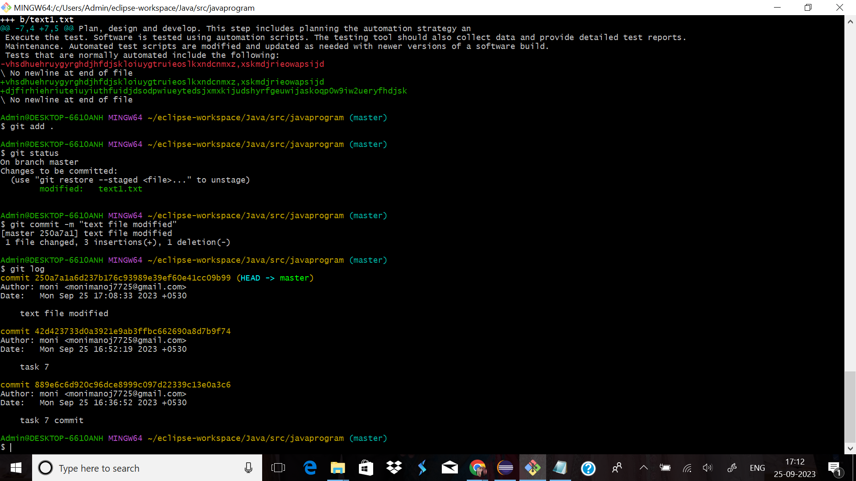

14.Using show command

show is a command line utility that is used to view expanded details on Git objects such as blobs, trees, tags, and commits. git-show has specific behavior per object type. Tags show the tag message and other objects included in the tag. Trees show the names and content of objects in a tree.

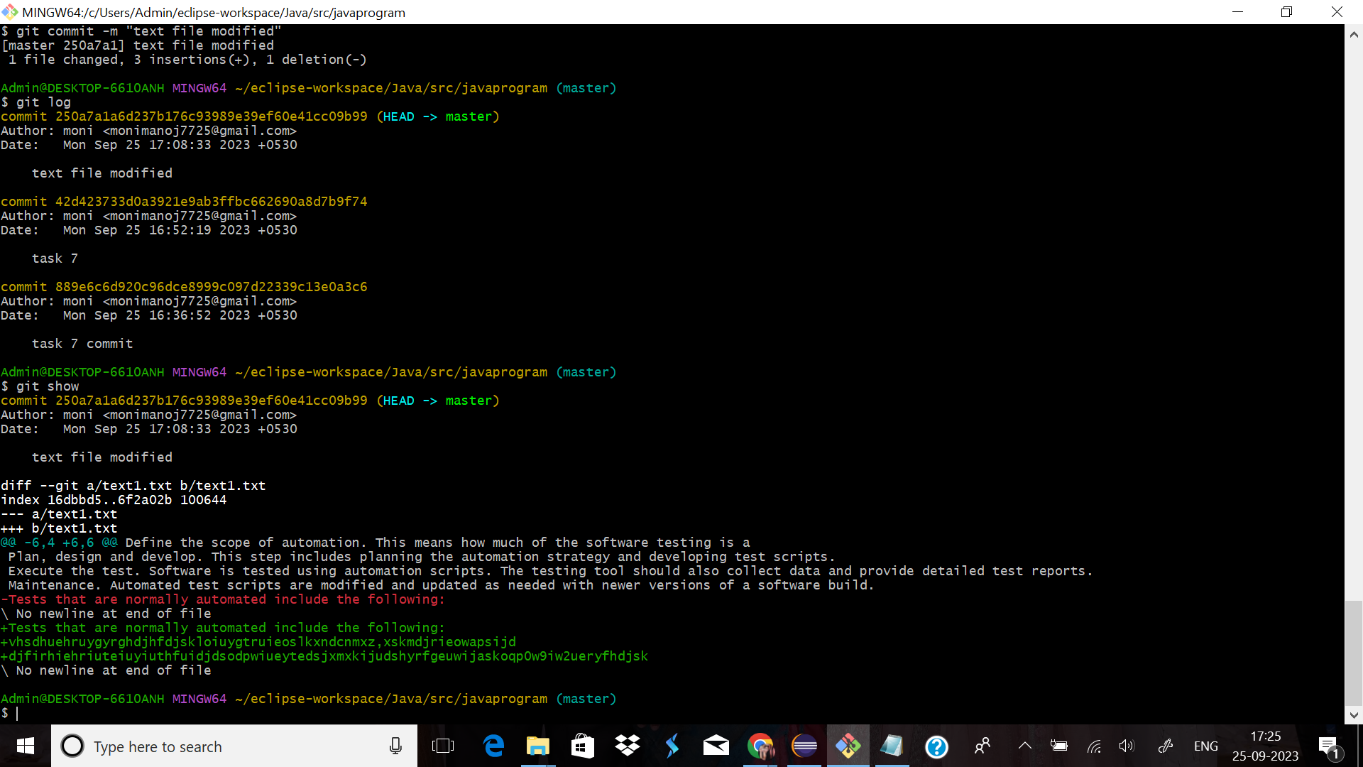

15.Done two more commits by adding new text file and modified existing text file .

