Name: Monisha Raghini Chelle

Roll no:2520030537

DBSE&DBD SKILL SESSION NUMBER 4 AND 5

MONGODB ATLAS - BANK TRANSACTION DATABASE

Database and Collections
Database: bankdb
Collections:
- customers
- transactions

Query 1: Display All Customers
MongoDB Query:
JSON
{}
Operation: Documents → Filter → Find
Expected Result: 8 customer documents.
📸 Paste Screenshot – Query 1
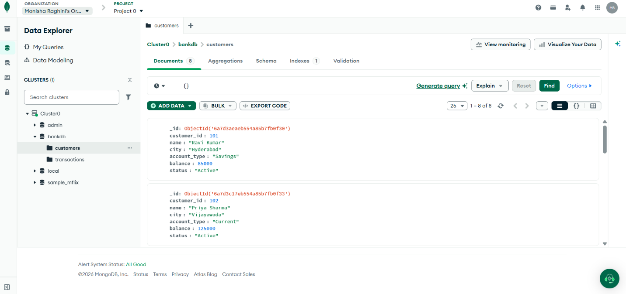

Query 2: Find Active Customers
MongoDB Query:
JSON
{
"status": "Active"
}
Expected Result: Ravi Kumar, Priya Sharma, Arjun Reddy, Sneha Rao, Anjali Singh, Rahul Verma and Meena Devi.
📸 Paste Screenshot – Query 2
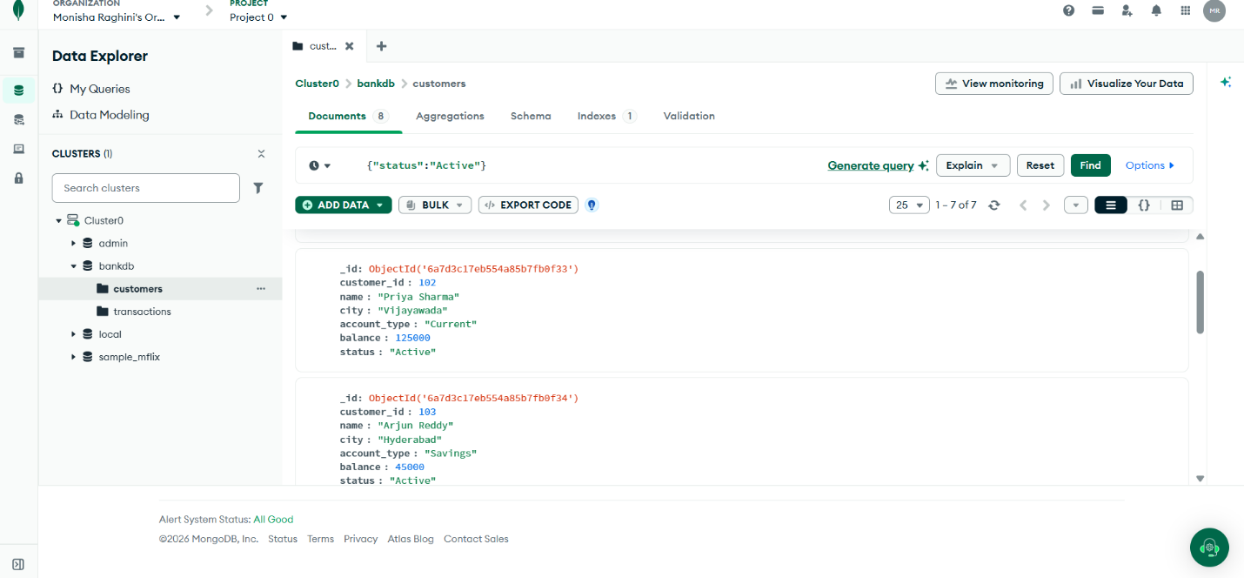

Query 3: Find Customers with Balance Greater Than 100000
MongoDB Query:
JSON
{
"balance": {
"$gt": 100000
}
}
Expected Result: Priya Sharma, Sneha Rao, Anjali Singh and Meena Devi.
📸 Paste Screenshot – Query 3
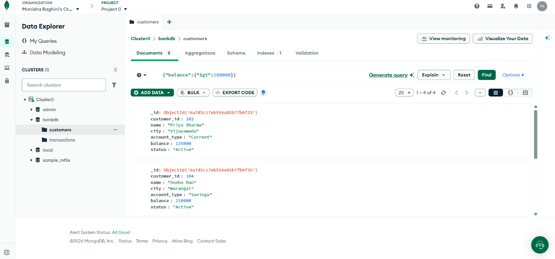

Query 4: Find Hyderabad Customers
MongoDB Query:
JSON
{
"city": "Hyderabad"
}
Expected Result: Ravi Kumar, Arjun Reddy and Anjali Singh.
📸 Paste Screenshot – Query 4
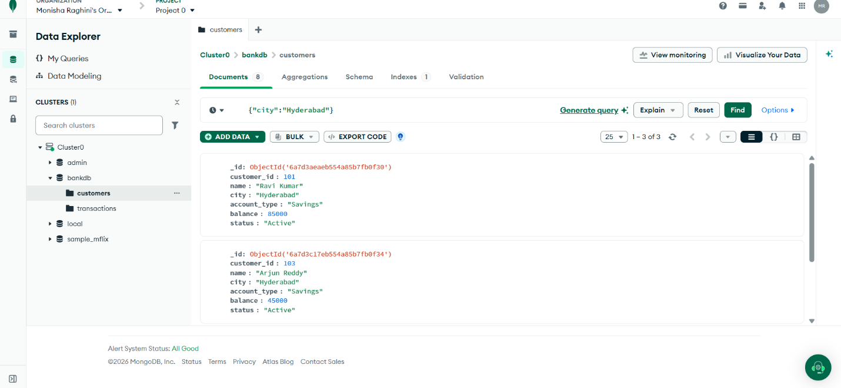

Query 5: Find Savings Account Customers
MongoDB Query:
JSON
{
"account_type": "Savings"
}
Expected Result: Ravi Kumar, Arjun Reddy, Sneha Rao, Anjali Singh and Meena Devi.
📸 Paste Screenshot – Query 5
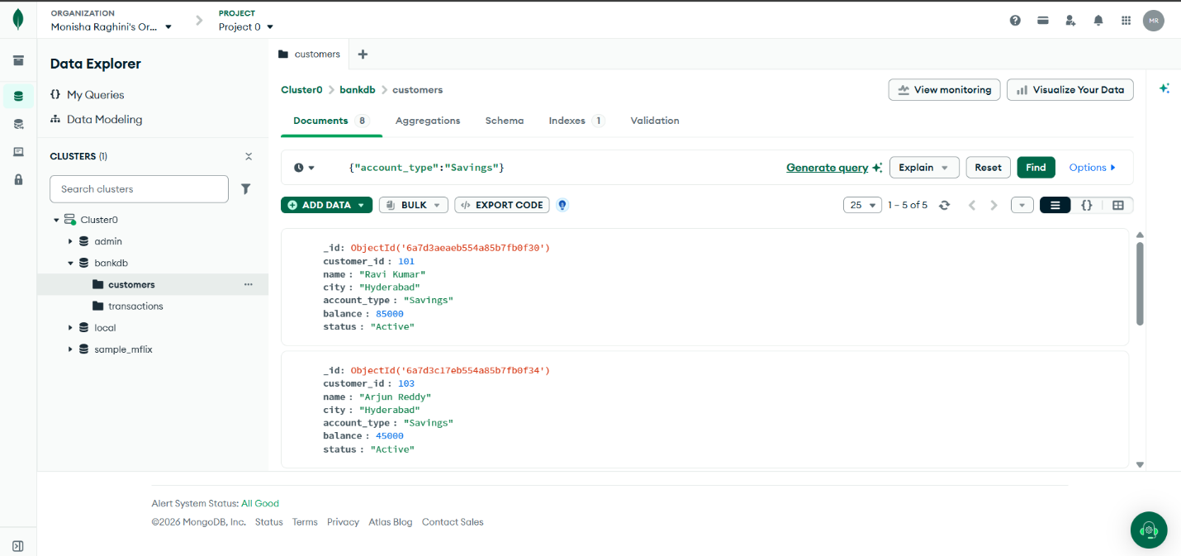

Query 6: Find Transactions Greater Than 20000
Go to transactions → Documents.
MongoDB Query:
JSON
{
"amount": {
"$gt": 20000
}
}
Expected Transactions: 1001, 1003, 1005, 1007, 1008, 1010, 1012 and 1014.
📸 Paste Screenshot – Query 6
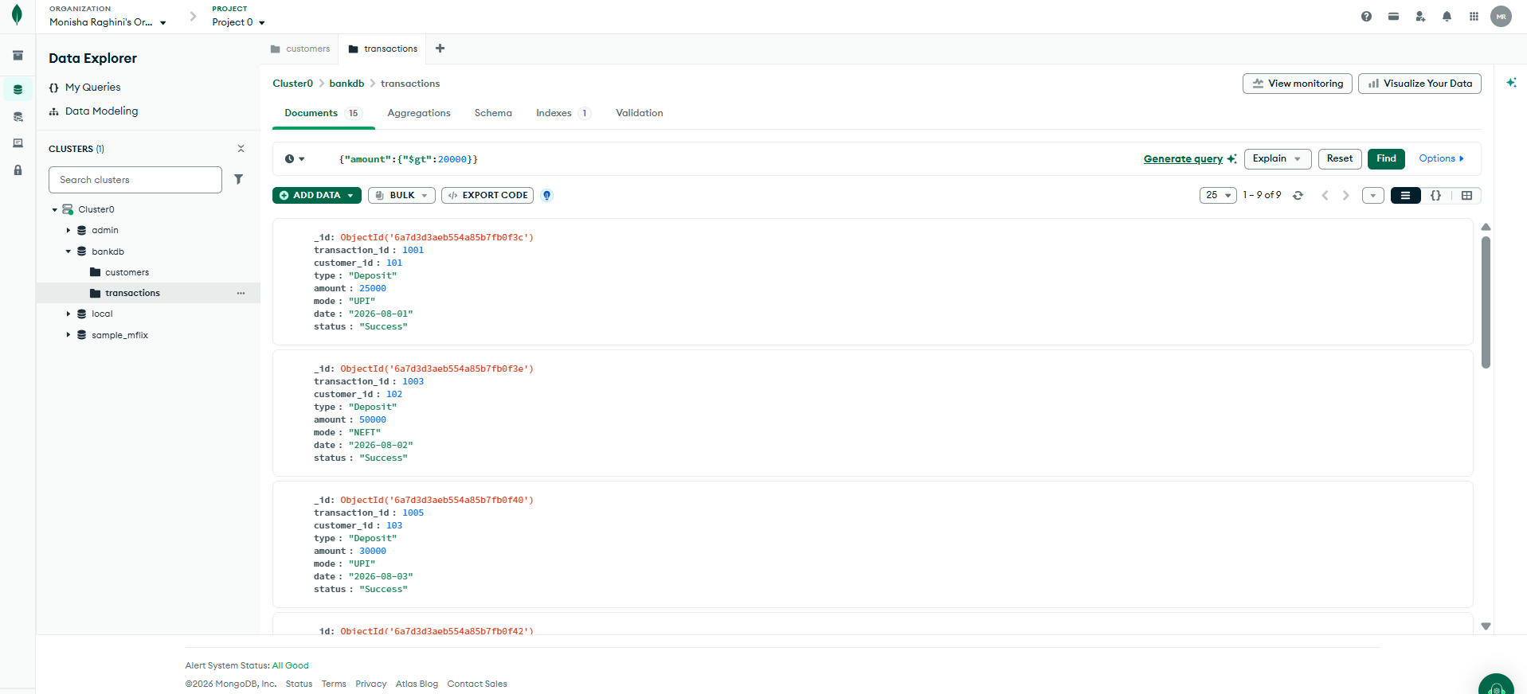

Query 7: Find Deposits
MongoDB Query:
JSON
{
"type": "Deposit"
}
Expected Transactions: 1001, 1003, 1005, 1007, 1009, 1010, 1012 and 1014.
📸 Paste Screenshot – Query 7
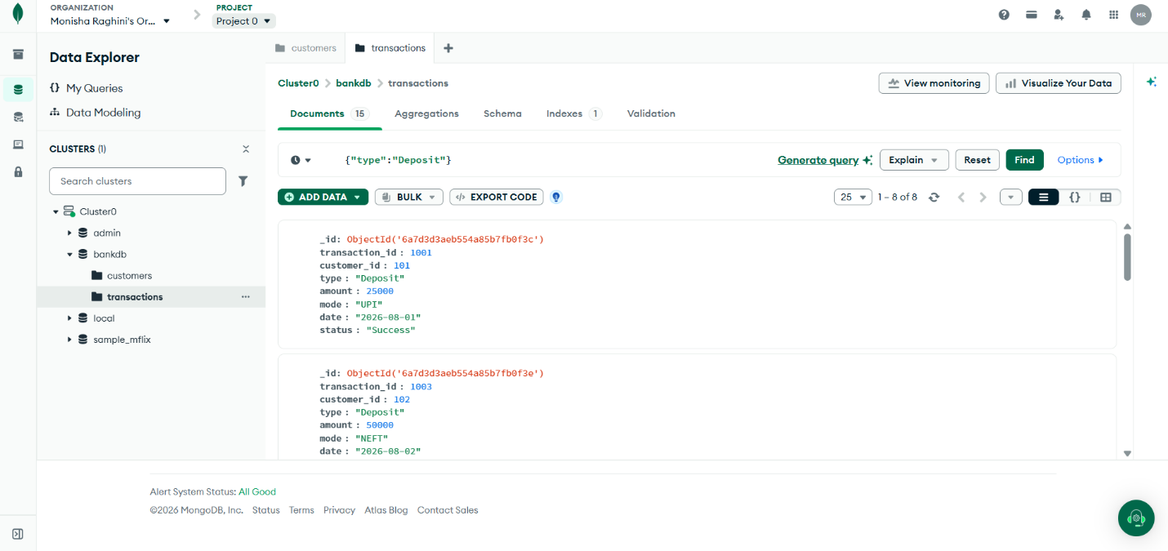

Query 8: Find ATM Transactions
MongoDB Query:
JSON
{
"mode": "ATM"
}
Expected Transactions: 1002, 1004, 1006, 1008, 1011, 1013 and 1015.
📸 Paste Screenshot – Query 8
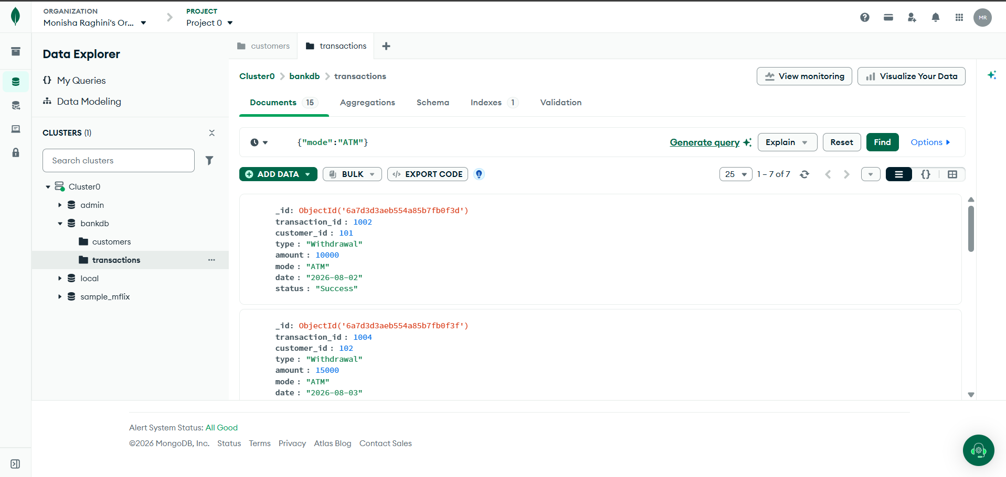

Query 9: Find Deposits Greater Than 50000
MongoDB Query:
JSON
{
"type": "Deposit",
"amount": {
"$gt": 50000
}
}
Expected Transactions: 1007, 1010 and 1014.
📸 Paste Screenshot – Query 9
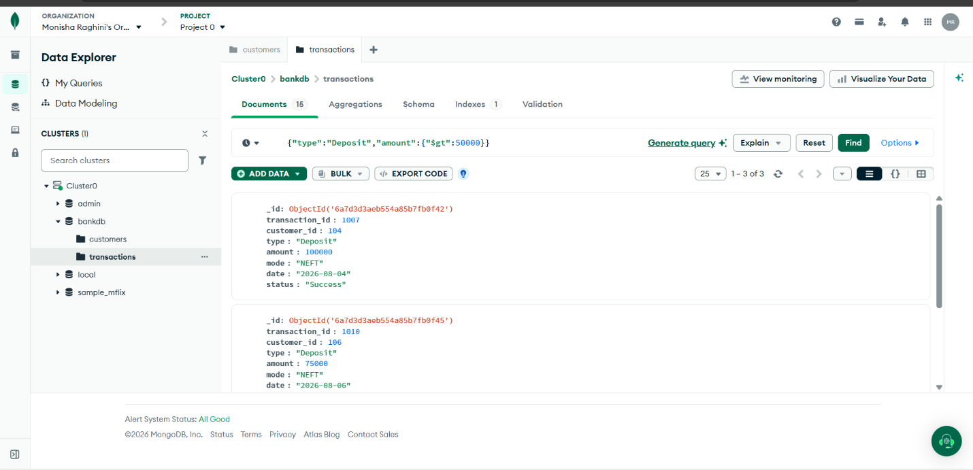

Query 10: Find Hyderabad Customers with High Balance
MongoDB Query:
JSON
{
"city": "Hyderabad",
"balance": {
"$gt": 100000
}
}
Expected Result: Anjali Singh.
📸 Paste Screenshot – Query 10
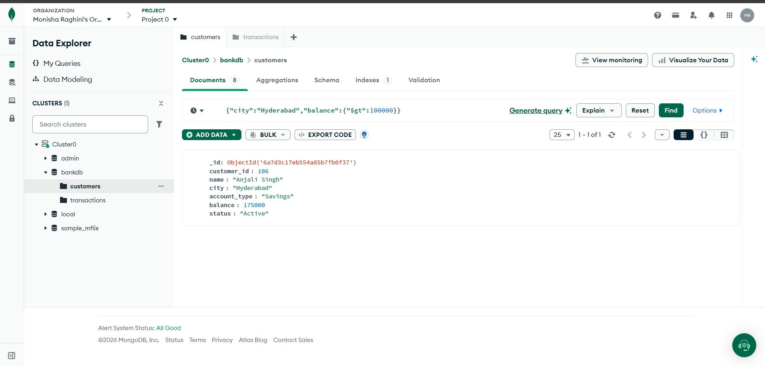

Query 11: Find Customers in Multiple Cities
MongoDB Query:
JSON
{
"city": {
"$in": [
"Hyderabad",
"Vijayawada",
"Warangal"
]
}
}
Expected Result: Ravi Kumar, Priya Sharma, Arjun Reddy, Sneha Rao and Anjali Singh.
📸 Paste Screenshot – Query 11

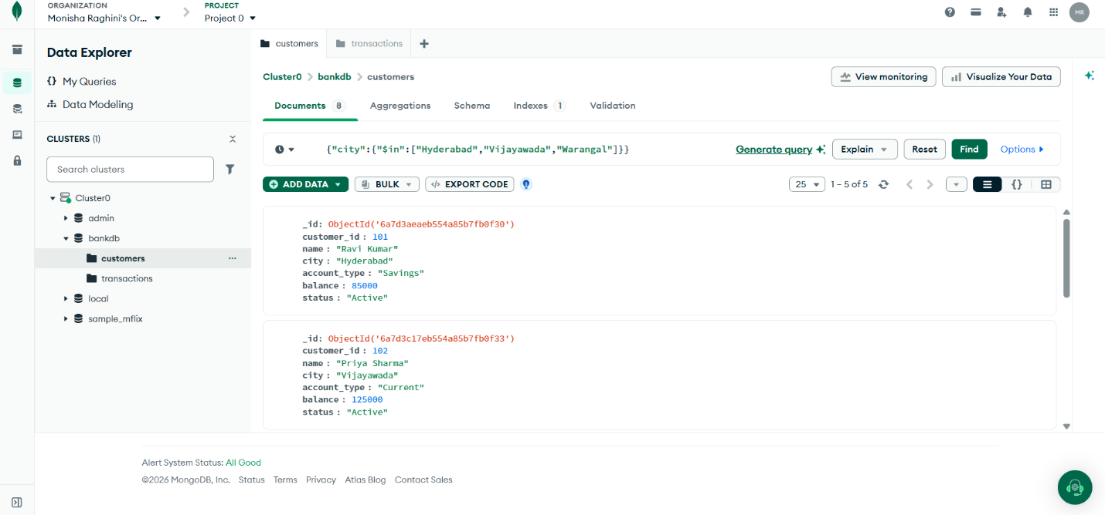

The above Queries 1–11 follow the experiment's specified filters and expected results. 

Query 12: Sort Customers by Balance
Go to customers → Aggregations.
Stage: $sort
JSON
{
"balance": -1
}
Expected Order:
- Meena Devi — 320000
- Sneha Rao — 210000
- Anjali Singh — 175000
- Priya Sharma — 125000
- Rahul Verma — 95000
- Ravi Kumar — 85000
- Kiran Kumar — 65000
- Arjun Reddy — 45000
📸 Paste Screenshot – Query 12
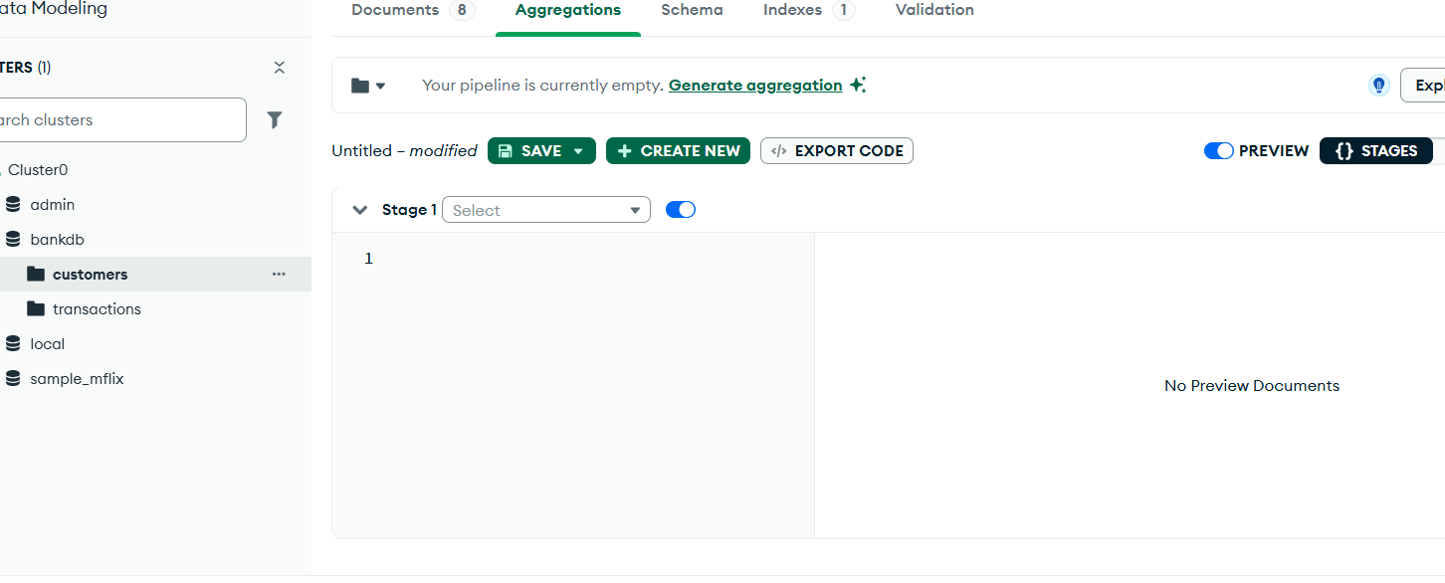

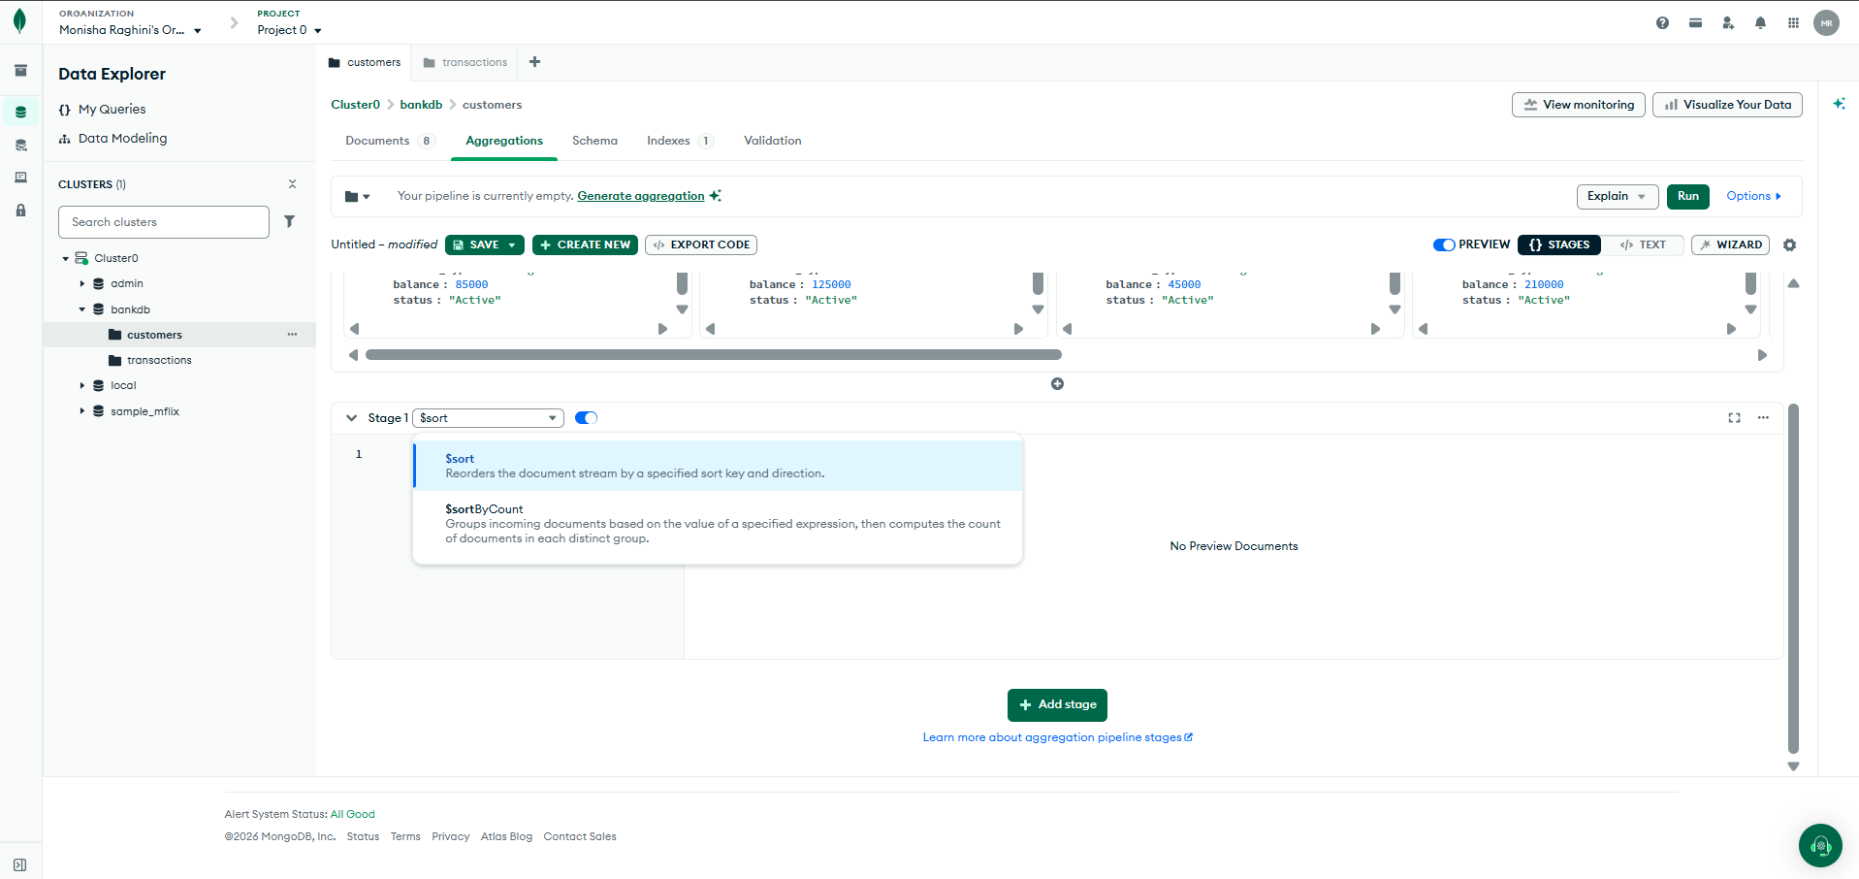

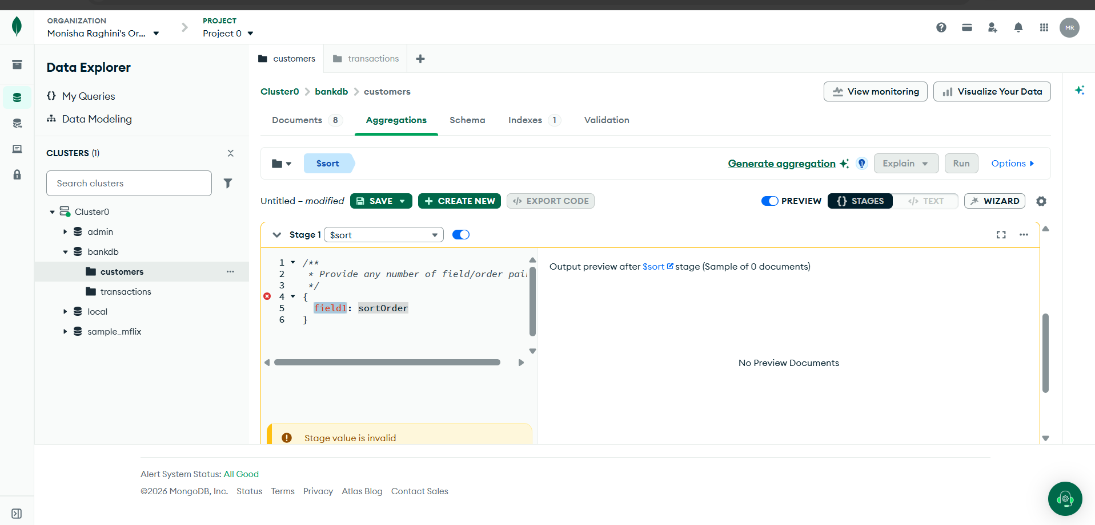

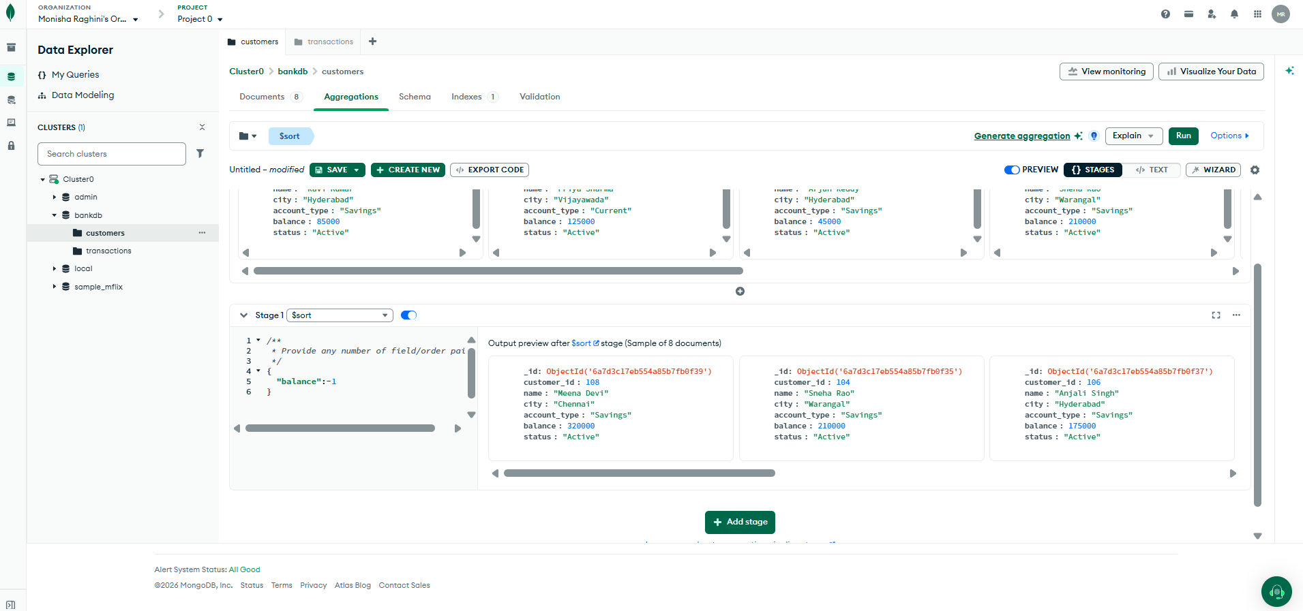

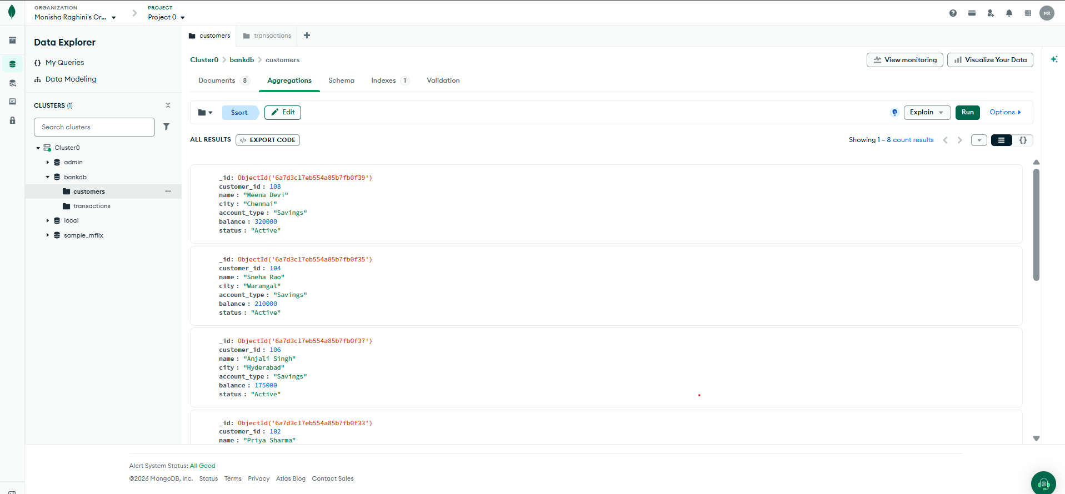

Query 13: Calculate Total Transaction Amount
Go to transactions → Aggregations.
Stage: $group
JSON
{
"_id": null,
"total_amount": {
"$sum": "$amount"
}
}
Expected Result:
total_amount = 632000
📸 Paste Screenshot – Query 13

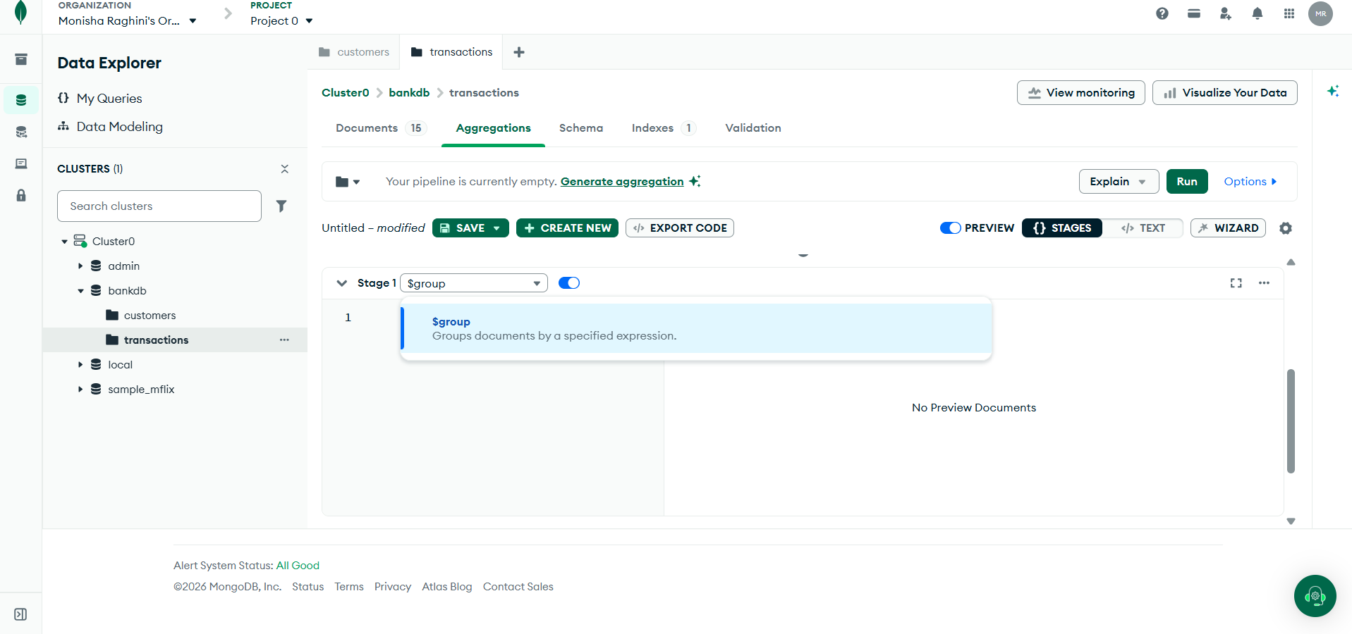

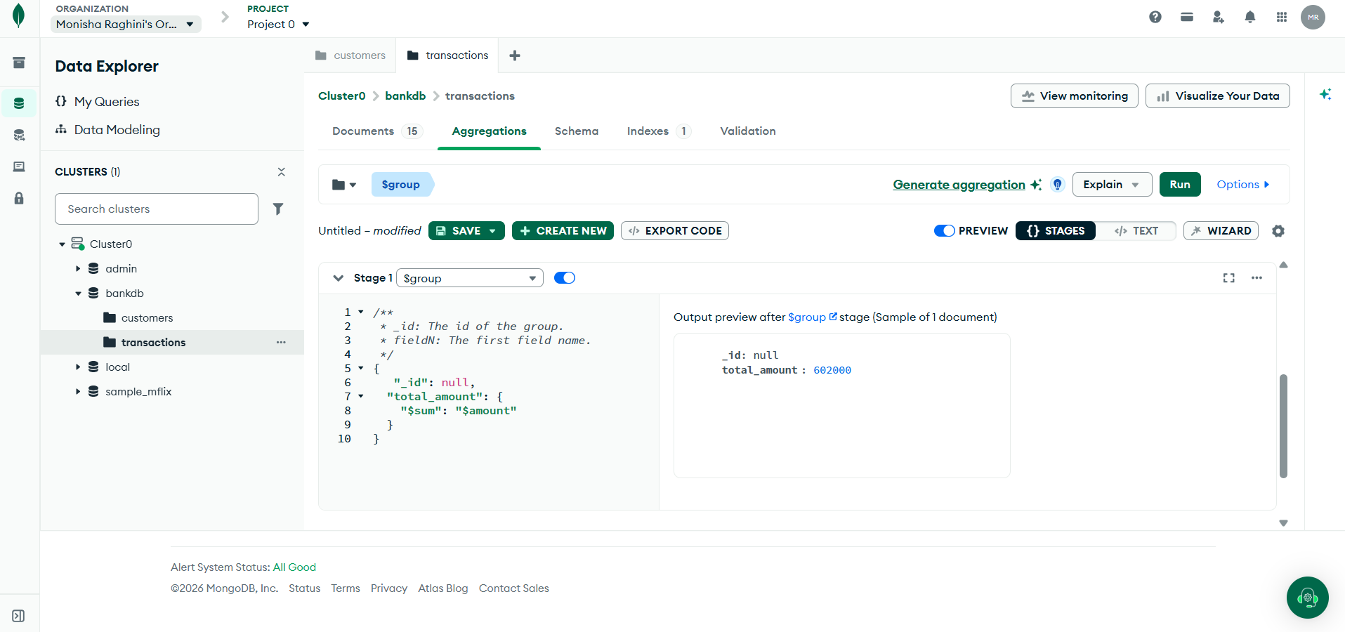

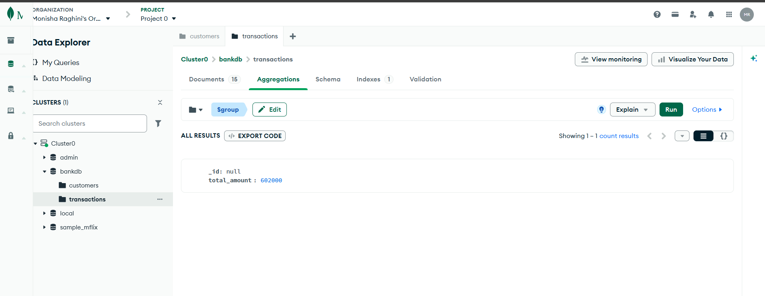

Query 14: Calculate Average Transaction Amount
Stage: $group
JSON
{
"_id": null,
"average_amount": {
"$avg": "$amount"
}
}
Expected Result:
average_amount = 42133.33
📸 Paste Screenshot – Query 14

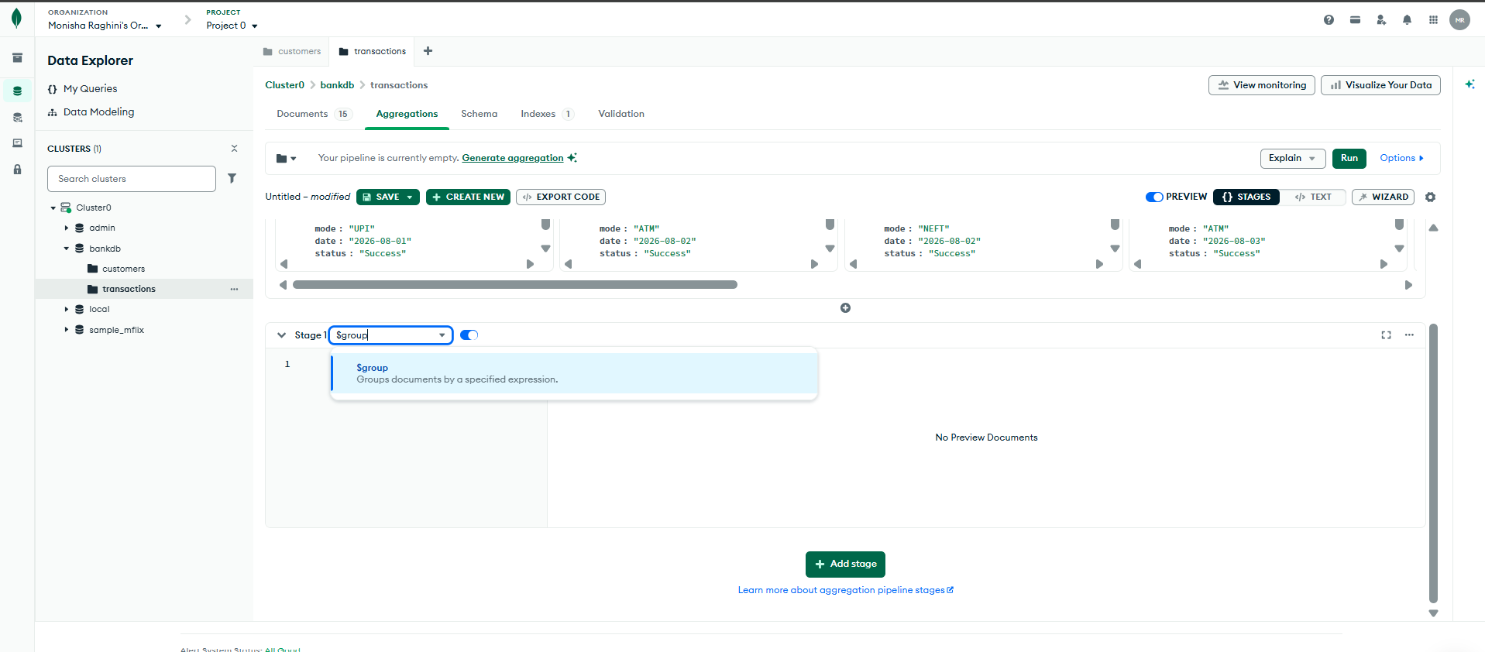
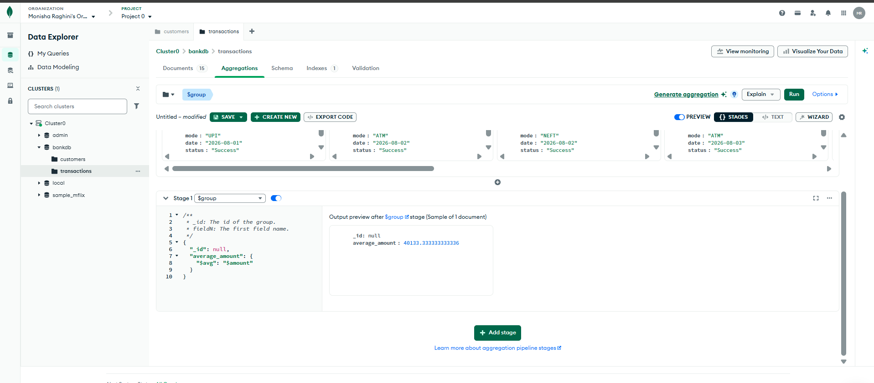

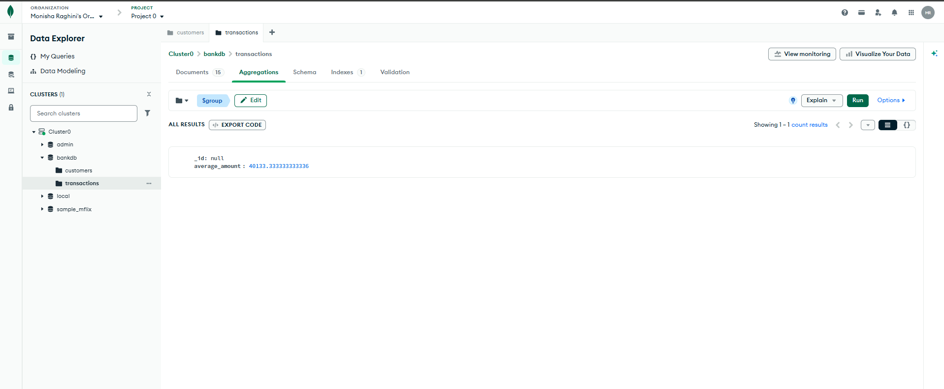

Query 15: Total Transaction Amount by Type
Stage: $group
JSON
{
"_id": "$type",
"total_amount": {
"$sum": "$amount"
}
}
Expected Result:
- Deposit = 485000
- Withdrawal = 147000
📸 Paste Screenshot – Query 15
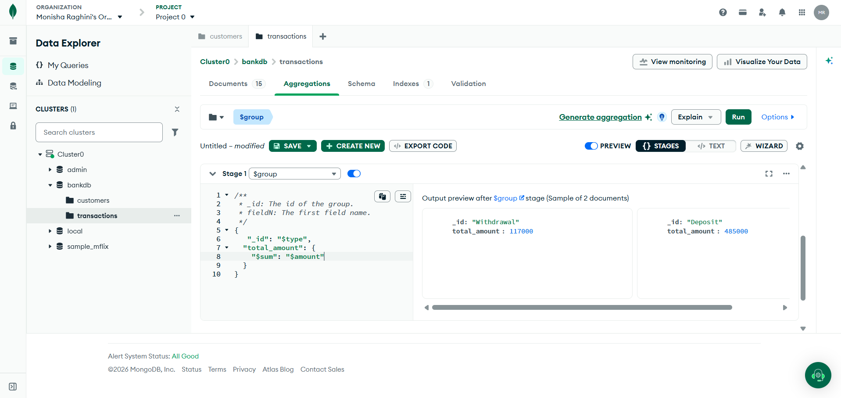
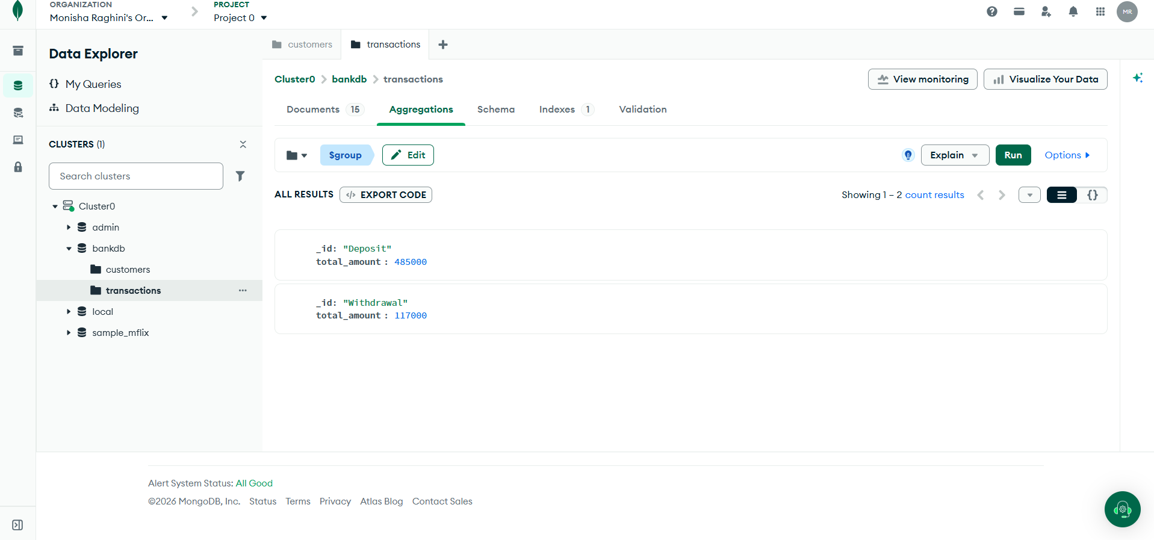

Query 16: Number of Transactions per Customer
Use two aggregation stages.

Stage 1 — $group
JSON
{
"_id": "$customer_id",
"transaction_count": {
"$sum": 1
}
}

Stage 2 — $sort
JSON
{
"transaction_count": -1
}
Expected Result:
- 101 → 2
- 102 → 2
- 103 → 2
- 104 → 2
- 106 → 2
- 107 → 2
- 108 → 2
- 105 → 1
📸 Paste Screenshot – Query 16
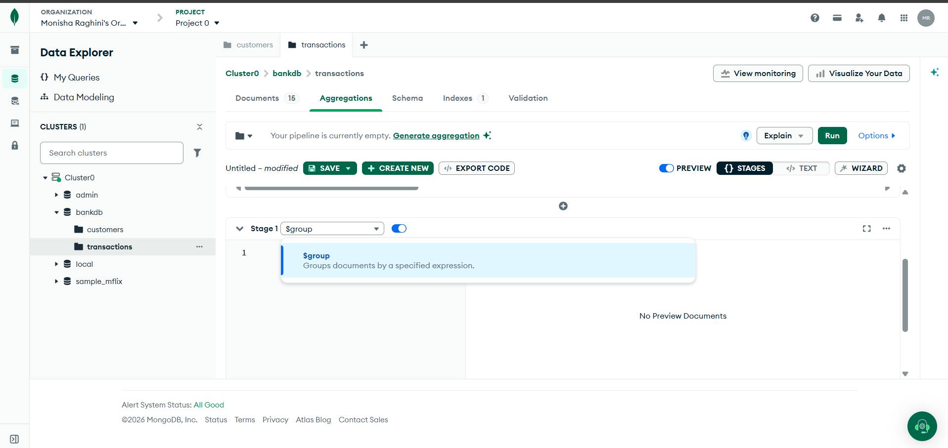
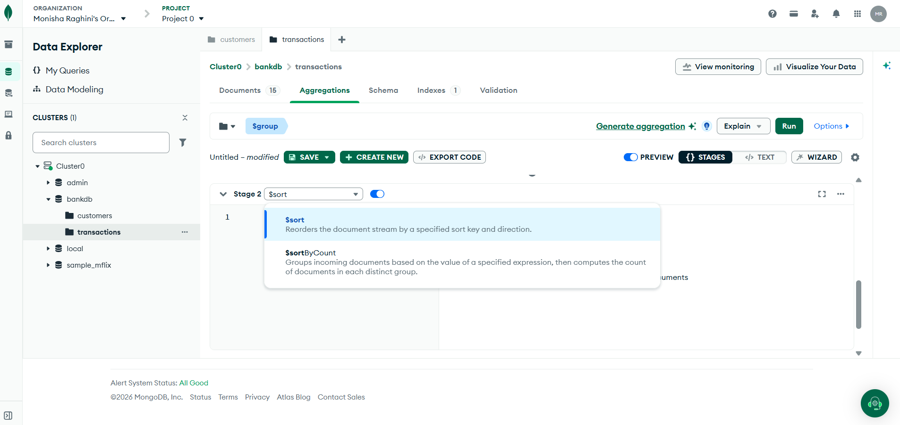

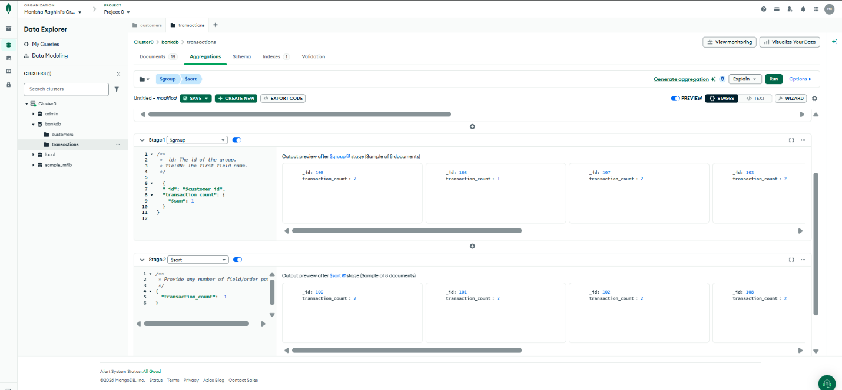

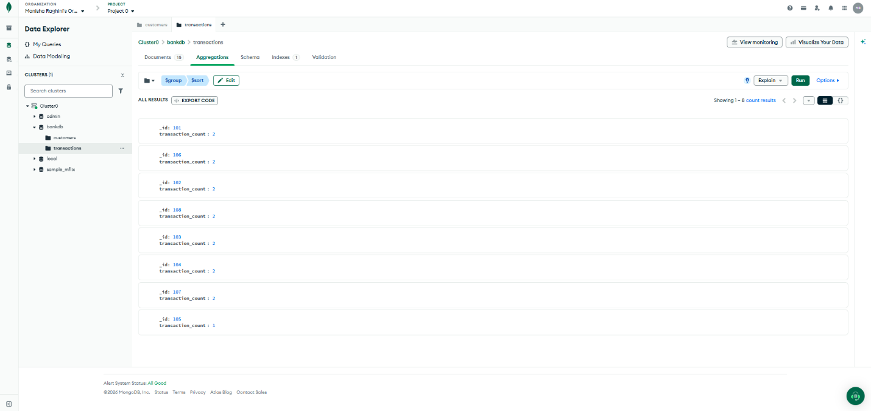

Query 17: Customer + Transaction JOIN
Objective: Display customer details together with their transactions.
Go to transactions → Aggregations.

Stage 1 — $lookup
JSON
{
"from": "customers",
"localField": "customer_id",
"foreignField": "customer_id",
"as": "customer_details"
}

Stage 2 — $unwind
According to the experiment:
JSON
{”path”: “$customer_details"}
Expected Example:
- Transaction: 1001
- Customer: Ravi Kumar
- Amount: 25000
- Type: Deposit
📸 Paste Screenshot – Query 17
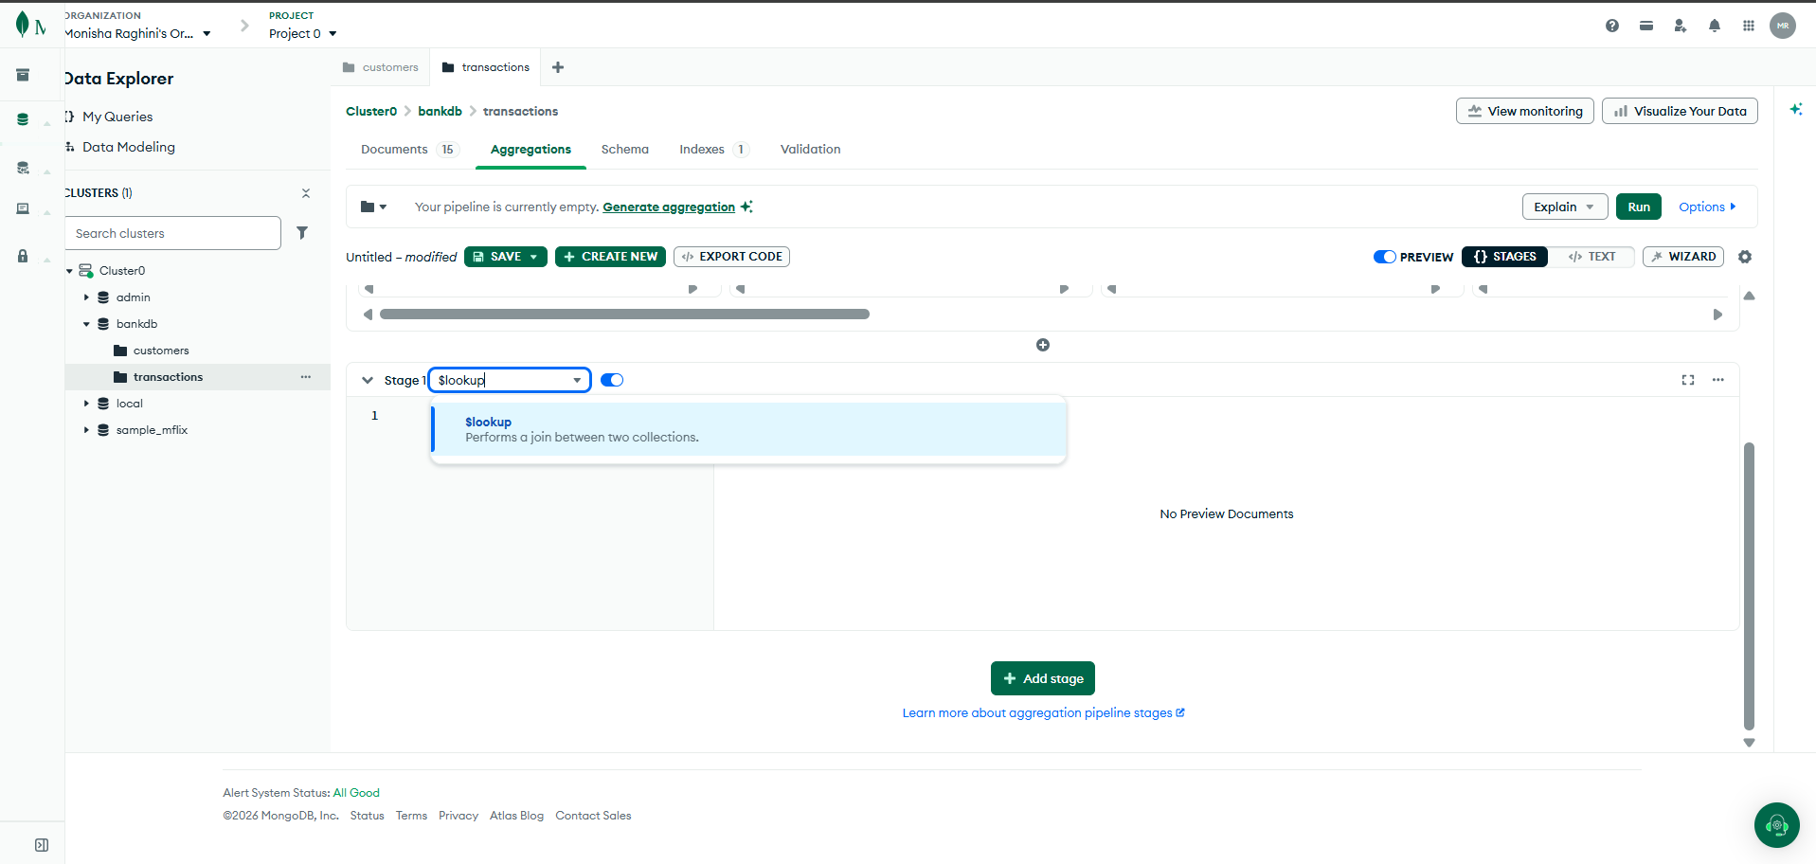
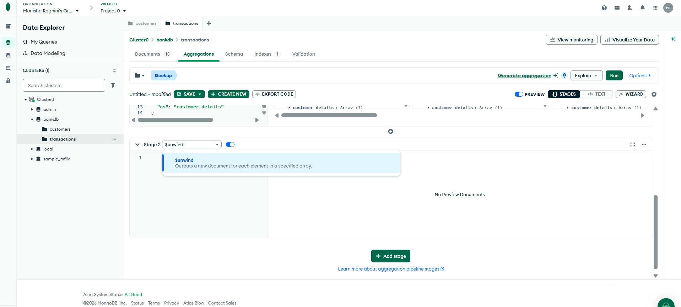

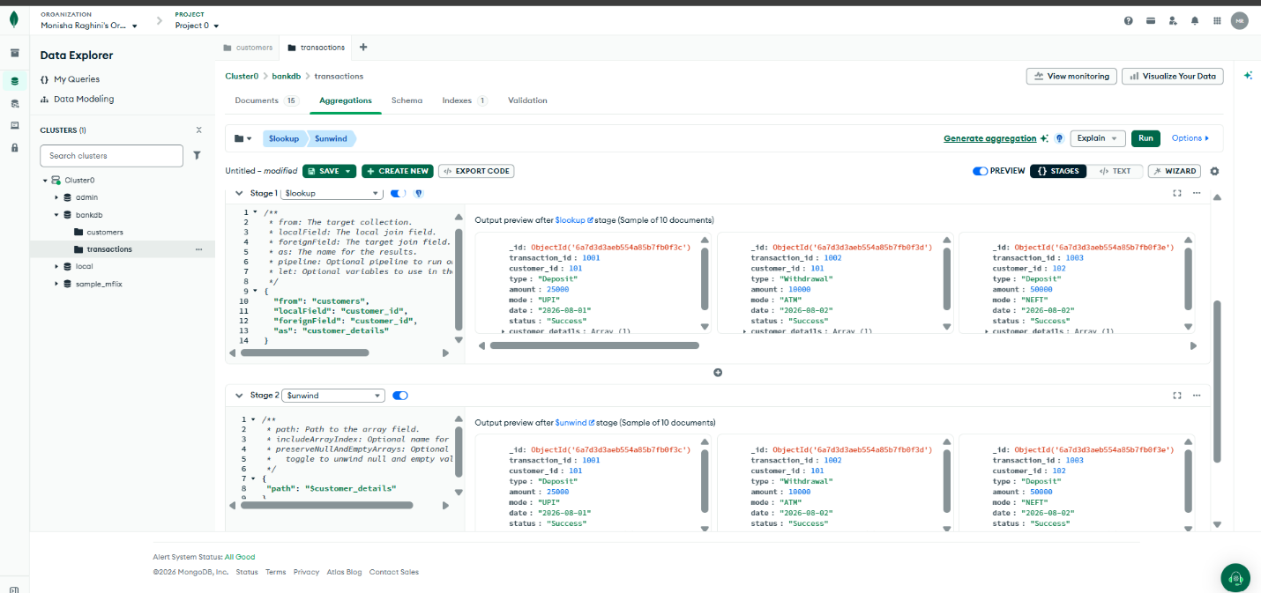

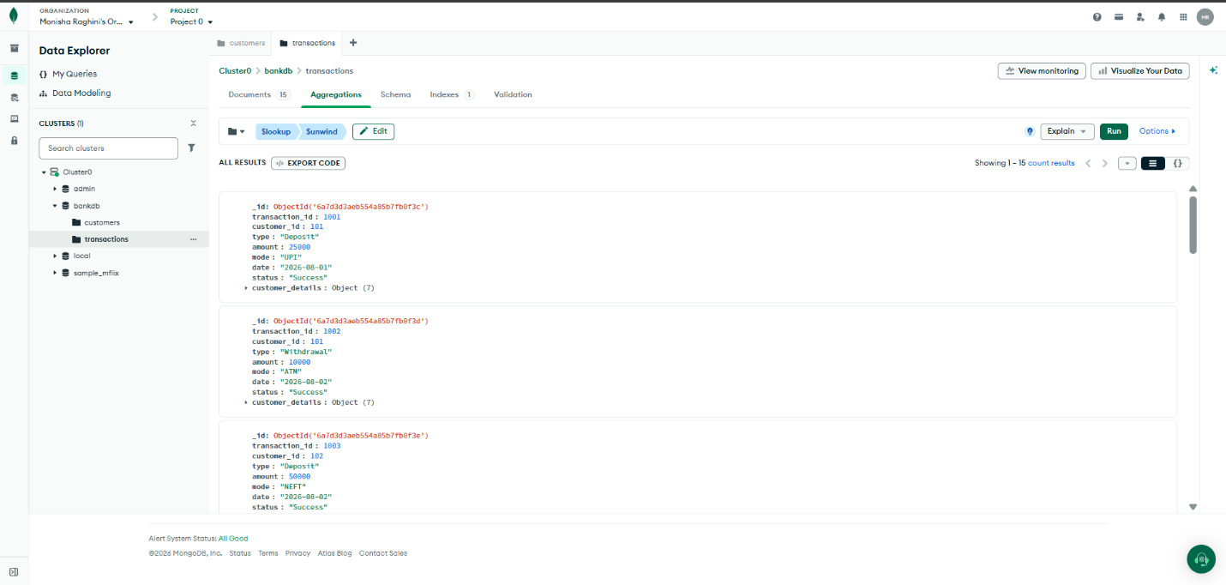

Query 18: Display Customer Name and Transaction Amount
Use three stages:
$lookup → $unwind → $project

Stage 1 — $lookup
JSON
{
"from": "customers",
"localField": "customer_id",
"foreignField": "customer_id",
"as": "customer"
}

Stage 2 — $unwind
JSON
"$customer"

Stage 3 — $project
JSON
{
"_id": 0,
"transaction_id": 1,
"customer_name": "$customer.name",
"city": "$customer.city",
"type": 1,
"amount": 1,
"mode": 1
}
Expected Example:
transaction_id: 1001
customer_name: Ravi Kumar
city: Hyderabad
type: Deposit
amount: 25000
mode: UPI
📸 Paste Screenshot – Query 18
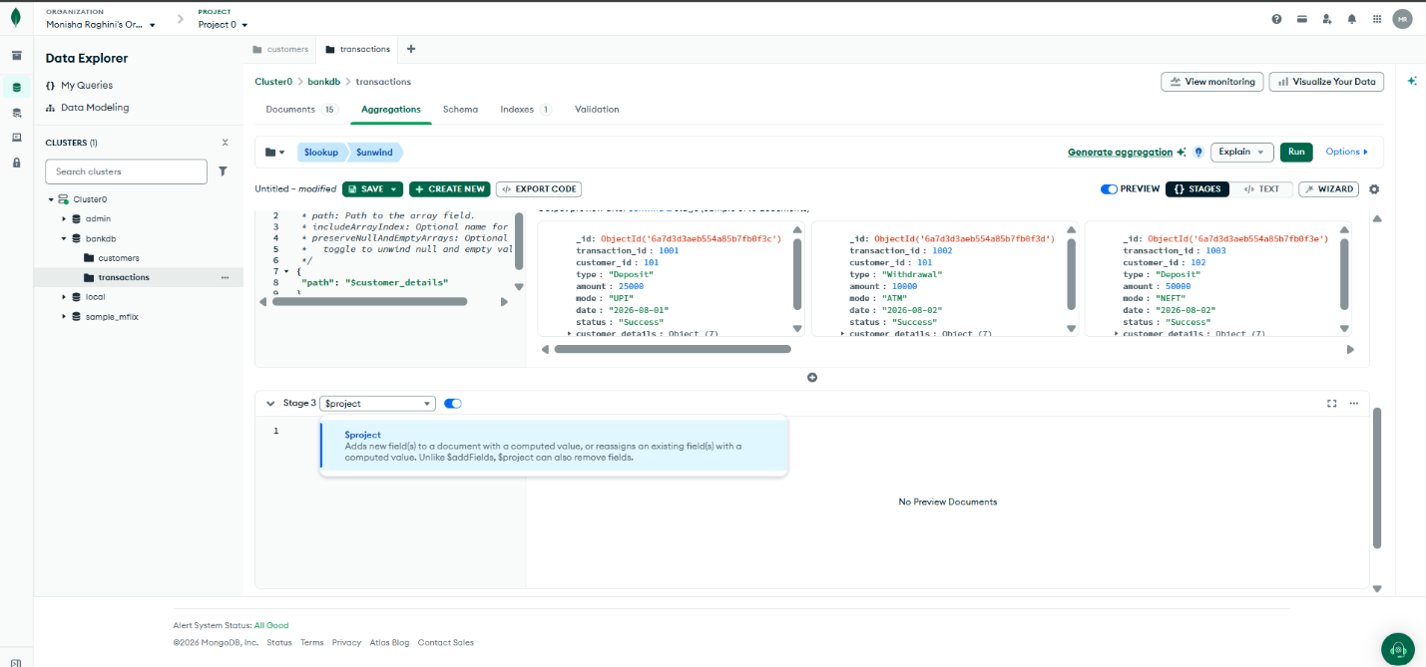

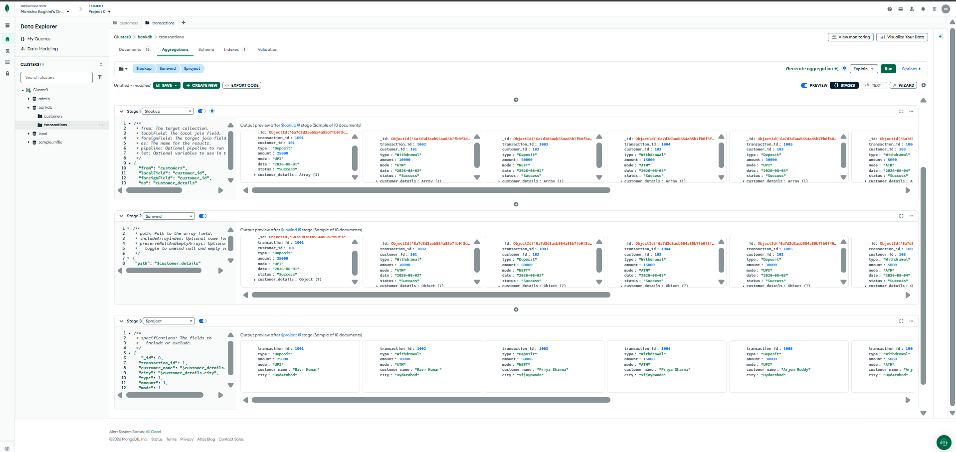

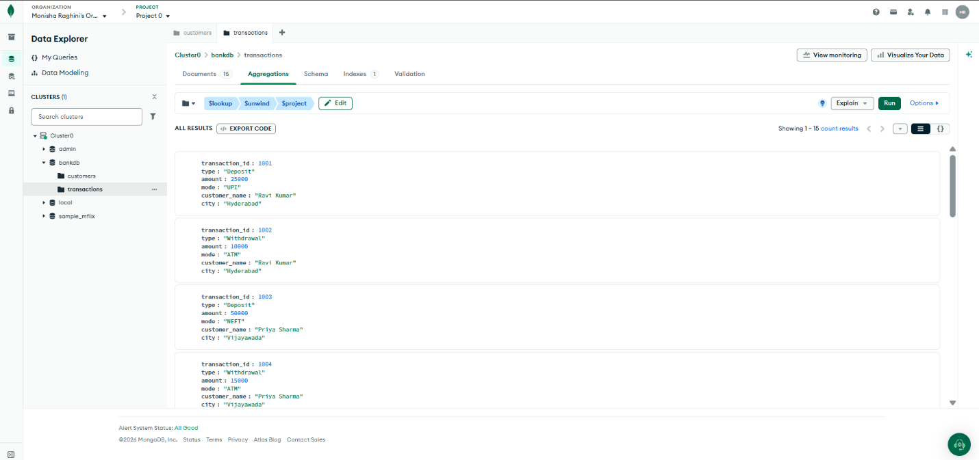

DBSE&DBD SKILL SESSION NUMBER 4…

Query 19: Total Transaction Amount for Each Customer
Use the following five stages:

Stage 1 — $group
JSON
{
"_id": "$customer_id",
"total_transaction": {
"$sum": "$amount"
}
}

Stage 2 — $lookup
JSON
{
"from": "customers",
"localField": "_id",
"foreignField": "customer_id",
"as": "customer"
}

Stage 3 — $unwind
JSON
"$customer"

Stage 4 — $project
JSON
{
"_id": 0,
"customer_id": "$_id",
"customer_name": "$customer.name",
"total_transaction": 1
}

Stage 5 — $sort
JSON
{
"total_transaction": -1
}
Expected Top Results:
- Meena Devi — 180000
- Sneha Rao — 125000
- Anjali Singh — 95000
- Priya Sharma — 65000
📸 Paste Screenshot – Query 19
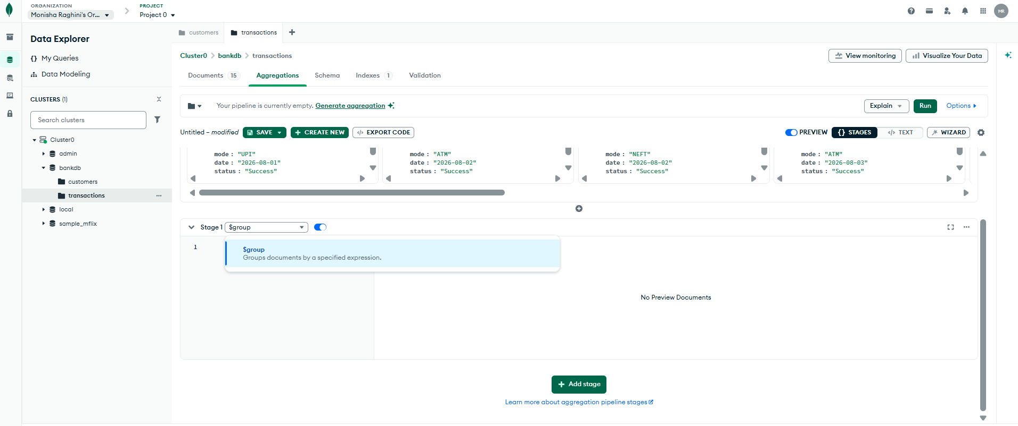

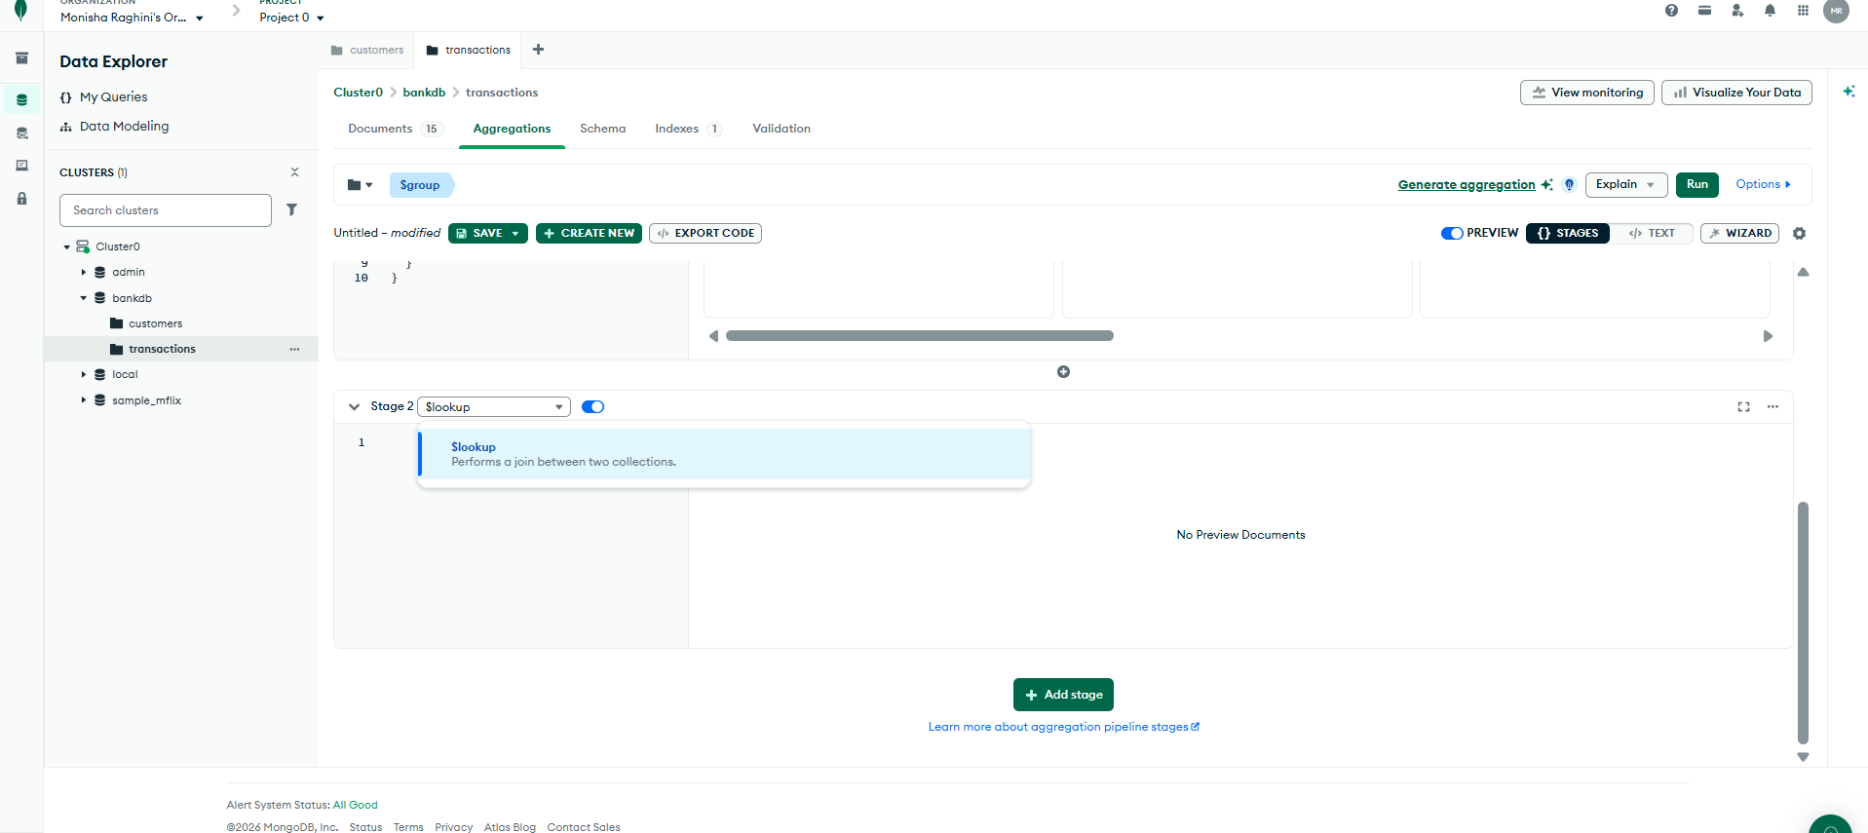

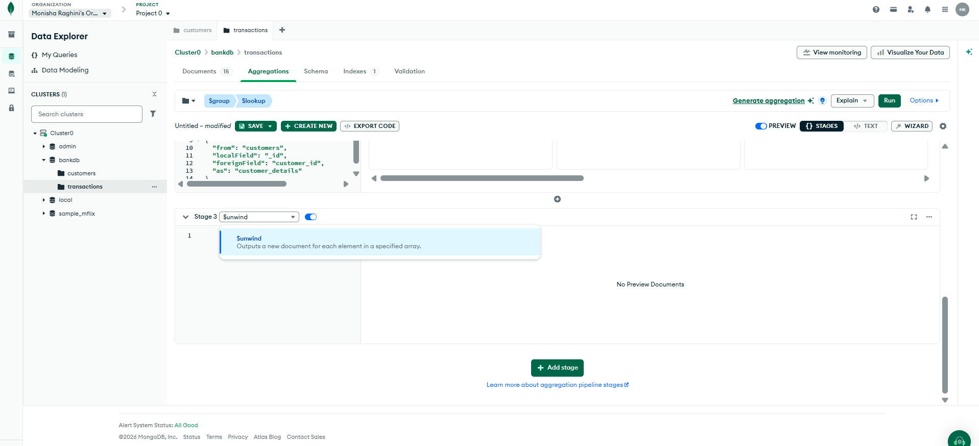

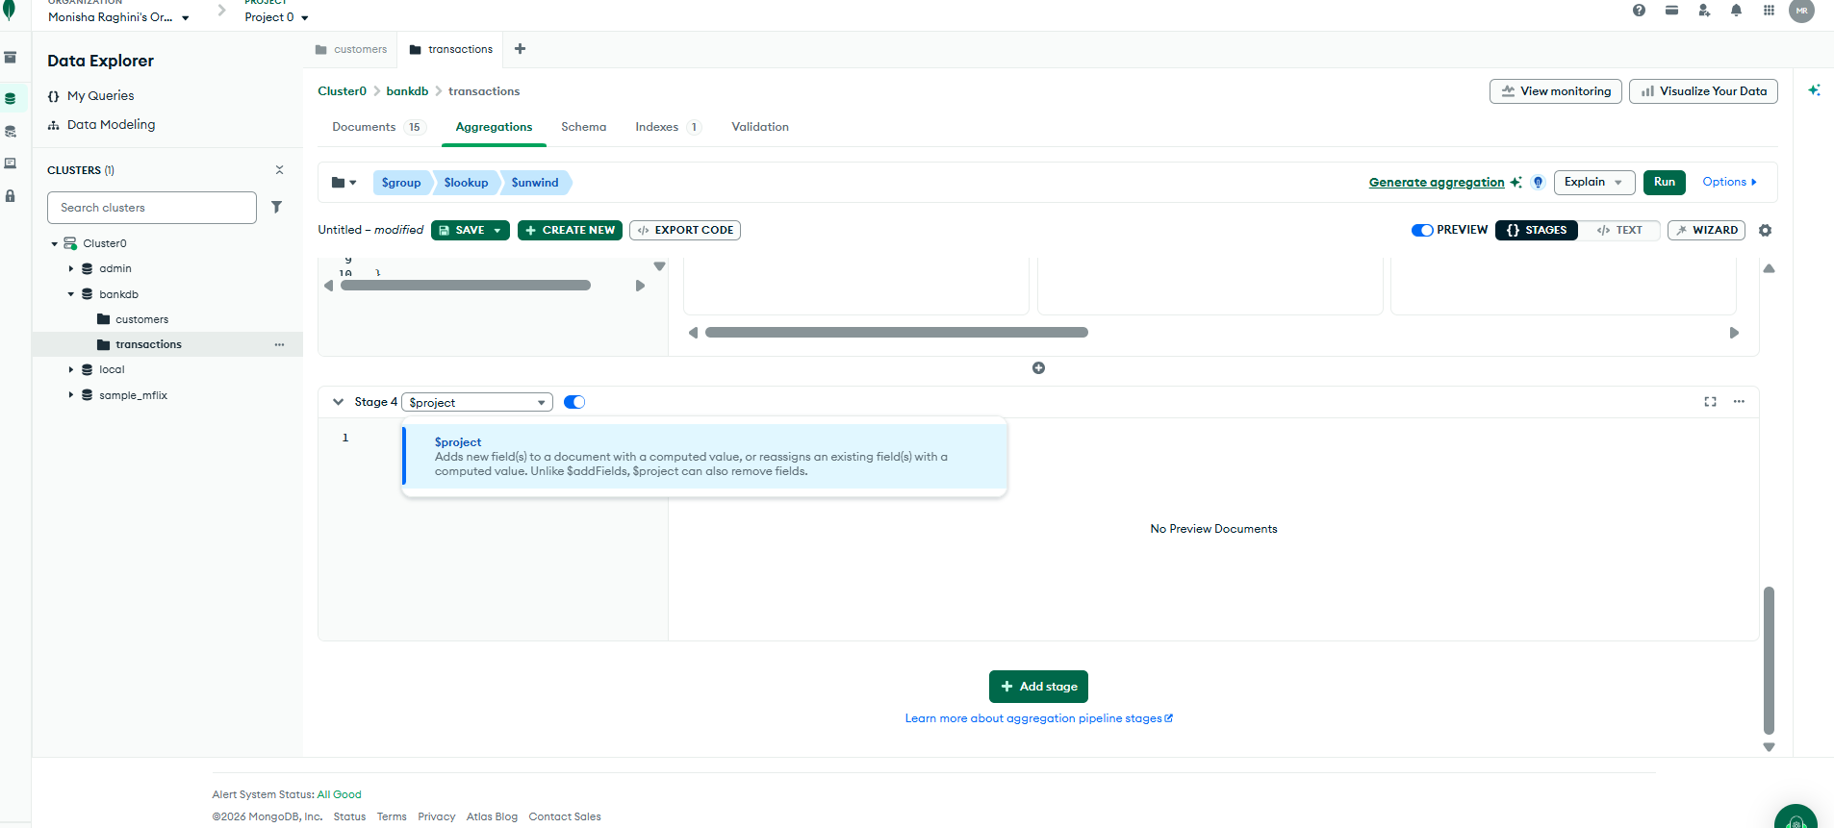

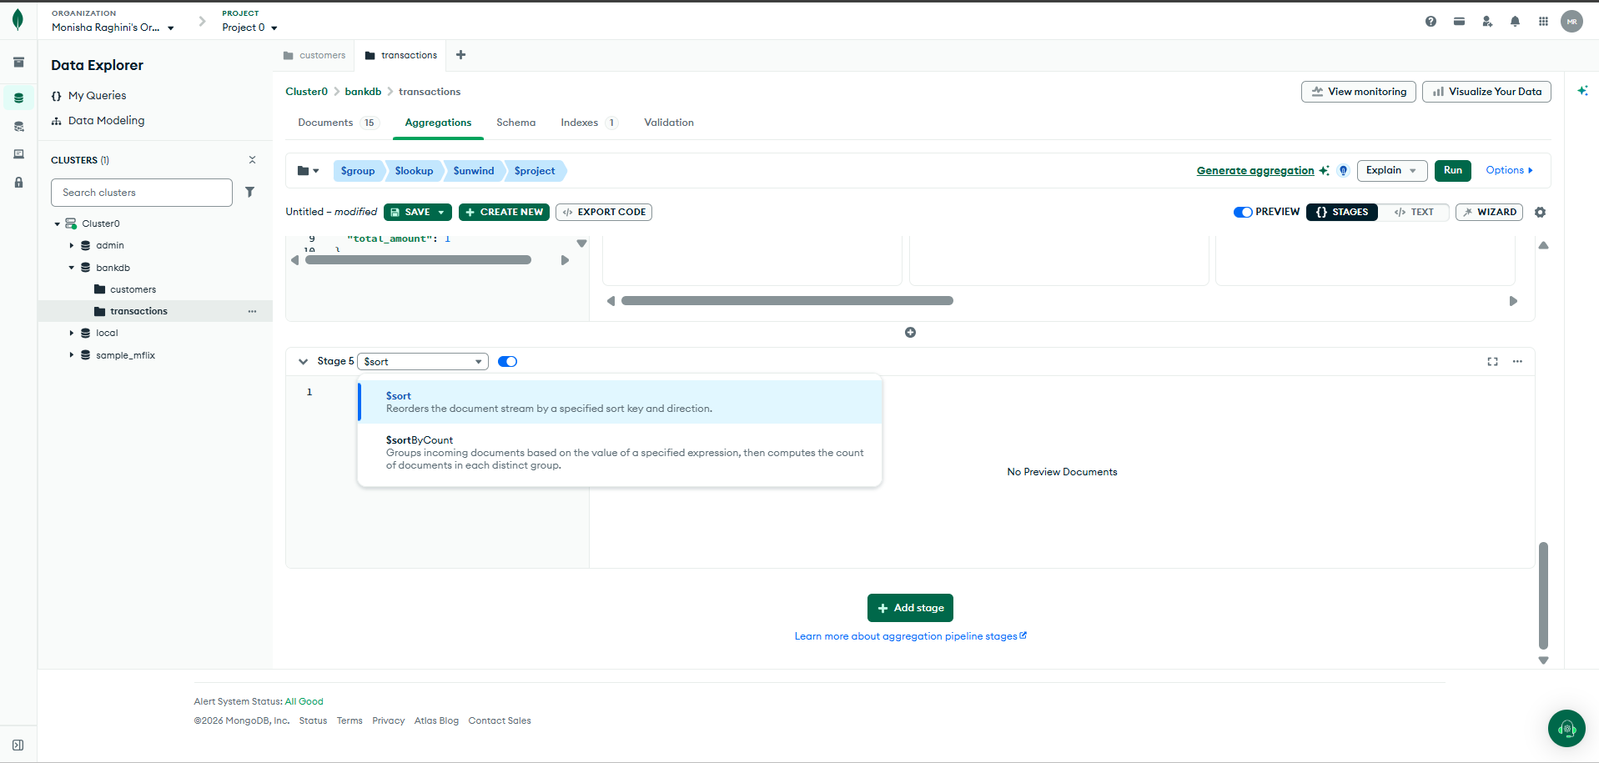

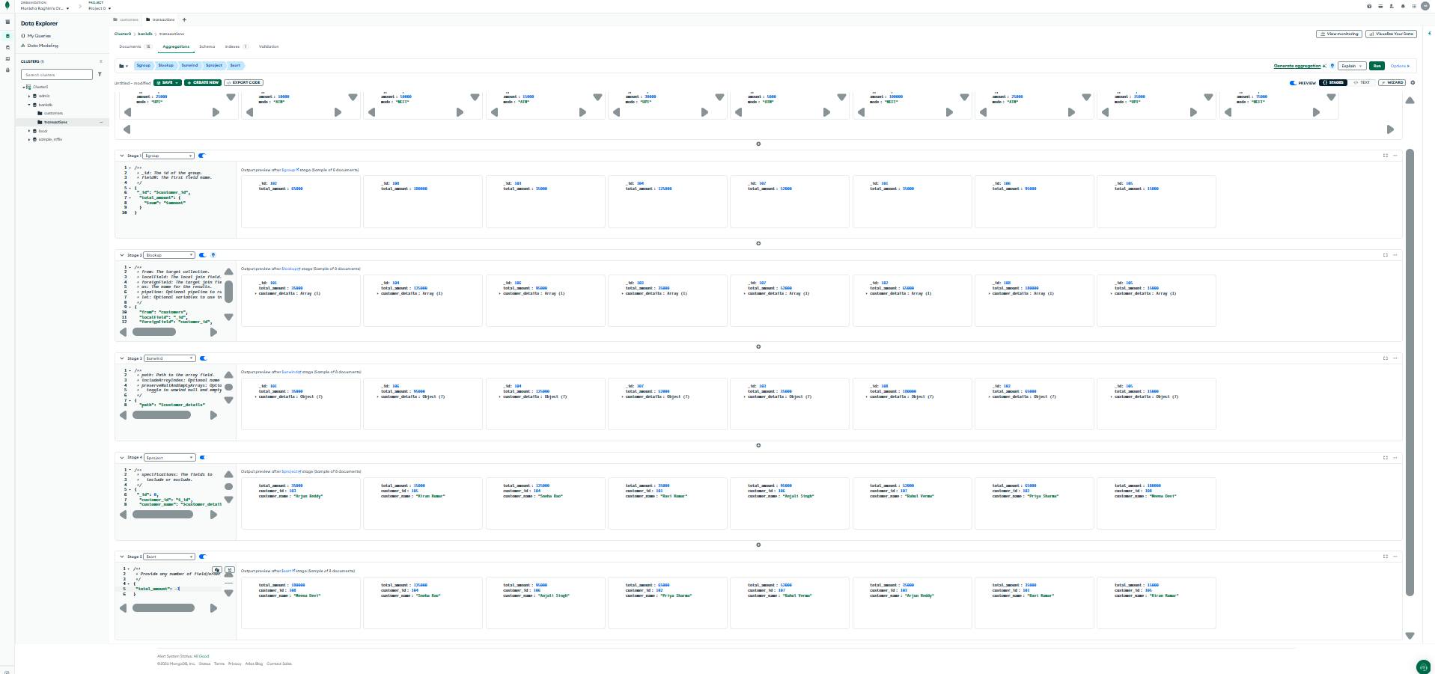

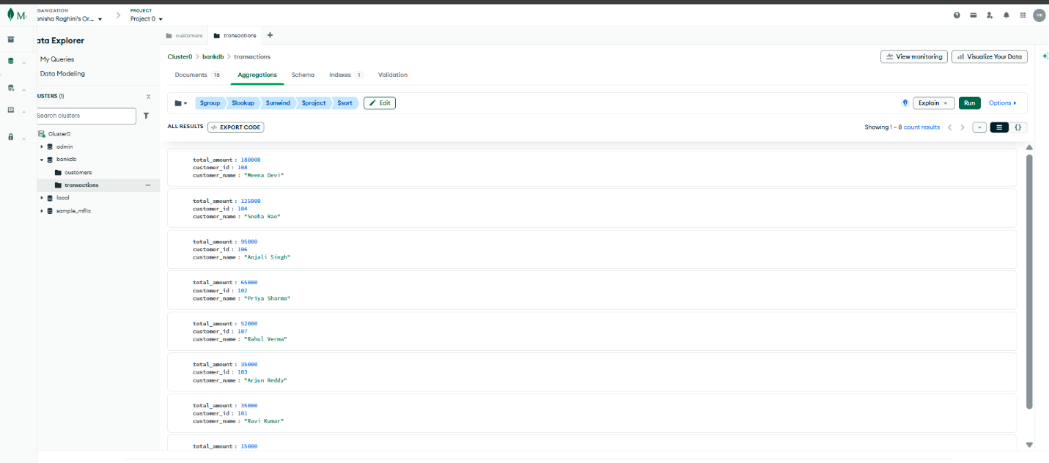

Query 20: Complex Bank Transaction Report
Objective: Find customers whose account is Active, balance is greater than 80000, and who have at least one transaction. The report displays customer name, city, account balance, total transaction amount and transaction count.

Stage 1 — $match
JSON
{
"status": "Active",
"balance": {
"$gt": 80000
}
}

Stage 2 — $lookup
JSON
{
"from": "transactions",
"localField": "customer_id",
"foreignField": "customer_id",
"as": "transactions"
}

Stage 3 — $unwind
JSON
"$transactions"

Stage 4 — $group
JSON
{
"_id": "$customer_id",
"customer_name": {
"$first": "$name"
},
"city": {
"$first": "$city"
},
"balance": {
"$first": "$balance"
},
"total_transactions": {
"$sum": "$transactions.amount"
},
"transaction_count": {
"$sum": 1
}
}

Stage 5 — $sort
JSON
{
"total_transactions": -1
}
Report Displays:
- Customer ID
- Customer Name
- City
- Account Balance
- Total Transaction Amount
- Transaction Count
📸 Paste Screenshot – Query 20
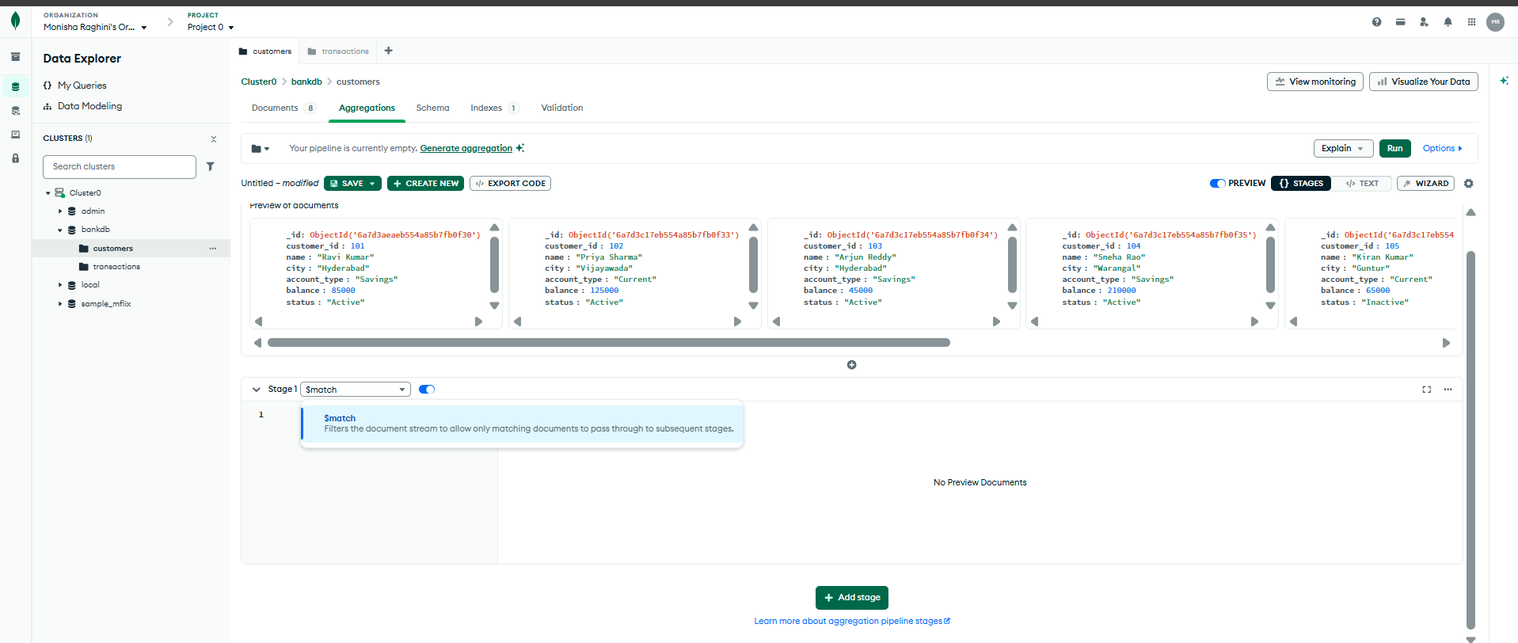

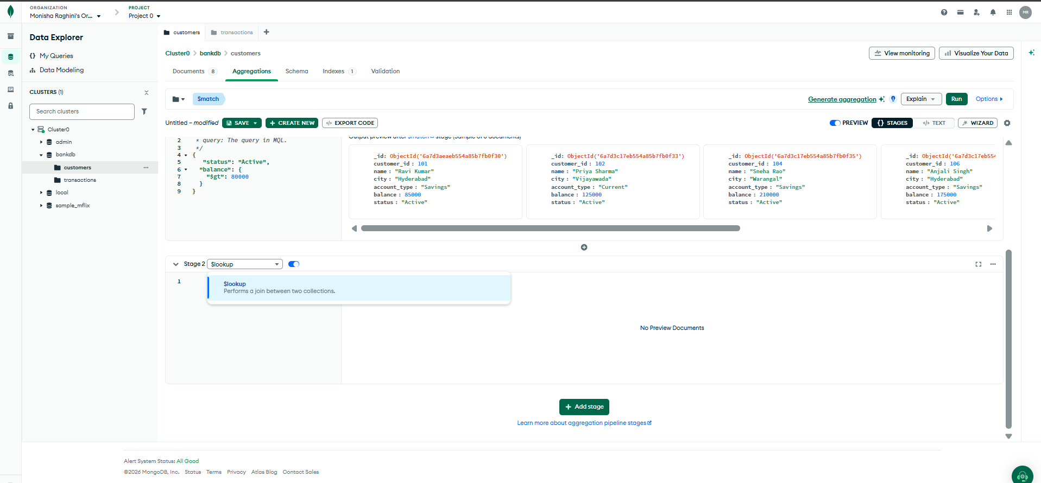

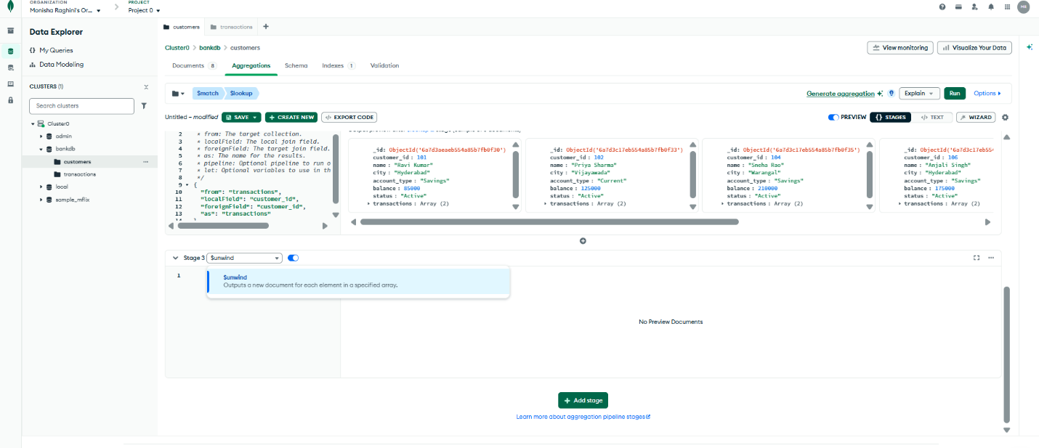

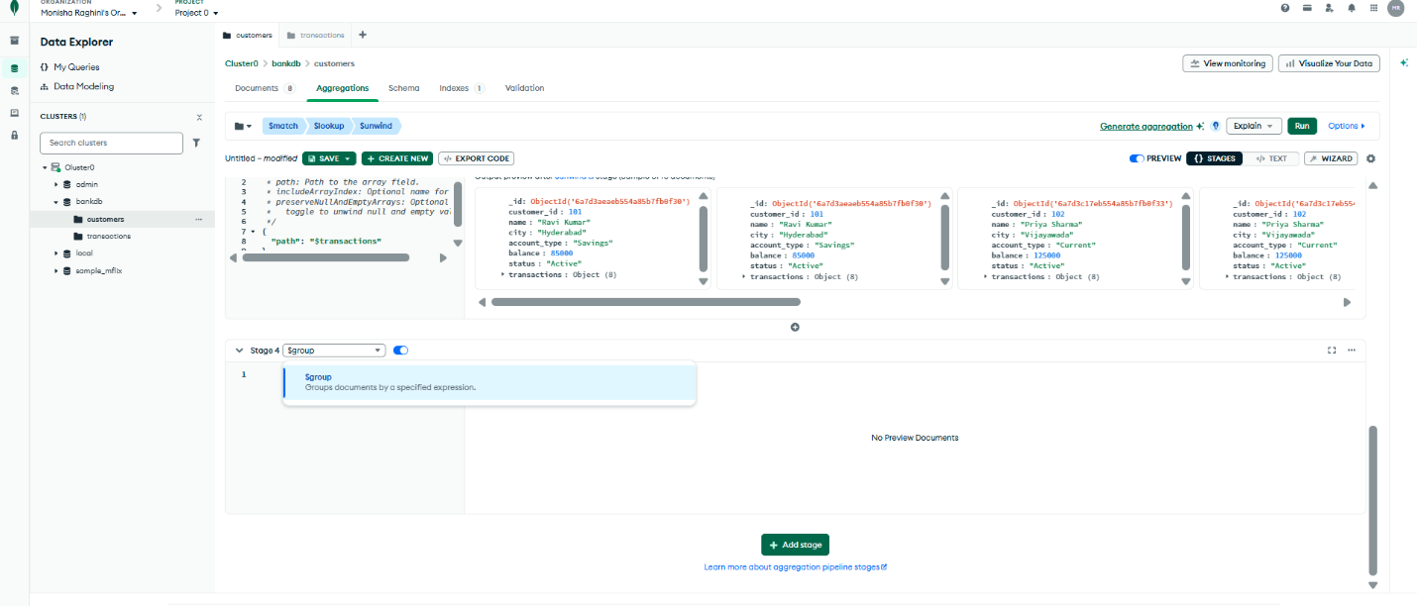
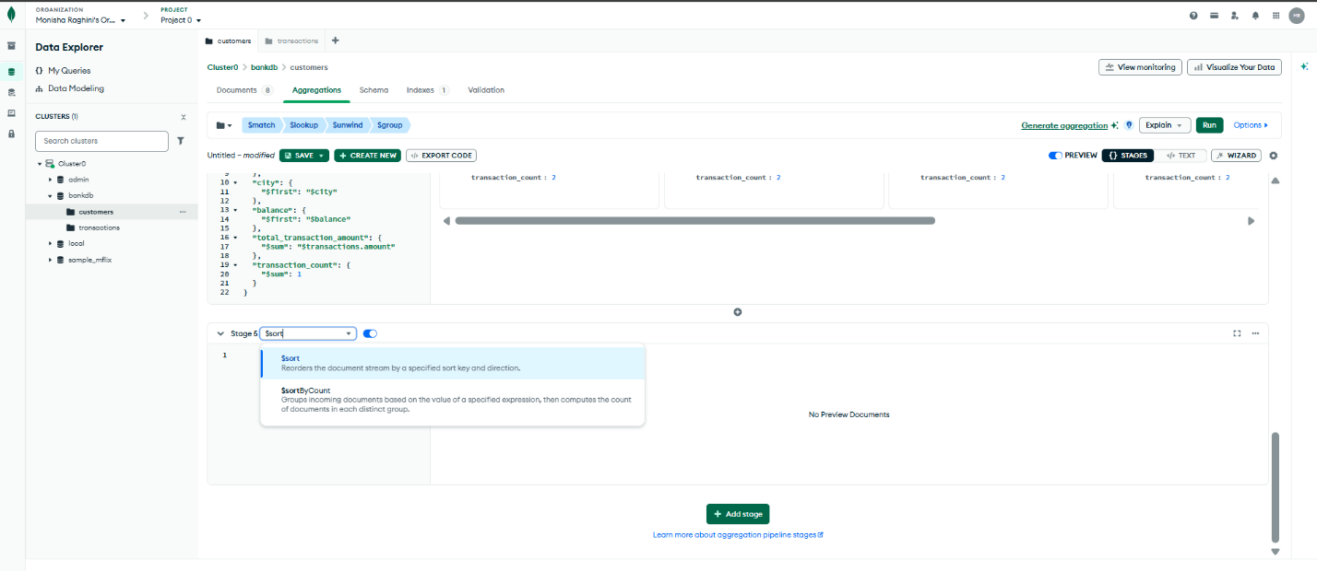

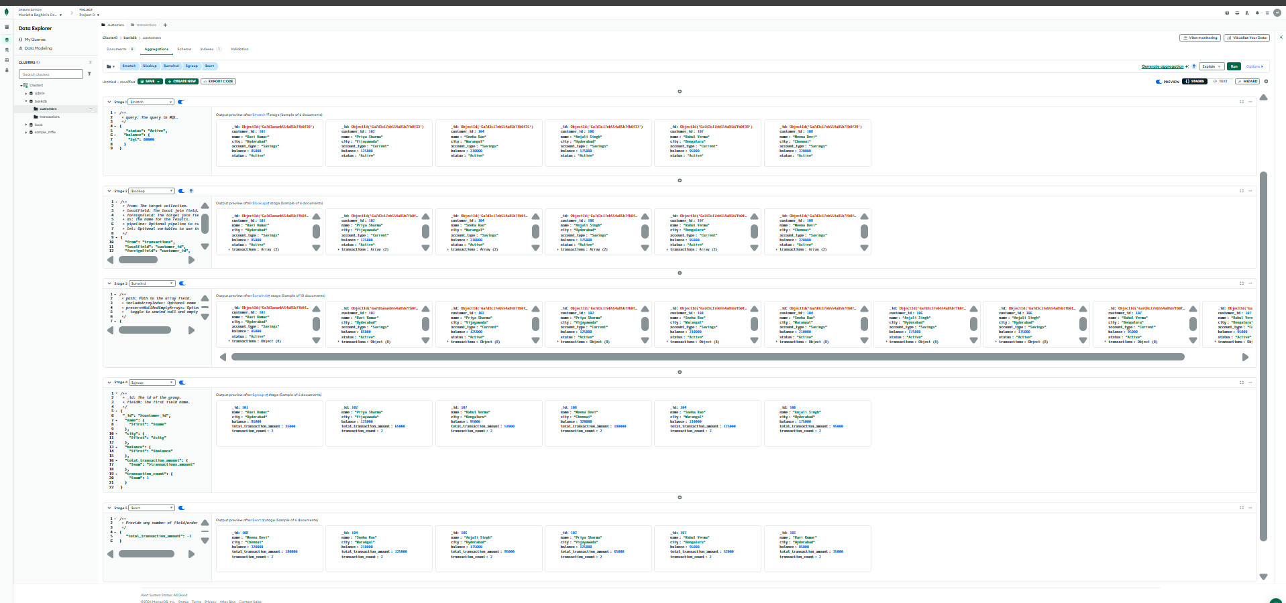
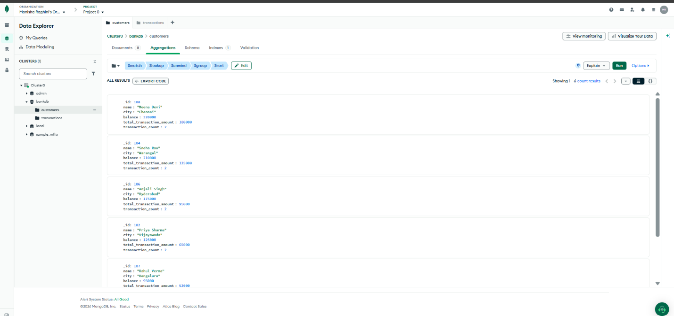

~END~

