Week 1 – Linux System Programming Lab
Name: Monisha Raghini Chelle
Roll No: 2520030537
Branch: B.Tech CSE
Subject: Linux System Programming Lab
Week: 1

- Hello.c

#include<stdio.h>

int main()
{
printf("Hello Linux\n");
return 0;
}

Compile: gcc hello.c -o hello

./hello

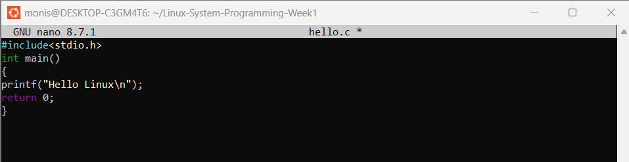

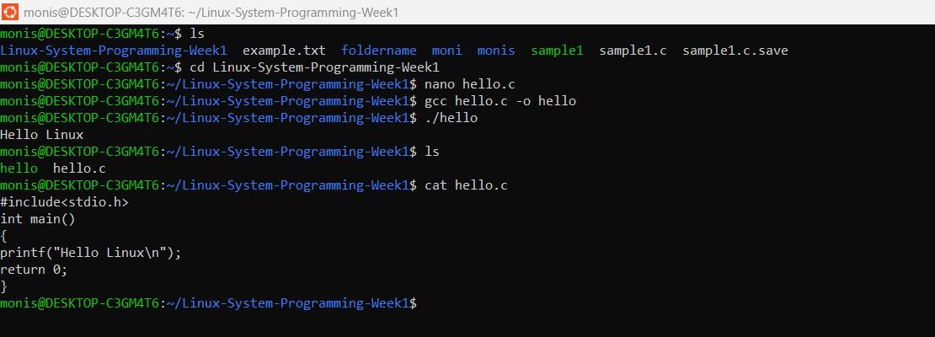

- Read User Name

#include<stdio.h>

int main()
{
char name[30];

printf("Enter your name: ");
scanf("%s",name);

printf("Welcome %s\n",name);

return 0;
}

Compile: gcc read_username.c -o read_username

./read_username

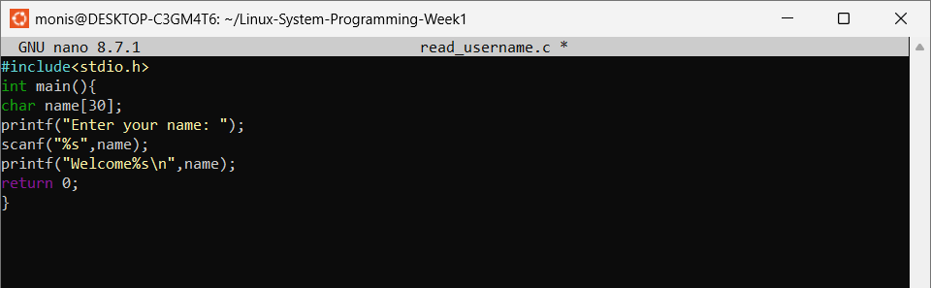
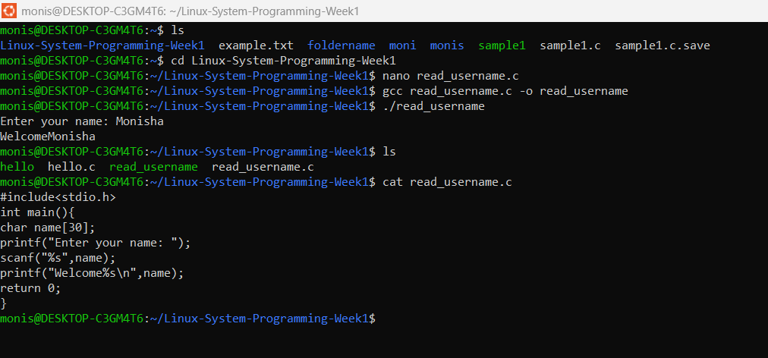

- Display Process ID

#include<stdio.h>
#include<unistd.h>

int main()
{
printf("Process ID = %d\n",getpid());

return 0;
}

Compile: gcc display_pid.c -o display_pid

./display_pid

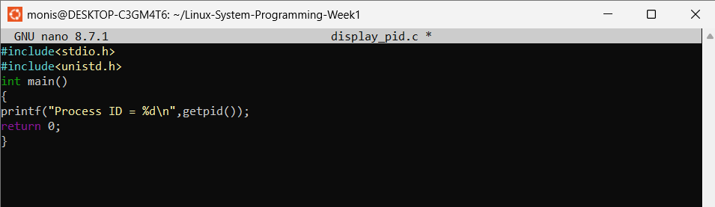

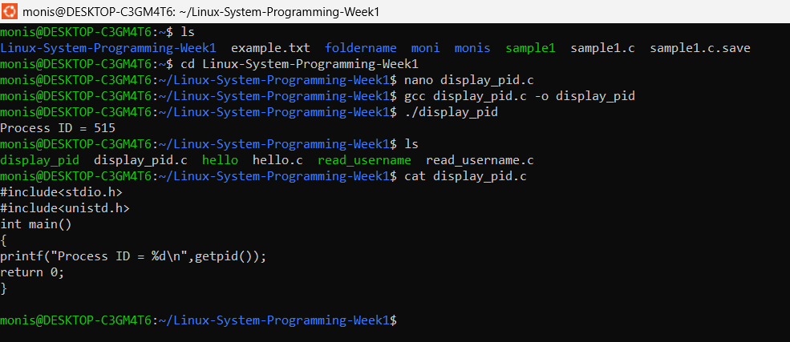

- Fork()

#include<stdio.h>
#include<unistd.h>

int main()
{
fork();

printf("Hello\n");

return 0;
}

Compile: gcc fork_demo.c -o fork_demo
./fork_demo

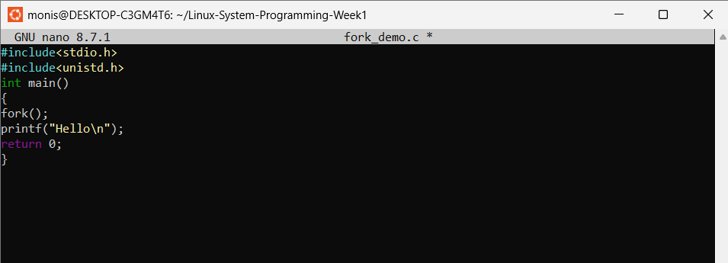

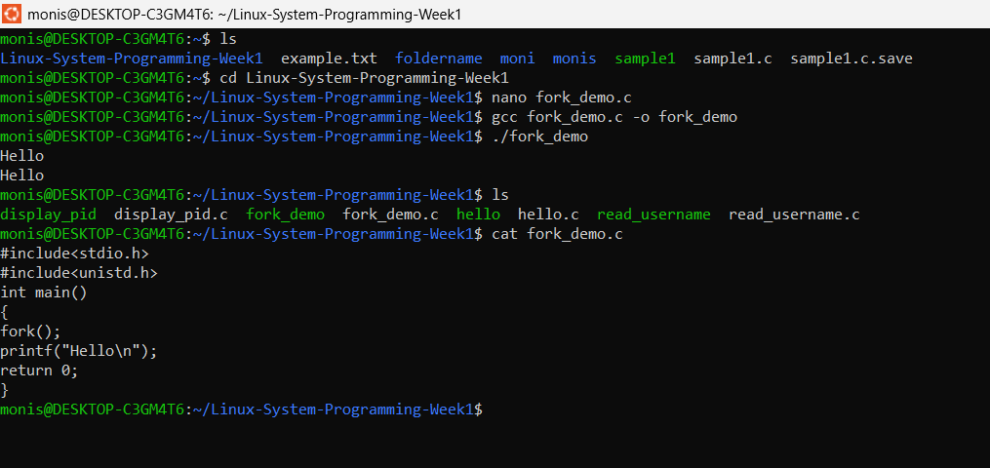

- Parent and Child
#include<stdio.h>
#include<unistd.h>

int main()
{
pid_t pid;

pid=fork();

if(pid==0)
{
printf("I am Child Process\n");
}
else
{
printf("I am Parent Process\n");
}

return 0;
}

Compile: gcc parent_child.c -o parent_child
./parent_child

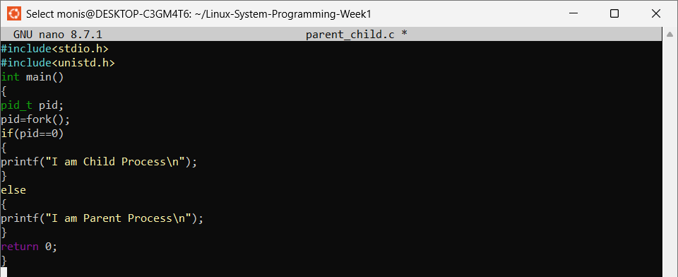

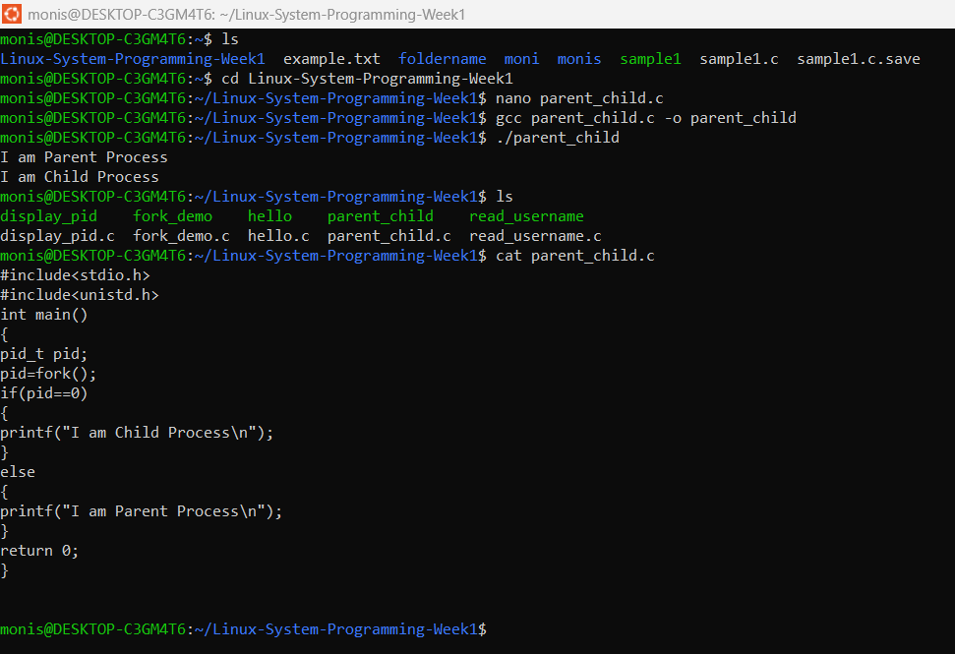

- Display parent and Child PID

#include<stdio.h>
#include<unistd.h>

int main()
{
pid_t pid;

pid=fork();

if(pid==0)
{
printf("Child PID = %d\n",getpid());
printf("Parent PID = %d\n",getppid());
}
else
{
printf("Parent PID = %d\n",getpid());
}

return 0;
}

Compile: gcc parent_child_pid.c -o parent_child_pid
./parent_child_pid

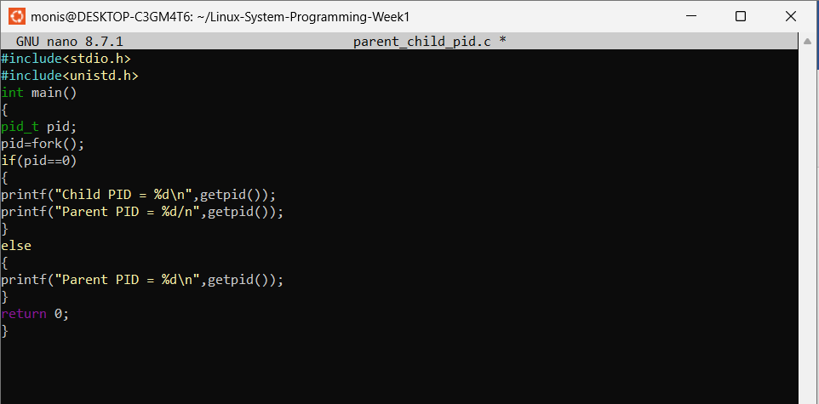

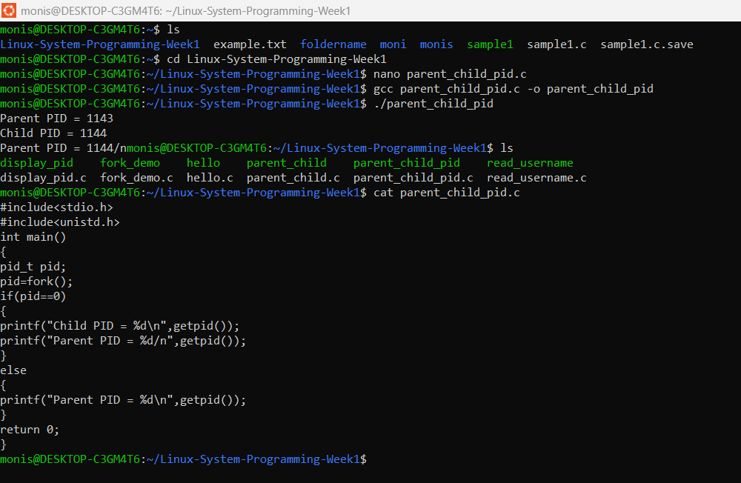

- Wait()

#include<stdio.h>
#include<unistd.h>
#include<sys/wait.h>

int main()
{
pid_t pid;

pid=fork();

if(pid==0)
{
printf("Child Running\n");
}
else
{
wait(NULL);

printf("Parent Running After Child\n");
}

return 0;
}

Compile: gcc wait_demo.c -o wait_demo
./wait_demo

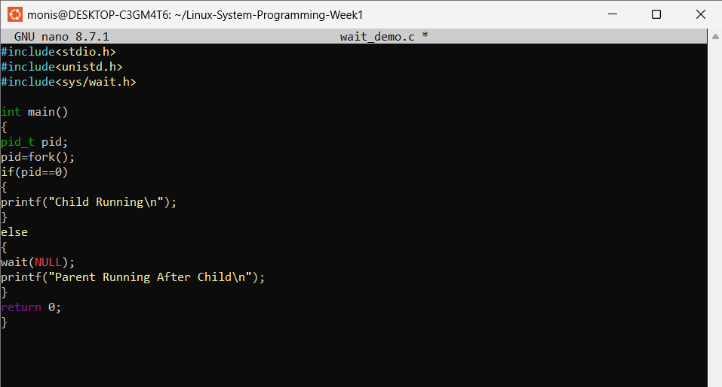

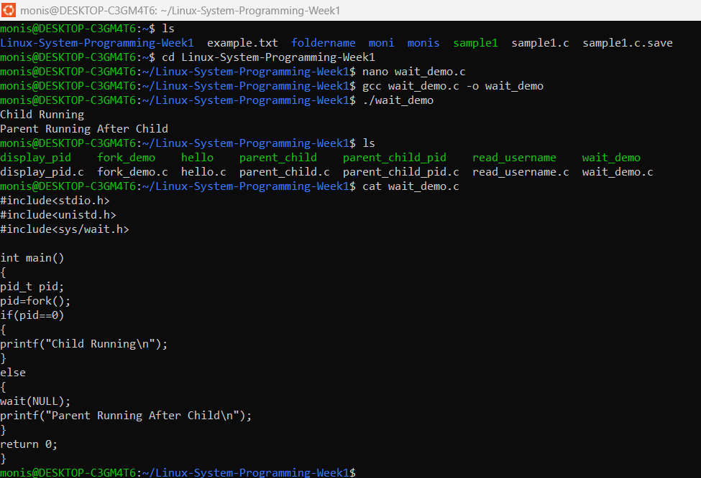

- exec()

#include<stdio.h>
#include<unistd.h>

int main()
{
printf("Before exec()\n");

execlp("ls","ls",NULL);

printf("After exec()\n");

return 0;
}

Compile: gcc exec_demo.c -o exec_demo
./exec_demo

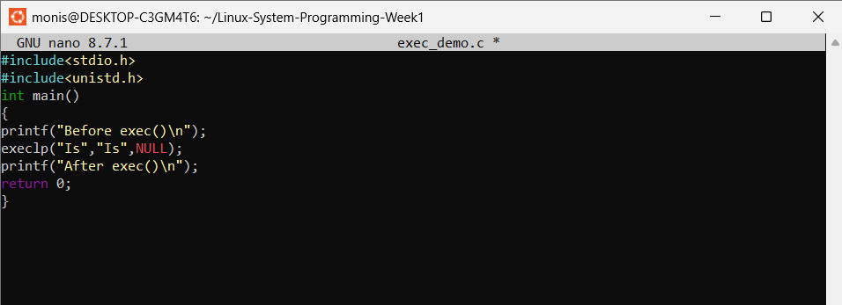

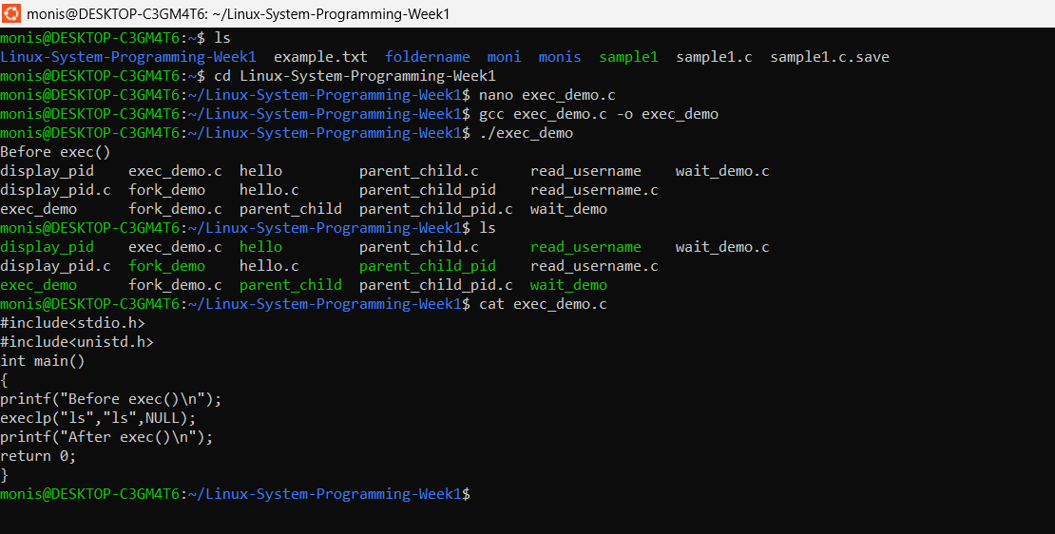

- fork() + exec()

#include<stdio.h>
#include<unistd.h>
#include<sys/wait.h>

int main()
{
pid_t pid;

pid=fork();

if(pid==0)
{
execlp("date","date",NULL);
}
else
{
wait(NULL);

printf("Child Completed\n");
}

return 0;
}

Compile: gcc fork_exec.c -o fork_exec
./fork_exec

