
Department of CSE

B.Tech. CSE Trimester -5

2520030537
Monisha Raghini Chelle

Cloud Infrastructure and Services
25CS2206E

LAB RECORD
2026

Experiment -1

AIM: To create an AWS Free Tier account to provision the resources.

Description:
Amazon Web Services (AWS) is a cloud computing platform that provides various cloud services such as computing, storage, databases, and networking.
The objective of this experiment is to create an AWS Free Tier account and explore the AWS Management Console. The Free Tier allows users to access selected AWS services within specified usage limits.
Using AWS, we can create and manage cloud resources based on our requirements.

Steps:
- Open a web browser and visit https://aws.amazon.com/.
- Click on the "Create an AWS Account" option.
- Enter your email address and account name.
- Verify your email address.
- Create a secure password for your AWS account.
- Enter the required contact information.
- Complete the payment verification process as instructed by AWS.
- Complete the identity verification process.
- Select the required support plan.
- Sign in to the AWS Management Console.
- Explore the AWS Management Console and available services.
- Check the AWS Free Tier section to understand the available free usage limits.

Output:
Successfully created an AWS account and accessed the AWS Management Console. Explored the available AWS services and Free Tier options.
The AWS account is ready to provision cloud resources.

AWS Console screenshots

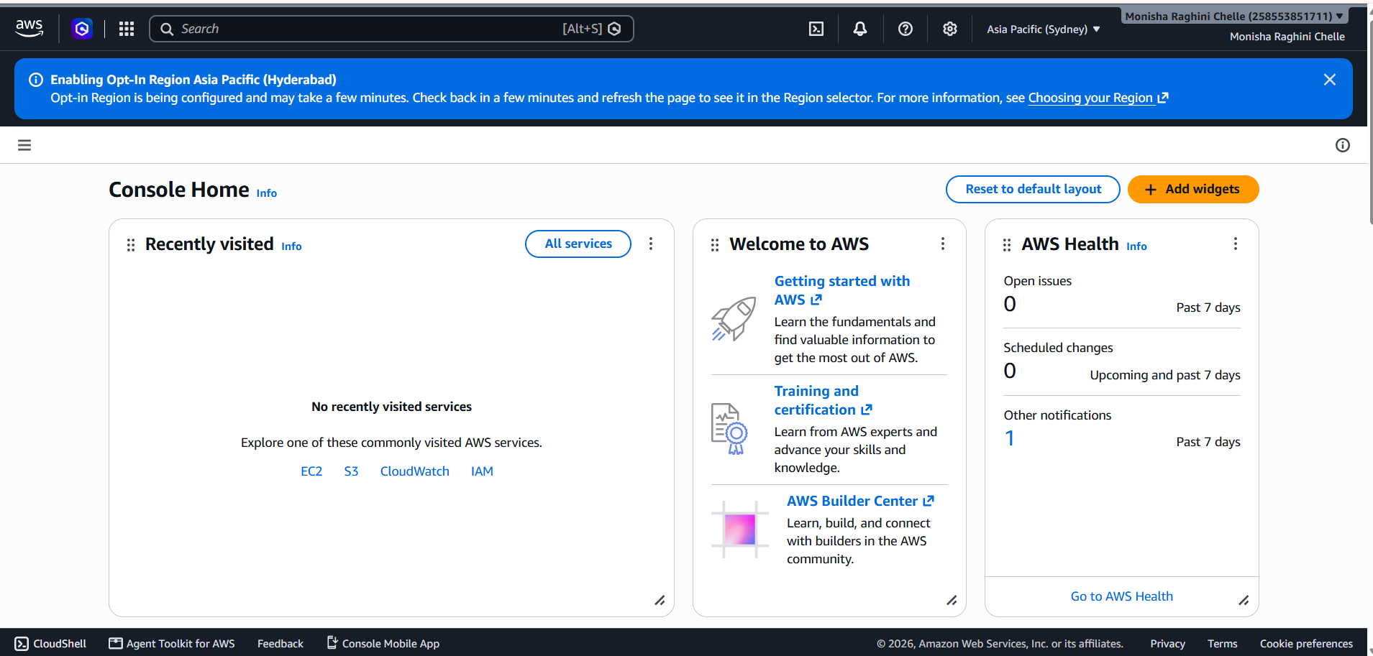

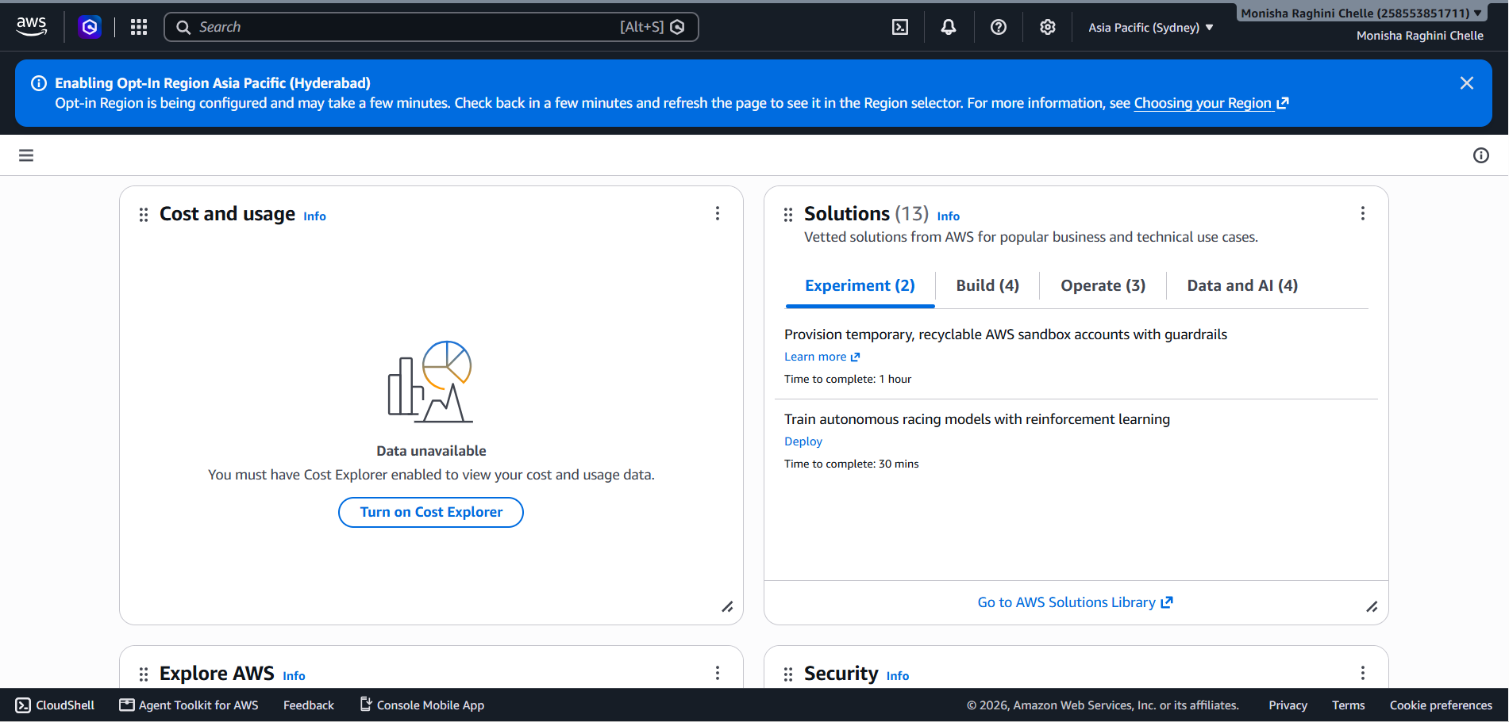

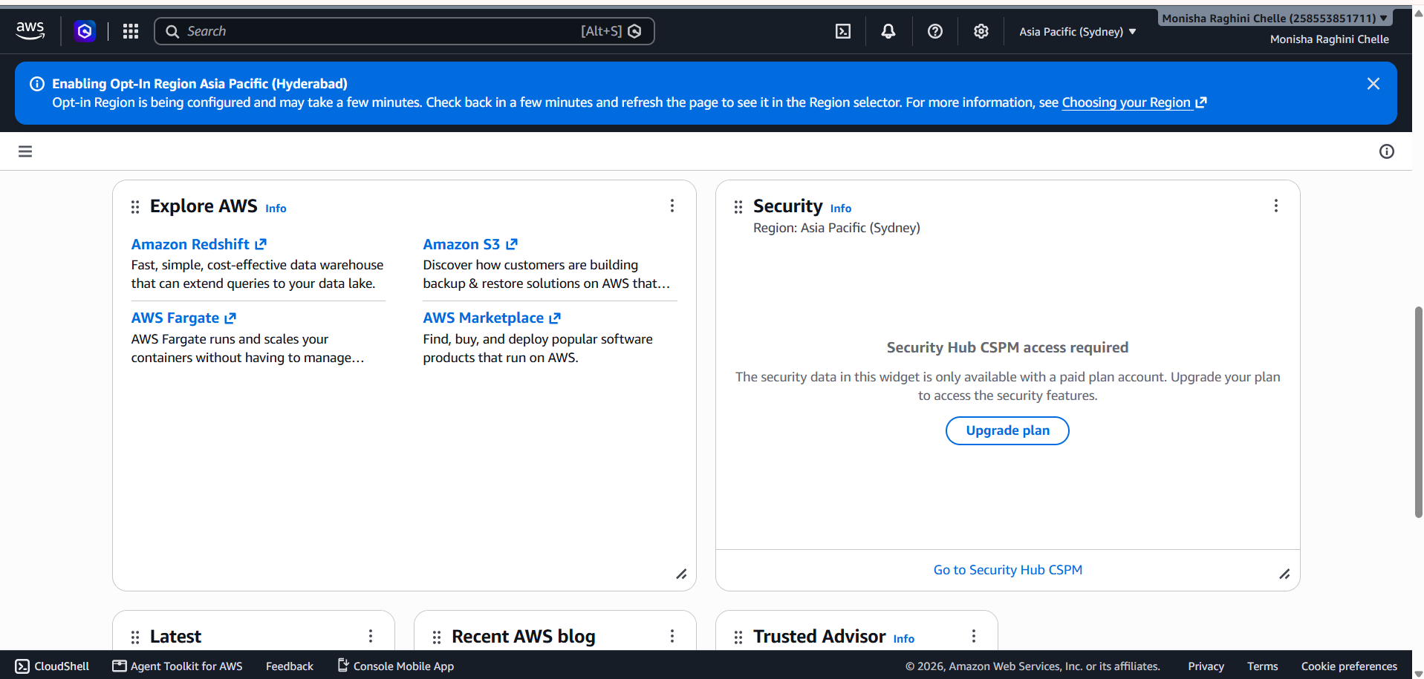

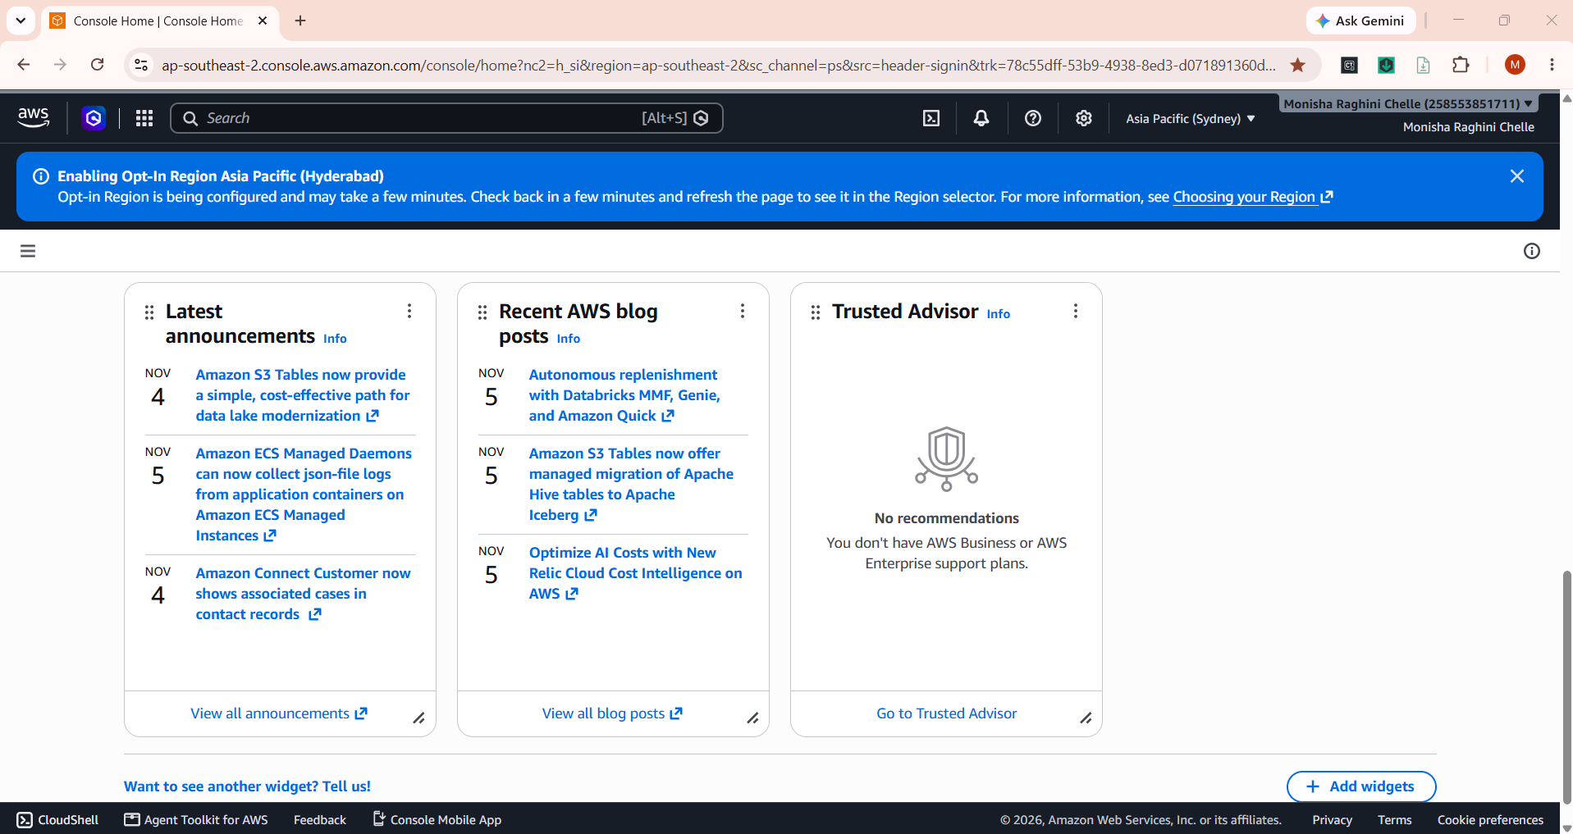

AWS Billing search screenshots
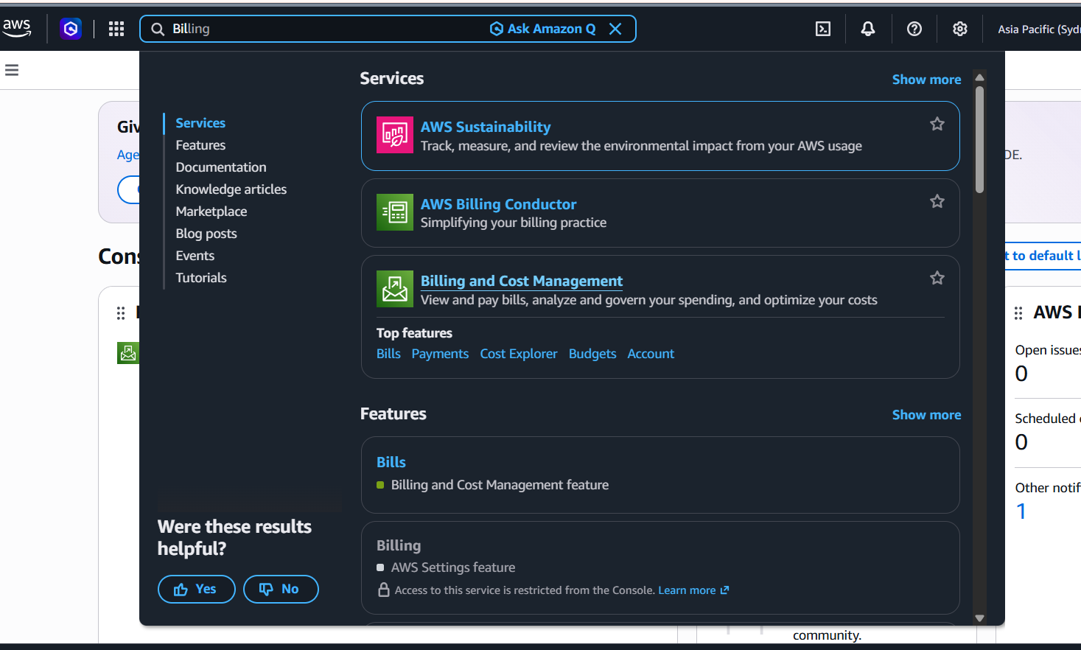

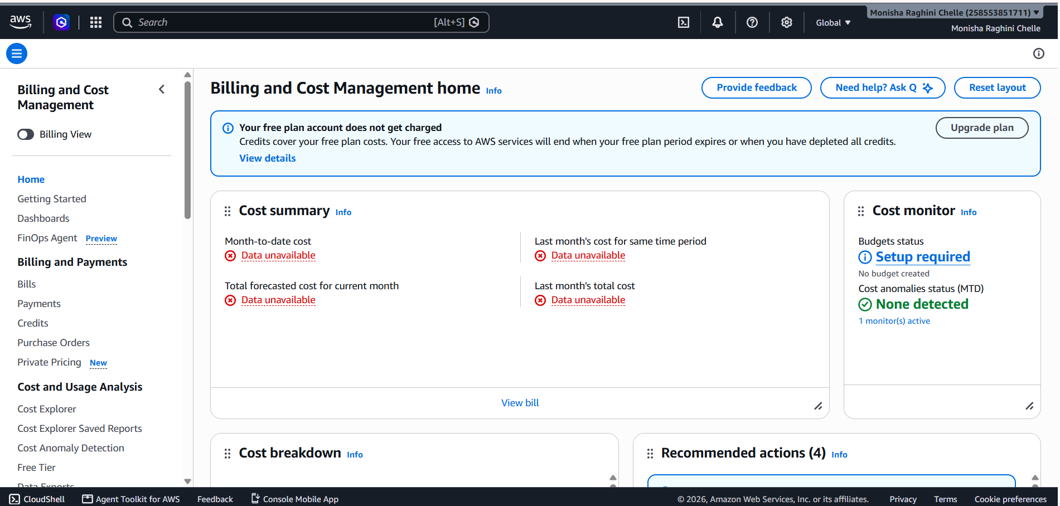
AWS Free Tier Dashboard Screenshot


