FRESH BITES CATERING

PROJECT REPORT TEMPLATE

1 INTRODUTION

1.1 OVERVIEW

Zoho books is your one-step platfrom for managing your accountion tasks and organizing your transactions.

1.2PURPOSE

Zoho books is an online accounting application that takes careof the accounting needs of your business

2 Problem definition & design thinking

2.1 Empathy Map

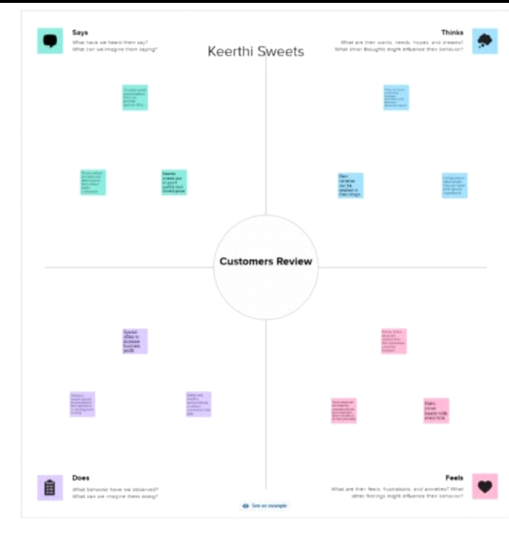

2.2 Ideation & Brainstorming Map

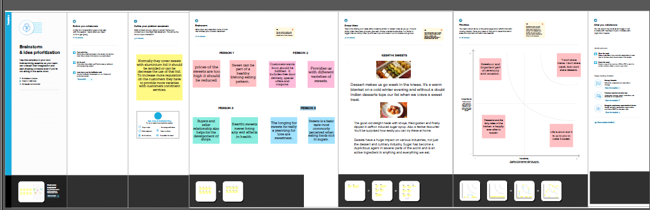

3. RESULT

In the result,I can find out

Item creation

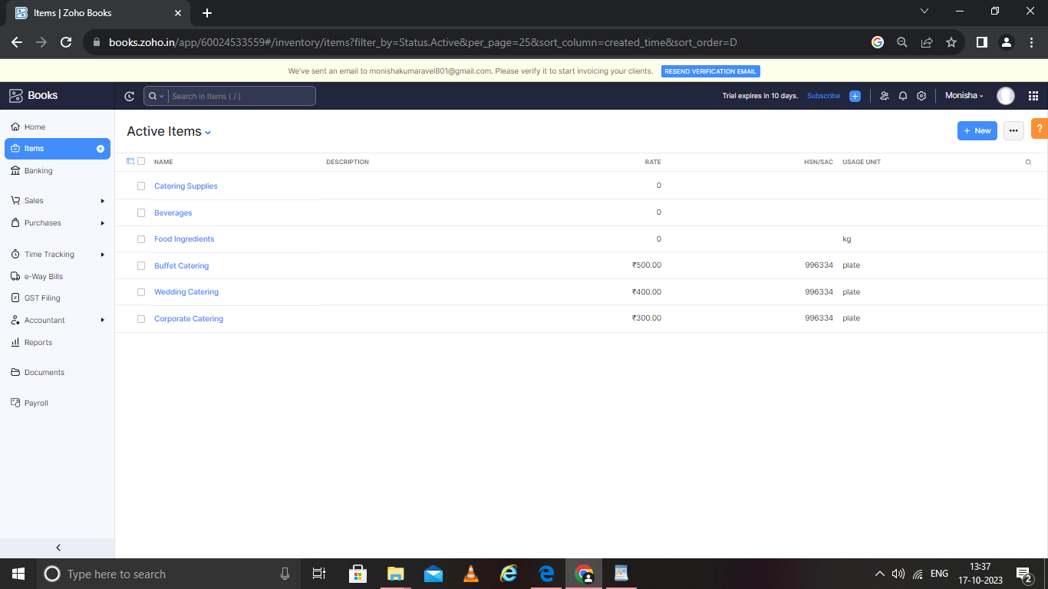

Vendor creation

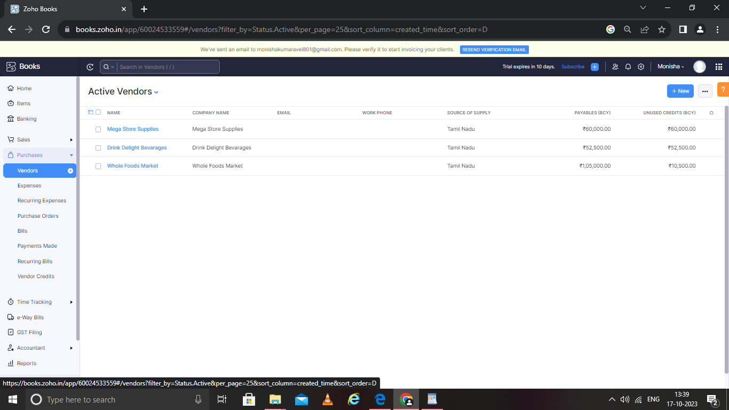

Purchase order

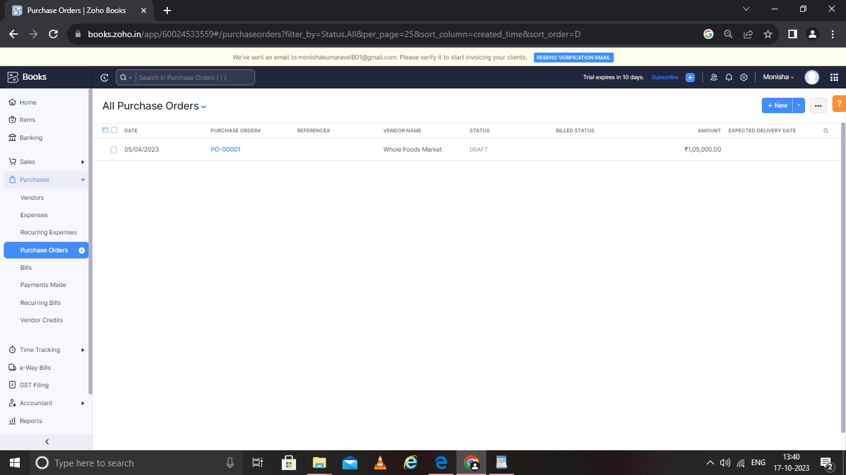

Sales order

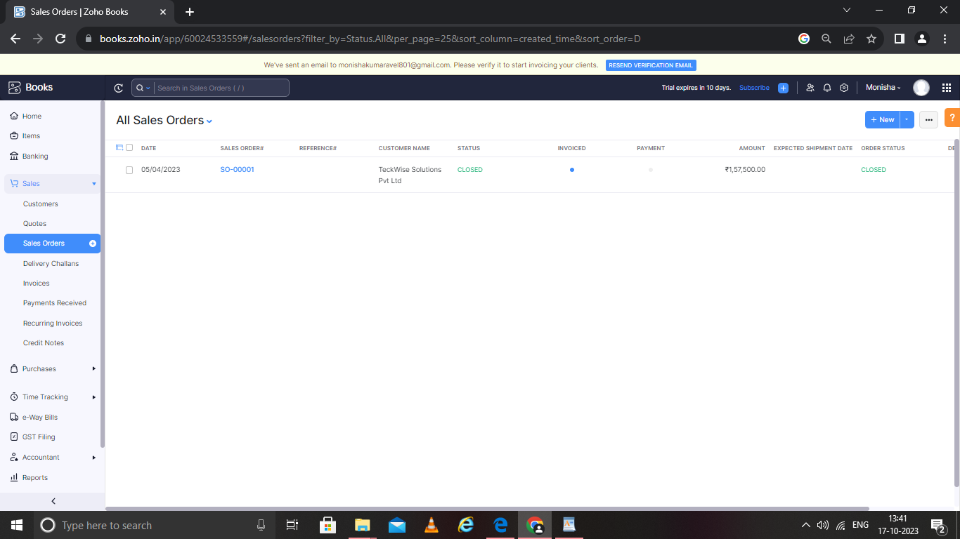

Bank details

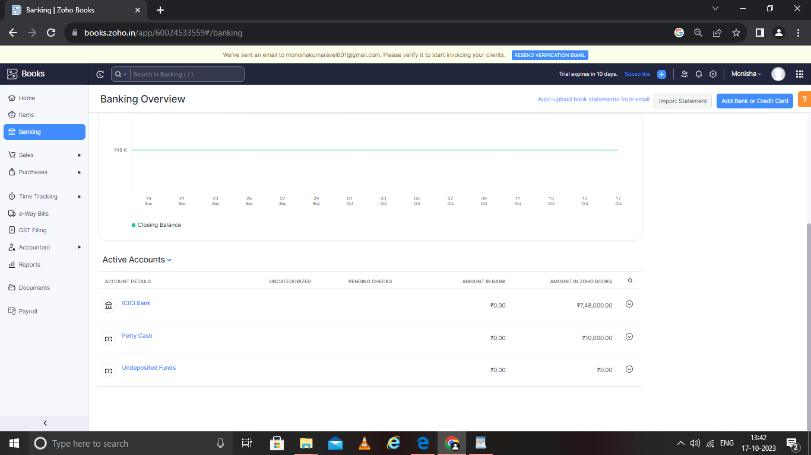

Profit & loss account

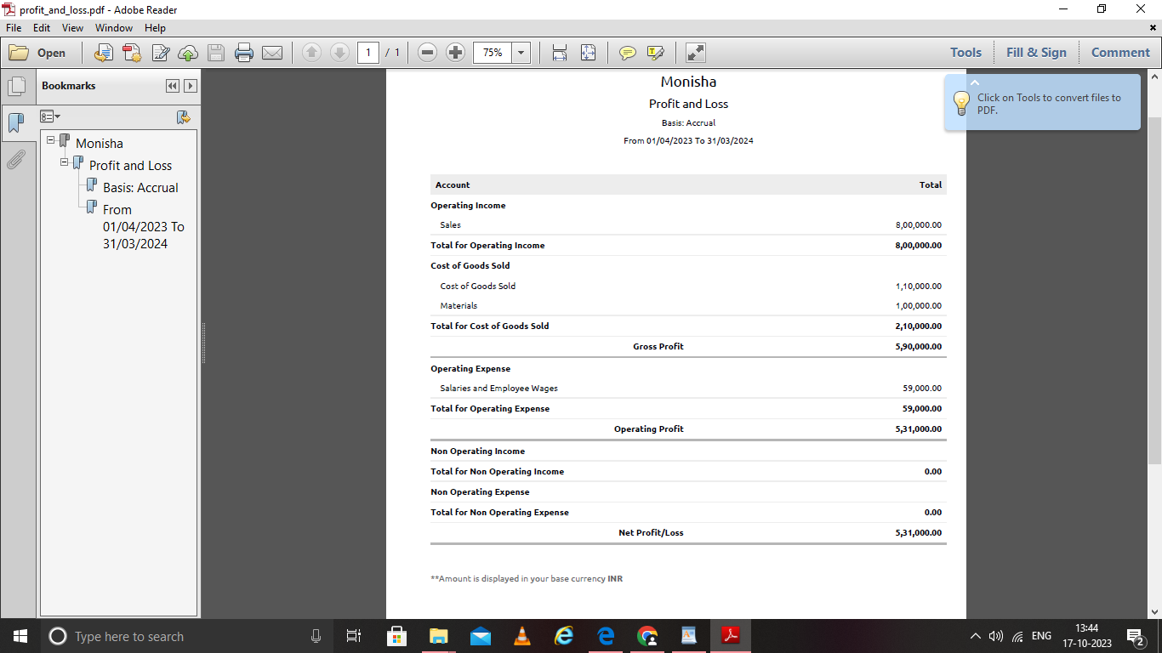

Balance sheet

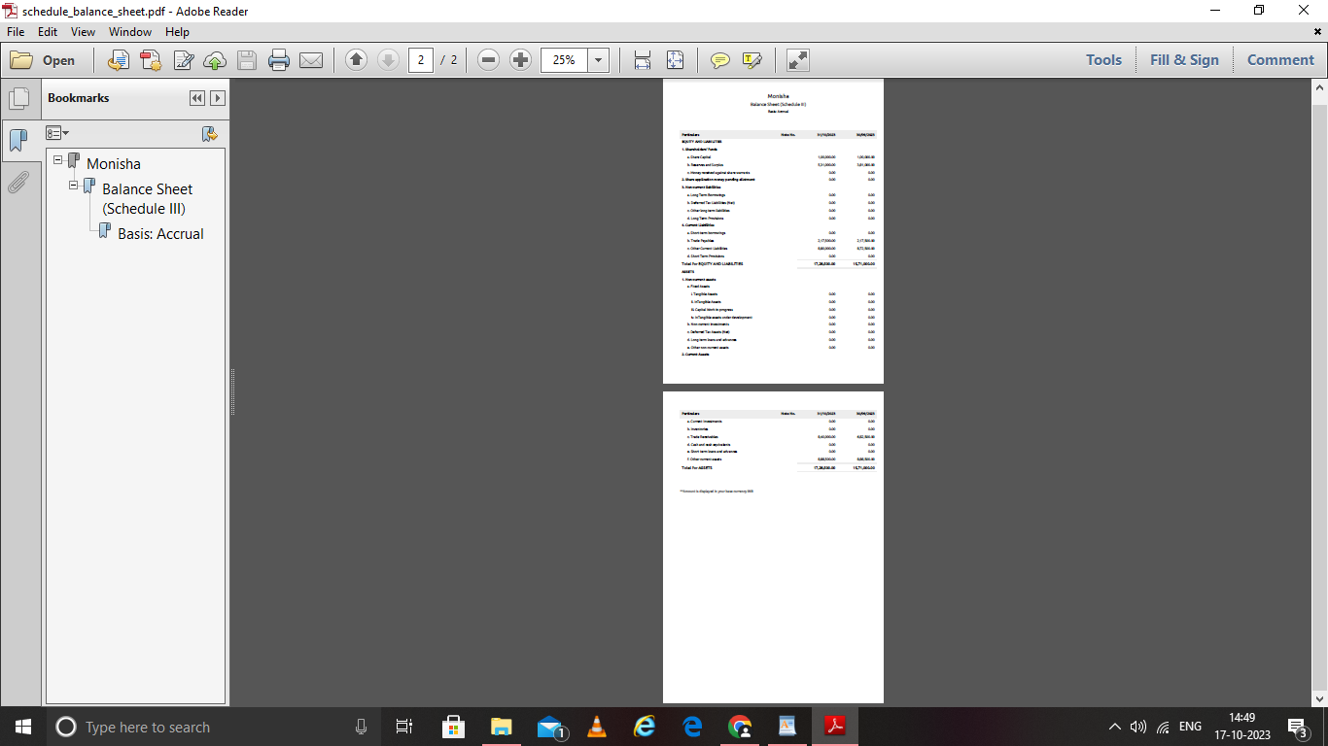

GSTR-3B SUMMARY

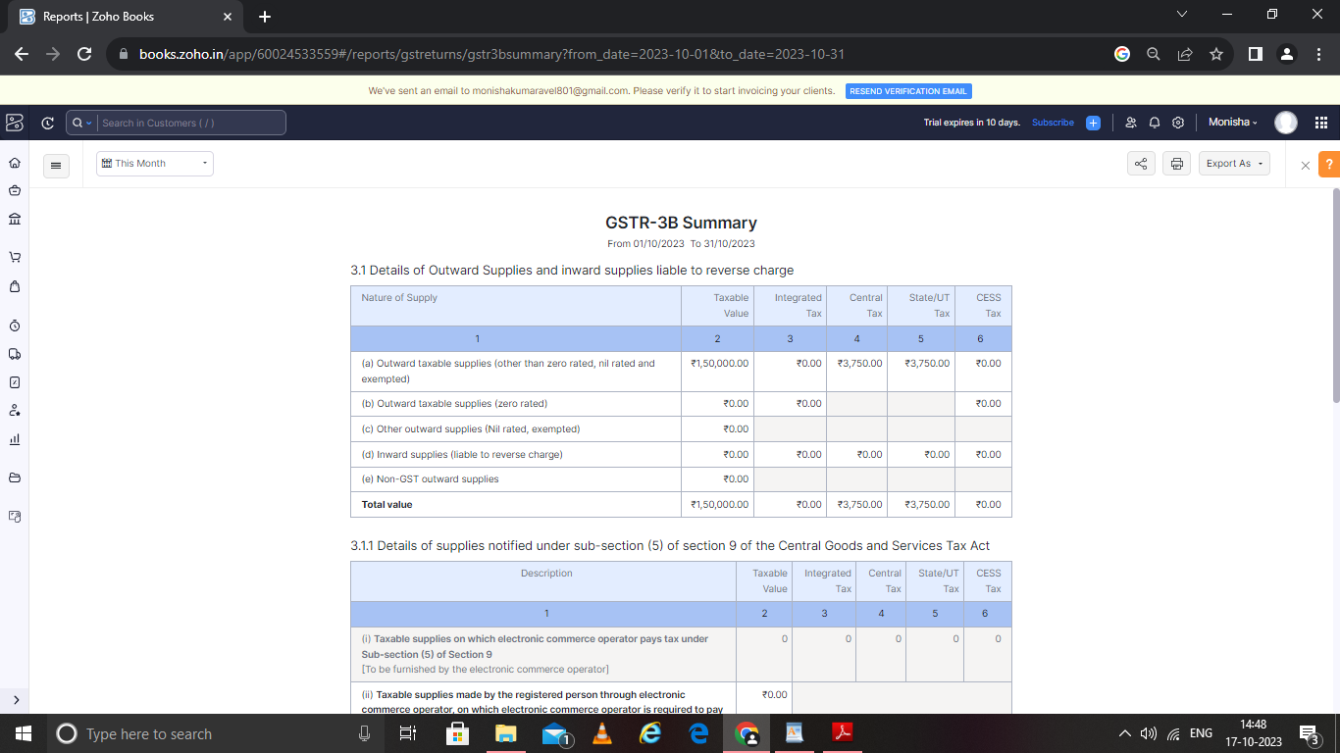

4. ADVANTAGES & DISADVANTAGES

ADVANTAGES

1. Invoicing and billing

2. Online payment

3. Expense tracking

4. Project management & timesheets

DISADVANTAGES

1. Monthly transaction cap. one significant zoho book limitation is the cap on monthy transaction

2. Multiple subscription for mtiple businesses

3. No payroll services

4. Accounts payable limitation

APPLICATION

This application used to maintain the company details and ledger account, profit and loss account and balance sheet of the company mega store supplies

CONCLUSION

It is service the DELIVERS, COOKS and SERVES FOOD on sit at a clients location.

FUTURE SCOPE

Preparing and storing food safety before during events, setting up all tablets and food service areas with chairs, lines and dishes, serving food to guest at events. It also helped to reduce the work of the accountant to maintain account.

APPENDIX:

Approved Development

Future Assessment

Plan of Development

Convactless Free Delivery and Pickup.