Business Process Innovation (BPI) Industry Visit
Submitted by
Name MONISHA.K


(Roll No 7376252AL173)

BANNARI AMMAN INSTITUTE OF TECHNOLOGY – INSTITUTION’S INNOVATION COUNCIL
&
Industry Exploration and Collaboration Cell

Duration: 28/03/2026 – 03/04/2026

ABOUT THE STUDENT

S.NO | Description | Details
 | Name of the student | MONISHA.K
 | Register Number | 7376252AL173
 | Department | B.TECH.AIML
 | Year of study | I
 | Contact Number | 9025996304
 | Mail id | monishak.al25@bitsathy.ac.in
 | Location | kangayam

Local Context – BPI Industry Visit (Basic Details)
Parameter | Details
Organization / Industry Name | SRI SHAKTHI DEPARMENTAL STORE
Location (City / Area) | kullampalayam
Date of Visit | 31/03/2026
Time of Visit | 11.20AM
Department / Unit Visited | WHOLE STORE
Industry Contact Persons | DEVARAJ
 | GOMATHI
Photographic Evidence | ATTACHED BELOW

Relevant SDG Aligned with Industry Operations: SDG 8 – Decent Work and Economic Growth

DAY 1 ORIENTATION, OVERVIEW & THE BIG PICTURE

BPI – SECTION 1 BUSINESS OVERVIEW & END-TO-END FLOW

1.1 Core Purpose
Product/Service | Category | Variants | Problem Solved | Customer Impact
Grocery items | Trading | Rice, oil, snacks | Provides daily needs | Saves time
Vegetables | Trading | Fresh vegetables | Easy access | Convenient
Household items | Trading | Soap, detergent | One place purchase | Effort reduced
Category: ☐ Manufacturing ☐ Service ☑Trading ☐ Hybrid

Additional Remarks:During my visit, I observed that most customers come regularly for daily need.

1.2 Revenue Model
Revenue Source | Description | Pricing Method | Frequency | % Contribution
Product sales | Selling grocery items | Cost + profit | Daily | High
Main Revenue Driver:DIRECT SELLING OF PRODUCT
Additional Remarks:I noticed that most customers pay using cash and UPI.

1.3 Customer Profile
Segment | Characteristics | Needs | Source Channel
Families | Regular buyers | Daily groceries | Nearby
Workers | Quick purchase | Small items | Walk-in
Students | Limited budge | Snacks | Nearby
Customer Type: ☐ B2B ☑ B2C ☐ Both
Additional Remarks:I observed that many customers are regular and known to the shop owner

1.4 Department Map
Department | Role | Depends On | Outputs To
Procurement | Buying goods | Suppliers | Storage
Storage | Keeping items | Procurement | Sales
Sales | Serving customers | Storage | Billing
Billing | Calculating bill | Sales | Payment
Inventory | Stock checking | Storage | Procurement
Draw Flow Diagram Below:
Additional Remarks: All activities are connected and depend on each other.

1.5 Single Unit Trace
Step No | Department | Activity | Input | Output | Time Taken | Waiting Time
1 | Sales | Customer enters | customer | Visit start | 0 | 0
2 | Sales | Select items | need | Items selected | 2-5mins | low
3 | Storage | Check stock | items | confirmed | 1-2mins | medium
4 | Billing | Calculate bill | items | total | 2mins | low
5 | Billing | payment | money | paid | 1min | low
6 | Sales | packing | items | packed | 2mins | low

Additional Remarks:During my visit, the process was simple but slow in busy time.

1.6 Time at Each Step
Covered in above table
Additional Remarks:
During peak time, waiting time increases
1.7 Biggest Risk Point
Identify the most critical risk in the process:
Stock shortage and billing errors
Reason:
Items not available leads to customer loss
Additional Remarks:
I observed that some customers leave if items are not available.

1.8 Most Critical Task
Identify the most important task affecting success:
Sales and billing
Reason:
Main process for earning money
Additional Remarks:
It should be done fast and correctly.

BPI – SECTION 2 (ROUTINE TASKS & DEPENDENCIES)

2.1 Daily Tasks
Task | Time of Day | System/Memory | Owner | Output | Risk if Missed | Backup Available (Y/N)
Opening shop | morning | memory | owner | Shop open | delay | no
Arranging items | morning | memory | worker | Clean shop | mess | no
sales | Full day | memory | worker | service | loss | no
Cash count | night | memory | owner | record | error | no
Additional Remarks:
Most daily tasks are done based on memory and experience.
2.2 Weekly / Monthly Tasks
Task | Frequency | System/Memory | Owner | Output | Risk if Missed | Backup Available (Y/N)
weekly | weekly | memory | owner | stock | shortage | no
monthly | monthly | memory | owner | paid | delay | no
Additional Remarks:
Stock purchase and payments are not properly recorded.

2.3 System vs Memory Mapping
Task | Is Documented (Y/N) | Where Stored | Access Level | Error Risk
stock | no | memory | owner | high
sales | no | memory | owner | medium
Additional Remarks:
There is no digital system, everything is managed manually.

2.4 Task Ownership
Task | Primary Owner | Secondary Owner | Approval Required (Y/N) | Escalation Path
Purchase | owner | none | yes | owner
sales | worker | owner | no | owner
Additional Remarks:
Owner handles most important tasks in the shop
2.5 Impact if Task is Missed
Task | Immediate Impact | Downstream Impact | Customer Impact | Recovery Time
Stock check | Item missing | Sales loss | Customer leaves | 1-2 days
Additional Remarks:Missing tasks can affect sales and customer satisfaction.

2.6 Dependency Risk (Key Person Absence)
Task | Key Person | Can Others Perform (Y/N) | Time to Substitute | Risk Level (H/M/L)
purchase | owner | no | high | hogh
Overall Dependency Level: ☑High ☐ Medium ☐ Low
Additional Remarks:Shop depends highly on the owner for major activities.

2.7 Handover Readiness
Task | Handover Document Exists (Y/N) | Steps Clearly Defined (Y/N) | Training Required | Time to Handover
Shop work | no | no | needed | 1-2 months
Additional Remarks:
New person needs time to learn shop work.

BPI – SECTION 3 (LEAD & ORDER CAPTURE SYSTEM)

3.1 Inquiry Channels
Channel | Type (Online/Offline) | Volume | Handled By | Recorded (Y/N) | Risk
walkin | offline | high | worker | no | loss
phone | offline | medium | owner | no | miss
watsapp | online | low | owner | no | delay
Additional Remarks:Most customers come directly to the shop
______________________________________________

3.2 Recording System
Channel | Where Recorded | Format (Digital/Manual) | Accessible To | Error Risk
Walk in | no | none | none | high
phone | partial | notebook | owner | medium
Additional Remarks:
Customer details are not properly recorded.

3.3 Follow-up Process
Stage | Action | Responsible Person | Timeline | System Used | Miss Risk
inquiry | No followup | owner | none | none | high
Additional Remarks:
There is no follow-up system in the shop.

3.4 Lead/Order Tracking
Lead ID | Current Stage | Tracking Method | Updated (Y/N) | Visibility | Delay Risk
none | none | memory | no | low | high
Additional Remarks:
Tracking is done only by memory.

3.5 Lost Lead Evidence
Has any lead/customer inquiry been missed?
☑Yes ☐ No
If Yes, fill below:
Case | Channel | Reason Missed | Detected How | Impact
Missed call | phone | No response | later | Lost sale
Additional Remarks:Some customers are lost due to missed calls.

3.6 Conversion Gap
Stage | Drop-off % | Reason | Improvement Opportunity
Inquiry purchase | medium | No stock | Better inventory
Additional Remarks:
Stock issues reduce customer purchase.
3.7 Ideal Lead & Order System
Describe ideal process flow:
Digital billing + stock system
Key improvements needed:
Reduce errors, easy tracking
Additional Remarks:
I feel digital system will improve shop work.

BPI – SECTION 4 (STAKEHOLDER INTERACTIONS)

4.1 Owner – Biggest Risk
Owner Name | Role | Identified Risk | Why Critical | Impact Level
owner | owner | Stock issue | Affects sales | high
Additional Remarks:
Owner faces problems in stock and management.

4.2 Owner – Pride vs Concern
Aspect | Pride Area | Concern Area | Reason
customers | trust | competition | price
Additional Remarks:
Customer trust is strong but competition is high.

4.3 Manager – Resource Constraint
Manager Name | Department | Resource Constraint | Impact | Frequency
owner | shop | time | delay | daily
Additional Remarks:
Time and manpower are limited.

4.4 Manager – Operational Gap
Process | Gap Identified | Cause | Impact | Suggested Fix
billing | error | rush | loss | digital
Additional Remarks:
Mistakes happen during busy time.

4.5 Frontline Worker – Shortcut Observation
Worker Role | Task | Shortcut Taken | Reason | Risk Level
worker | sales | No arrangement | Time save | medium
Additional Remarks:
Items are not always arranged properly.

4.6 Worker – Frustration
Worker Role | Task | Frustration | Cause | Impact
worker | sales | Searching items | No items | delay
Additional Remarks:
Worker faces difficulty during rush hours.

4.7 Unimplemented Ideas
Stakeholder | Idea | Why Not Implemented | Feasibility | Expected Impact
owner | Digital system | cost | yes
Additional Remarks:
Ideas are not implemented due to cost and knowledge.

4.8 Stakeholder Summary Insights
Common patterns observed across stakeholders:
Most work is done based on memory. No proper system is used.
Conflicts between stakeholders:
Workers feel pressure during busy time, but work has to be done fast.
Alignment opportunities:
All agree that a simple digital system can make work easier
Additional Remarks:I observed that better system can improve shop efficiency.

Mandatory for all (Day 1/ Day 1+2/Day 1+2+3)
FINAL SUMMARY
Top 3 Improvements:
Implement digital billing system
Maintain proper stock management
Improve product arrangement in shop
Conclusion:
The grocery shop is working well but mostly depends on manual work and memory. With simple improvements like digital system and better organization, the shop can become more efficient and avoid mistakes.

Attachment Proofs: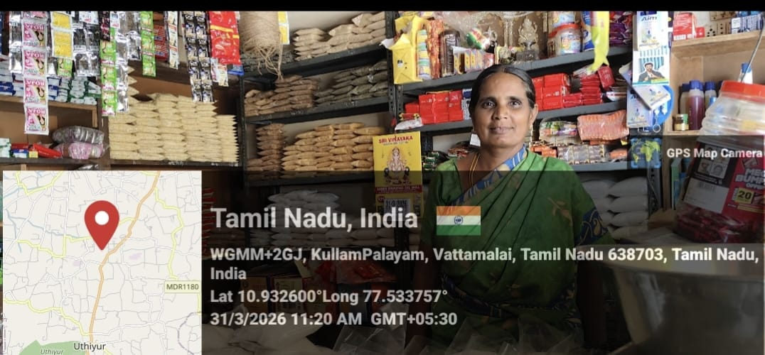

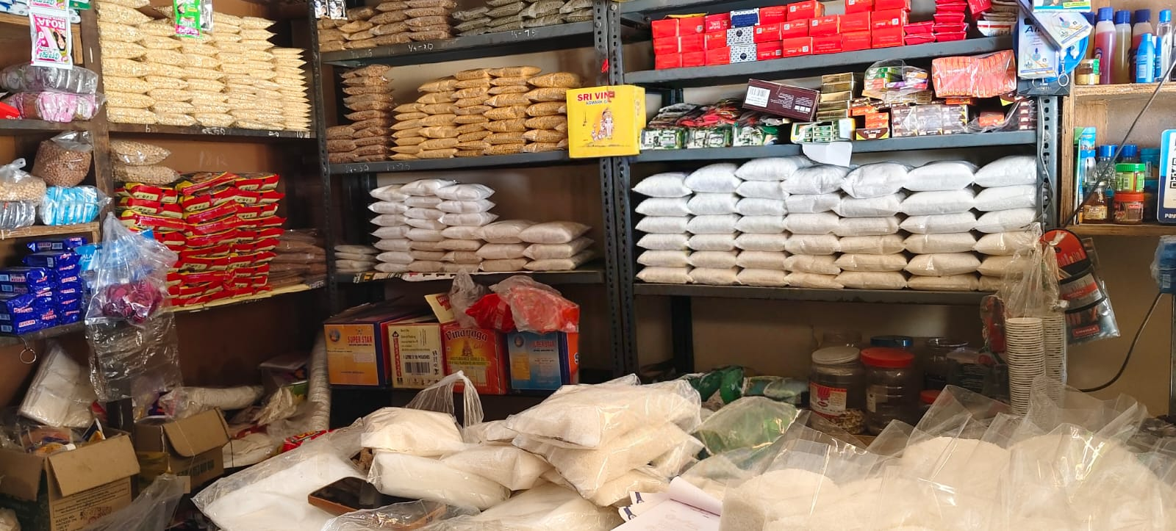

Declaration
I confirm that the data in this report was collected in person on DATE at LOCATION and verified with the official mentioned above.
All photographs were taken by me using my own device, and the names of individuals were recorded with their consent for academic purposes only.
Name: MONISHA.K
Department:AIML
Register No:7376252AL173
Signature: MONISHA.K
Date: 02/04/2026

