WEEK 2 PROJECT REPORT
Product and Category Management System

1. Introduction:
The Product and Category Management System is an SQL-based project designed for an e-commerce company. The system maintains information about products and their categories. Each product belongs to a specific category, and the system stores product details such as product name, price, stock availability, and category.

2. Objectives:
- To create and manage Product and Category tables.
- To maintain product and category information.
- To insert product and category values.
- To perform CRUD operations on product data.
- To generate category-wise product reports.
- To calculate the average product price category-wise.

3. Database Design:
The database contains Category and Product tables. Category_ID is used to connect products with their respective categories. The Product table stores product name, price, stock, and category information.
Table Name | Purpose
Category | Stores category ID and category name.
Product | Stores product ID, product name, price, stock, and category ID.
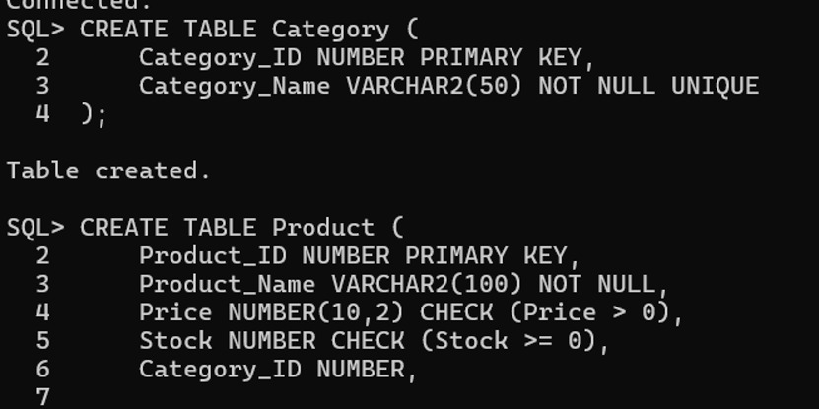

4. Inserting Category Values:
Category values were inserted into the Category table for different product categories.
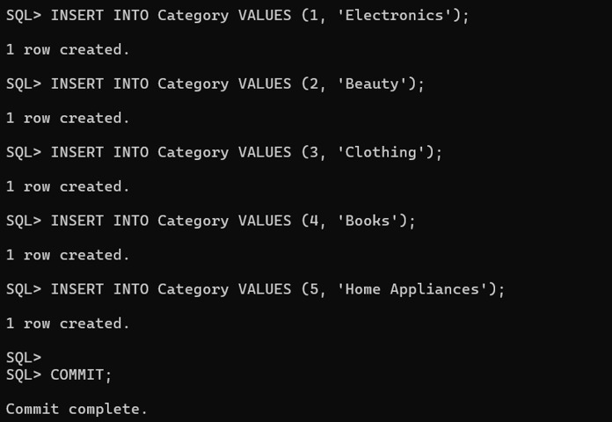

5. Inserting Product Values:
Product values were inserted with product ID, product name, price, stock, and category ID.
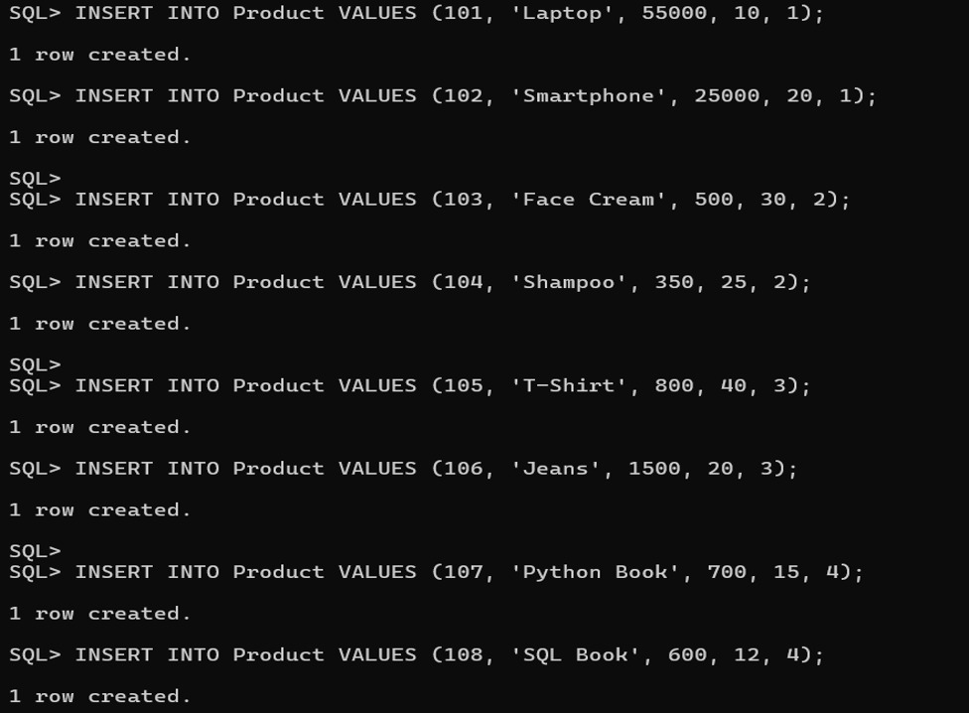
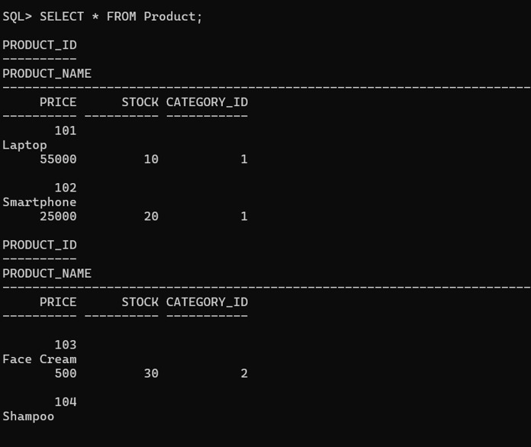

6. CRUD Operations:
CRUD operations are used to manage product records. The project demonstrates insertion and modification of product data.


7. UPDATE:
The UPDATE operation was used to modify the price of the product with Product_ID 101. The price was updated to 58000.
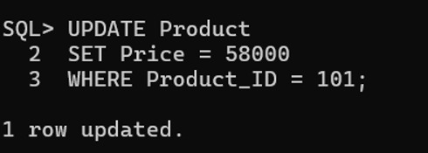

8. Delete:
The DELETE operation was used to remove the product with Product_ID 111 from the Product table.
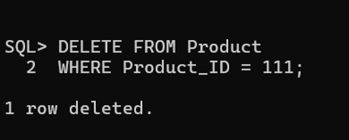

9. Category-wise Product Reports:
Category-wise reports were generated using JOIN and GROUP BY operations. The report displays the number of products in each category and the highest product price in each category.
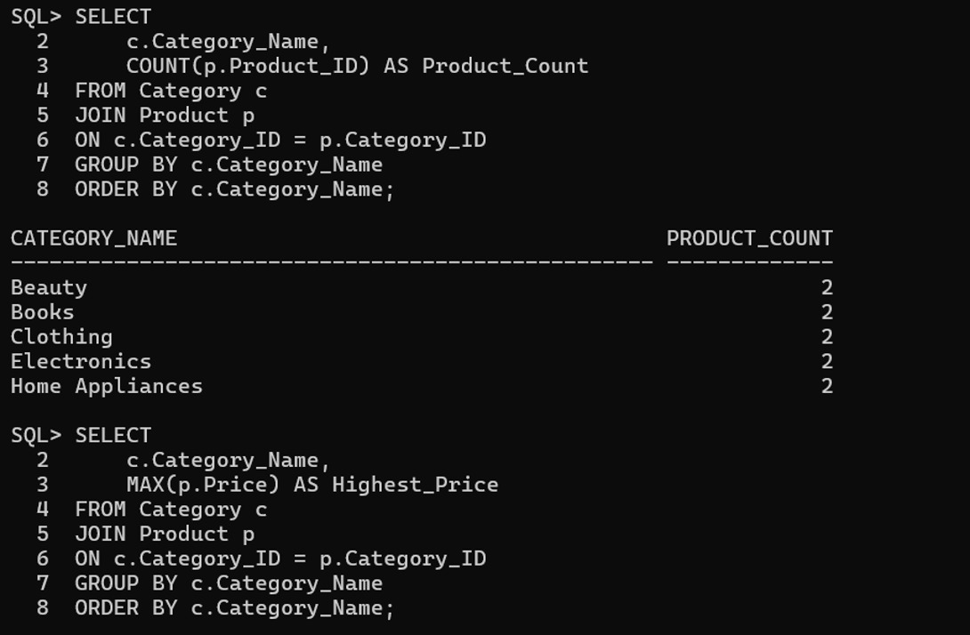

10. Average Product Price Category-wise:
The average product price was calculated for each category using the AVG aggregate function.
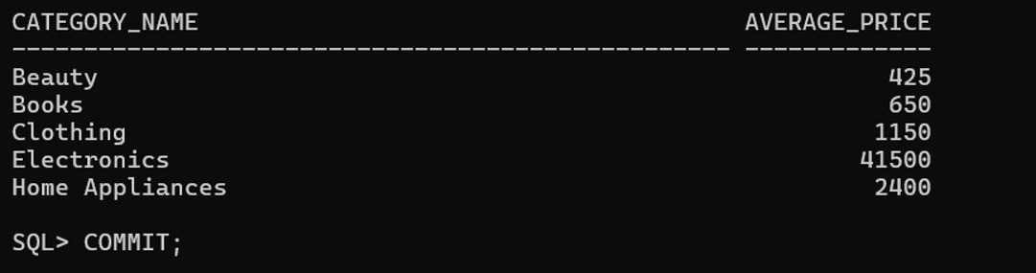

11. Final Results:
Category | Average Price
Beauty | 425
Books | 650
Clothing | 1150
Electronics | 41500
Home Appliances | 2400

12. Conclusion:
The Product and Category Management System was successfully implemented using SQL. The project demonstrates database design, insertion of category and product values, CRUD operations, UPDATE and DELETE operations, category-wise reporting, and average price calculation. The SQL runtime screenshots are included as evidence of the completed operations.

