WEEK 2 PROJECT REPORT
Product and Category Management System
Product and Category Management System
The Product and Category Management System is an SQL-based project designed for an e-commerce company. The system maintains information about products and their categories. Each product belongs to a specific category, and the system stores product details such as product name, price, stock availability, and category.
Database Design
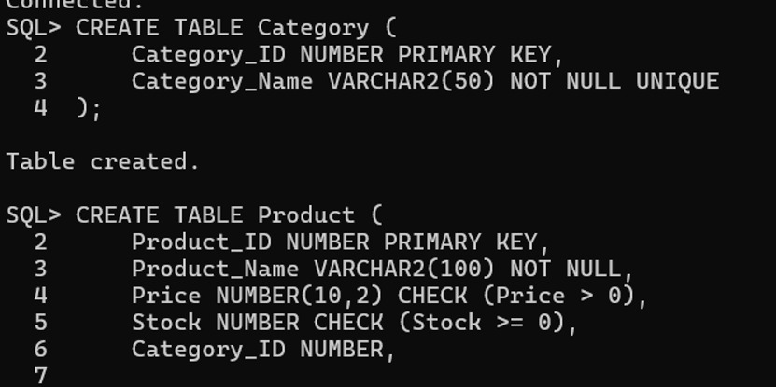
Inserting Product Values
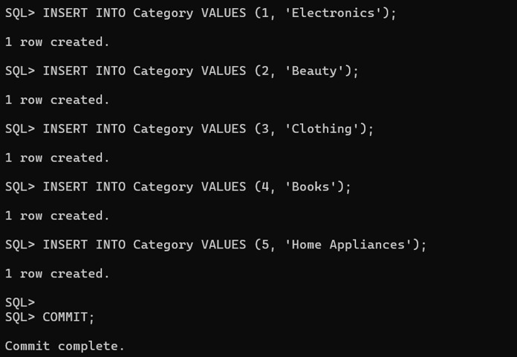
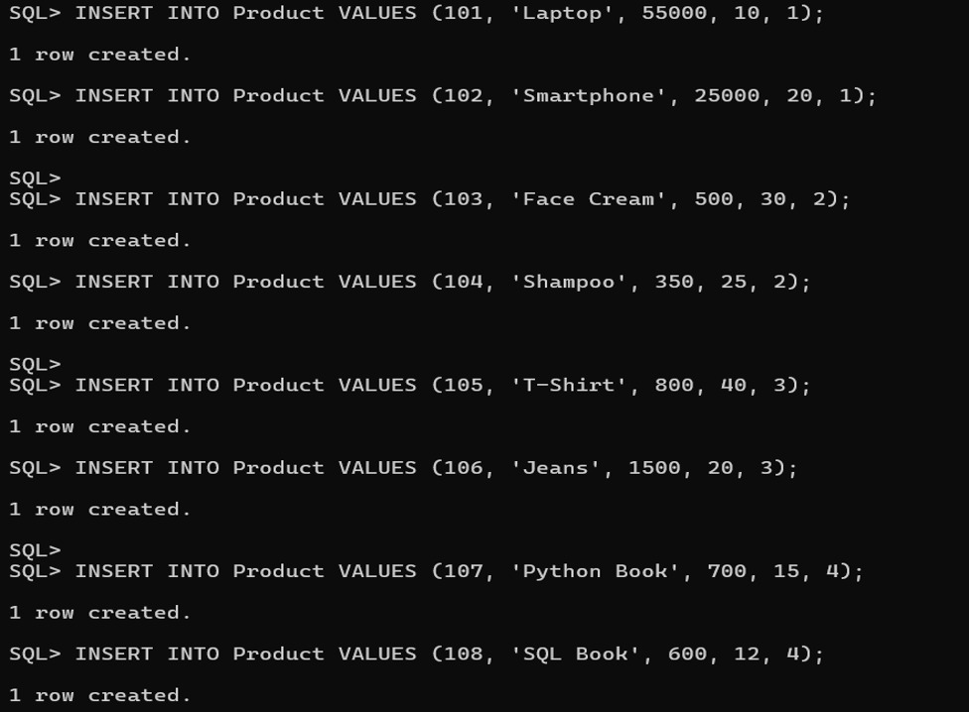
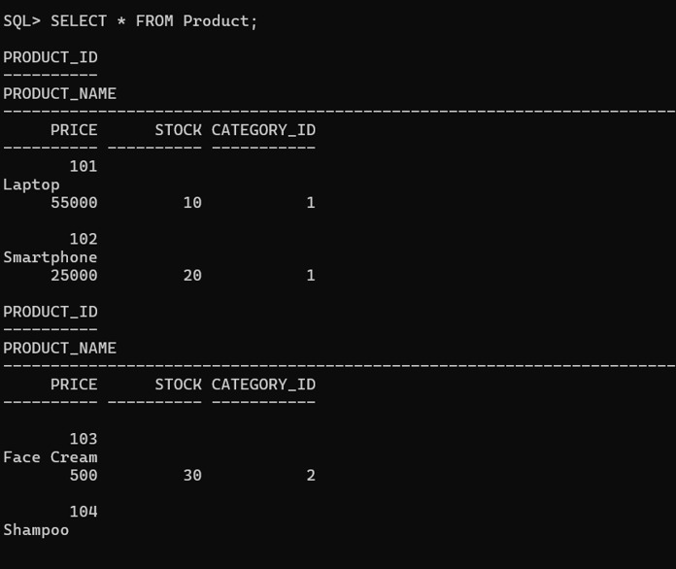
CRUD Operations

UPDATE
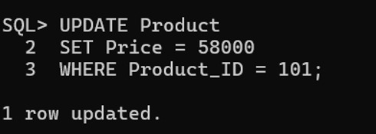
Delete
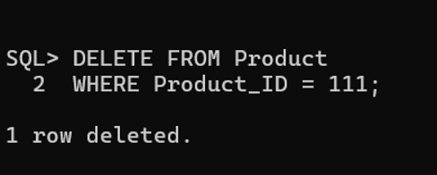
Category-wise Product Reports
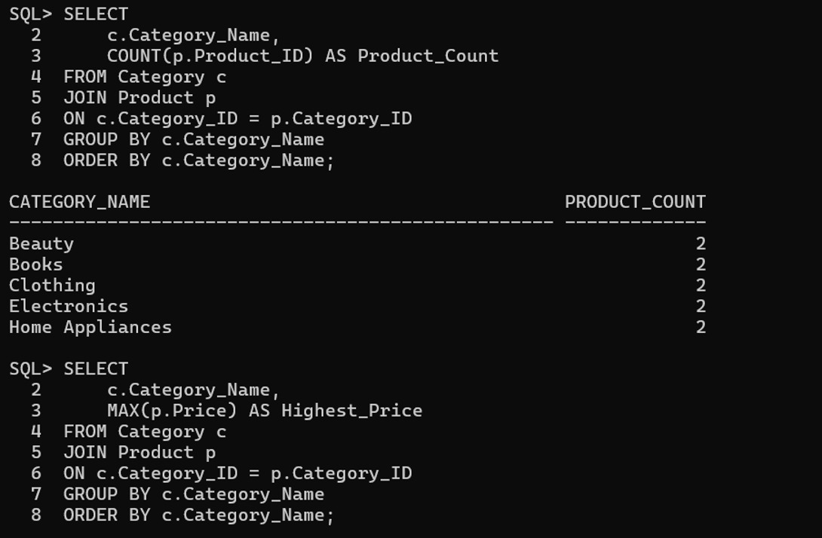
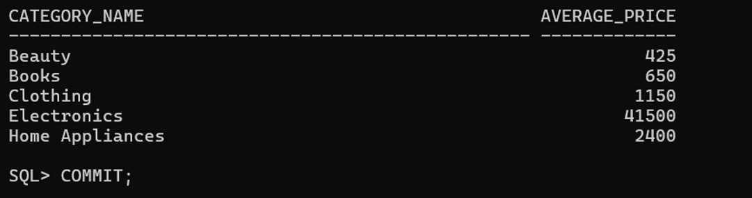
Average Product Price Category-wise

