WEEK 3 PROJECT REPORT
Seller and Inventory Management System

1. Introduction:
The Seller and Inventory Management System is an SQL-based database project designed for an e-commerce company. The system maintains seller details, tracks products supplied by sellers, and monitors inventory levels to ensure product availability.

2. Objectives:
- To create and manage Seller and Inventory tables.
- To maintain seller information.
- To track products supplied by each seller.
- To monitor available stock.
- To establish relationships between Seller, Product, and Inventory.
- To generate seller-wise and inventory reports.

3. Database Design:
The project uses the following main tables:
Table Name | Purpose
Seller | Stores seller information such as Seller ID, Seller Name, Email, and Phone.
Product | Stores product details such as Product ID, Product Name, Category, Price, Stock, and Seller ID.
Inventory | Stores inventory information and stock quantity for products.
Relationships: Seller → Product is one-to-many, and Product → Inventory is one-to-one.

4. Creating Seller and Inventory Tables:
The Seller and Inventory tables were created in Oracle SQL*Plus using CREATE TABLE statements.
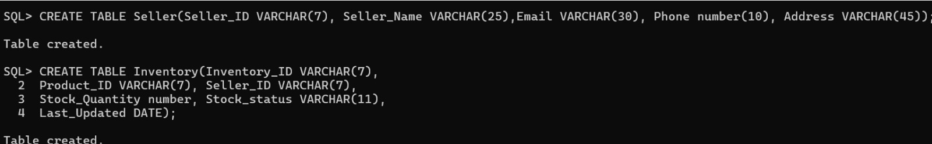

5. Adding Primary Key Constraints:
Primary key constraints were added to uniquely identify Seller and Inventory records.
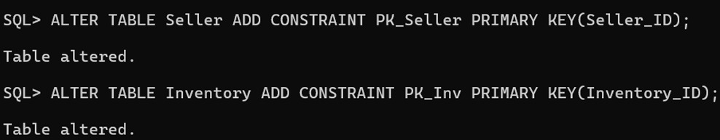

6. Adding Foreign Key and CHECK Constraints:
The Inventory table was linked with the Product table using a foreign key. CHECK constraints were added to validate stock quantity and stock status.
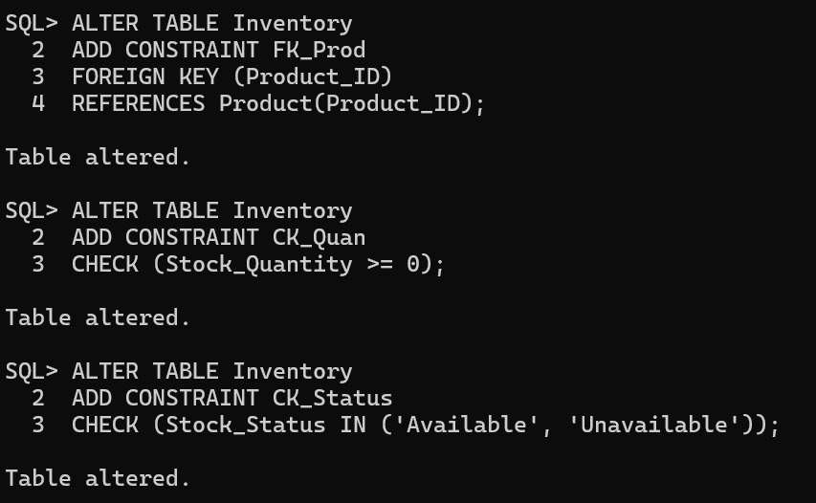

7. Linking Inventory with Seller:
A foreign key was added to Inventory to reference Seller_ID.
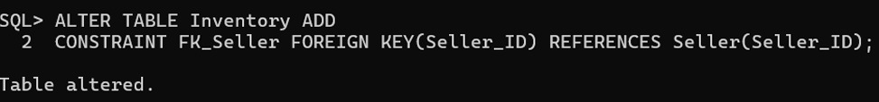

8. Unique Email Constraint:
A UNIQUE constraint was added to the Seller Email column to prevent duplicate email values.
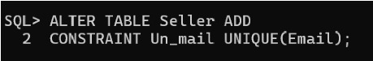

9. NOT NULL Constraint for Email:
The Seller Email column was modified to NOT NULL so that every seller record contains an email address.
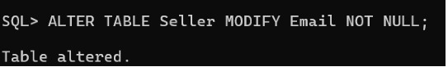

10. Inserting Seller Values:
Five different seller records were inserted into the Seller table.
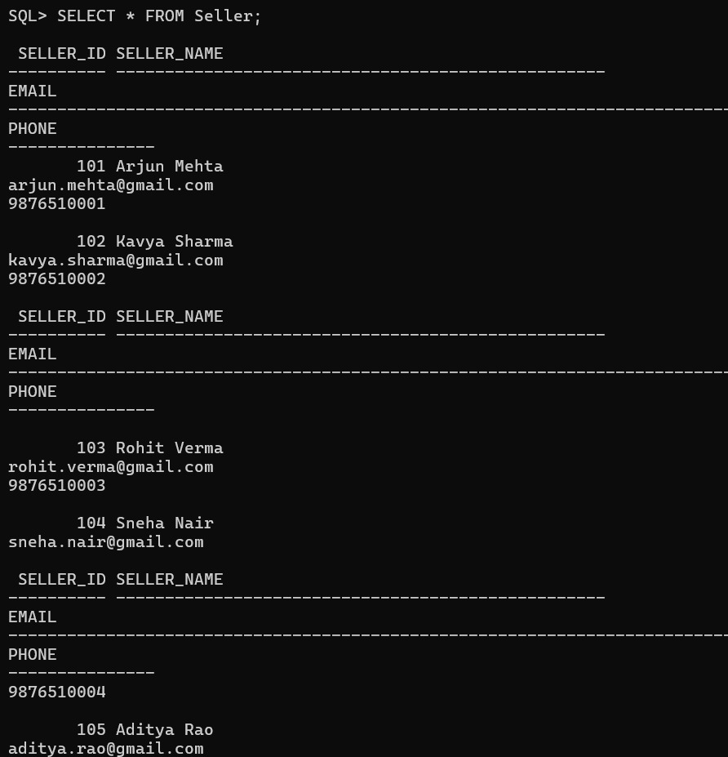

11. Inventory Values:
Inventory records were inserted for the five products and the stored stock quantities were verified.
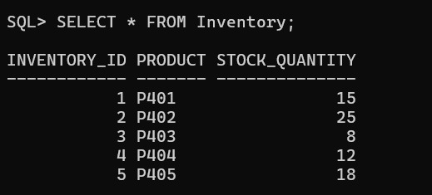

12. Report 1 – Seller-wise Product Report
This report displays the seller name, number of products supplied, and available stock. Joins are used to obtain information from Seller, Product, and Inventory.
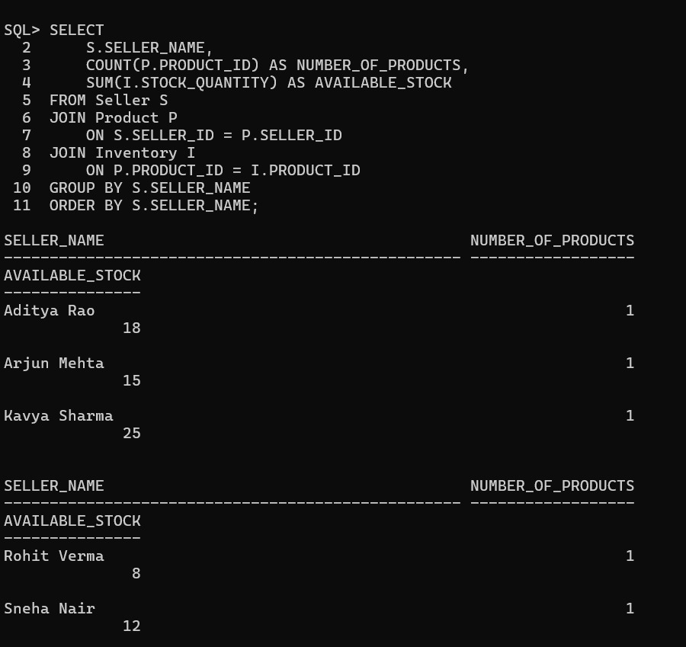

13. Report 2 – Stock Availability Report
This report displays the product name, stock quantity, and stock status. The CASE expression classifies products as Out of Stock, Low Stock, or Available.
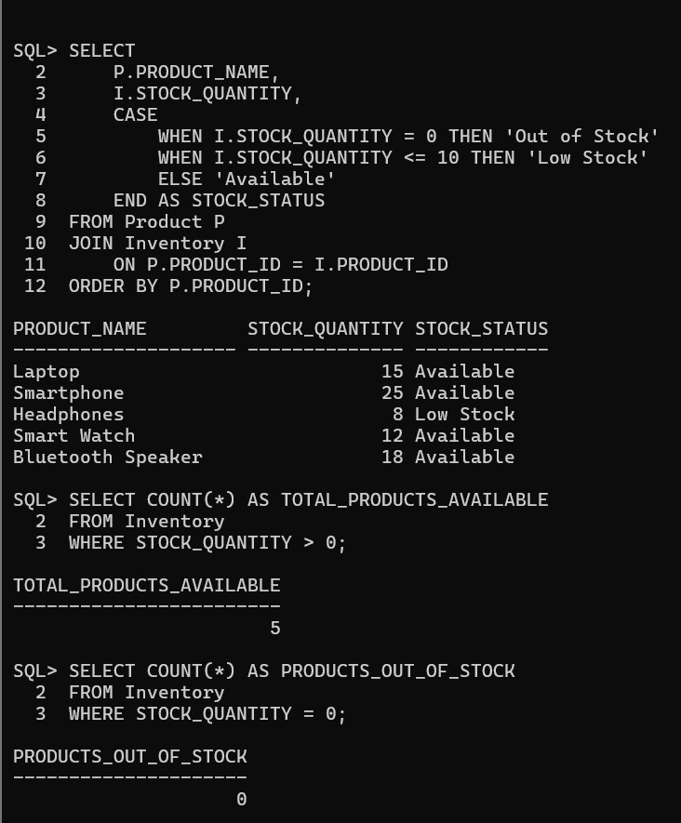

14. Report 3 – Inventory Analysis
The Inventory Analysis identifies the total products available, products out of stock, highest stocked product, and average inventory quantity.
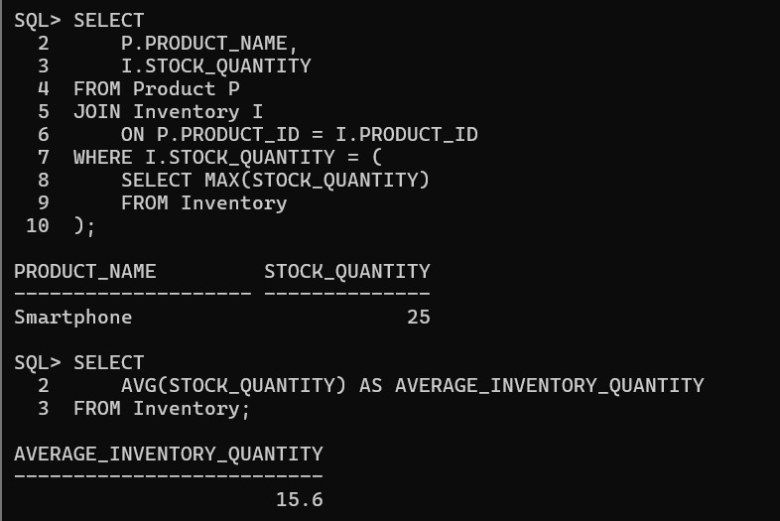

15. Final Report Results
Seller Name | Number of Products | Available Stock
Aditya Rao | 1 | 18
Arjun Mehta | 1 | 15
Kavya Sharma | 1 | 25
Rohit Verma | 1 | 8
Sneha Nair | 1 | 12

Product Name | Stock Quantity | Stock Status
Laptop | 15 | Available
Smartphone | 25 | Available
Headphones | 8 | Low Stock
Smart Watch | 12 | Available
Bluetooth Speaker | 18 | Available

Inventory Analysis | Result
Total Products Available | 5
Products Out of Stock | 0
Highest Stocked Product | Smartphone – 25
Average Inventory Quantity | 15.6

16. Conclusion:
The Seller and Inventory Management System was successfully implemented using Oracle SQL*Plus. The project manages seller information, product details, and inventory quantities. Primary keys, foreign keys, UNIQUE, NOT NULL, and CHECK constraints were applied. The required seller-wise, stock availability, and inventory analysis reports were executed successfully, and the SQL*Plus runtime screenshots are included as evidence of the implementation.

