Week 4: Customer Order Management and Order History
System

Scenario:
The phone case business allows customers to place orders for different phone case products. The system stores overall order information, including the customer, order date, total amount, and order status. It also maintains individual product details for every order, such as product ID, quantity, and price. The system is used to manage customer orders and generate useful order history and purchase analysis reports.

1. Create Orders and Order_Details Tables
Orders:
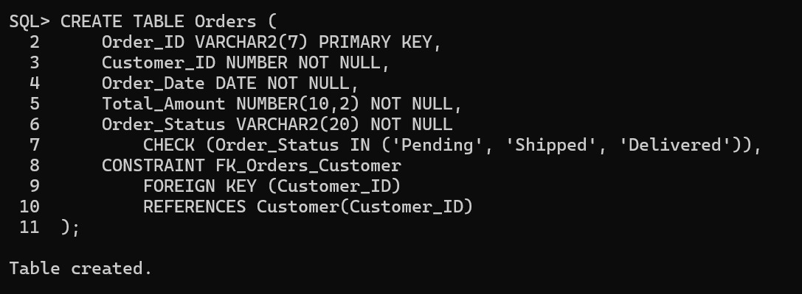
Order_Details:
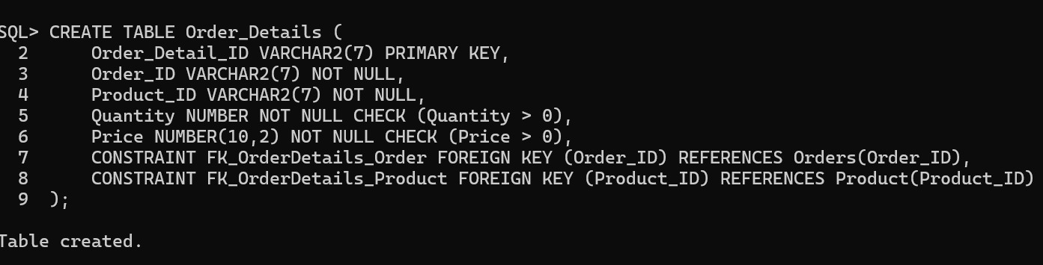

2. Inserting values:
Orders:
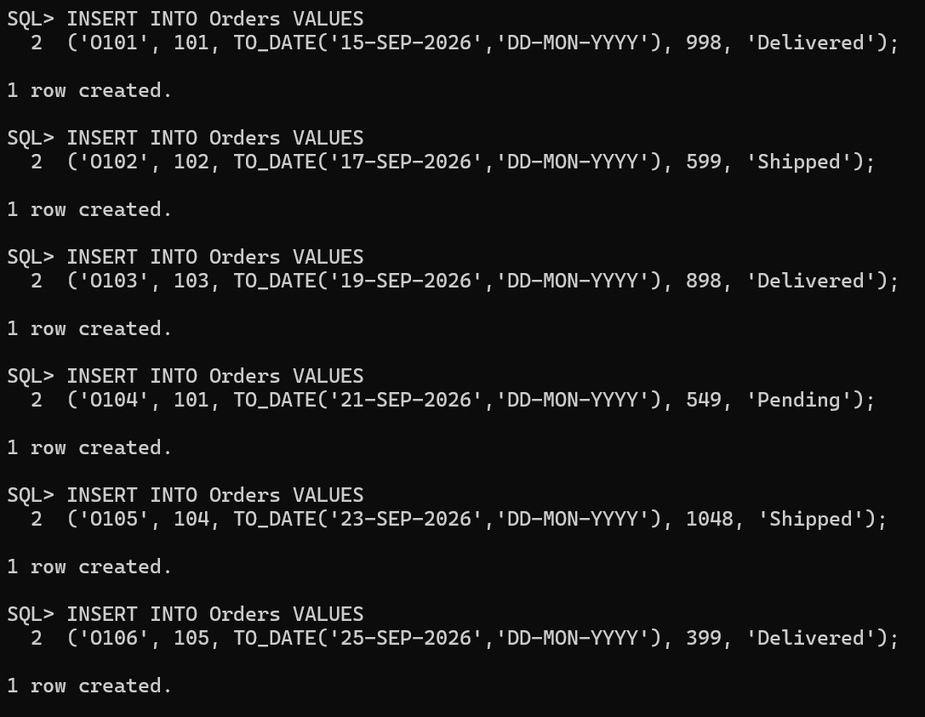
Order_Details:
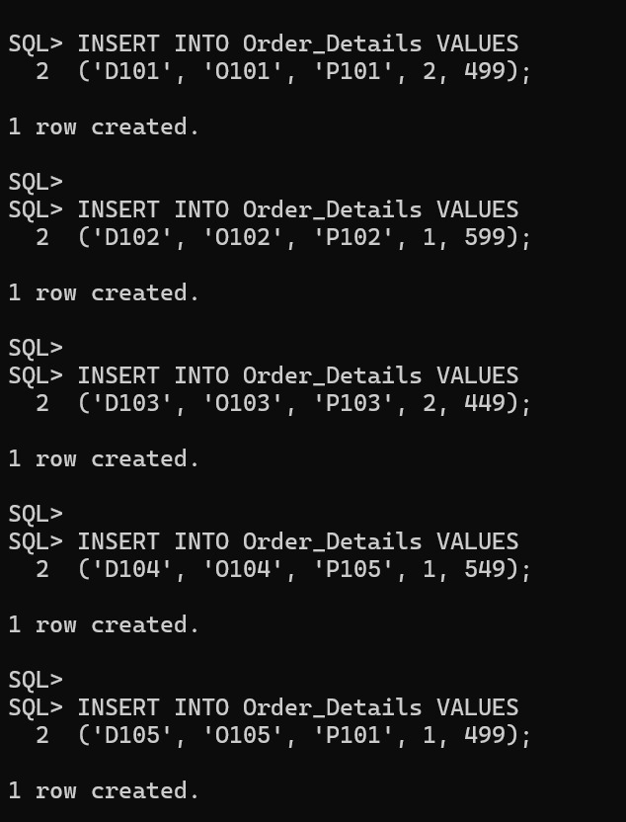

3. Viewing Table structure:
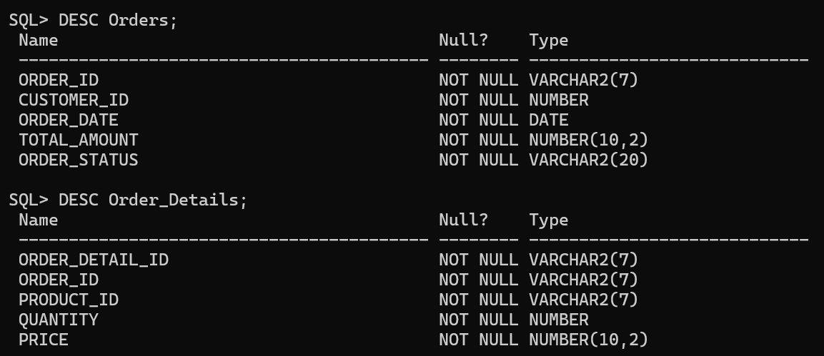

4. Viewing Values in Table:
Orders:
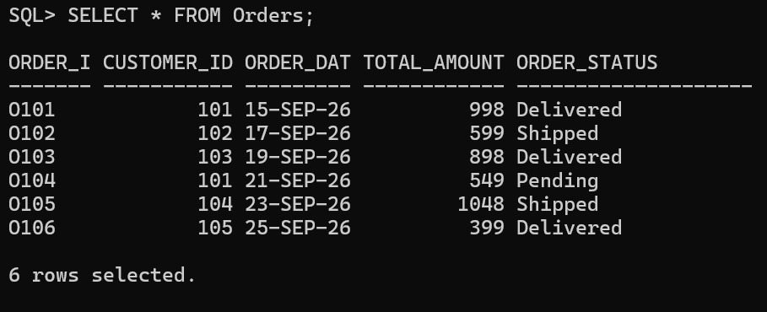
Order_Details:
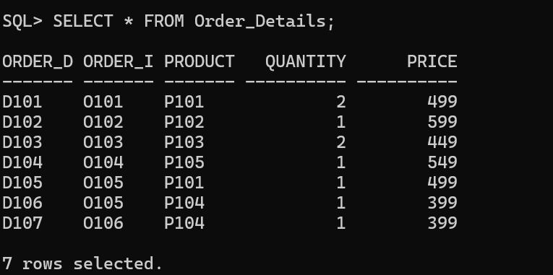

5. Establish Relationships
Customer and Orders
• One customer can place multiple orders.
• Each order belongs to one customer.
Relationship:
Customer (1) → Orders (Many)
The Customer_ID in the Orders table is used as a foreign key referencing the Customer table.
Orders and Products
• One order can contain multiple products.
• One product can appear in multiple orders.
This creates a many-to-many relationship between Orders and Products.
Relationship:
Orders (Many) ↔ Products (Many)
This relationship is implemented using the Order_Details table.

6. Apply Constraints:
Applied Primary key, Foreign key, NOT NULL, check while creating table itself.
Primary Key
• Customer_ID is the primary key in the Customer table.
• Order_ID is the primary key in the Orders table.
• Order_Detail_ID is the primary key in the Order_Details table.
• Product_ID is the primary key in the Product table.
Foreign Key
• Orders.Customer_ID references Customer.Customer_ID.
• Order_Details.Order_ID references Orders.Order_ID.
• Order_Details.Product_ID references Product.Product_ID.
NOT NULL
Important attributes such as customer ID, order date, total amount, order status, quantity, and price are defined as NOT NULL so that essential information cannot be left empty.
CHECK Constraint
The order status is restricted to valid values:
• Pending
• Shipped
• Delivered
The quantity and price are also checked to ensure that they are greater than zero.

7. Update and Delete Records:
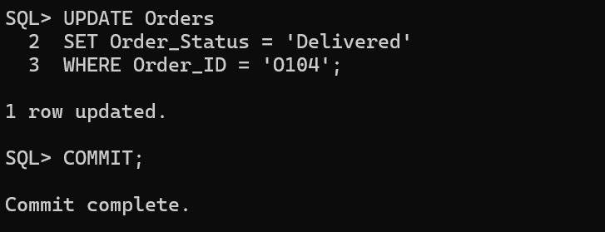

8. Report 1: Customer Order History
Displays:
• Customer Name
• Order ID
• Order Date
• Total Amount
• Order Status
QUERY: SELECT Customer.Customer_Name, Orders.Order_ID, Orders.Order_Date, Orders.Total_Amount, Orders.Order_Status
FROM Customer
JOIN Orders
ON Customer.Customer_ID = Orders.Customer_ID;
This report combines customer and order information to display the complete order history of customers.
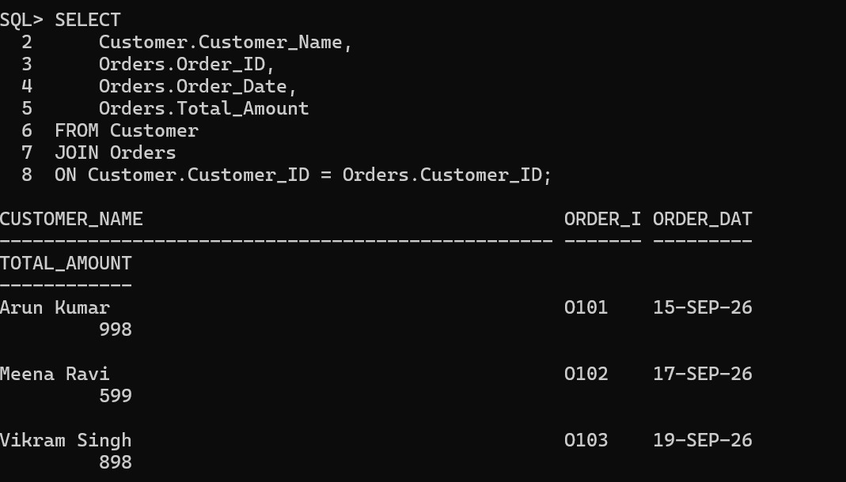

9. Report 2: Product-wise Order Report
Finds:
Number of times each product was ordered.
Total quantity of each product sold.
QUERY: SELECT Product.Product_ID, Product.Product_Name,
COUNT(Order_Details.Order_ID) AS Times_Ordered,
SUM(Order_Details.Quantity) AS Total_Quantity_Sold
FROM Product
JOIN Order_Details
ON Product.Product_ID = Order_Details.Product_ID
GROUP BY Product.Product_ID, Product.Product_Name;
This report helps identify how frequently each product is ordered and the total number of units sold.

10. Report 3: Customer Purchase Analysis
❖ Customers with Maximum Orders:
QUERY: SELECT Customer.Customer_ID, Customer.Customer_Name,
COUNT(Orders.Order_ID) AS Total_Orders
FROM Customer
JOIN Orders
ON Customer.Customer_ID = Orders.Customer_ID
GROUP BY Customer.Customer_ID, Customer.Customer_Name
ORDER BY Total_Orders DESC;
This report calculates the number of orders placed by each customer.
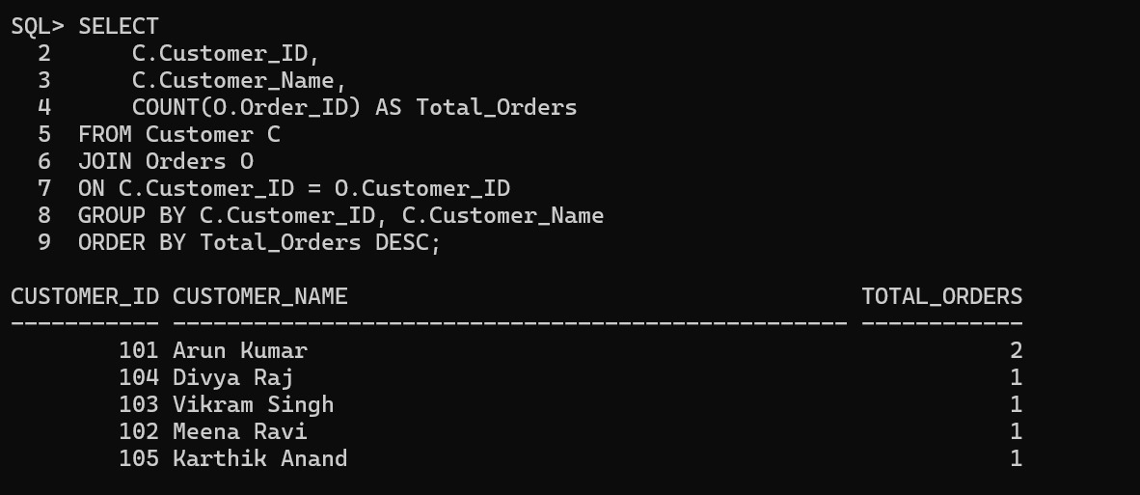
❖ Total Spending by Each Customer:
QUERY: SELECT Customer.Customer_ID, Customer.Customer_Name, SUM(Orders.Total_Amount) AS Total_Spending
FROM Customer
JOIN Orders
ON Customer.Customer_ID = Orders.Customer_ID
GROUP BY Customer.Customer_ID, Customer.Customer_Name;
This report calculates the total amount spent by each customer.
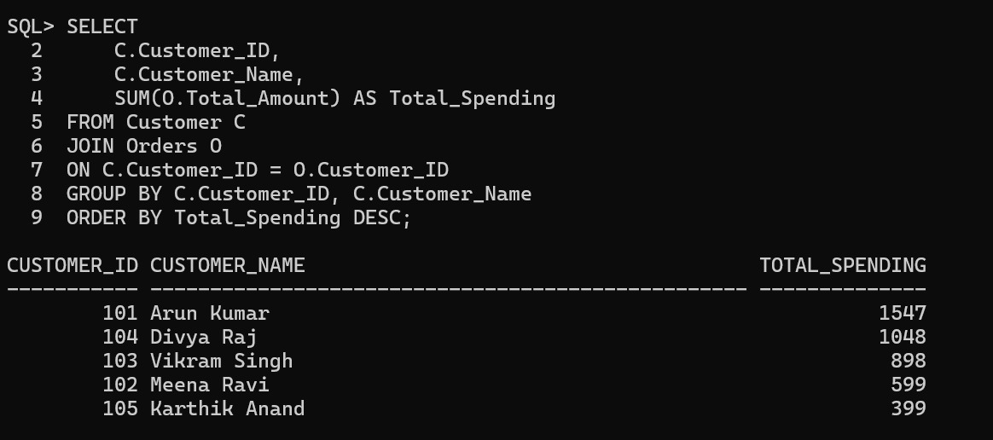
❖ Average Order Value:
QUERY: SELECT Customer.Customer_ID, Customer.Customer_Name,
AVG(Orders.Total_Amount) AS Average_Order_Value
FROM Customer
JOIN Orders
ON Customer.Customer_ID = Orders.Customer_ID
GROUP BY Customer.Customer_ID, Customer.Customer_Name;
This report calculates the average value of orders placed by each customer.
