AI BlogNest
Generate High-Quality Blog Content Using AI

Description:
AI BlogNest is a secure AI-powered blogging and content management backend application designed to help users create, manage, improve, and summarize blog content with the support of Artificial Intelligence.
The application is developed using Node.js and Express.js for backend API development, MongoDB with Mongoose for data storage, JWT-based authentication for secure access, and Google Gemini AI for intelligent content-generation features.
The system provides APIs for user registration, login, authentication, blog post management, comments, likes, saved posts, feed access, role-based authorization, and AI-assisted content operations.
The AI module provides the following capabilities:
- Generate blog ideas based on a given topic.
- Improve existing blog content.
- Summarize blog content.
- Provide an AI chatbot for blogging and platform-related assistance.
The application also includes backend security and validation mechanisms such as:
- JWT authentication.
- Role-based authorization.
- Password hashing using bcrypt.
- Request validation using Express Validator.
- Security headers using Helmet.
- CORS configuration.
- API rate limiting.
- Request logging using Morgan.
- Centralized error handling.
- Environment-based configuration using dotenv.
The backend follows a modular structure using routes, controllers, models, middleware, services, and database configuration. This makes the system easier to maintain, test, and extend.

Scenario-Based Case Study:

Background:
Blogging has become an important method for sharing information, knowledge, ideas, and technical content. However, creating high-quality content requires time and effort. Writers need to generate suitable topics, organize information, improve readability, and prepare concise summaries.
AI BlogNest is developed to provide backend services that combine traditional blog management with AI-assisted content operations.

Problem:
Blog writers may face several challenges while creating content:
- Difficulty in generating new blog topics.
- Time required to improve written content.
- Difficulty in creating concise summaries.
- Managing blog posts manually.
- Maintaining secure user authentication.
- Controlling access to different operations based on user roles.
A backend system is therefore required to manage users and blog posts while also providing AI-powered writing assistance.

Solution:
AI BlogNest provides a centralized backend API that manages authentication, users, blog posts, and AI services.
The system uses:
- **Express.js** to create REST APIs.
- **MongoDB and Mongoose** to store application data.
- **JWT** for authentication.
- **bcryptjs** for password hashing.
- **Express Validator** for request validation.
- **Google Gemini AI** for AI-assisted content operations.
The architecture separates routing, controllers, models, middleware, and services so that each part of the application has a specific responsibility.

Usage:
The application can be used by registering a user account and logging into the platform. After authentication, authorized users can create and manage posts and use AI features.
The major workflow is:
User Registration
↓
User Login
↓
JWT Token Generation
↓
Authentication
↓
Role Authorization
↓
Blog Management / AI Services
↓
JSON Response

Outcome:
The developed backend provides a structured API-based environment for managing blog content and using AI-assisted writing operations.
The system successfully supports user authentication, blog post operations, database connectivity, role-based access control, and AI-powered operations such as idea generation and content summarization.

1. Software Requirements:
The following software requirements are used for developing and testing the AI BlogNest backend.
Software | Requirement
Operating System | Windows 10/11, macOS, or Linux
Node.js | Node.js v16+
Package Manager | npm v8+
Backend Framework | Express.js
Database | MongoDB
ODM | Mongoose
API Testing | Thunder Client
Code Editor | Visual Studio Code

Node.js
Node.js is used as the runtime environment for executing the backend JavaScript application.

Express.js
Express.js is used to create the REST API endpoints and handle HTTP requests and responses.

MongoDB
MongoDB is used as the database for storing user and blog-related information.

Mongoose
Mongoose provides schema definitions and database interaction between the Node.js application and MongoDB.

Thunder Client
Thunder Client is used inside Visual Studio Code to test the backend APIs.

Visual Studio Code
Visual Studio Code is used as the development environment for writing, organizing, and executing the project.

2. Hardware Requirements:
The minimum hardware requirements for developing and running the project are:
Hardware | Requirement
Processor | Intel Core i5 8th Gen or AMD Ryzen 5 equivalent
RAM | 8 GB minimum, 16 GB recommended
Storage | Approximately 1 GB available space
Network | Internet connection for AI API communication
The system should provide sufficient resources to run Node.js, MongoDB, Visual Studio Code, and Thunder Client simultaneously.

EPIC:-1 PROJECT ARCHITECTURE:

Architecture:
AI BlogNest follows a modular backend architecture. The client or API testing tool sends HTTP requests to the Express server. The request is processed through routes, middleware, controllers, database models, and AI services.
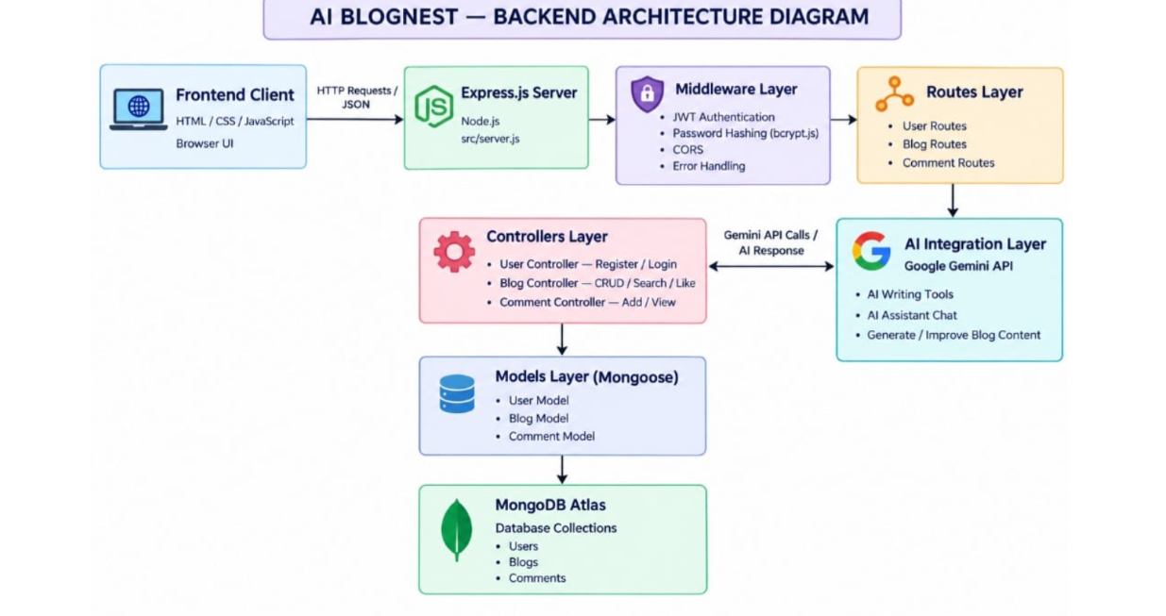
The architecture separates different responsibilities of the application and provides a structured approach to backend development.

Components Definition:

1. Client / API Testing Layer
Thunder Client is used to send HTTP requests to the backend. It allows the developer to test registration, login, post management, and AI endpoints.

2. Express Server
The Express server receives incoming HTTP requests and sends appropriate responses.
The main server is configured in:
src/server.js

3. Routes
Routes define the API endpoints available in the application.
Major route groups include:
/api/auth
/api/posts
/api/users
/api/ai

4. Middleware
Middleware handles common processing tasks such as:
- Authentication.
- Authorization.
- Request validation.
- Security.
- Error handling.

5. Controllers
Controllers contain the application logic for processing requests and generating responses.

6. Models
Mongoose models define the structure of documents stored in MongoDB.

7. AI Service
The Gemini service communicates with the Google Gemini API and provides AI-powered operations.

Entity-Relationship (ER) Diagram Description:
The main data entity demonstrated in the backend is the User entity. Blog posts and related operations are associated with authenticated users.
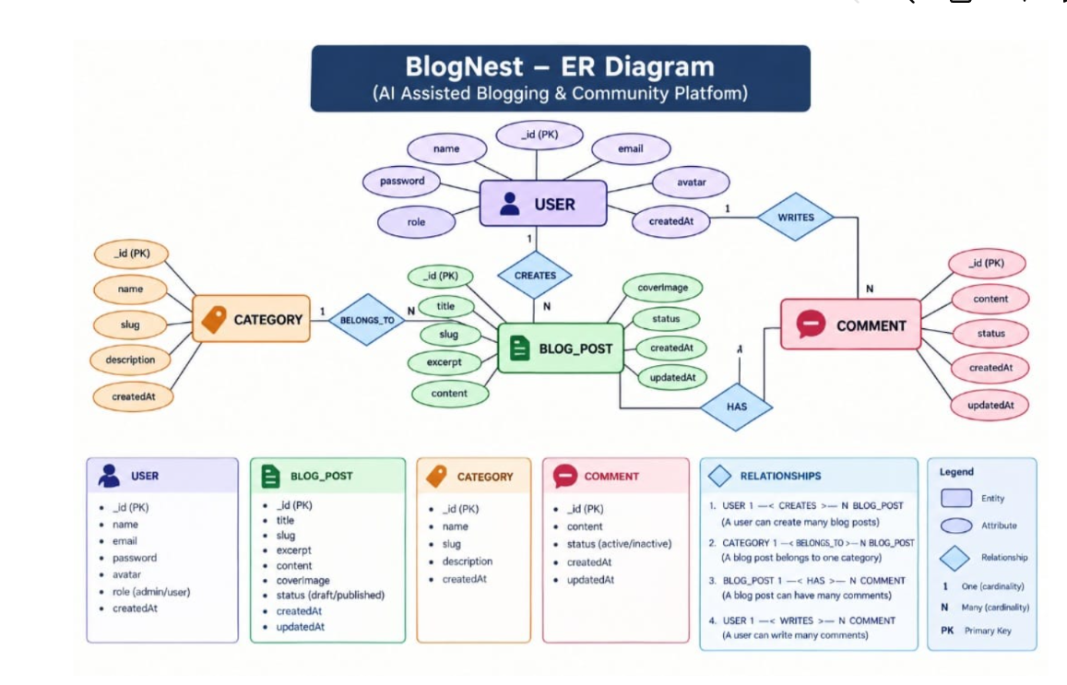

User Entity:
The User entity represents users registered in the application.
Important fields include:
- _id
- name
- email
- password
- role
- bio
- avatarUrl
- followers
- following
- isActive
- createdAt
- updatedAt
The password is not directly exposed when retrieving normal user information. Passwords are securely hashed before being stored.
The available user roles are:
admin
editor
author
reader
The default role for a newly registered user is:
reader

Post Entity:
The Post entity represents blog content managed through the post APIs.
Authenticated and authorized users can create posts, update posts, delete posts, like posts, save posts, add comments, and perform other available post operations according to their permissions.

Key Structural Mappings:
The application uses relationships between users and other resources through MongoDB ObjectId references.
The User model contains:
followers → User references
following → User references
The authentication system associates an authenticated request with the corresponding user account.

Key Features:
The major features of AI BlogNest include:

User Authentication
Users can register and log in securely using email and password.

JWT Authentication
After successful authentication, the backend generates a JWT token that is used to access protected APIs.

Role-Based Authorization
Different operations are controlled based on the user's role.

Blog Post Management
Authorized users can create, retrieve, update, and delete blog posts.

AI Blog Ideas
Users with appropriate permissions can provide a topic and receive AI-generated blog ideas.

AI Content Improvement
Existing blog content can be submitted to the AI service for grammar, clarity, readability, accessibility, and structural improvement.

AI Summarization
Blog content can be summarized using the Gemini AI service.

AI Chatbot
The system provides an AI assistant that can help with blogging, writing, accessibility, technology, knowledge sharing, and platform usage.

Comments
Authenticated users can add comments to posts.

Likes and Saved Posts
Authenticated users can like and save posts.

Feed
Authenticated users can access the feed endpoint.

Security
The application uses Helmet, CORS, rate limiting, authentication, validation, and centralized error handling.

Roles and Responsibilities:
The application contains four defined roles:
Role | Responsibility
Admin | Administrative operations and authorized post management
Editor | Content management and authorized post management
Author | Create and manage permitted blog content
Reader | Read and access permitted user-level functionality
Role-based authorization is implemented using middleware.
For example, creating a post is allowed for:
admin
editor
author
Administrative post management operations are restricted to:
admin
editor

User Flow:
The overall user flow of the application is:
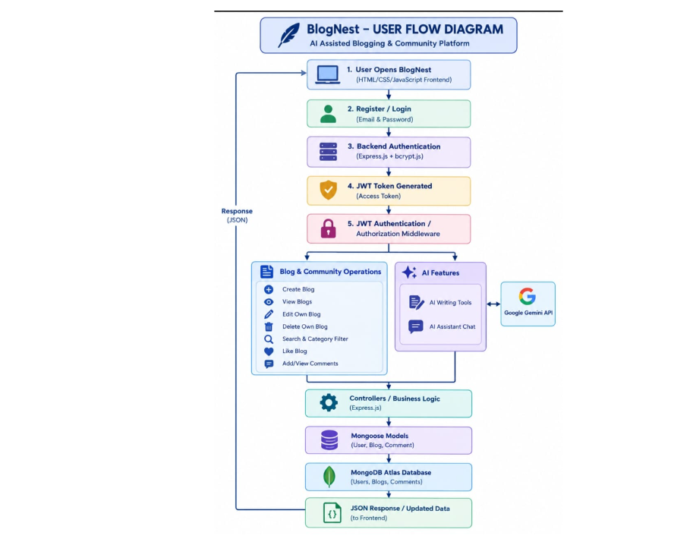

The authentication middleware verifies the JWT token before allowing access to protected resources.

MVC Architecture Pattern:
AI BlogNest follows an MVC-oriented backend structure that separates data models, application logic, and API routing.
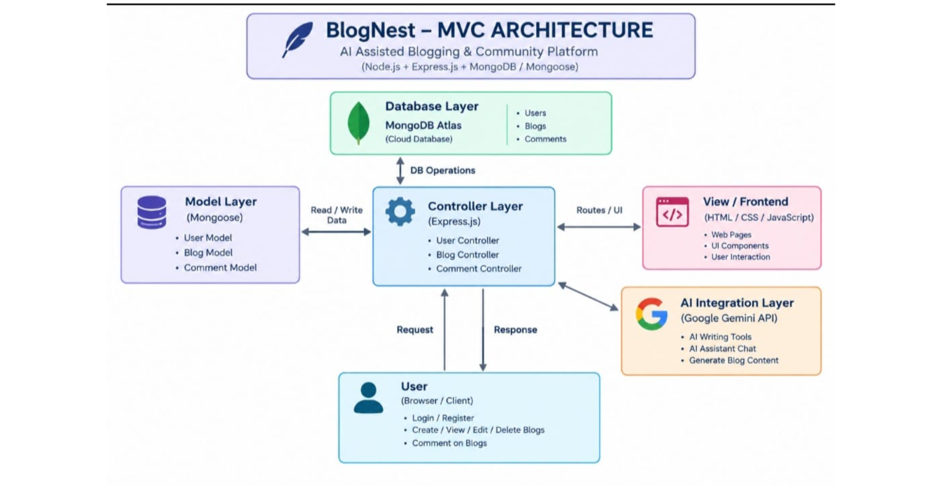

Model Layer (Data Blueprint):
The Model layer defines the structure of application data using Mongoose.
For example, the User model defines:
- Name.
- Email.
- Password.
- Role.
- Bio.
- Avatar URL.
- Followers.
- Following.
- Account status.
Mongoose handles communication between the application and MongoDB.

Controller Layer (Execution Matrix):
Controllers process incoming requests and execute the required application logic.
Examples include:
- Register user.
- Login user.
- Retrieve current user.
- Create post.
- Retrieve posts.
- Generate AI ideas.
- Improve content.
- Summarize content.
- Chat with the AI assistant.

View Layer (Routing Network Interface):

In this backend API architecture, the API response acts as the interface consumed by the client.
Responses are generally returned in JSON format.
For example:
{
"message": "Login successful",
"token": "JWT_TOKEN",
"user": {}
}

Epic2: Project Setup and Configuration:

Creating project folder:

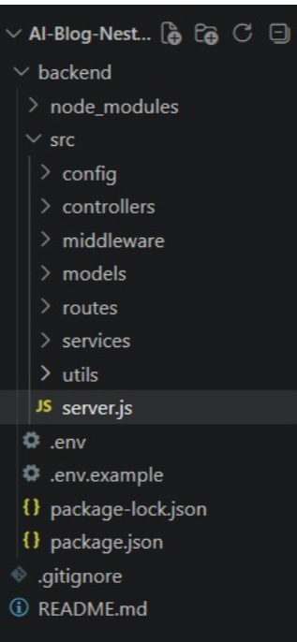
The project is organized as a backend application with source code separated into different modules.
A simplified structure is:
AI BlogNest
│
├── backend
│ ├── src
│ │ ├── config
│ │ ├── controllers
│ │ ├── middleware
│ │ ├── models
│ │ ├── routes
│ │ ├── services
│ │ ├── utils
│ │ └── server.js
│ │
│ ├── package.json
│ └── .env

Server setup (npm init):
The backend project is initialized using npm.
npm init
Required dependencies are installed through npm.
The project uses packages including:
express
mongoose
jsonwebtoken
bcryptjs
dotenv
cors
helmet
express-rate-limit
express-validator
morgan
@google/genai
slugify
Nodemon is used as a development dependency.

Create files: server.js:
The main backend entry point is:
src/server.js
The server loads environment variables, initializes Express, configures middleware, connects to MongoDB, registers API routes, and starts the HTTP server.

Create folders: models, controllers, routes:
The application separates responsibilities using dedicated folders.

Models
Stores Mongoose schemas and models.

Controllers
Contains request-processing and business logic.

Routes
Defines API endpoints and connects them to controllers.

Middleware
Contains authentication, validation, and error-handling middleware.

Services
Contains external service integrations such as Google Gemini AI.

Config
Contains configuration logic such as MongoDB connection.

Epic 3: Backend Development:

Server.js:

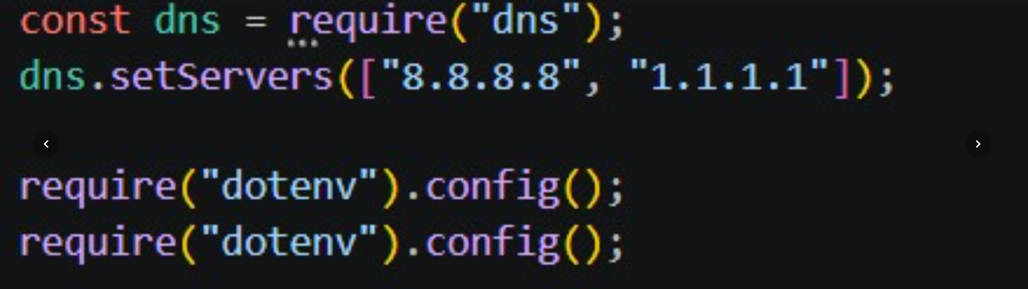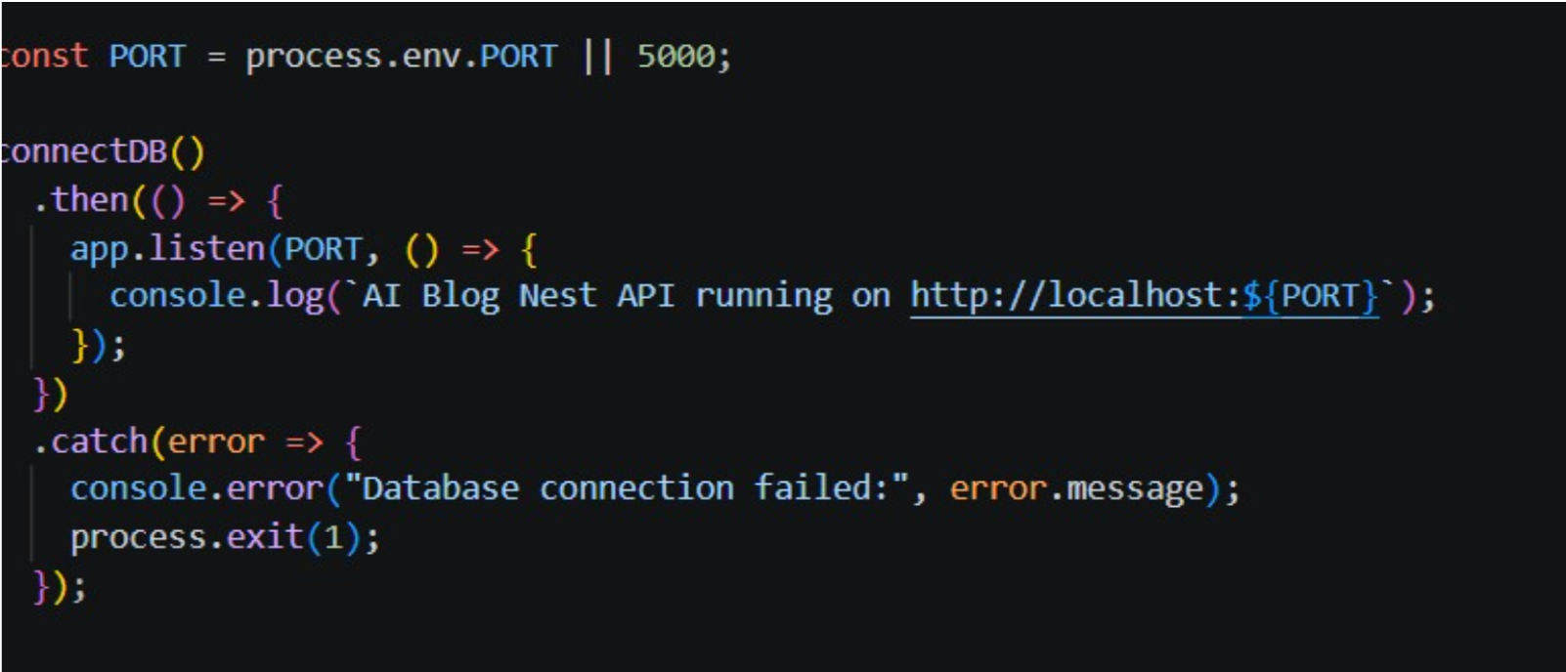
The server.js file is the main entry point of the application.
The server performs the following tasks:
- Loads environment variables.
- Imports Express and required middleware.
- Creates the Express application.
- Configures Helmet.
- Configures CORS.
- Enables JSON request parsing.
- Enables URL-encoded request parsing.
- Enables Morgan request logging.
- Configures rate limiting.
- Provides a health-check endpoint.
- Registers application routes.
- Registers error handling middleware.
- Connects to MongoDB.
- Starts the server.
The health endpoint is:
GET /api/health
A successful response contains the application status and current server time.

App.js:

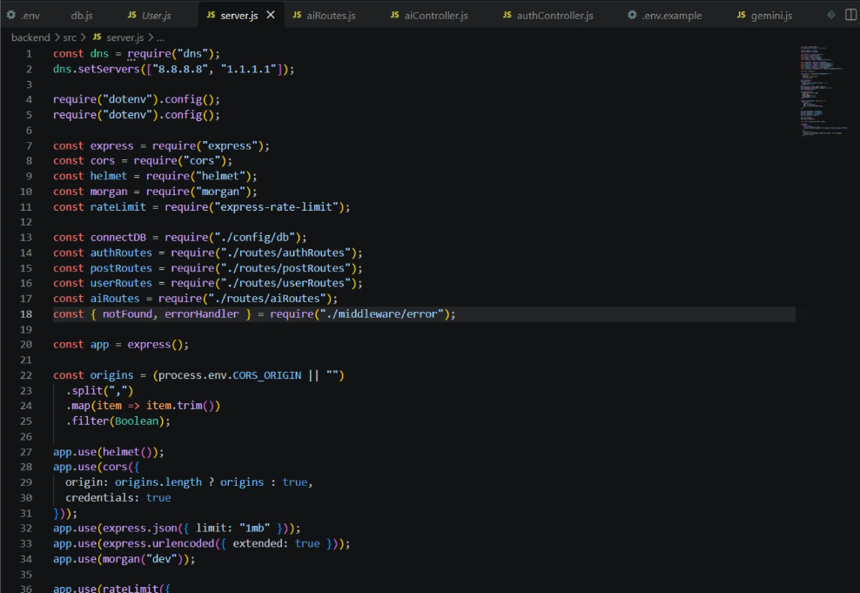

The application architecture centralizes the Express application configuration in the backend server structure. The request-processing pipeline consists of Express middleware, route handlers, controllers, services, and database operations.
The backend uses middleware to provide:
- Security.
- Authentication.
- Authorization.
- Validation.
- Error handling.
- Request logging.
- Rate limiting.

Epic4: Database Configuration:

DB Connection:

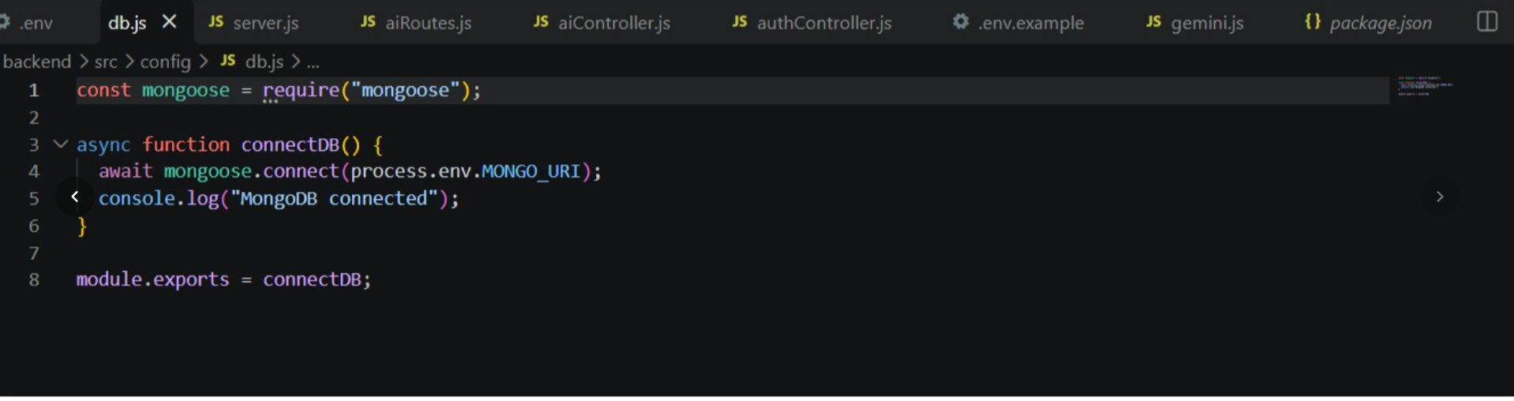

The application connects to MongoDB before starting the HTTP server.
The connection process ensures that the database is available before the application begins accepting requests.
Successful startup output is:
MongoDB connected
AI Blog Nest API running on http://localhost:5000

Configure MongoDB:
MongoDB is used as the database management system.
The database connection string is stored in an environment variable:
MONGO_URI=your_mongodb_connection_string
Sensitive database credentials are not stored directly inside the source code.

Mongoose
Mongoose is used as the Object Data Modeling library for MongoDB.
It provides:
- Schema definitions.
- Model creation.
- Validation.
- Database operations.
- ObjectId references.
- Middleware such as password hashing hooks.

Create Schemas & Models:
The application uses Mongoose schemas to define the structure of database documents.
Schemas provide a consistent structure for stored application data.

Create Database connection:
The MongoDB connection is configured separately from the main server logic.
The server waits for the database connection to complete successfully before starting the application.
Application Start
↓
Load Environment Variables
↓
Connect to MongoDB
↓
Connection Successful
↓
Start Express Server
If the database connection fails, the application reports the failure and stops instead of running without the required database connection.

Mongoose Schema Definitions:
Mongoose schema definitions describe the fields and rules associated with application entities.
The schema can also define:
- Required fields.
- Default values.
- String length restrictions.
- Enumerated values.
- References.
- Timestamps.
- Password processing methods.

Identity Resource Document Schema (schemas/userModel.js):

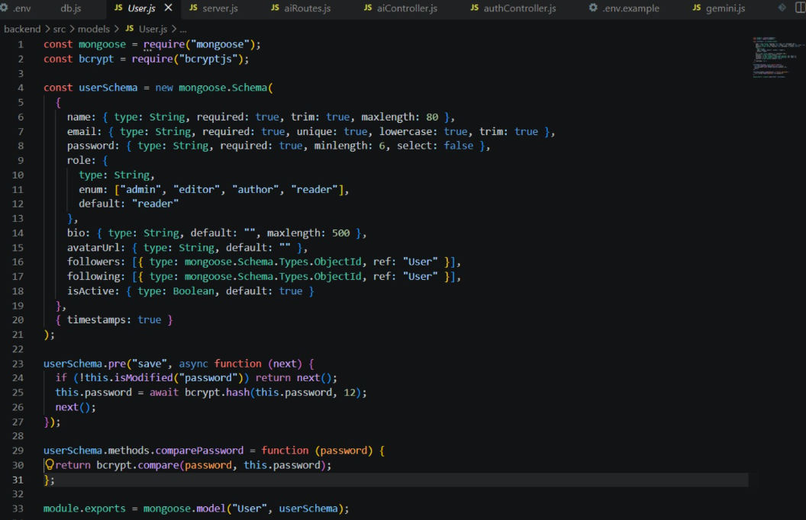
The User schema represents the identity and account information of users.
Important fields include:
name
email
password
role
bio
avatarUrl
followers
following
isActive
createdAt
updatedAt

Name
The name is required and is limited to 80 characters.

Email
The email is required, unique, converted to lowercase, and trimmed.

Password
The password is required and has a minimum length of six characters.
The password field is configured with:
select: false
Passwords are hashed using bcrypt before being saved.

Role
The role determines the permissions available to the user.
Available roles are:
admin
editor
author
reader
The default role is:
reader

Bio
The bio field stores optional user information and has a maximum length of 500 characters.

Avatar URL
The avatar URL stores the user's profile image reference.

Followers and Following
The followers and following fields contain references to other User documents.

Account Status
The isActive field determines whether the user account is active.

Epic 5: Project Executions:

Install Postman or ThunderClient:
Thunder Client is used for API testing within Visual Studio Code.
It allows the developer to send HTTP requests and inspect JSON responses without requiring a separate frontend application.

Start backend server: npm start:
The backend is started using:
npm start
The application successfully starts with:
MongoDB connected
AI Blog Nest API running on http://localhost:5000
The default port is:
5000

API Testing:
The API testing workflow is performed using Thunder Client.
The main testing sequence is:
Register
↓
Login
↓
Create Post
↓
Get Posts
↓
AI Ideas
↓
AI Summarize
↓
Authentication Test

User Registration:

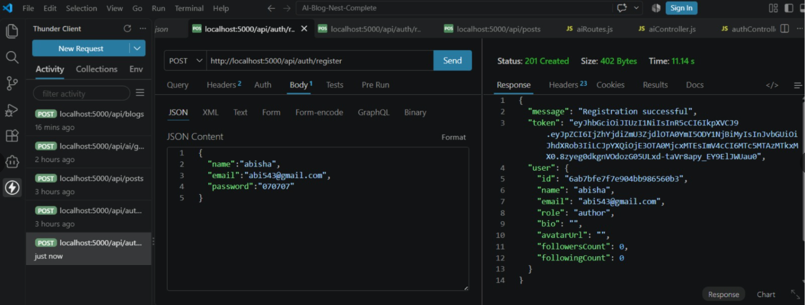

The registration API creates a new user account.

Endpoint
POST /api/auth/register

Request
{
"name": "User Name",
"email": "user@example.com",
"password": "password123"
}

Processing
The backend:
- Receives the registration request.
- Checks whether the email is already registered.
- Creates the user.
- Hashes the password using bcrypt.
- Assigns the default role as reader.
- Generates a JWT token.
- Returns the user information and token.

Expected Result
Registration successful
[Insert actual Thunder Client Registration Screenshot Here]

User Login:

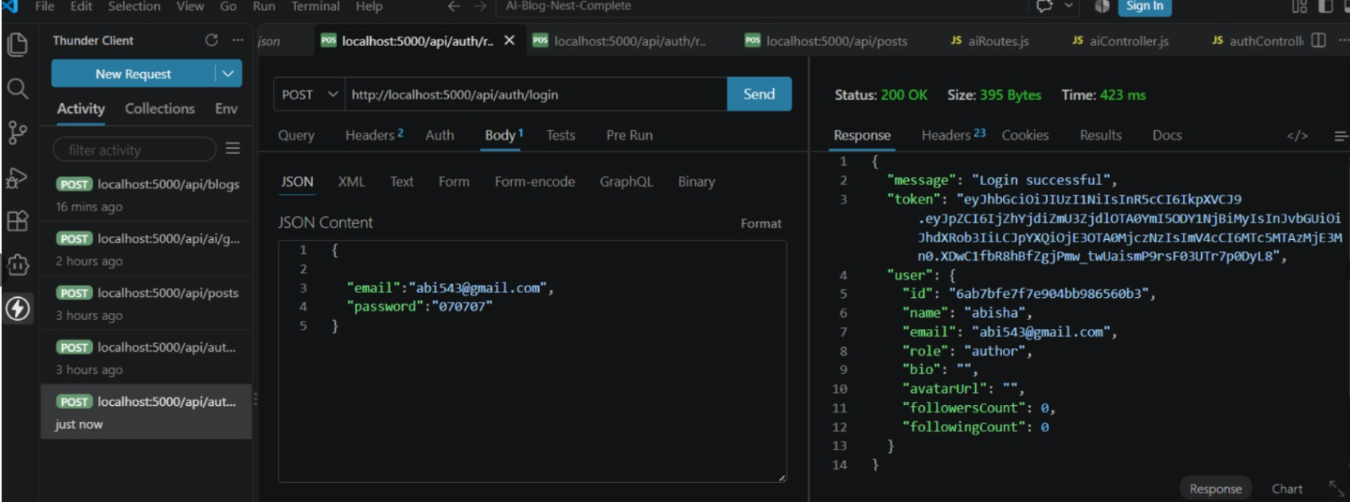
The login API authenticates an existing user.

Endpoint
POST /api/auth/login

Request
{
"email": "user@example.com",
"password": "password123"
}

Processing
The backend:
- Finds the user using the email.
- Checks whether the account is active.
- Compares the password using bcrypt.
- Generates a JWT token.
- Returns the authenticated user information.

Expected Result
Login successful
The returned JWT token is used as a Bearer token for protected API requests.
[Insert actual Thunder Client Login Screenshot Here]

Create Blogs:

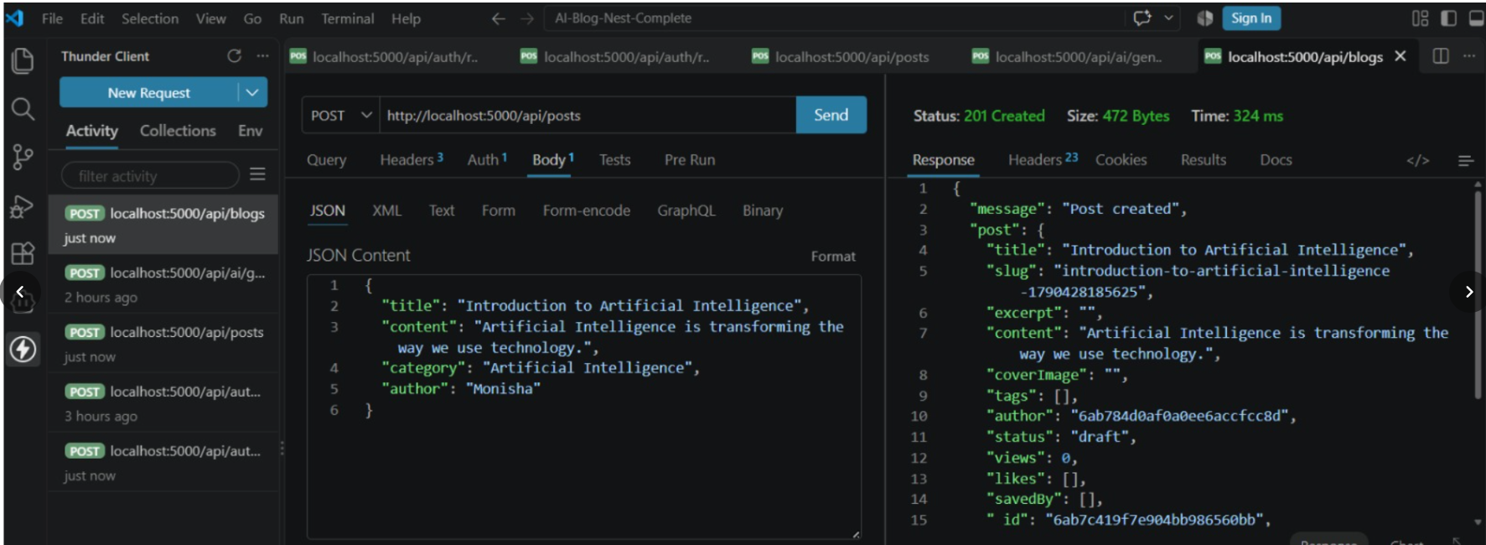
Authorized users can create blog posts using the posts API.

Endpoint
POST /api/posts

Authentication
The request requires a valid JWT Bearer token.

Authorization
The following roles are permitted:
admin
editor
author

Request Example
{
"title": "Introduction to React.js",
"content": "React.js is a JavaScript library used for building user interfaces."
}
The request is validated before the controller processes it.
The title must contain between 3 and 180 characters, and the content must contain at least 10 characters.
[Insert actual Thunder Client Create Post Screenshot Here]

Fetch Blogs:

The available blog posts can be retrieved using an HTTP GET request.

Endpoint
GET /api/posts
The backend retrieves the available posts from MongoDB and returns them as a JSON response.
This confirms that posts stored in the database can be successfully fetched through the API.

Testing Explanation
Now I am fetching the posts using an HTTP GET request in Thunder Client. I am using the /api/posts endpoint and sending the request to the backend. The backend retrieves the available posts from MongoDB and returns them as a JSON response. This confirms that the posts stored in the database can be successfully fetched.
[Insert actual Thunder Client GET Posts Screenshot Here]

Generate AI blogs:

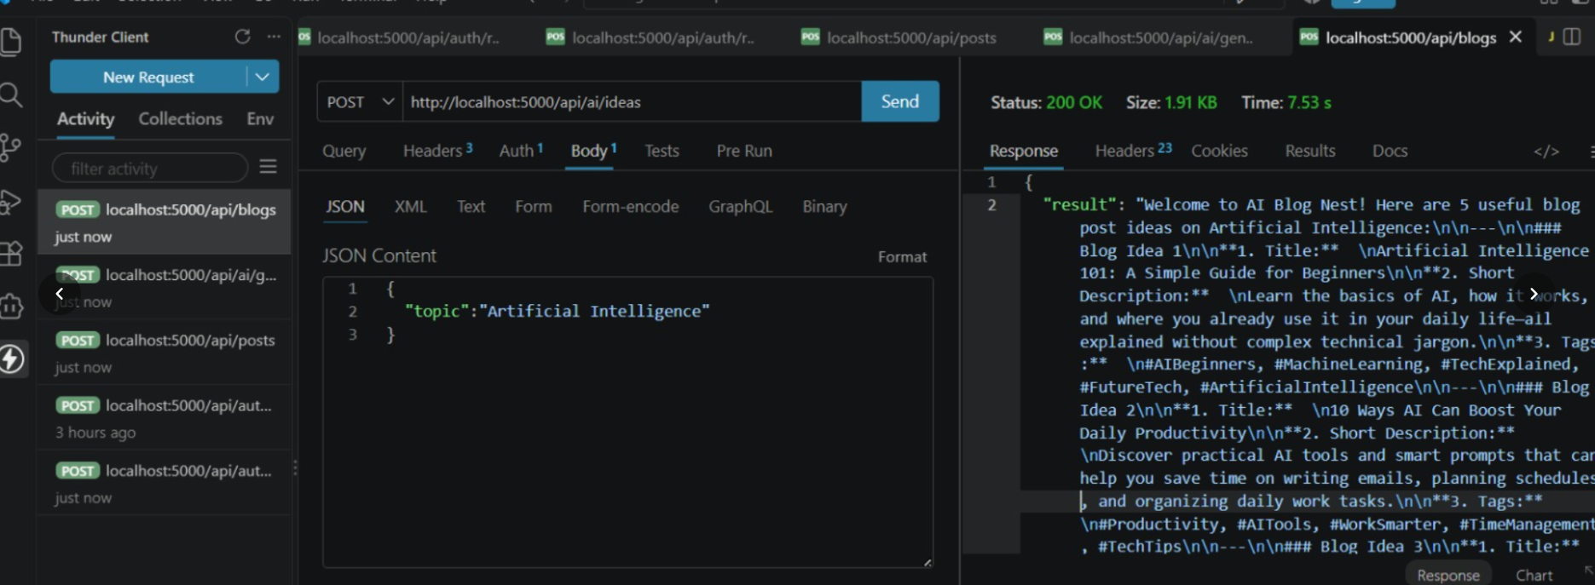

AI BlogNest uses Google Gemini AI to provide AI-assisted blog content operations.

Endpoint
POST /api/ai/ideas

Authentication
A valid Bearer token is required.

Authorization
The endpoint is available to:
admin
editor
author

Request
{
"topic": "React.js"
}

Processing
The backend receives the topic and sends a structured prompt to the Gemini AI service.
The AI service generates five useful blog ideas.
For each idea, the system requests:
- Title.
- Short description.
- Five tags.

Example Testing Flow
Thunder Client
↓
POST /api/ai/ideas
↓
Bearer Token
↓
Topic: React.js
↓
AI Controller
↓
Gemini Service
↓
Generated Blog Ideas
↓
JSON Response
[Insert actual Thunder Client AI Ideas Screenshot Here]

Summarize Blogs:

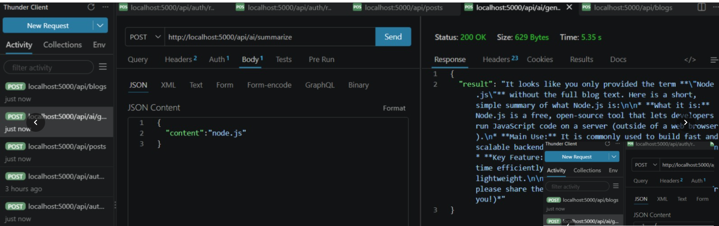
The application provides an AI-powered blog summarization feature.

Endpoint
POST /api/ai/summarize

Authentication
A valid Bearer token is required.

Authorization
The endpoint is available to:
admin
editor
author

Request
{
"content": "Your blog content goes here."
}

Processing
The backend receives the blog content and sends it to the Gemini service.
The AI service is instructed to:
- Keep the main points.
- Preserve important information.
- Use simple and clear English.
- Keep the summary concise.
The generated summary is returned as a JSON response.

Testing Explanation
The AI summarize API is tested using Thunder Client. A valid Bearer token is included in the request, and the blog content is provided in the request body. The backend sends the content to the Gemini service, receives the generated summary, and returns the result to the client.
[Insert actual Thunder Client AI Summarize Screenshot Here]

Demo Video:
The project demonstration can be organized using the following sequence:
Project Introduction
↓
Server Startup
↓
MongoDB Connection
↓
User Registration
↓
User Login
↓
Create Blog
↓
Fetch Blogs
↓
Generate AI Ideas
↓
Summarize Blog
↓
Authentication Test
↓
Final Result
The demonstration should use the actual running project and actual API responses.
[Insert Demo Video Reference Here]

API Testing Video:
The API testing video can demonstrate the following operations using Thunder Client:

1. Register
POST /api/auth/register

2. Login
POST /api/auth/login

3. Create Post
POST /api/posts

4. Fetch Posts
GET /api/posts

5. Generate AI Ideas
POST /api/ai/ideas

6. Summarize Content
POST /api/ai/summarize

7. Authentication Test
A protected endpoint can be tested without a Bearer token.
Expected response:
{
"message": "Authentication required"
}
This confirms that protected APIs cannot be accessed without authentication.
[Insert API Testing Video Reference Here]

CodeDrive:
The complete project source code is maintained as the project CodeDrive/source-code reference.
The project contains the following major backend components:
src/
│
├── config/
├── controllers/
├── middleware/
├── models/
├── routes/
├── services/
├── utils/
└── server.js
The source code demonstrates the implementation of:
- Express server configuration.
- MongoDB connectivity.
- Mongoose models.
- JWT authentication.
- Role-based authorization.
- Password hashing.
- Request validation.
- Blog post APIs.
- AI service integration.
- Error handling.
- API security middleware.
[Insert CodeDrive / Source Code Reference Here]

Final Project Result:
AI BlogNest provides a backend platform for AI-assisted blogging and content management.
The project integrates:
Node.js
+
Express.js
+
MongoDB
+
Mongoose
+
JWT Authentication
+
Role-Based Authorization
+
Google Gemini AI
+
REST APIs
The completed backend supports user registration and login, secure authentication, role-based access control, blog post operations, comments, likes, saved posts, feed access, and AI-powered content operations.
The AI module provides:
- Blog idea generation.
- Content improvement.
- Blog summarization.
- AI chatbot assistance.
The project also implements backend security mechanisms including password hashing, JWT verification, request validation, Helmet security headers, CORS configuration, rate limiting, request logging, and centralized error handling.
Overall, the project demonstrates how a modern Node.js backend can integrate database management, authentication, REST API development, and generative AI services into a single blogging platform.
Demo video: https://drive.google.com/file/d/1A4D6017NdVpefYsXG3byHz4chYvC3AIz/view?usp=drivesdk
API Testing: https://drive.google.com/file/d/1ZjsmiStR_dyvMHMp_coChOtDkn0nuYFc/view?usp=drivesdk
Code Drive: https://drive.google.com/drive/folders/1k_df9T5sxJM5snPooewC2Gv5qgm4z3ta

