JOB APPLICATION TRACKER
Project README / Reference Document

Job Application Tracker
A web-based Job Application Tracker developed using Flask, SQLite, HTML5, CSS3, Bootstrap 5, and JavaScript. The application helps job seekers manage applications, follow-up dates, recruiter details, interview progress, and notes through a clear and professional dashboard.

Features
- Job application creation, editing, and deletion
- Company, role, location, salary, job URL, and recruiter details
- Application-stage tracking: Wishlist, Applied, Interviewing, Offer, and Rejected
- Dashboard statistics and recent application overview
- Upcoming follow-up list with overdue follow-up highlighting
- Search by company, role, or location• Status-based filtering
- CSV export for reporting and backup
- Responsive Bootstrap 5 interface
- SQLite database storage

Tech Stack
Layer | Technologies
Frontend | HTML5, CSS3, Bootstrap 5, JavaScript
Backend | Python, Flask
Database | SQLite

Project Structure
job-application-tracker/ |-- app.py
|-- requirements.txt
|-- README.md |-- job_tracker.db # created automatically on first run |-- static/
| `-- style.css `-- templates/
|-- base.html
|-- index.html
|-- applications.html
`-- application_form.html

Database Table
The system uses SQLite to store application data. The database and the applications table are created automatically when the application starts.
Field | Description
Application ID | Unique application identifier
Company | Employer name
Job Title | Role applied for
Location | Job location or work arrangement
Job URL | Original job-posting link
Salary | Salary or compensation details
Status | Wishlist, Applied, Interviewing, Offer, or Rejected
Application Date | Submission date
Follow-up Date | Date to contact the recruiter or check progress
Contact Name / Email | Recruiter or hiring-manager details
Notes | Interview notes and next actions
Created At | Record creation time

Application Workflow
- Open the dashboard.
- Select Add Application.
- Enter company and job-role details.
- Set application status and submission date.
- Add a follow-up date when required.
- Save the application.
- Use the Applications page to search, filter, edit, or delete records.
- Check the dashboard for upcoming follow-ups and stage statistics.
- Export a CSV backup when required.

User Interface
- Navigation bar
- Dashboard statistic cards
- Upcoming follow-up and recent-application sections
- Application form
- Search and status filters
- Status badges
- Responsive data table
- CSV export action

Installation
- Clone or download the project
git clone https://github.com/monishansammu-dotcom/job-application-tracker.git cd job-application-tracker
- Create and activate a virtual environment
python -m venv venv
venv\Scripts\Activate.ps1 # Windows source venv/bin/activate # Linux/macOS 3. Install dependencies and run the application
pip install -r requirements.txt python app.py
Open http://127.0.0.1:5000 in a browser.

Easy Deployment
Render is a straightforward deployment choice for this Flask application. Push the project to GitHub, create a Render Web Service from the repository, use pip install -r requirements.txt as the build command, and use gunicorn app:app as the start command. SQLite is suitable for a local demonstration or academic project; use a managed database for persistent multi-user cloud data.

Screenshots
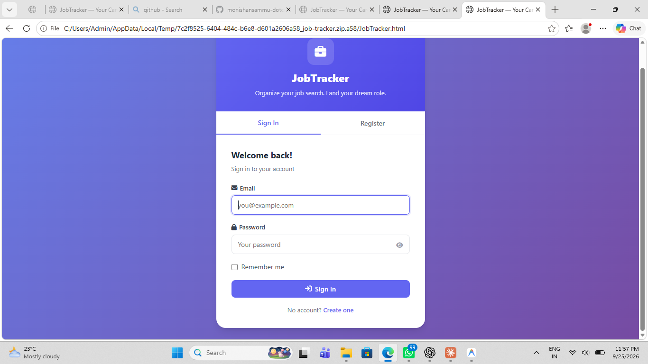
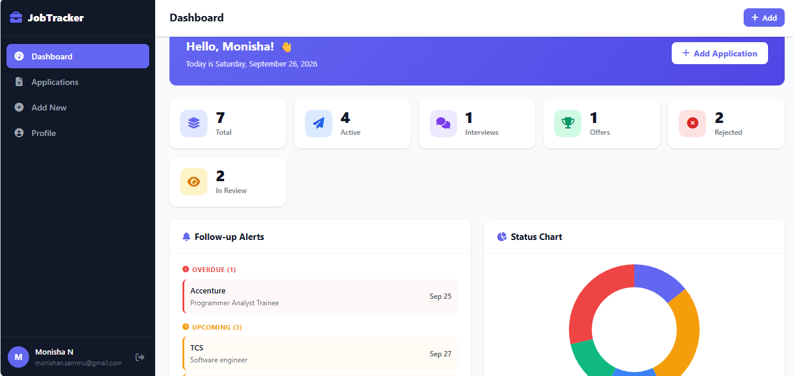
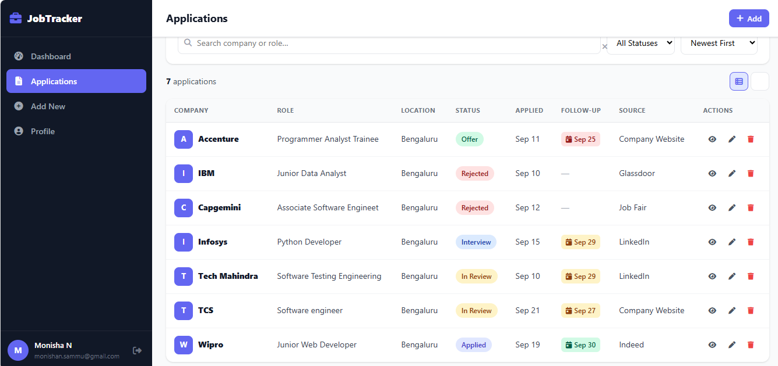
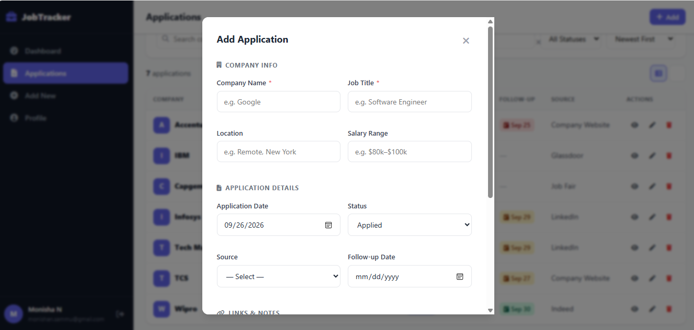
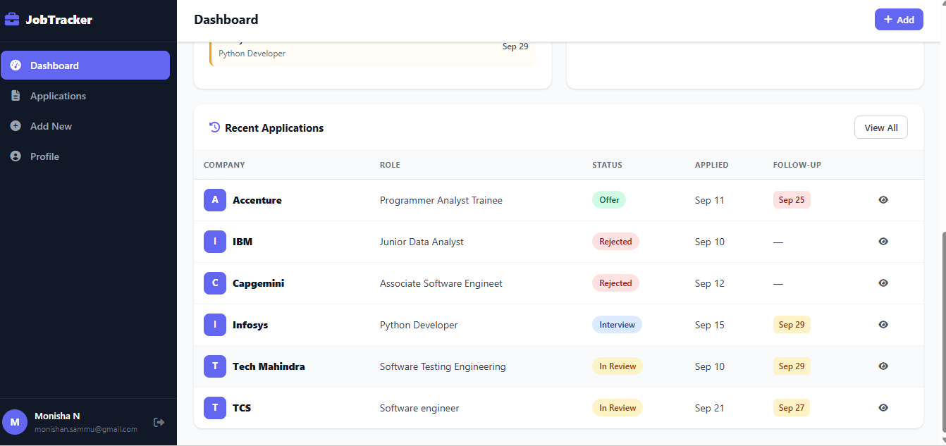

Future Enhancements
- User registration and authentication
- Personal dashboards for multiple users
- Email follow-up reminders
- Calendar integration
- Resume and cover-letter uploads
- Interview scheduling
- Charts and advanced reports
- REST API endpoints
- PostgreSQL production database

Learning Outcomes
- Python programming
- Flask web application development
- SQLite database design and CRUD operations
- HTML and CSS form design
- Bootstrap responsive UI development
- Search, filters, and CSV export

Author
Student Name: Monisha N
USN: U18IN24S0032
Course: BCA
Project: Job Application Tracker
Technologies: Python | Flask | SQLite | HTML | CSS | Bootstrap | JavaScript

GITHUB
https://github.com/monishansammu-dotcom/job-application-tracker.git
project\CampusFlow-Ready-To-Open\job-tracker

License
This project is intended for educational, academic, internship, and portfolio use.

