PIZZA SALES SQL QUERIES

1. **KPI’s**
2. **Total Revenue:**

Select SUM(total_price) AS Total_Revenue from pizza_sales

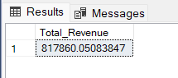

1. **Average Order Value:**

Select (SUM(total_price) / COUNT(DISTINCT order_id)) as AVG_Order_value from pizza_sales

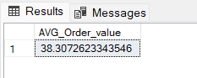

1. **Total Pizzas Sold:**

Select SUM(quantity) as Total_pizza_sold from pizza_sales

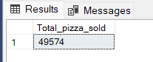

1. **Total Orders:**

Select COUNT(DISTINCT order_id) as Total_orders from pizza_sales

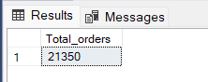

1. **Average Pizzas per order:**

SELECT CAST(CAST(SUM(quantity) AS DECIMAL(10,2)) / CAST(COUNT(DISTINCT order_id) AS DECIMAL(10,2)) AS DECIMAL(10,2)) AS Avg_Pizzas_per_order

FROM pizza_sales

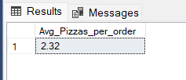

1. Daily Trend for Total Orders.

Select DATENAME(DW, order_date) as order_day, count(DISTINCT order_id) as total_orders

from pizza_sales

Group by DATENAME(DW, order_date)

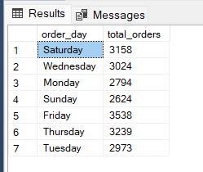

1. Monthly Trend for Total Orders.

Select DATENAME(MONTH, order_date) as Month_name, count(DISTINCT order_id) as total_orders

from pizza_sales

Group by DATENAME(MONTH, order_date)

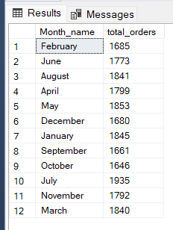

1. % of sales by Pizza Category

Select pizza_category,sum(total_price) as Total_sales, sum(total_price)*100/

(Select sum(total_price) from pizza_sales Where MONTH(order_date) = 1) as Percnt

from pizza_sales

Where MONTH(order_date) = 1

Group by pizza_category

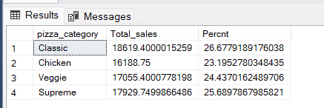

1. % of sales by Pizza Size

Select pizza_size, Cast(sum(total_price) as decimal(10,2)) as Total_sales, CAST(sum(total_price)*100/

(Select sum(total_price) from pizza_sales) as decimal(10,2)) as Percnt

from pizza_sales

# WHERE DATEPART(quarter, order_date) = 1

Group by pizza_size

order by percnt DESC

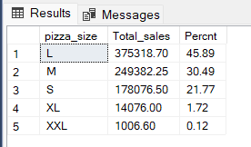

1. Total Pizzas Sold by Pizza Category

SELECT pizza_category, SUM(quantity) as Total_Quantity_Sold

FROM pizza_sales

WHERE MONTH(order_date) = 2

GROUP BY pizza_category

ORDER BY Total_Quantity_Sold DESC

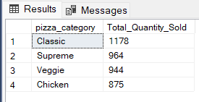

1. Top 5 Pizzas by Revenue

SELECT Top 5 pizza_name, SUM(total_price) as Total_Revenue FROM pizza_sales

GROUP BY pizza_name

ORDER BY Total_Revenue DESC

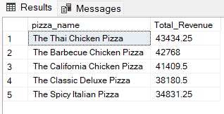

1. Bottom 5 Pizzas by Revenue

SELECT Top 5 pizza_name, SUM(total_price) as Total_Revenue FROM pizza_sales

GROUP BY pizza_name

ORDER BY Total_Revenue

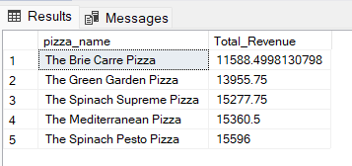

1. Top 5 Pizzas by Quantity

SELECT Top 5 pizza_name, SUM(quantity) as Total_Quantity FROM pizza_sales

GROUP BY pizza_name

ORDER BY Total_Quantity DESC

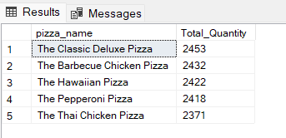

1. Bottom 5 Pizzas by Quantity

SELECT Top 5 pizza_name, SUM(quantity) as Total_Quantity FROM pizza_sales

GROUP BY pizza_name

ORDER BY Total_Quantity

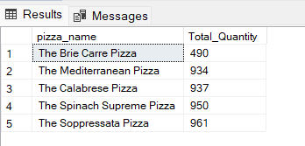

1. Top 5 Pizzas by Total Orders

SELECT Top 5 pizza_name, count(DISTINCT order_id) as Total_Orders FROM pizza_sales

GROUP BY pizza_name

ORDER BY Total_Orders DESC

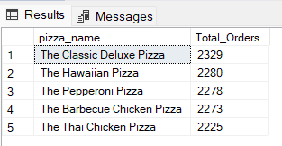

1. Bottom 5 Pizzas by Total Orders

SELECT Top 5 pizza_name, count(DISTINCT order_id) as Total_Orders FROM pizza_sales

GROUP BY pizza_name

ORDER BY Total_Orders

