Latest news need or not
If need
its separate form or ongoing events

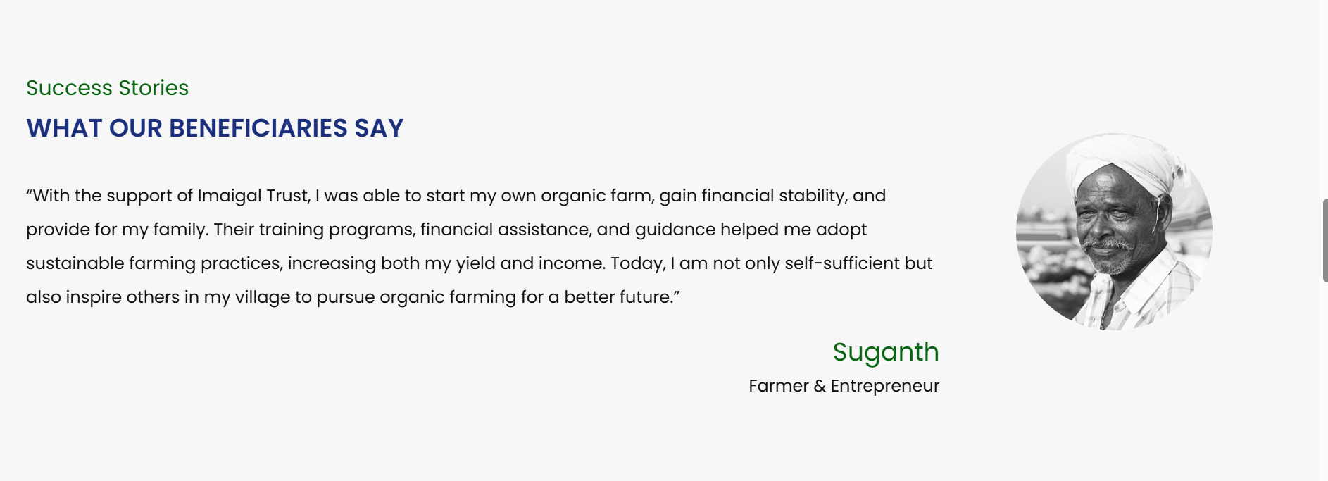
Name need to check

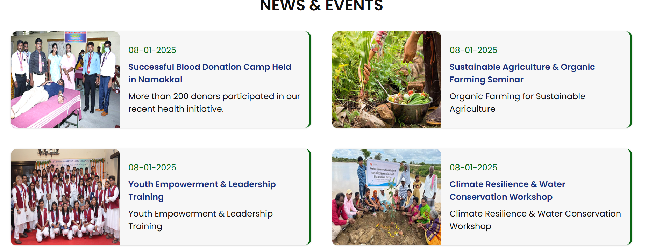

Need to confirm this date and event (client)

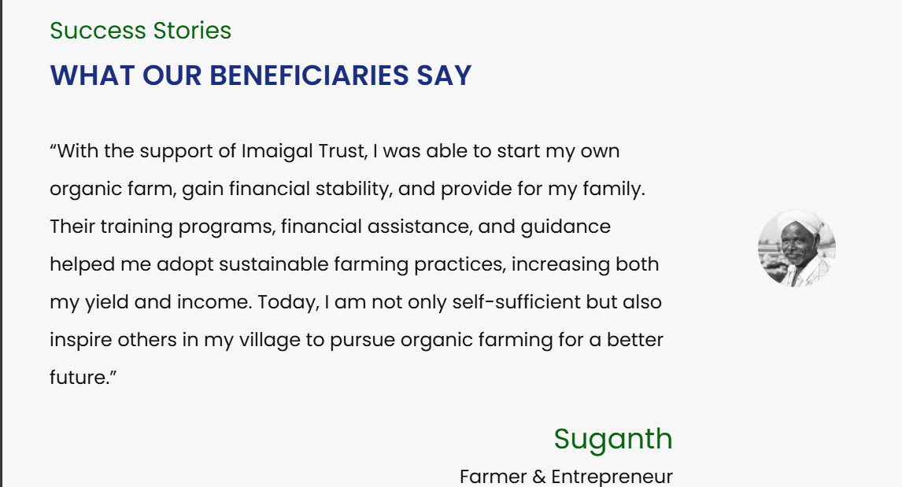

Need to check the picture size tab view
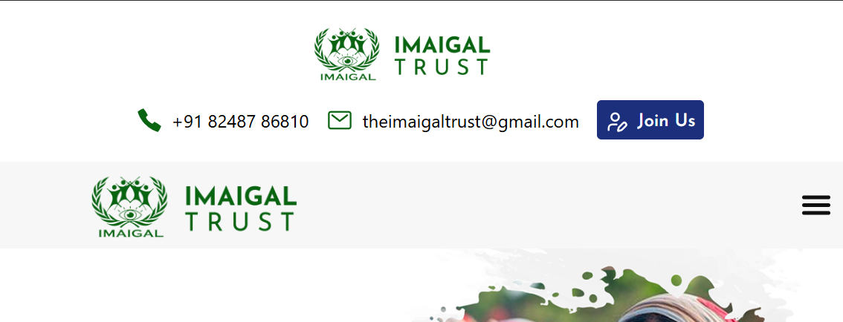

There have two logo need to check in tab view
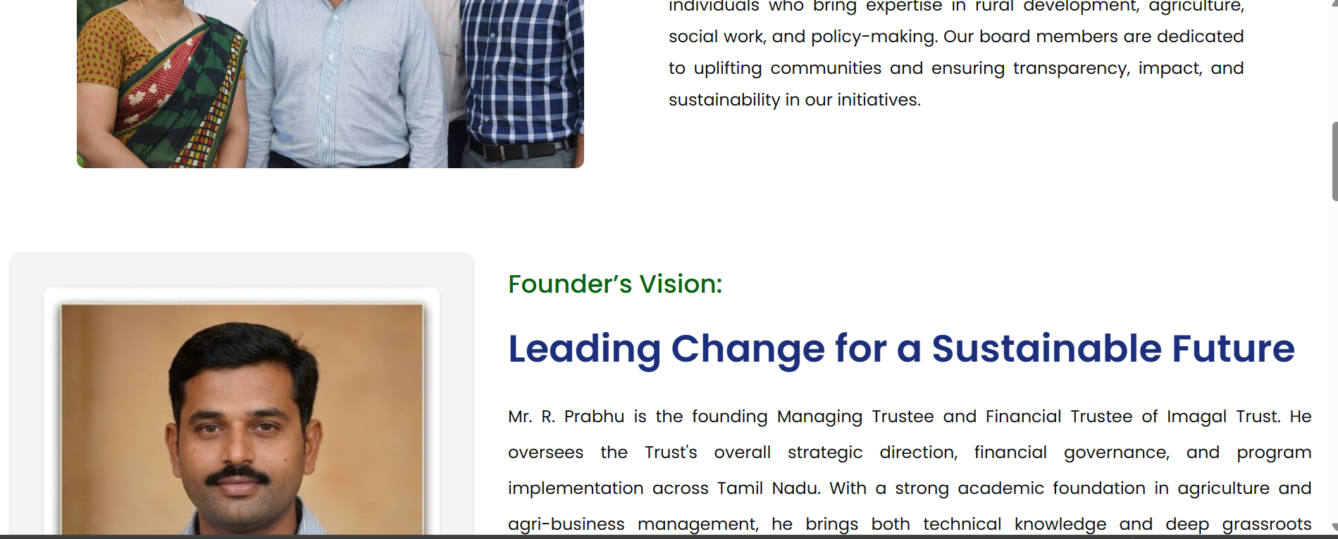

Need to have same space left and right
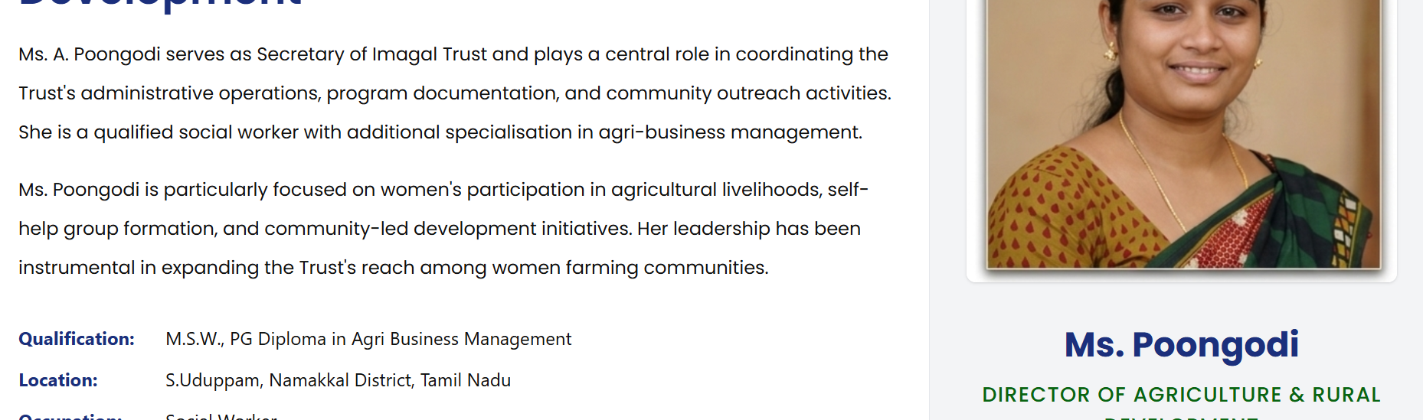

One place initial mention other place didn’t mention check that
Its not ms its mrs
Also mention a initial same pattern prefix or suffix one place
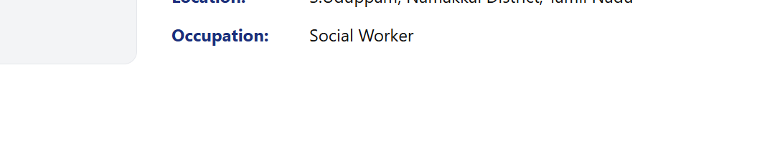
Need to confirm this occupation
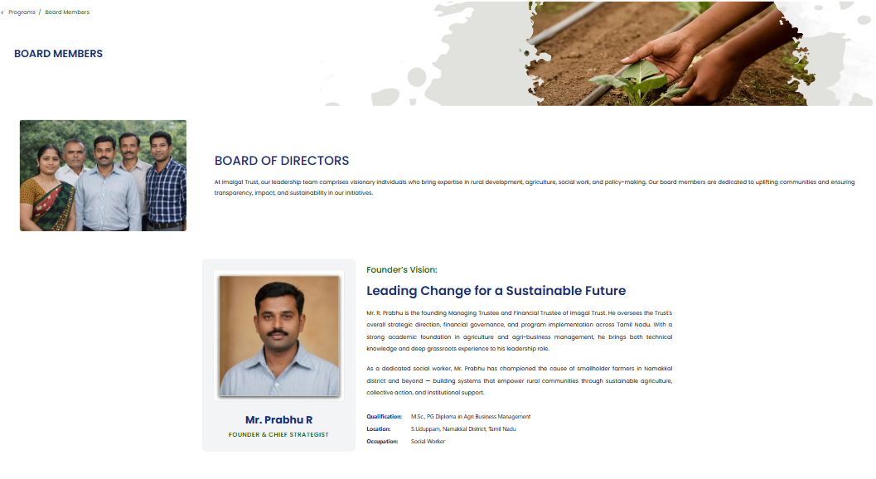

Need to same size expanding
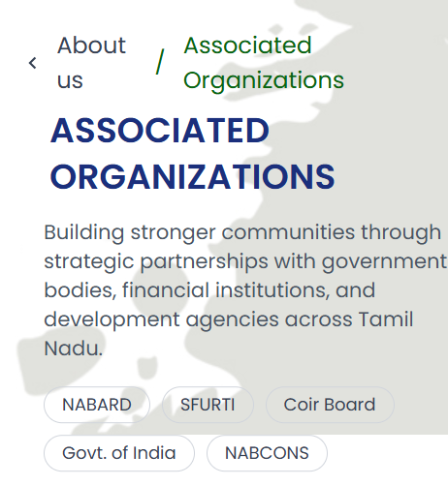
Its overlapping need to check this
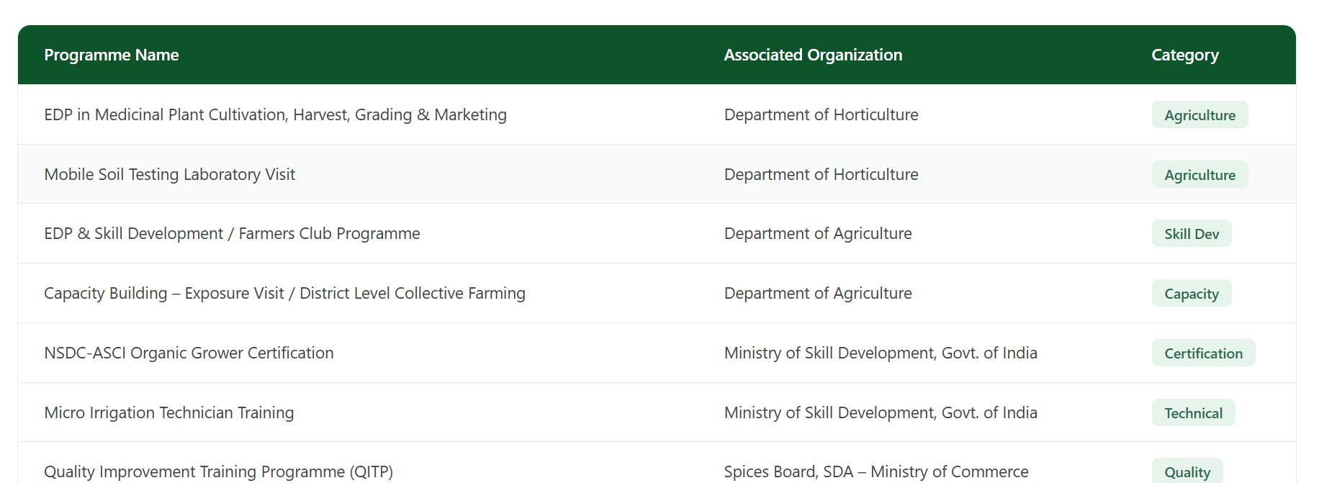

Need to change UI when mobile view
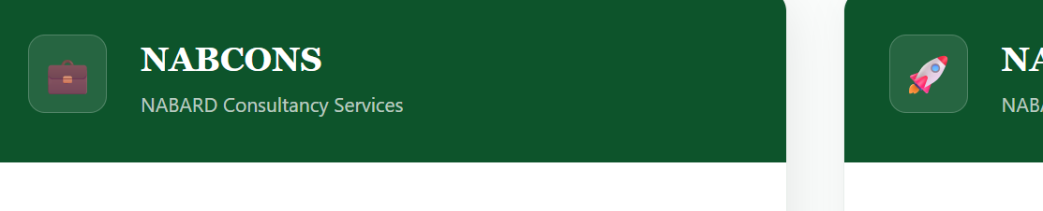
Follow the one type of icon
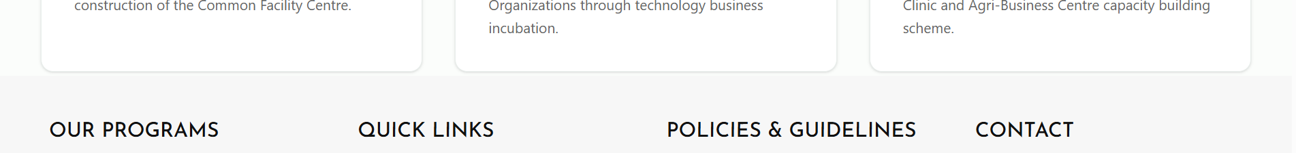

Need Gap
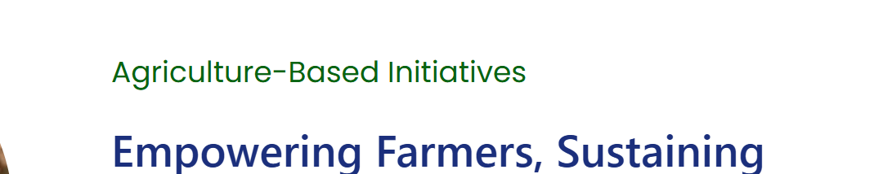

This type of heading need to be change all page same size font
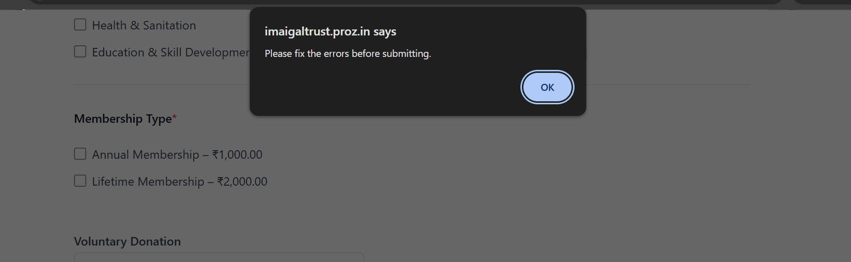

I need manual popup don’t use alret
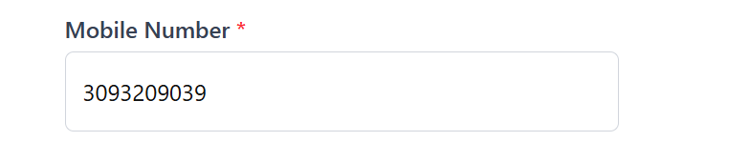
Need Mobile number validation
Start 6 and 6 above , same number not repeated 5 times above

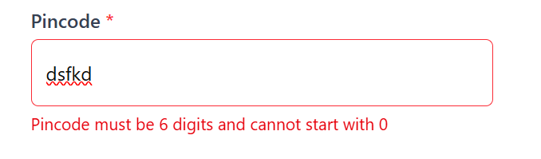
Need to change error msg
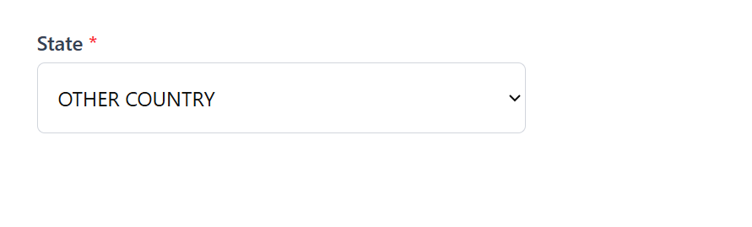
If Select other need to show select option

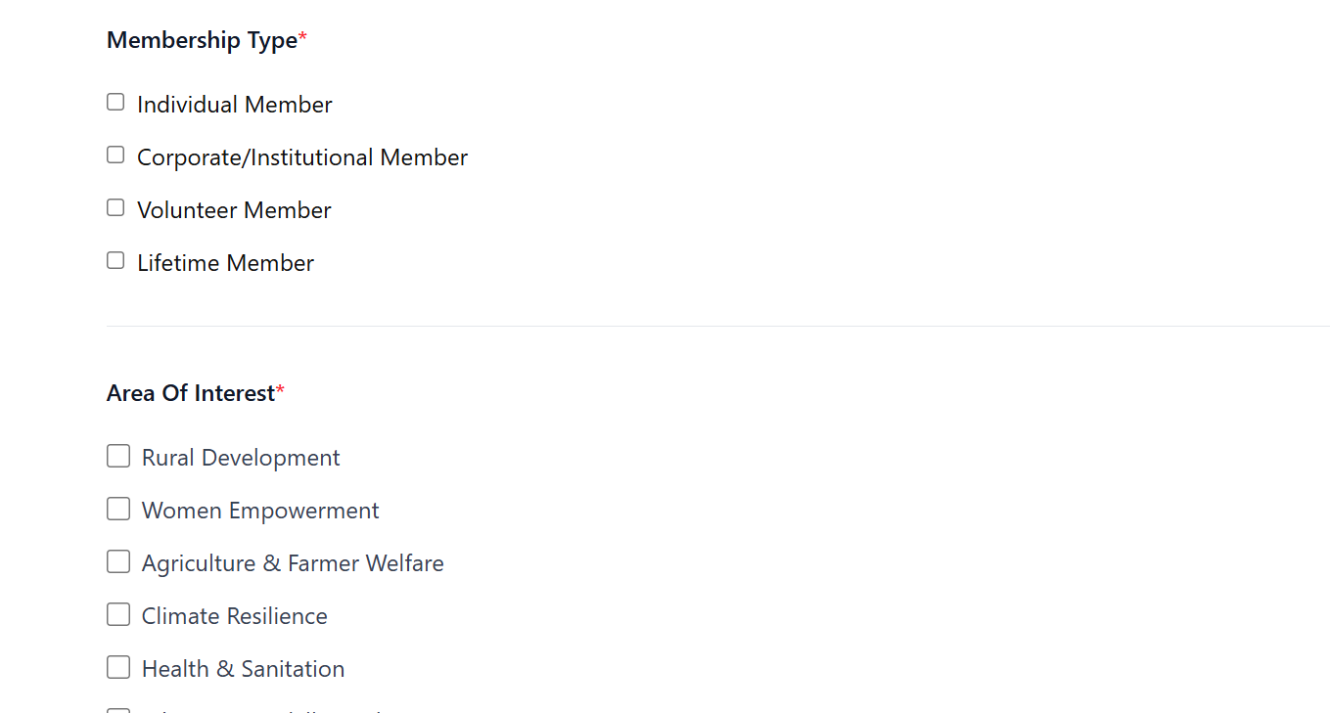

Need to change same size the box
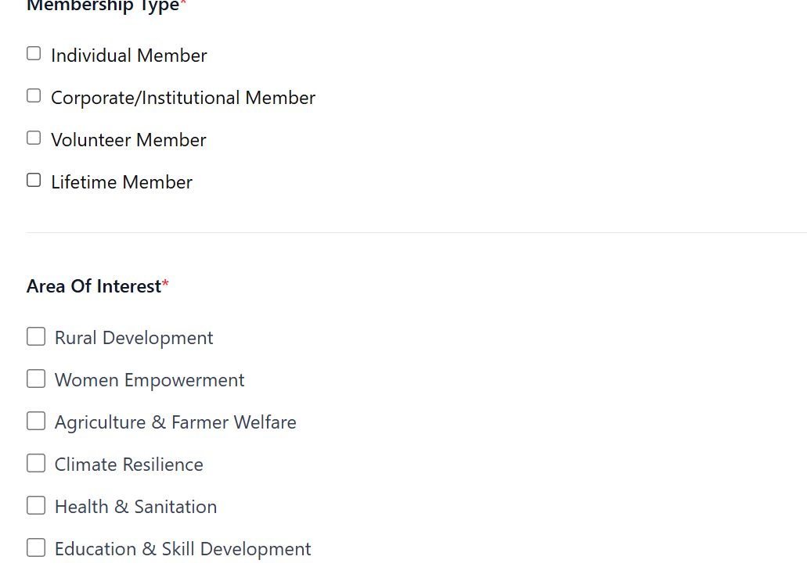
Didn’t show error msg

