Exp:8 joins

1)inner join

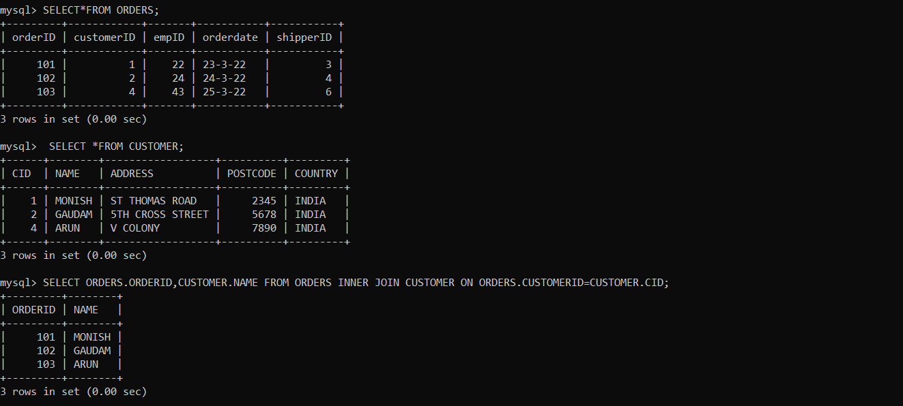

2)right join

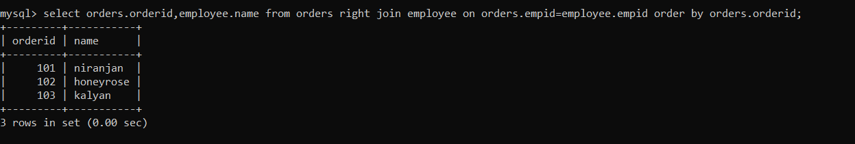

3)left join

