Asynchronous in javascript

How work java script .

V8 is javascript engine which is developed by google

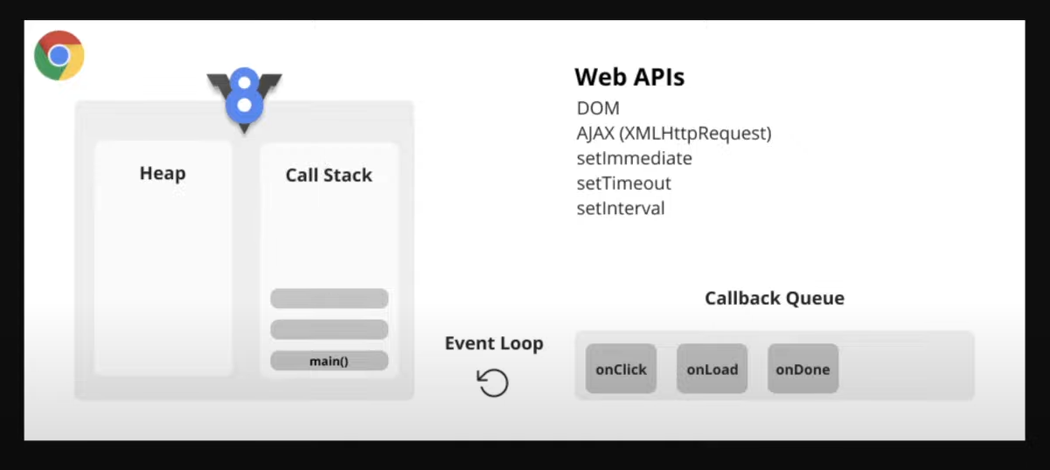
how work console.log()

if we write console.log it will into call stack and run one by one

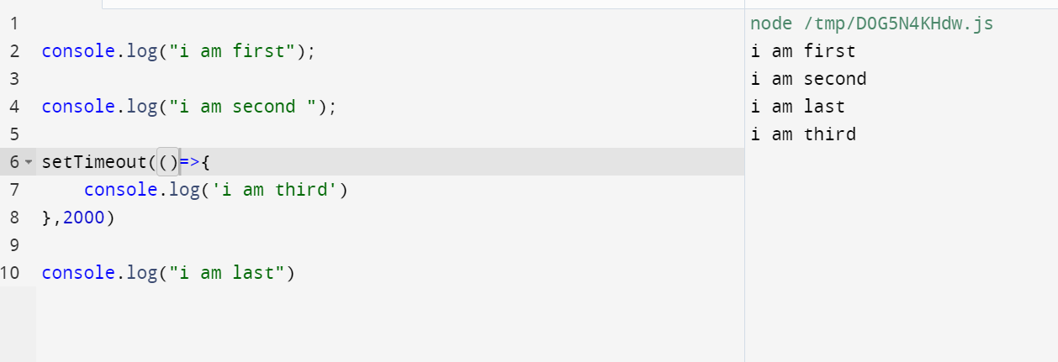
Ok we said java script compile line by line I here we can see third came lasr how is it ?
1st and 2nd into call stack

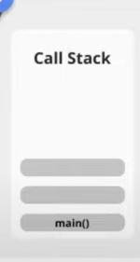

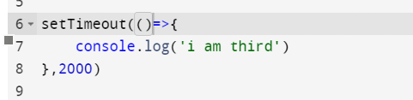
javascript wiill compile the code line by line I send the all function to call stack if we use setIntravel , setTimeout , on click events it will store in call back queue if the event done event loop send the function to call stack that will run. This is asyncronus java script will not wait.
1st

2nd

Last

3rd
3rd

Event loop will work

Call back function

give the function as another function argument called call back function
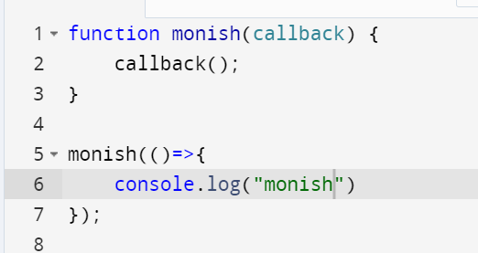

some examples

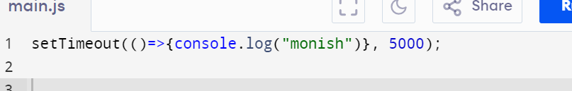

set time out is is function we gave anonomynous function to the setTime out function as a argument that called callback function.
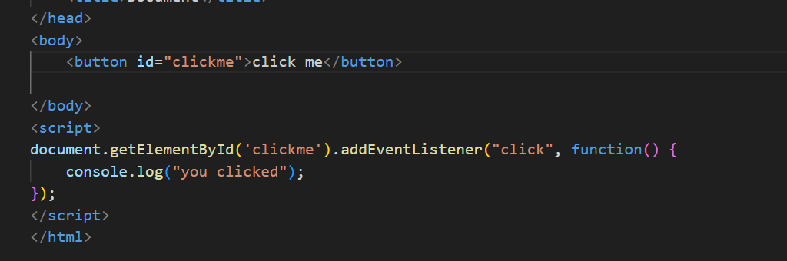
Now we can see the function chaining addEventlistner is a function we have 2 parameters one is that event name another is function .

We can see now we use callback function

Event loop

Java script engine

Function

Call stack

The java script is execute the code line by line using the call stack. Browser has super power link communicate external world things like timer , location , dns if we need to access that we have to connect that .

The js engine need to wait but we said js is not wait to any one it will run all code . Here we use event loop .

The location , bluetooth , doms all in web apis.

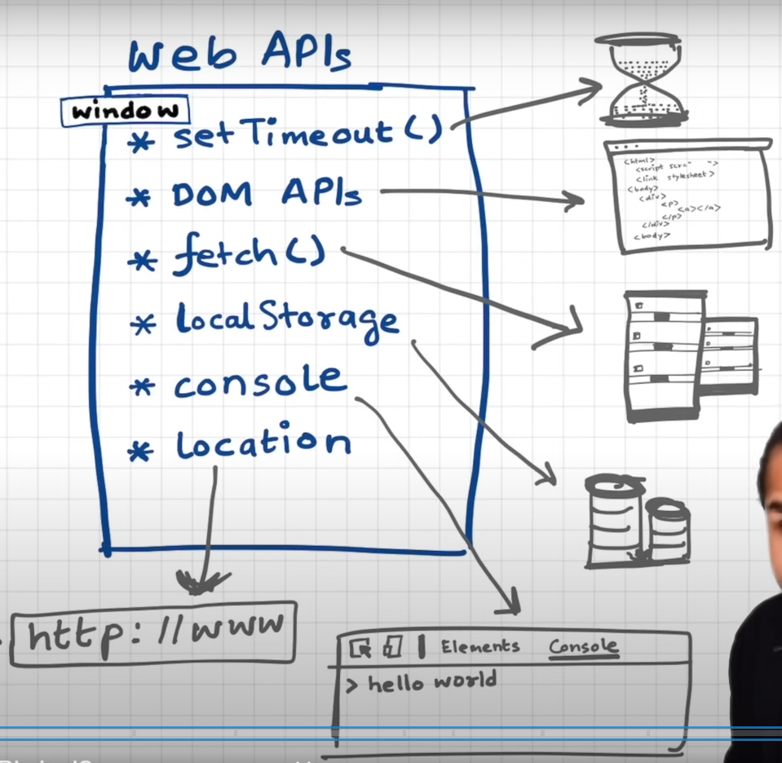

SetTimeout()

console.log()

dom

this is not part of javascript this is part of browser .

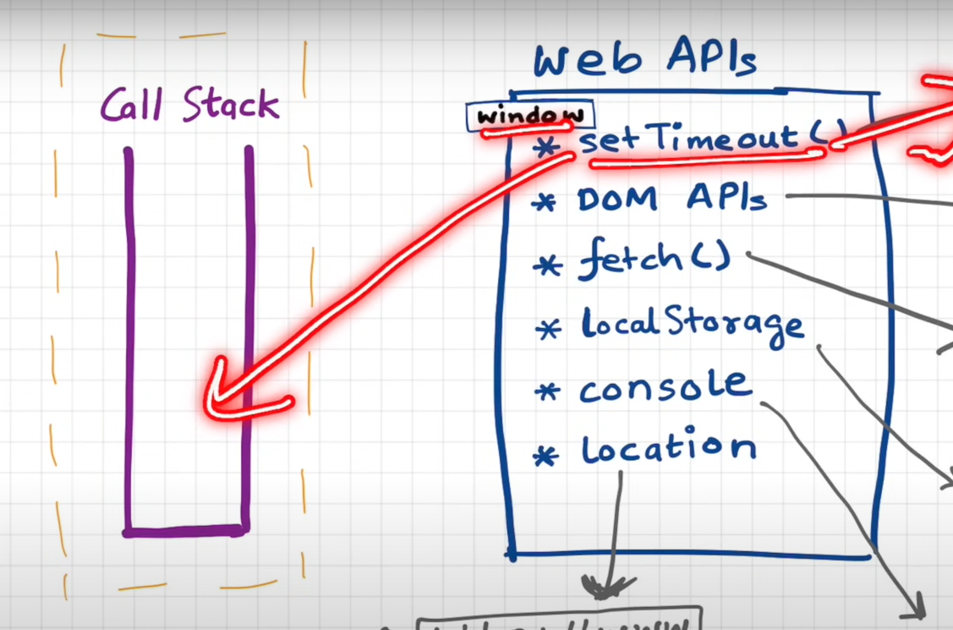
If we call the web api it will be set in call stack

these function come under global object the global object is window but we no need to mention that

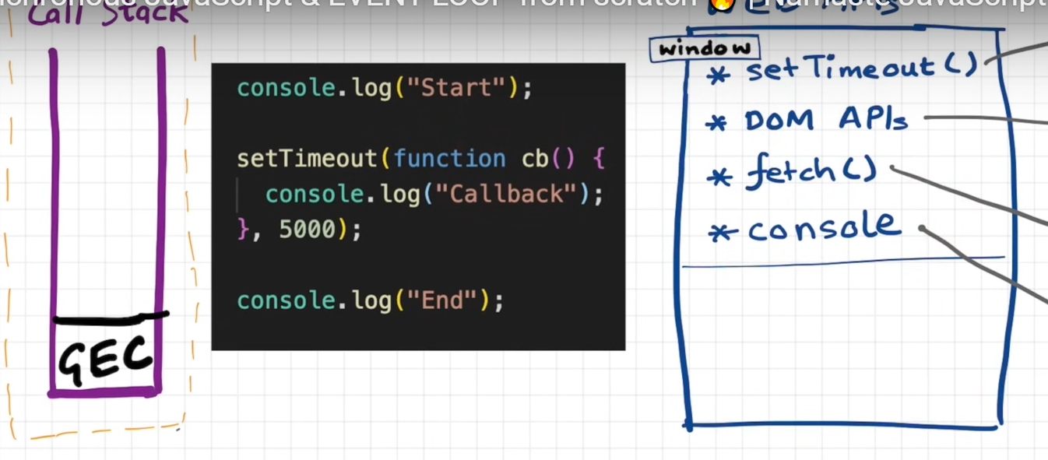

1. the console api will excute and print start

2.setTime out will call the browser will register the function separate area timer will run

3. Then last end cosnole will execute now the GEC (global execute compile will remove from the call stack)

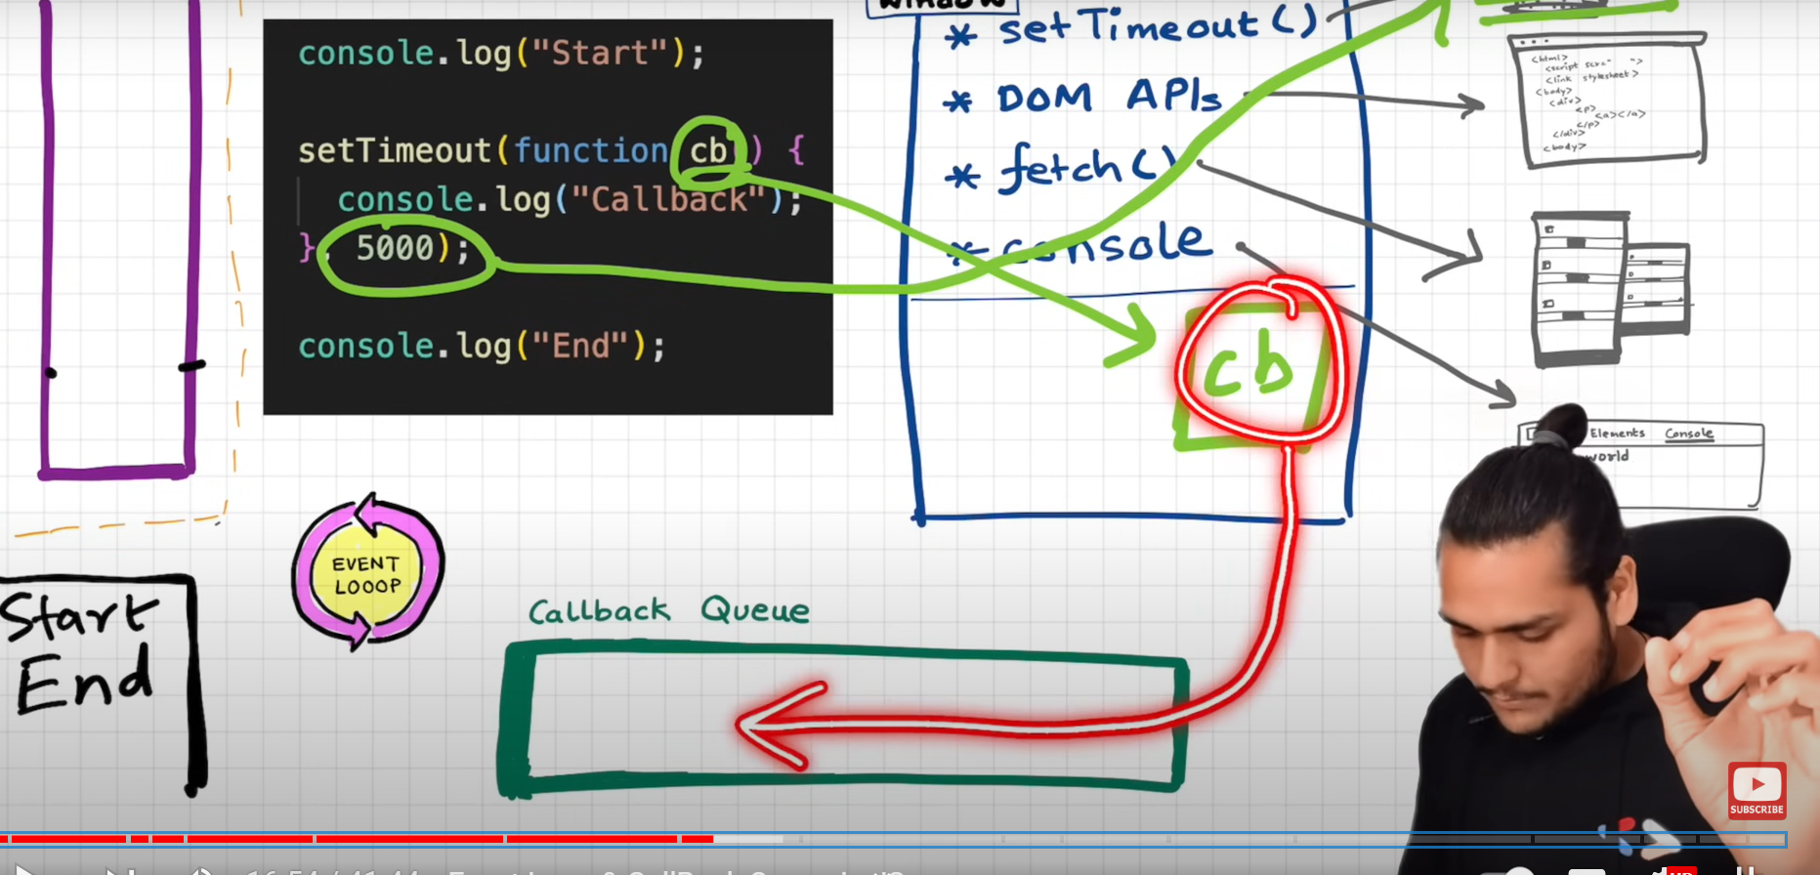
4.that timer function will not go to call stack directly .

5.When the time is over that function will store in CallBack queue

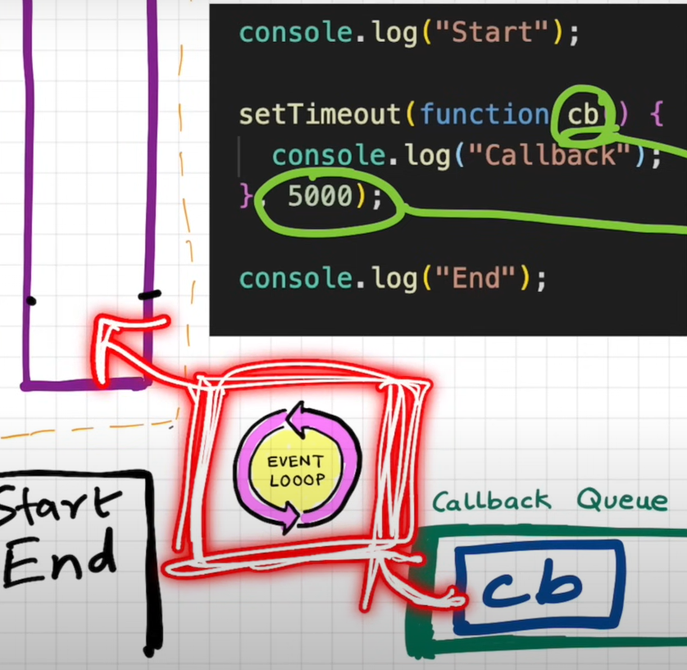

The event loop will bring the call back queue function to call stack

fetch api

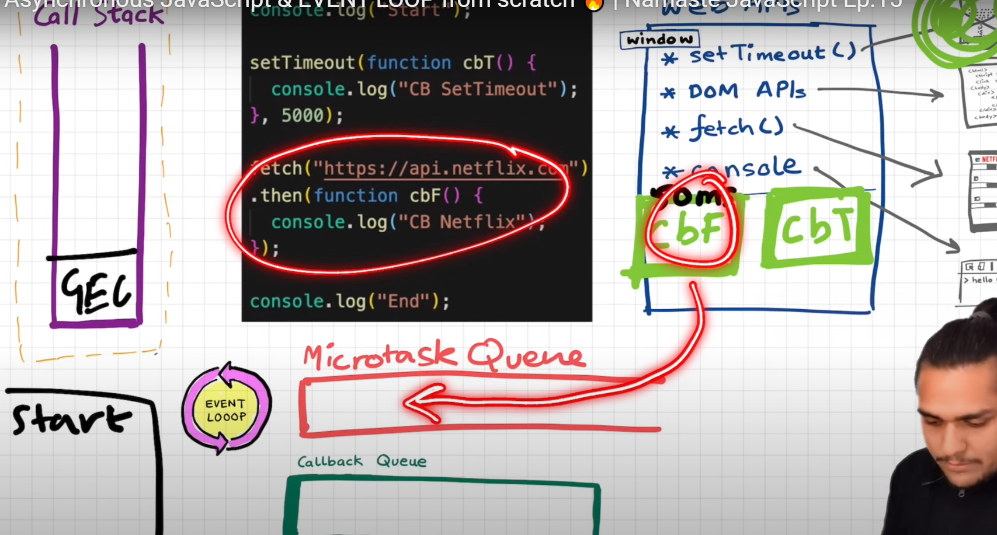

If we give request to javascript when the code compile js will call fetch api in web api’s we used call back function .

1. it will register that call back function when the fetch api completed it will not go to call back queues it will go to micro task queues . It is high priority when means event loop monitor the call stack is empty or not once the call stack is empty GEC will come outsite of call stack then event loop first see the microtask queue then will see callback queue

which call back function will come to micro task queue ?
The call back function come with promise that will come to micro stack queue .and mutation observe

call back hell

call back hell is not a topic of java script its technical word or developer emotional word . If we have a website like ecommerce .

1.order
2.summary of order
3.payment

after complete the order we show the summary order after complete the payment we show payment link .

Api.order();
Api.summary();
Api.payment();

This is our apis what we do is we will first call order.

Api.order( ()=>{

api.summary( ()=>{

api.payment()

})

})

which make unreadable and understand the code we thats why people call this call back method is hell .

Promise
Promise is convert the javascript to Asyncronous.

There are 3 state

1.pending (promise is running )
2.full fill (promise is completed)
3.reject ( promise is not running because of error )

Promise

promise is very important topic in javascript
in example to create ecommerce website using call back function it will make more problems so we use promise.

Promise it reduce the drawback of call back function .

Create order api

We create the Createorder api it will not call back the any function but it will return the promise .
Promise is a object.
Const promise =CreateOrder(OrderID); // capture the promise object using promise variable.

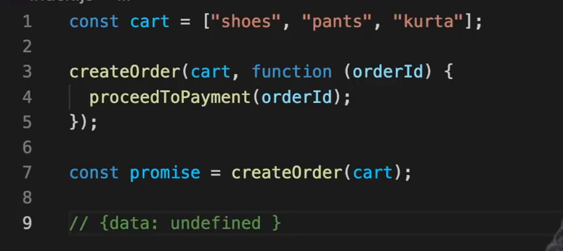

The create order Api is asyncronous so we don’t know when it will return the object so when the code is execute it will return the undefined data .

The create order api will take some time so after complete that task The promise object filled with some data .

THEN
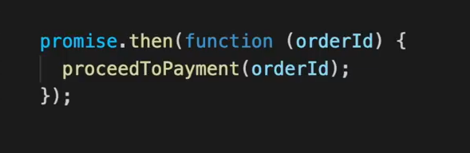
Then function is comes under promise it will execute when promise object have data then function will call automatically.

For reducing callback we use promise but still we using call back?

In call back function we will pass the function into another function
OrderDetails(function payment(){
proccedPayment();
})

In promise we will send the function attached another promise function (then). When fill the data in promise then function will called automatically.The then function will called only one time .

Promise states

1.pending
2.full filled
3.rejected

normal call back

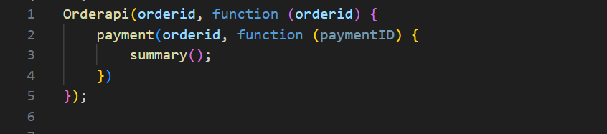

promise used

version -1
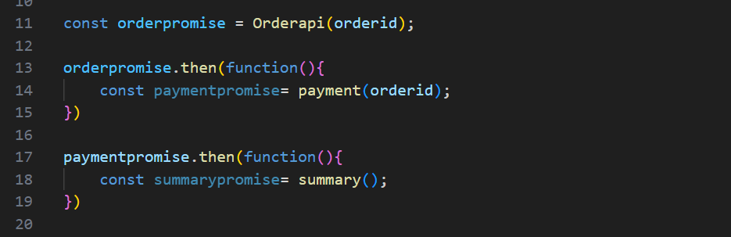
version -2 (promise chaining )

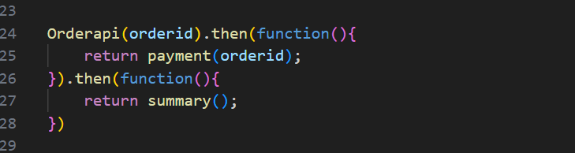
version -3 (promise chaining with arrow function )

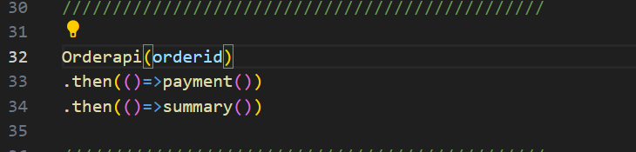
Creating own promise

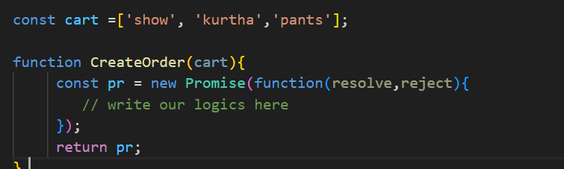
This is the right way to create the promise.

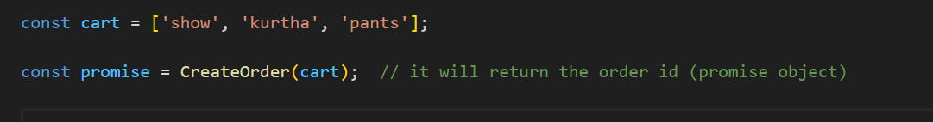
This is our CreateOrder() api function. It will return the promise so we have to write the promise.

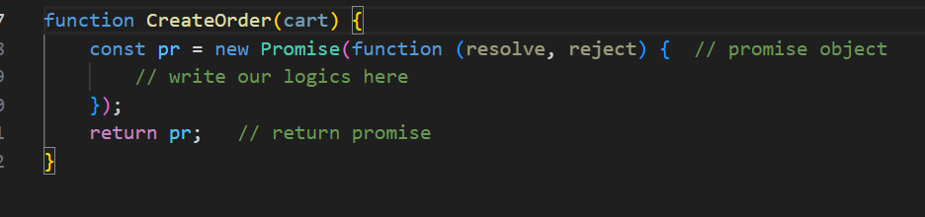
In promise we will pass the function and we give 2 argument that is resolve,reject which was given by the javascript

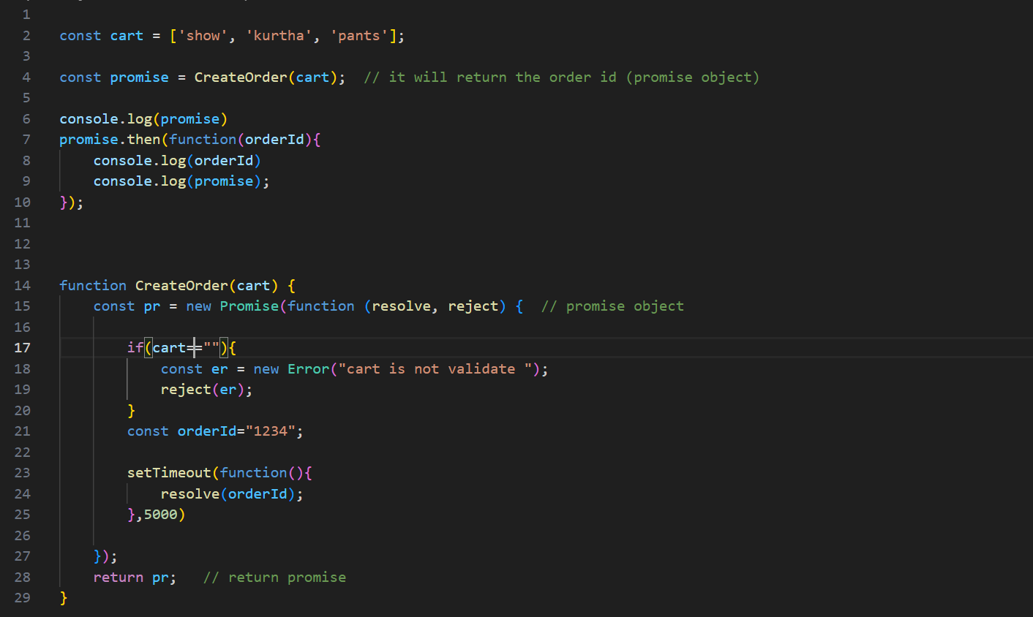

Promise chaining

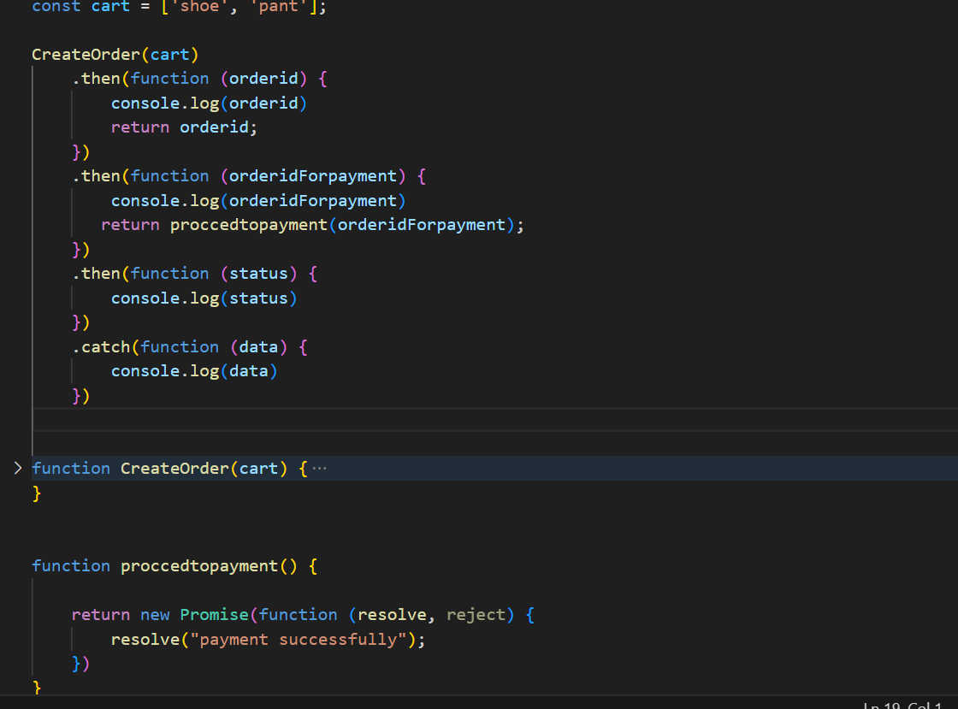
When we chaining we have to return the data to that chained function .

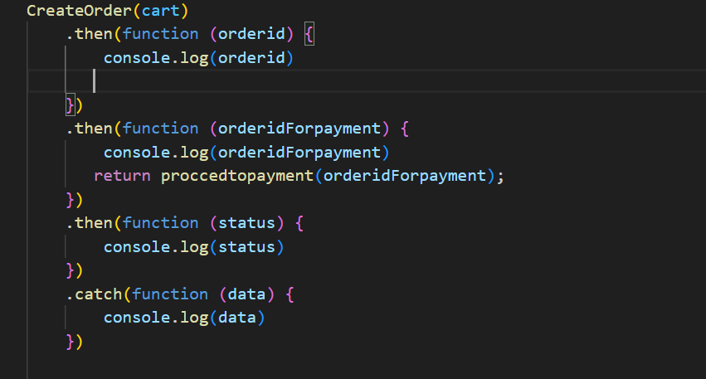
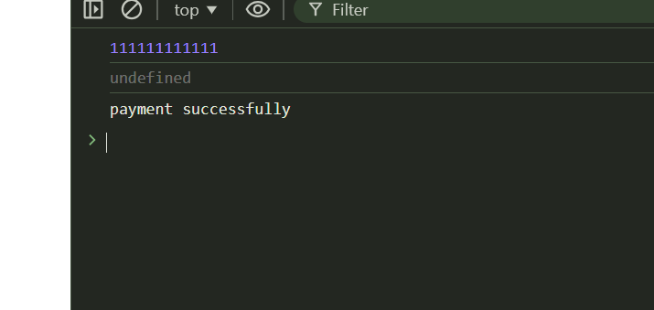
Here I am not return the promise
So here we can see the the order id is not passed to chained function

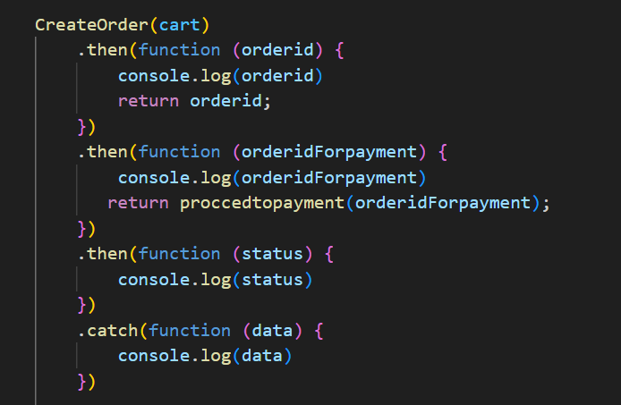
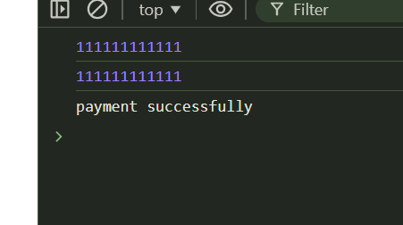
Here we can see the order id I return we can use in that then function

catch in promise chaining

Here catch will run if any rejection occur in this the all then will not run .

When a .catch() block is called in a promise chain, it stops the execution of any subsequent .then() blocks. If an error occurs, the promise is rejected, and the chain jumps directly to .catch(), skipping the remaining .then() blocks.

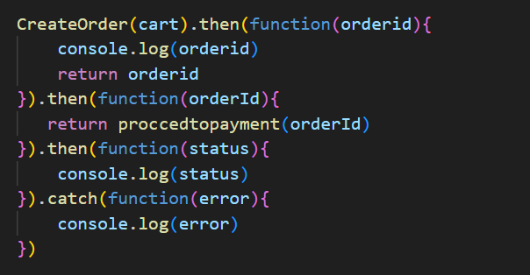
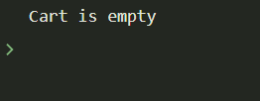
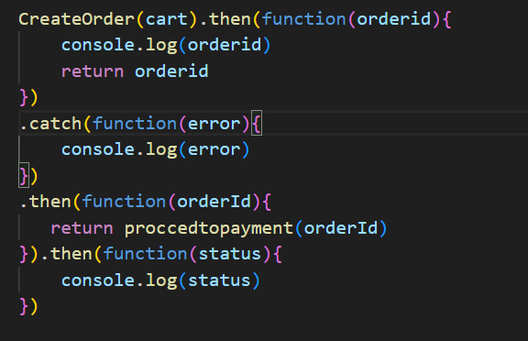
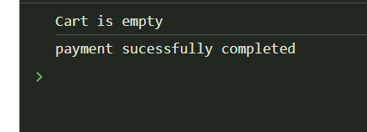
But after catch block then any then function are there the code will run.

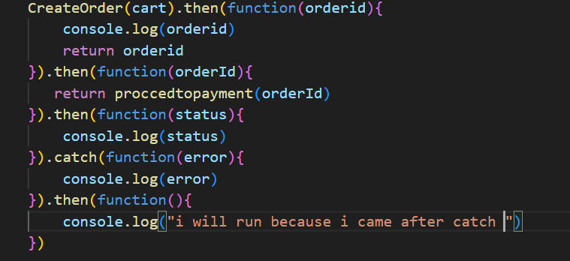
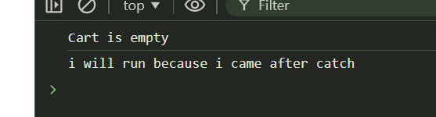

Promise api

Promise.all()

promise all api is help to call many promise in parallel . We will give the promise in array format in promise.all()

if we have 3 promise
here it will take 3 parallel api calls and get the results.

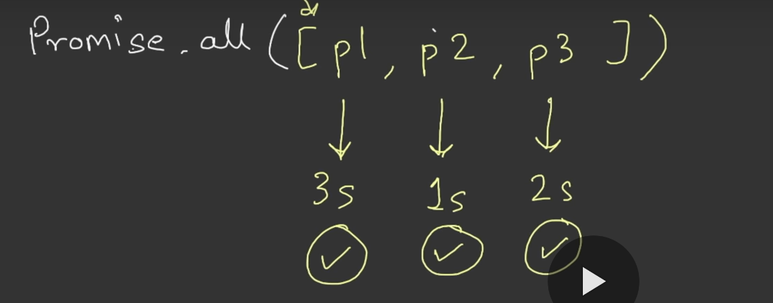
time(sec)->
If the all api calls are success it will return the success promise in array format
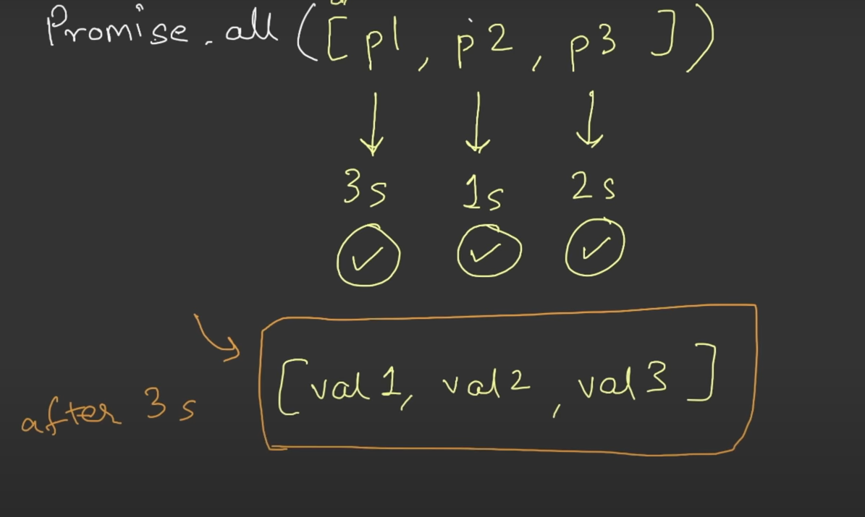
1 st promise 2 sec takes 2nd promise takes 5 sec last takes 3 sec on the time ethu first mudiyumo athu first antha result array la store aagathu .

Ippo 5 sec than athigam na 5 sec aagum ella result um store aaga .

Failure scenario
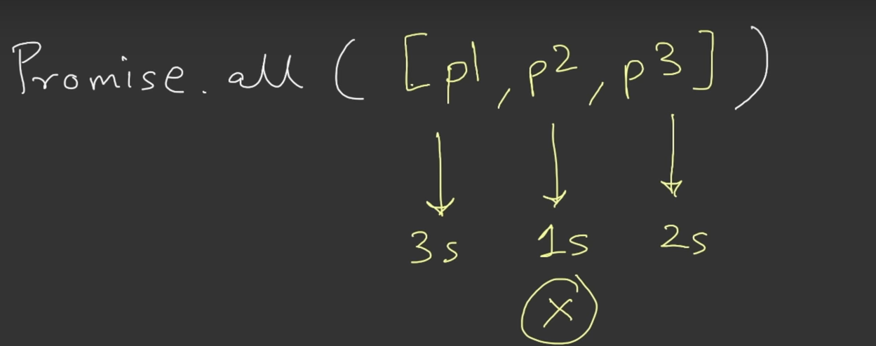
If any promise will failure(rejected) in these 3 promises all will be error

here have 3 promises p2 got error in 1 sec then other promises will not called immediately all will be error.

It will not wait for p1 or p3 (oru promise promise reject aagiduchi na ellame stop aagidum )

Promise.settled()
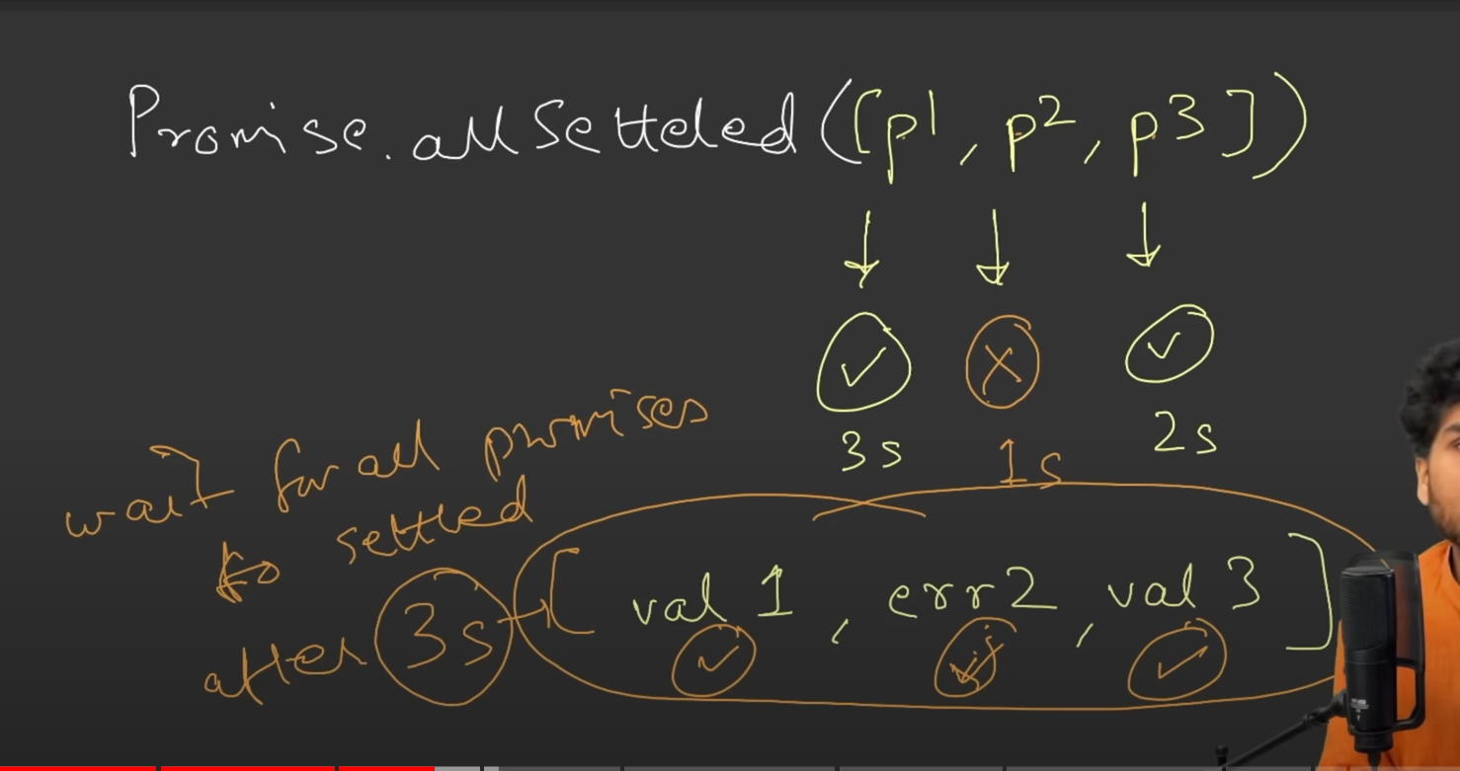
If our promise all success it will store the value in array format . If the second promise is failure that also store in array format

[p1(3),p2(5),p3(1)]=====> the p3 is failure after 5 sec because the 5 is highest sec so it will wait 5 sec then return the value like

[val1,val2,failure]======> the result .

Promise.race()

success case

[p1(3),p2(5),p3(1)]=====> which one is settled(success) first it will give the that result here p3 is 1 sec so in output come p3 (not array) give only one result like race .

(p3(result)=======>output

failure

if p3 is failure error will come in output.

Promise.any()

it similar to race but race is only wait for first success and ignore the failure

[p1(3),p2(5),p3(1)]=====> p3 is failure in 1 sec it will ignore.p1 take 2 success it will sore the that result

(p1(result))==> o/p

Incase all promise is failure it will return the error of array

[p1(3),p2(5),p3(1)]=====> all are error

[p1(error),p2(error),p3(error)] Aggrigated error
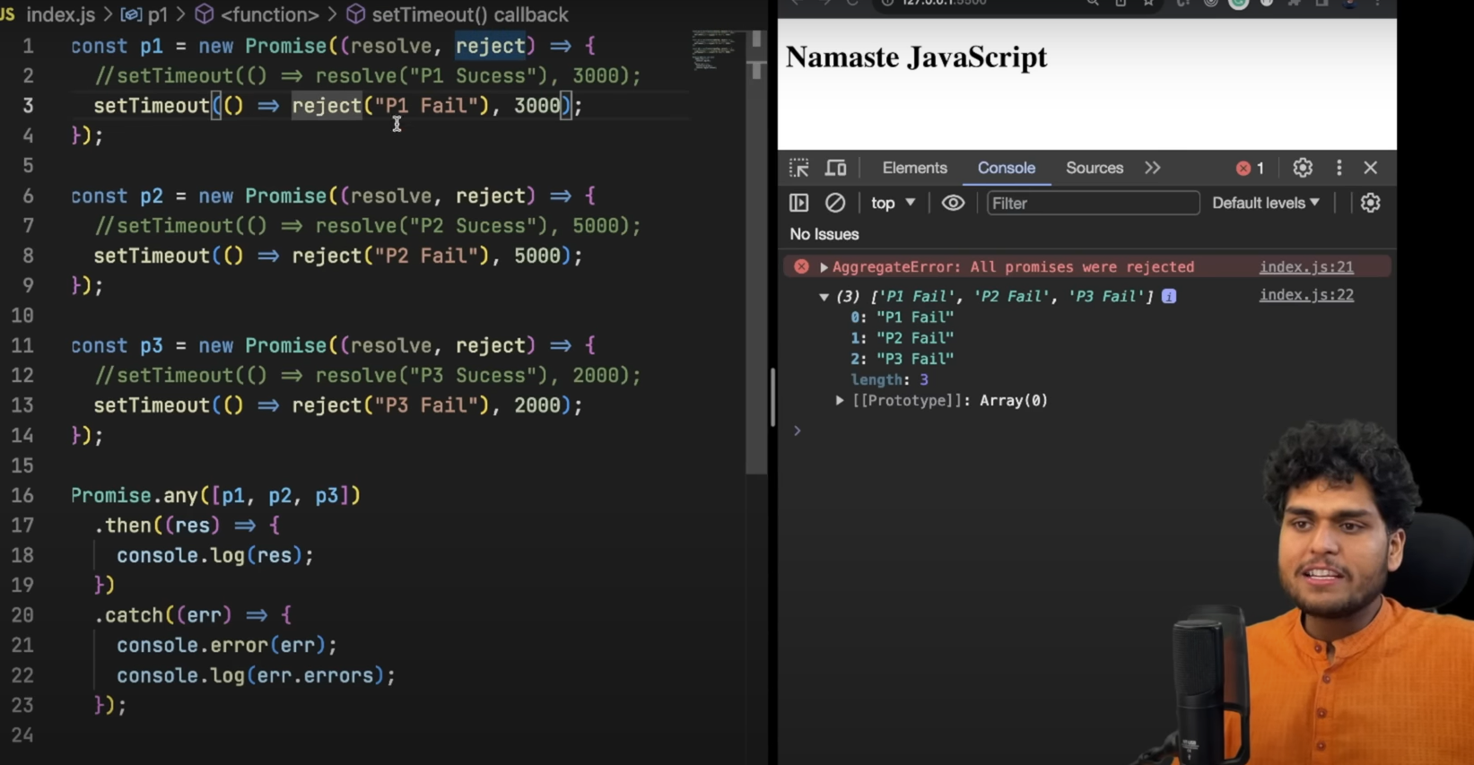
all result was error thats called aggricated error if we want to print we use errors (object)

Async

async is a keyword we use it before function.async function is always return promises

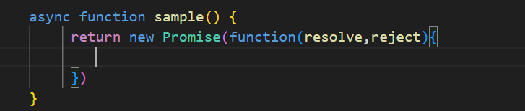
this is valid async function

what if we didn’t return the promise in async function ?

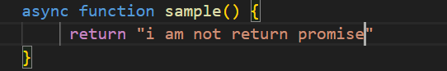
If we return promise we just return string,number it will wrap the return data to promise (async function always return promise)

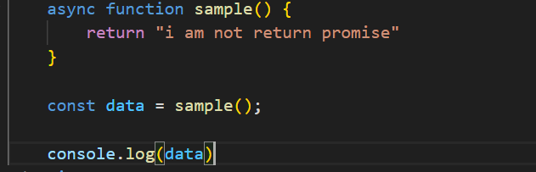
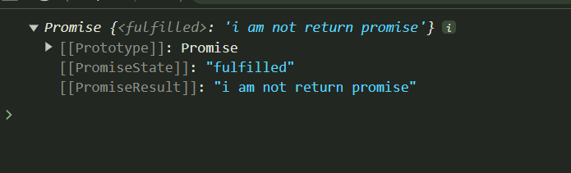
Here we can see we return the string but async function always return the promise

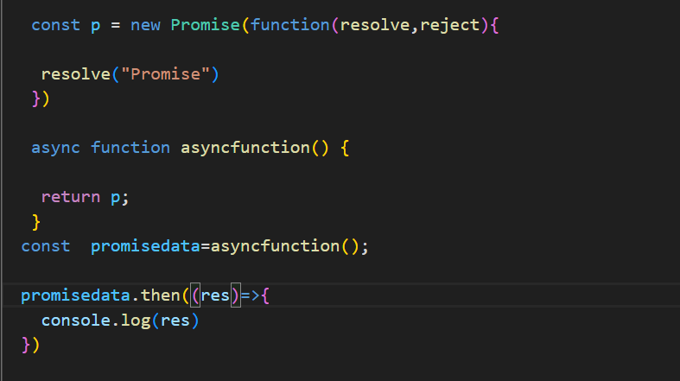
This is the way to return the promise in async function

using await with async

async and await is use to handle the promises

using normal function to handle the promise

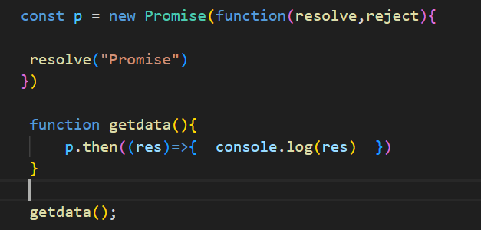
Using async function with await

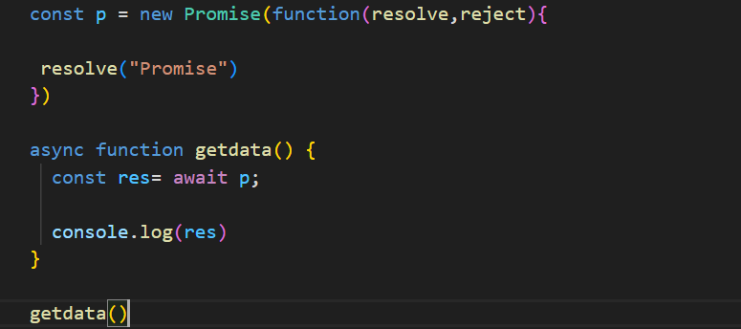
Here we use await and promise here we will not use then function await is used in async function

---------------------------------------------------------------------------------------------

different between normal function and await aynsc function
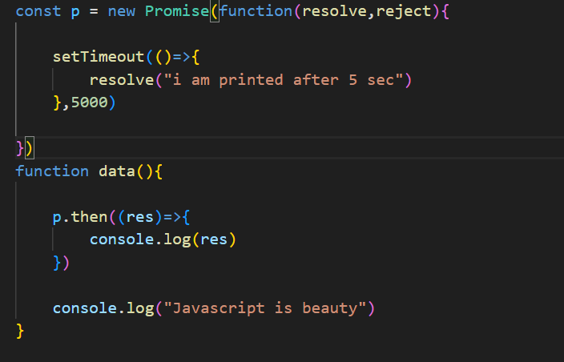
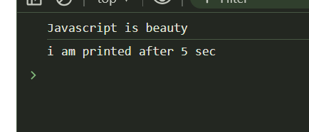
Here we can see first javascript beauty will print first the promise data will print because of event loop js engine not waiting for anything .

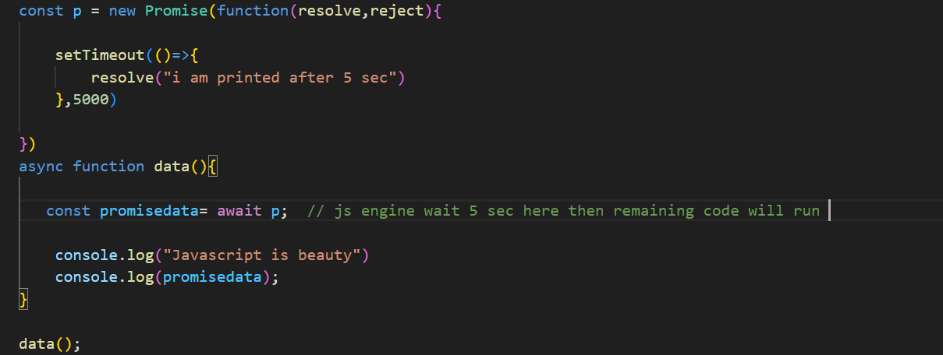
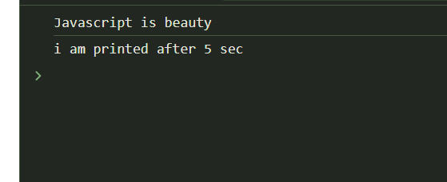
Both print after 5 sec the engine was waiting then remaining code will run

await sample -1

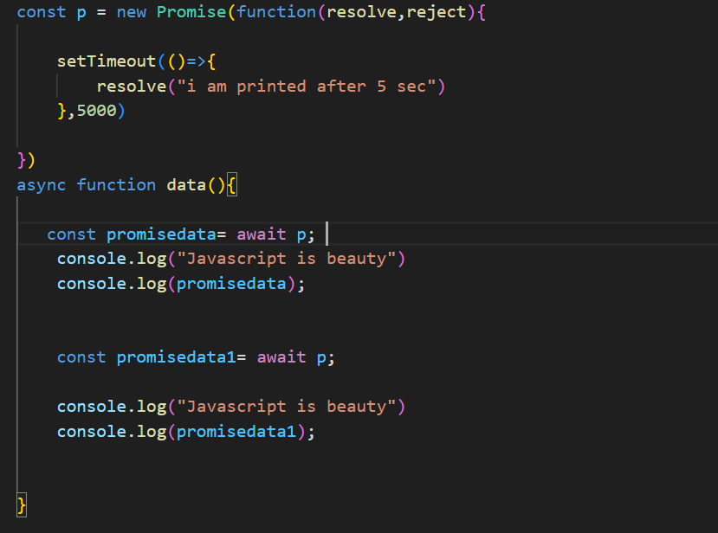
here we can thing first await wait 5 sec then the data wil print

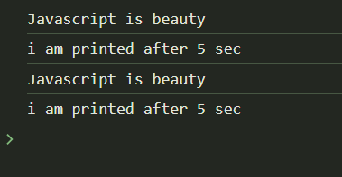
second await will wait 5 sec after 10 sec it will print
but it will not happen both are print in same time
await sample -2
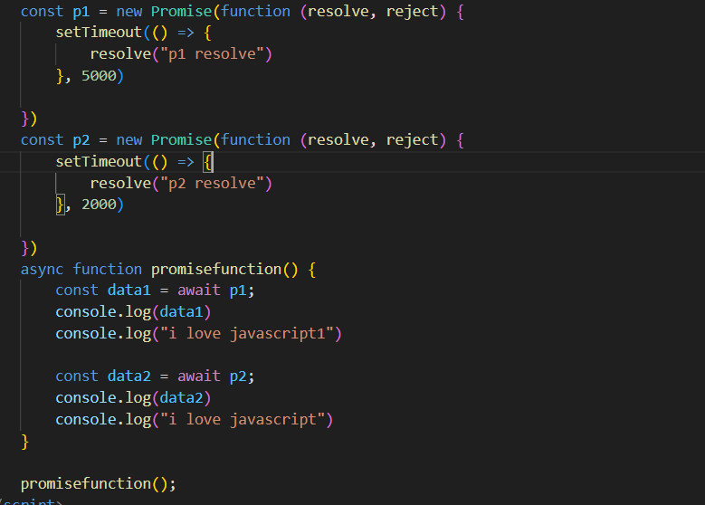
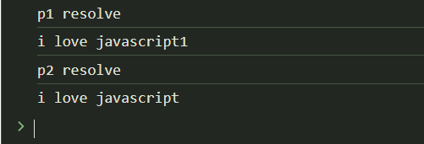
the p2 is completed 2 sec the p1 is completed 5 sec but it print after 5 sec .

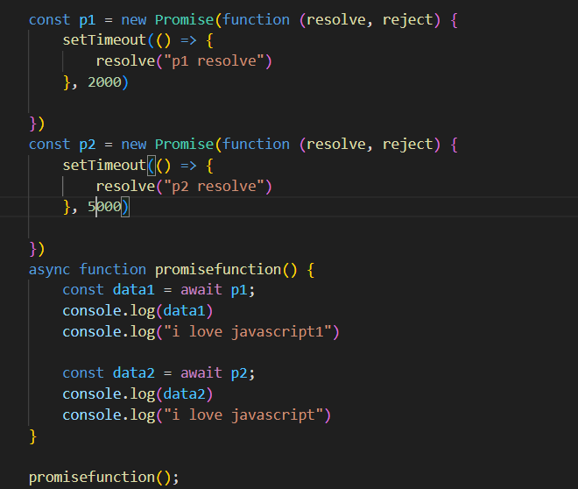
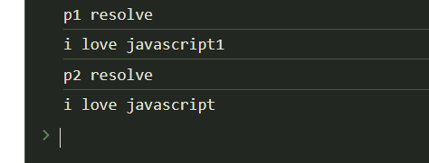
await sample -3 change the order
Here the data will not print same time

after 2 sec p1 will print after 5 sec p2 will print .

Behind the scene
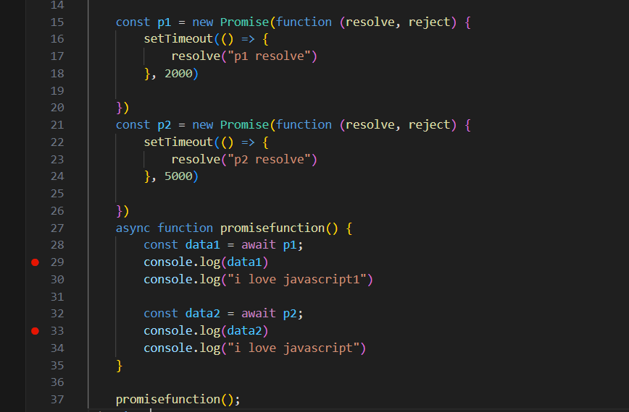
the javascript execute line by line promisefunction() come to call stack it will go to line number 27
call stack
from line -27
promisefunction()

it see the await const data1 = await p1; line number 28 remove the promisefunction() from call stack.
call stack
After complete the promise again promisefunction() come to call stack . Inga promisefunction() first line la irunthu start aagathu yenga athu stop aacho anga irunthu than start aagum 28 line la stop aachi again call aagum pothu athu 29 line ku varum .

Real await

we can use github api

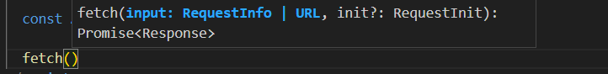
for use api we can use fetch that is given by the brower it will return the promises that is response

if we want to read the response we have to convert that response to json that jason also return promise


await

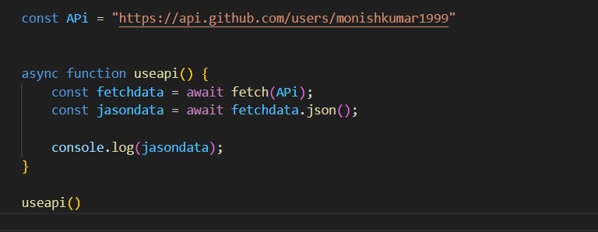
promise

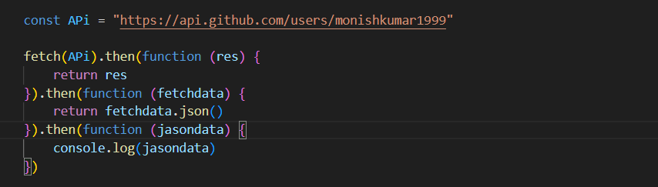
await reduce the code both functionality are same

error handle

In promise we catch the error using catch block here we also we use but not like that we use like exception handle (try and catch)

method -1

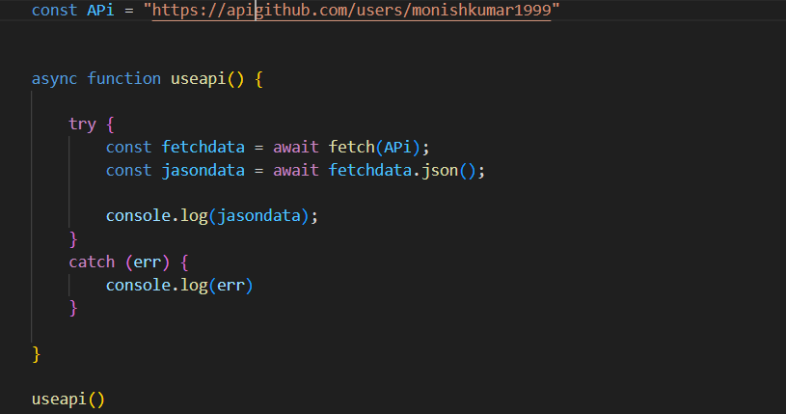

method -2



