PHASE 3
FitBuddy – Project Design

1. System Architecture
The application uses a layered MVP structure: browser templates call FastAPI routes; routes validate form data and delegate persistence and AI work to service modules; the AI layer selects Gemini or local fallback logic; SQLite stores users and plans.
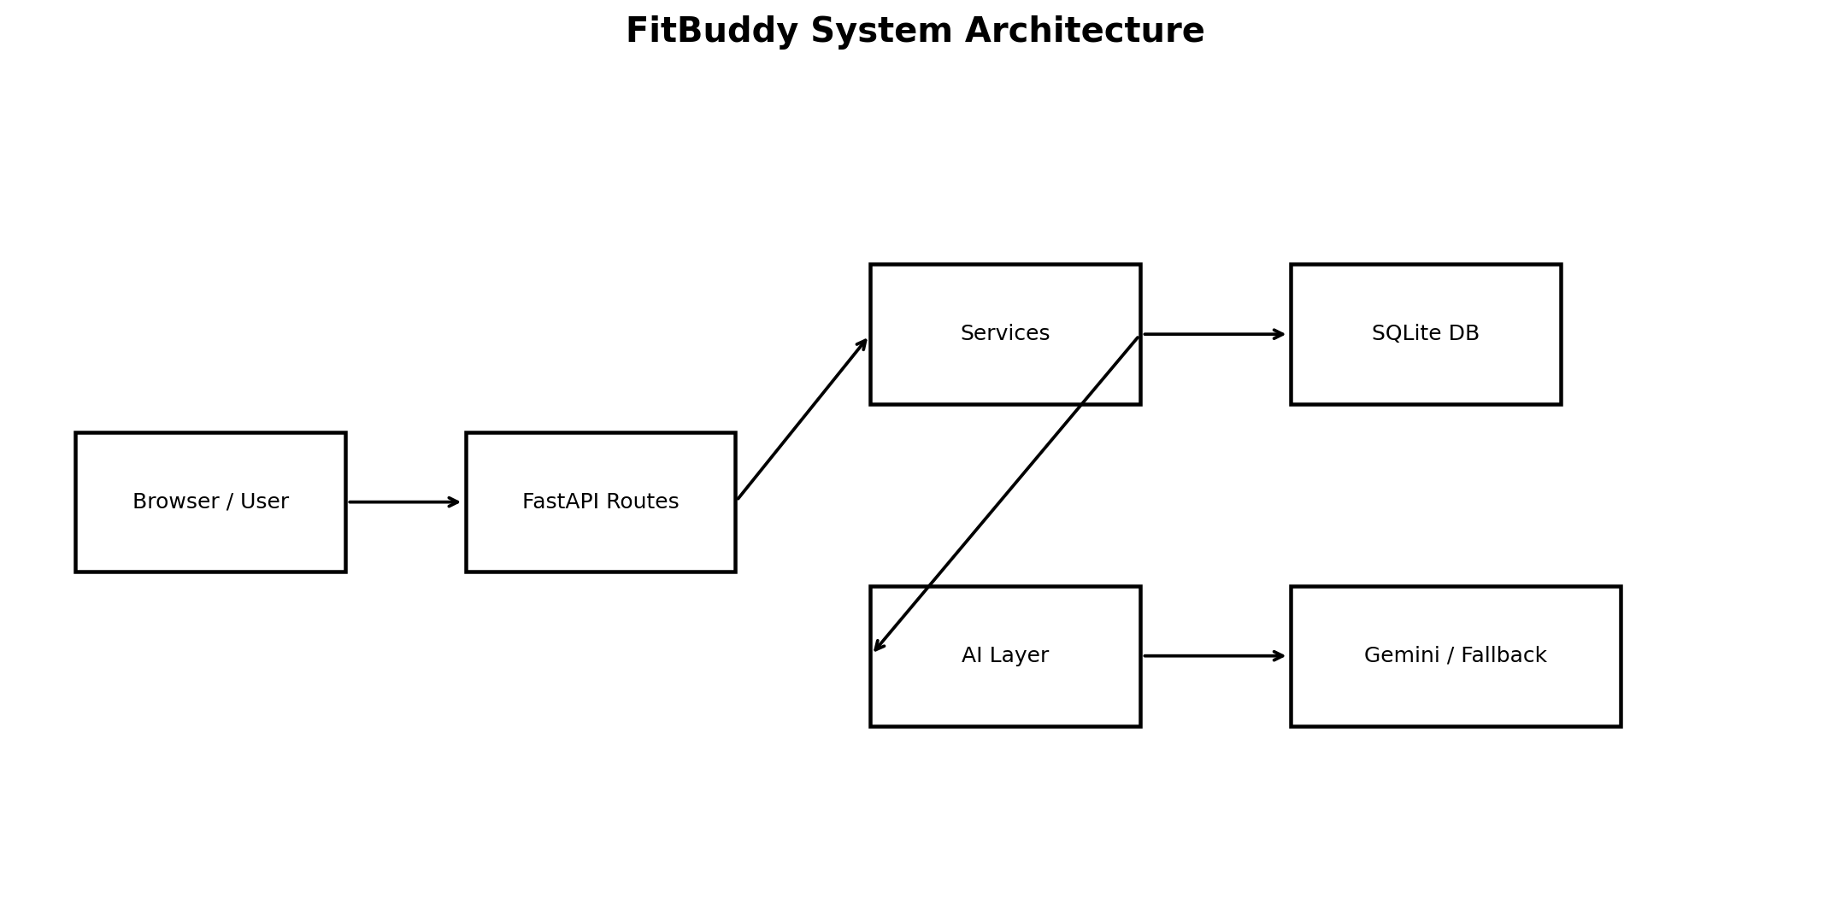

2. Use Case Diagram
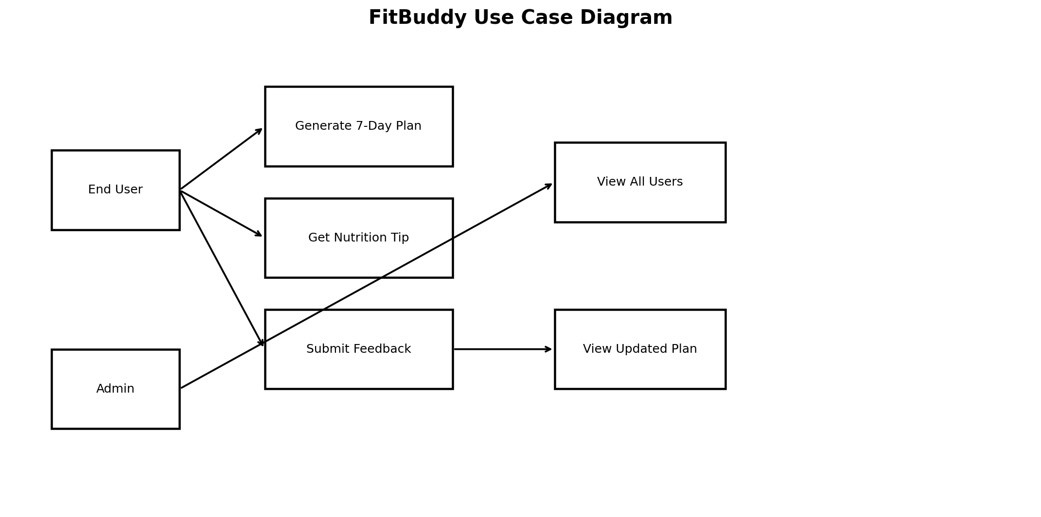

3. Data Flow Diagram
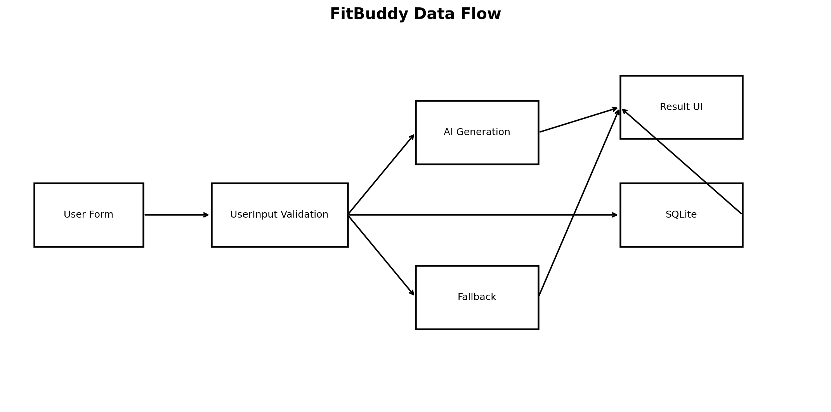

4. System Workflow
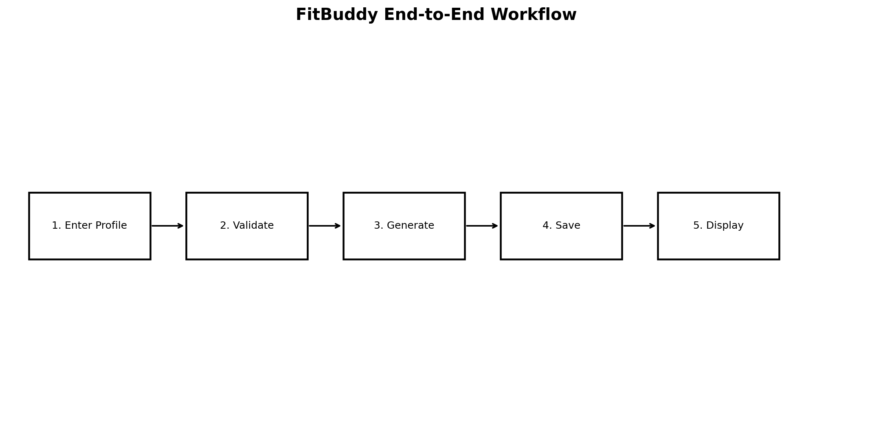

5. AI Generation Flow
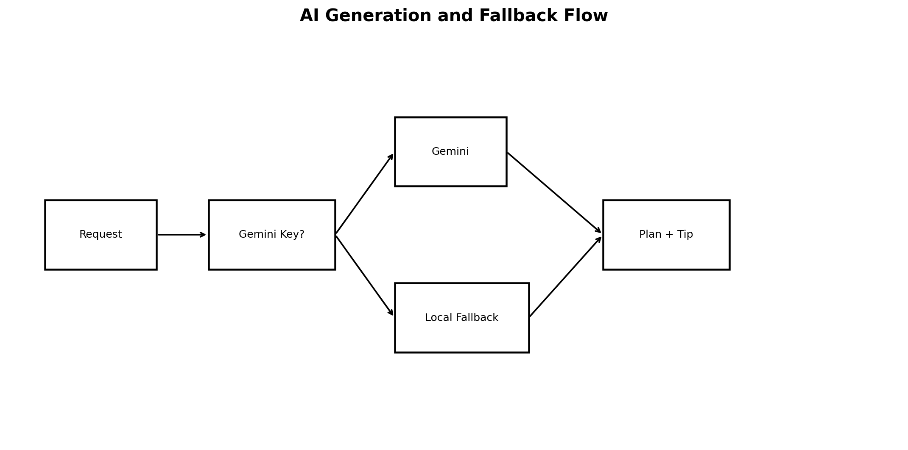

6. Fallback Flow
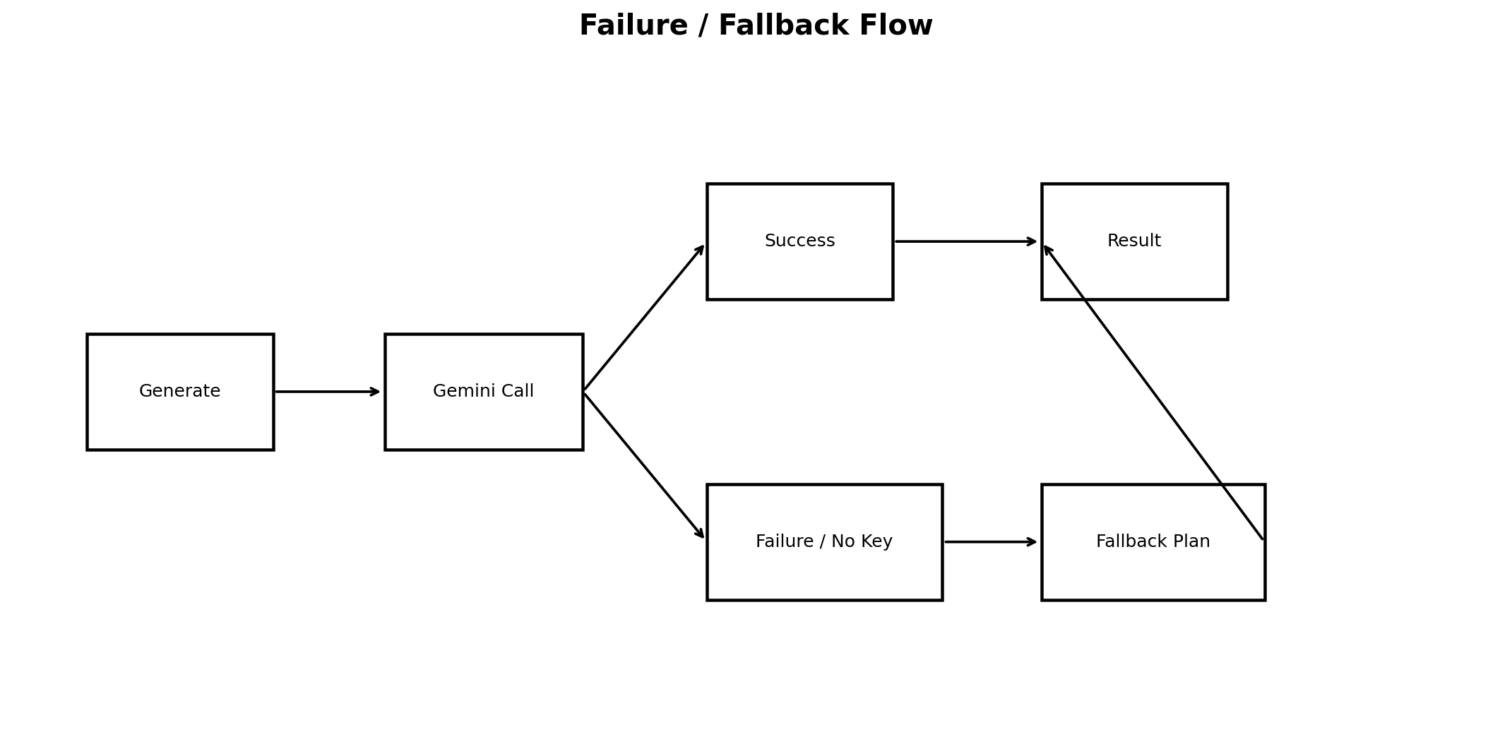

7. Plan Update Flow
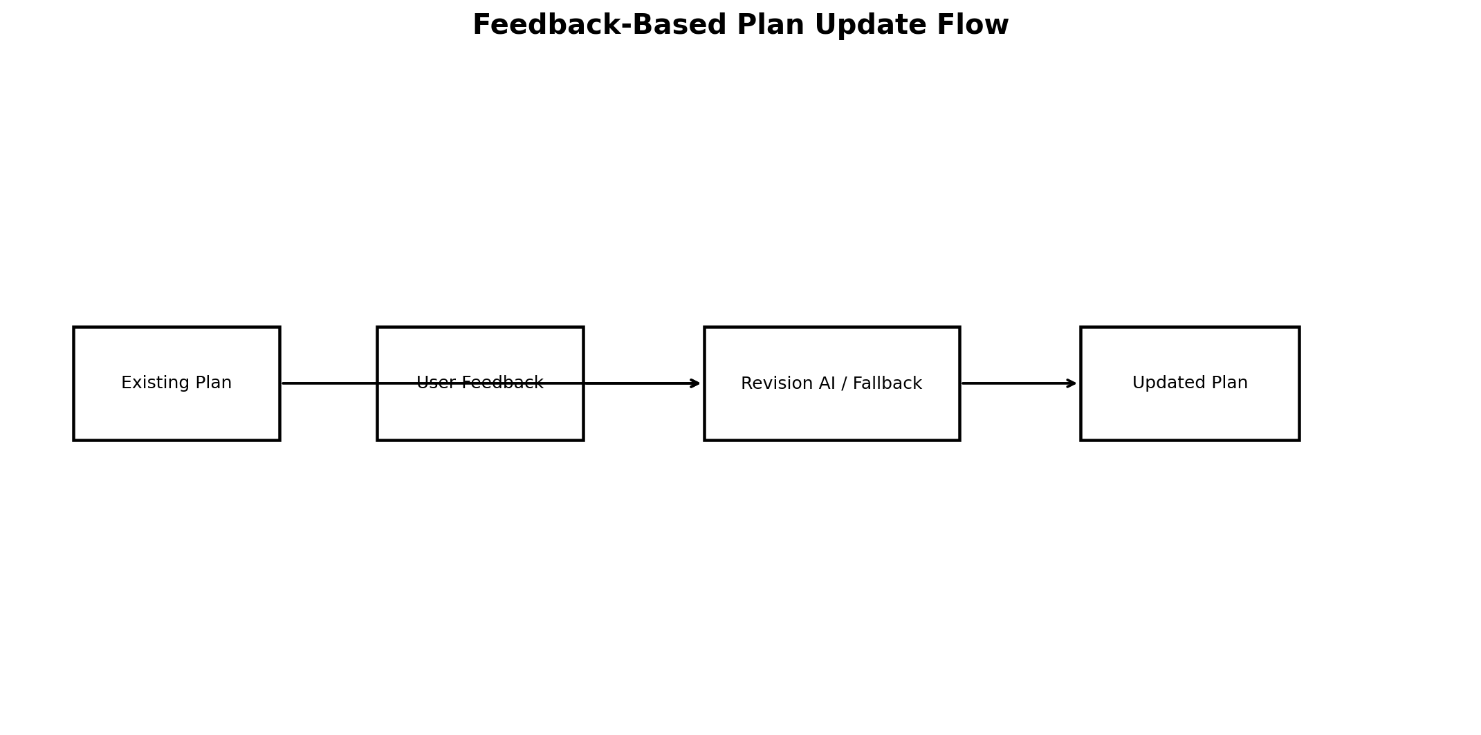

8. Database Design
Table | Important fields | Purpose
users | id, user_id, name, age, weight, goal, intensity, created_at | Stores fitness profile.
plans | id, user_id, original_plan, updated_plan, nutrition_tip, feedback, created_at | Stores generated and revised plans.

