PHASE 7
FitBuddy – Final Project Report

Abstract
FitBuddy is an AI-assisted fitness planning web application built as a FastAPI MVP. It captures a user's basic fitness profile, generates a 7-day workout plan and nutrition/recovery tip, persists the result in SQLite, and supports feedback-driven plan refinement. Gemini integration is optional; the application contains deterministic local fallback logic so the main workflow remains demonstrable without external credentials.

Chapter 1. Introduction
The project addresses the need for a lightweight personalized fitness planning assistant. The emphasis is on a clear user workflow, modular backend design, persistence and resilience to AI-service unavailability.

Chapter 2. Objectives
- Generate practical 7-day plans from a small set of profile inputs.
- Provide a concise nutrition/recovery recommendation.
- Support optional Gemini-based generation.
- Keep the MVP functional without an API key.
- Persist users and plans for later review.
- Allow users to refine plans through feedback.

Chapter 3. Existing Problem
A beginner may need to combine exercise selection, weekly scheduling and nutrition guidance. Manual planning is time-consuming, while AI-only prototypes can become unusable when credentials or network access are unavailable.

Chapter 4. Proposed System
FitBuddy combines a browser form, FastAPI routes, Pydantic validation, an AI layer, SQLite persistence and Jinja2 templates. The AI layer attempts Gemini and falls back to deterministic local content. This makes the project suitable for classroom demonstrations and local development.

Chapter 5. System Design
The design separates routes, schemas, services, database models and AI helpers. The two database tables are users and plans. A user can have multiple plan records; the latest plan is selected when feedback is submitted.
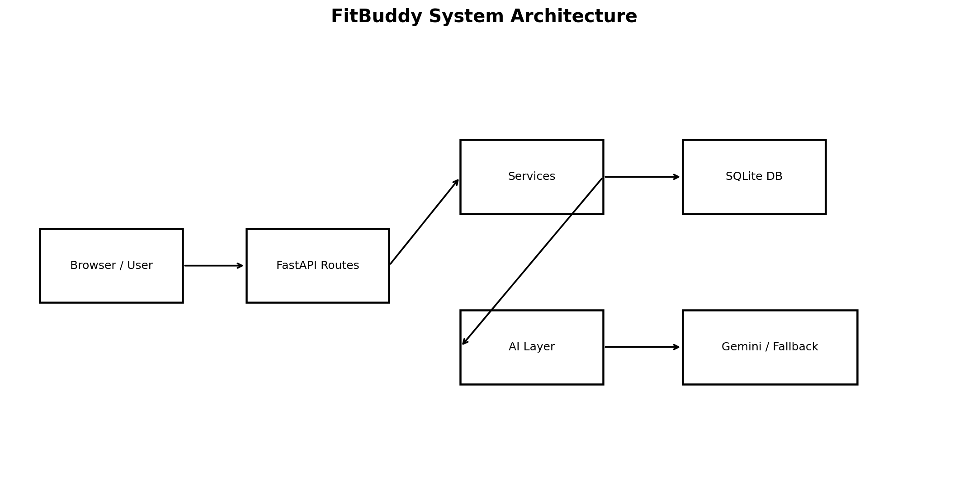

Chapter 6. Implementation
The main entry point is app.main:app. The run.py script starts Uvicorn on 127.0.0.1:8000. Routes expose the home page, generation endpoint, feedback endpoint and all-users view. The optional Gemini client is isolated from the rest of the application.

Chapter 7. Testing and Results
The repository's pytest suite was executed and completed with 5 passed tests. Coverage includes home page availability, Swagger availability, generation without Gemini, feedback-based revision and the unknown-user error path.

Chapter 8. Security and Safety Considerations
- API keys are read from environment variables.
- Input validation limits age and weight and restricts goal/intensity values.
- The generated workout includes a warning to adjust difficulty and stop for pain, dizziness or unusual symptoms.
- The application should not be treated as medical diagnosis or professional medical advice.

Chapter 9. Limitations and Future Enhancements
- Add authentication and role-based authorization.
- Add structured exercise metadata and equipment preferences.
- Add progress tracking, charts and history filters.
- Add stronger AI output validation and provider observability.
- Add automated database migrations.
- Add production-grade secret management and rate limiting.
- Add richer test coverage for live provider failure cases.
- Add optional wearable integrations and exercise media.

Chapter 10. Conclusion
FitBuddy demonstrates a complete AI-assisted web application pipeline in a compact MVP: validated user input, AI-or-fallback generation, persistent storage, plan refinement and automated tests. The fallback design is a central reliability feature because the application can still demonstrate its core workflow without a Gemini credential.

References
- FastAPI documentation
- Pydantic documentation
- SQLAlchemy documentation
- Google GenAI Python SDK documentation
- Pytest documentation
- Python standard library documentation

