CE 4720 – Computer Applications in Highway and Traffic Engineering
Homework 1 – R

For codes please refer adjoining R script file
This document contains outputs, plots and inferences

1.a) Continuous Variable: If a variable can take all values between any two real numbers it is called a continuous variable.
Discrete variable: If a variable cannot take all values between any two real numbers it is called discrete variable.

1.b) Quantitative data: Data that is a measure of count or values is called quantitative data.
Qualitative data: Data that is a measure of approximation or characterization is called qualitative data.

1.c) Objects used in R:
- Vectors: Simplest data structure in R, can store data of the same type.
- Matrix (Arrays): Multidimensional generalization of vectors.
- Factors: Provide a compact way to handle categorical data.
- Data frames: Matrix like structures, in which the columns can be of different types.
- Lists: General form of a vector in which the elements may not be of the same type.
- Functions: These are objects in R that can be stored in project’s workspace.

1.d) Exploratory data analysis: It is an approach to analyzing data sets to summarize their main characteristics through visual representation.

1.e) Indexing of vectors: Indexing of vectors can be done using square brackets. For example, a is the following vector (1,2,3,4,5,6,7,8,9,10)
- a[1] gives the first element of vector a, ‘1’.
- a[1:5] gives the first five elements of vector a, ‘1 2 3 4 5’.
- a[!is.na(x)] gives only those elements that satisfy the logical condition inside the [], ‘1 2 3 4 5’.
- iv) a[-1:-2] drops the first two elements and gives the rest of the vector.

2.a)
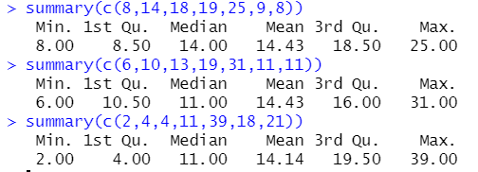

2.b)
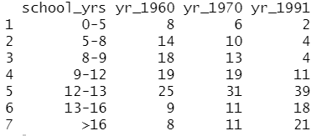

2.c) Class intervals are not uniform. So, we should make the class interval length equal to before plotting the histogram.

2.d) We observe the spikes at ‘8-9’ and ’12-13’ because the new class interval is equal to the original class interval for these two classes.

2.e) The distribution shifts towards the right as year increases. This may be as the result of awareness of the importance of education.

3.a) Type of UCBAdmissions dataset is ‘double’ and belongs to class ‘table’.

3.b) The first 5 rows of the dataset is as follows,

Admit Gender Dept Freq
1 Admitted Male A 512
2 Rejected Male A 313
3 Admitted Female A 89
4 Rejected Female A 19
5 Admitted Male B 353
. . . . .
. . . . .
. . . . .

3c) percent_male_admitted = 26.46929
percent_male_rejected = 32.98719
percent_female_admitted = 12.30667
percent_female_rejected = 28.23685

3.d) Most females applied for departments with high demand (a smaller number of available seats), while males applied for departments with less demand. As a result, more males got admitted when compared to females.

4.a)
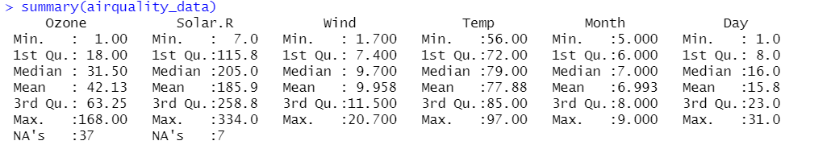

4.b) When we directly try to compute the mean we get NA as output because the data has missing values (NA). After removing the NA values, the mean of Ozone levels comes out to be 42.12931.

4.c) The wind speed gets Right-skewed as the Ozone level increases i.e., wind speed decreases as Ozone level rises.

4.d) Temperature rises as Ozone level rises. In most cases Solar.R seems to increase as Ozone increases but there doesn’t seem to be a definite linear relationship between Solar Radiation and Ozone levels.

4.e) The correlation values seem to be more or less consistent with the observations made from the CrossTable.
- Ozone vs Wind = -0.6015465 (-ve means as one variable increases other var decreases)
- Ozone vs Temp = 0.6983603 (+ve means as one variable increases other var increases)
- Ozone vs Solar.R = 0.3483417 (Even though correlation value is +ve, the value is close to zero. So, linearity between the variables is very less – no definite relationship)

4.f) In general, Ozone levels seem to be higher on weekends (this is because people travel often during weekdays for jobs, schools, etc…)

4.g) Ozone levels differ significantly while comparing May and September. When compared to May, September has a very high variation.

5.a) Histograms:
There are two extreme cases for number of bins used in a histogram,
- You can put all cases into one bin (the plot will have only one class interval with frequency = no. of data points). This does not provide useful information about distribution shape.
- You can make bin width so narrow that each bin contains only one score or a few scores. Depending on the way your scores are distributed, this might or might not produce a useful picture. You could conceivably end up with a uniform distribution (each class interval with frequency = 1).
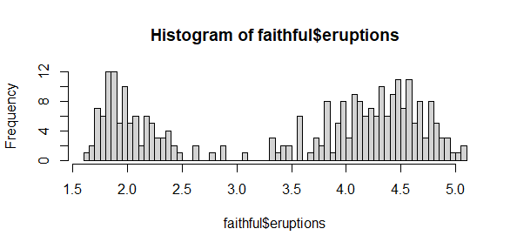

5.b) Density plots:
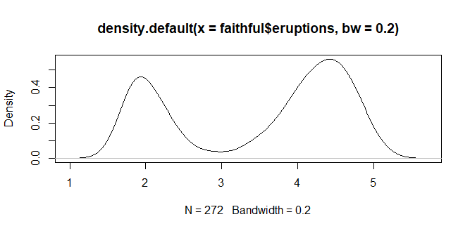

5.c) Scatter plots:
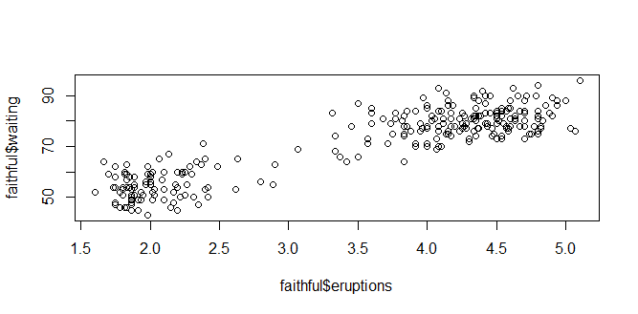
5.d) Time series plots:
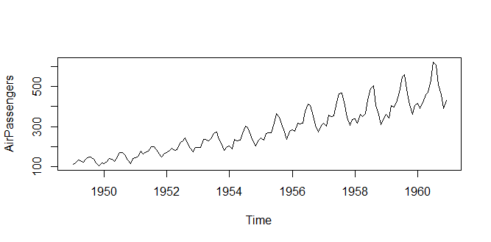
5.e) Box plots:
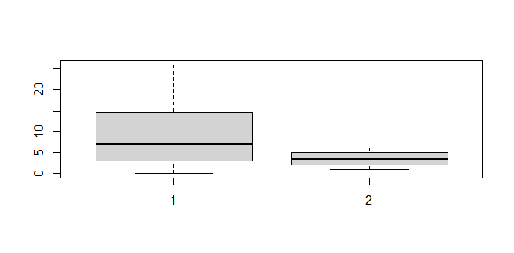
5.f) Bar plots:
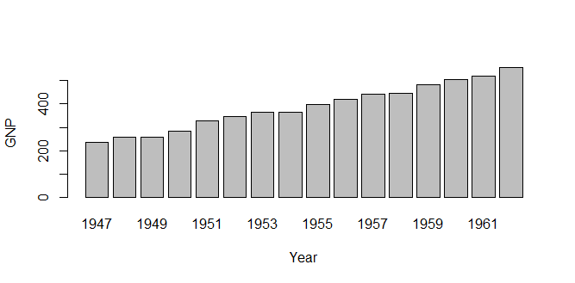
5.g) Pie charts:
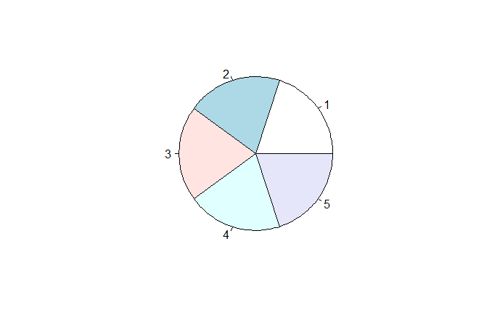

6. Scatter plot of Ozone versus Temp data:

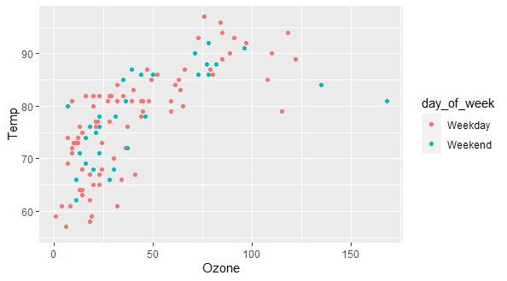

7. 5% quantile – 2
10% quantile – 3
75% quantile – 12

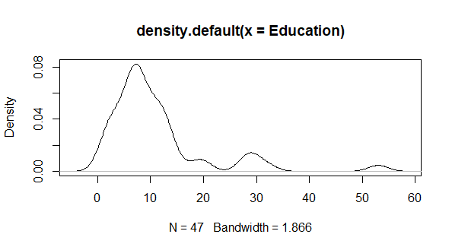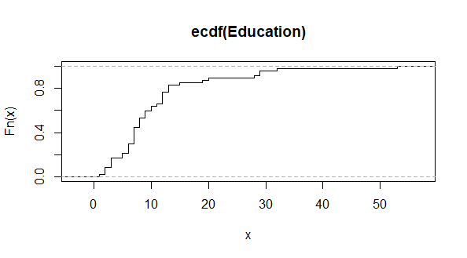
No, the probability distribution is not symmetric. The distribution in Right-skewed

8. Carbon dioxide concentrations v/s carbon dioxide uptake rates:
- Covariance = 1552.687
- Correlation = 0.4851774

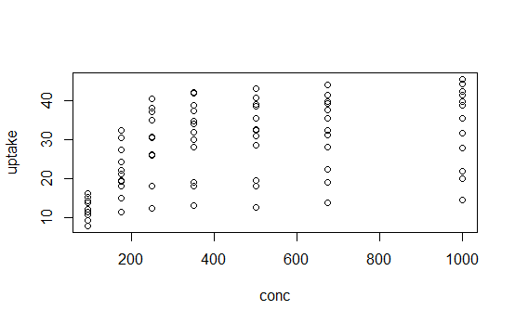
From the correlation value we may think that ‘uptake’ is linearly dependent on ‘conc’ of C02. But in this case, we are comparing categorial variable with a continuous variable. So, correlation value must not be used to infer the linear relationship between ‘uptake’ and ‘conc’.

