**EXP NO 2** Create a simple cloud software application for Property Buying & Rental process (In Chennai city) using any Cloud Service Provider to demonstrate SaaS include the necessary fields such as Buy, Rent, commercial, Rental Agreement, Rental Agreement, Area, place, Range, property value etc.

**PROCEDURE**

**STEP 1** GO TO ZOHO.COM

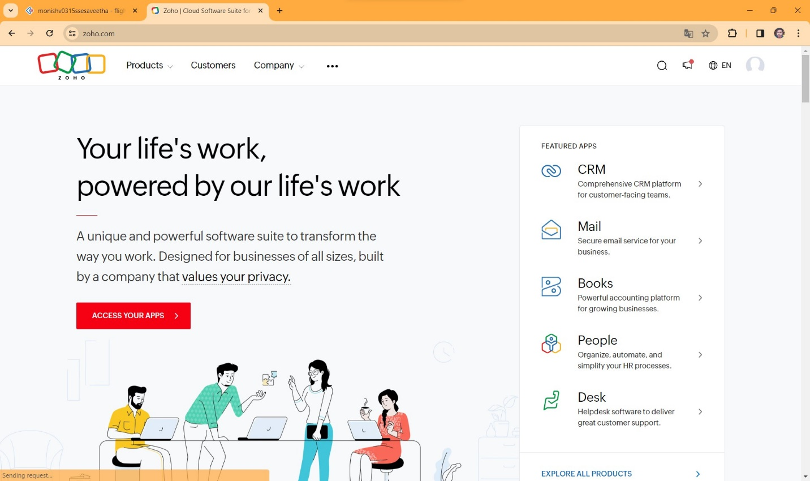

**STEP2** LOGIN TO THE ZOHO.COM

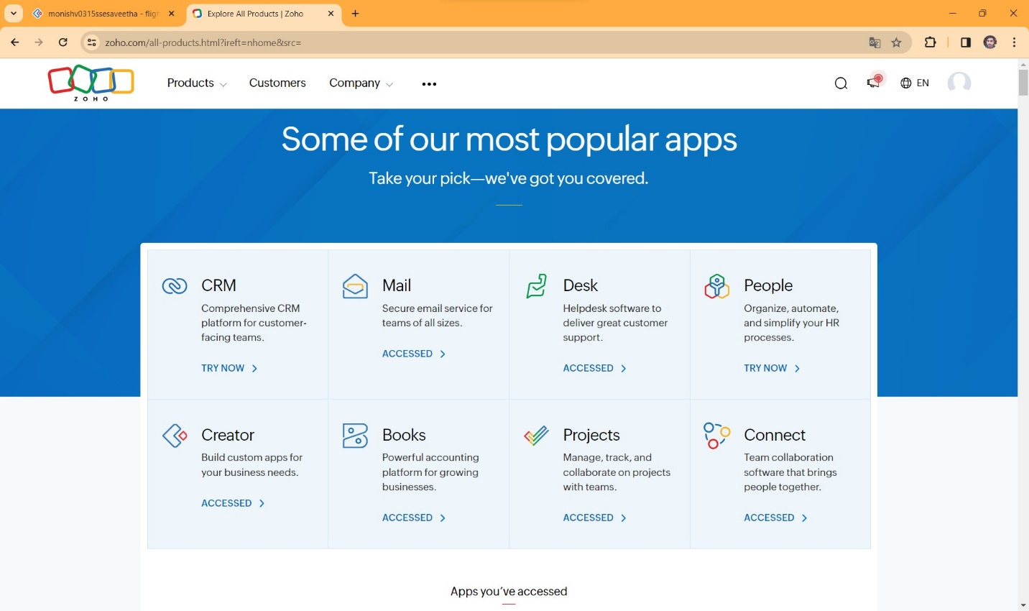

**STEP:3** SELECT A CREATE FROM SCRATCH

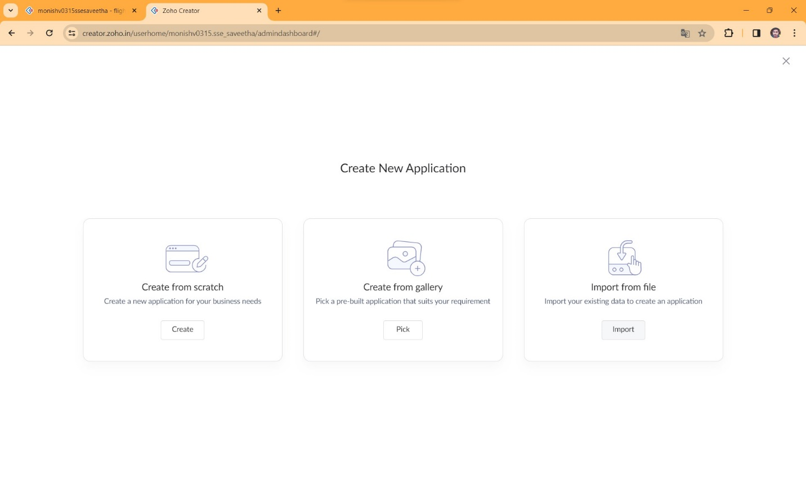

**STEP 4** SELECT APPLICATION NAME AS PROPERTY BUYING AND RENTAL

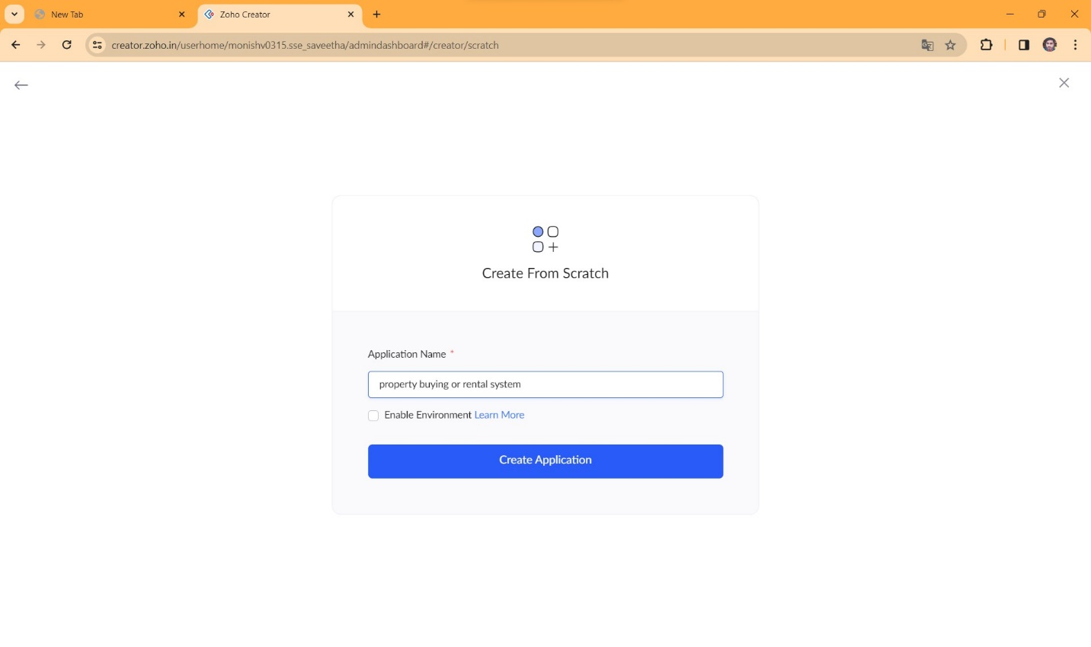

**STEP 5** CREATE A NEW FORM

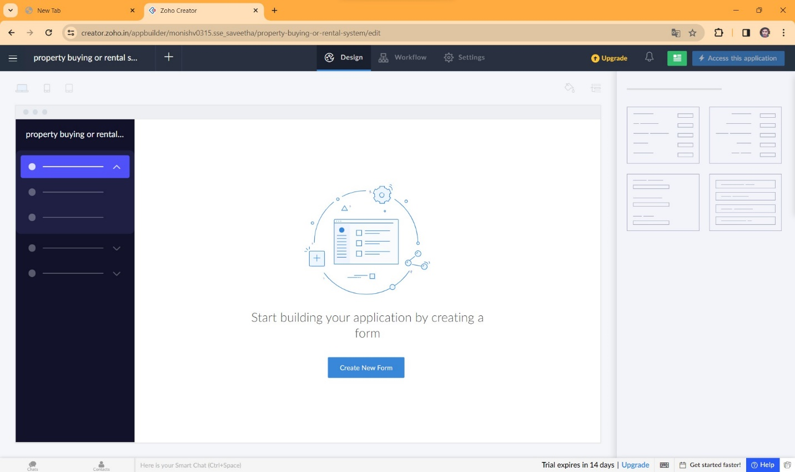

**STEP 6** SELECT BASIC FIELD FROM GIVEN BELOW AND DEVELOP APPLICATION

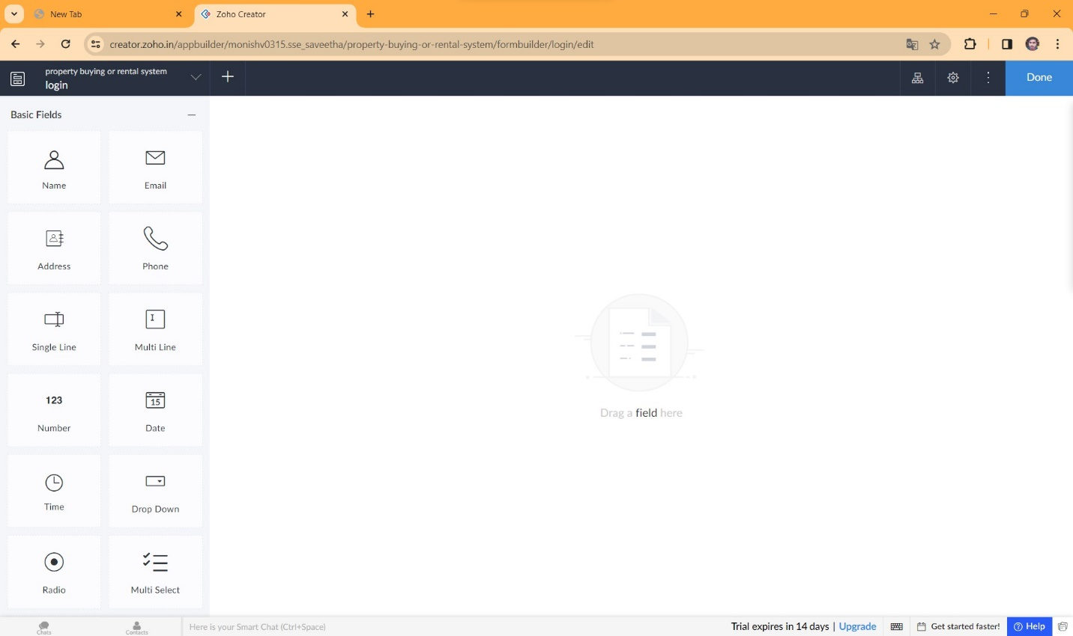

**STEP 7** THE SOFTWARE HASE BEEN CREATED LOGIN PAGE

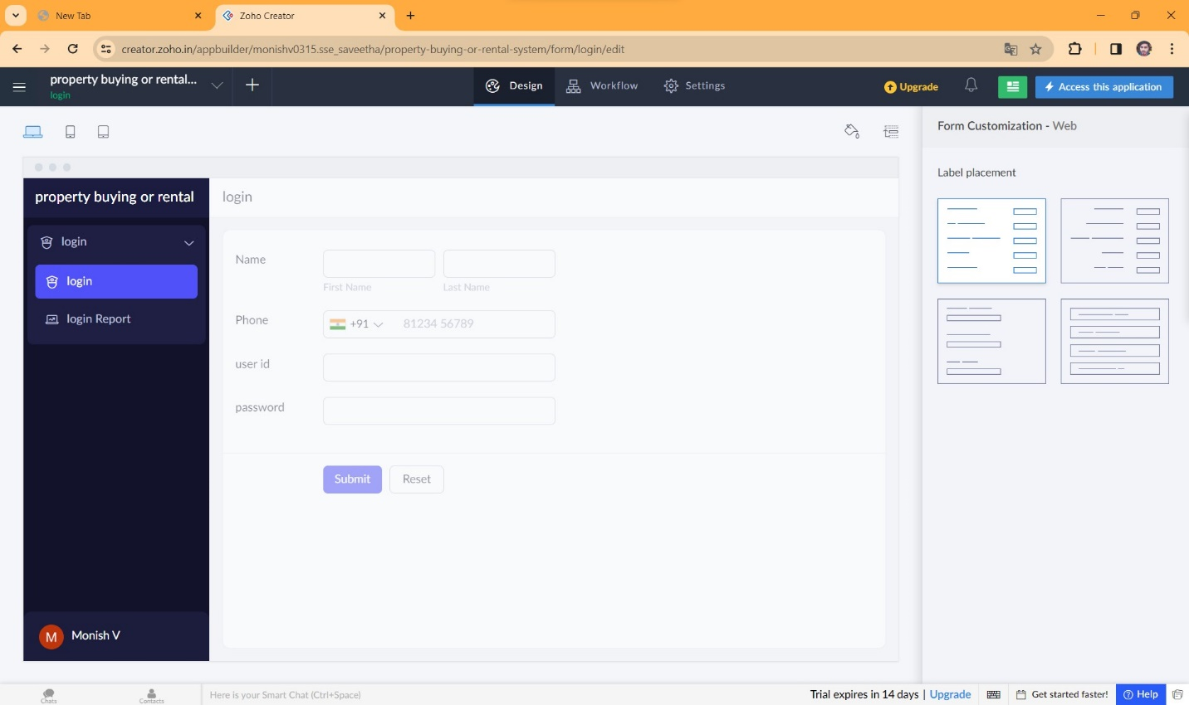

**STEP 8** THE SOFTWARE HASE BEEN CREATED OWNER

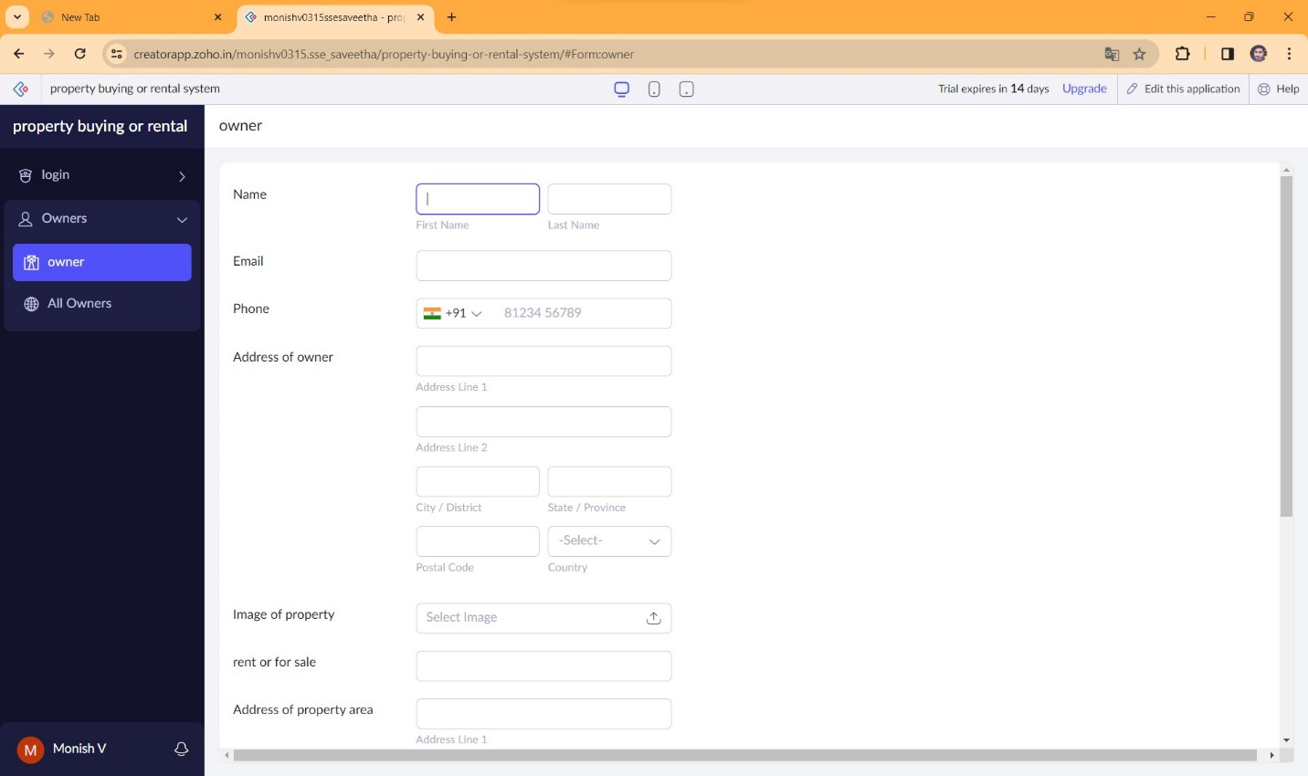

**STEP 9** THE SOFTWARE HASE BEEN CREATED BUY OR TENANT

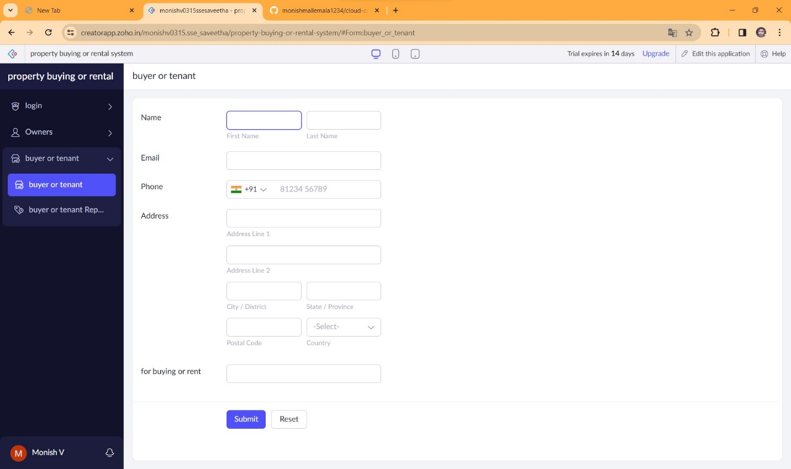

**STEP 10** THE SOFTWARE HASE BEEN CREATED VERIFICATION

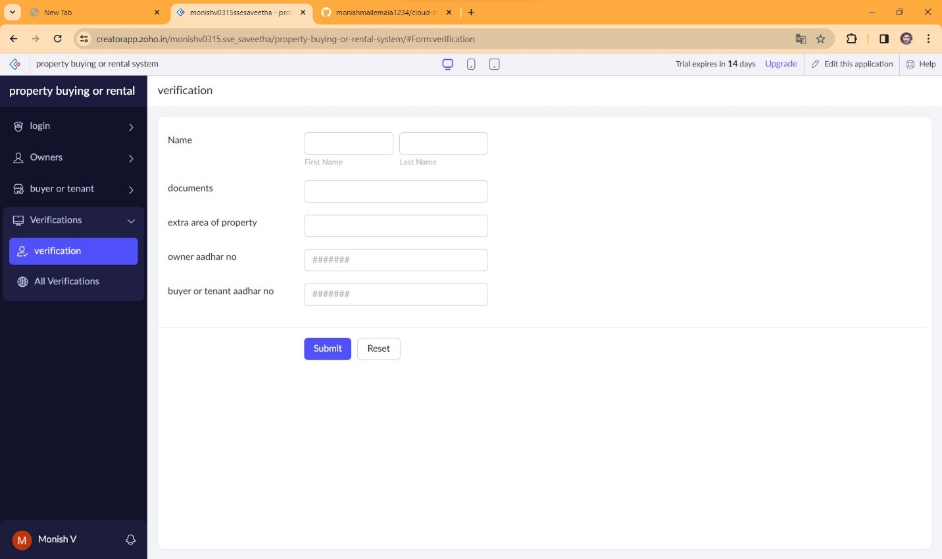

**STEP 11** THE SOFTWARE HASE BEEN CREATED PAYMENT

