**EXP NO 1** Create a simple cloud software application for Flight Reservation System using any Cloud Service Provider to demonstrate SaaS include the necessary fields such as one-way, round trip, From, to, Departure, Departure, Travelers & Class, Fare Type, International and Domestic Flights etc.

**PROCEDURE**

**STEP 1** GO TO ZOHO.COM

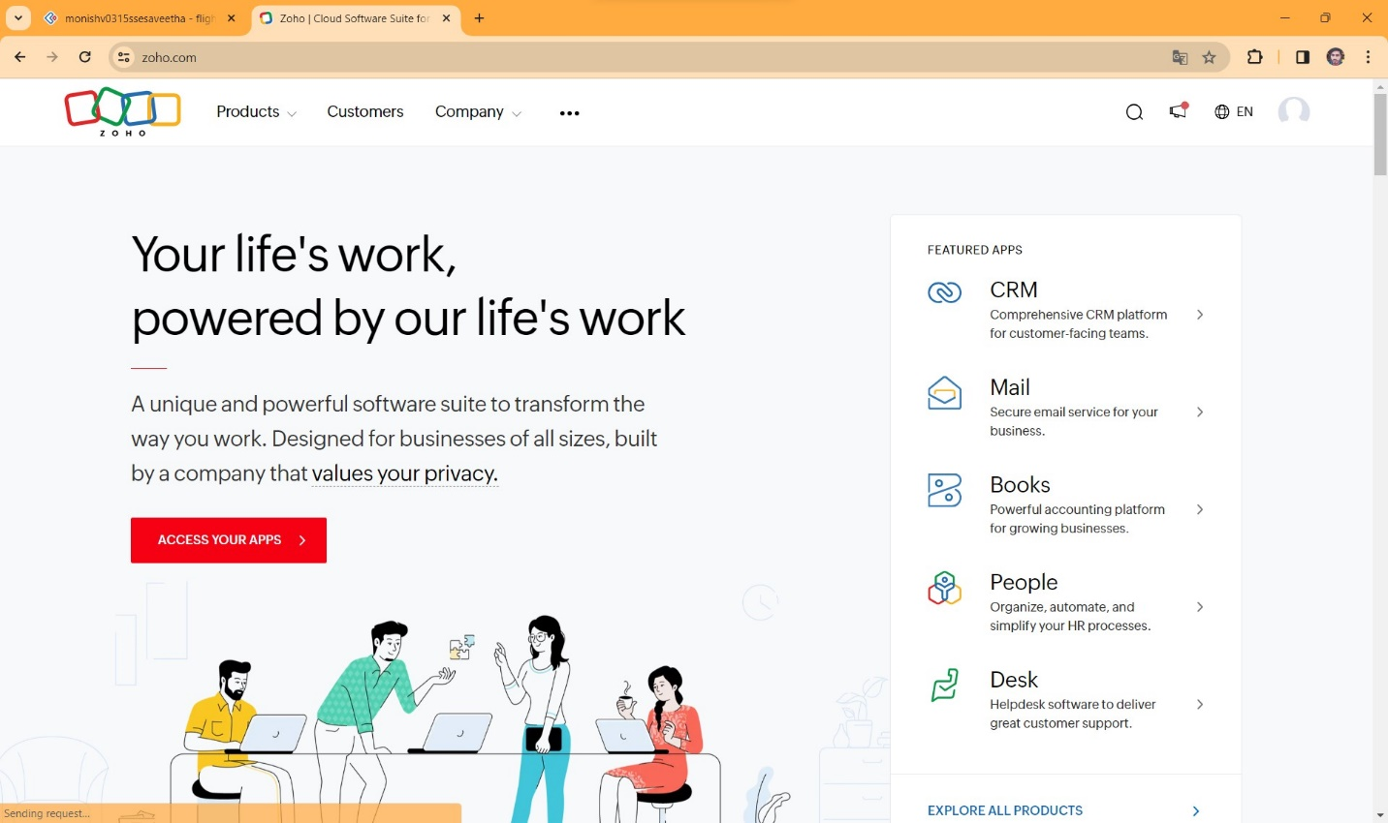

**STEP2** LOGIN TO THE ZOHO.COM

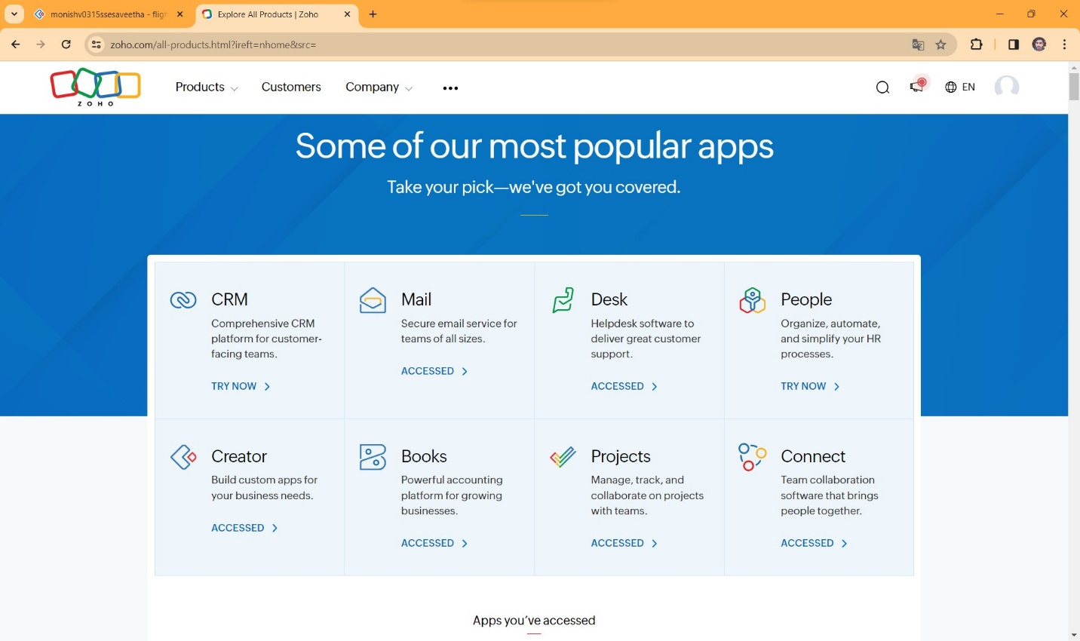

**STEP 3** SELECT A CREATE FROM SCRATCH

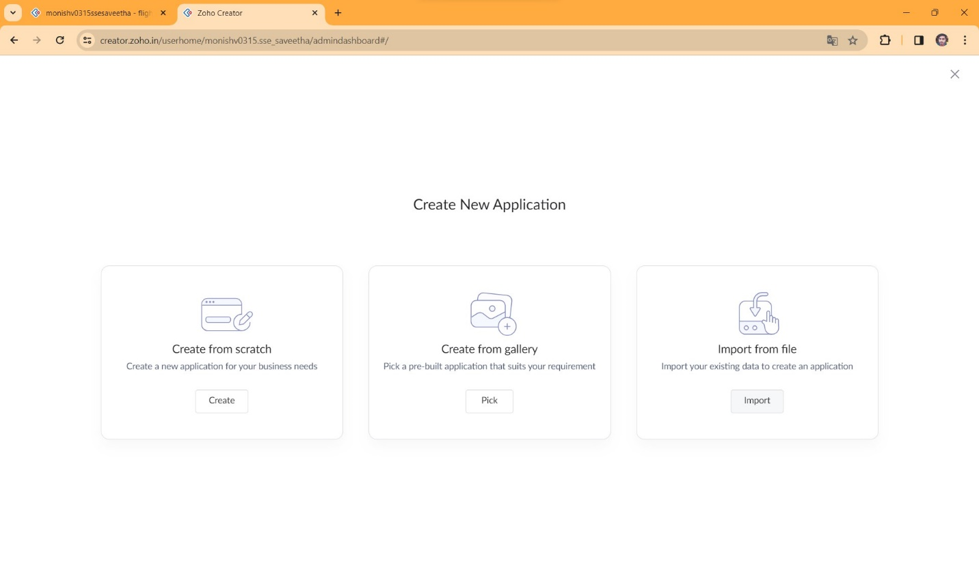

**STEP 4** SELECT APPLICATION NAME AS FLIGHT RESERVATION SYSTEM

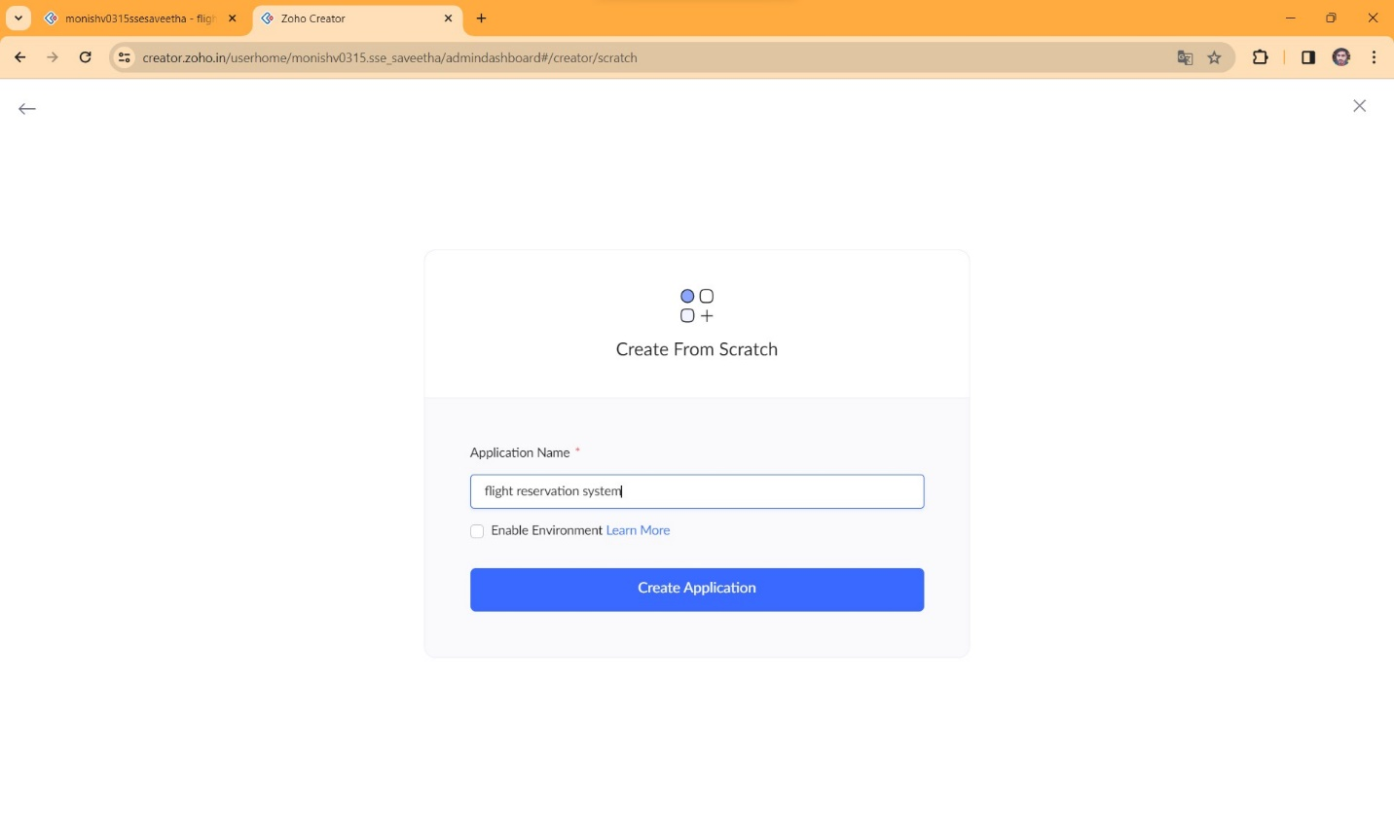

**STEP 5** CREATE A NEW FORM

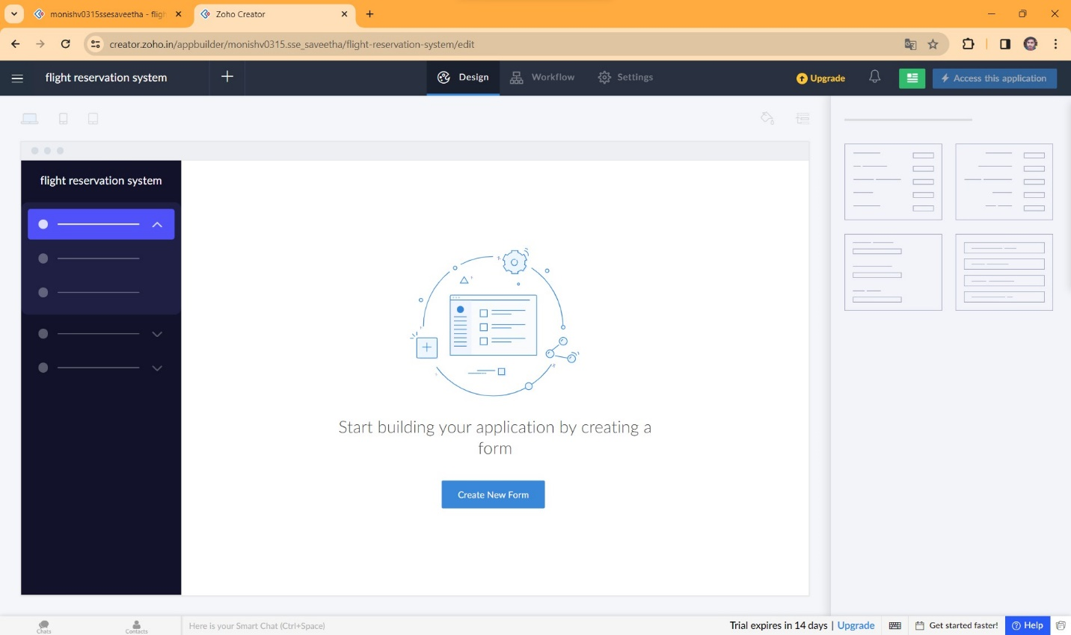

**STEP 6** SELECT BASIC FIELD FROM GIVEN BELOW AND DEVELOP APPLICATION

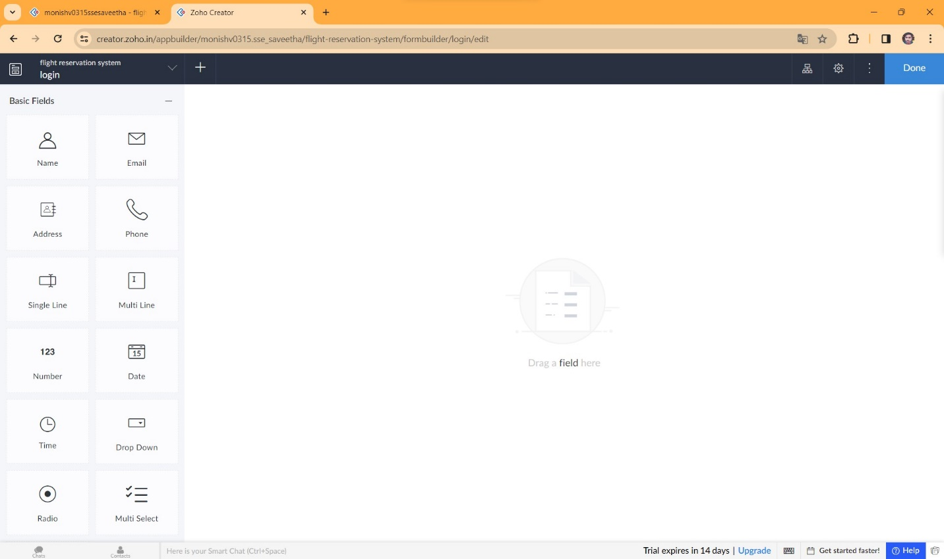

**STEP 7** THE SOFTWARE HASE BEEN CREATED LOGIN PAGE

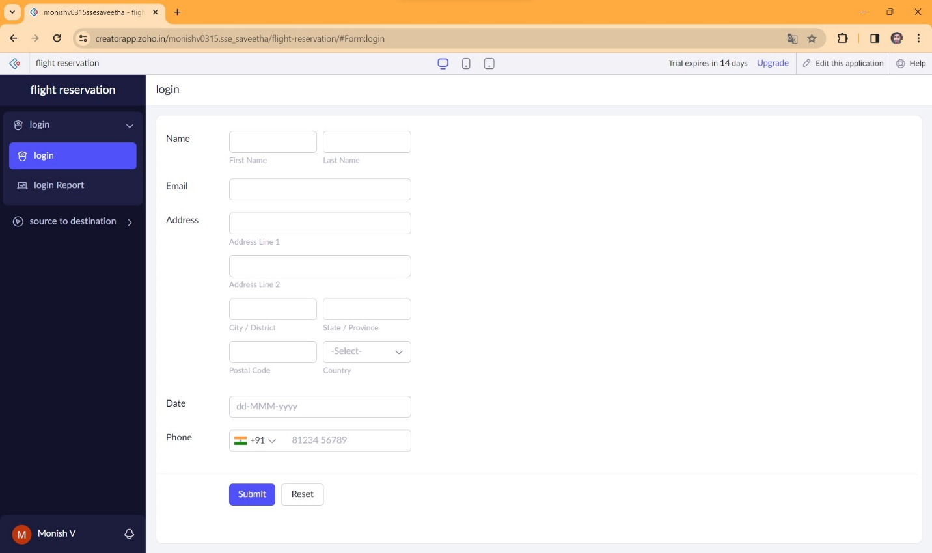

**STEP 8** THE SOFTWARE HASE BEEN CREATED WHERE TO WHERE

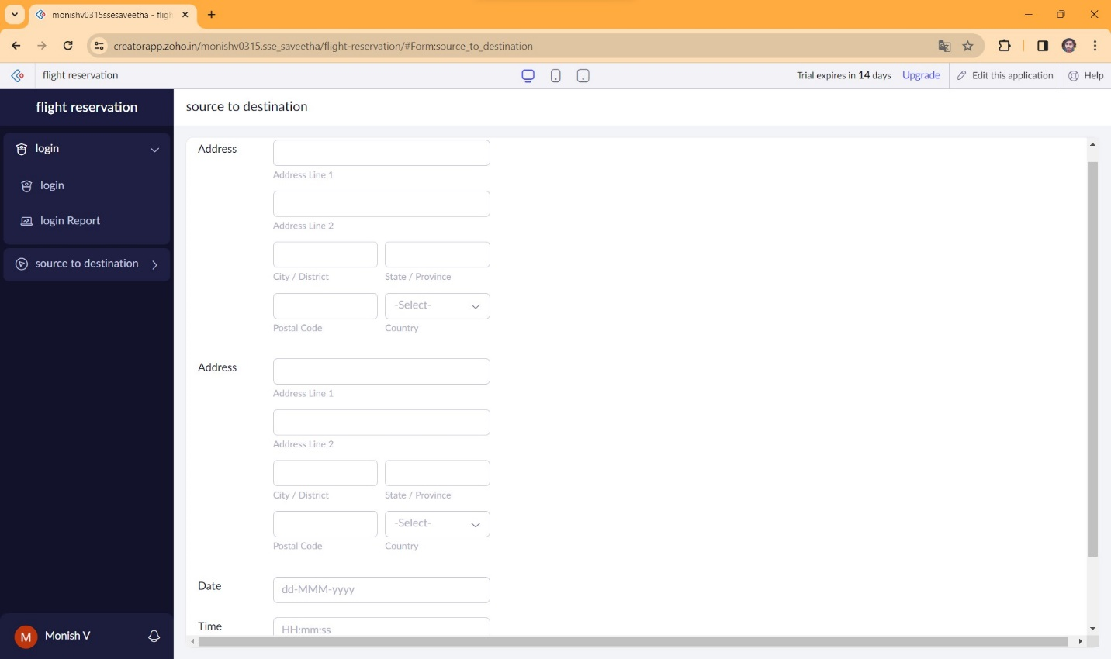

**STEP 9** THE SOFTWARE HASE BEEN CREATED AVAILABILITY OF FLIGHTS AND SEATS

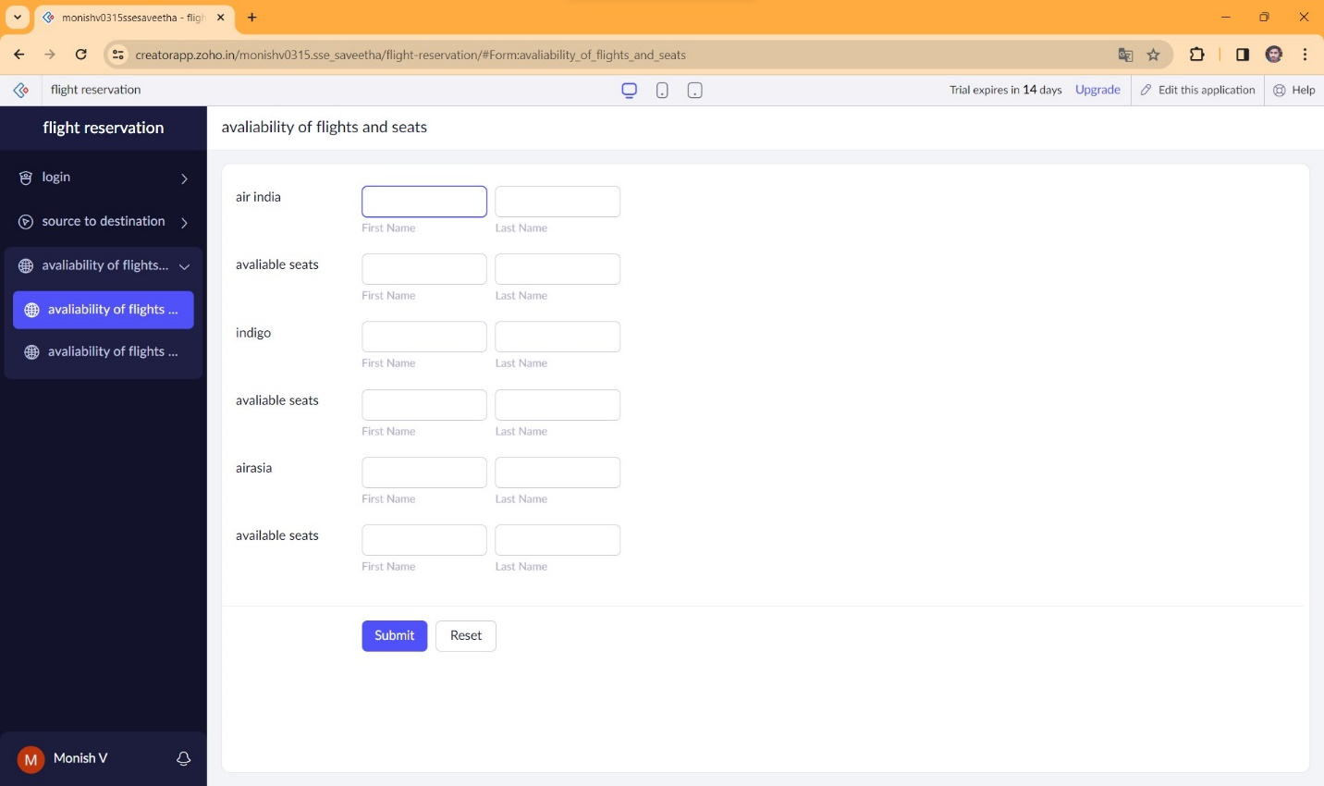

**STEP 10** THE SOFTWARE HASE BEEN CREATED BOOKING

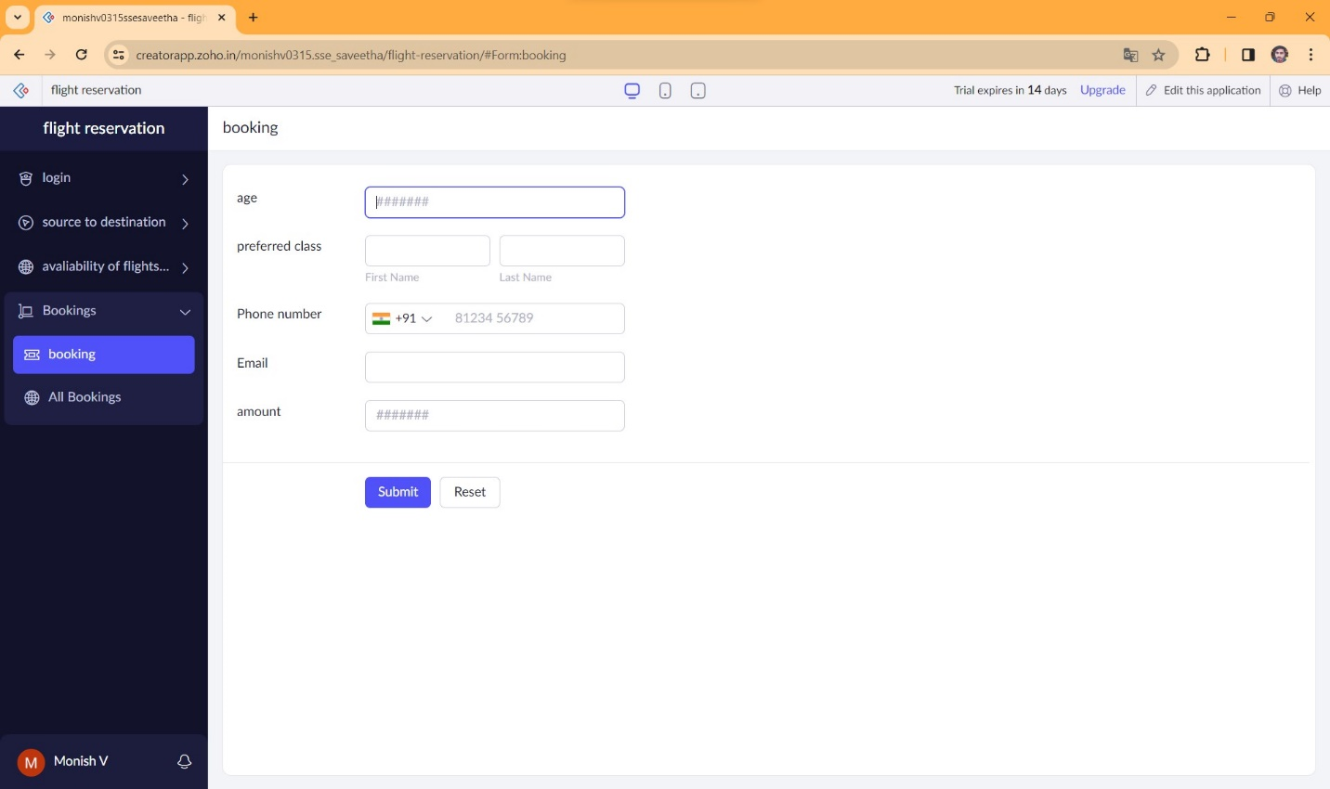

**STEP 11** THE SOFTWARE HASE BEEN CREATED PAYMENTS

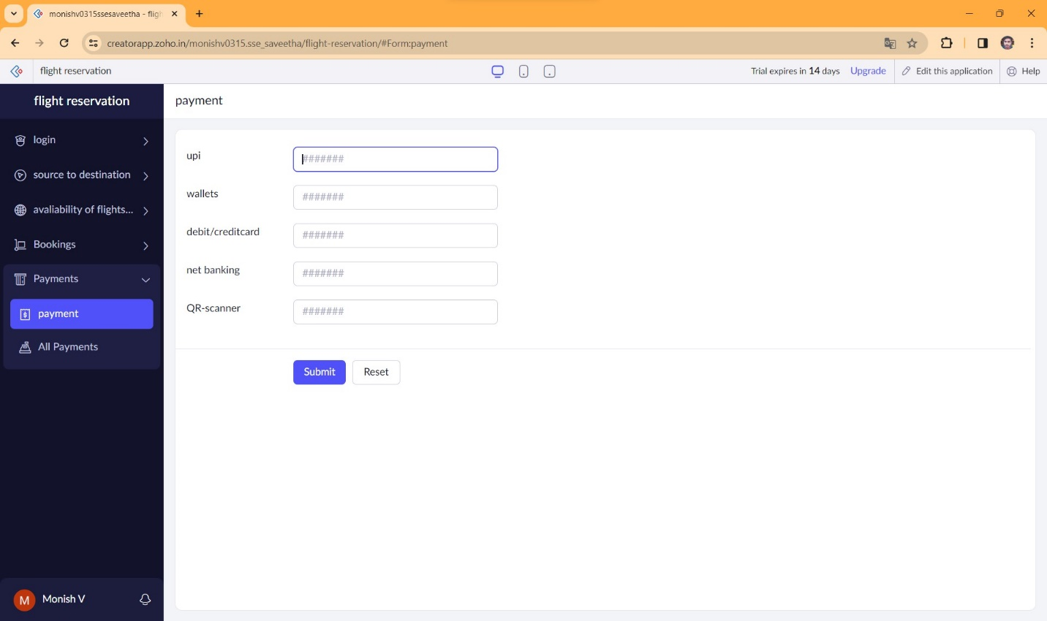

**STEP 12** THE SOFTWARE HASE BEEN CREATED

