**EXP 11)** Demonstrate virtualization by Installing Type -2 Hypervisor in your device, create and configure VM image with a Host Operating system (Either Windows/Linux).

**PROCEDURE:**

**STEP 1:** install VM ware software

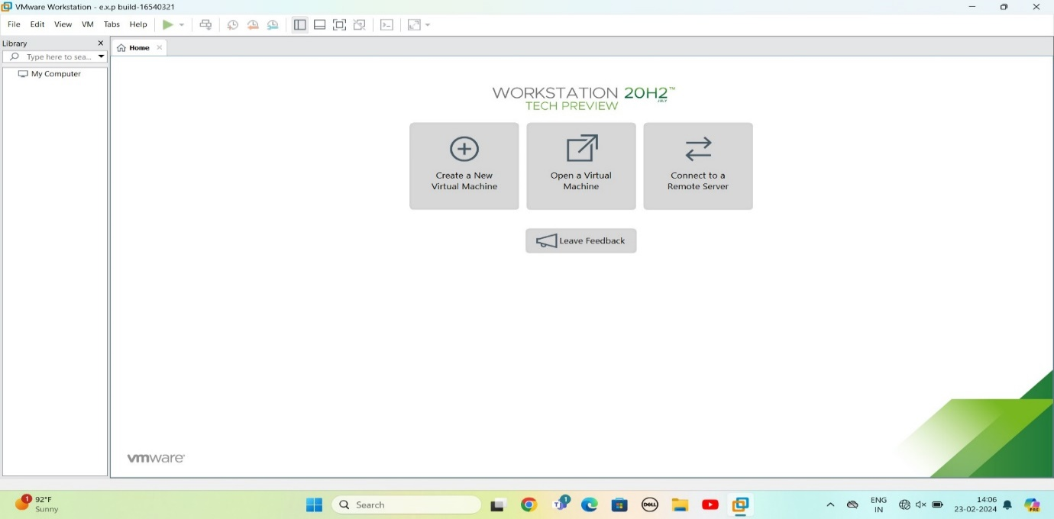

Step 2: CREAT A NEW VIRTUAL MACHINE

GIVE NEXT

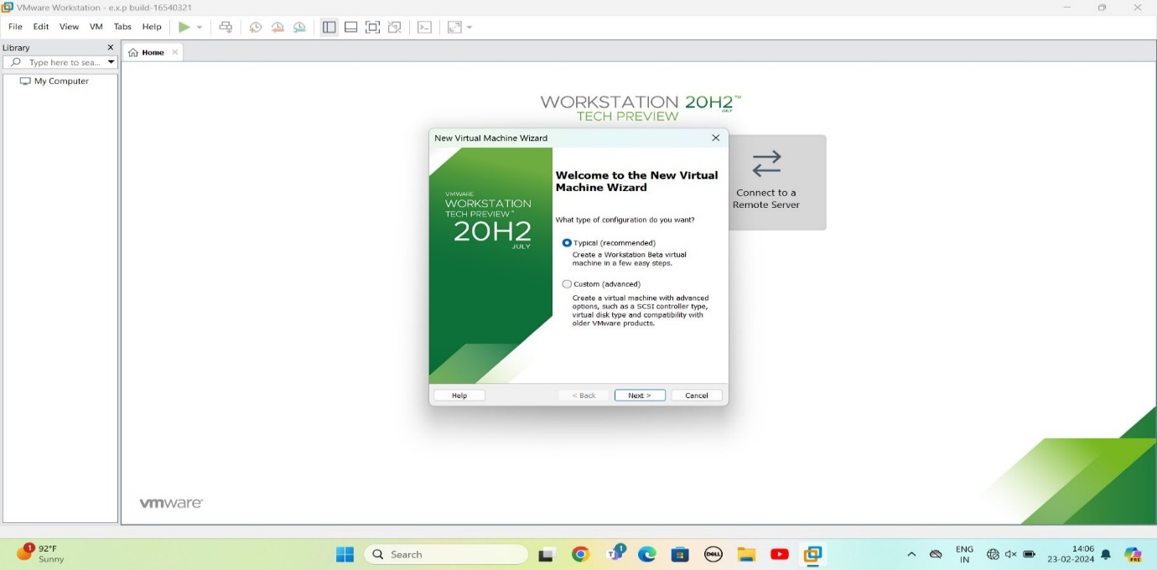

STEP 3: select INSTALL disc image file

Choose browse image file

Give next

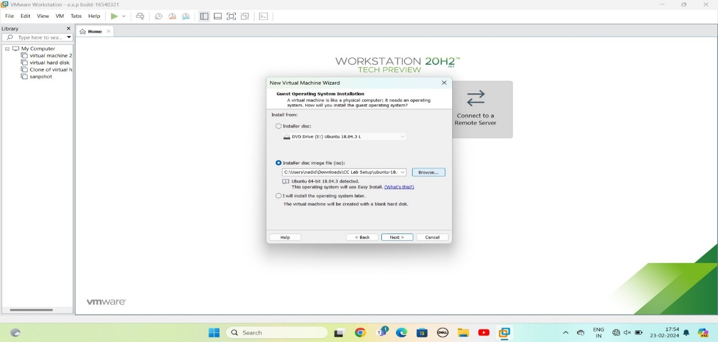

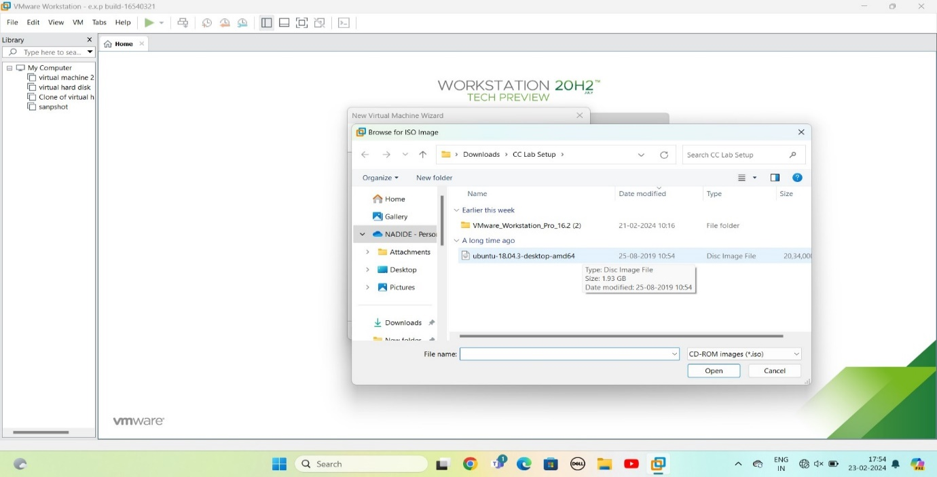

**Step 4:** easy install information

Give next

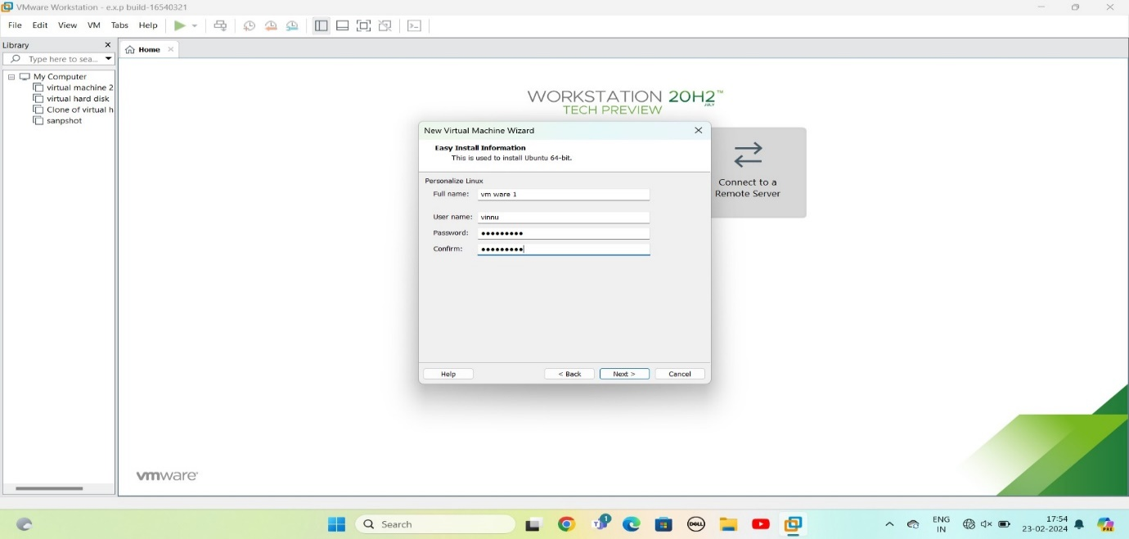

**Step 5:** Ready to create virtual machine

Give finish

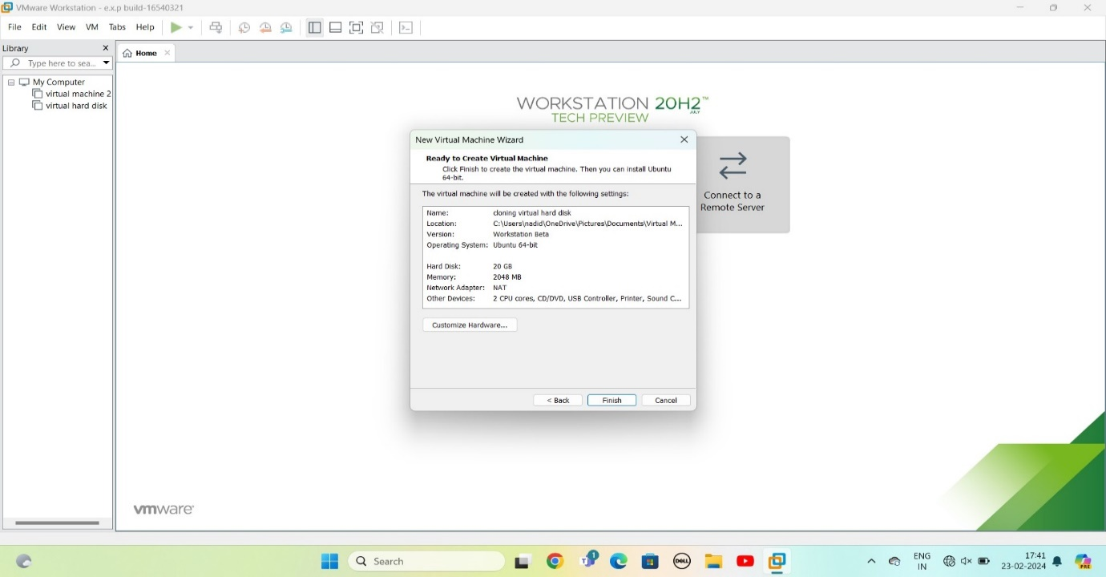

**Step 6:** OS installing

Give ok

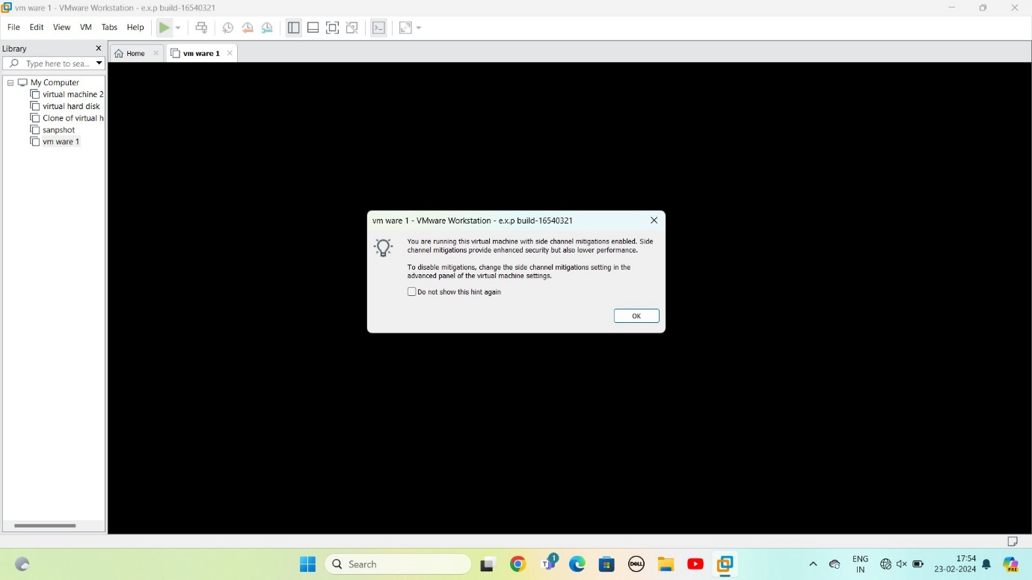

**Step 7:** running program

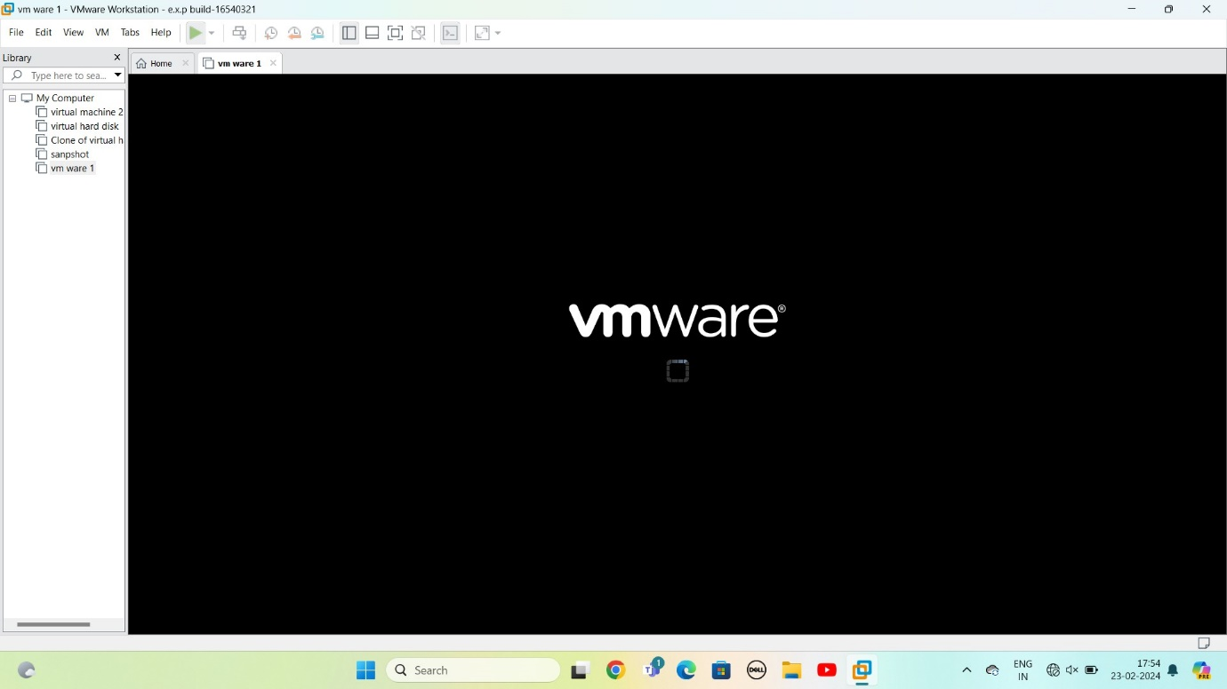

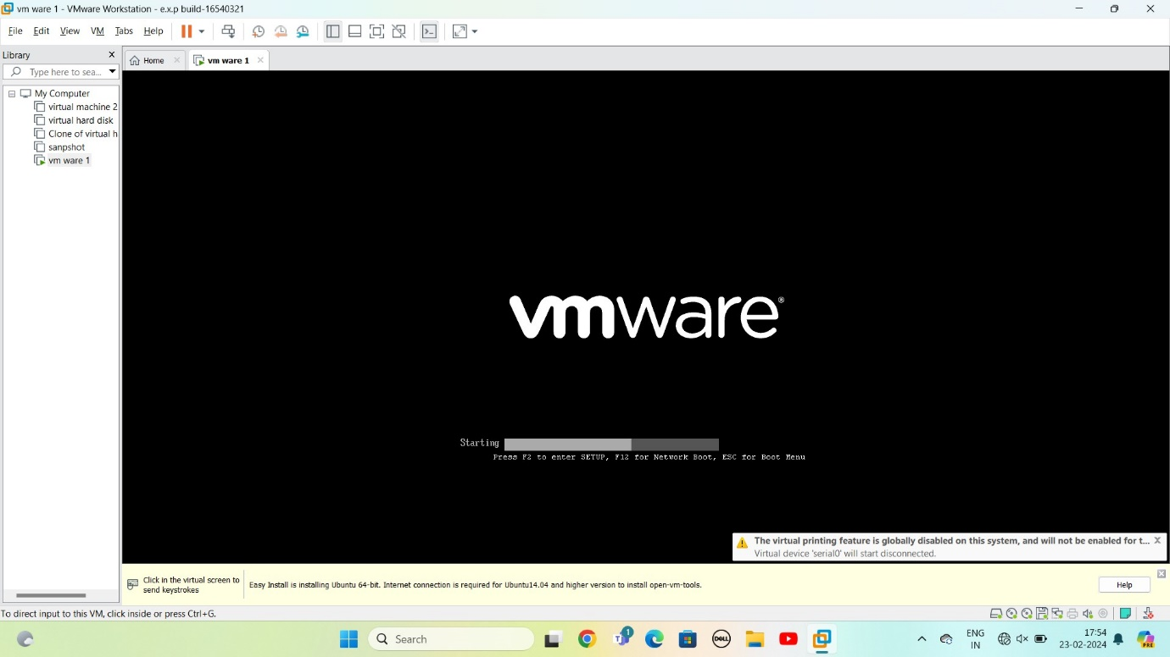

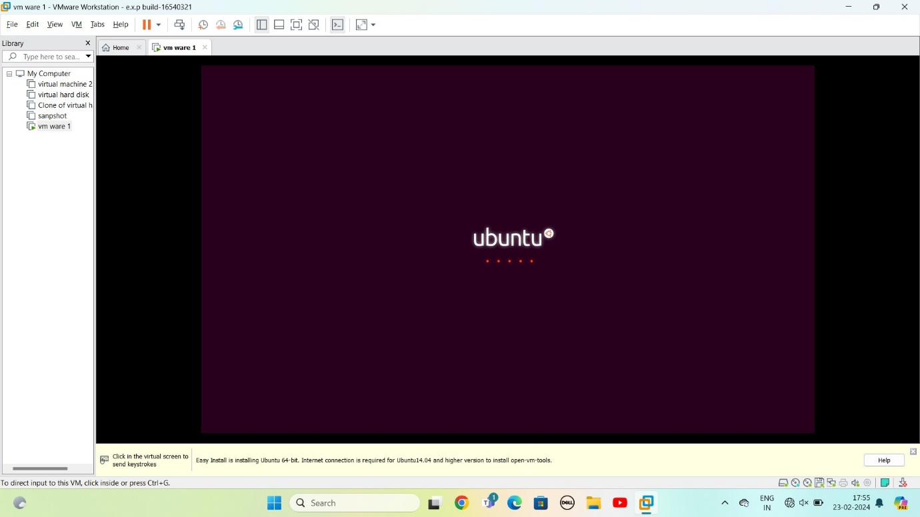

**Step 8:** installing software os

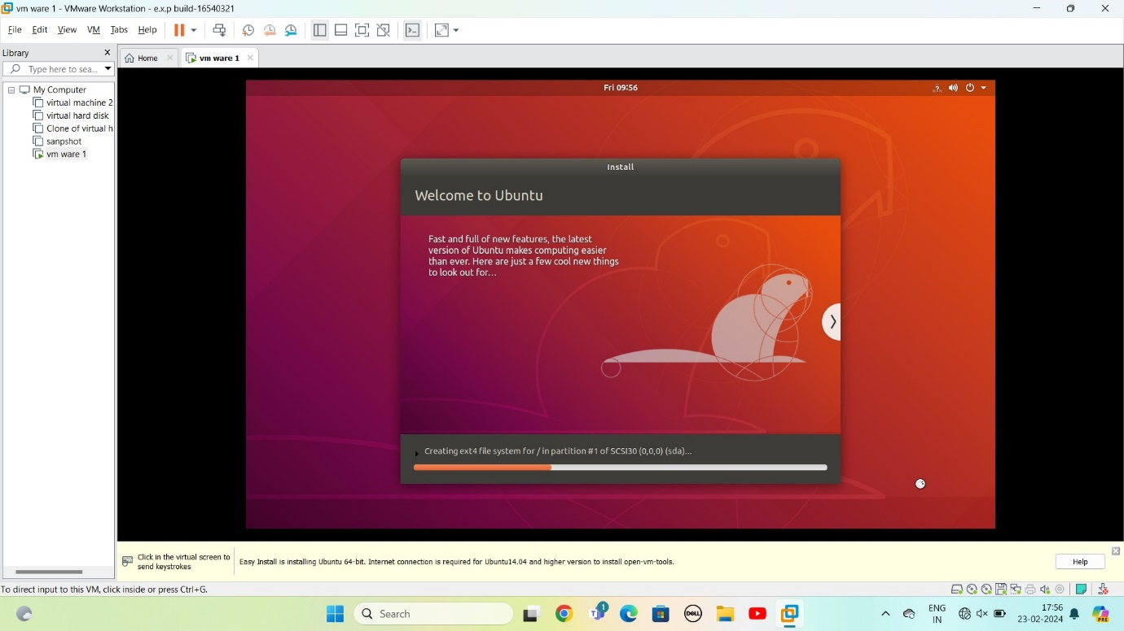

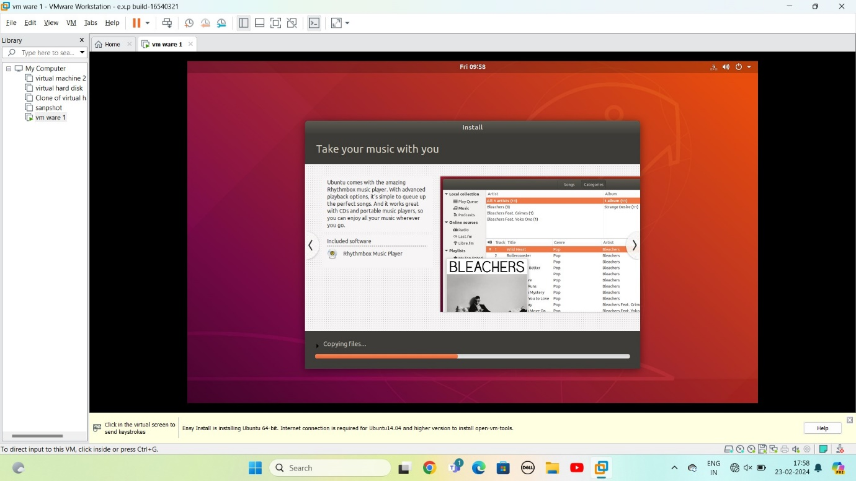

Step 9: if installation completed

It will ask user name and password

Enter it

It show screen with apps

