**EXP 12**) Create a Virtual Machine with 1 CPU, 2GB RAM, and 15GB storage disk using a Type 2 Virtualization Software

**PROCEDURE:**

**STEP 1:** Install VM ware software

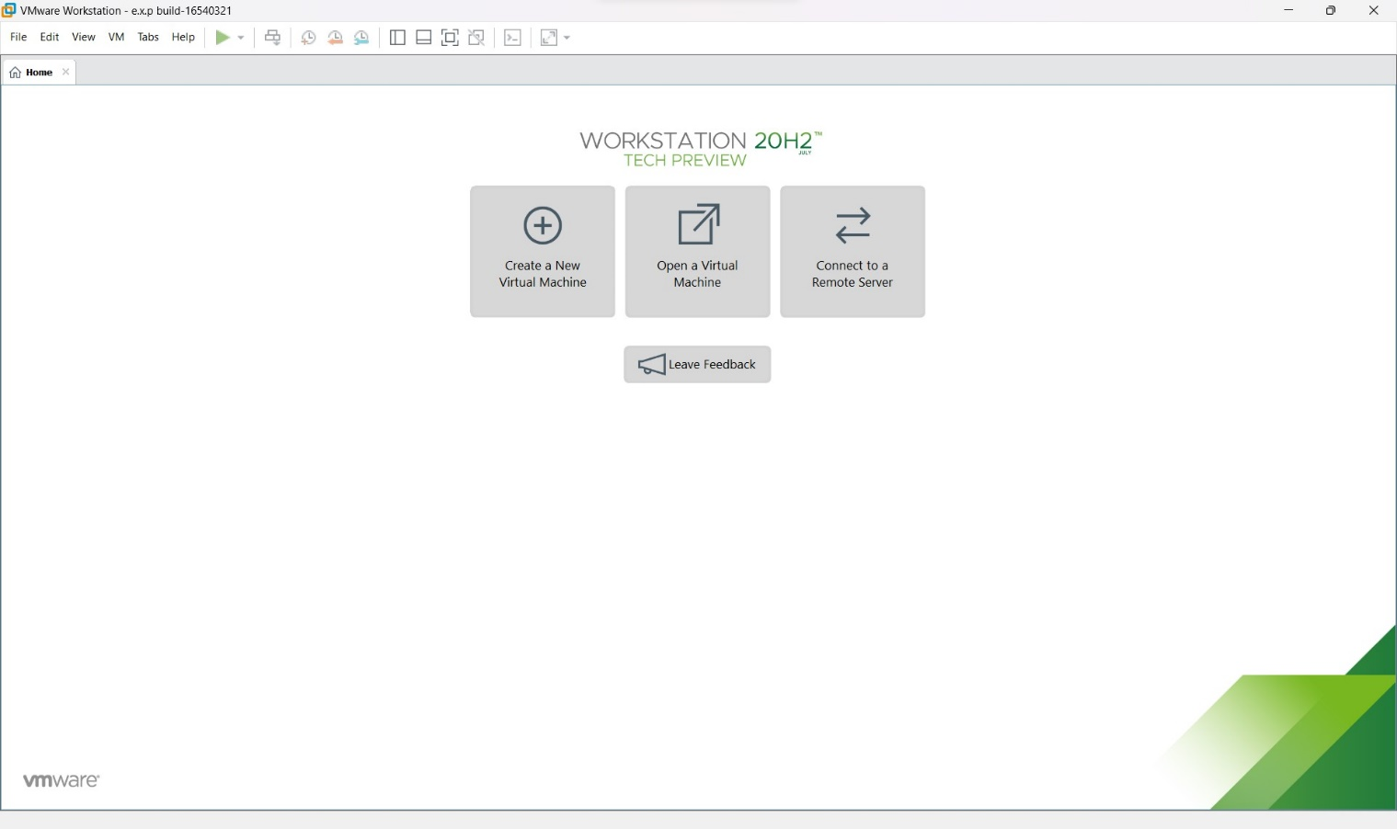

Step 2: CREAT A NEW VIRTUAL MACHINE

GIVE NEXT

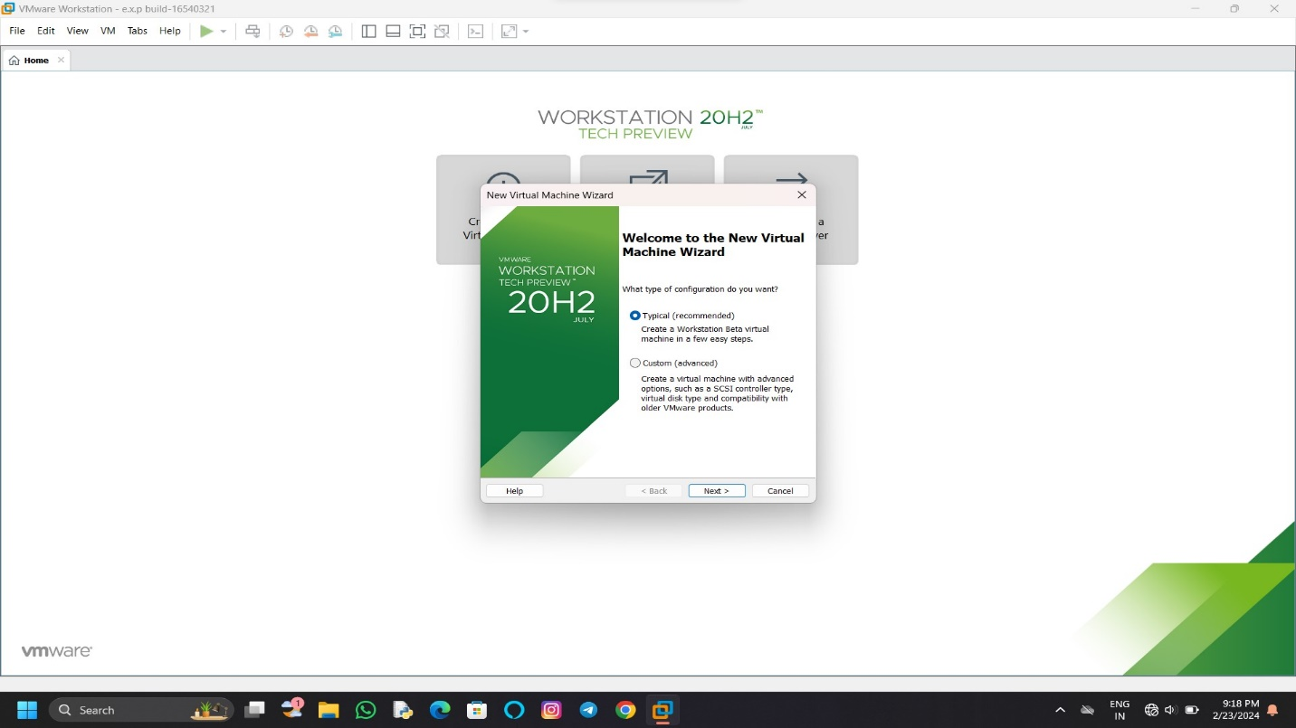

STEP 3: Select I will install operating system later

Give next

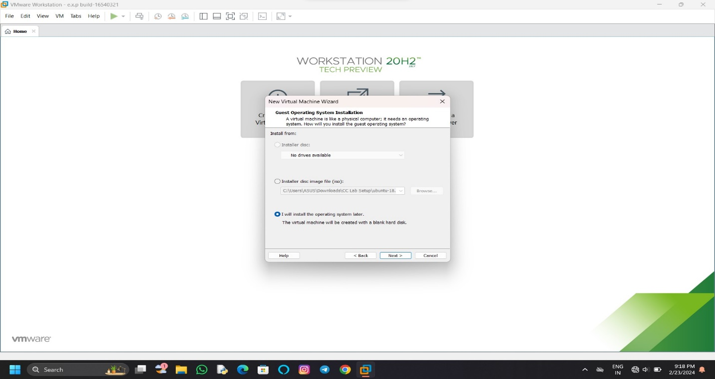

STEP 4: Select gust operating system

Give next

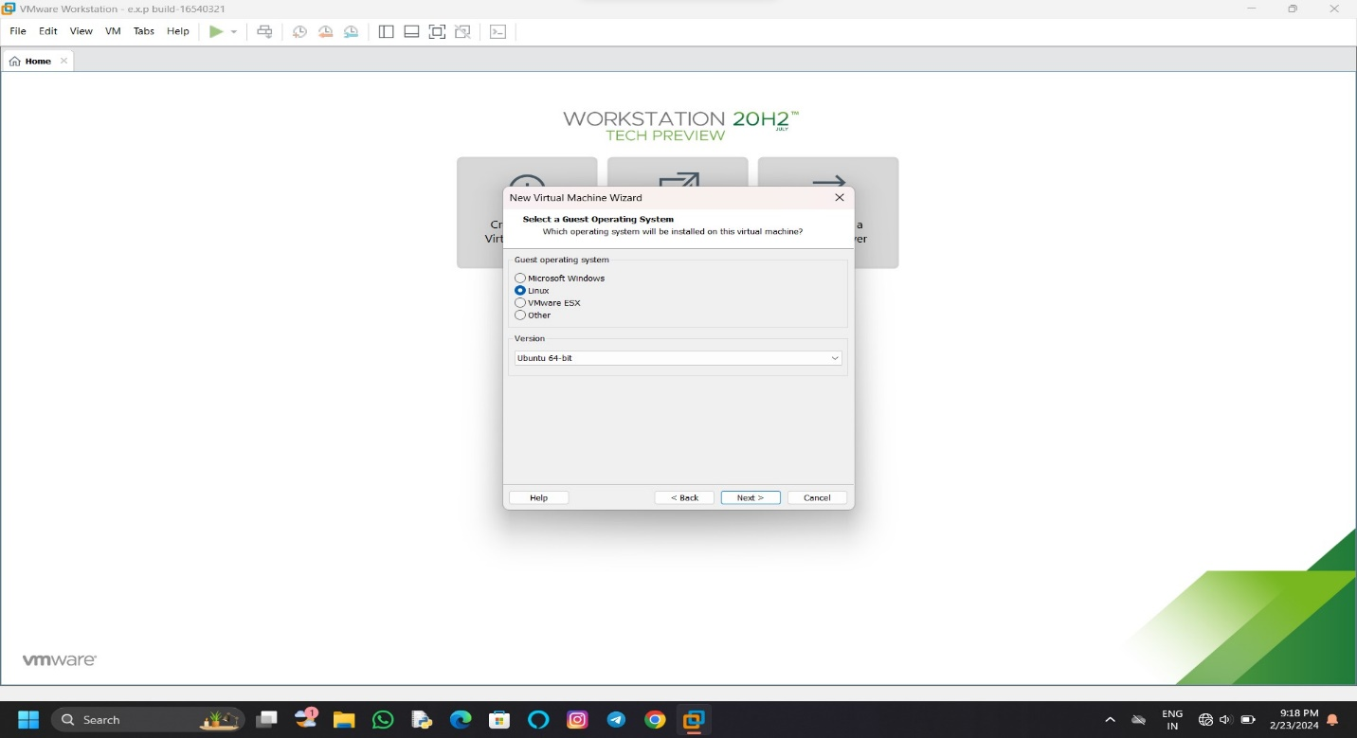

STEP 5: select name of virtual machine

Give next

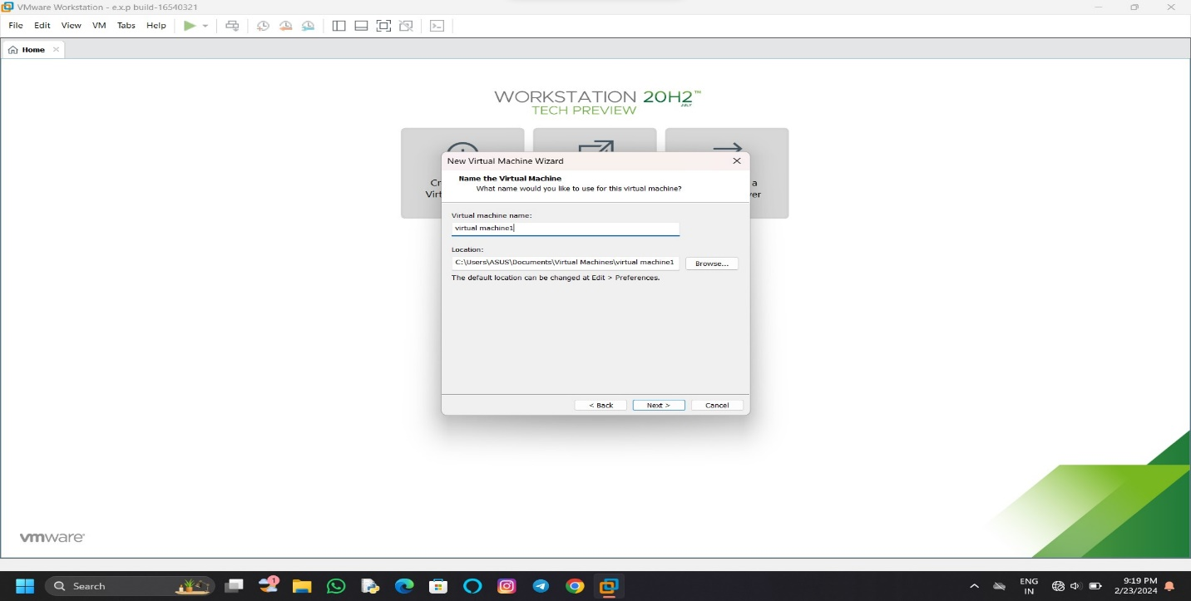

STEP 6: Select the data storing disk and the maximum size of the disk

IN question they are given maximum size=15.0 change value

Give next

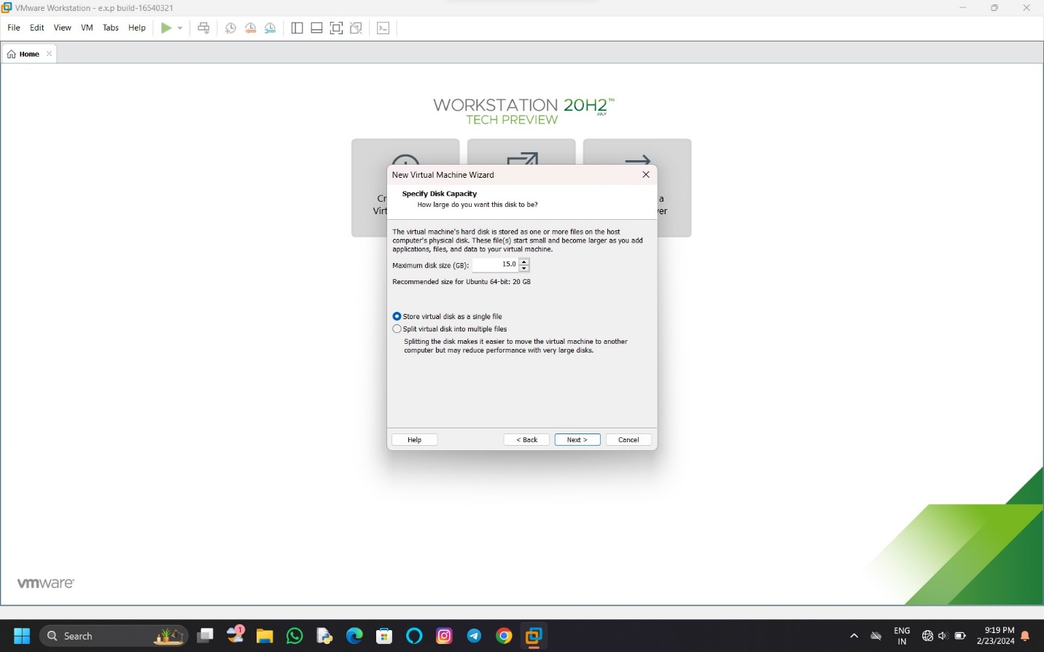

STEP 7: Ready to create virtual machine

Give finish

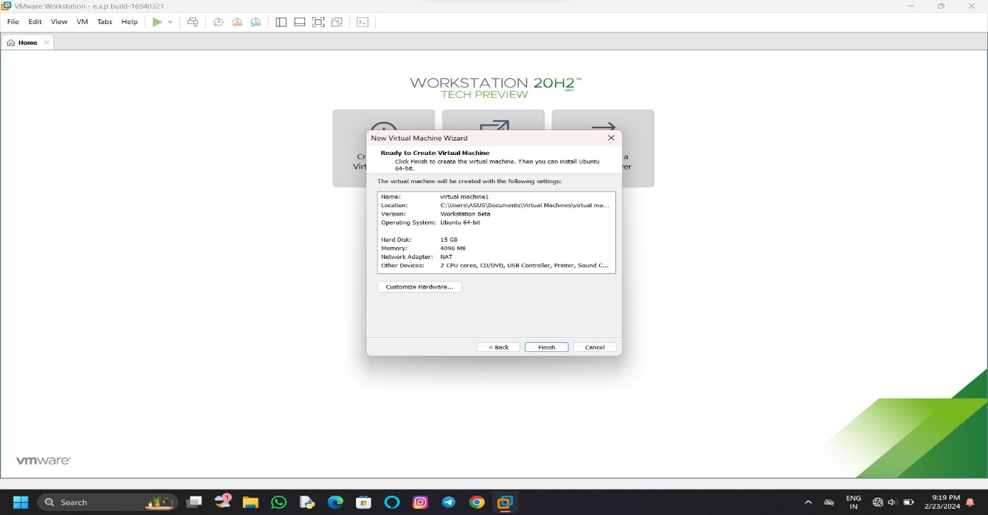

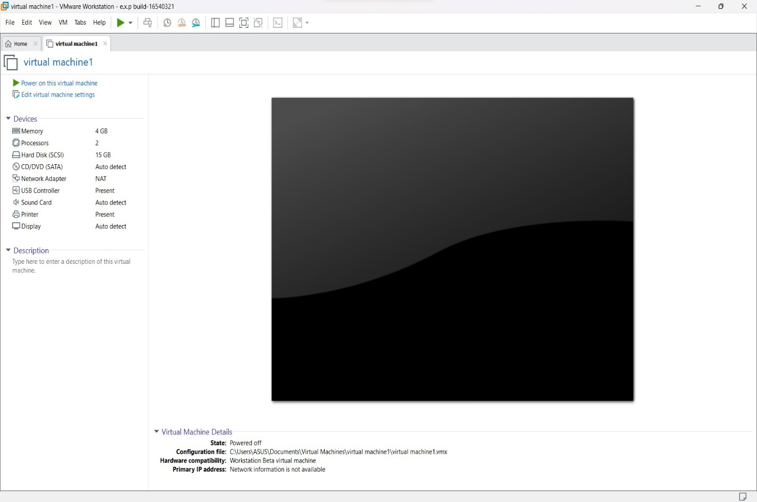

STEP 9: In the problem, the given CPU value =1

Change according to it

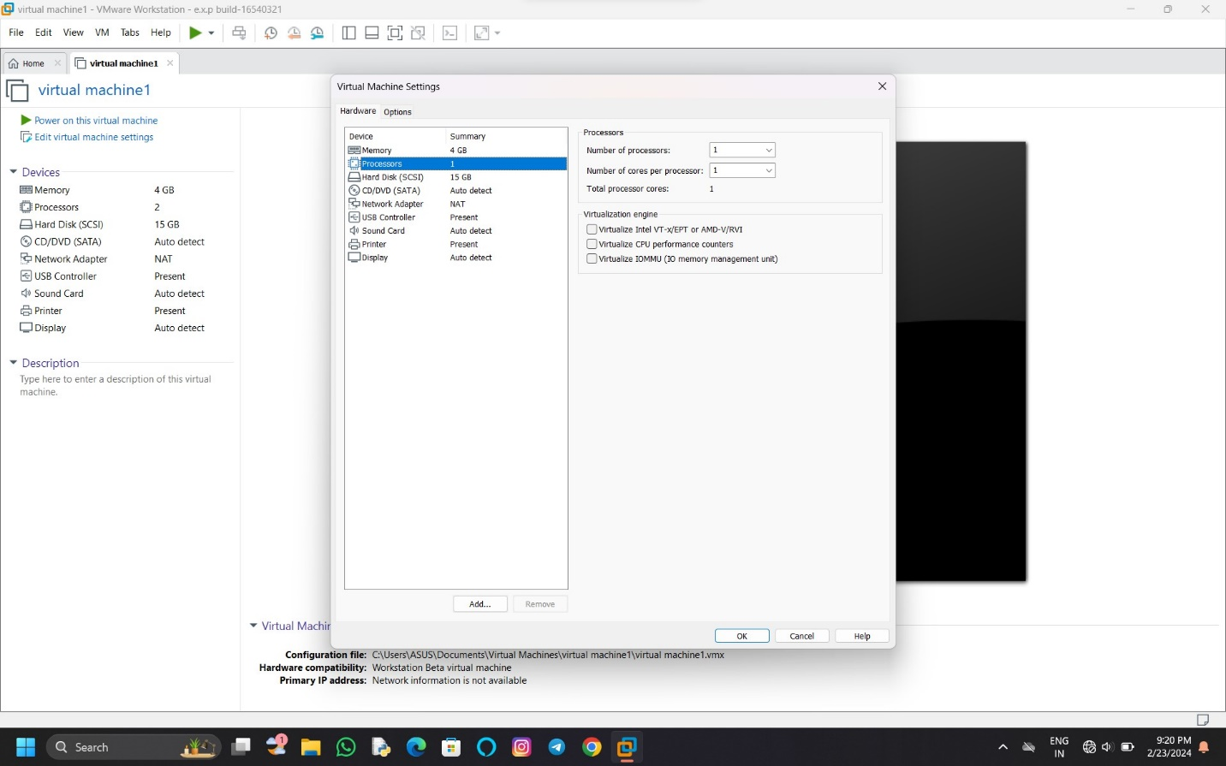

STEP 10: change RAM=2gb

And complete the virtual machine as per the given question

