**Experiment-17**

To write a procedure to run the virtual machine of different configuration and to check how many virtual machines can be utilized at a particular time.

**Implementation:**

**Step-1:**

Open task manager and track CPU and Memory usage

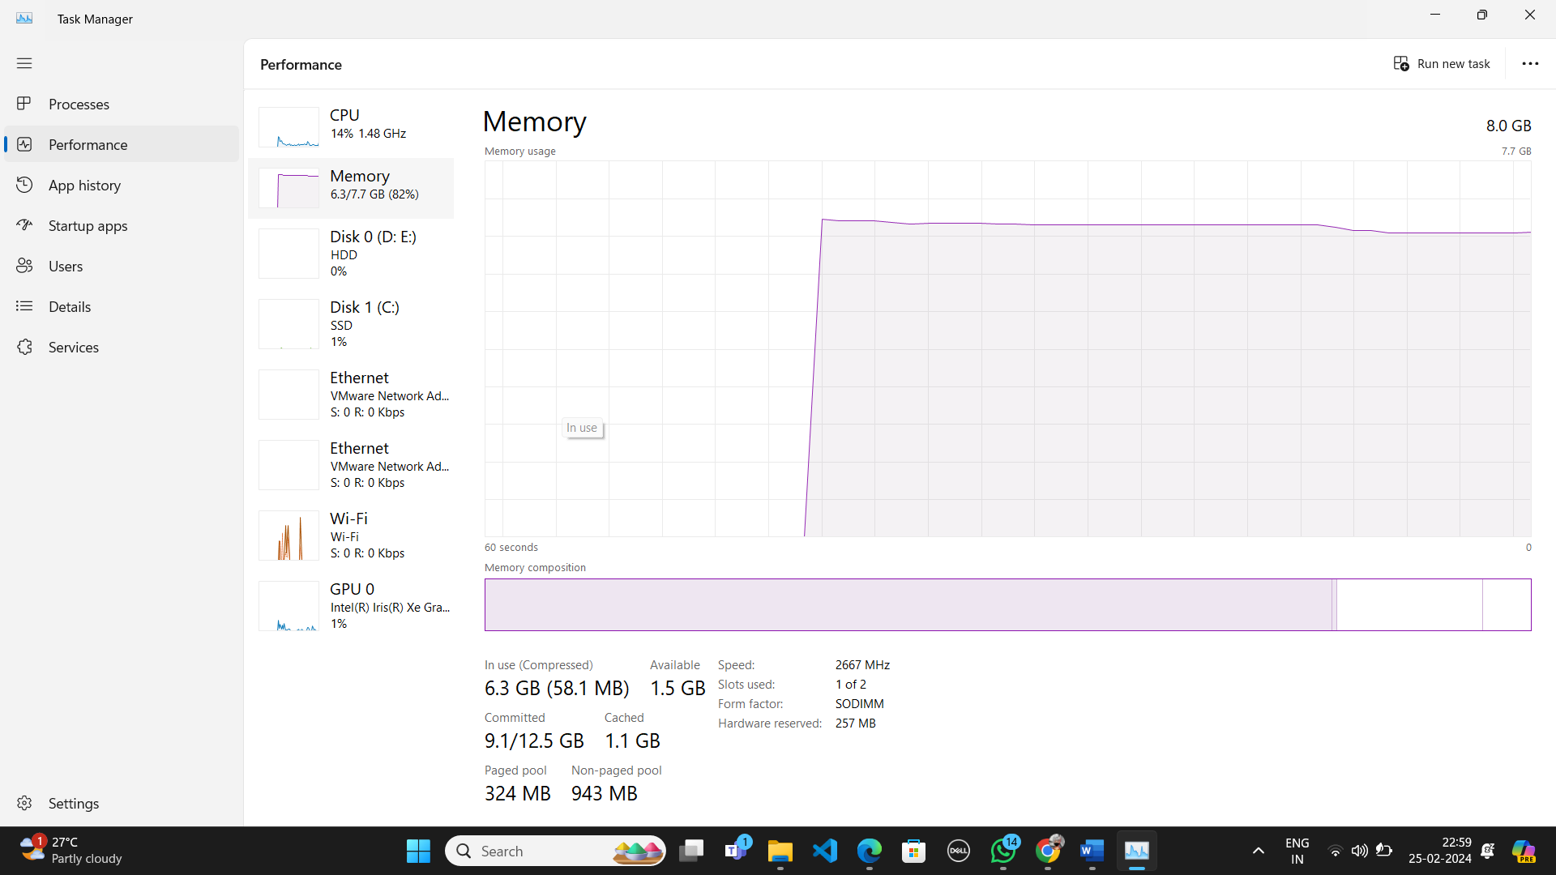

**Step-2:**

Open VMware and create some virtual machines.

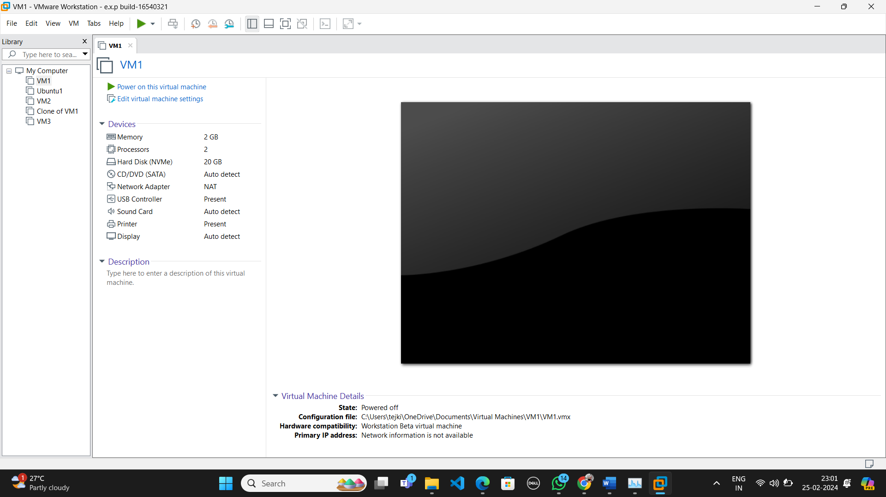

**Step-3:**

Launch one Virtual machine and capture the cpu and memory usage.

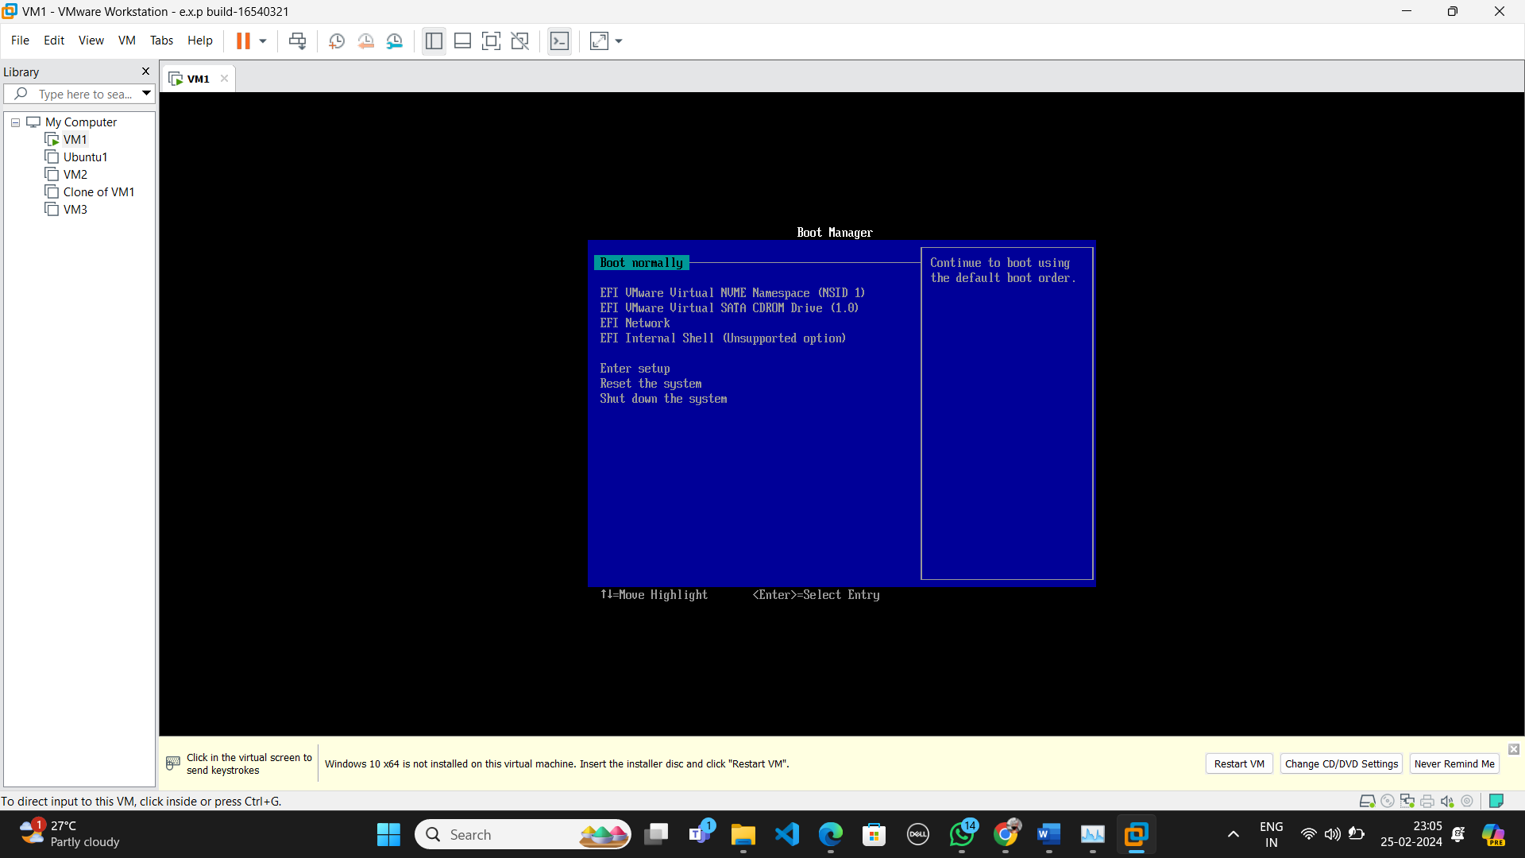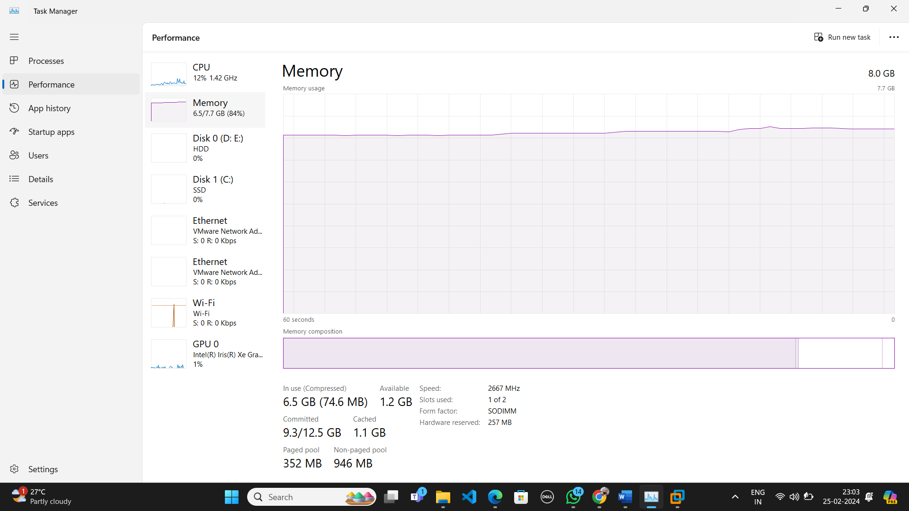

**Step-4:**

Launch another virtual machine and capture the cpu and memory usage.



