**EXP NO 4** Create a simple cloud software application for Library book reservation system for SIMATS library using any Cloud Service Provider to demonstrate SaaS include the necessary fields such as Title of the book, author, publications, Year, edition, no of copies, Rack no, status (taken/returned) etc.

**PROCEDURE**

**STEP 1** GO TO ZOHO.COM

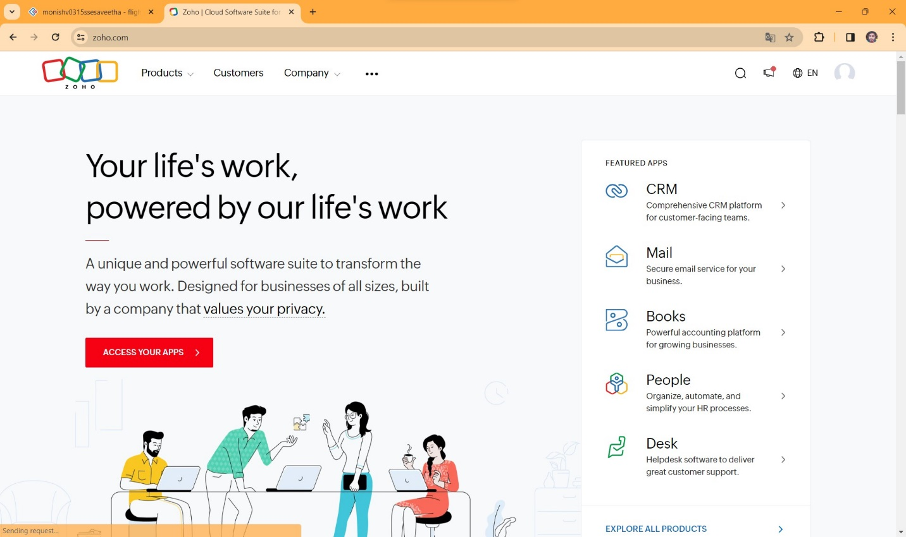

**STEP2** LOGIN TO THE ZOHO.COM

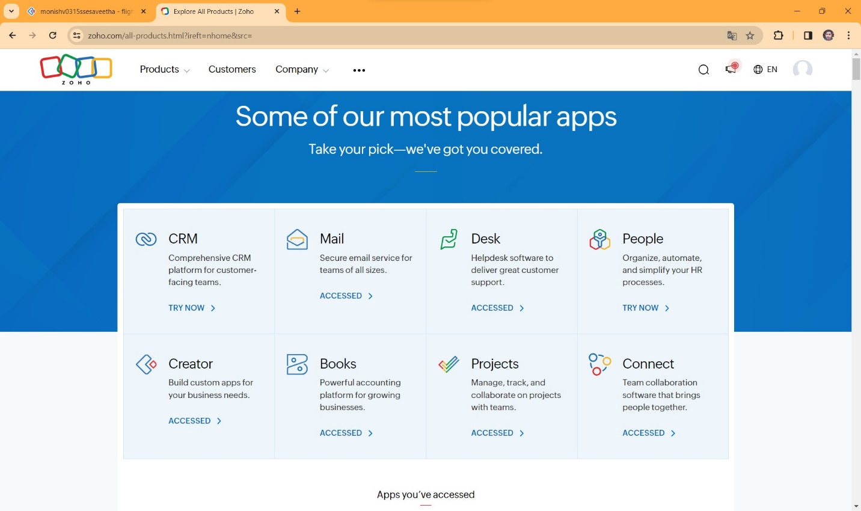

**STEP 3** SELECT A CREATE FROM SCRATCH

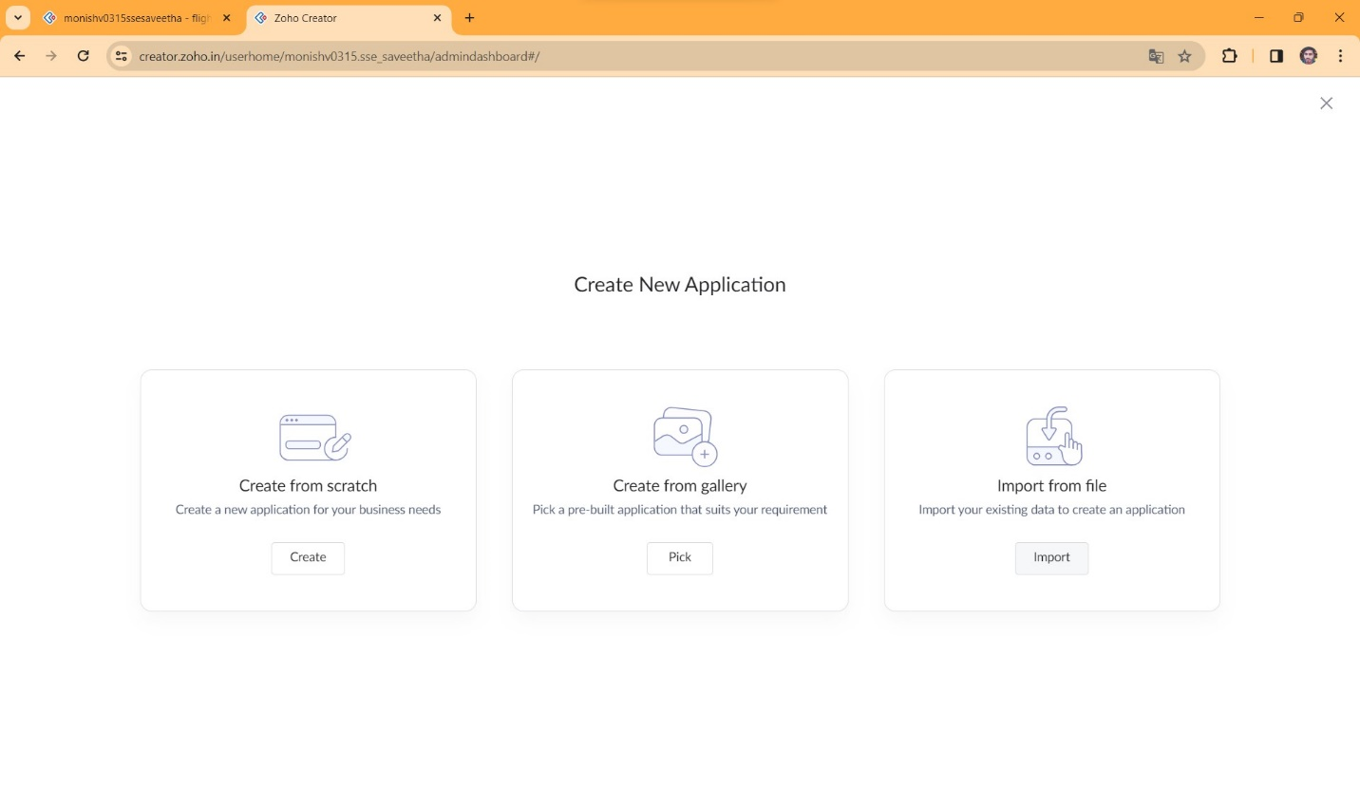

**STEP 4** SELECT APPLICATION NAME AS LIBRARY BOOK RESERCATION

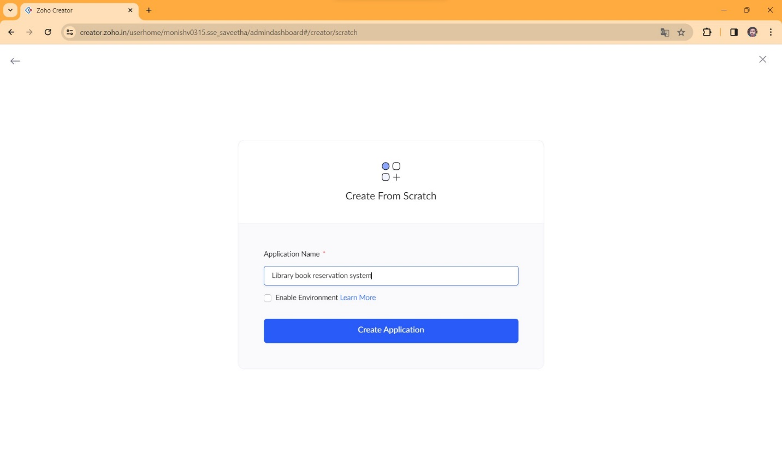

**STEP 5** CREATE A NEW FORM

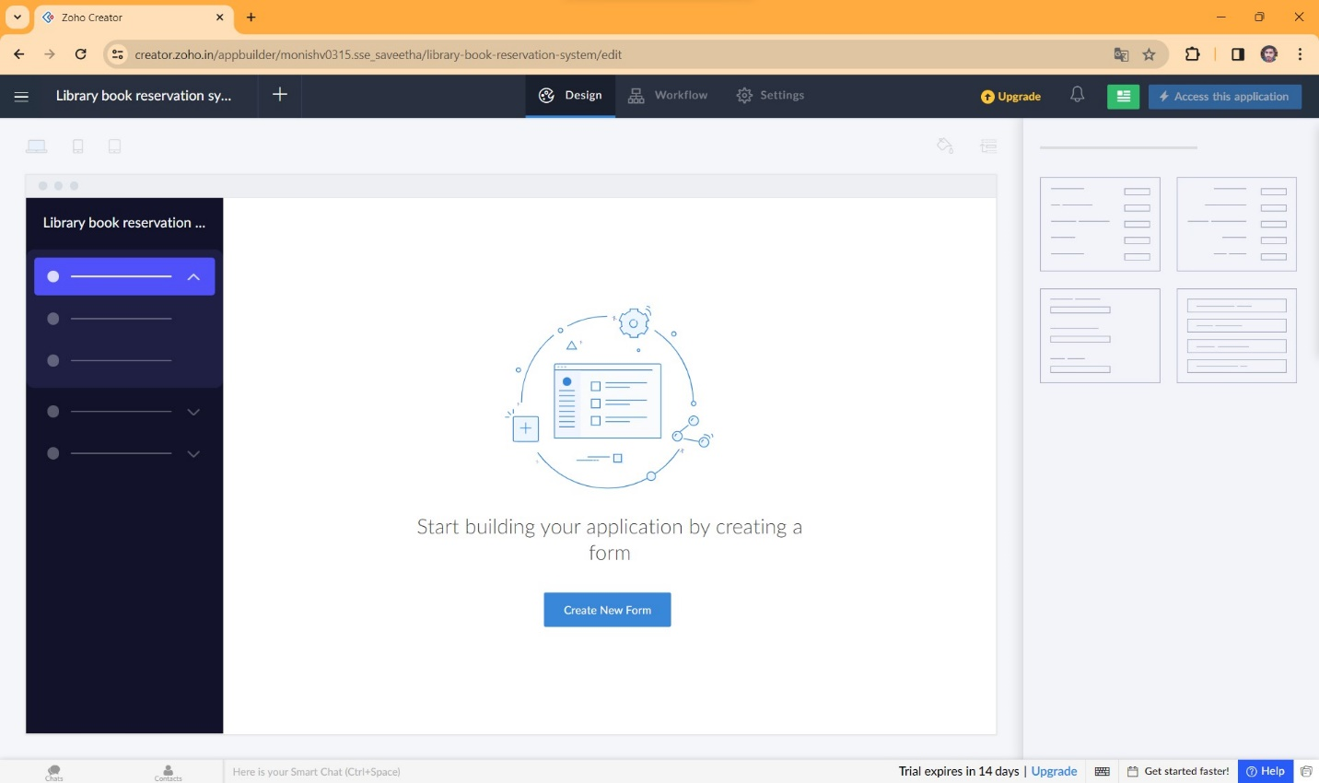

**STEP 6** SELECT BASIC FIELD FROM GIVEN BELOW AND DEVELOP APPLICATION

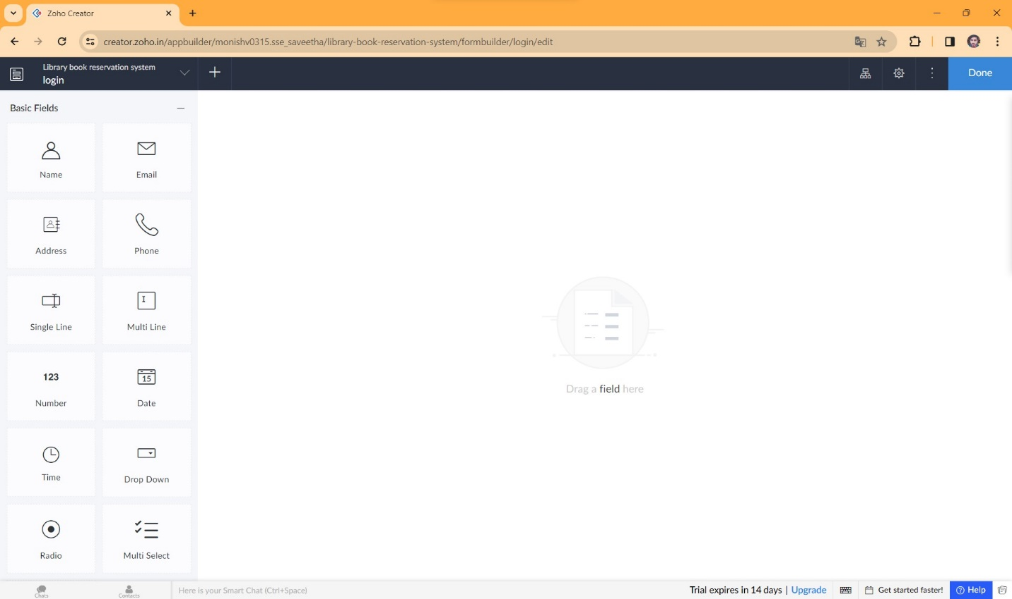

**STEP 7** THE SOFTWARE HASE BEEN CREATED LOGIN PAGE

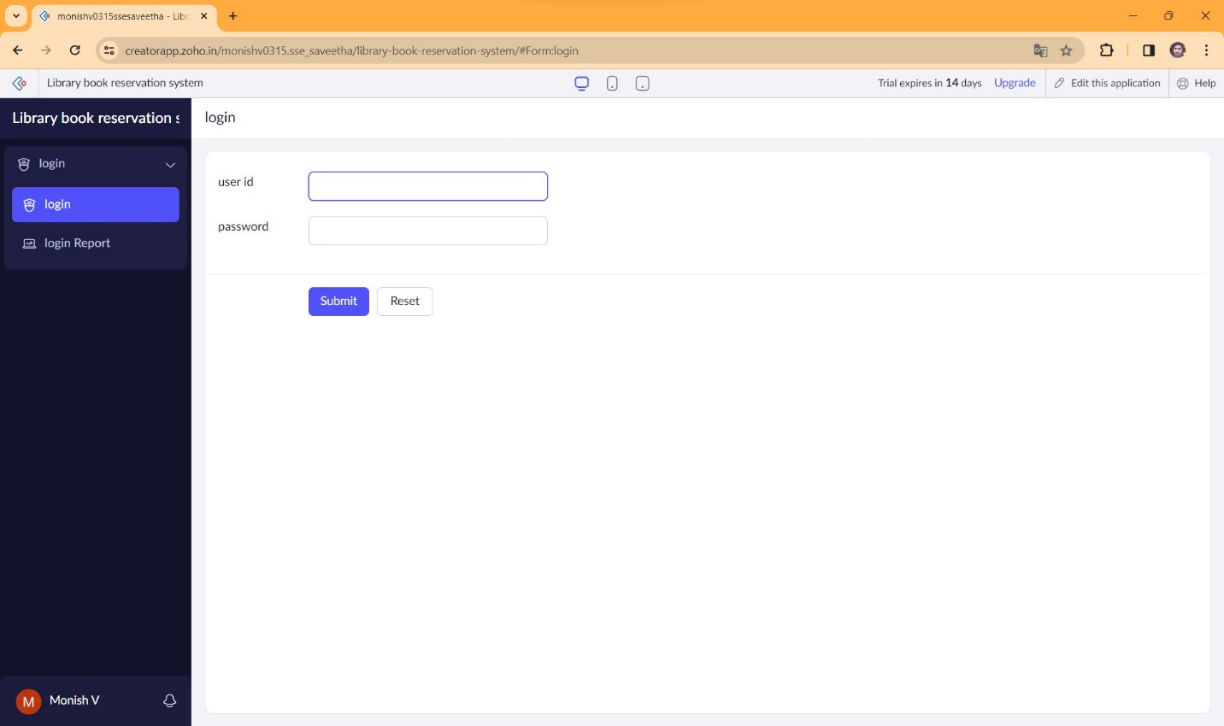

**STEP 8** THE SOFTWARE HASE BEEN CREATED USER DETAILS

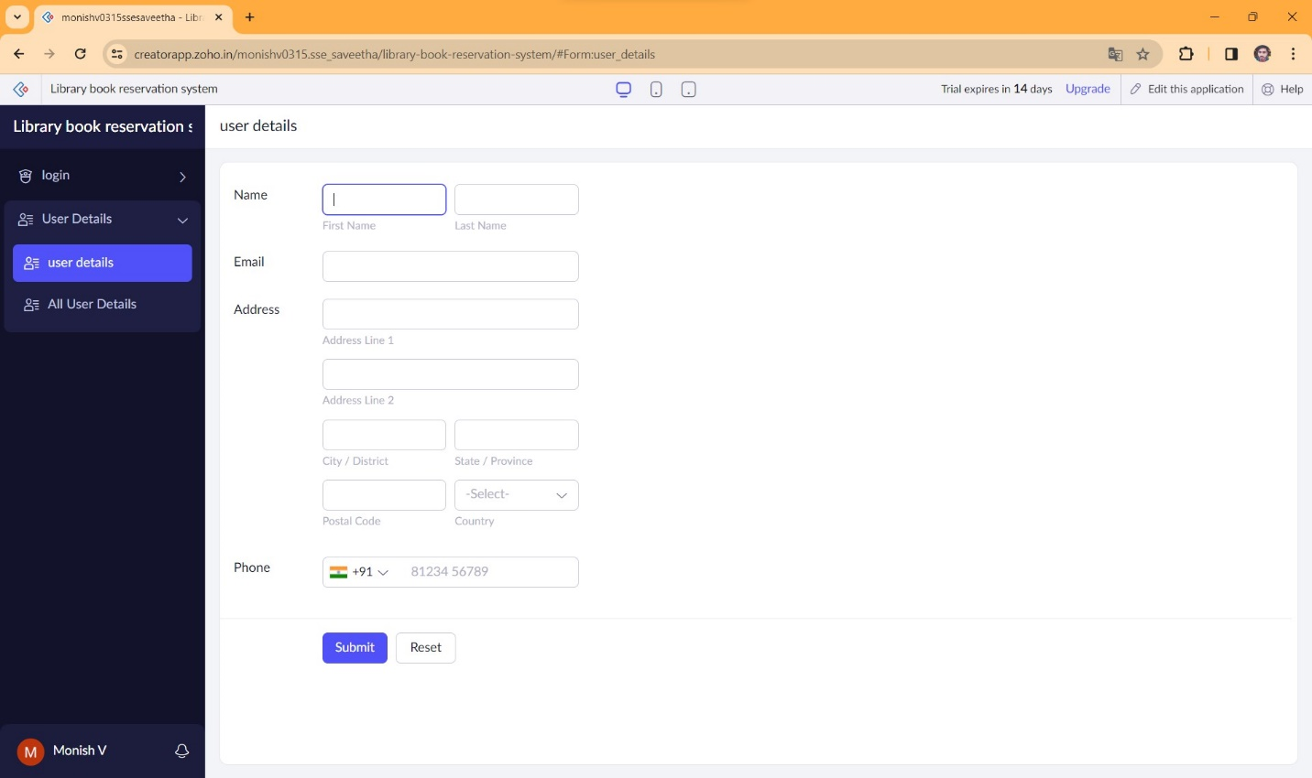

**STEP 9** THE SOFTWARE HASE BEEN CREATED SERACHING BOOK FOR

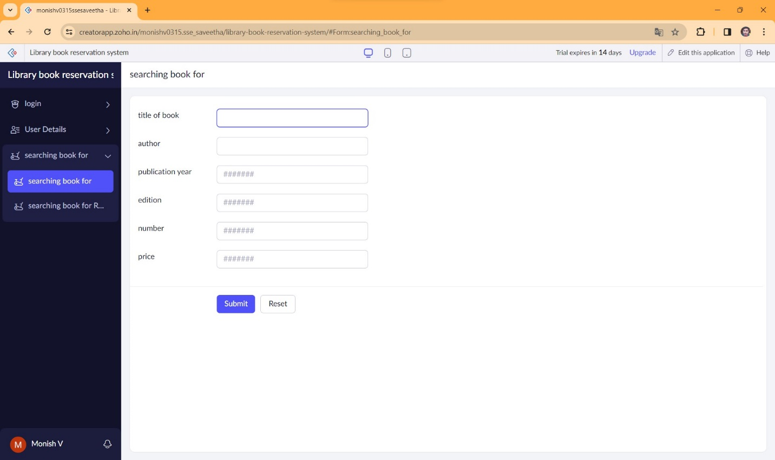

**STEP 10** THE SOFTWARE HASE BEEN CREATED RETURN DATE

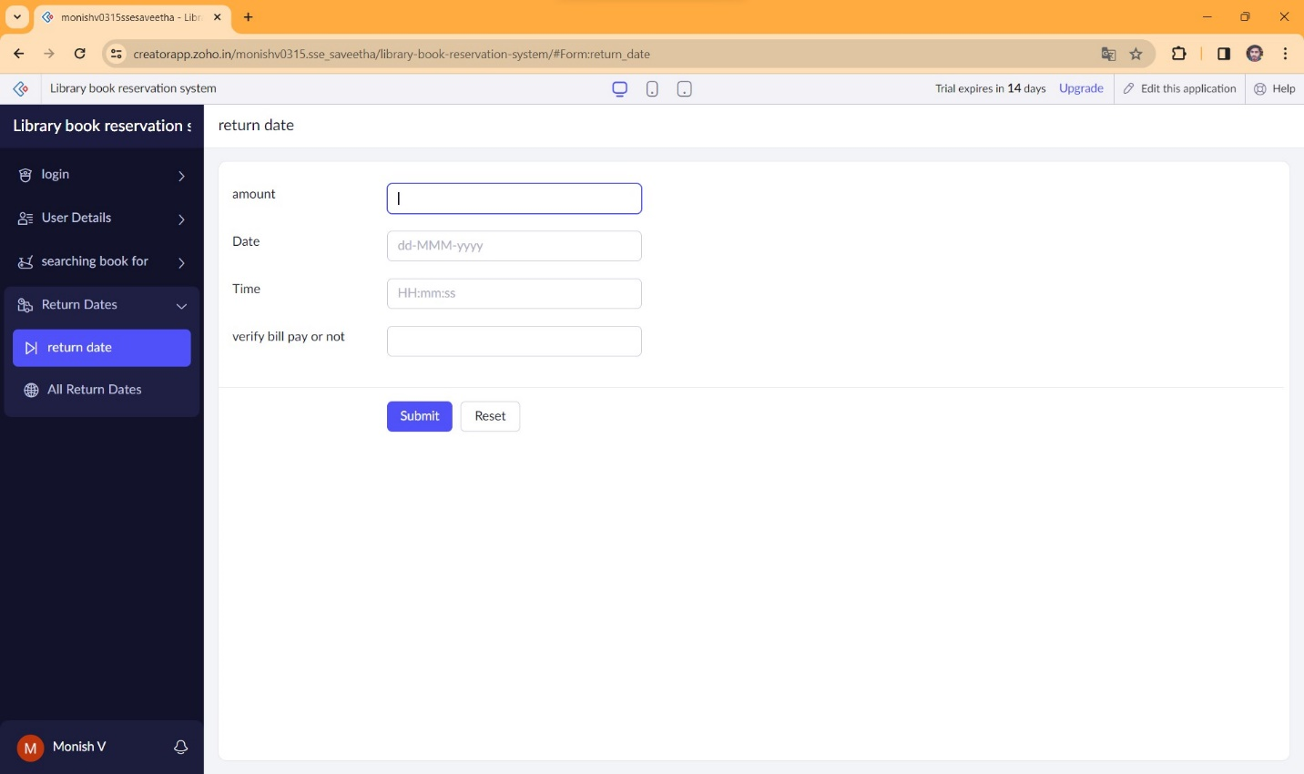

**STEP 11** THE SOFTWARE HASE BEEN CREATED PAYMENT

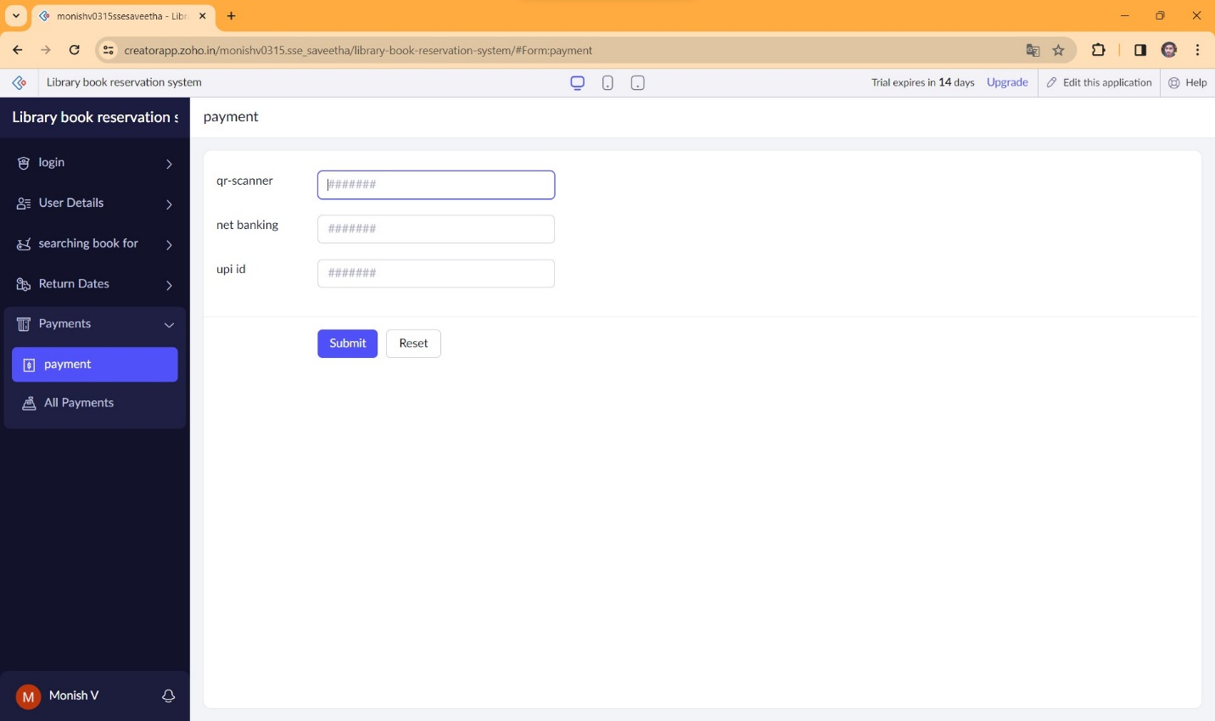

**STEP 12** THE SOFTWARE HAS BEEN CREATED

