**EXP NO 5** Create a simple cloud software application for Mark Sheet Processing System using any Cloud Service Provider to demonstrate SaaS include the necessary fields such as name of the student, Reg no of the student, Subjects, Marks, Average, percentage, rank, overall performance etc.

**PROCEDURE**

**STEP 1** GO TO ZOHO.COM

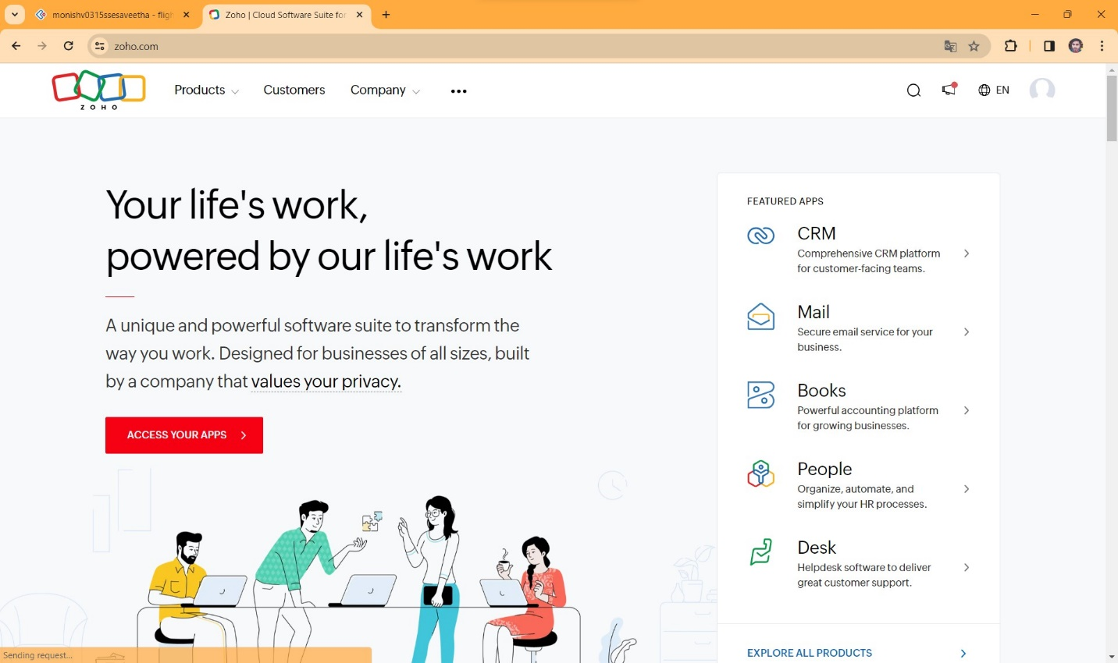

**STEP2** LOGIN TO THE ZOHO.COM

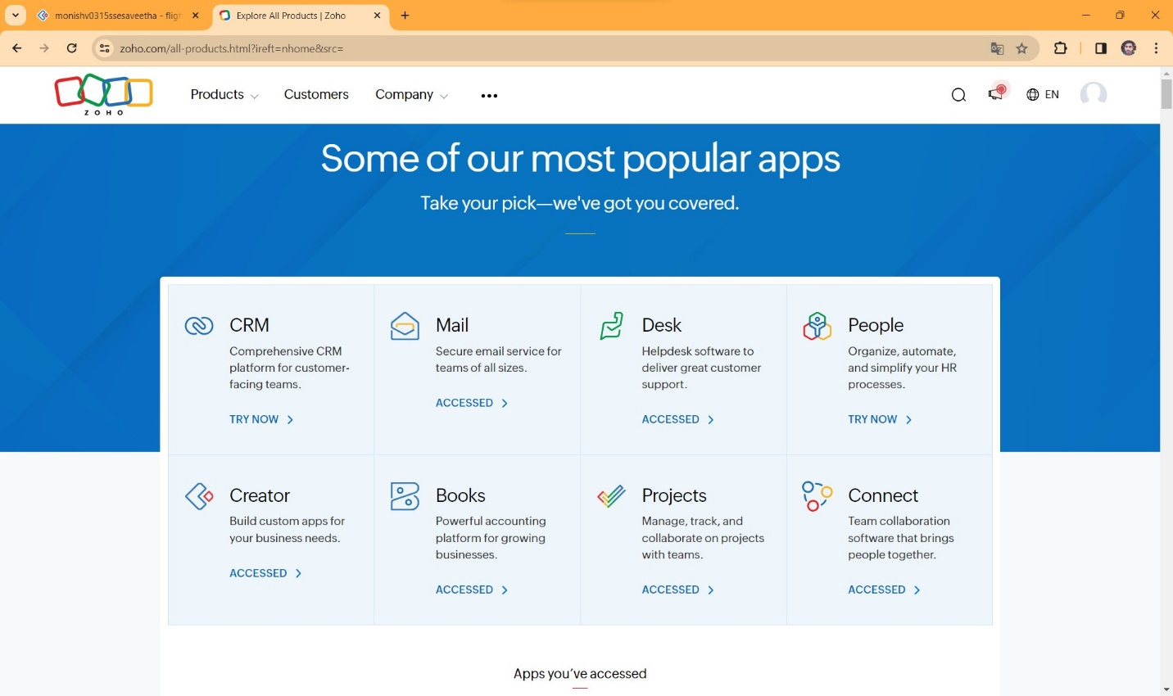

**STEP 3** SELECT A CREATE FROM SCRATCH

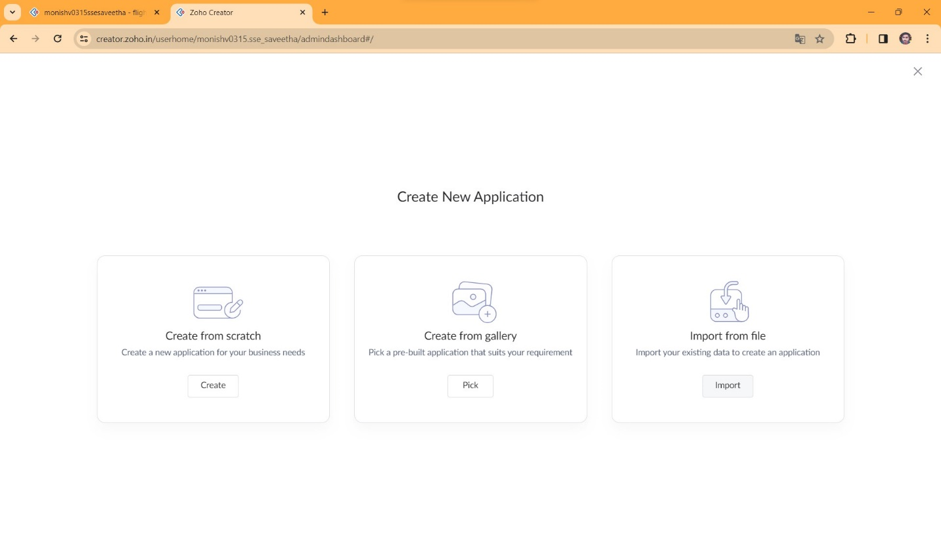

**STEP 4** SELECT APPLICATION NAME AS MARK SHEET PROCESSING SYSTEM

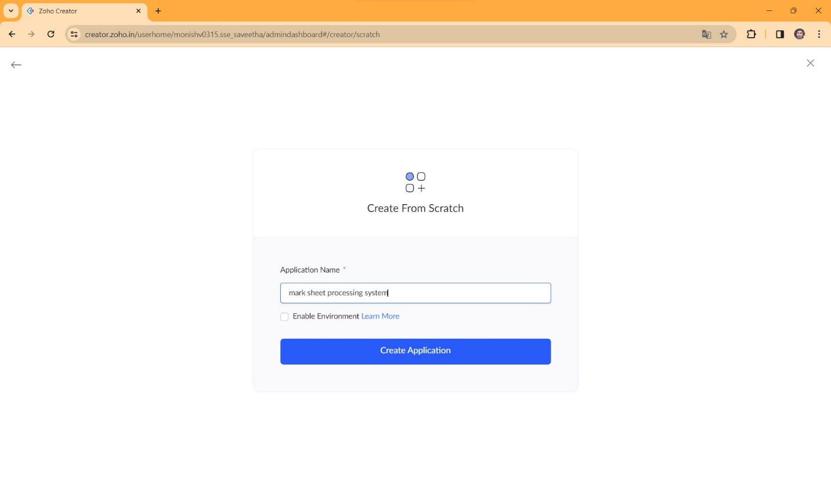

**STEP 5** CREATE A NEW FORM

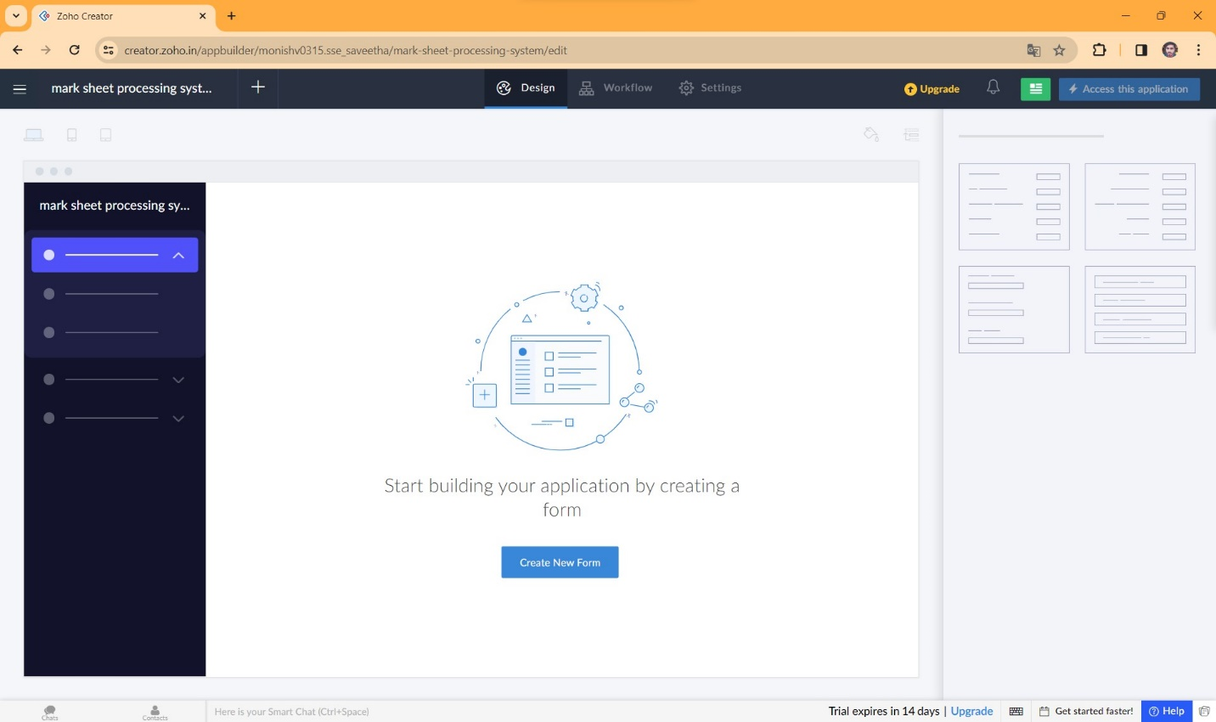

**STEP 6** SELECT BASIC FIELD FROM GIVEN BELOW AND DEVELOP APPLICATION

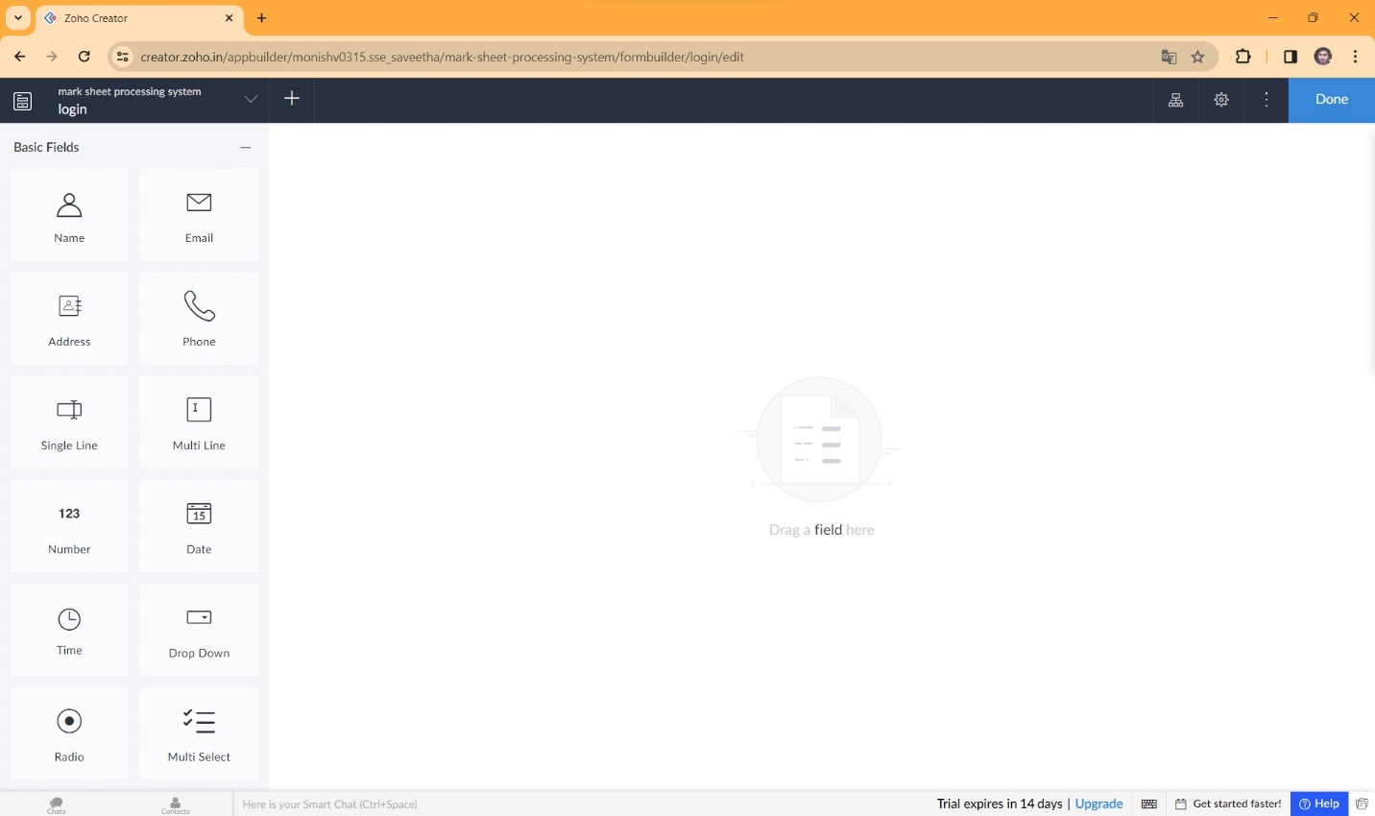

**STEP 7** THE SOFTWARE HASE BEEN CREATED LOGIN PAGE

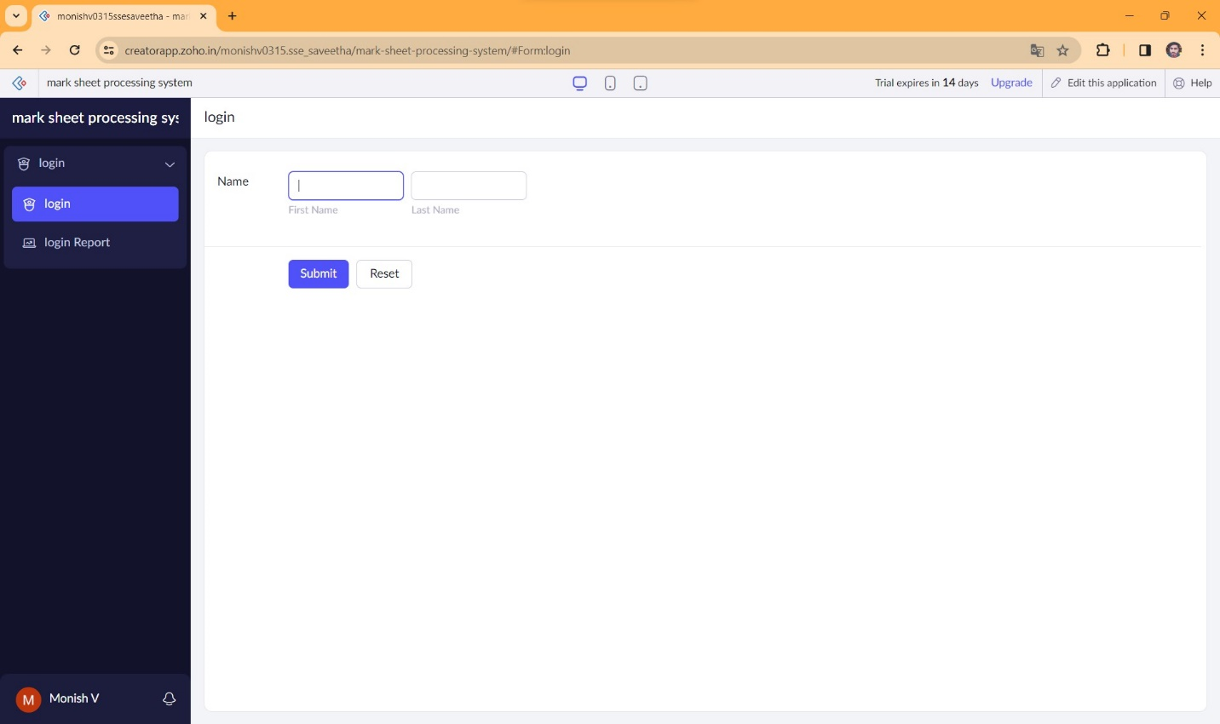

**STEP 8** THE SOFTWARE HASE BEEN CREATED DETAILS OF STUDENT SUBJECT MARKS

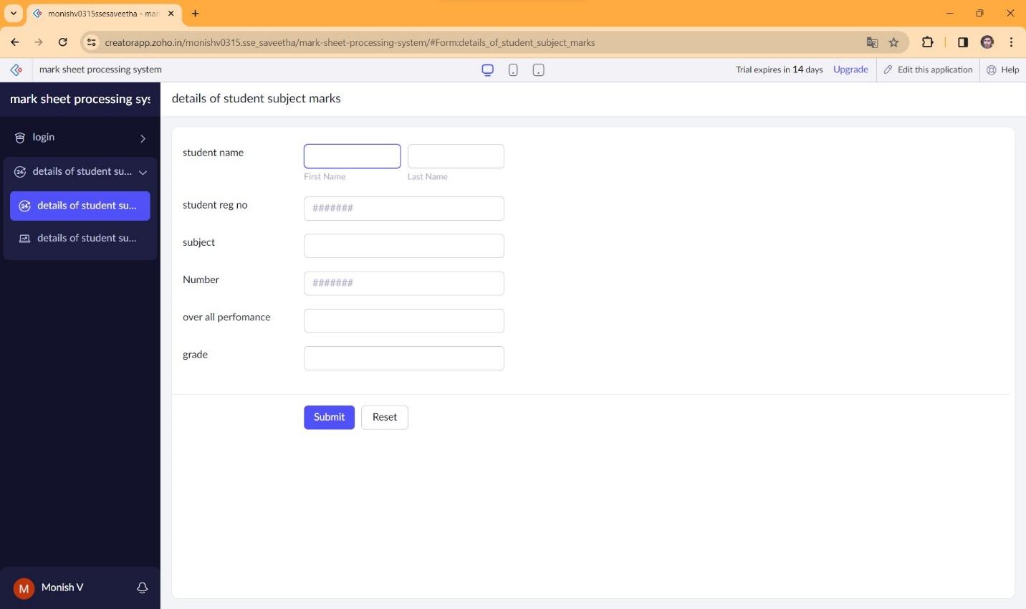

**STEP 9** THE SOFTWARE HASE BEEN CREATED DISCUSSION WITH PARENTS

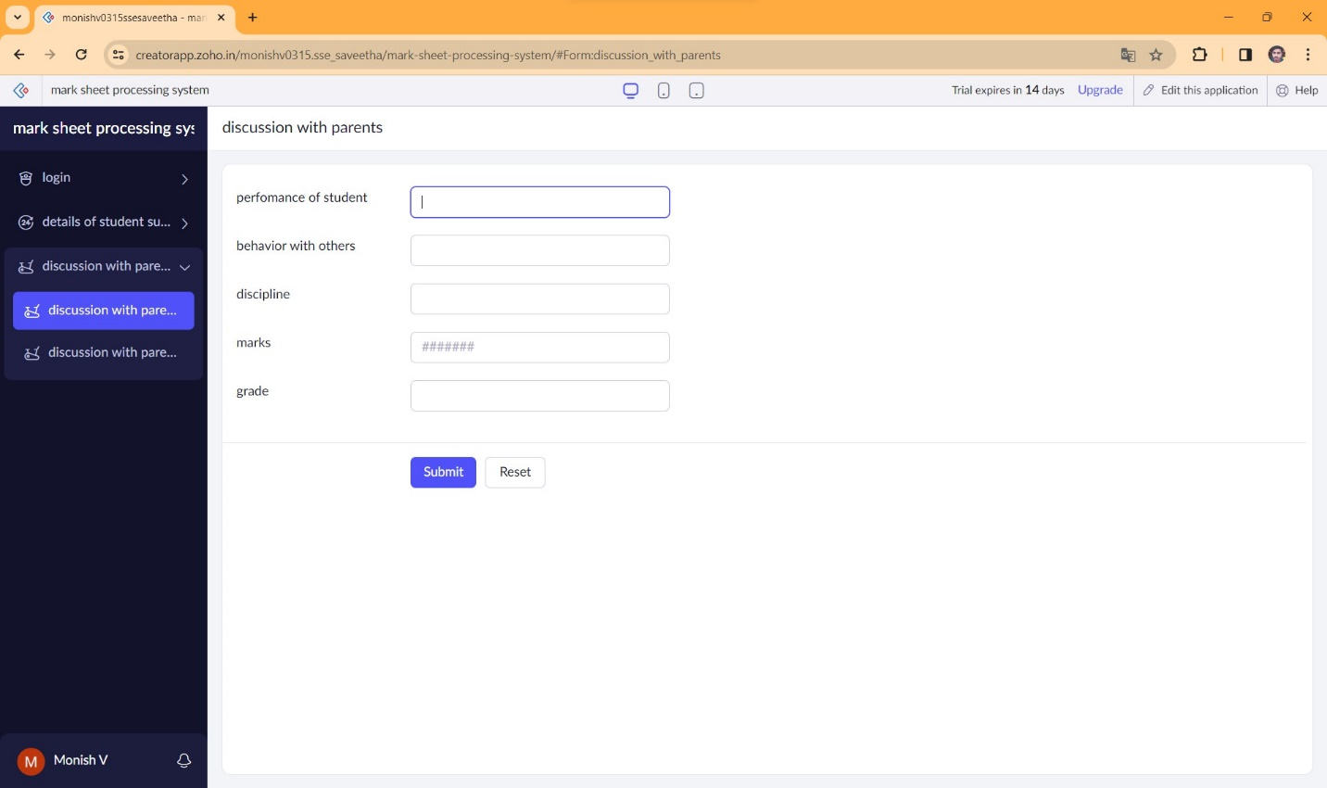

**STEP 10** THE SOFTWARE HASE BEEN CREATED EXEL

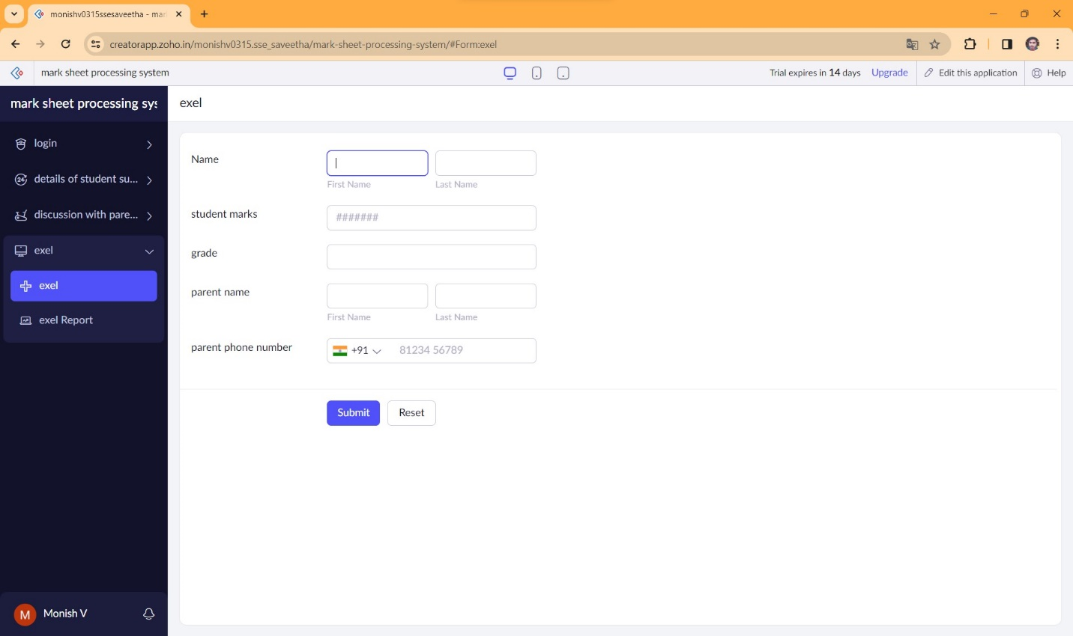

**STEP 11** THE SOFTWARE HASE BEEN CREATED

