**EXP NO 7** Create a simple cloud software application for Students Attendance System using any Cloud Service Provider to demonstrate SaaS include the necessary fields such as name of the students, course, present, Absent, course attendance, OD request, grade, attendance percentage, etc.

**PROCEDURE**

**STEP 1** GO TO ZOHO.COM



**STEP2** LOGIN TO THE ZOHO.COM

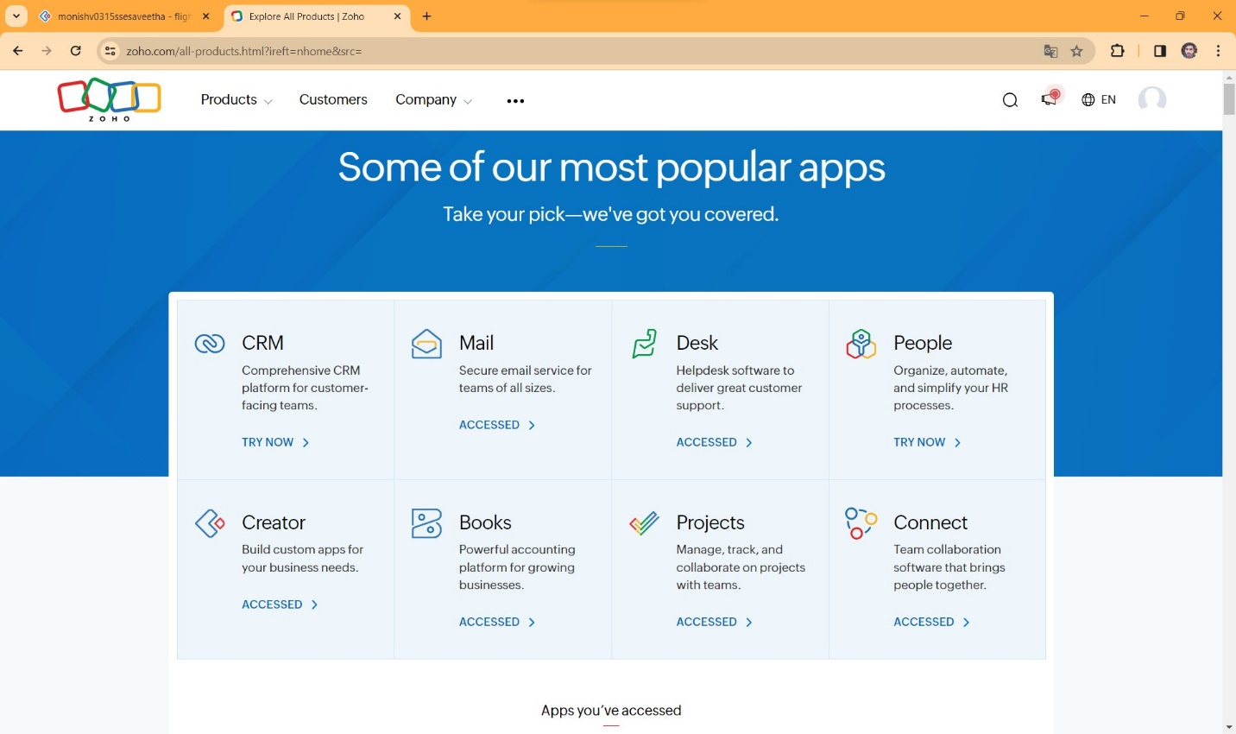

**STEP 3** SELECT A CREATE FROM SCRATCH

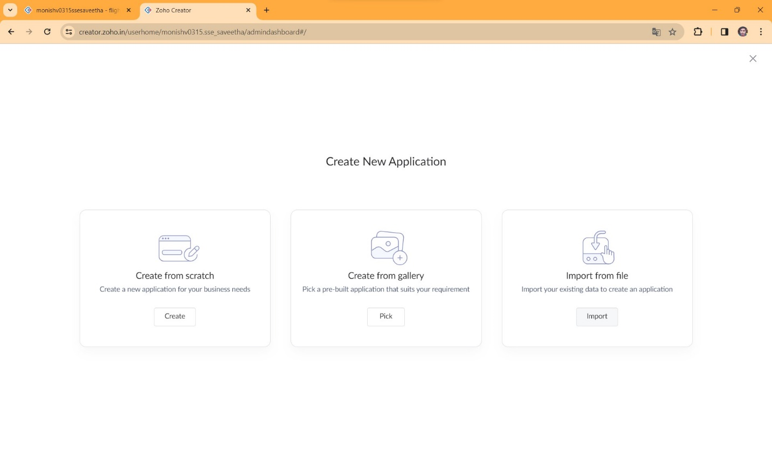

**STEP 4** SELECT APPLICATION NAME AS STUDENTS ATTENDANCE SYSTEM

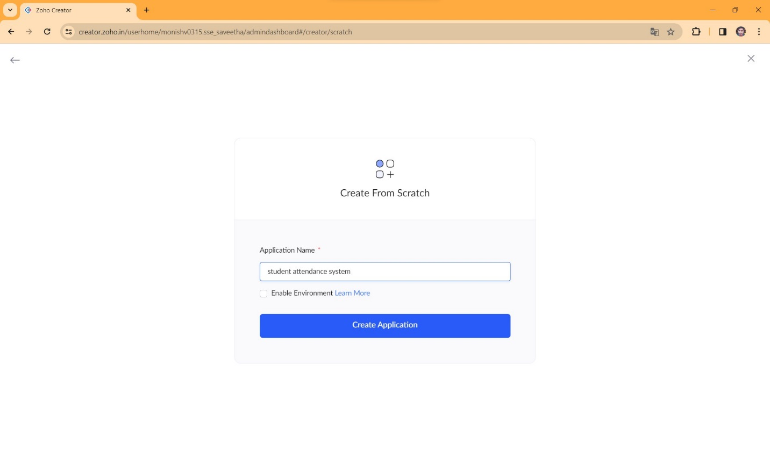

**STEP 5** CREATE A NEW FORM

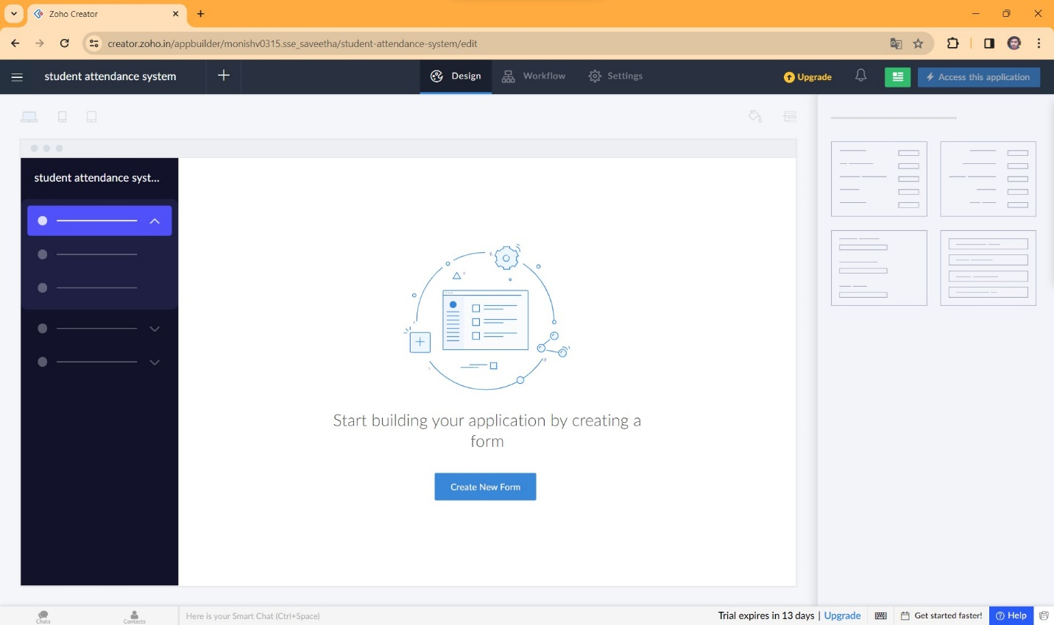

**STEP 6** SELECT BASIC FIELD FROM GIVEN BELOW AND DEVELOP APPLICATION

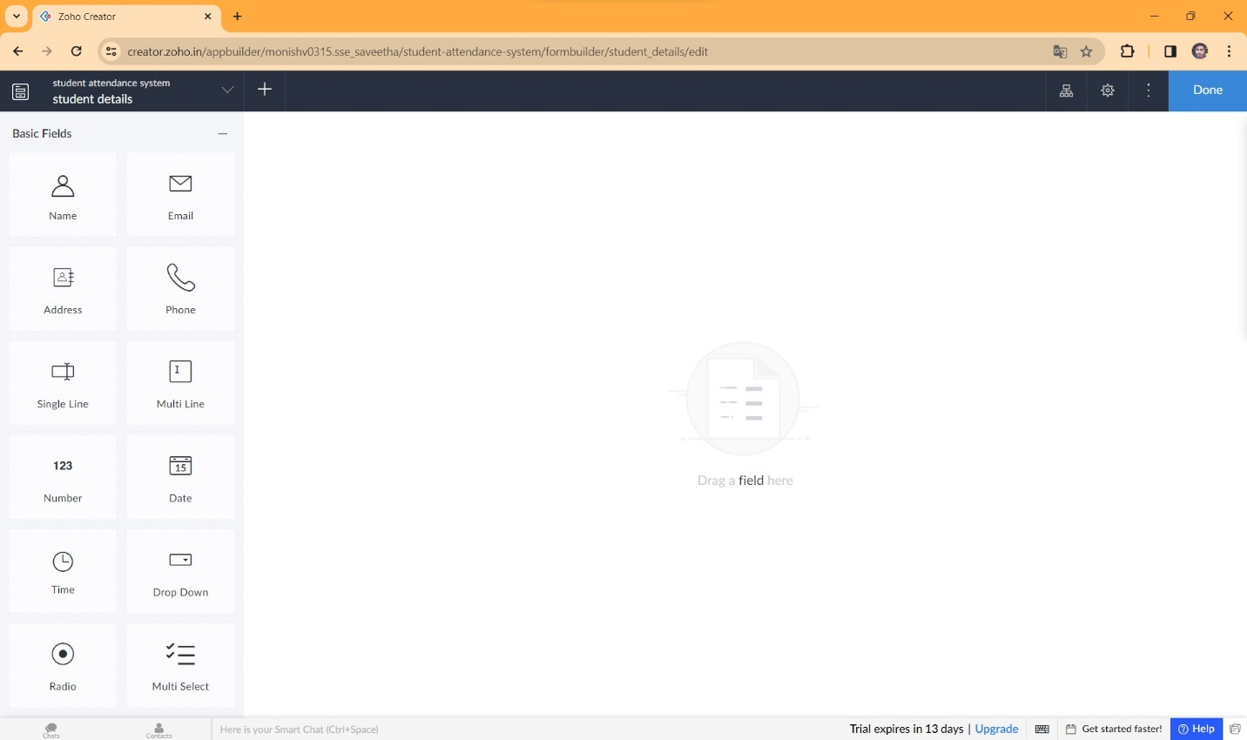

**STEP 7** THE SOFTWARE HASE BEEN CREATED STUDENT DETAILS

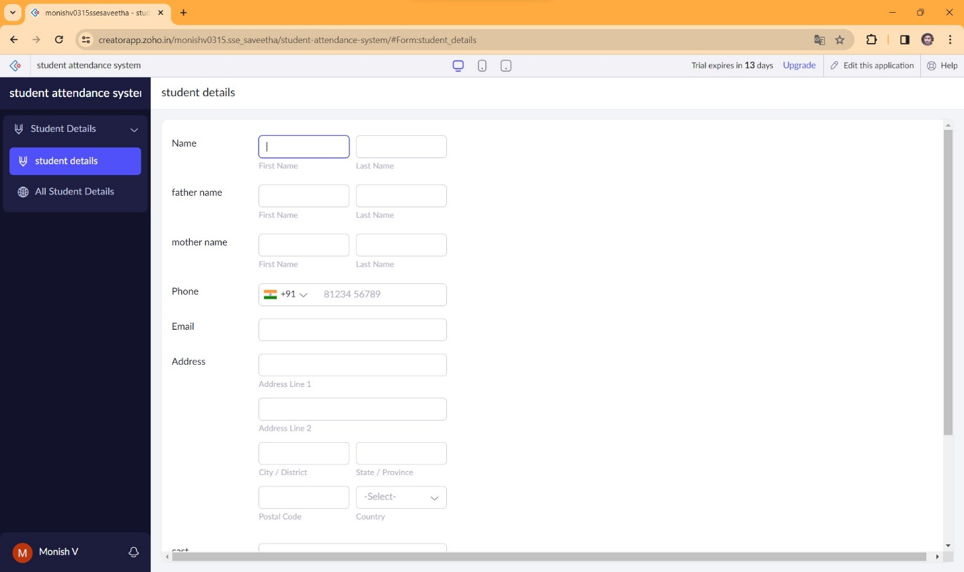

**STEP 8** THE SOFTWARE HASE BEEN CREATED COURSE ATTENDANCE

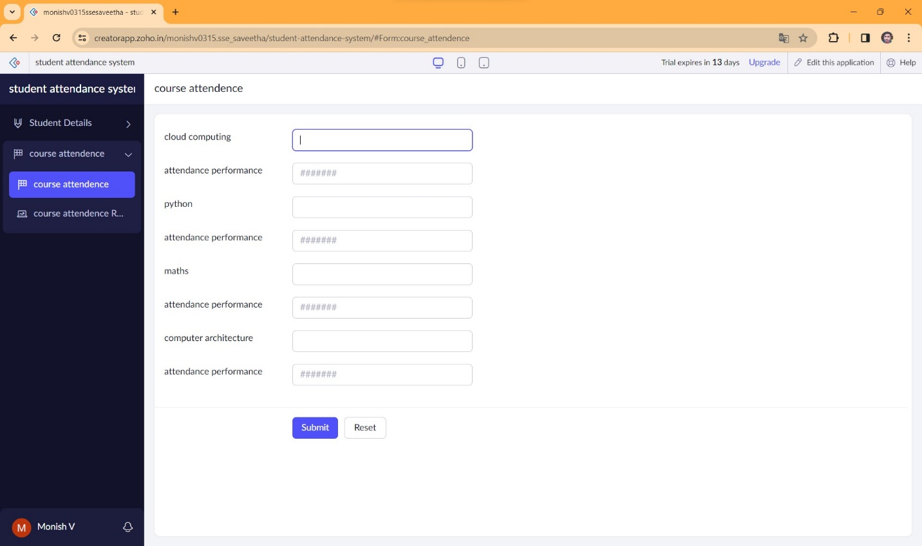

**STEP 9** THE SOFTWARE HASE BEEN CREATED ABSENT REASON

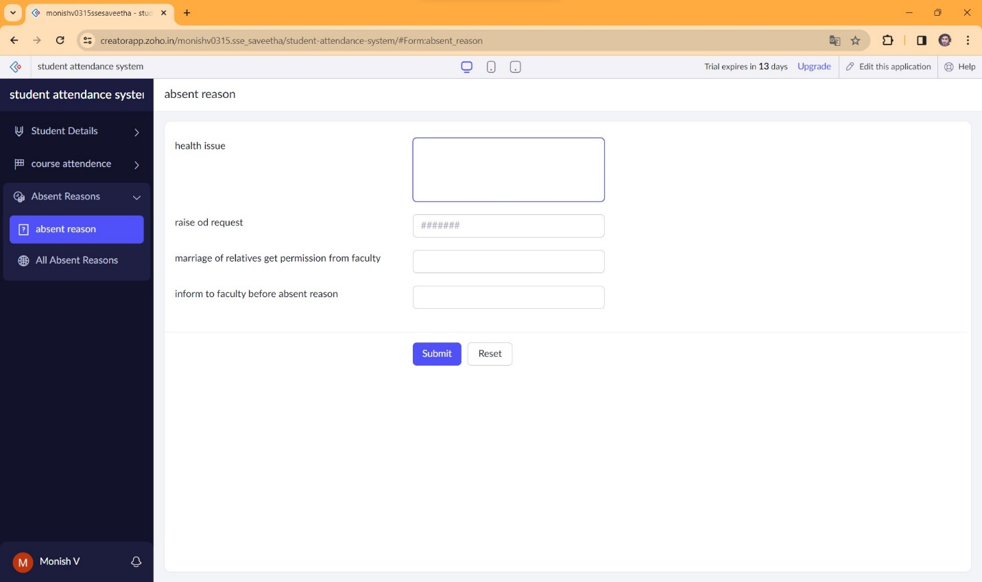

**STEP 10** THE SOFTWARE HASE BEEN CREATED WITHOUT ANY REASON ABSENT

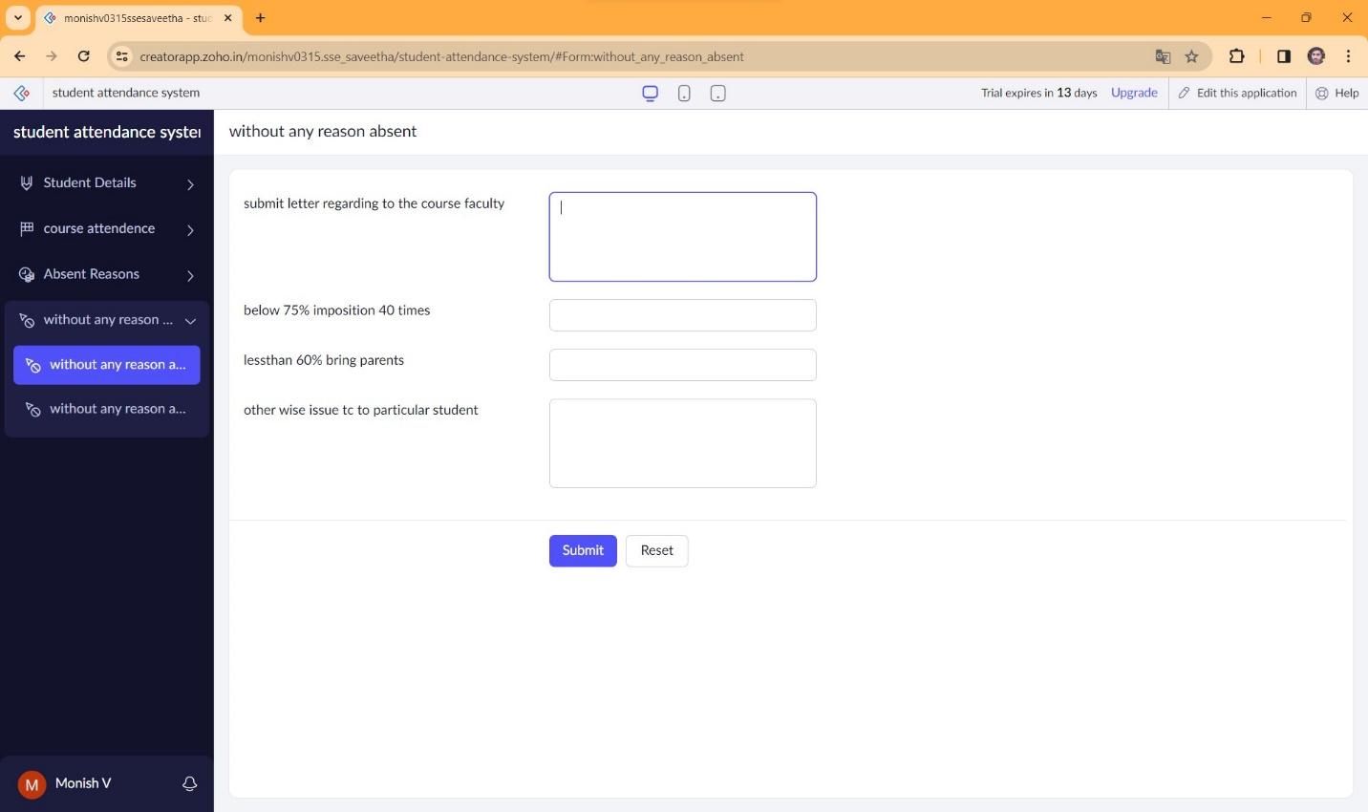

**STEP 11** THE SOFTWARE HASE BEEN CREATED

