Monish Nene

ESD LAB2 Report

**Things Learnt in Lab1**

RS 232

Interrupts in MSP432 and 89C51

External and internal address Program memory access for 89C51

MAX232

LOGIC Analysis

**Toughest Thing to do**

Interfacing 89C51 with EEPROM

Debugging Hardware

**Schematic**

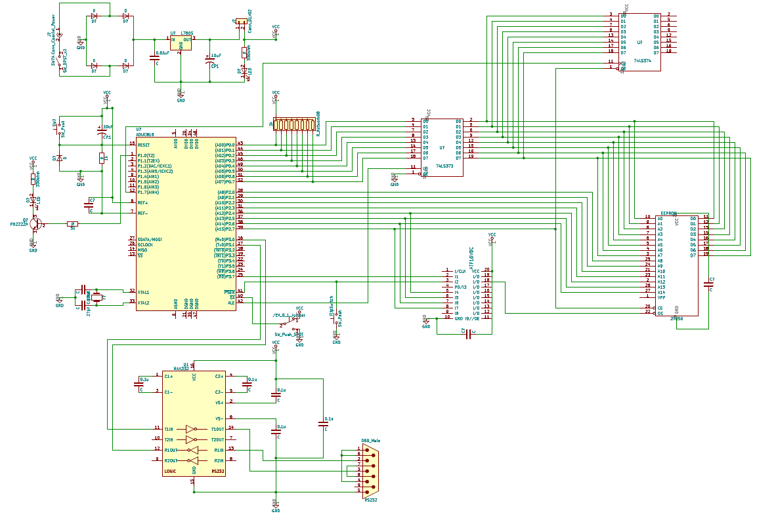

LED Waveform (period 1.122 S)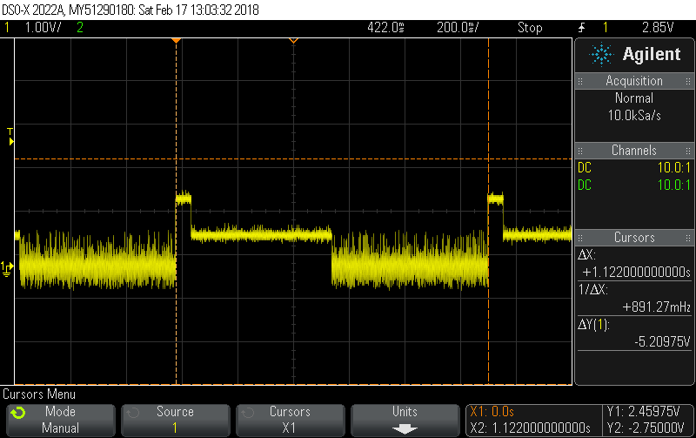

ISR Routine Cycles

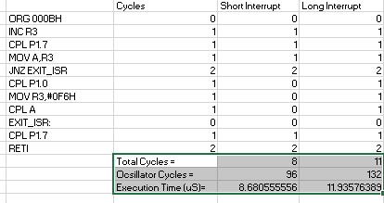

ALE_PSEN_TLL_PL 92ns

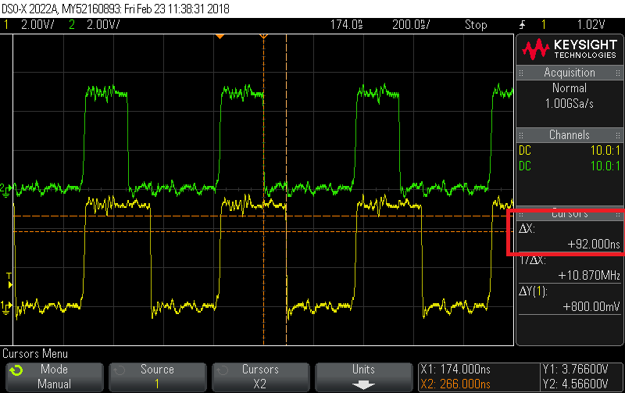

MSP_CODE_LED_INTERRUPT

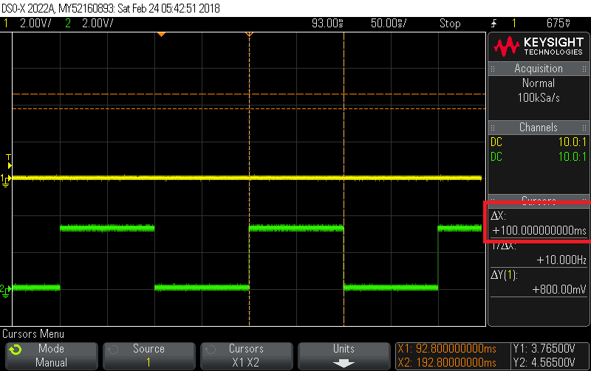

TLL-PL time 90ns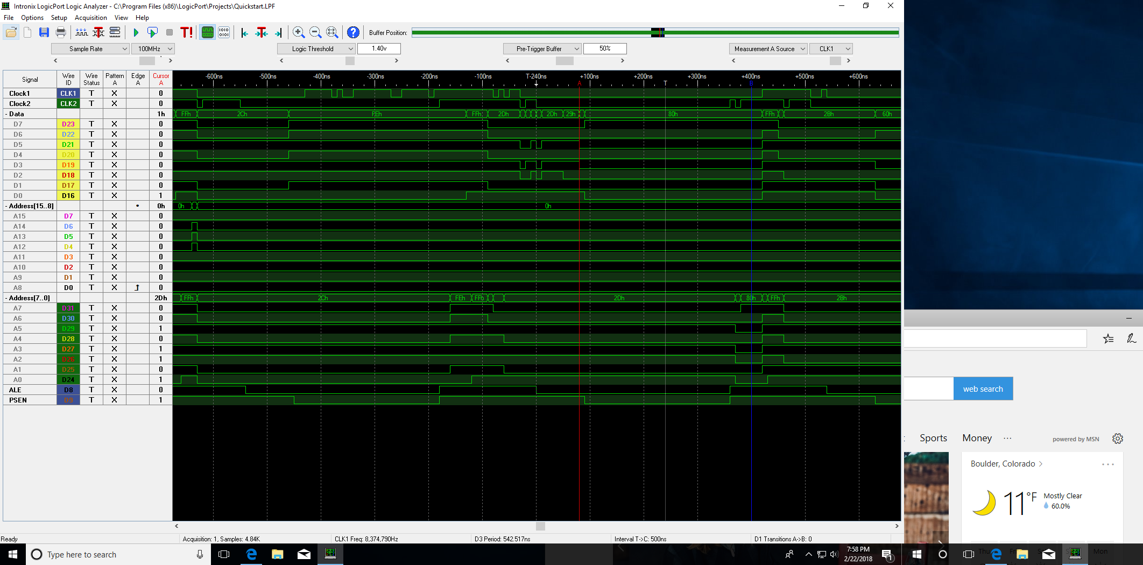

Data Latched (Supplemental)

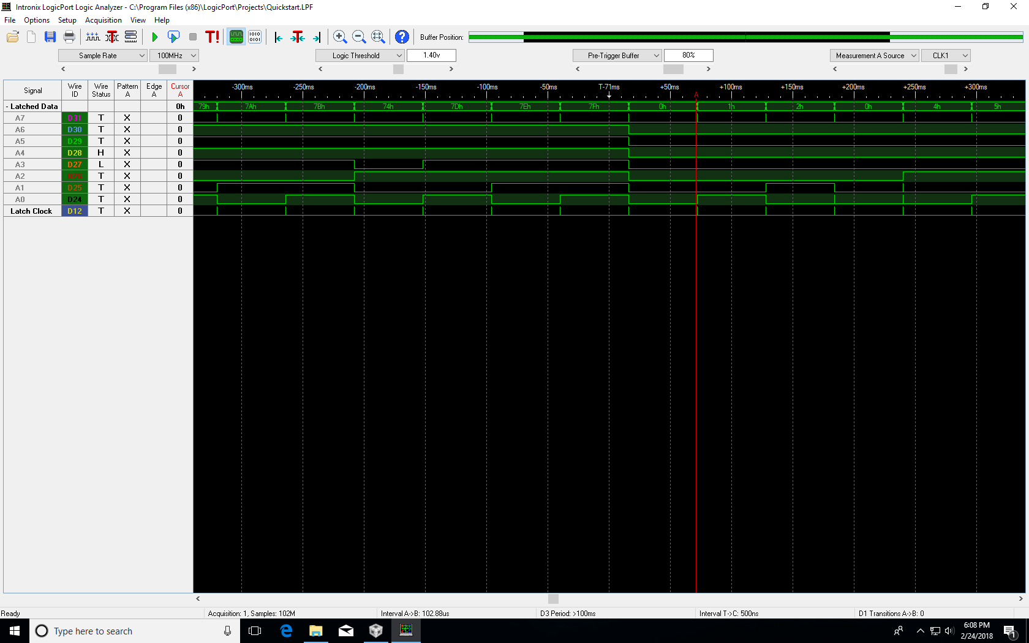

Data Latched 80h (Supplemental)

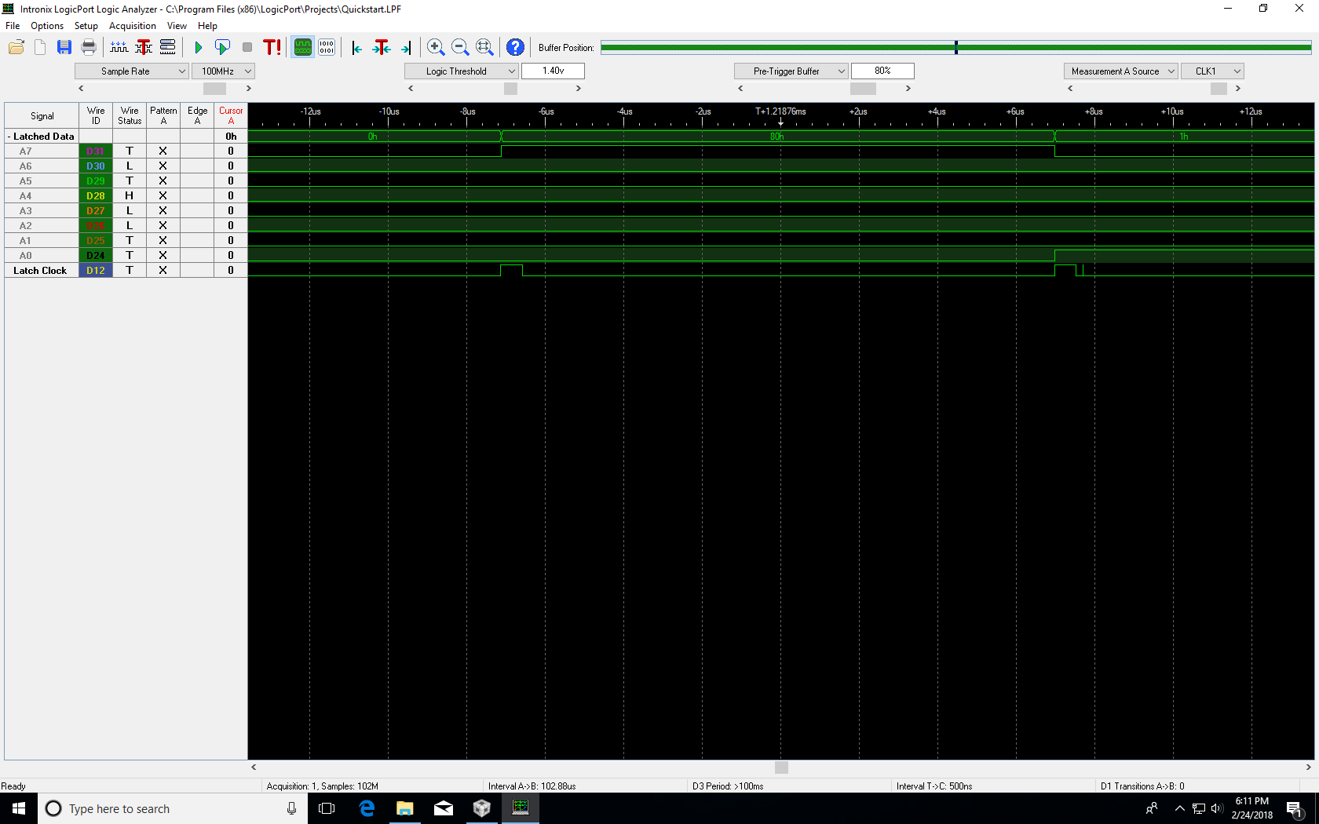

Data Latched FEh (Supplemental)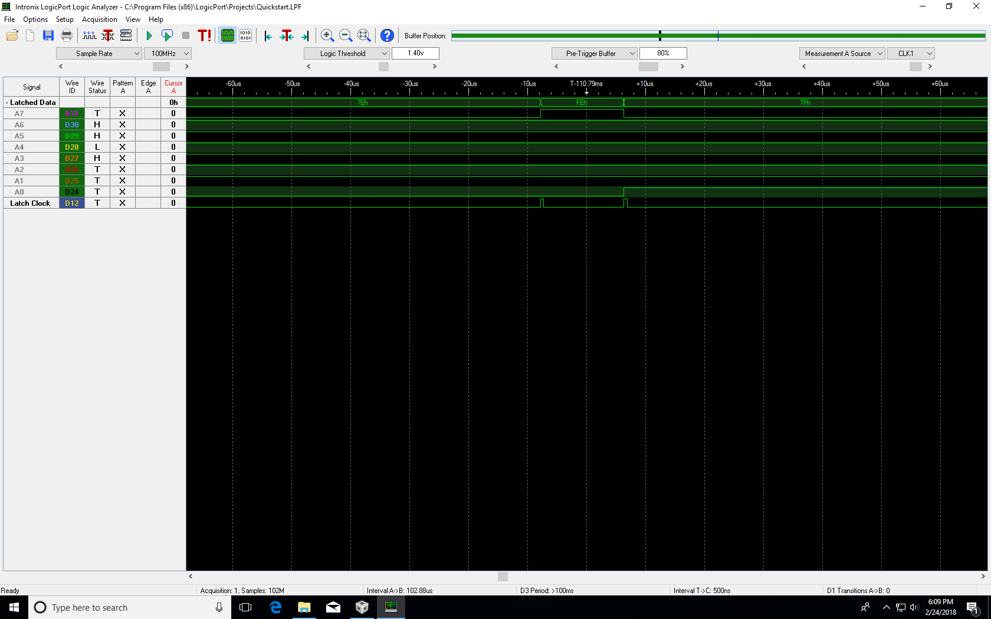

DATA Latched in ISR FF (Supplemental)