Class Activity 2:

multichain-cli mychain getnewaddress # Asif

multichain-cli mychain getnewaddress # Ali

multichain-cli mychain getnewaddress # Bilal

multichain-cli mychain getnewaddress # Sajid

multichain-cli mychain getnewaddress # Faiza

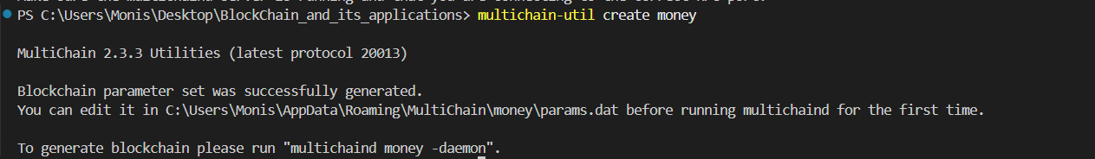

New address

Address

"1VnwujtingCPgeVZy8mZsrv9QEm9vtvhNkTYLz", #Asif

"1798Jc8t1yDucKQedmybe6R6e2Sr3hj3XHR4AE", #Ali

"19UptnQUzYqaRzfDrmzw4GmgFrFoRdq8ReD4Av", #Bilal

"15hYeTNgxzvvwM2BDKZEpNEqg59TaxGujco979", #Sajid

"1JfWmES7SNudFjnf95KwfJuApghYMaV9epJJpG" #Faiza

Grant Permissions  
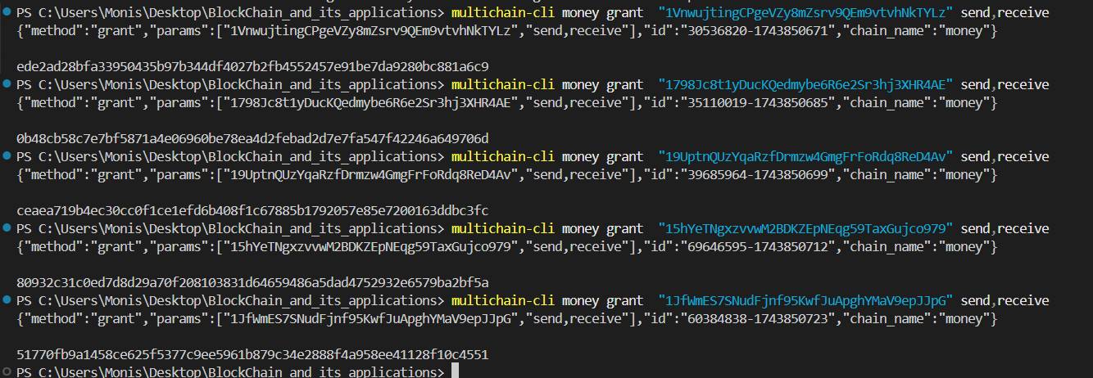

Assign Money to asif

Asif address : 1VnwujtingCPgeVZy8mZsrv9QEm9vtvhNkTYLz

multichain-cli money issue "1VnwujtingCPgeVZy8mZsrv9QEm9vtvhNkTYLz" '{"name":"PKRToken","open":true}' 500000 1 0

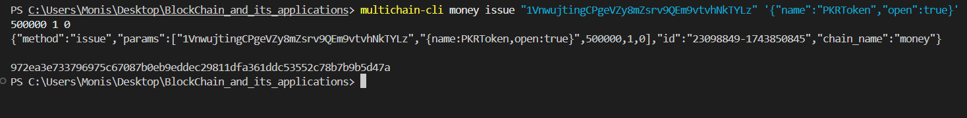

Sending 50,001 to other address with a crude implementation of smurfing

multichain-cli money sendassetfrom "1VnwujtingCPgeVZy8mZsrv9QEm9vtvhNkTYLz" "1798Jc8t1yDucKQedmybe6R6e2Sr3hj3XHR4AE" PKRToken 50001

sleep 5 //Sleeping for 5 seconds

multichain-cli money sendassetfrom "1VnwujtingCPgeVZy8mZsrv9QEm9vtvhNkTYLz" "19UptnQUzYqaRzfDrmzw4GmgFrFoRdq8ReD4Av" PKRToken 50001

sleep 5 //Sleeping for 5 seconds

multichain-cli money sendassetfrom "1VnwujtingCPgeVZy8mZsrv9QEm9vtvhNkTYLz" "15hYeTNgxzvvwM2BDKZEpNEqg59TaxGujco979" PKRToken 50001

sleep 5 //Sleeping for 5 seconds

multichain-cli money sendassetfrom "1VnwujtingCPgeVZy8mZsrv9QEm9vtvhNkTYLz" "1JfWmES7SNudFjnf95KwfJuApghYMaV9epJJpG" PKRToken 50001

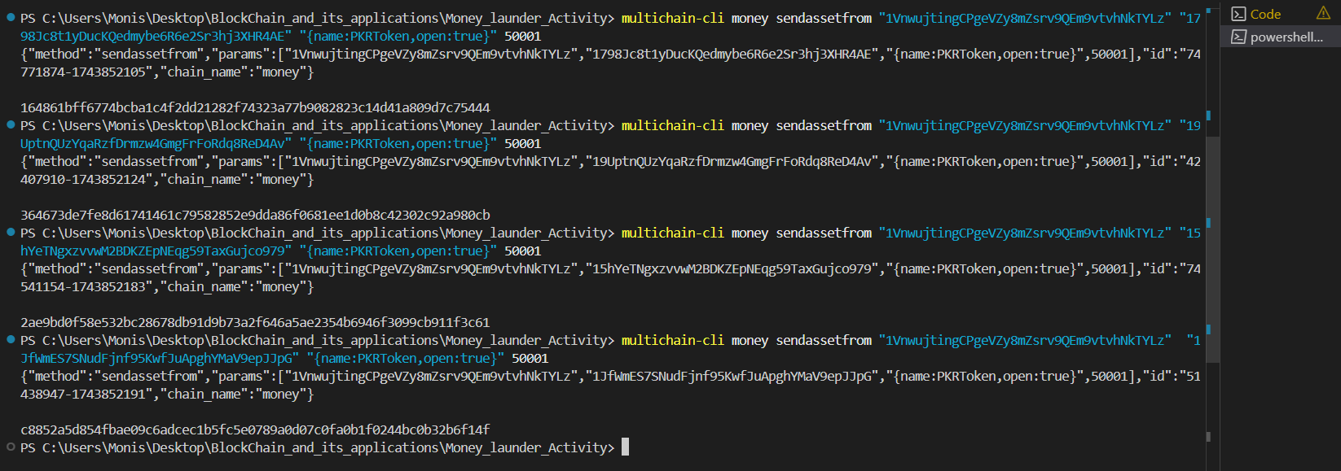

List audit trail

multichain-cli money listassettransactions PKRToken