Create a new chain

Multichain-util create mixer

Multichaind mixer

Get new address:

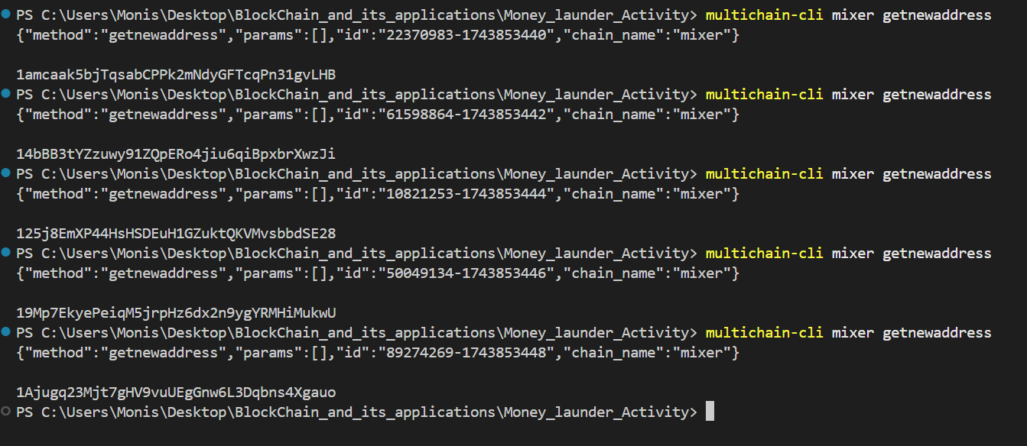

“1amcaak5bjTqsabCPPk2mNdyGFTcqPn31gvLHB”  
“14bBB3tYZzuwy91ZQpERo4jiu6qiBpxbrXwzJi”  
“125j8EmXP44HsHSDEuH1GZuktQKVMvsbbdSE28”  
“19Mp7EkyePeiqM5jrpHz6dx2n9ygYRMHiMukwU”  
“1Ajugq23Mjt7gHV9vuUEgGnw6L3Dqbns4Xgauo”

Grant send/receive permissions:

multichain-cli mixer grant "1amcaak5bjTqsabCPPk2mNdyGFTcqPn31gvLHB" send,receive  
multichain-cli mixer grant "14bBB3tYZzuwy91ZQpERo4jiu6qiBpxbrXwzJi" send,receive  
multichain-cli mixer grant "125j8EmXP44HsHSDEuH1GZuktQKVMvsbbdSE28" send,receive  
multichain-cli mixer grant "19Mp7EkyePeiqM5jrpHz6dx2n9ygYRMHiMukwU" send,receive  
multichain-cli mixer grant "1Ajugq23Mjt7gHV9vuUEgGnw6L3Dqbns4Xgauo" send,receive

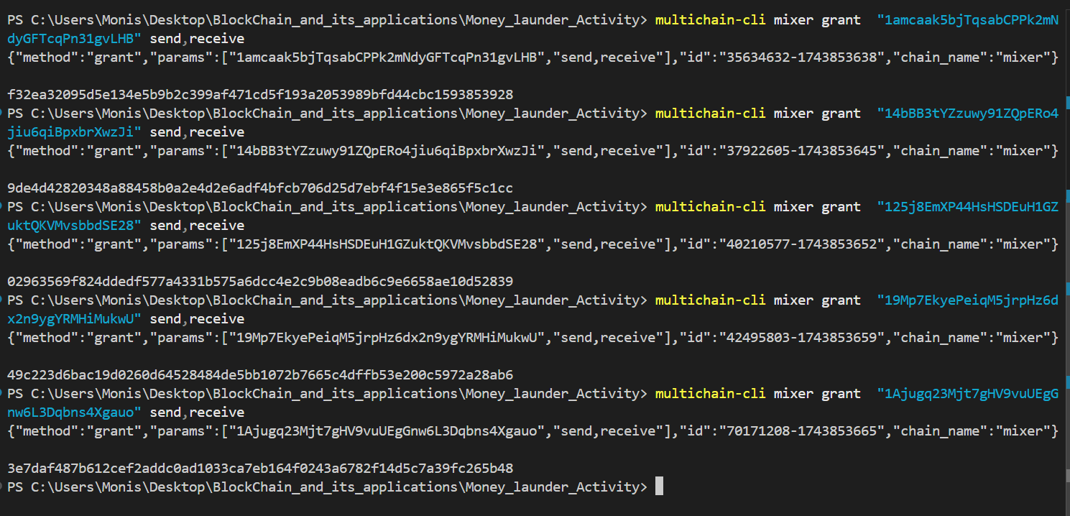

Assign 500,000 to first address:

multichain-cli mixer issue "1amcaak5bjTqsabCPPk2mNdyGFTcqPn31gvLHB" 'Linus' 500000 1

{"method":"issue","params":["1amcaak5bjTqsabCPPk2mNdyGFTcqPn31gvLHB","Linus",500000,1],"id":"97272560-1743853866","chain_name":"mixer"}

86a7c31b278e0ae5215fb02e32cacc64c2acf6fc2b57c11262027a173851a8df

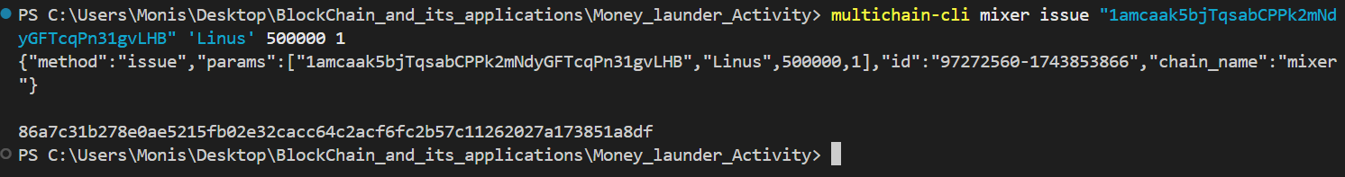

Create new mixer address  
mixer1=$(multichain-cli mixer getnewaddress)

mixer2=$(multichain-cli mixer getnewaddress)

mixer3=$(multichain-cli mixer getnewaddress)

mixer4=$(multichain-cli mixer getnewaddress)

mixer5=$(multichain-cli mixer getnewaddress)

“1T3gHahCdC6MSEYBDr4RBwFiVCtxRqmyVXNe4X” Mixer 1  
“1Yt3ABouXPvw1L8hmjgkW418khKi5aVM9QXubD” Mixer 2  
“1NwsHZgdqid4iUDtimDvKMwDgFPKWzeAgVN11n” Mixer 3  
“1TvwHb6zS4tz5x7xizTnBfqUU3qYBdn2w4aWLv” Mixer 4  
“1bPi3aLUQzypgL7YdW6nGXsBY17e6yrR24NYX3” Mixer 5

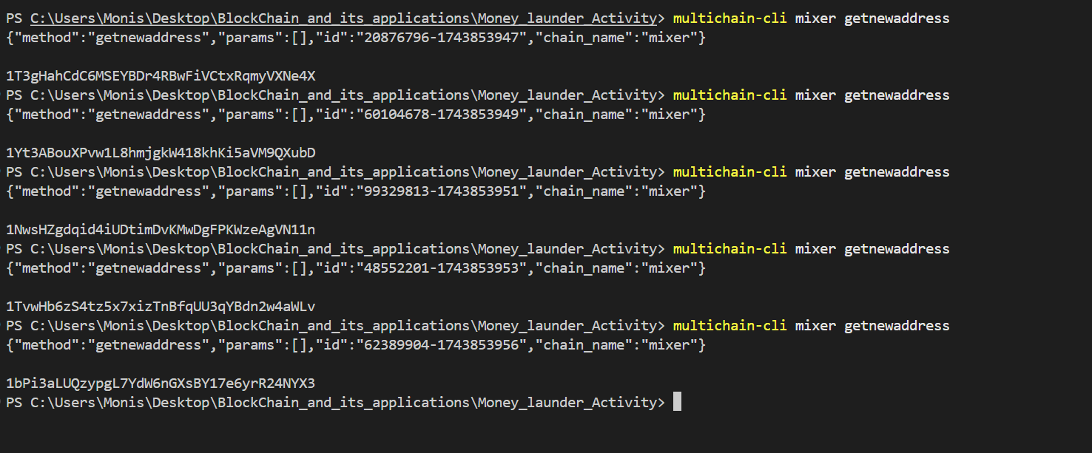

Grant Permissions:  
multichain-cli mixer grant "1T3gHahCdC6MSEYBDr4RBwFiVCtxRqmyVXNe4X" send,receive  
multichain-cli mixer grant "1Yt3ABouXPvw1L8hmjgkW418khKi5aVM9QXubD" send,receive  
multichain-cli mixer grant "1NwsHZgdqid4iUDtimDvKMwDgFPKWzeAgVN11n" send,receive  
multichain-cli mixer grant "1TvwHb6zS4tz5x7xizTnBfqUU3qYBdn2w4aWLv" send,receive  
multichain-cli mixer grant "1bPi3aLUQzypgL7YdW6nGXsBY17e6yrR24NYX3" send,receive

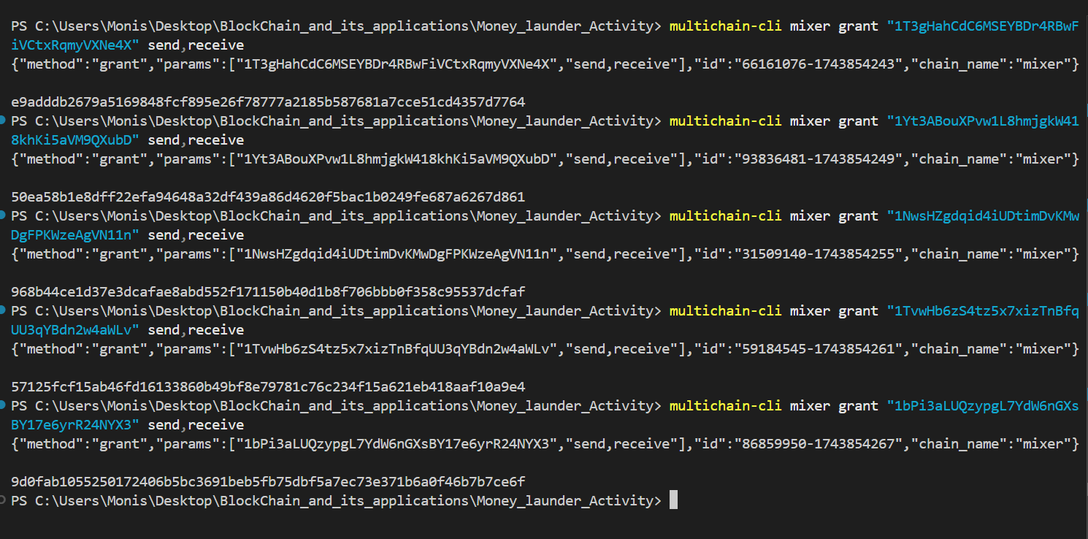

Send assets to mixers:

Basic Demo:  
multichain-cli mychain sendassetfrom 1AsifAddr... $mixer1 PKRToken 40000

multichain-cli mychain sendassetfrom 1AsifAddr... $mixer2 PKRToken 40000

multichain-cli mychain sendassetfrom 1AsifAddr... $mixer3 PKRToken 40000

multichain-cli mychain sendassetfrom 1AsifAddr... $mixer4 PKRToken 40000

multichain-cli mychain sendassetfrom 1AsifAddr... $mixer5 PKRToken 40004

Practical:

multichain-cli mixer sendassetfrom "1amcaak5bjTqsabCPPk2mNdyGFTcqPn31gvLHB" "1T3gHahCdC6MSEYBDr4RBwFiVCtxRqmyVXNe4X" "Linus" 100000

multichain-cli mixer sendassetfrom "1amcaak5bjTqsabCPPk2mNdyGFTcqPn31gvLHB" "1Yt3ABouXPvw1L8hmjgkW418khKi5aVM9QXubD" "Linus" 100000

multichain-cli mixer sendassetfrom "1amcaak5bjTqsabCPPk2mNdyGFTcqPn31gvLHB" "1NwsHZgdqid4iUDtimDvKMwDgFPKWzeAgVN11n" "Linus" 100000

multichain-cli mixer sendassetfrom "1amcaak5bjTqsabCPPk2mNdyGFTcqPn31gvLHB" "1TvwHb6zS4tz5x7xizTnBfqUU3qYBdn2w4aWLv" "Linus" 100000

multichain-cli mixer sendassetfrom "1amcaak5bjTqsabCPPk2mNdyGFTcqPn31gvLHB" "1bPi3aLUQzypgL7YdW6nGXsBY17e6yrR24NYX3" "Linus" 100000

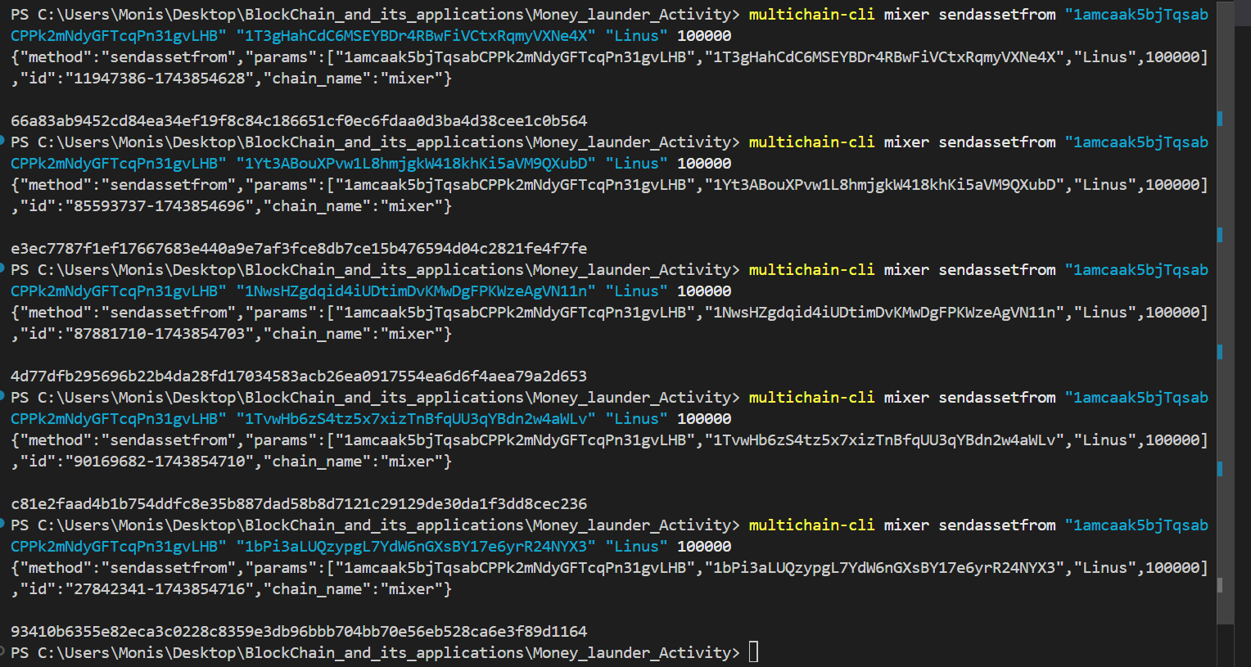

Mixer Wallets Randomly Pay Recipients:

Demo:  
# Mixer1 ➝ Ali

multichain-cli mychain sendassetfrom $mixer1 1AliAddr... PKRToken 27000

# Mixer2 ➝ Bilal and Sajid

multichain-cli mychain sendassetfrom $mixer2 1BilalAddr... PKRToken 20000

multichain-cli mychain sendassetfrom $mixer2 1SajidAddr... PKRToken 15000

# Mixer3 ➝ Faiza

multichain-cli mychain sendassetfrom $mixer3 1FaizaAddr... PKRToken 30000

# Mixer4 ➝ Sajid

multichain-cli mychain sendassetfrom $mixer4 1SajidAddr... PKRToken 20001

# Mixer5 ➝ Ali and Bilal

multichain-cli mychain sendassetfrom $mixer5 1AliAddr... PKRToken 13000

multichain-cli mychain sendassetfrom $mixer5 1BilalAddr... PKRToken 19999

Clients:  
“1amcaak5bjTqsabCPPk2mNdyGFTcqPn31gvLHB” Asif  
“14bBB3tYZzuwy91ZQpERo4jiu6qiBpxbrXwzJi” Ali  
“125j8EmXP44HsHSDEuH1GZuktQKVMvsbbdSE28” Raza  
“19Mp7EkyePeiqM5jrpHz6dx2n9ygYRMHiMukwU” Ahmed  
“1Ajugq23Mjt7gHV9vuUEgGnw6L3Dqbns4Xgauo” Faiza

Mixers:  
“1T3gHahCdC6MSEYBDr4RBwFiVCtxRqmyVXNe4X” Mixer 1  
“1Yt3ABouXPvw1L8hmjgkW418khKi5aVM9QXubD” Mixer 2  
“1NwsHZgdqid4iUDtimDvKMwDgFPKWzeAgVN11n” Mixer 3  
“1TvwHb6zS4tz5x7xizTnBfqUU3qYBdn2w4aWLv” Mixer 4  
“1bPi3aLUQzypgL7YdW6nGXsBY17e6yrR24NYX3” Mixer 5

Practical:

multichain-cli mixer sendassetfrom "1T3gHahCdC6MSEYBDr4RBwFiVCtxRqmyVXNe4X" "14bBB3tYZzuwy91ZQpERo4jiu6qiBpxbrXwzJi" "Linus" 13000

multichain-cli mixer sendassetfrom "1Yt3ABouXPvw1L8hmjgkW418khKi5aVM9QXubD" "125j8EmXP44HsHSDEuH1GZuktQKVMvsbbdSE28" "Linus" 11000

multichain-cli mixer sendassetfrom "1Yt3ABouXPvw1L8hmjgkW418khKi5aVM9QXubD" "19Mp7EkyePeiqM5jrpHz6dx2n9ygYRMHiMukwU" "Linus" 14000

multichain-cli mixer sendassetfrom "1NwsHZgdqid4iUDtimDvKMwDgFPKWzeAgVN11n" "1Ajugq23Mjt7gHV9vuUEgGnw6L3Dqbns4Xgauo" "Linus" 15000

multichain-cli mixer sendassetfrom "1TvwHb6zS4tz5x7xizTnBfqUU3qYBdn2w4aWLv" "19Mp7EkyePeiqM5jrpHz6dx2n9ygYRMHiMukwU" "Linus" 12000

multichain-cli mixer sendassetfrom "1bPi3aLUQzypgL7YdW6nGXsBY17e6yrR24NYX3" "14bBB3tYZzuwy91ZQpERo4jiu6qiBpxbrXwzJi" "Linus" 9000

multichain-cli mixer sendassetfrom "1bPi3aLUQzypgL7YdW6nGXsBY17e6yrR24NYX3" "125j8EmXP44HsHSDEuH1GZuktQKVMvsbbdSE28" "Linus" 16000

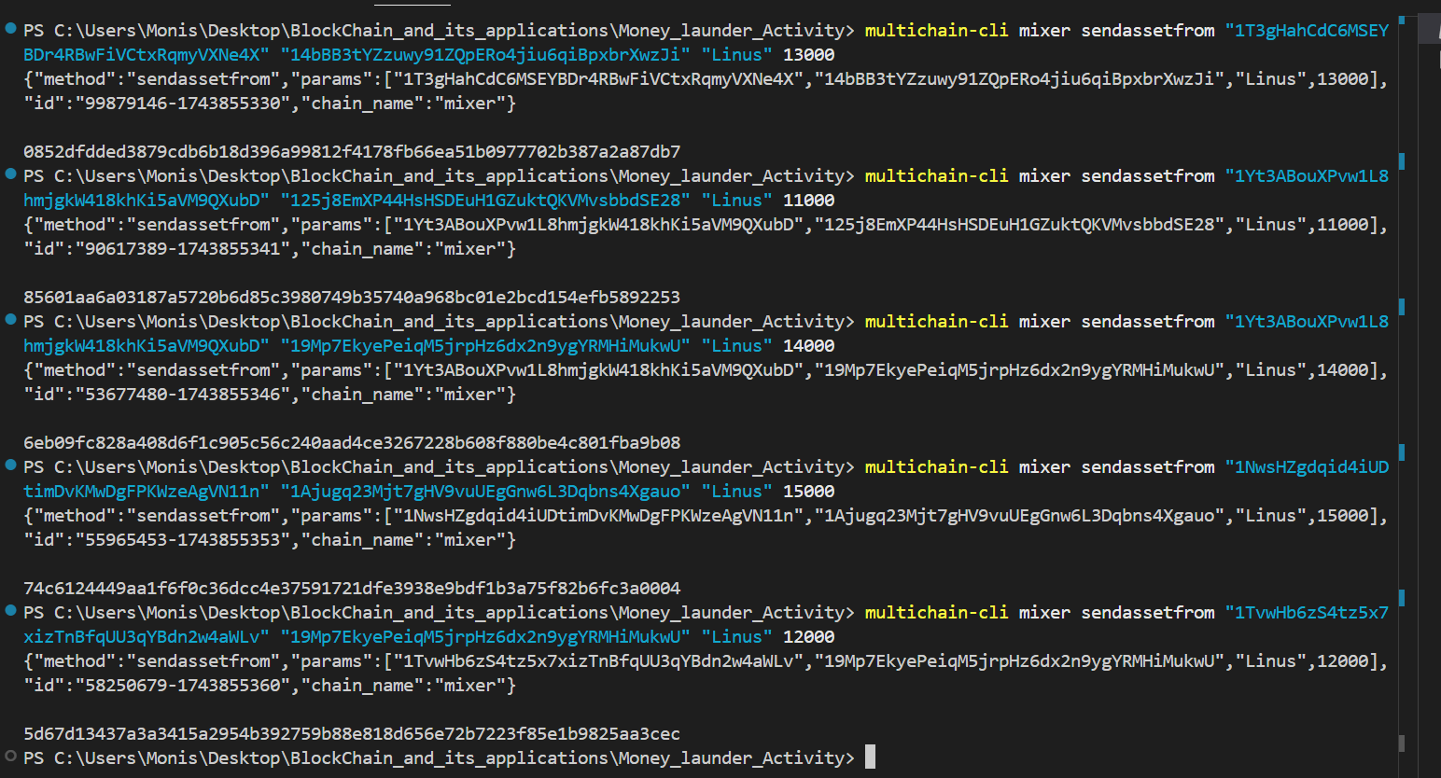

Audit Trail:

multichain-cli mixer subscribe "Linus"

{"method":"subscribe","params":["Linus"],"id":"74145634-1743855448","chain_name":"mixer"}

PS C:\Users\Monis\Desktop\BlockChain_and_its_applications\Money_launder_Activity> multichain-cli mixer listassettransactions "Linus"

{"method":"listassettransactions","params":["Linus"],"id":"62595904-1743855452","chain_name":"mixer"}

[

{

"addresses" : {

"1amcaak5bjTqsabCPPk2mNdyGFTcqPn31gvLHB" : -100000,

"1NwsHZgdqid4iUDtimDvKMwDgFPKWzeAgVN11n" : 100000

},

"items" : [

],

"data" : [

],

"confirmations" : 25,

"blockhash" : "004e3c59ef16c542e11f02634878946d3e3d9597e634e7aaaac76dbdce5131d0",

"blockheight" : 79,

"blockindex" : 2,

"blocktime" : 1743854703,

"txid" : "4d77dfb295696b22b4da28fd17034583acb26ea0917554ea6d6f4aea79a2d653",

"valid" : true,

"time" : 1743854703,

"timereceived" : 1743854703

},

{

"addresses" : {

"1amcaak5bjTqsabCPPk2mNdyGFTcqPn31gvLHB" : -100000,

"1TvwHb6zS4tz5x7xizTnBfqUU3qYBdn2w4aWLv" : 100000

},

"items" : [

],

"data" : [

],

"confirmations" : 24,

"blockhash" : "000edfd3825b7cc67639ae17bfc07ee9464a0b7d23fe38eebcd53ccad495db9e",

"blockheight" : 80,

"blockindex" : 1,

"blocktime" : 1743854710,

"txid" : "c81e2faad4b1b754ddfc8e35b887dad58b8d7121c29129de30da1f3dd8cec236",

"valid" : true,

"time" : 1743854710,

"timereceived" : 1743854710

},

{

"addresses" : {

"1amcaak5bjTqsabCPPk2mNdyGFTcqPn31gvLHB" : -100000,

"1bPi3aLUQzypgL7YdW6nGXsBY17e6yrR24NYX3" : 100000

},

"items" : [

],

"data" : [

],

"confirmations" : 23,

"blockhash" : "0065c78e873db8b1577fa45a867f43f5f3d2c0b477aabe9585853aae79fca470",

"blockheight" : 81,

"blockindex" : 1,

"blocktime" : 1743854722,

"txid" : "93410b6355e82eca3c0228c8359e3db96bbb704bb70e56eb528ca6e3f89d1164",

"valid" : true,

"time" : 1743854716,

"timereceived" : 1743854716

},

{

"addresses" : {

"1T3gHahCdC6MSEYBDr4RBwFiVCtxRqmyVXNe4X" : -13000,

"14bBB3tYZzuwy91ZQpERo4jiu6qiBpxbrXwzJi" : 13000

},

"items" : [

],

"data" : [

],

"confirmations" : 12,

"blockhash" : "003acbd07448cdc0afbe947cf27849afc62f50ff130a6234c9569fb3f5565e5a",

"blockheight" : 92,

"blockindex" : 1,

"blocktime" : 1743855341,

"txid" : "0852dfdded3879cdb6b18d396a99812f4178fb66ea51b0977702b387a2a87db7",

"valid" : true,

"time" : 1743855330,

"timereceived" : 1743855330

},

{

"addresses" : {

"125j8EmXP44HsHSDEuH1GZuktQKVMvsbbdSE28" : 11000,

"1Yt3ABouXPvw1L8hmjgkW418khKi5aVM9QXubD" : -11000

},

"items" : [

],

"data" : [

],

"confirmations" : 12,

"blockhash" : "003acbd07448cdc0afbe947cf27849afc62f50ff130a6234c9569fb3f5565e5a",

"blockheight" : 92,

"blockindex" : 2,

"blocktime" : 1743855341,

"txid" : "85601aa6a03187a5720b6d85c3980749b35740a968bc01e2bcd154efb5892253",

"valid" : true,

"time" : 1743855341,

"timereceived" : 1743855341

},

{

"addresses" : {

"19Mp7EkyePeiqM5jrpHz6dx2n9ygYRMHiMukwU" : 14000,

"1Yt3ABouXPvw1L8hmjgkW418khKi5aVM9QXubD" : -14000

},

"items" : [

],

"data" : [

],

"confirmations" : 11,

"blockhash" : "009289edea07ca6e0ce20ae228aafe1dc972bc6457f500b6549e8d8620703a63",

"blockheight" : 93,

"blockindex" : 1,

"blocktime" : 1743855351,

"txid" : "6eb09fc828a408d6f1c905c56c240aad4ce3267228b608f880be4c801fba9b08",

"valid" : true,

"time" : 1743855346,

"timereceived" : 1743855346

},

{

"addresses" : {

"1NwsHZgdqid4iUDtimDvKMwDgFPKWzeAgVN11n" : -15000,

"1Ajugq23Mjt7gHV9vuUEgGnw6L3Dqbns4Xgauo" : 15000

},

"items" : [

],

"data" : [

],

"confirmations" : 10,

"blockhash" : "004675933318ada136861385ceaaa568a6373c4d7f04ed2ef294f186d457ef01",

"blockheight" : 94,

"blockindex" : 1,

"blocktime" : 1743855359,

"txid" : "74c6124449aa1f6f0c36dcc4e37591721dfe3938e9bdf1b3a75f82b6fc3a0004",

"valid" : true,

"time" : 1743855353,

"timereceived" : 1743855353

},

{

"addresses" : {

"1TvwHb6zS4tz5x7xizTnBfqUU3qYBdn2w4aWLv" : -12000,

"19Mp7EkyePeiqM5jrpHz6dx2n9ygYRMHiMukwU" : 12000

},

"items" : [

],

"data" : [

],

"confirmations" : 9,

"blockhash" : "00138e899ba76f96e05b6b94ef9846e583a63e9dc7269cd2ce8621053f0ee5fc",

"blockheight" : 95,

"blockindex" : 1,

"blocktime" : 1743855360,

"txid" : "5d67d13437a3a3415a2954b392759b88e818d656e72b7223f85e1b9825aa3cec",

"valid" : true,

"time" : 1743855360,

"timereceived" : 1743855360

},

{

"addresses" : {

"1bPi3aLUQzypgL7YdW6nGXsBY17e6yrR24NYX3" : -9000,

"14bBB3tYZzuwy91ZQpERo4jiu6qiBpxbrXwzJi" : 9000

},

"items" : [

],

"data" : [

],

"confirmations" : 6,

"blockhash" : "000ba1254f282f48fba1620eeedf465bd36b43094a635151d6f44ec40f3ef5fa",

"blockheight" : 98,

"blockindex" : 1,

"blocktime" : 1743855382,

"txid" : "6ac9dfff98aabc7339deb21ed767866ace96a80a22b11491f6b4e5c8de2dfd8b",

"valid" : true,

"time" : 1743855381,

"timereceived" : 1743855381

},

{

"addresses" : {

"125j8EmXP44HsHSDEuH1GZuktQKVMvsbbdSE28" : 16000,

"1bPi3aLUQzypgL7YdW6nGXsBY17e6yrR24NYX3" : -16000

},

"items" : [

],

"data" : [

],

"confirmations" : 5,

"blockhash" : "00a1e3d06f2c12f90cfd1b5154abd9d11007dec7a70760c7820af284d90723ce",

"blockheight" : 99,

"blockindex" : 1,

"blocktime" : 1743855397,

"txid" : "bc311a4b799188814ea8c15f248b0c499f9a7c86f7dfbba9c134177cf05f972e",

"valid" : true,

"time" : 1743855385,

"timereceived" : 1743855385

}

]

PS C:\Users\Monis\Desktop\BlockChain_and_its_applications\Money_launder_Activity>