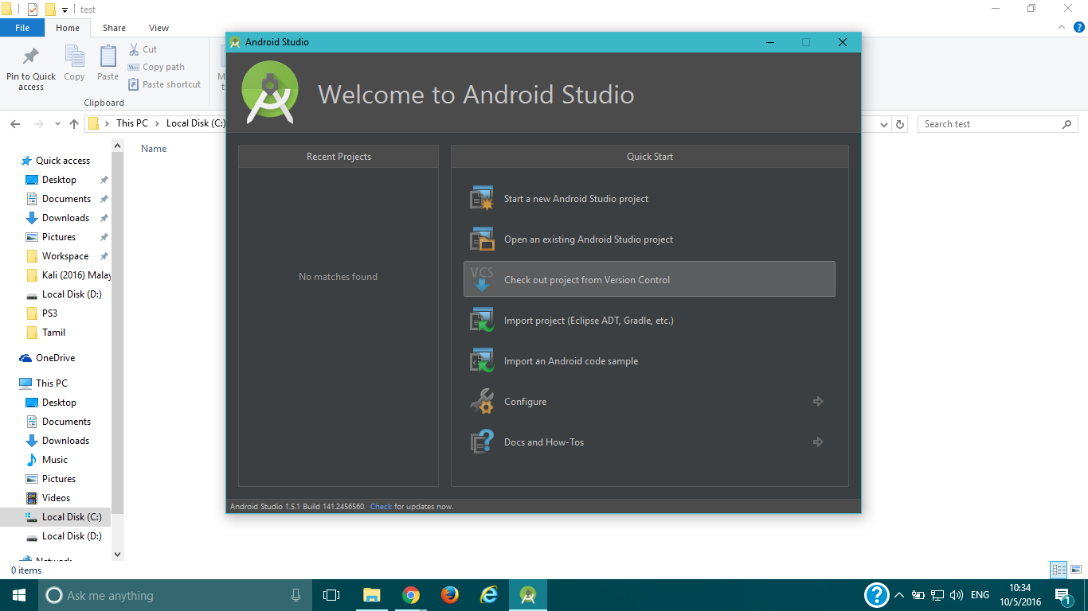

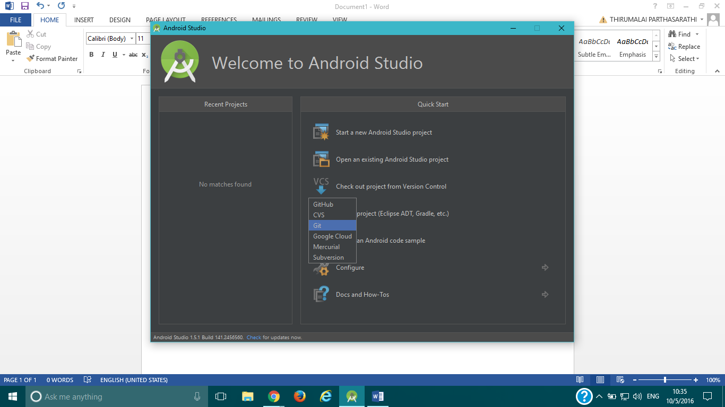

Repo URL: https://gitlab.com/tparthasarathi16/monitpro_mobile_app_android.git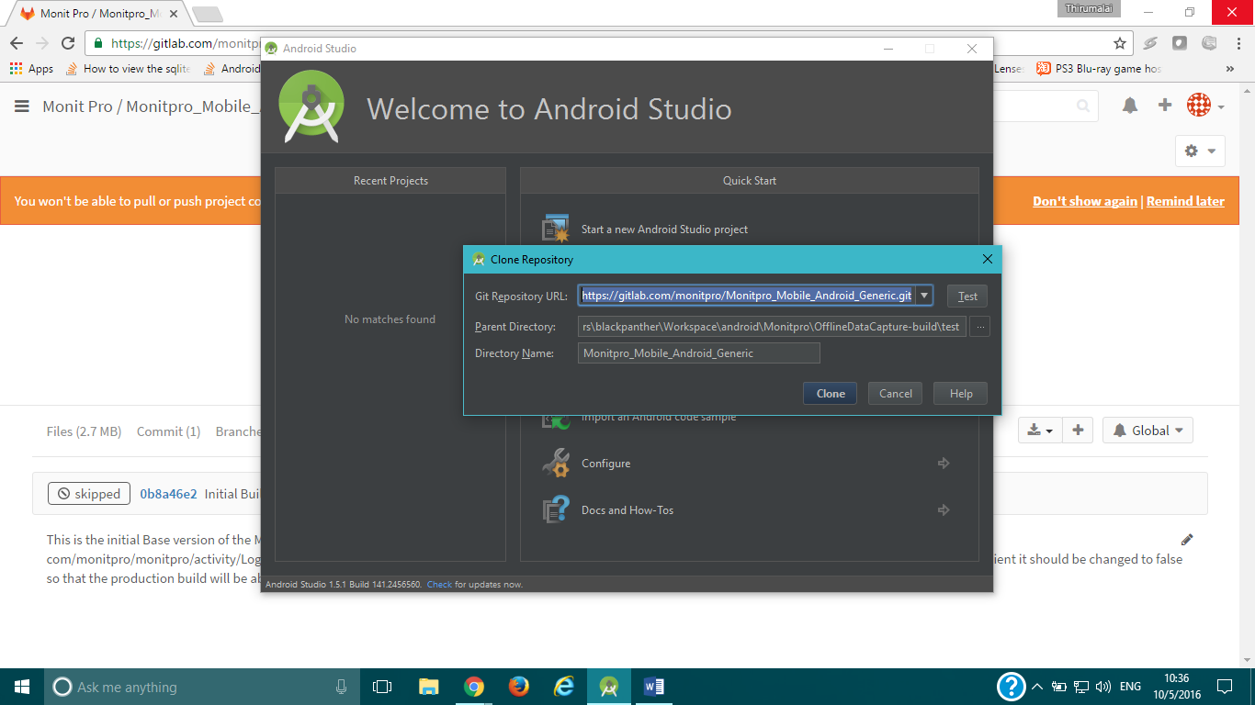

The repository url is

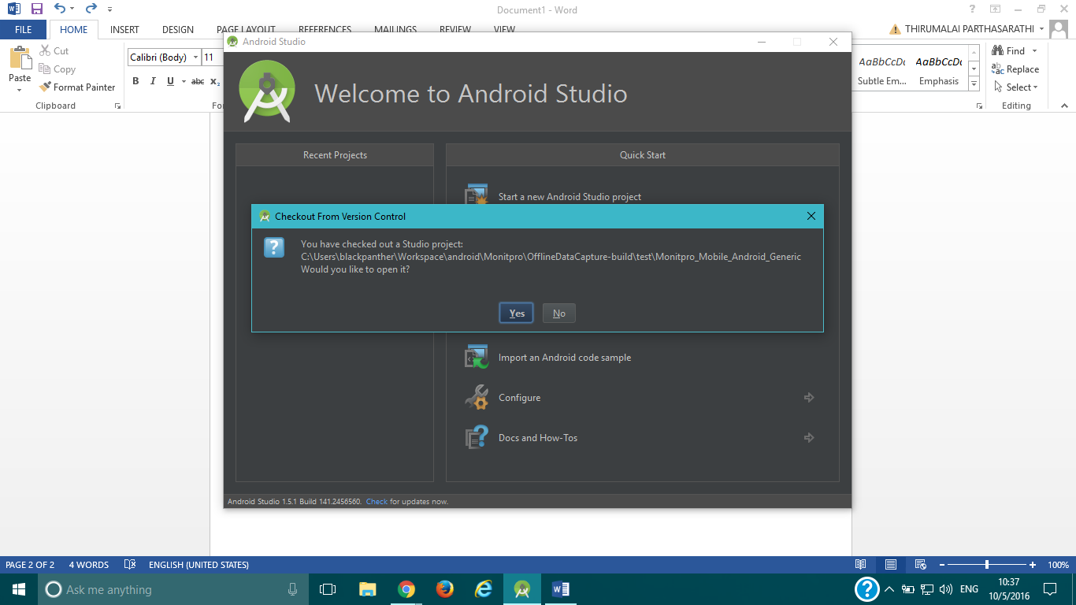

Ignore any errors regarding modules at this stage.

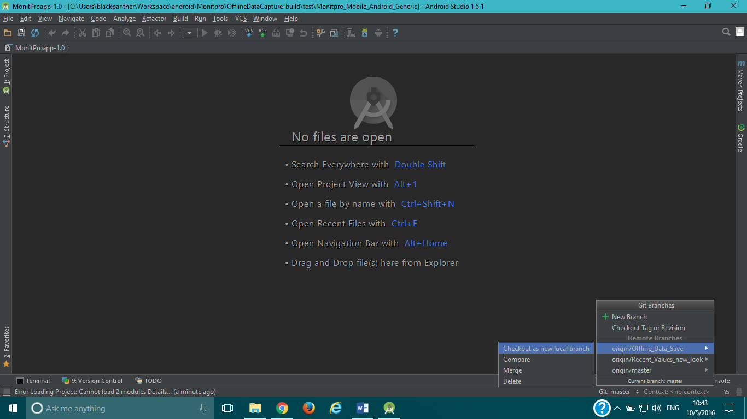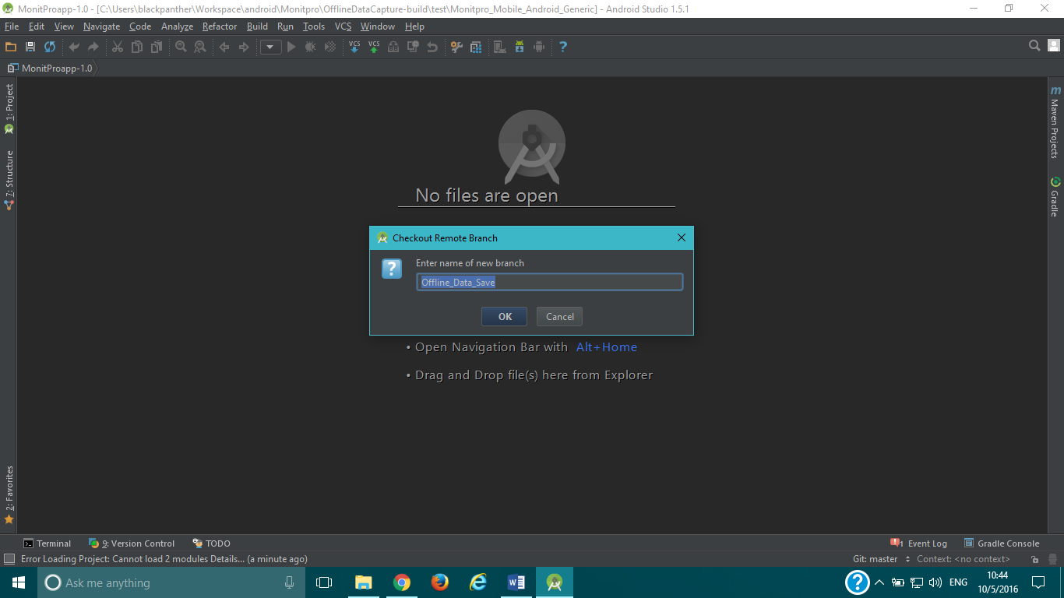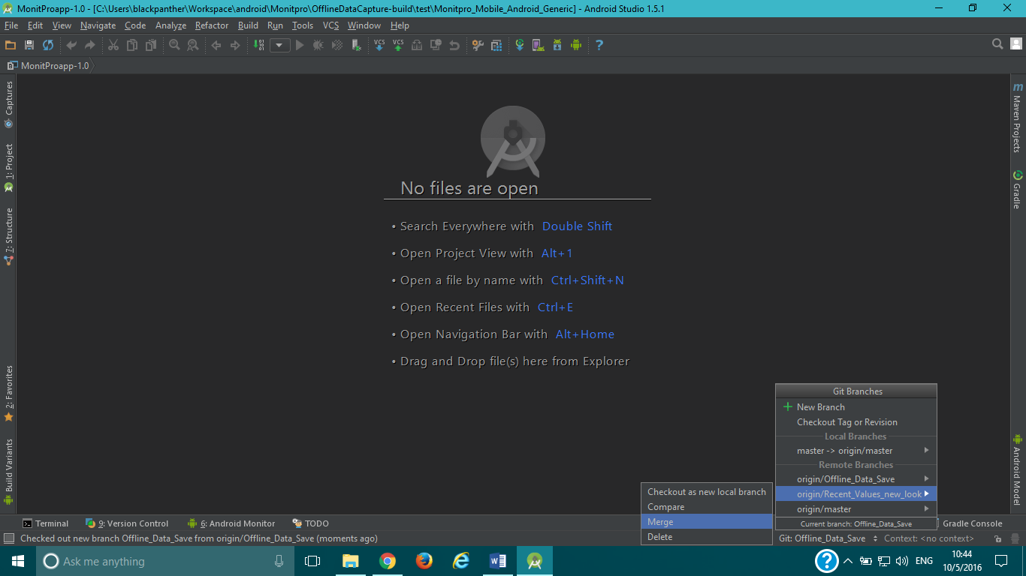

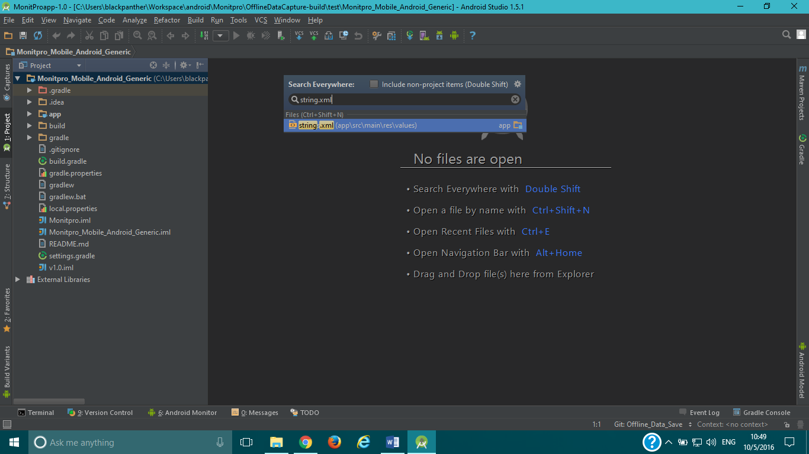

The String.xml file has the URLs for different service. Change the URLs here and click on Build -> Build APK.

The APK would be available in PROJECT_FOLDER\build\output, where PROJECT_FOLDER will be the project folder of Monitpro in the studio.