Membership plan entity and attributes:



Guest entity and attributes:



Member entity and attributes:



Class entity and attributes:



Trainer entity and attributes:  


Order entity and attributes:



Manager entity and attributes:



Assistant manager entity and attributes:



Sales entity and attributes:



Payment entity and attributes:



Inventory entity and attributes:



ERD:



Wireframe for welcome page:  
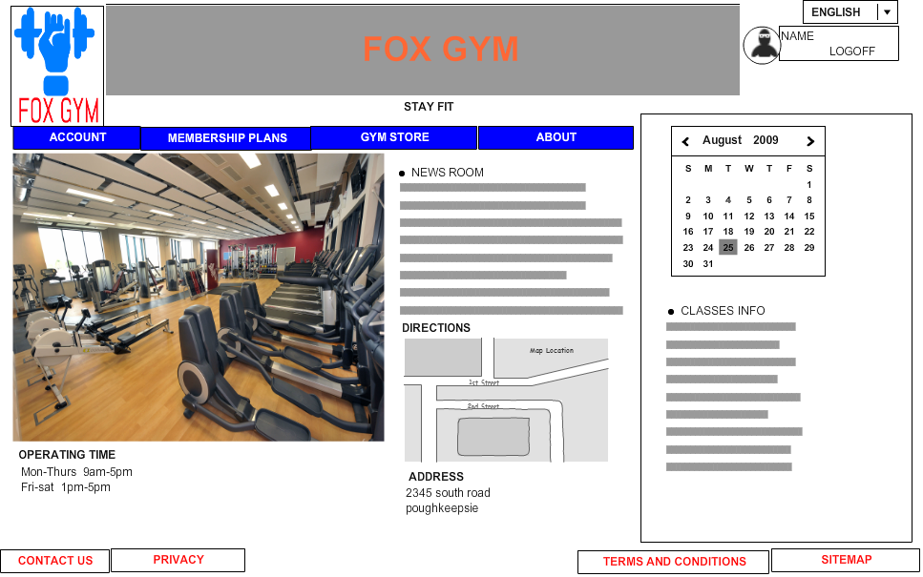

Wire frame for sales

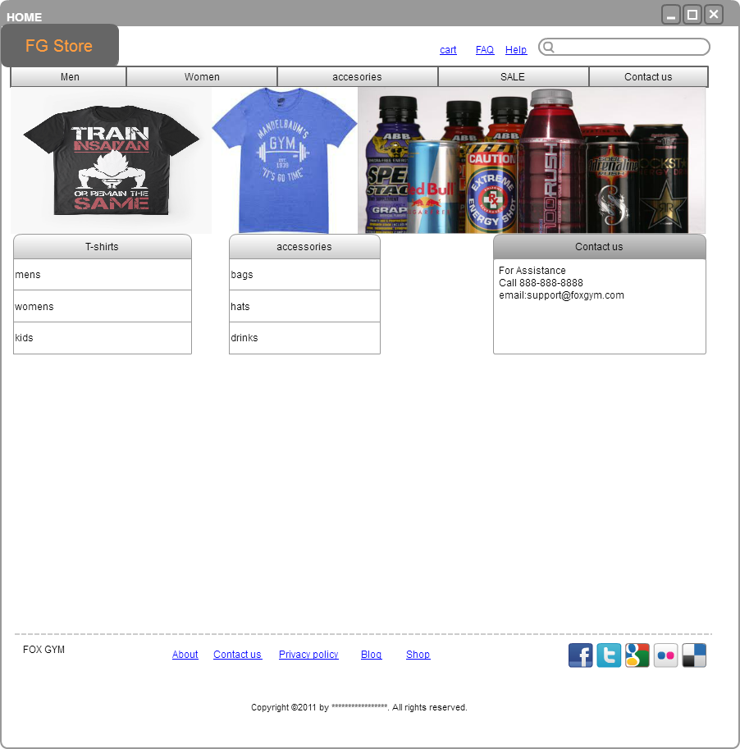

WIREFRAME FOR MEMBERSHIP PLANS

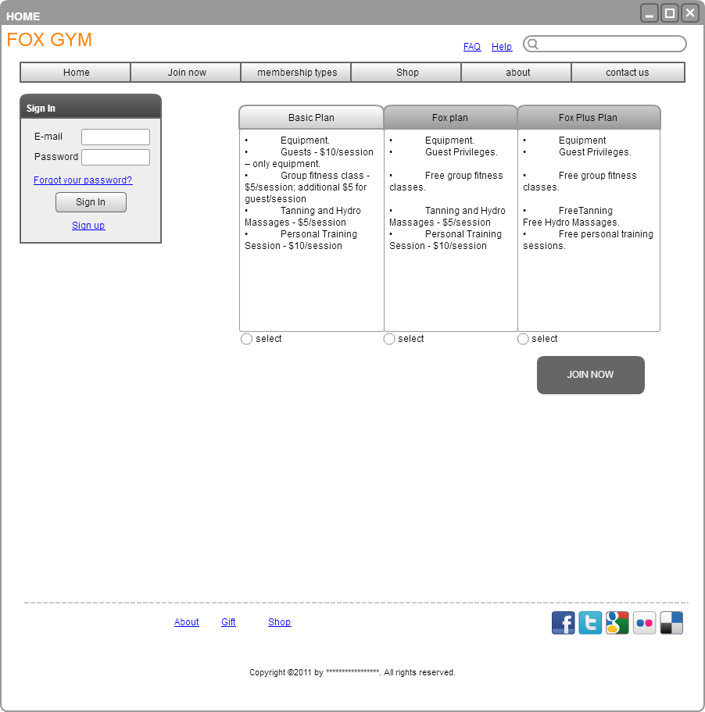

WIREFRAME FOR MY ACCOUNT

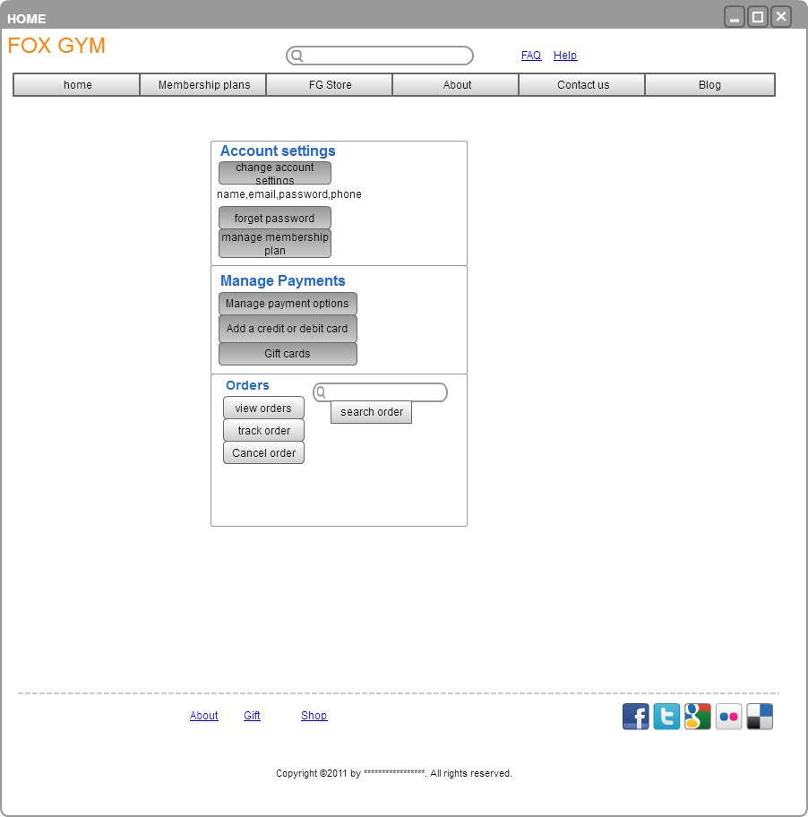

WIREFRAME FOR CLASS SCHEDULE

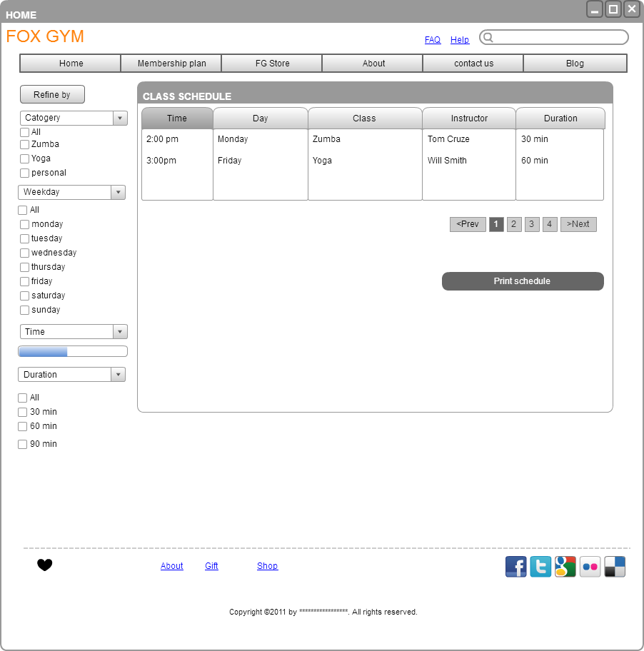

Sql query:

Select class_type, classes_enrolled, trainer_name, no_of_classesheld from Class, Member

Where Class.Member_Id= Member.Member_Id

OUTPUT:

|  |  |  |  |
| --- | --- | --- | --- |
| **Class_type** | **Classes_enrolled** | **Trainer_Name** | **No_of_classesheld** |
| Zumba | 23 | Tom cruise | 44 |
| Yoga | 44 | Michael | 44 |
| Zumba | 12 | Mark twain | 19 |

Use case diagram:

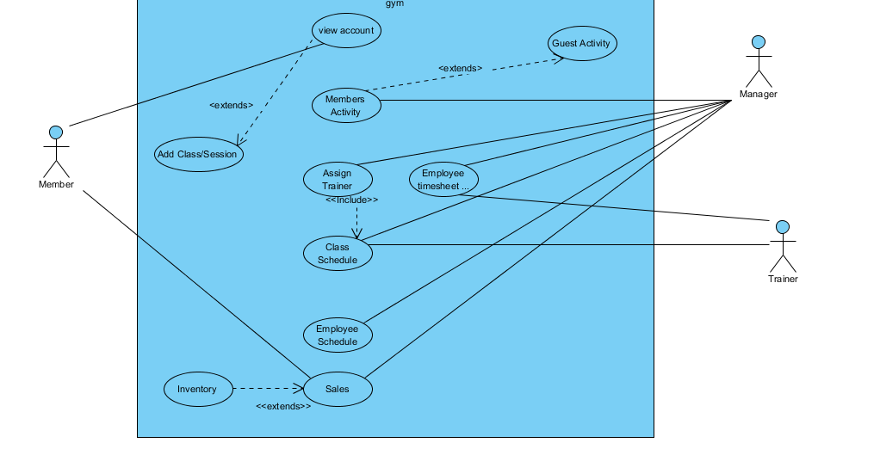

Activity diagrams:

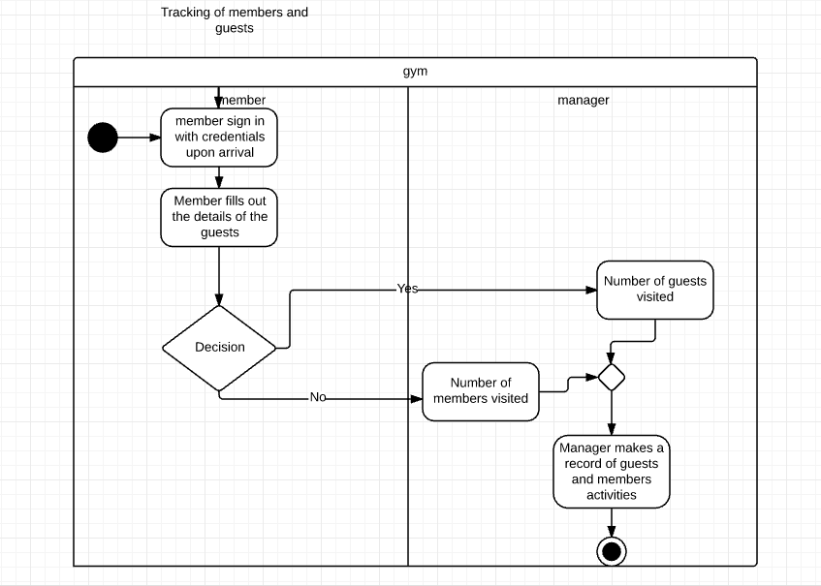

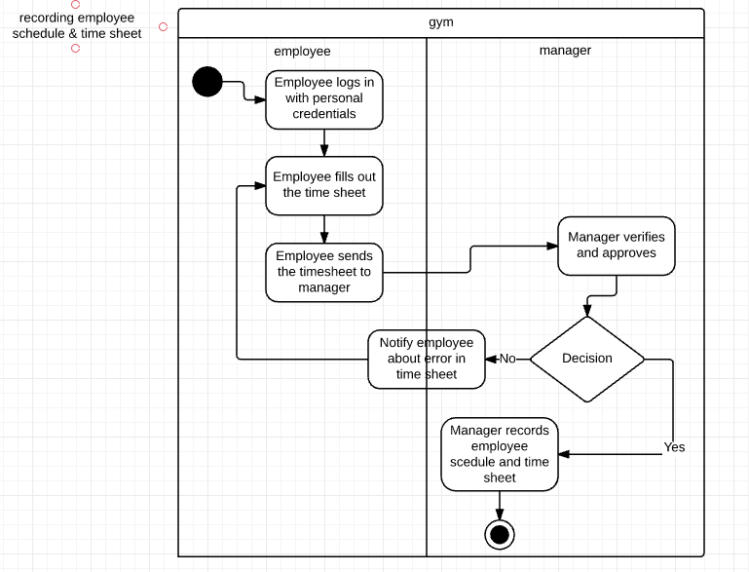

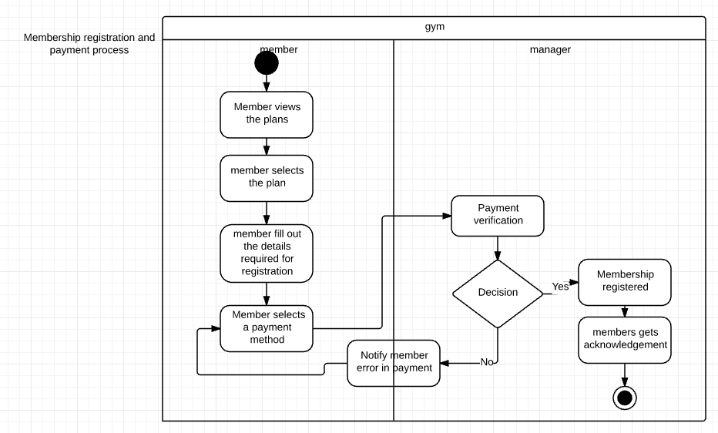

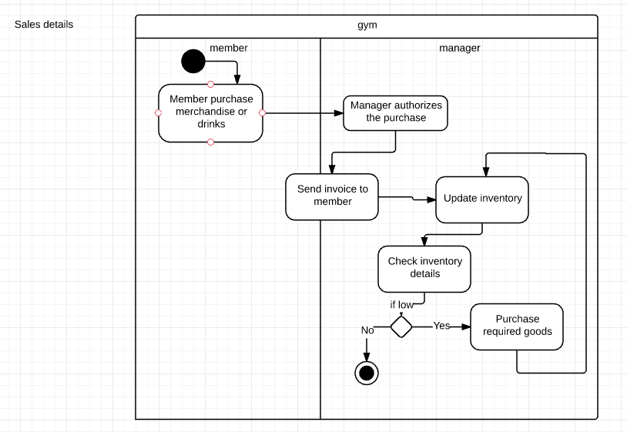

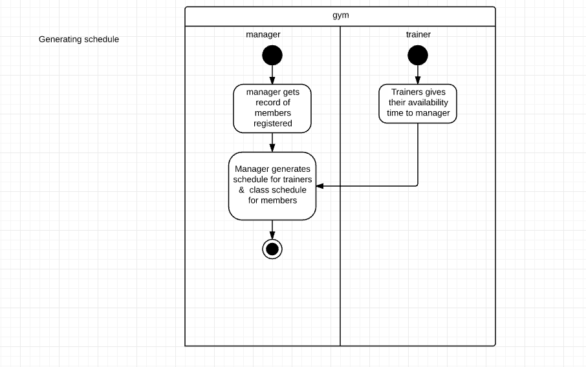

 Member Registration and payment sequence diagram:



Generating schedule sequence diagram:



Employee timesheet sequence diagram:



Sales and inventory sequence diagram:



Registering for classes sequence diagram:

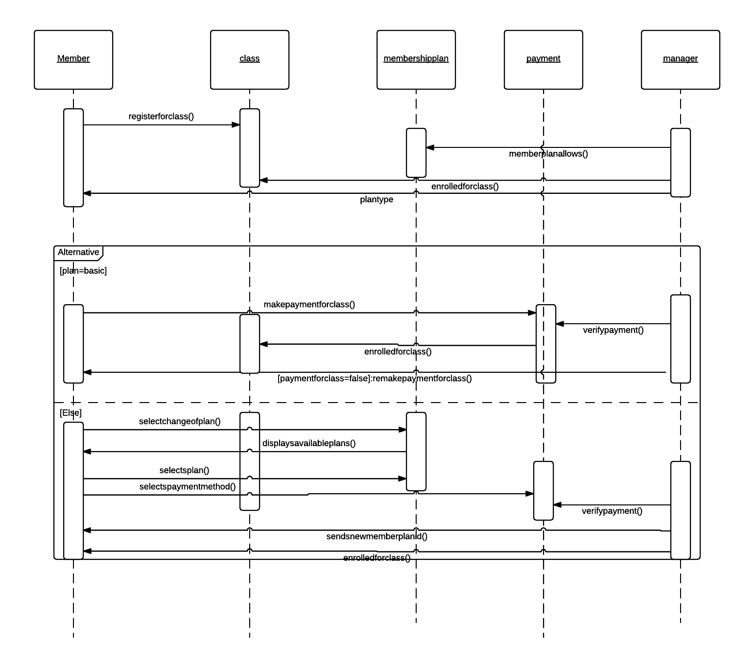

Sequence diagram for tracking of guests brought by the members:

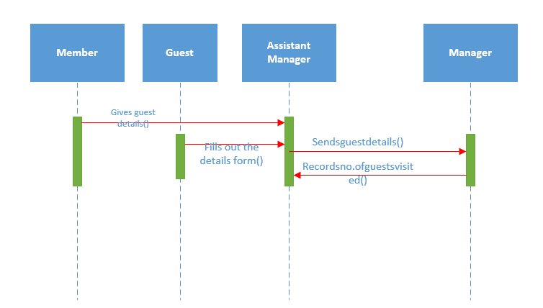

CONTRACT FOR CLASS REGISTRATION

Method Name: +Enrollinclass()

Class Name: Member

Associated Use Cases: View account, Sales, add class/session

Description of Responsibilities: Member can enroll in group class based on plan types.

Arguments Received/ Parameters for this method: Member Id, planid.

Data type of Arguments Received: String

Value Returned: Enrolled

Data type of Return Value: string

Pre-Condition: Manager must have generated group class schedule and allowed members to register online.

Post-Conditions: member gets enrolled for group classes and gets acknowledgement.

CONTRACT FOR GYM ENROLLMENT

Method Name: +Registration()

Class Name: Member

Associated Use Cases: Sales

Description of Responsibilities: Registers for different plans for the gym and can use gym equipment.

Arguments Received/ Parameters for this method: Name, Email and plan type.

Data type of Arguments Received: String

Value Returned: Member Id

Data type of Return Value: string

Pre-Condition: Not Applicable

Post-Conditions: Gets acknowledgement of registration and can use different types of gym equipment and classes based on plan.

Submitted by:

Sasanka Reddy Chintam

Mourya Dinagari

Dileep podduturi

Ravi Vempati

Rohith Neelamraju