Marist College

**Class Diagram, Sequence Diagrams, and Contracts**

Assignment 3

Team Fleek: Erik, Evan, William, Amber

MSIS 657 Section 711

Professor Singh

November 14, 2016

**Use Case Diagram for Fox Fitness**

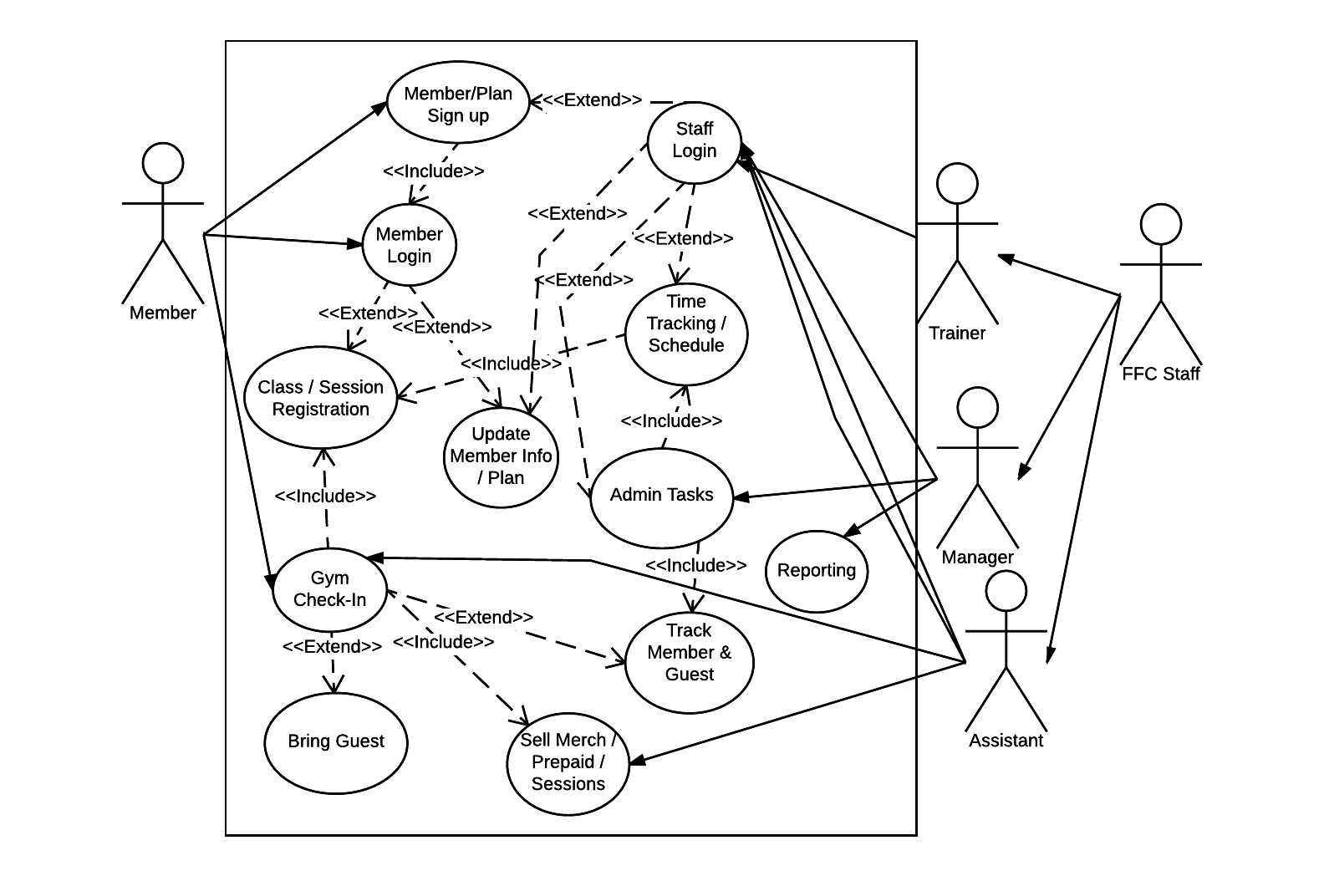

We developed 6 Activity Diagrams based on the 5 major use cases that we identified:

1. Member/Plan Signup
2. Gym Check In
3. Class / Session Registration
4. Sell Merch / Prepaid / Sessions
5. Admin
6. Reporting

**Activity Diagram - Member/Plan Signup**

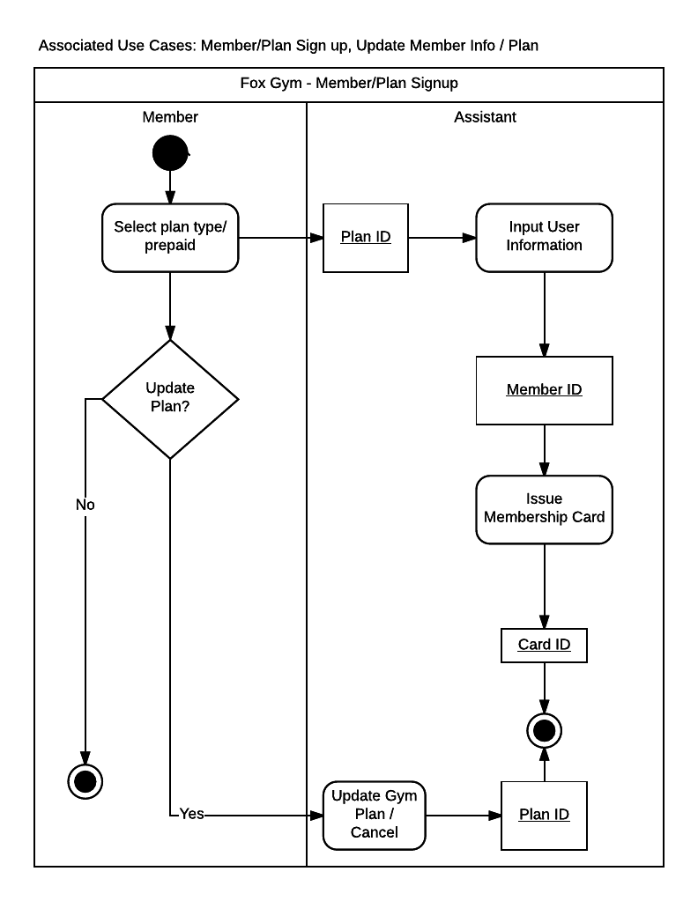

**Activity Diagram - Gym Check-In**

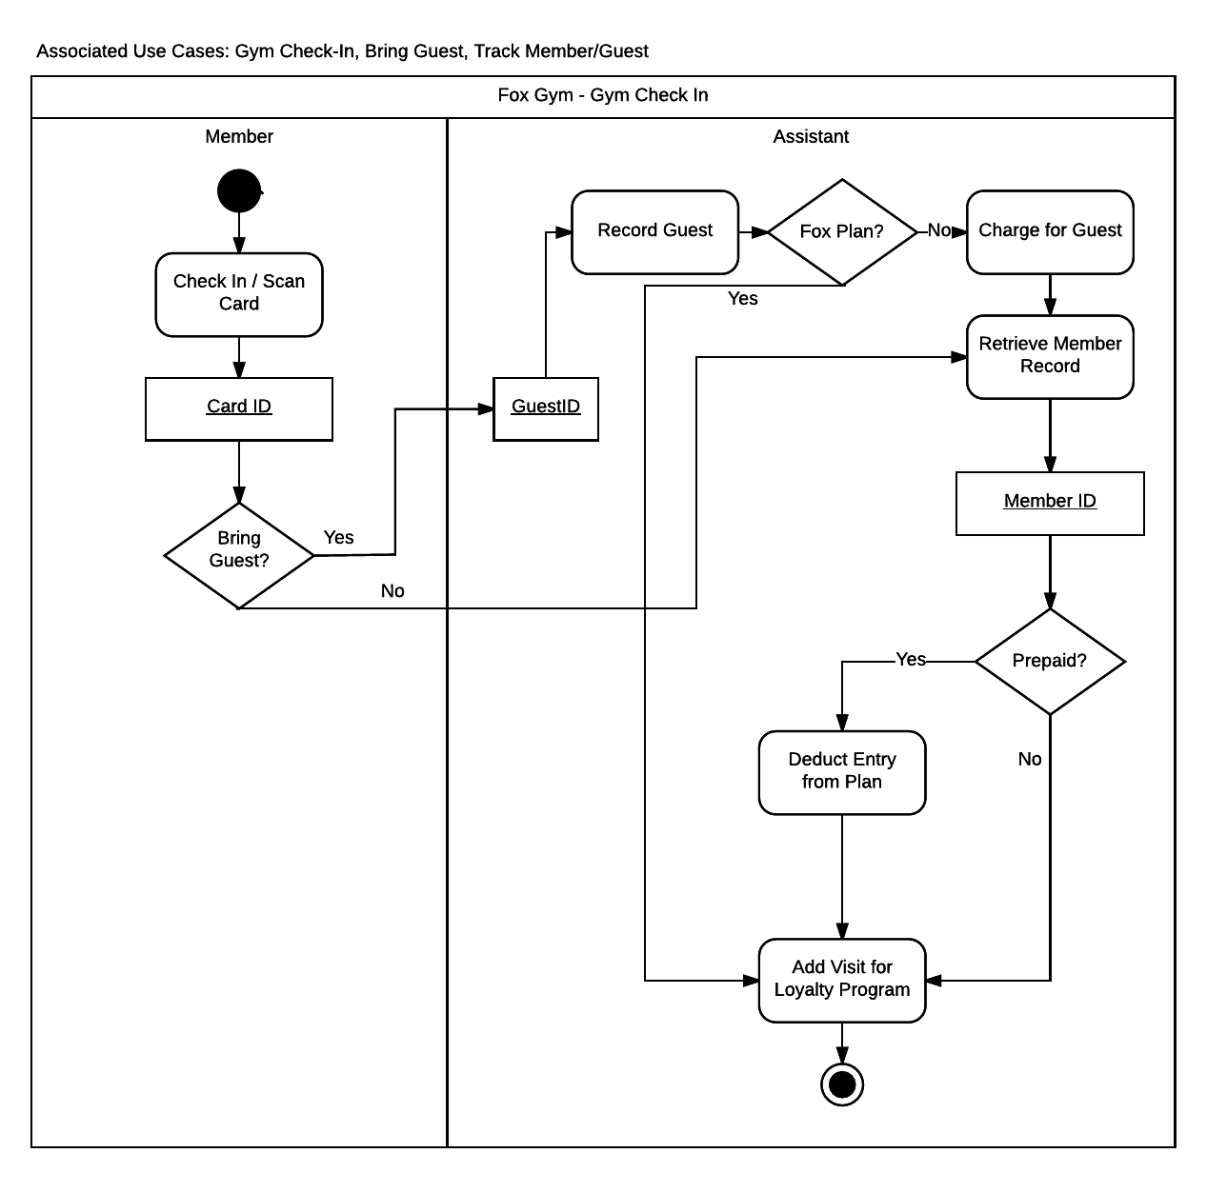

**Activity Diagram - Class / Session Registration**

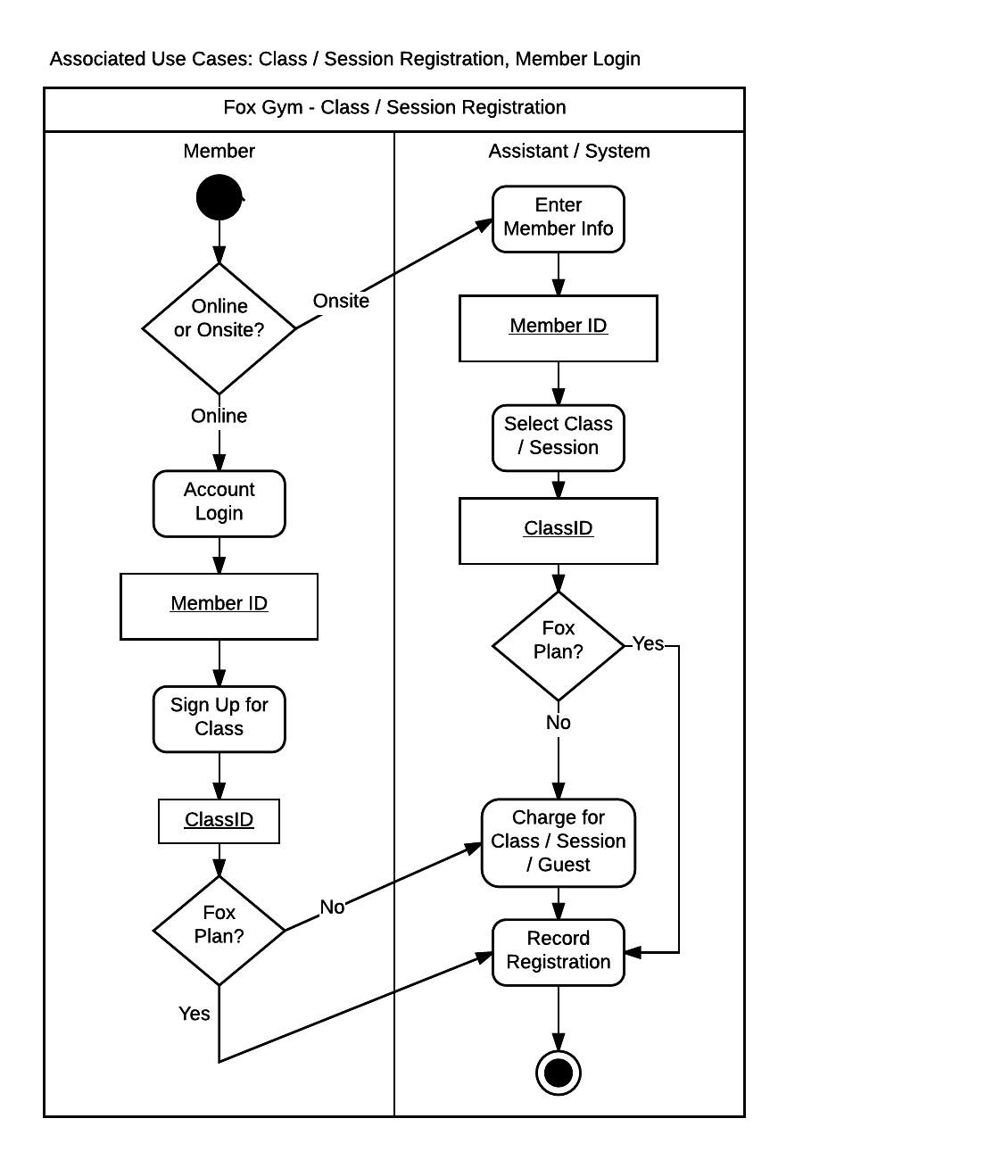

**Activity Diagram - Sell Merch / Prepaid / Sessions**

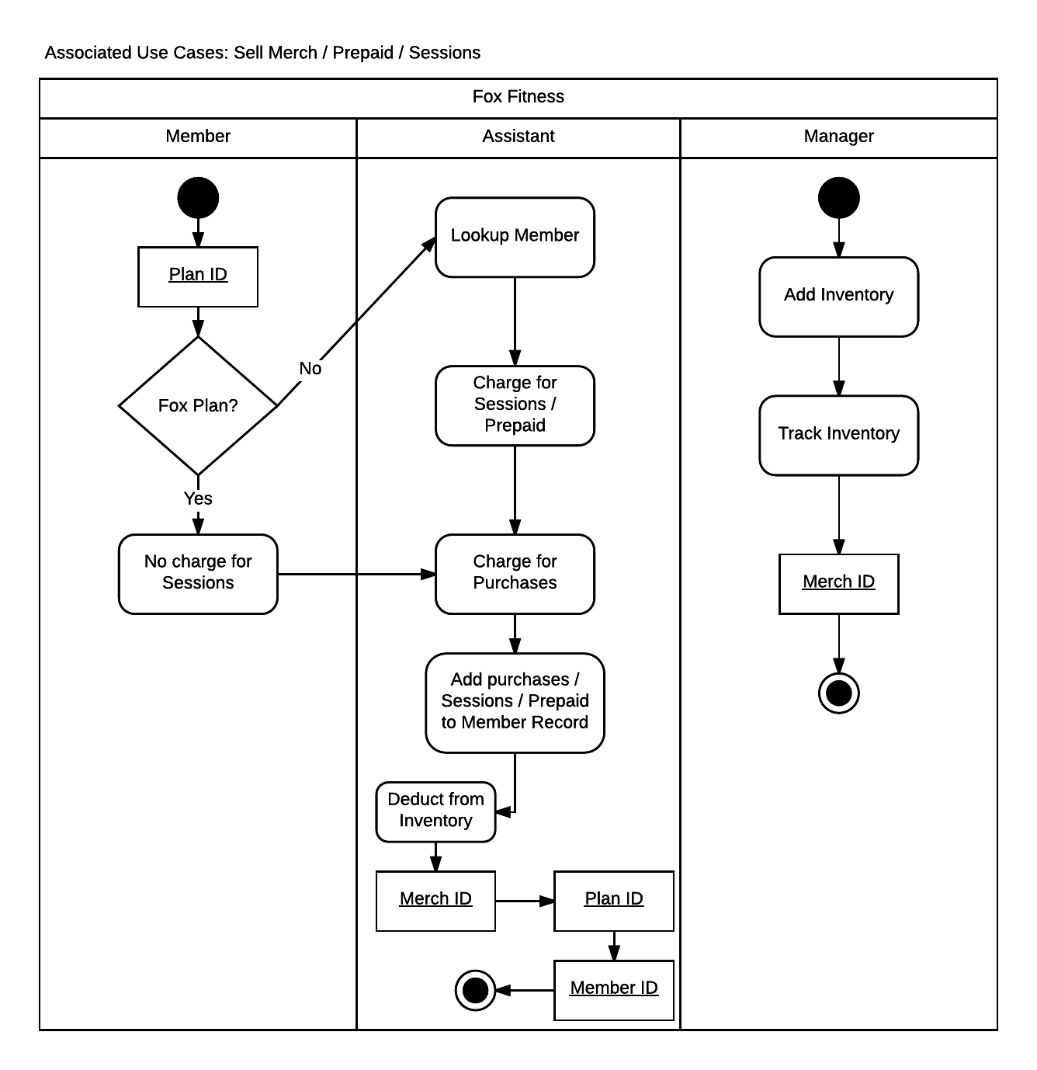

**Activity Diagram - Admin**

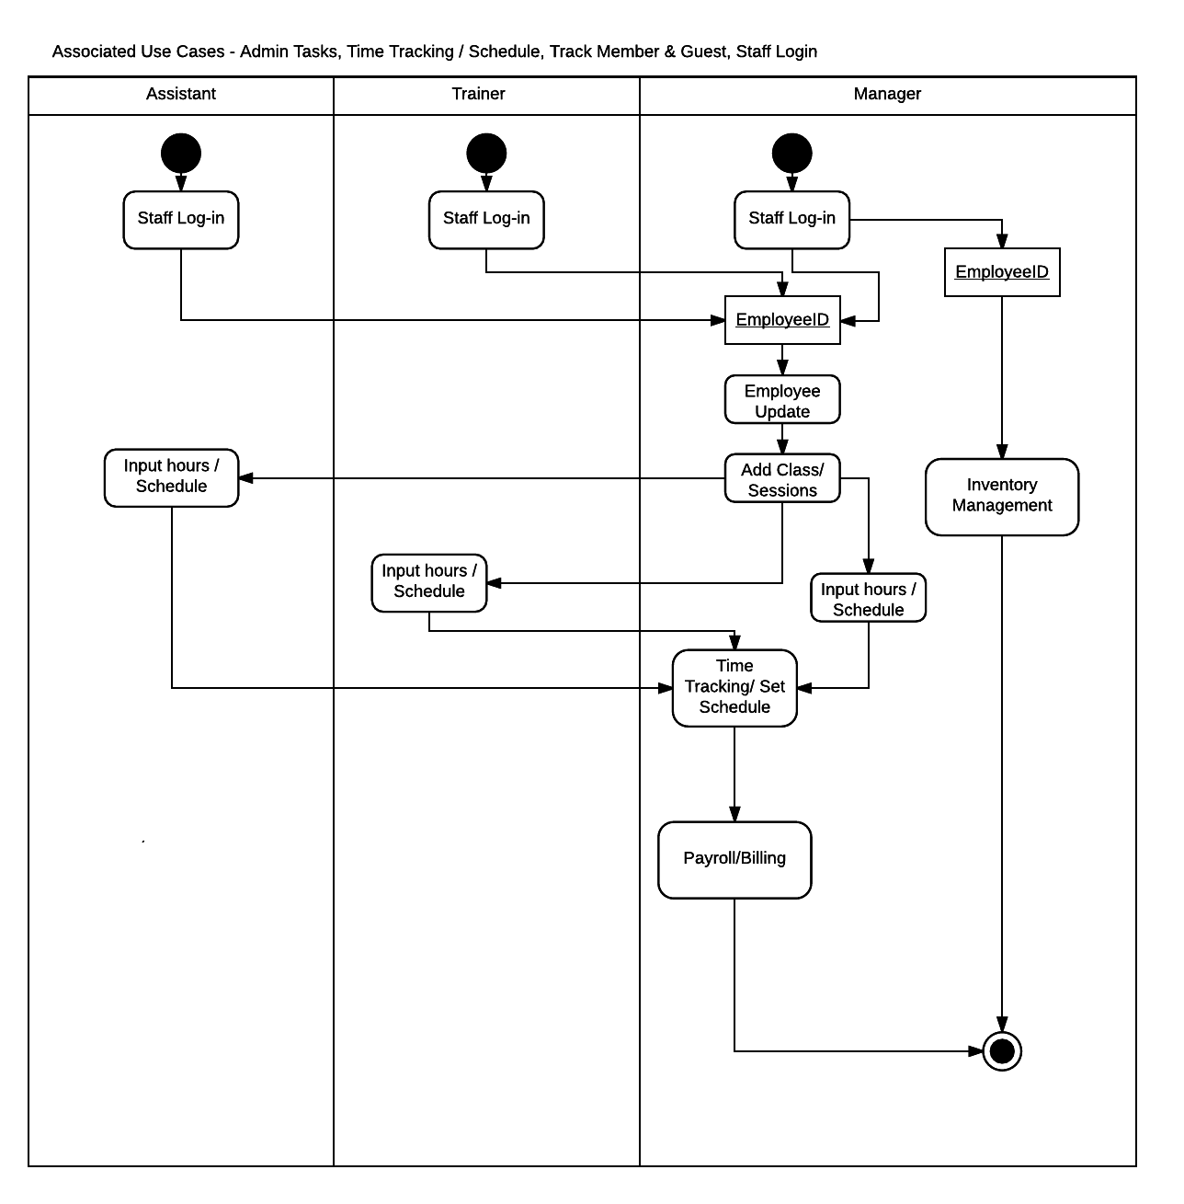

**Activity Diagram - Reporting**

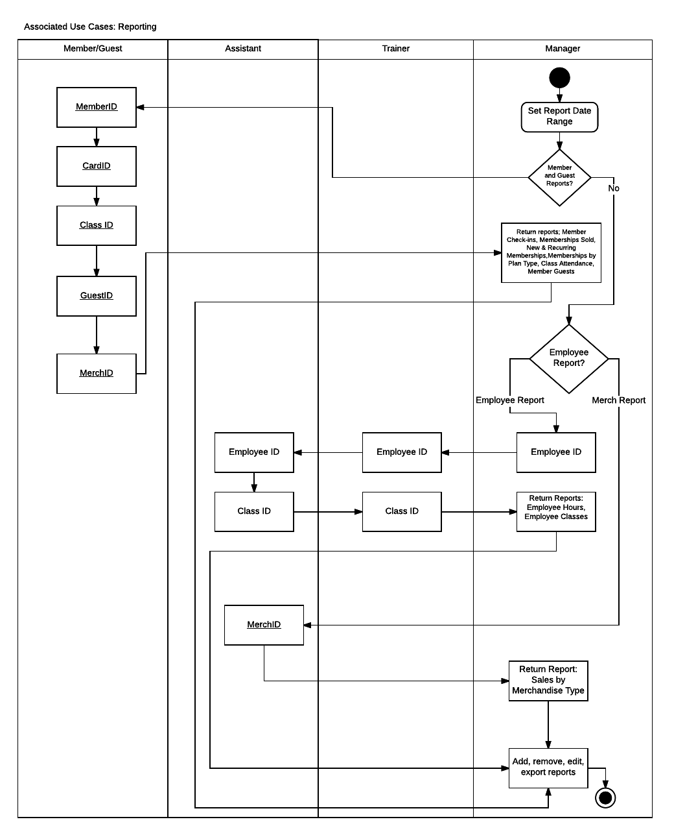

**Fox Fitness Class Diagram**

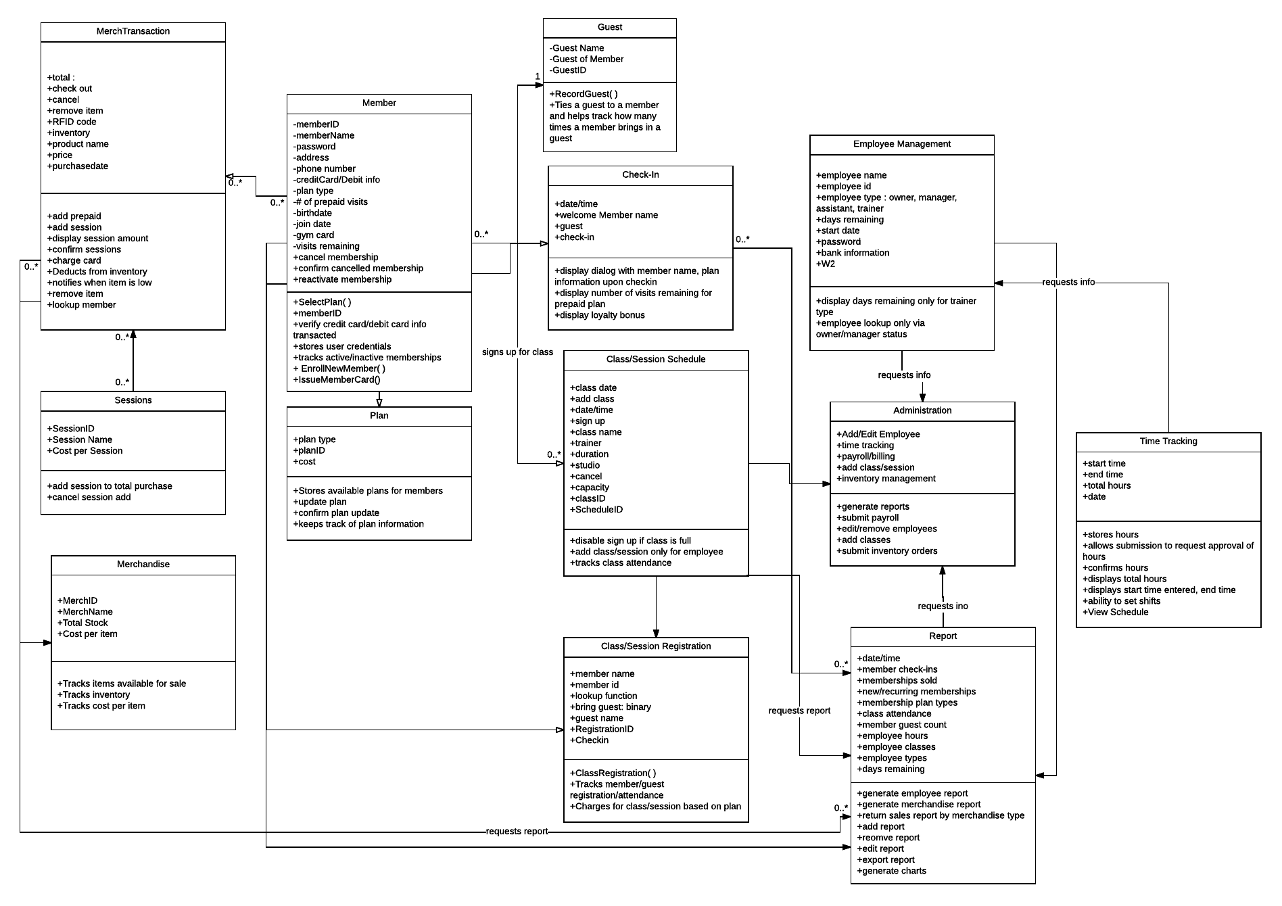

**Sequence Diagram - Member/Plan Sign Up**

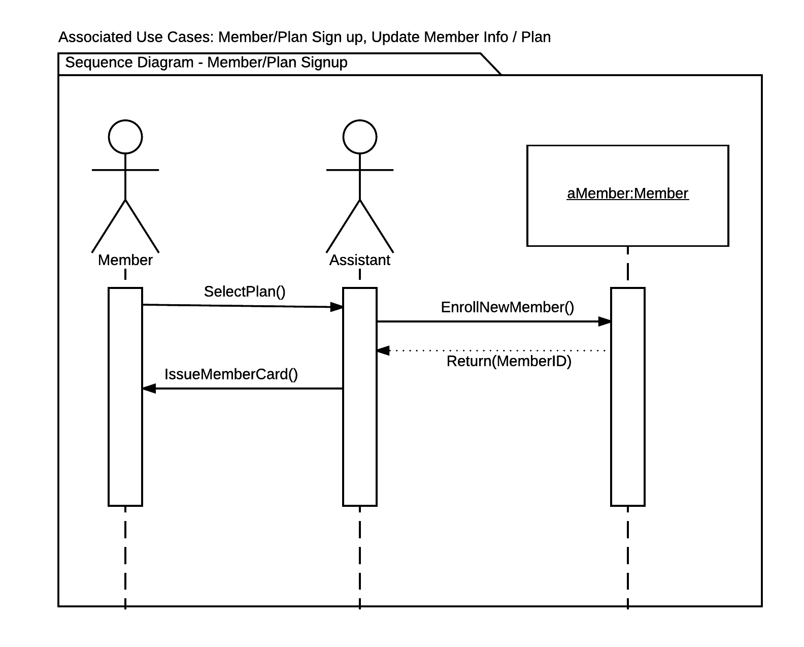

**Sequence Diagram - Gym Check In**

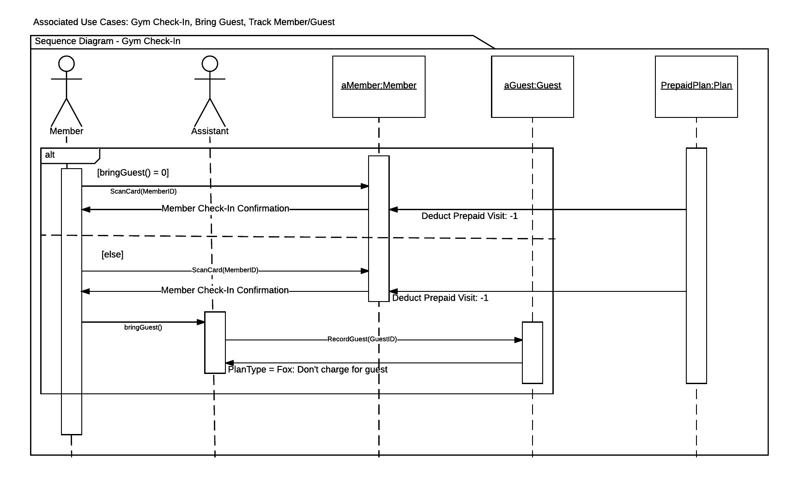

**Sequence Diagram: Class/Session Registration**

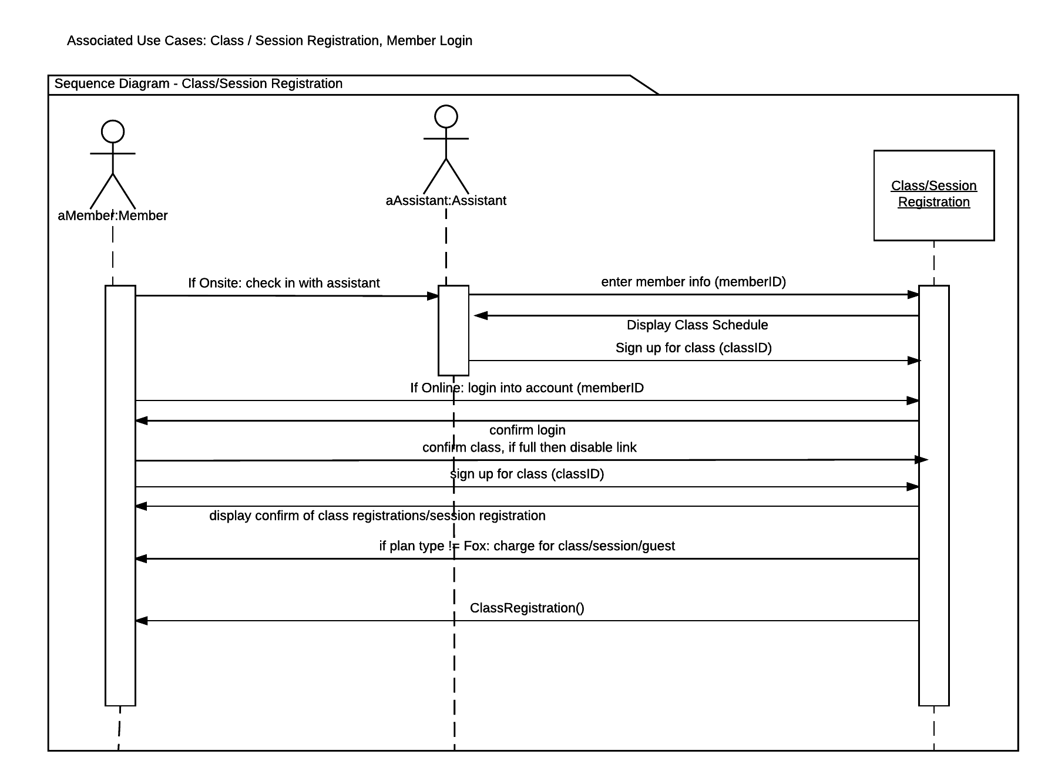

**Sequence Diagram: Sell Merch/Prepaid/Sessions**

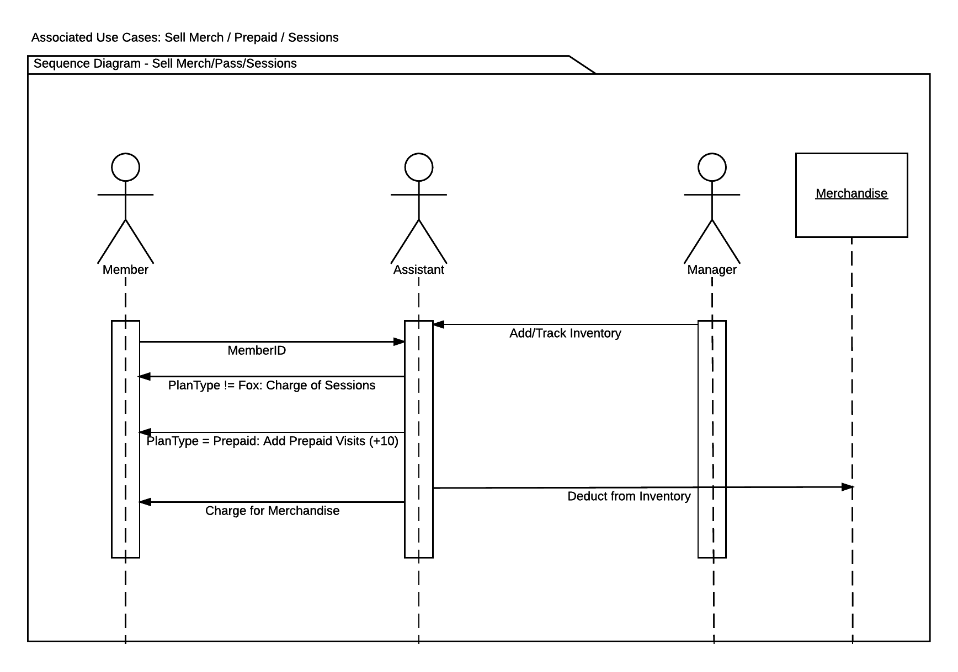

**Sequence Diagram: Admin Tasks**

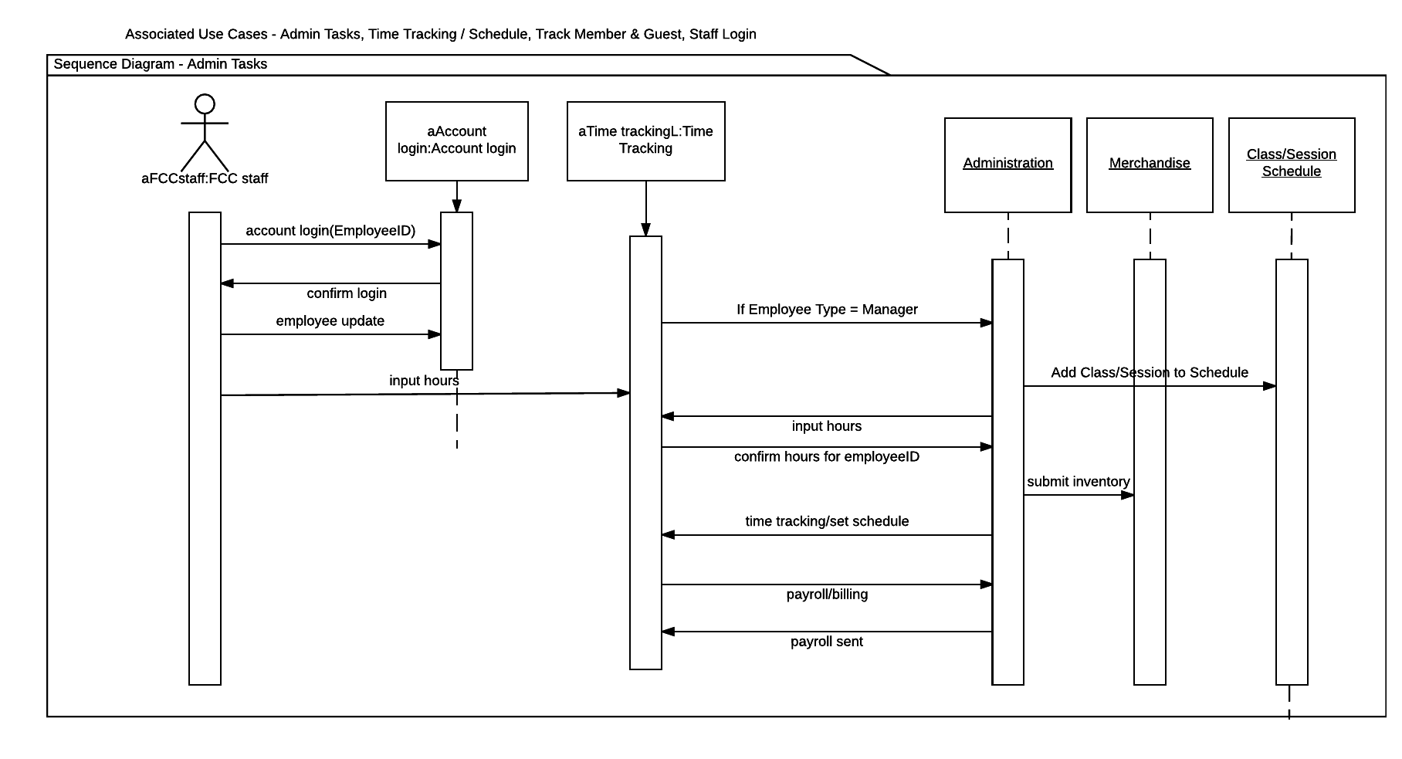

**Sequence Diagram: Reporting**

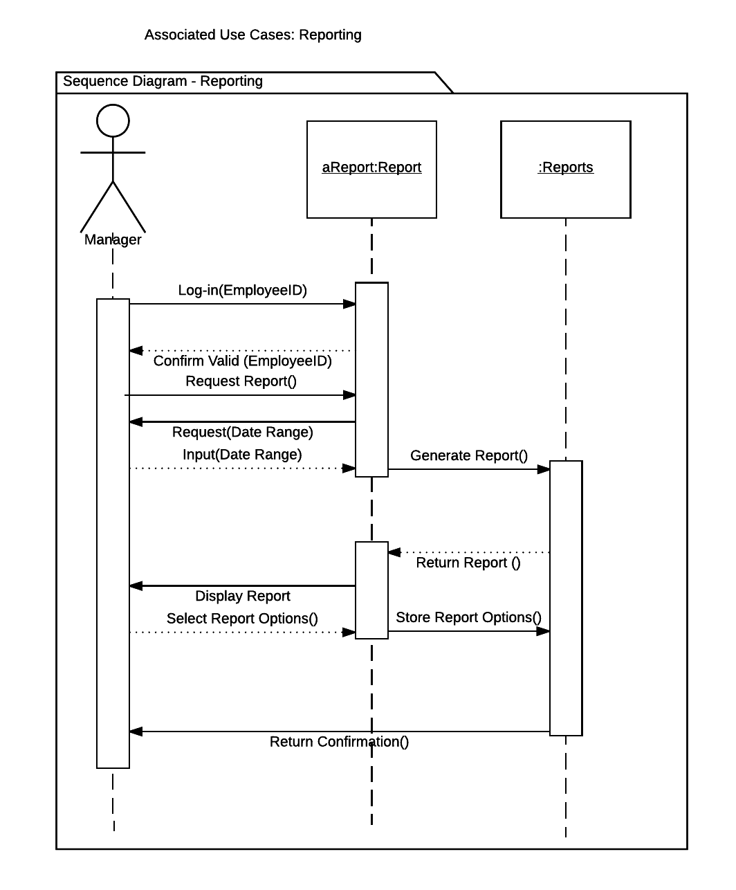

**Contract: New Member Enrollment**

Method Name: EnrollNewMember( )

Class Name: Member Sign Up

Associated Use Cases: Member/Plan Sign Up

Description of Responsibilities: Used to add new members to the system

|  |  |
| --- | --- |
| Arguments Received / Parameters | Data Type |
| Member Name | String |
| Password | String |
| Address | String |
| Phone Number | String |
| Credit/Debit Card | String |
| Birthdate | Date |
| Plan Type | Dropdown (Fox, Basic, Prepaid) |
| Join Date | Date |
| Gym Card | String |

Value Returned: Member ID

Data Type of Value Returned: Integer

Pre-Condition: Person is not a current member of Fox Gym

Post-Conditions: Person is a current member of Fox Gym

**Contract: Group Class Registration**

Method Name: ClassRegistration( )

Class Name: Class/Session Registration

Associated Use Cases: Class/Session Registration

Description of Responsibilities: Used by members to view and sign up themselves and a guest (if needed) for a class or session

|  |  |
| --- | --- |
| Arguments Received / Parameters | Data Type |
| ClassID | String |
| MemberID | String |
| GuestID | String |

Value Returned: Registration ID

Data type of Return Value: Integer

Pre-Condition: Member has not signed up for the class

Post-Condition: Member has signed up for the class

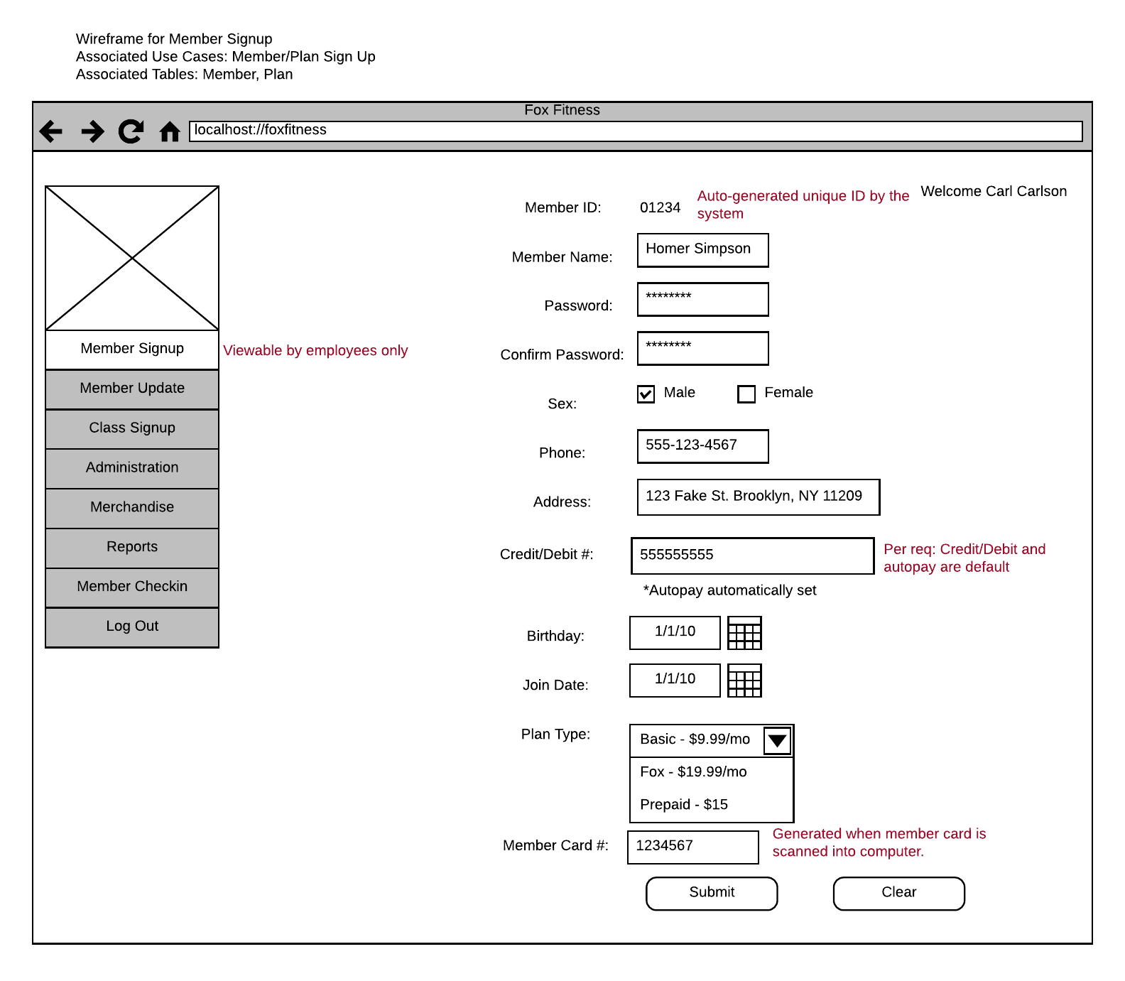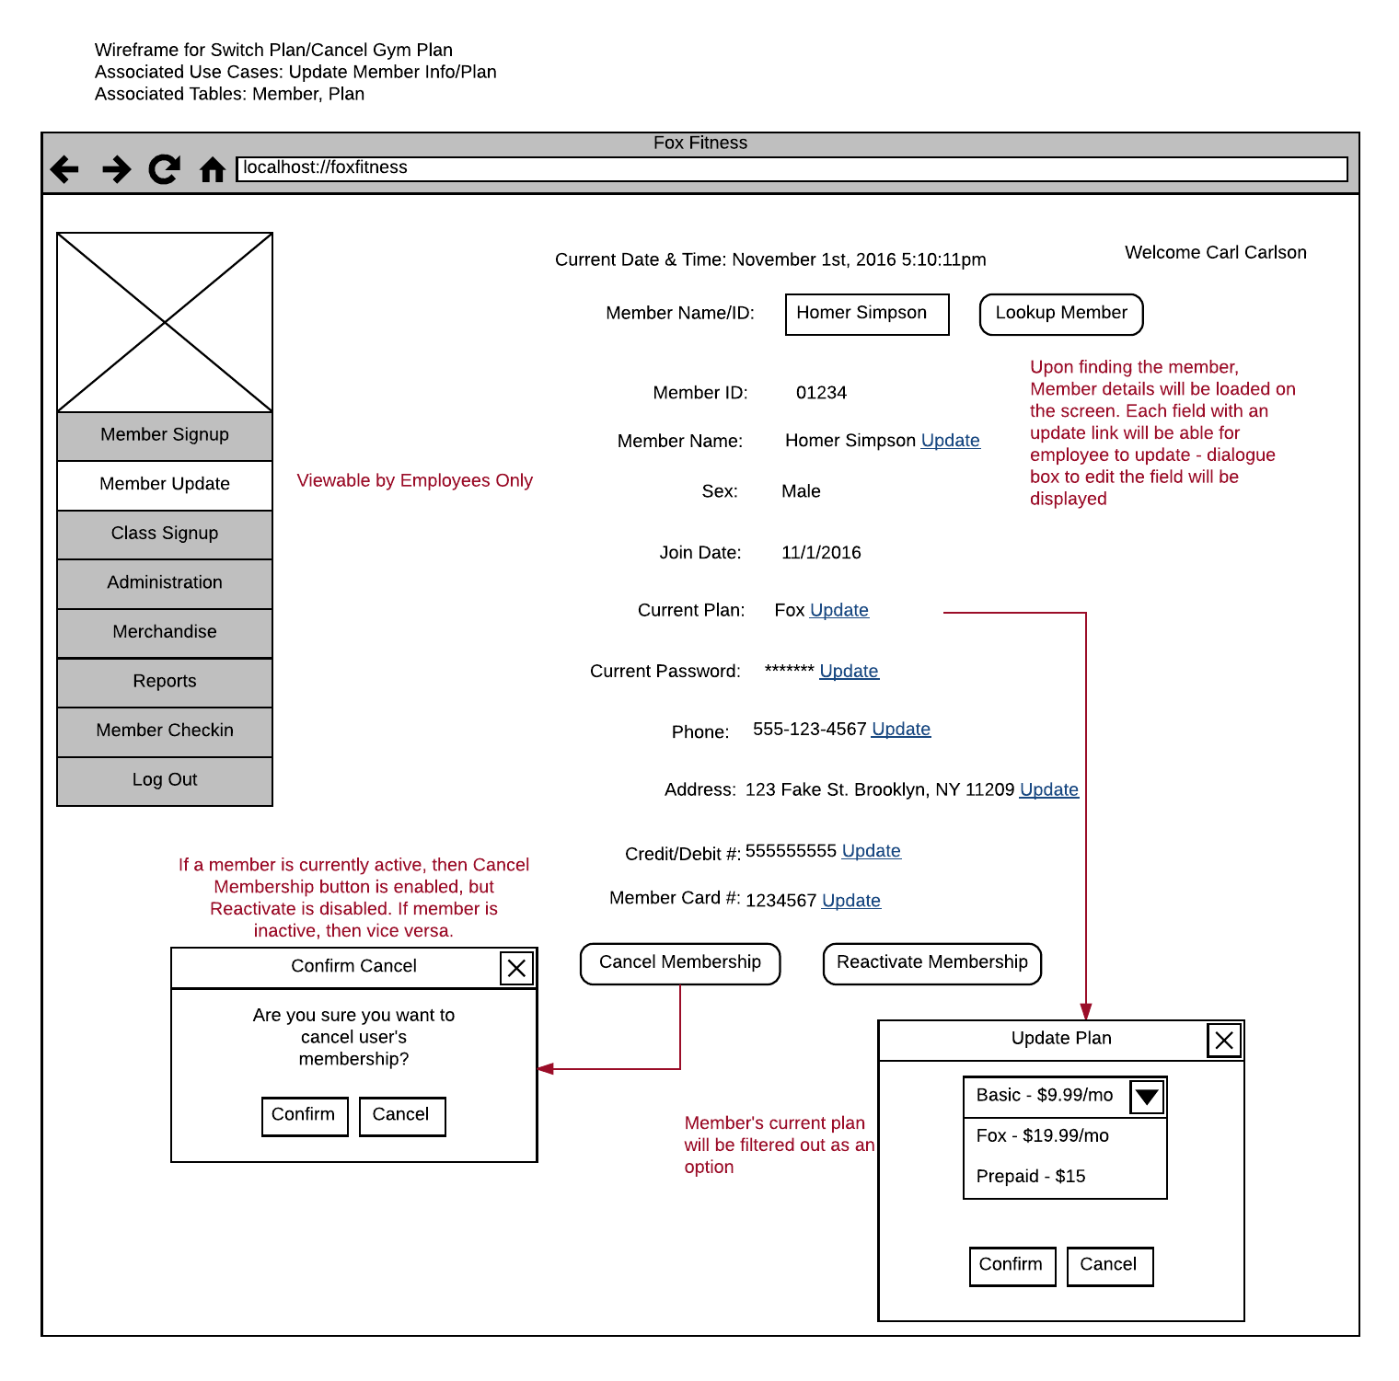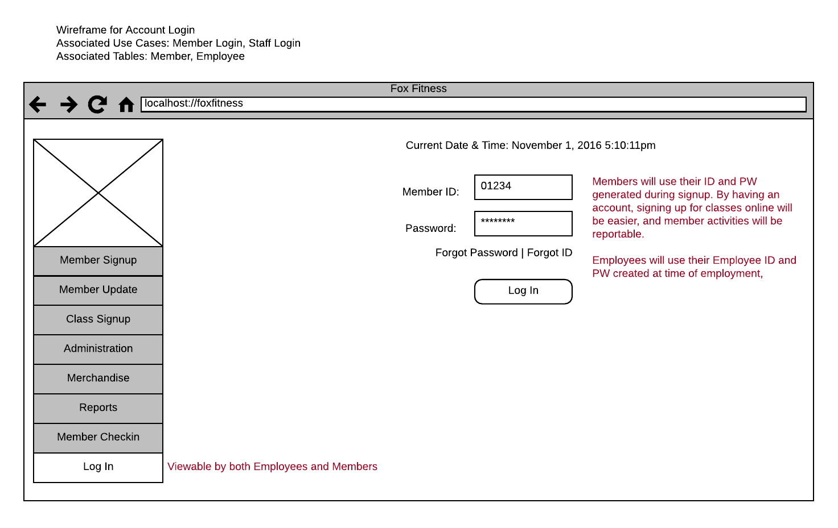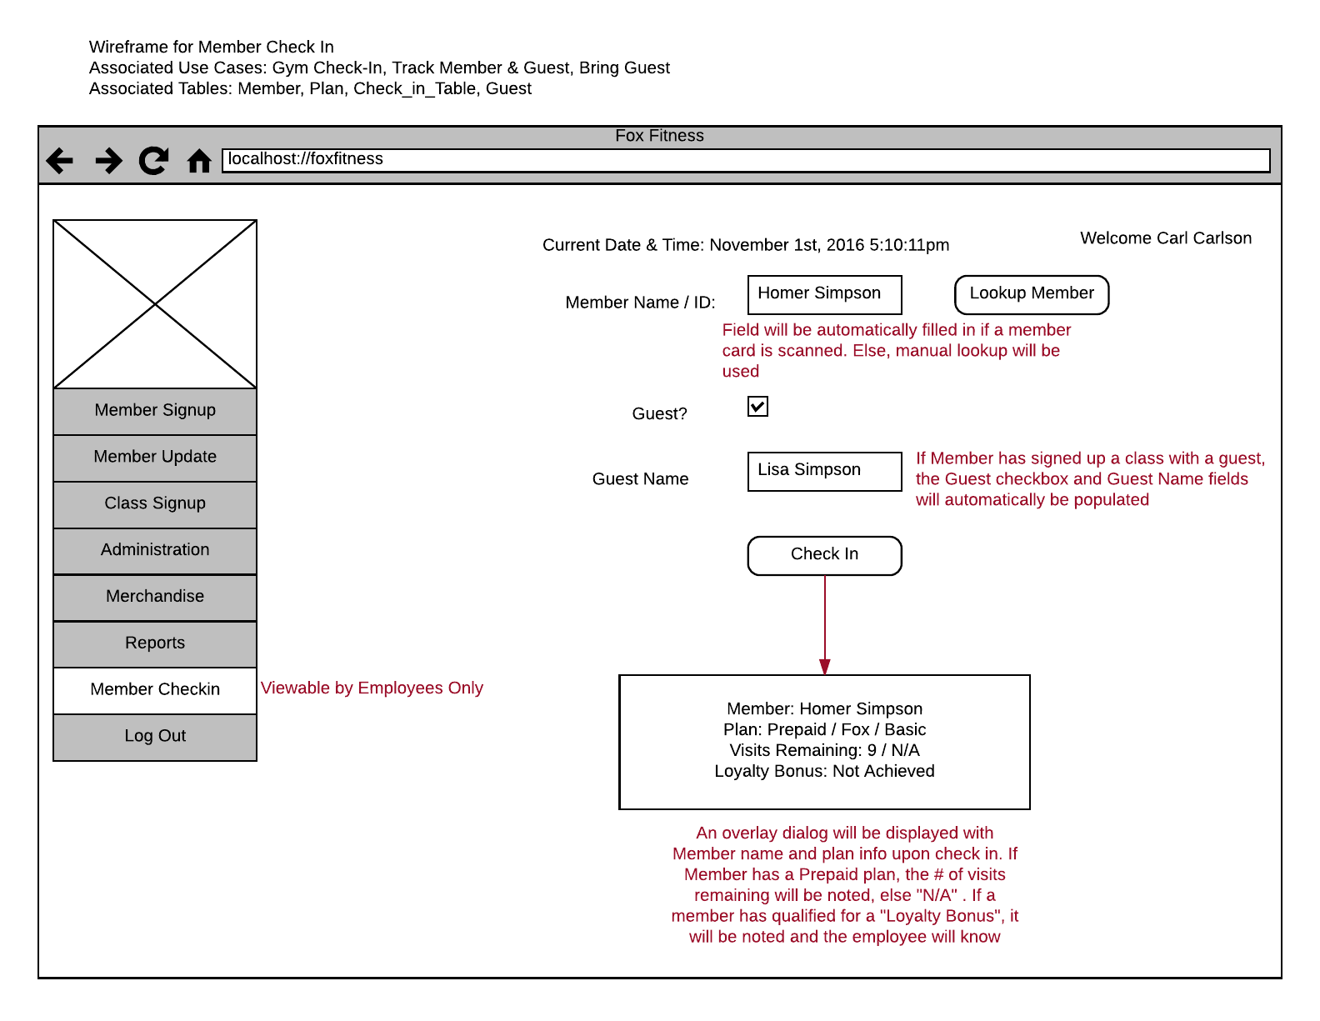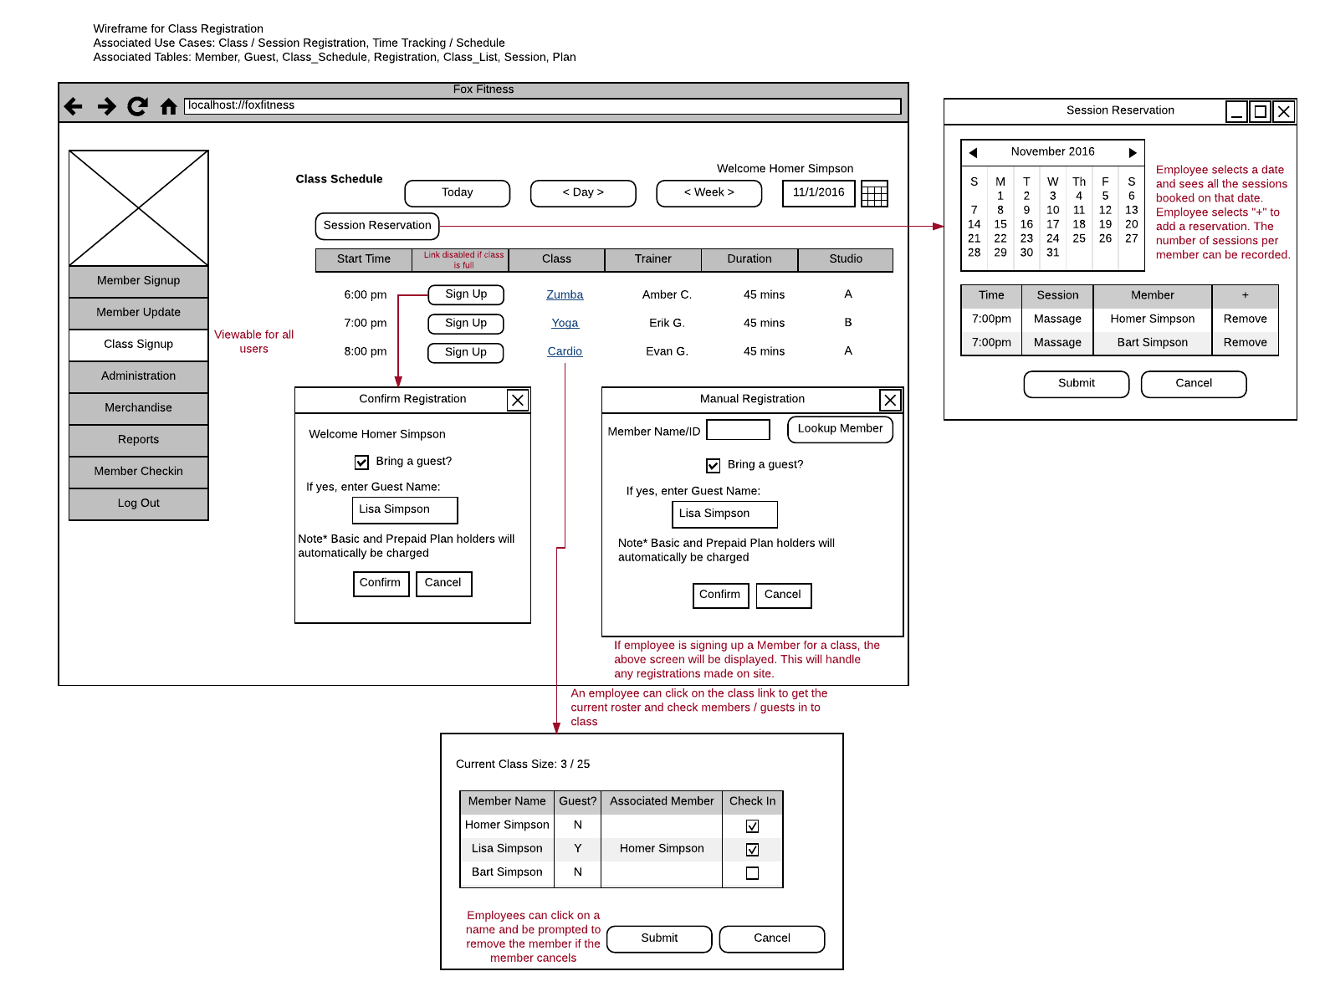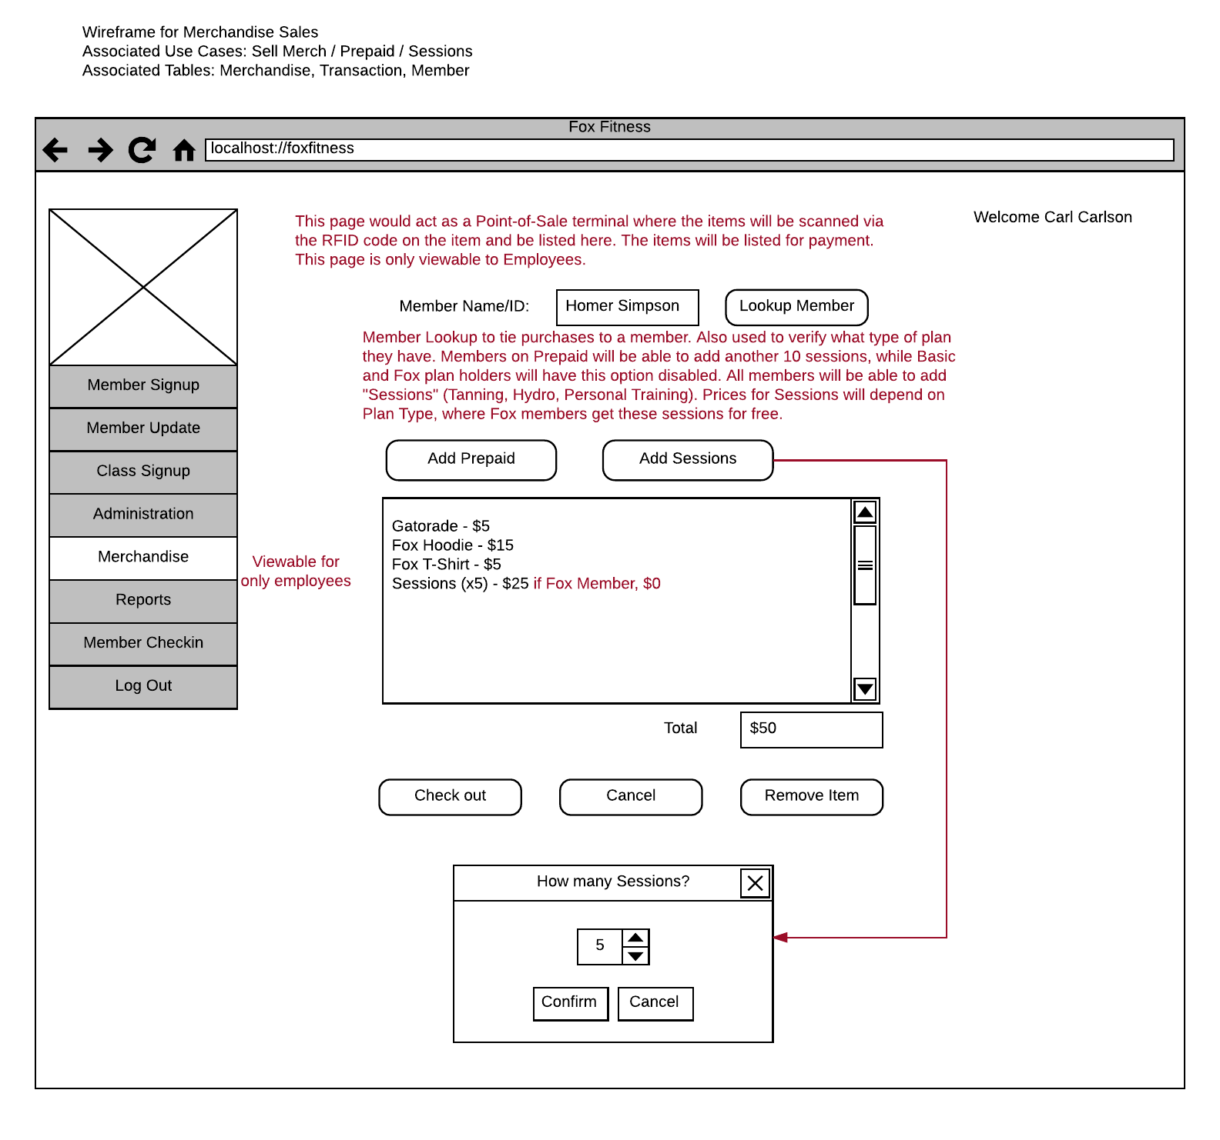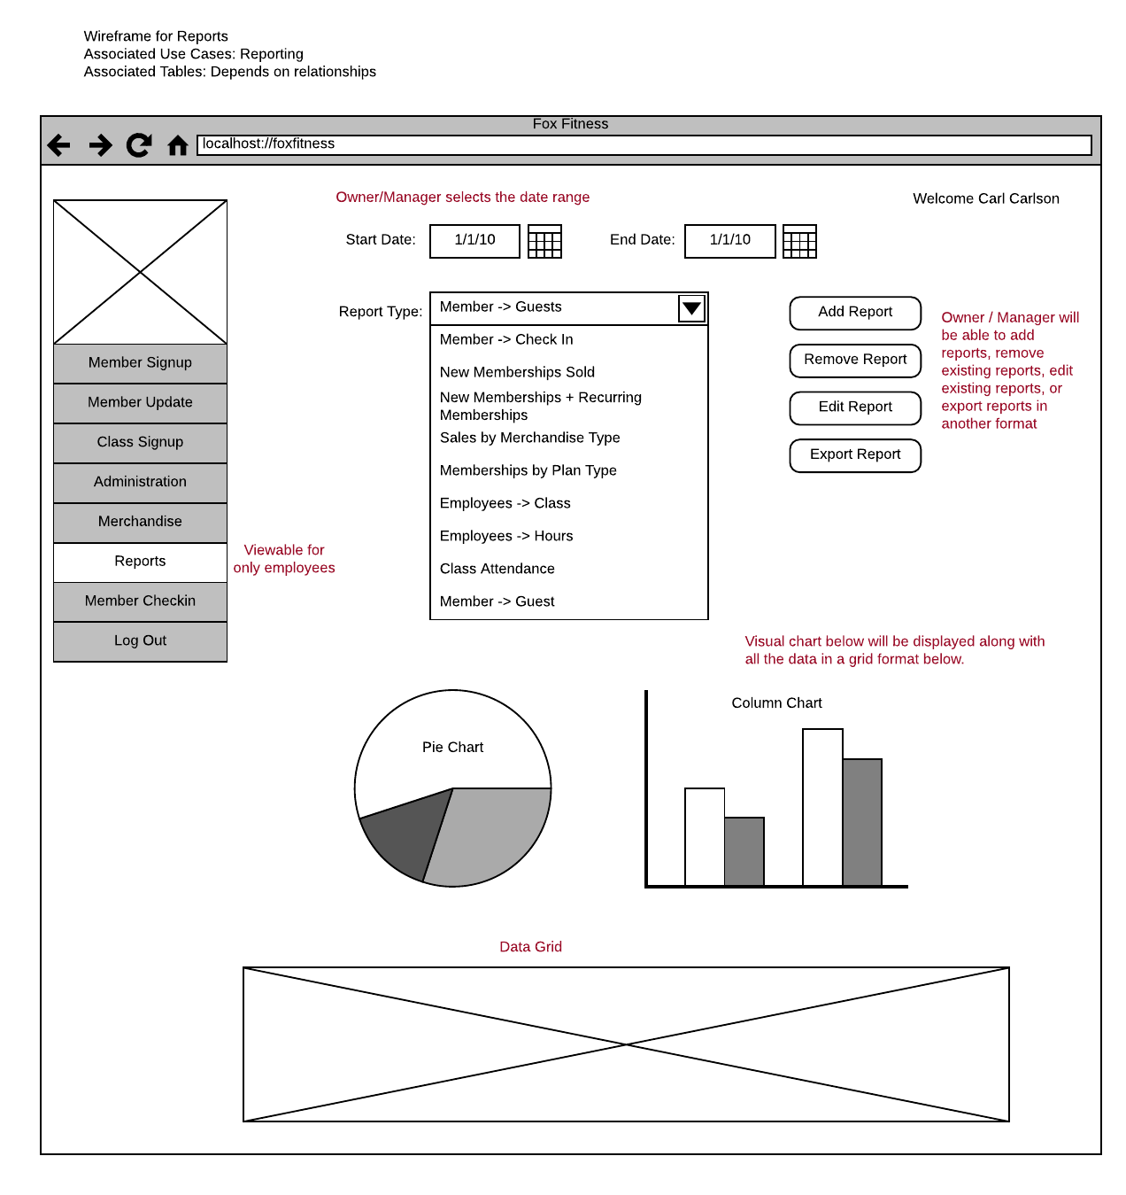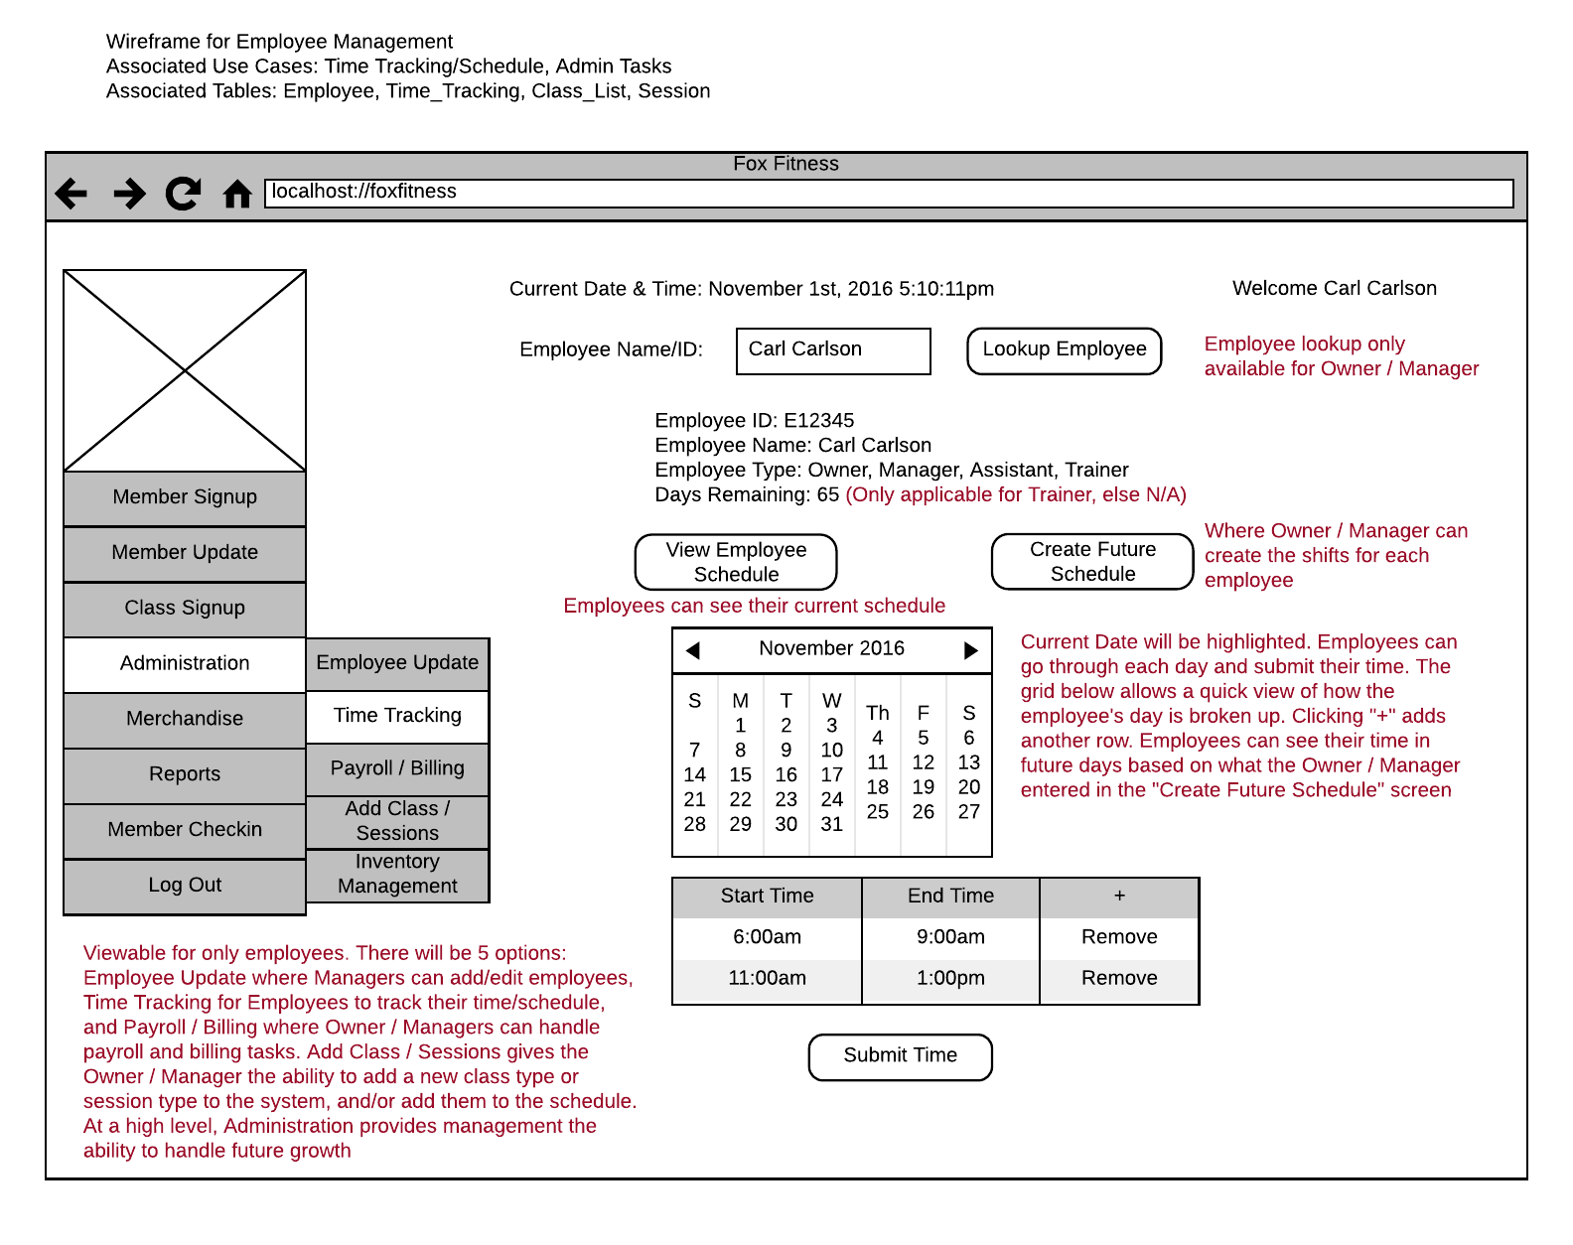

ERD

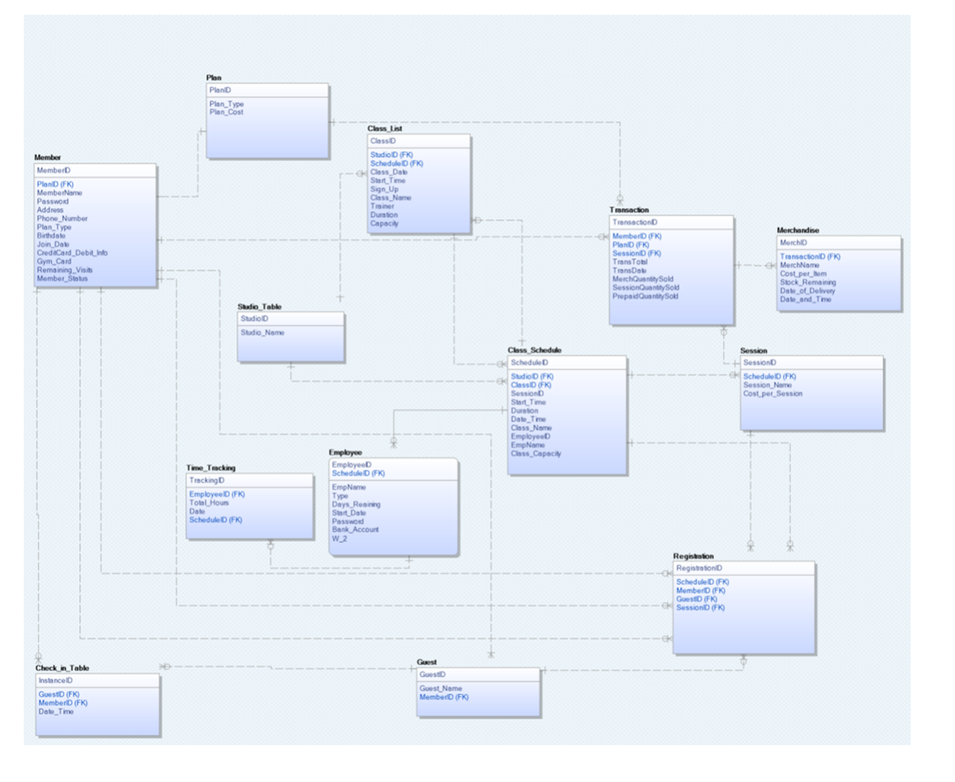

SQL for Popularity of Classes

SELECT ClassName AS Class Name, EmpName AS Trainer, Count(Class_Schedule.ClassID) AS No of Times , Count(MemberID) AS No of Members, Count(GuestID) AS No of Guests

FROM Class_Schedule, Registration

WHERE Class_Schedule.ScheduleID = Registration.ScheduleID

AND Date_Time BETWEEN '1-JAN-2016' AND '31-JAN-2016'

GROUP BY ClassName

ORDER BY Count(MemberID);

SQL for Popularity of Merchandise by Mer

SELECT MerchName AS Merchandise Name, SUM(MerchQuantitySold) As Quantity Sold, MerchQuanitySold*Cost_per_Item AS Revenue

FROM Transaction, Merchandise

Where Merchandise.MerchID = Transaction.MerchID

AND TransDate BETWEN '1-JAN-2016' AND '31-JAN-2016

GROUP BY MerchName

ORDER BY MerchQuantitySold;

SQL for Loyalty Program (More than 10 check-ins for a month)

SELECT Count(InstanceID), MemberID From Check_in_Table WHERE InstanceID >= 10 AND Date_Time BETWEEN '1/1/2016' AND '1/31/2016'

When a member reaches 10 or more check-ins for a month, the system will automatically recognize that the member has achieved a loyalty bonus and will let the receptionist know during Check-In (Wireframe notes the property “Loyalty Bonus Achieved”. At that time, the member can choose to redeem a 20% discount to be used on merchandise, during their current visit.