## uGitHub Repository Vulnerability Status Survey Report

### Which of the following situations for our issue was true?

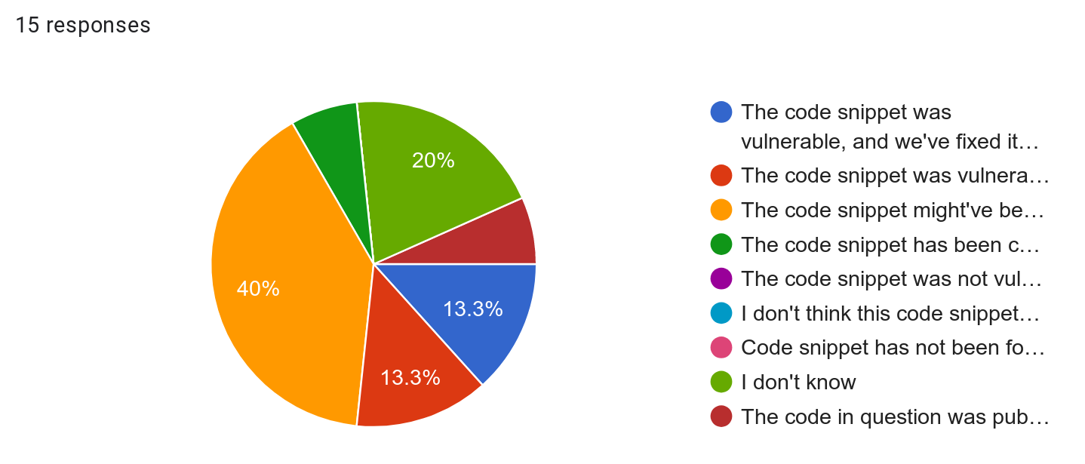

### Please Justify Your Choice Above (in couple of sentences):

* We are planning to fix it
* I'm not an expert in coding or c++ (I'm self taught) so I'm not really sure about the vulnerability
* The program of this repository is not actively used, so we won't fix it soon.
* Our code does not connect to internet and the use of sysctl is only for ram detection.
* the code in QGIS source code already replaces the substring in the both strings.
* I'm not sure if it is vulnerable and I didn't specifically copy it from Stack Overflow. This is part of one of the npm modules which was likely used by the contributors of the Libsass module.
* The code snippet was never used.
* Its an alias to other function (inside namespace moose) which is used
* The criticity of that code is null as it is a proof of concept.
* The code is intended to with the files supplied by the user. While the issue with non-ASCII characters exists, there are much bigger unsafe pieces when parsing the input data.
* The code in question was open source code, not my own, and I now realize I should not have posted publicly available open source code to my own repository. I have long ago updated my corresponding install.
* Code itself can be vulnerable, but it is used for code that is not for users or production.

### 

### Could automated vulnerability analyses of code snippets in online forums be useful in your future development tasks?

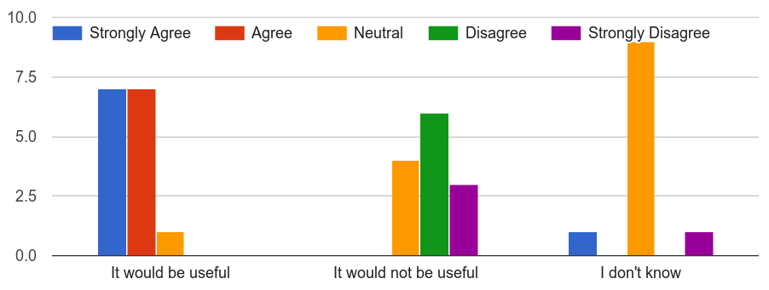

### What would be the best way to inform developers of potential vulnerabilities in code examples shared in Stack Overflow?

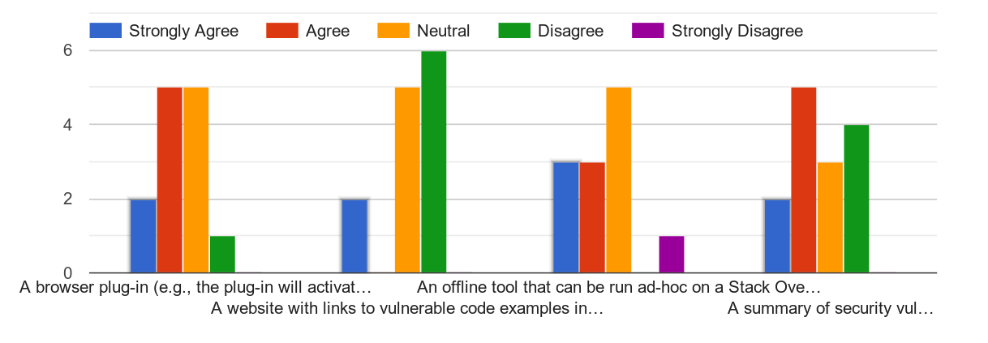

### Do you have any other suggestions to design automated techniques to assist developers to handle security vulnerabilities while using code from online forums? Please write in couple of sentences below:

* Making it as easy as possible, as in tailored to the developers code and automated, seems to be the best way to go
* Contact StackOverflow developers to put the security alert directly into the forum.
* I liked it being added to a github issue
* Github plugin?

### Would you like to be informed of such a tool that could be developed in future?

