ADESOKAN MUHAMMED
YOUTUBE THUMBNAIL DESIGNER
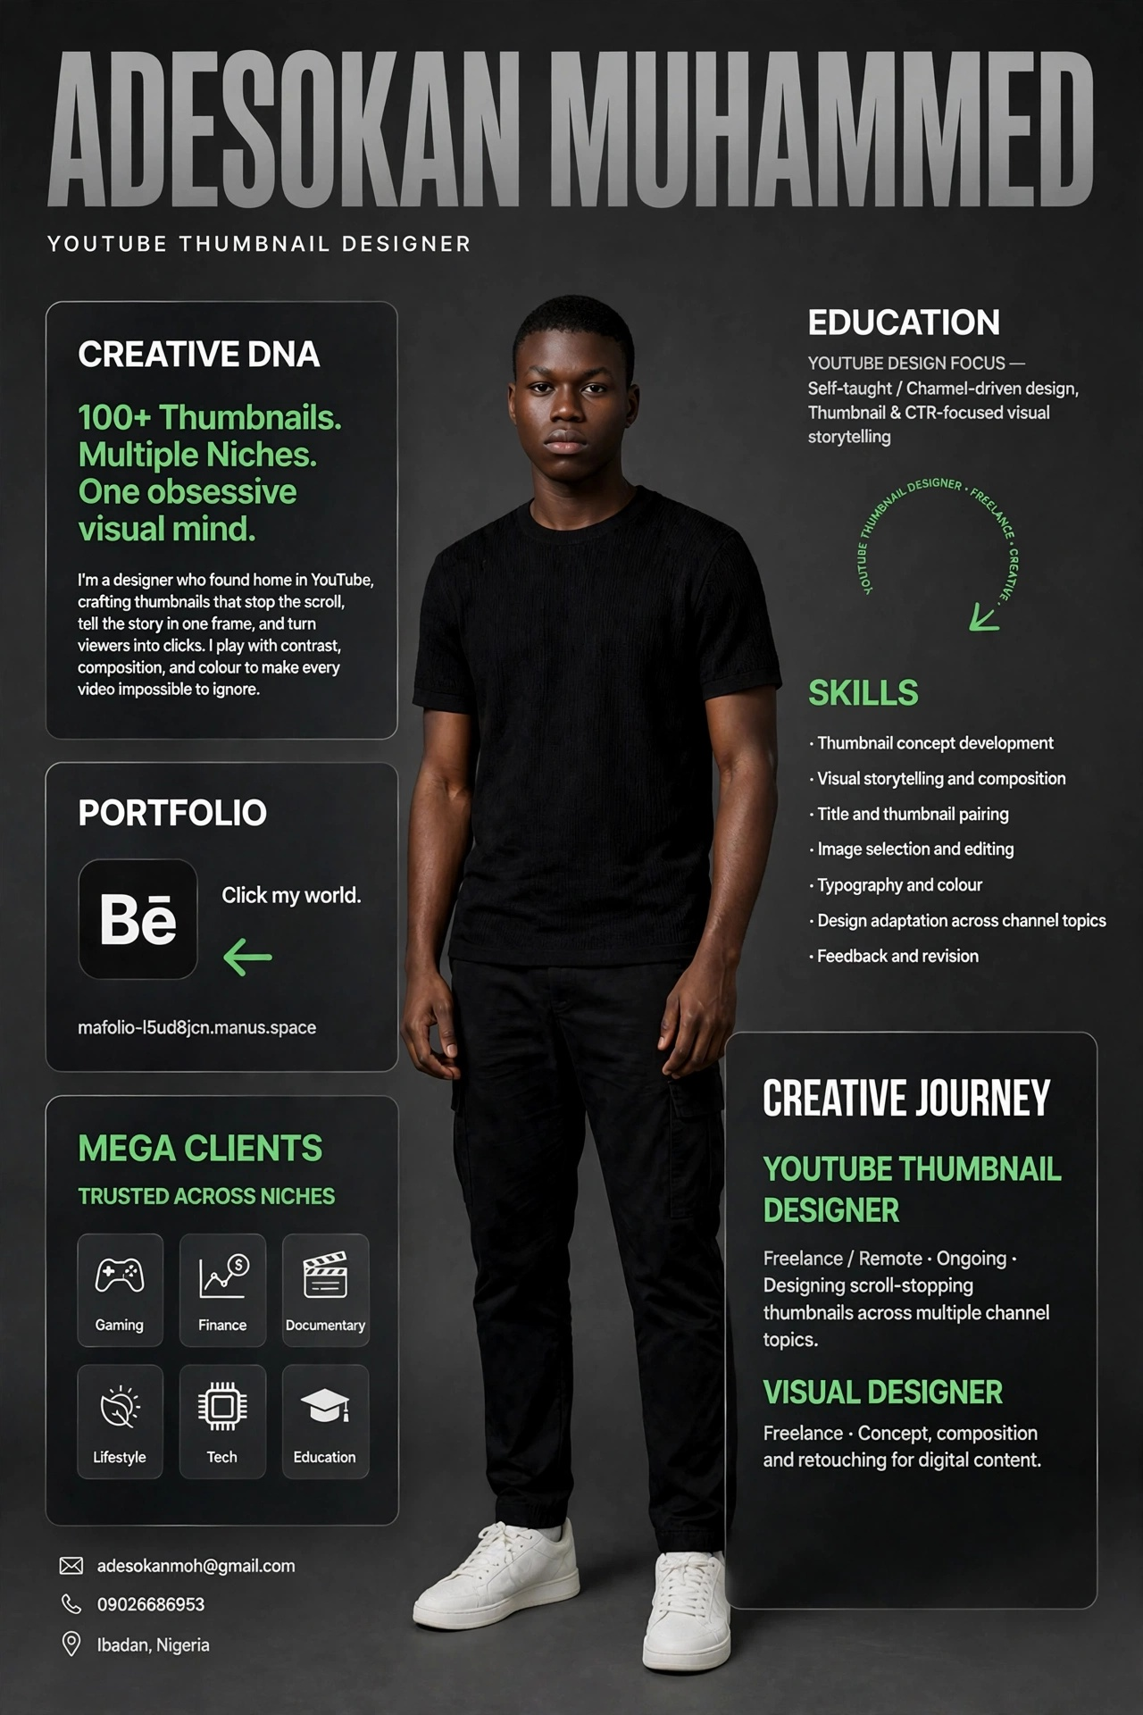
Ibadan, Nigeria • 09026686953 • adesokanmoh@gmail.com • mafolio-l5ud8jcn.manus.space

ADESOKAN MUHAMMED
YOUTUBE THUMBNAIL DESIGNER
Ibadan, Nigeria | 09026686953 | adesokanmoh@gmail.com | Portfolio: mafolio-l5ud8jcn.manus.space
CREATIVE DNA
100+ Thumbnails. Multiple Niches. One obsessive visual mind.
I'm a designer who found home in YouTube, crafting thumbnails that stop the scroll, tell the story in one frame, and turn viewers into clicks. I play with contrast, composition, and colour to make every video impossible to ignore.
SKILLS
- Thumbnail concept development
- Visual storytelling and composition
- Title and thumbnail pairing
- Image selection and editing
- Typography and colour
- Design adaptation across channel topics
- Feedback and revision
CREATIVE JOURNEY
YOUTUBE THUMBNAIL DESIGNER — Freelance / Remote — Ongoing
Designing scroll-stopping thumbnails across multiple channel topics.
VISUAL DESIGNER — Freelance
Concept, composition and retouching for digital content.
EDUCATION / FOCUS
YouTube Design Focus — Self-taught / Channel-driven design, Thumbnail & CTR-focused visual storytelling
TRUSTED ACROSS NICHES
Gaming • Finance • Documentary • Lifestyle • Tech • Education
PORTFOLIO
Click my world: mafolio-l5ud8jcn.manus.space

