IOT ONOFF

Gateway zigbee France, Tarbes August 24, 2019

Inside This Issue
1 | Introduction
2 | Configuration
3 | Settings Dashboard
4 | Topic Four
5 | Topic Five
6 | Game for Scouts or whatever
7 | Phone Numbers

Topic One:

Put something here

Topic Two:

Put something here

Introduction

This document describe the settings of smartphone to manage MQTT protocol who communicate with zigbee gateway.
You can download this application in AppleStore or GoogleStore for android

Broker Configuration

To use this application ,you must install Mosquitto software with websocket configuration on your raspberry
A good procedure has showed here :

https://gist.github.com/smoofit/dafa493aec8d41ea057370dbfde3f3fc

After this step, go to Settings menu and give a name to the Device (example Gateway zigbee)

- Go to Broker menu and set the host address (see in line 227 script python of zbmqtt_ws_log.py) and parameter as you can see in this picture

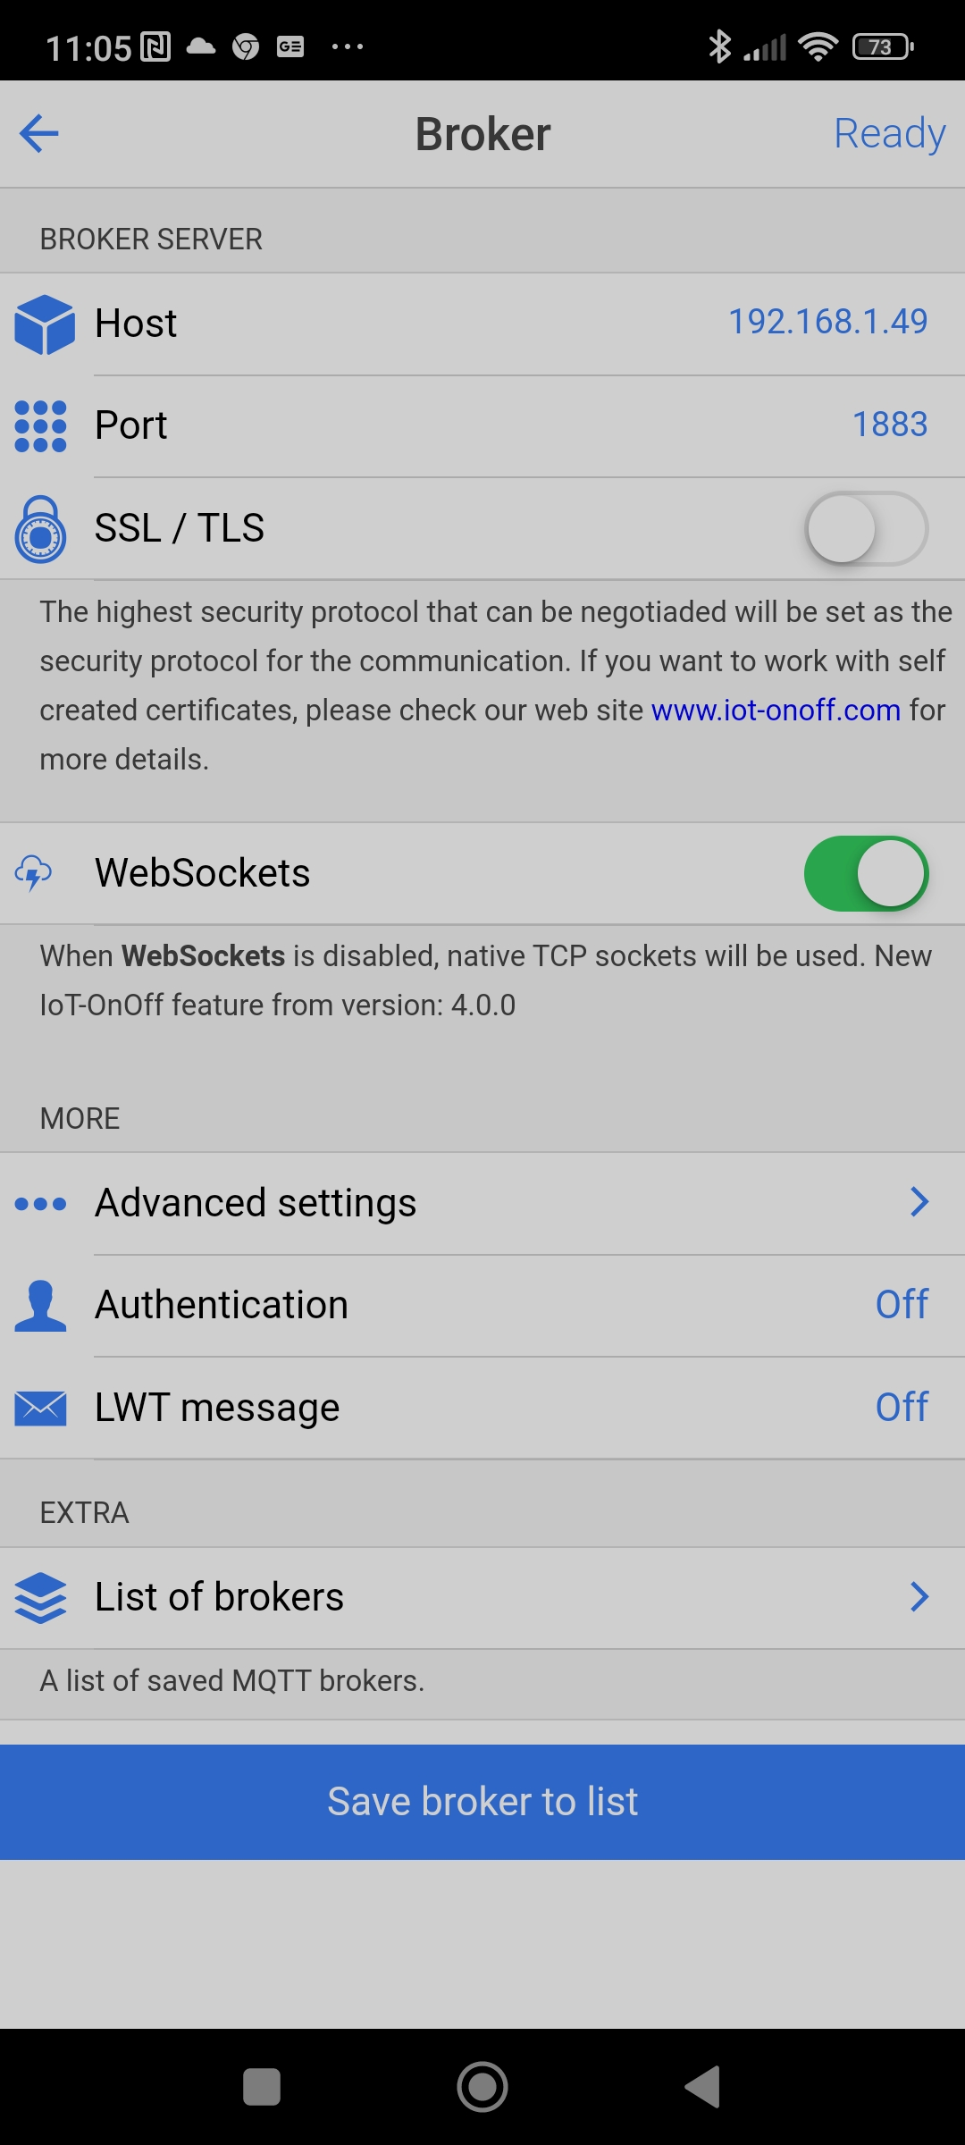

After this step, the status message display "Connected" if your gateway is power on.

Settings Dashboard

I show a example of Dashboard that i Configurated but it is free depending on your home

For the temperature device, you can name a dashboard

For the widget value, here the setting and topic (sensor/tmp/<id>) , id is the number of device depending the order of appairing join network

for the message public, prefix device name must be off

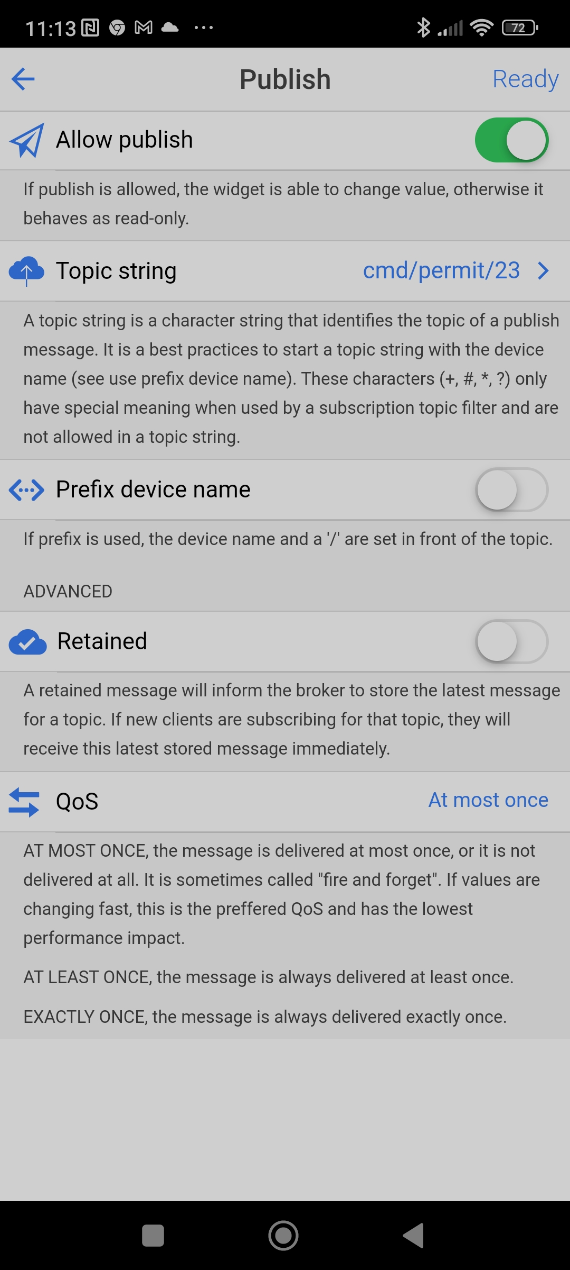

For the widget value, here the setting for the smart plug , the payload value must be set to " on" and "off"

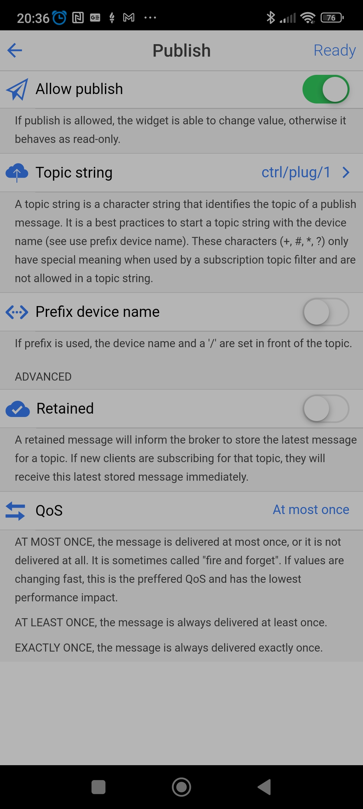

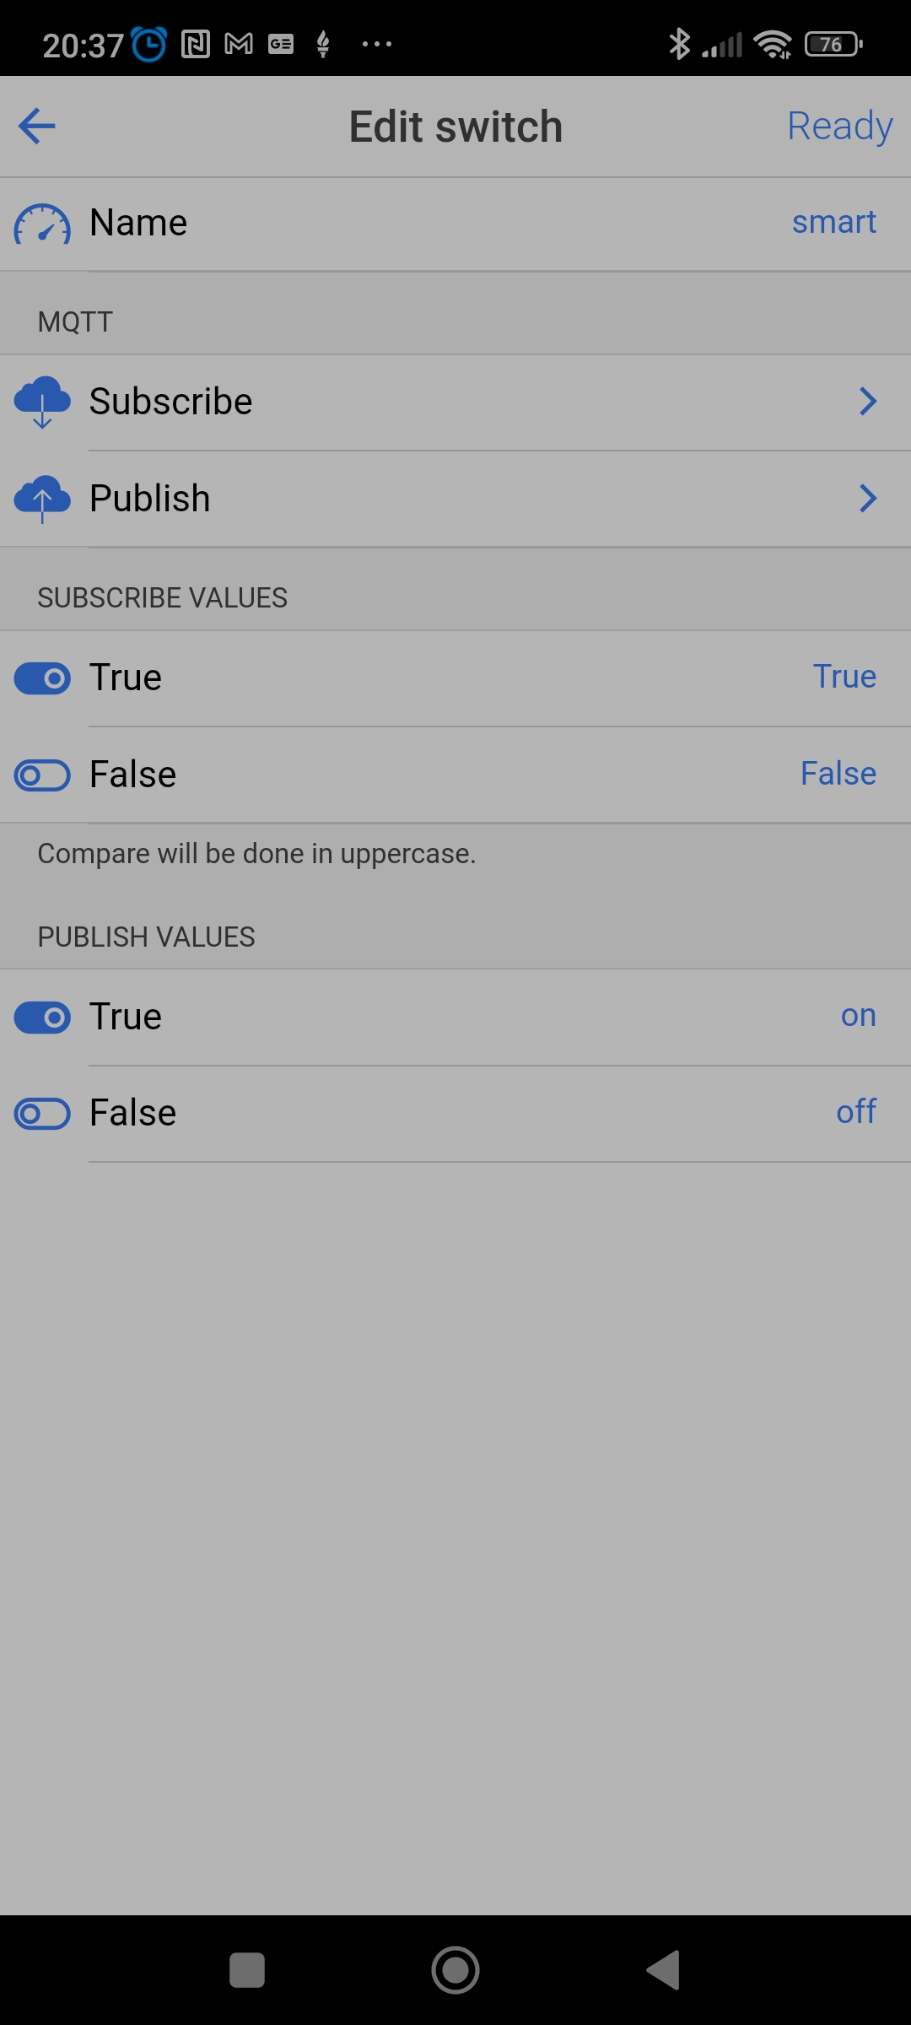
Payload
Smart plug

