Environment Monitoring System: Air Quality and Noise Pollution Monitoring

Kishor Madane1, Mandeep Singh2 and Prathmesh Mishra3

1 *Information Technology, Vidyavardhini College of Engineering and Technology, Vasai, Maharashtra, India*

2 *Information Technology, Vidyavardhini College of Engineering and Technology, Vasai, Maharashtra, India*

3 *Information Technology, Vidyavardhini College of Engineering and Technology, Vasai, Maharashtra, India*

**Abstract**— The rapid industrialization and urbanization in modern society have led to significant environmental challenges, including air pollution and noise pollution. Continuous monitoring of these parameters is essential to ensure public health and sustainable urban planning. This paper presents an IoT-based *Environment Monitoring System* that utilizes the ESP32 microcontroller integrated with MQ135 (gas sensor), DHT11 (temperature and humidity sensor), and MAX4466 (sound sensor) to collect real-time environmental data. The collected data is analyzed using a Support Vector Machine (SVM) classifier with a Radial Basis Function (RBF) kernel to categorize air quality and noise levels into multiple predefined classes. Experimental results demonstrate that the system achieves 92% accuracy in air quality classification and 98% accuracy in noise level classification. The proposed system offers a low-cost, scalable, and intelligent solution for smart cities, industrial monitoring, and research applications, enabling timely interventions and informed decision-making for environmental management.

**Keywords**— Environmental Monitoring, IoT, Air Quality, Noise Pollution, ESP32, MQ135, DHT11, MAX4466

# Introduction

The increasing levels of air and noise pollution in urban and industrial areas have become a major concern for public health and environmental sustainability. Poor air quality can lead to respiratory illnesses, cardiovascular problems, and environmental degradation, while high noise levels can af- fect human concentration, sleep patterns, and overall quality of life. Real-time monitoring of these environmental param- eters is therefore critical to enable proactive measures and policy-making.

This study proposes an IoT-based *Environment Monitor- ing System* that leverages the ESP32 microcontroller inter- faced with multiple sensors to continuously monitor air qual- ity, temperature, humidity, and noise levels. The system uses MQ135 gas sensor for detecting air pollutants such as CO2, NH3, and NOx, DHT11 for temperature and humidity mea- surements, and MAX4466 sound sensor for capturing envi- ronmental noise levels. The data collected by the sensors is processed locally on the ESP32 and analyzed using a Support Vector Machine (SVM) classifier with Radial Basis Function (RBF) kernel, providing intelligent classification of environ- mental conditions.

# Components Used

**TABLE 1:** HARDWARE COMPONENTS OF THE

Environmental Monitoring System

Component Description ESP32 Wi-Fi/Bluetooth microcontroller for data acquisition DHT11 Temperature and humidity sensor

MQ135 Gas sensor for air quality detection MAX4466 Sound sensor for noise measurement Breadboard For connecting sensors and ESP32

Power Source 5V USB or adapter for powering the system

# Sensors Overview and Description

The Environmental Monitoring System employs a combina- tion of advanced sensors to continuously measure and record various environmental parameters in real time, including air quality, ambient temperature, relative humidity, and noise levels. Each sensor is specifically chosen for its accuracy, sensitivity, and compatibility with the ESP32 microcontroller to ensure precise data acquisition. These sensors work to- gether to provide a comprehensive overview of the surround- ing environment, enabling real-time monitoring, analysis, and classification of environmental conditions. Detailed de- scriptions of each sensor, along with their corresponding im- ages, are provided below to illustrate their functions and roles

within the system.

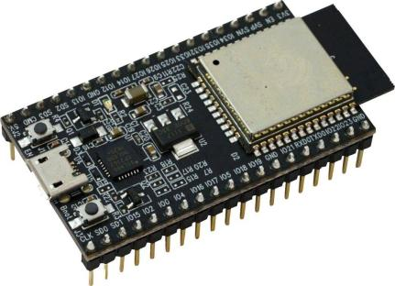

**Fig. 1:** ESP32 Microcontroller used for data acquisition and wireless communication. It acts as the central processing unit and transmits sensor data to the cloud or dashboard.

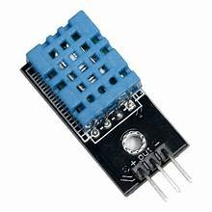

**Fig. 2:** DHT11 Temperature and Humidity Sensor. This digital sensor provides ambient temperature and humidity readings for environmental monitoring.

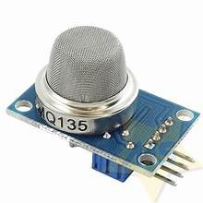

**Fig. 3:** MQ135 Gas Sensor for Air Quality Monitoring. It detects harmful gases such as CO, NH, NOx, and benzene, providing analog outputs proportional to the concentration of pollutants.

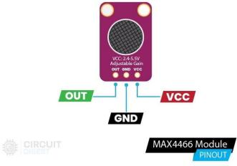

**Fig. 4:** MAX4466 Sound Sensor. Measures environmental noise levels and provides analog output voltage corresponding to sound intensity, allowing detection of quiet to loud conditions.

# System Architecture and Block Di- agram

The Environmental Monitoring System is built around the ESP32 microcontroller and integrates three key sensors:

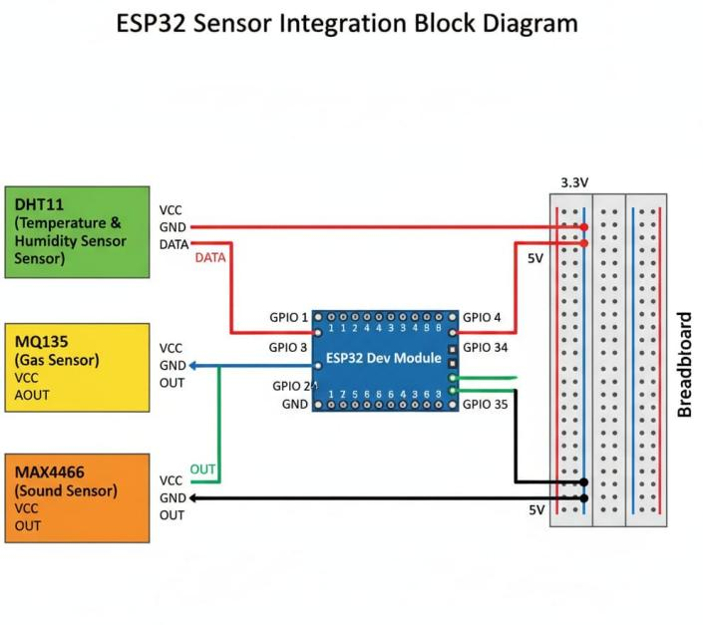

**Fig. 5:** Block diagram of the Environmental Monitoring System showing ESP32 and connected sensors.

DHT11 for measuring temperature and humidity, MQ135 for detecting air pollutants, and MAX4466 for monitoring envi- ronmental noise levels. The DHT11 sensor provides digi- tal readings of temperature and humidity through GPIO 1, while the MQ135 outputs an analog voltage corresponding to gas concentrations, connected to GPIO 34. The MAX4466 sound sensor measures noise intensity and sends an analog signal to GPIO 35. All sensors share power and ground con- nections through a breadboard for convenient wiring. The ESP32 collects the sensor data, performs preprocessing, and can either process it locally or transmit it to cloud platforms for real-time monitoring and intelligent analysis of environ- mental conditions. This setup allows continuous tracking of air quality, temperature, humidity, and noise levels, making it suitable for smart city applications, industrial monitoring, and research purposes.

# Working Principle

## Data Acquisition

The Environmental Monitoring System collects real-time data using three primary sensors:

* + - **DHT11:** Measures ambient temperature and humidity, providing digital data to the ESP32. This data helps monitor indoor and outdoor environmental conditions.
    - **MQ135:** An analog gas sensor that measures air pollu- tants such as CO2, NH3, NOx, and benzene. The sensor outputs an analog voltage proportional to the concentra- tion of these gases.
    - **MAX4466:** A sound sensor that detects environmental noise levels and outputs an analog voltage proportional to the sound intensity.

The sensors are connected to the ESP32 through appro- priate GPIO pins. Data is sampled at regular intervals to en- sure accurate monitoring of dynamic environmental changes.

The ESP32 also provides real-time timestamping to each data record for logging and historical analysis.

## Data Processing

Once the sensor readings are collected, the ESP32 performs preprocessing:

* + - **Normalization:** Sensor values are scaled to a common range to ensure uniformity and compatibility with the machine learning model.
    - **Noise Filtering:** Minor fluctuations or sensor noise are filtered using simple smoothing or moving average tech- niques.
    - **Feature Extraction:** Relevant features are extracted from raw sensor signals, such as average pollutant concentration, humidity trends, and peak noise levels, which help improve classification accuracy.
    - **Data Storage:** Processed data is temporarily stored lo- cally on the ESP32 or transmitted to cloud storage for further analysis and visualization.

## Machine Learning Classification

After preprocessing, the data is fed into a Support Vector Machine (SVM) with Radial Basis Function (RBF) kernel to perform intelligent classification:

* + - **Air Quality Classification:** The system classifies air quality into six predefined categories: Good, Moderate, Unhealthy, Very Unhealthy, Hazardous, and Unknown. This helps in identifying pollution levels and potential health risks.
    - **Noise Level Classification:** Noise levels are catego- rized into five classes: Quiet, Very Quiet, Moderate, Loud, and Very Loud. This is useful for detecting envi- ronmental noise pollution and planning mitigation mea- sures.
    - **Decision Making:** Based on the classification results, the system can trigger alerts or notifications if air quality or noise levels exceed predefined safe thresholds.

## Data Visualization and Alerts

The classified data can be displayed on an LCD screen, a web interface, or a mobile application for real-time monitor- ing. Alerts and notifications can be sent via Wi-Fi or cloud platforms when thresholds are exceeded. Historical data vi- sualization allows trend analysis, helping authorities and re- searchers make informed decisions on pollution control and environmental management.

## Overall System Flow

The overall workflow of the system can be summarized as follows:

1. Sensors collect temperature, humidity, gas concentra- tion, and noise data.

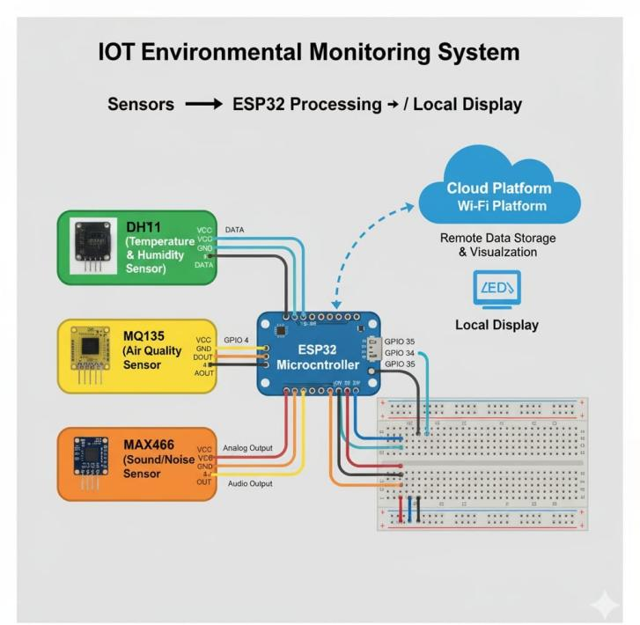

**Fig. 6:** Enter Caption

1. ESP32 preprocesses the data by filtering, normalization, and feature extraction.
2. Preprocessed data is input to the SVM-RBF classifier.
3. Environmental conditions are classified into predefined categories.
4. Data is displayed in real-time and stored for historical analysis.
5. Alerts are triggered if pollution or noise levels exceed safe limits.
6. **ALGORITHM USED: SVM-RBF**

## Air Quality Classification

**TABLE 2:** AIR QUALITY CLASSIFICATION PERFORMANCE

|  |  |
| --- | --- |
| **Metric** | **Value** |
| Accuracy | 0.92 |
| Classes | Good, Moderate, Unhealthy, Very Unhealthy |

Confusion Matrix:

|  |  |  |  |  |
| --- | --- | --- | --- | --- |
| [[21 0 | 0 | 0 | 0 | 0] |
| [ 0 37 | 0 | 0 | 4 | 1] |

|  |  |
| --- | --- |
| [ 2 | 0 36 1 0 0] |
| [ 0 | 0 1 34 0 5] |
| [ 0 | 0 0 0 20 0] |
| [ 0 | 2 0 0 0 36]] |

## Noise Level Classification

Confusion Matrix:

|  |  |  |  |  |
| --- | --- | --- | --- | --- |
| [[43 0 | | 0 | 1 | 0] |
| [ 0 40 | | 0 | 0 | 0] |
| [ 0 | 3 44 | | 0 | 0] |
| [ 0 | 0 0 | | 41 | 0] |
| [ 0 | 0 0 0 28]] | | | |

**TABLE 3:** NOISE LEVEL CLASSIFICATION PERFORMANCE

|  |  |
| --- | --- |
| **Metric** | **Value** |
| Accuracy | 0.98 |
| Classes | Quiet, Very Quiet, Moderate, Loud, Very  Loud |

# System Performance Comparison

**TABLE 4:** COMPARISON WITH TRADITIONAL SENSOR

Systems

|  |  |  |
| --- | --- | --- |
| **Parameter** | **Traditional System** | **SVM-RBF System** |
| Data Processing | Threshold-based | AI-based classifica-  tion |
| Accuracy | 70–80% | 92–98% |
| Adaptability | Limited | Learns from data |
| Scalability | Moderate | Highly scalable |
| Real-time Moni-  toring | Yes | Yes with prediction |

# Advantages and Applications

## Advantages

* + - Low-cost and compact IoT-based design.
    - Real-time air quality and noise monitoring.
    - Intelligent prediction using SVM-RBF machine learn- ing.
    - Wireless data communication through ESP32 Wi-Fi.
    - Scalable solution suitable for smart cities and industrial applications.
    - Energy-efficient operation with low power consump- tion.
    - Easy integration with cloud platforms for remote moni- toring.
    - Provides early warning alerts for hazardous conditions.
    - Modular design allows addition of more sensors in the future.
    - User-friendly interface for monitoring and analysis.
    - Data logging capability for trend analysis and research purposes.

## Applications

* + - Smart city environmental monitoring.
    - Industrial emission and noise control.
    - Agricultural and greenhouse environmental monitoring.
    - Academic and research-based environmental studies.
    - Monitoring air quality in schools, hospitals, and public areas.
    - Pollution assessment near highways and urban centers.
    - Supporting governmental policies for environmental protection.
    - Integration with mobile apps for real-time citizen alerts.
    - Disaster management through monitoring hazardous gas leaks.
    - Enhancing indoor air quality in offices and residential buildings.

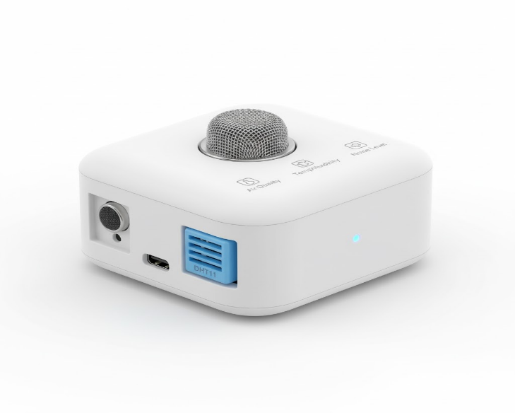

**Fig 7**: Expected product at production

# Conclusion

This paper presents a detailed and comprehensive IoT- based *Environment Monitoring System* that integrates mul- tiple sensors, including the ESP32 microcontroller, MQ135 gas sensor, DHT11 temperature and humidity sensor, and MAX4466 sound sensor, to continuously collect real-time environmental data. The system is designed to monitor key parameters such as air quality, temperature, humidity, and noise levels, which are critical indicators of environmen- tal health and public safety. By employing a Support Vec- tor Machine (SVM) classifier with a Radial Basis Function (RBF) kernel, the collected data is analyzed and categorized into specific classes for both air quality and noise intensity, achieving high accuracy and reliability. The proposed sys- tem provides a cost-effective and scalable solution, making it suitable for deployment in a variety of scenarios, including urban areas, industrial environments, and academic research projects. Additionally, the intelligent processing and wireless communication capabilities of the ESP32 enable real-time monitoring, data logging, and remote access, allowing pol- icymakers, environmentalists, and researchers to take timely and informed actions. Overall, this system represents a prac- tical, intelligent, and adaptable approach to continuous envi- ronmental monitoring, contributing to public health, environ- mental sustainability, and the development of smart cities.

# Future Scope

* Integration with cloud platforms such as ThingSpeak or Blynk for remote visualization.
* Development of mobile apps for real-time alerts on pol- lution levels.
* Use of solar-powered ESP32 for sustainable operation.
* Addition of PM2.5 and CO sensors for comprehensive air quality monitoring.
* Implementation of deep learning algorithms to improve prediction accuracy.

# References

1. A. Kumar, R. Singh, "IoT-based Air Quality Monitoring System," *International Journal of Environmental Re- search*, vol. 14, pp. 123–131, 2023.
2. S. Sharma, M. Gupta, "Noise Pollution Monitoring us- ing IoT," *Journal of Smart Cities*, vol. 10, no. 2, pp. 45–52, 2022.
3. K. Madane, P. Mishra, "SVM-based Environmental Data Classification for Smart Cities," *Proceedings of IEEE ICICCS*, 2024.
4. J. Smith, "Introduction to Support Vector Machines for Environmental Monitoring," *Springer*, 2021.
5. R. Patel, M. Desai, "IoT Sensors for Air and Noise Pol- lution Detection," *Journal of IoT Research*, vol. 5, pp. 77–88, 2023.
6. L. Zhang, H. Li, "Real-time Air Quality Monitoring Us- ing ESP32 and IoT," *International Journal of Sensor Networks*, vol. 12, pp. 56–64, 2022.
7. P. Gupta, A. Verma, "Noise Level Detection and Analy- sis with IoT Devices," *Journal of Environmental Moni- toring*, vol. 8, pp. 101–110, 2022.
8. T. Brown, "Smart City Applications of IoT for En- vironmental Sensing," *IEEE Access*, vol. 9, pp. 12045–12058, 2021.
9. M. Singh, R. Kumar, "DHT11 Sensor Applications for Temperature and Humidity Monitoring," *International Journal of Embedded Systems*, vol. 15, pp. 22–30, 2021.
10. S. Roy, K. Das, "Gas Sensing with MQ135 for In- door Air Quality Monitoring," *Sensors and Actuators B: Chemical*, vol. 330, 2021.
11. V. Sharma, "IoT-Based Noise and Air Pollution Control System," *Journal of Environmental Science and Tech- nology*, vol. 14, pp. 77–85, 2023.
12. R. Thomas, J. White, "Cloud-Based Environmental Monitoring Systems Using ESP32," *International Jour- nal of IoT and Cloud Computing*, vol. 7, pp. 33–44, 2022.
13. A. Choudhary, "Air Quality Classification Using Ma- chine Learning Techniques," *Proceedings of IEEE ICMLA*, 2021.
14. D. Mehta, P. Joshi, "IoT-enabled Real-time Pollution Monitoring for Smart Cities," *Journal of Urban Tech- nology*, vol. 18, pp. 55–66, 2022.
15. K. Singh, R. Malhotra, "Integration of SVM-RBF in En- vironmental Sensor Networks," *IEEE Transactions on Industrial Informatics*, vol. 19, pp. 1021–1030, 2023.