1.HEADLINE UPDATION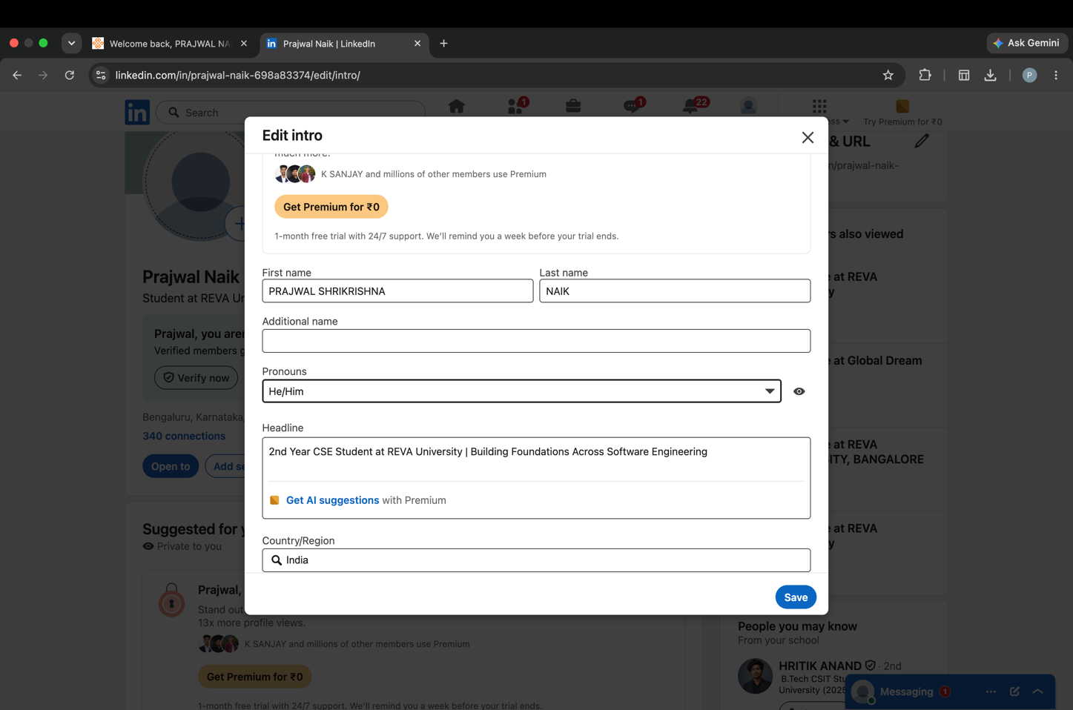2.UPDATION OF ABOUT SECTION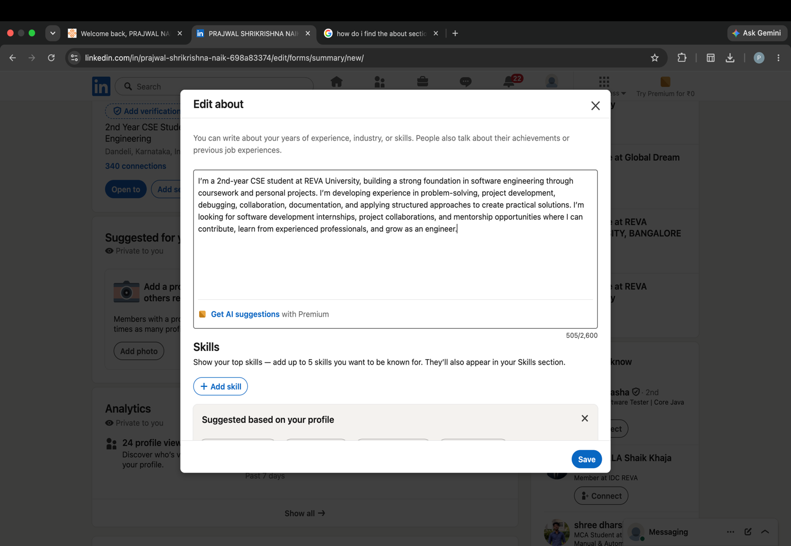
3.COMPLETED EDUCATION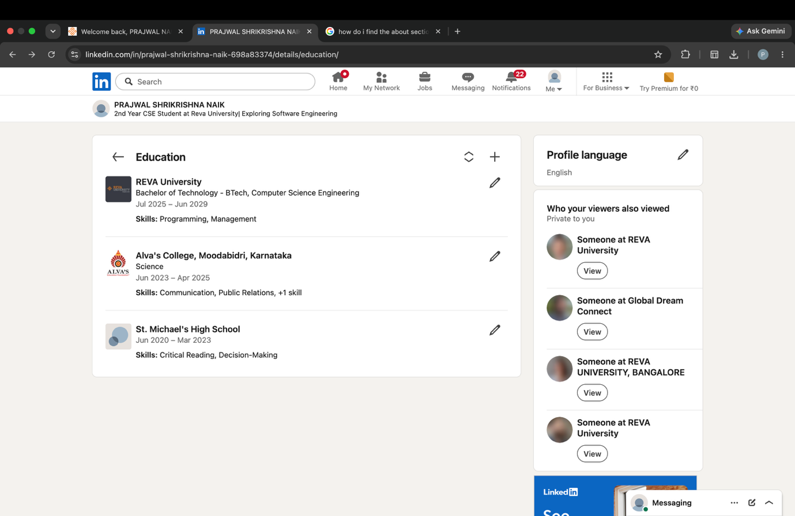4.ALL SKILLS WITH EDUCATION 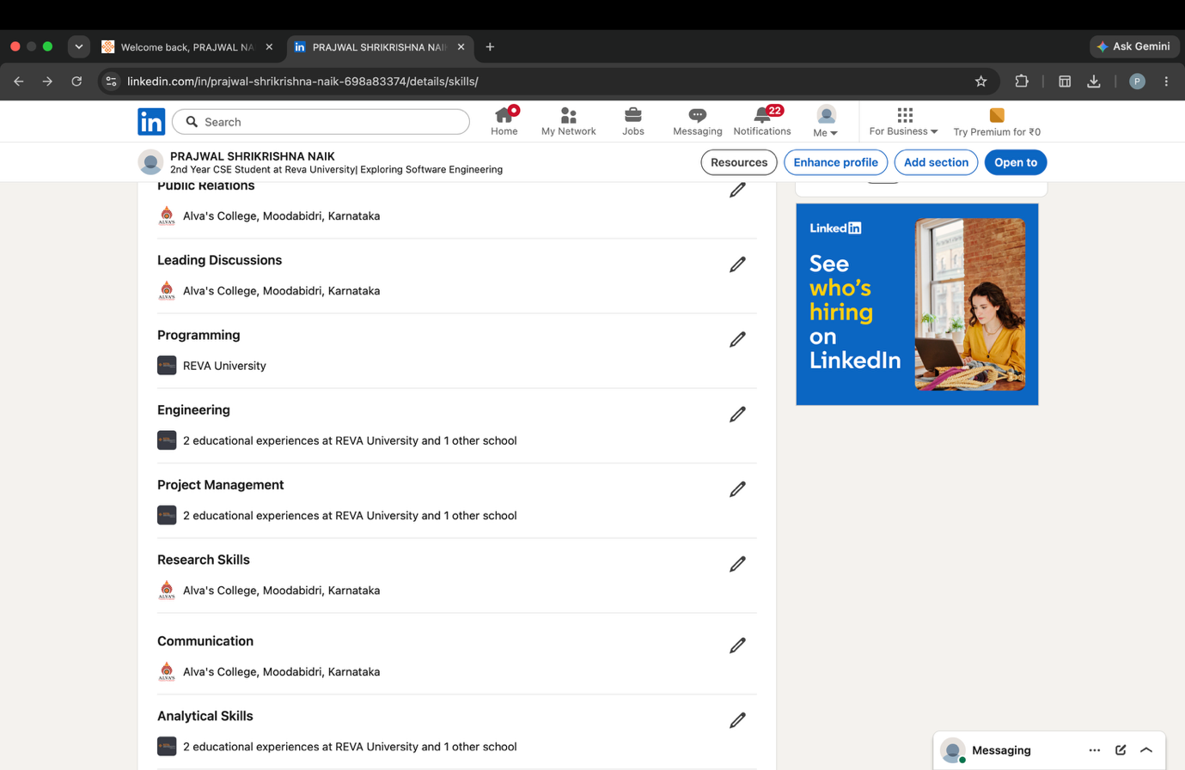
5.OPEN TO WORK WITH JOB POSTED 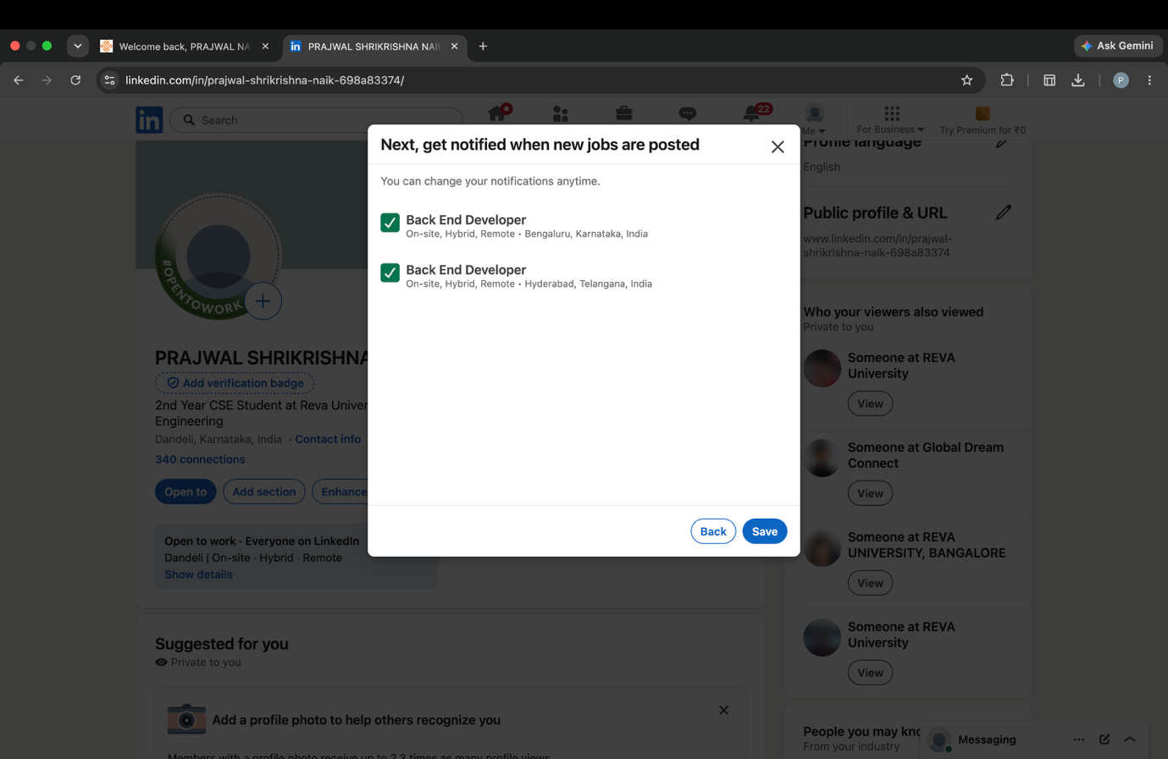6.PROFILE PHOTO 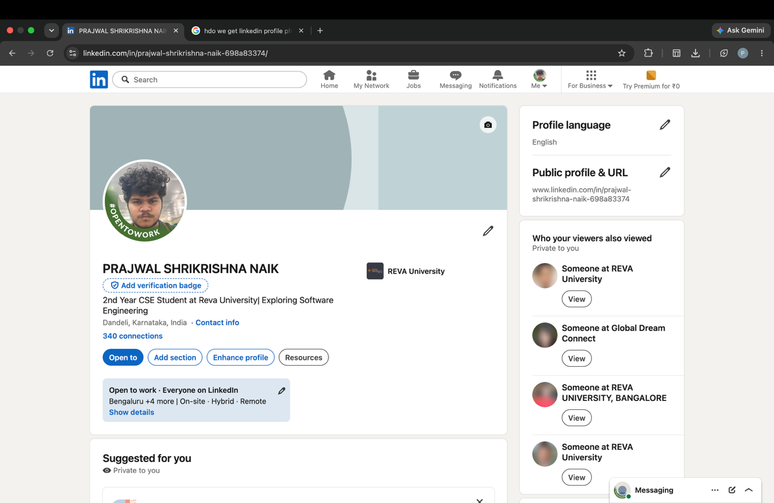
Public LinkedIn URL : www.linkedin.com/in/prajwalShrikrishnaNaik

