1.PAPER DESIGN
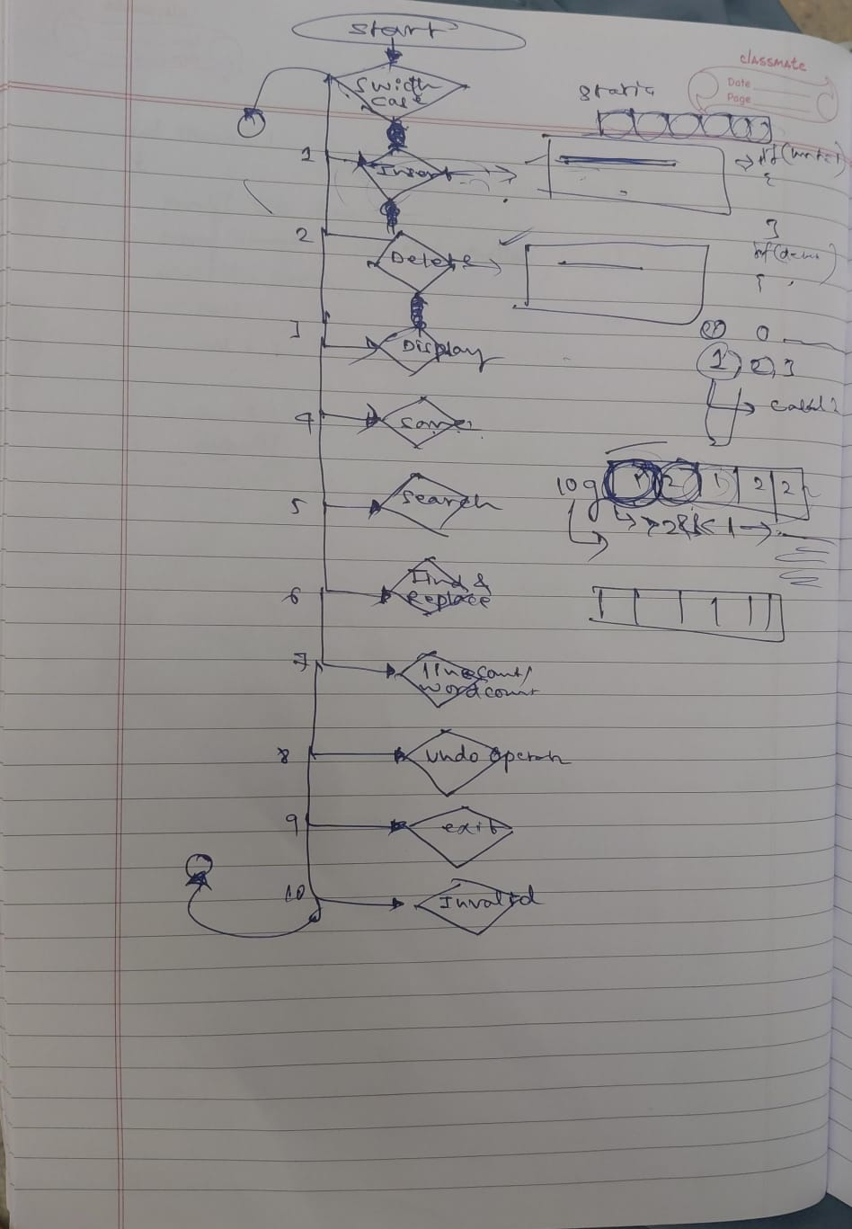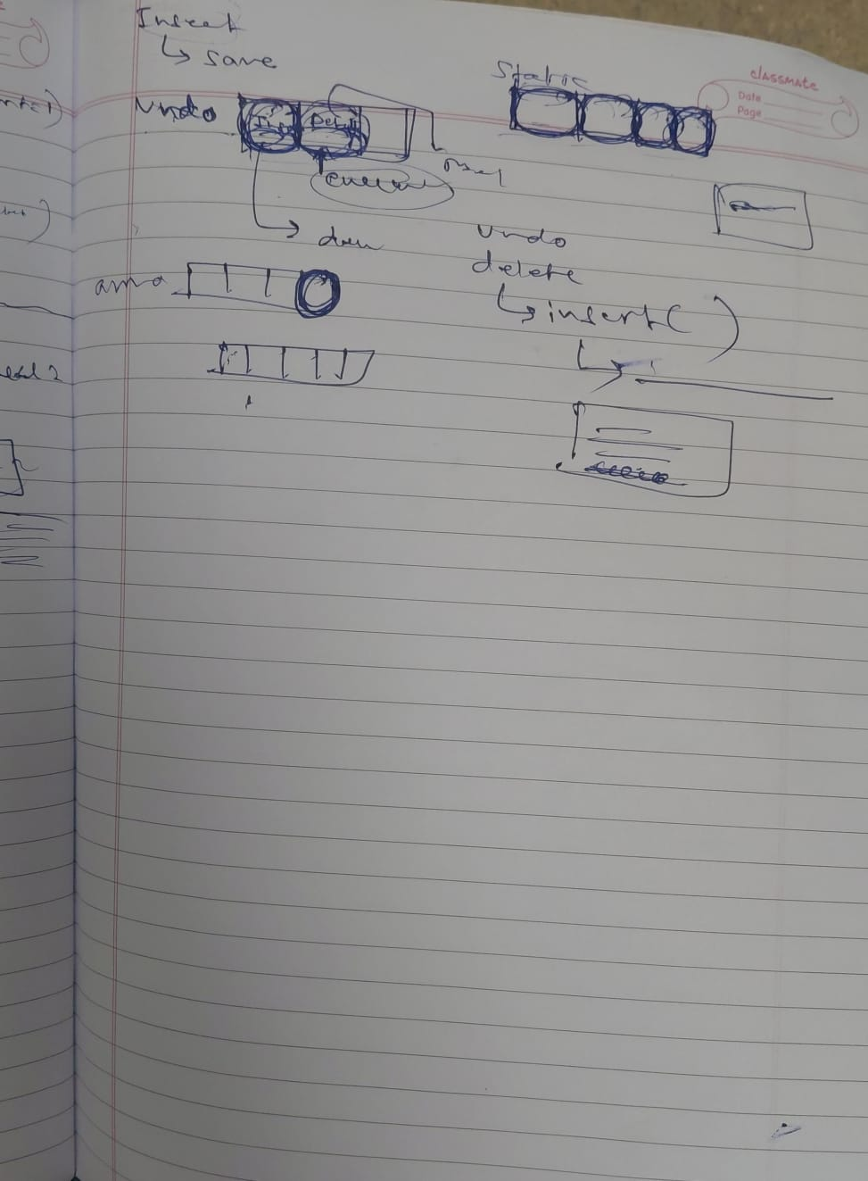
2.WORKING C CODE
#include <stdio.h>
#include <stdlib.h>
#include <string.h>

#define MAX_LINES 100
#define MAX_LEN 256

char lines[MAX_LINES][MAX_LEN];
int line_count = 0;

// Undo tracking variables
int last_action = 0; // 0: None, 1: Insert was done, 2: Delete was done
int undo_line_num = 0;
char undo_text[MAX_LEN];

void print_help() {
printf("\n--- Advanced Line Editor Help ---\n");
printf(" p - Display document state with line numbers\n");
printf(" i <line> <text> - Insert a line at a given number\n");
printf(" d <line> - Delete a line at a given number\n");
printf(" u - Undo last insert or delete action (Bonus!)\n");
printf(" f <keyword> - Search for a word or phrase (Bonus!)\n");
printf(" s <filename> - Save document to text file\n");
printf(" l <filename> - Load document from text file\n");
printf(" h - Show this help menu\n");
printf(" q - Quit the editor\n");
printf("----------------------------------\n");
}

void display_document() {
if (line_count == 0) {
printf("Document is empty.\n");
return;
}
printf("\n--- Document State ---\n");
for (int i = 0; i < line_count; i++) {
printf("%3d: %s", i + 1, lines[i]);
}
printf("----------------------\n");
}

void insert_line(int line_num, const char *text, int record_undo) {
if (line_num < 1 || line_num > line_count + 1) {
printf("Error: Invalid line number.\n");
return;
}
if (line_count >= MAX_LINES) {
printf("Error: Document is full.\n");
return;
}

// Shift lines down
for (int i = line_count; i >= line_num; i--) {
strcpy(lines[i], lines[i - 1]);
}

strcpy(lines[line_num - 1], text);
if (strchr(lines[line_num - 1], '\n') == NULL) {
strcat(lines[line_num - 1], "\n");
}

line_count++;

if (record_undo) {
last_action = 1; // 1 means last action was an insert
undo_line_num = line_num;
}
printf("Line inserted successfully.\n");
}

void delete_line(int line_num, int record_undo) {
if (line_num < 1 || line_num > line_count) {
printf("Error: Invalid line number.\n");
return;
}

if (record_undo) {
last_action = 2; // 2 means last action was a delete
undo_line_num = line_num;
strcpy(undo_text, lines[line_num - 1]);
}

// Shift lines up
for (int i = line_num - 1; i < line_count - 1; i++) {
strcpy(lines[i], lines[i + 1]);
}

line_count--;
printf("Line deleted successfully.\n");
}

void undo_last_action() {
if (last_action == 0) {
printf("Error: Nothing to undo.\n");
return;
}

if (last_action == 1) {
// Reverse of insert is deleting that line (without re-recording undo)
delete_line(undo_line_num, 0);
printf("Undo successful: Reversed last insert.\n");
} else if (last_action == 2) {
// Reverse of delete is inserting that line back (without re-recording undo)
insert_line(undo_line_num, undo_text, 0);
printf("Undo successful: Restored deleted line.\n");
}
last_action = 0; // Reset after undo
}

void search_keyword(const char *keyword) {
int found = 0;
printf("\n--- Search Results for '%s' ---\n", keyword);
for (int i = 0; i < line_count; i++) {
if (strstr(lines[i], keyword) != NULL) {
printf("Line %d: %s", i + 1, lines[i]);
found = 1;
}
}
if (!found) {
printf("Keyword not found in the document.\n");
}
printf("-------------------------------\n");
}

void save_file(const char *filename) {
FILE *file = fopen(filename, "w");
if (!file) {
printf("Error: Could not open file for writing.\n");
return;
}
for (int i = 0; i < line_count; i++) {
fputs(lines[i], file);
}
fclose(file);
printf("Document saved to %s successfully.\n", filename);
}

void load_file(const char *filename) {
FILE *file = fopen(filename, "r");
if (!file) {
printf("Error: Could not open file for reading.\n");
return;
}
line_count = 0;
last_action = 0;
while (fgets(lines[line_count], MAX_LEN, file) != NULL && line_count < MAX_LINES) {
line_count++;
}
fclose(file);
printf("Document loaded from %s successfully.\n", filename);
}

int main() {
char cmd[10];
char filename[50];
char text[MAX_LEN];
int line_num;

printf("=== Advanced Command-Line Line Editor ===\n");
printf("Type 'h' for help. Type 'q' to quit.\n");

while (1) {
printf("\ncmd> ");
if (scanf("%s", cmd) != 1) break;

if (strcmp(cmd, "q") == 0) {
break;
} else if (strcmp(cmd, "h") == 0) {
print_help();
} else if (strcmp(cmd, "p") == 0) {
display_document();
} else if (strcmp(cmd, "i") == 0) {
scanf("%d", &line_num);
getchar(); // clear newline buffer
fgets(text, MAX_LEN, stdin);
insert_line(line_num, text, 1);
} else if (strcmp(cmd, "d") == 0) {
scanf("%d", &line_num);
delete_line(line_num, 1);
} else if (strcmp(cmd, "u") == 0) {
undo_last_action();
} else if (strcmp(cmd, "f") == 0) {
scanf("%s", text);
search_keyword(text);
} else if (strcmp(cmd, "s") == 0) {
scanf("%s", filename);
save_file(filename);
} else if (strcmp(cmd, "l") == 0) {
scanf("%s", filename);
load_file(filename);
} else {
printf("Unknown command. Type 'h' for help.\n");
}
}
return 0;
}

3.OUTPUT OF THE CODE COMPILED USING GCC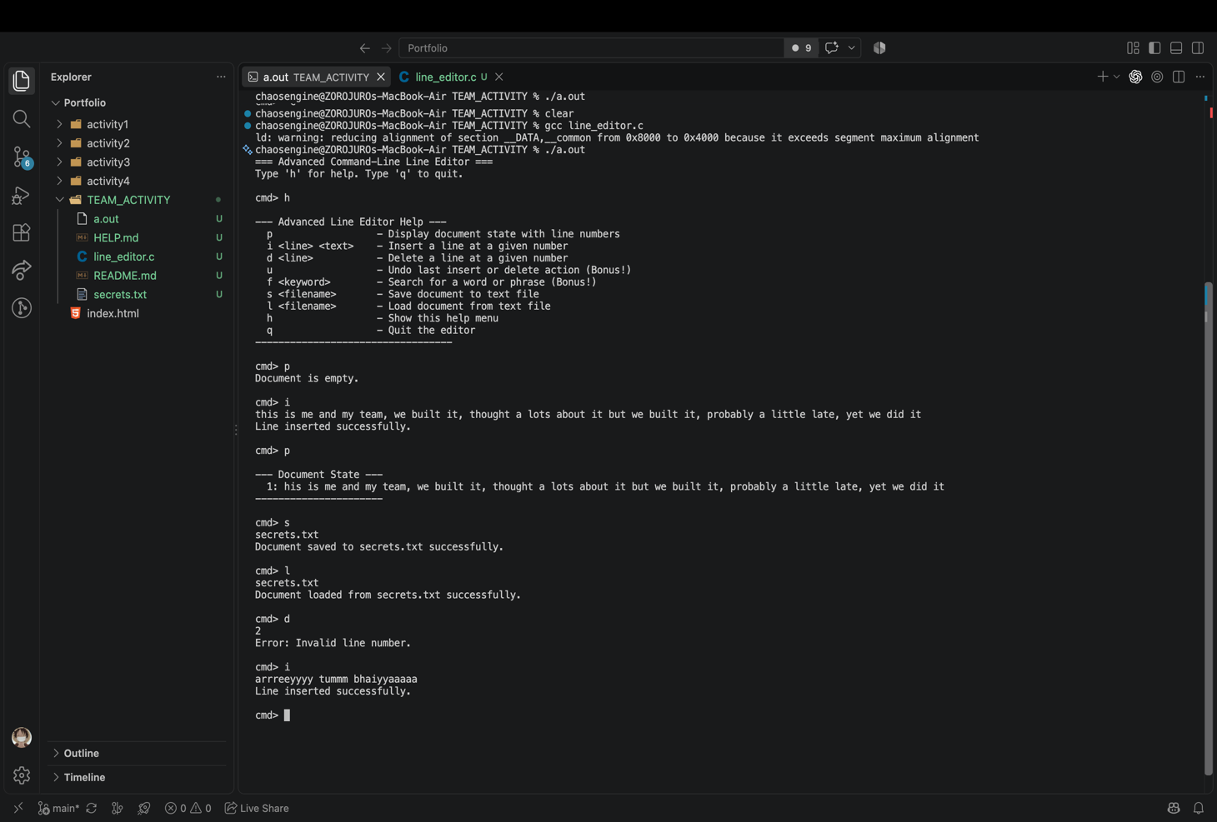
4.VERIFICATION INTO THE FILE FOR TEXT INSERT, DELETE AND UPDATE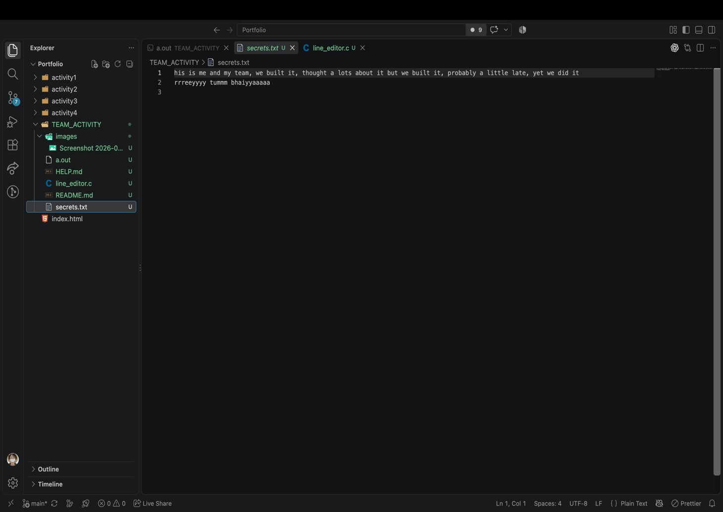
5.GITHUB REPRESENTATION OF THE FILES MADE(C CODE AND MD FILES)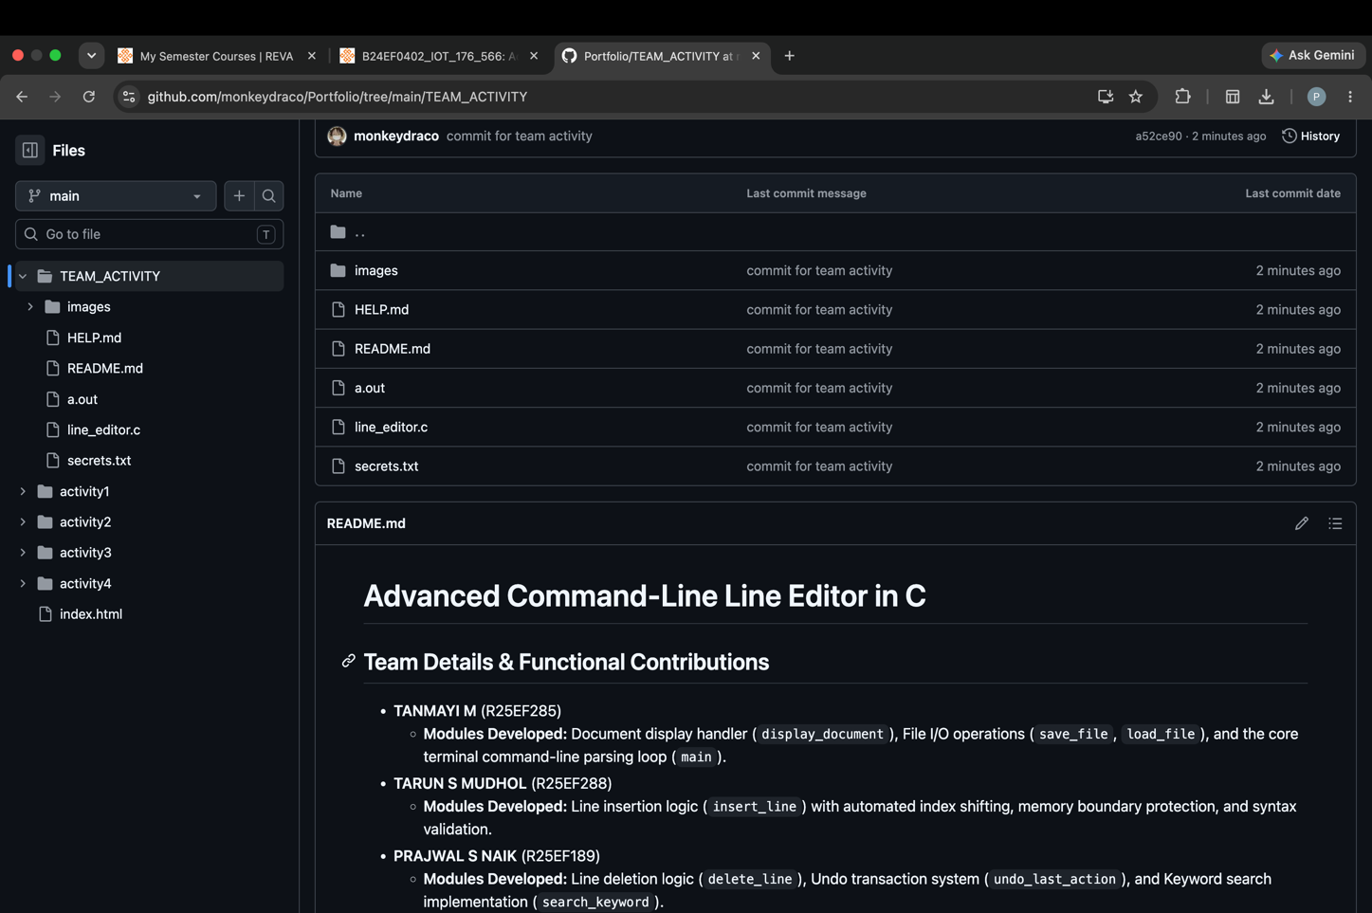6.SNAPSHOT OF THE HELPME.MD FILE 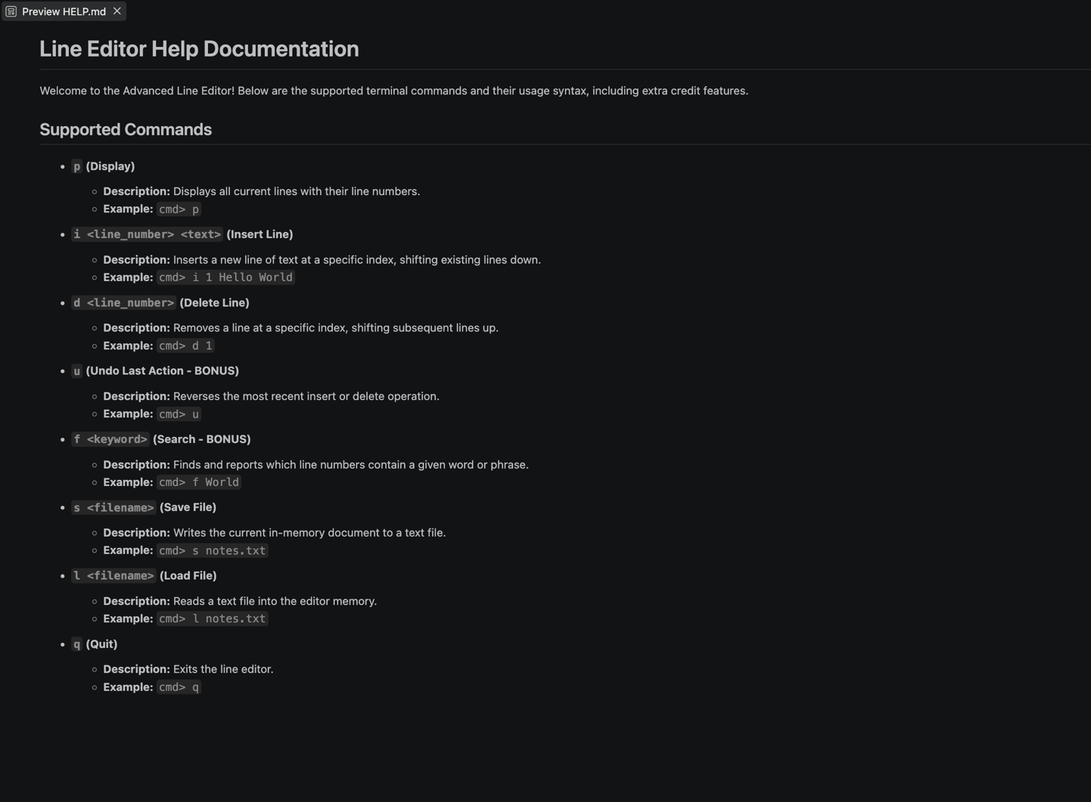
7.SNAPSHOT OF README.MD FILE