1.PYTHON PROGRAMMING 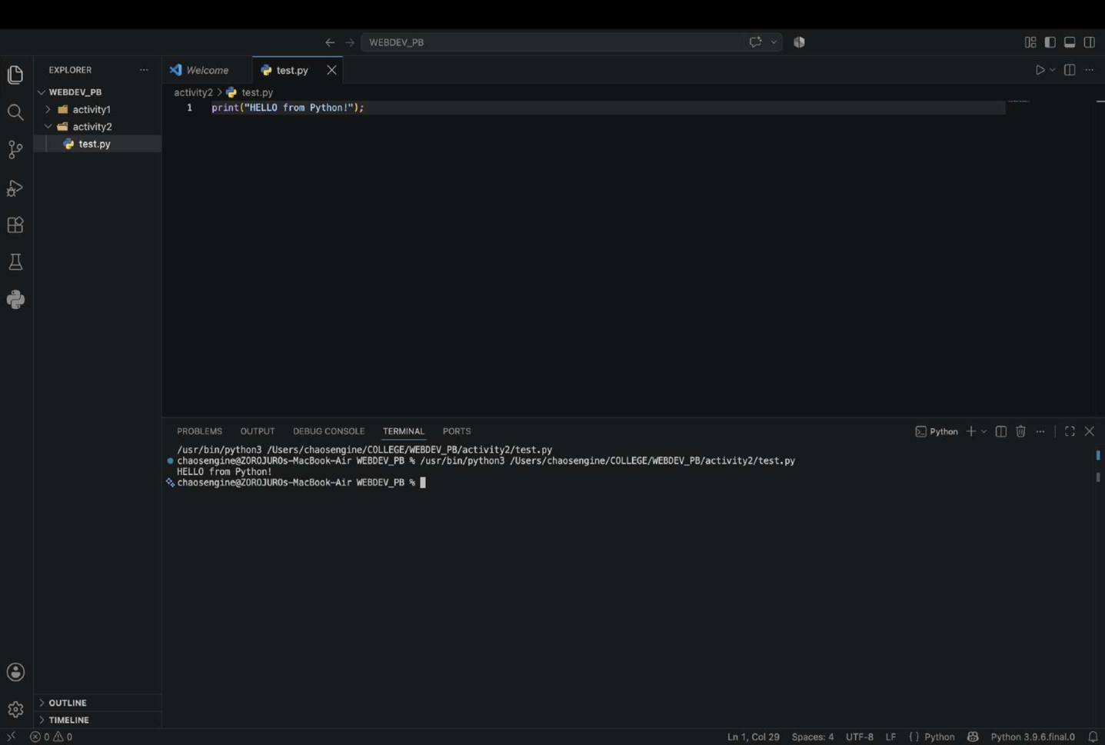
2.JAVA PROGRAMMING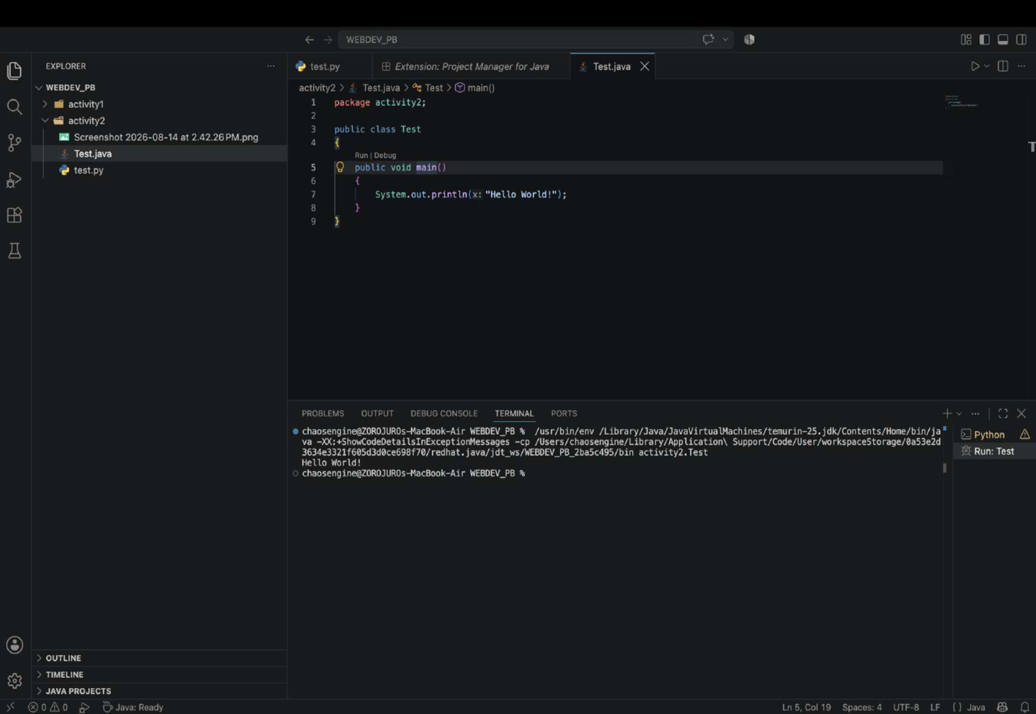
3.UNFORMATTED CODE 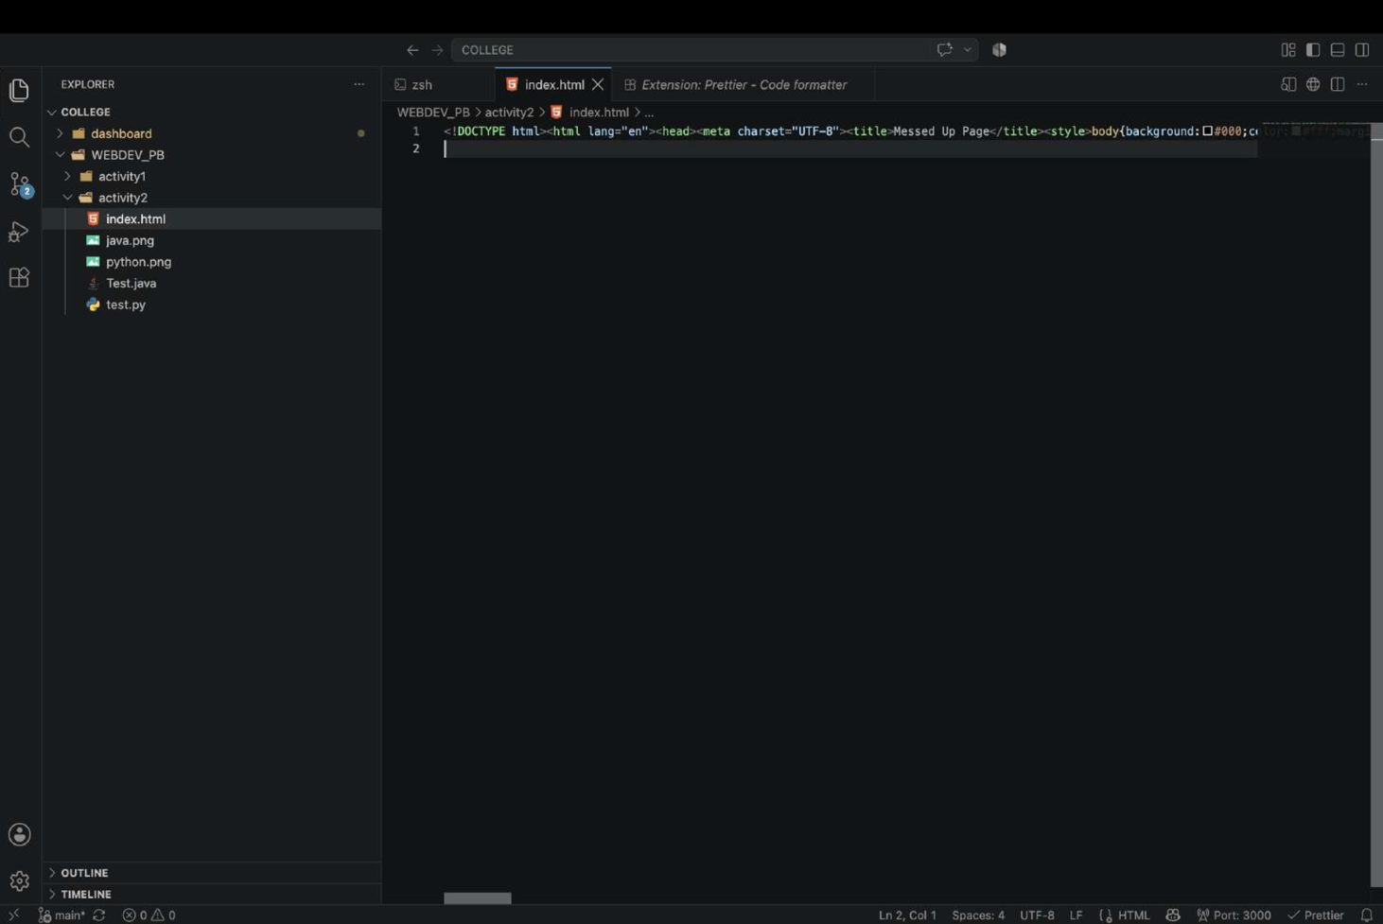4.FORMATTED CODE USING PRETTIER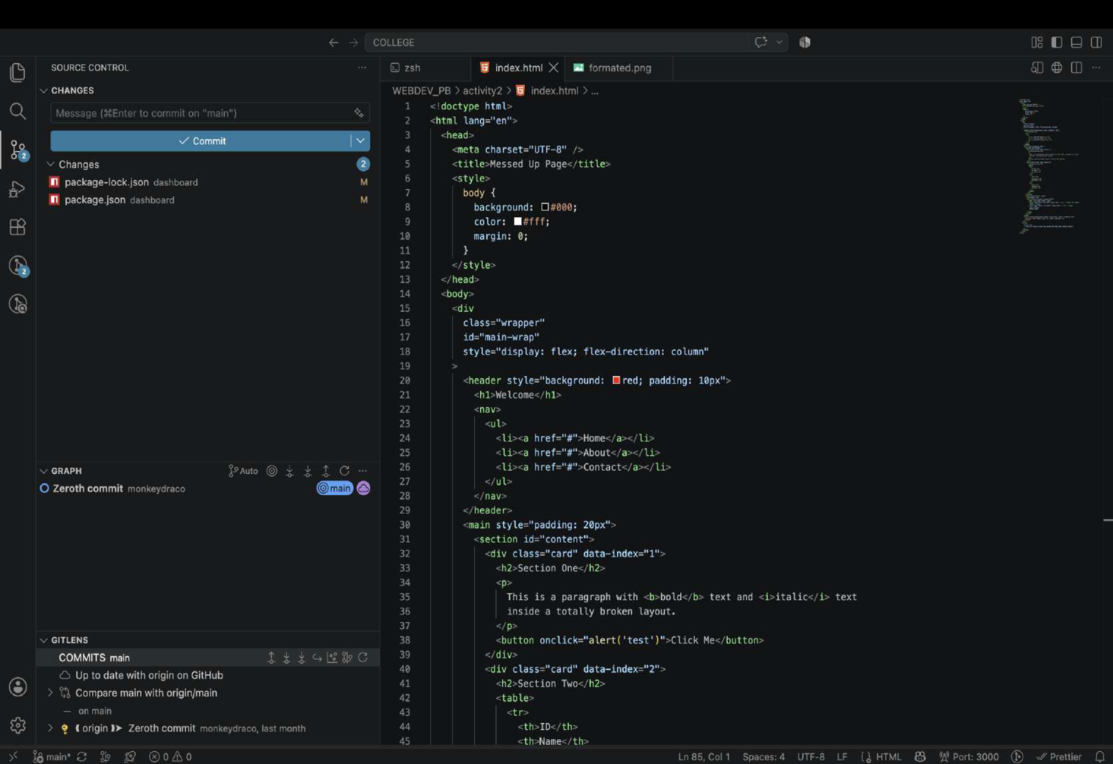
5.GITLENS-COMMIT GRAPH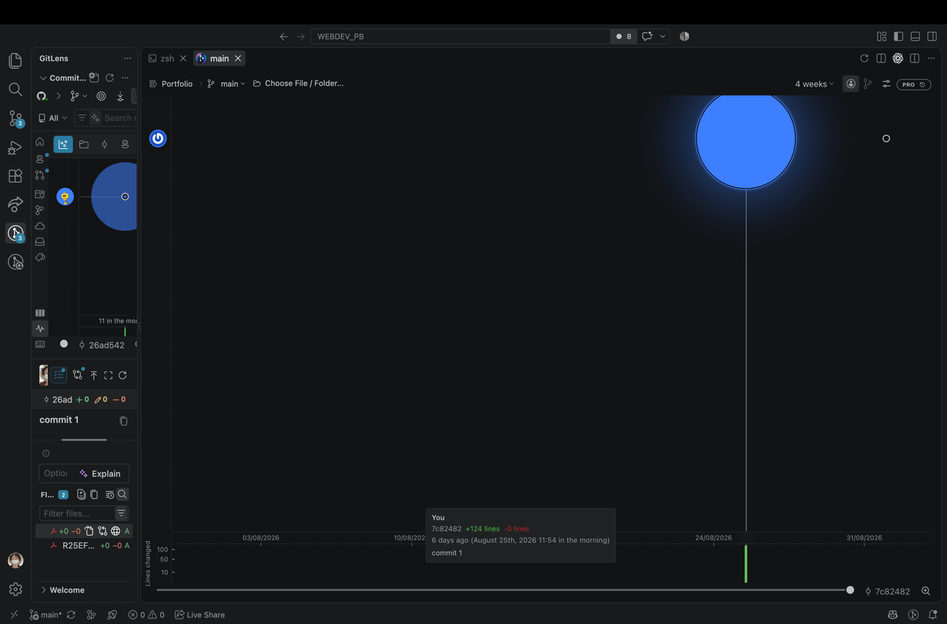6.BLAME ANAOTATIONS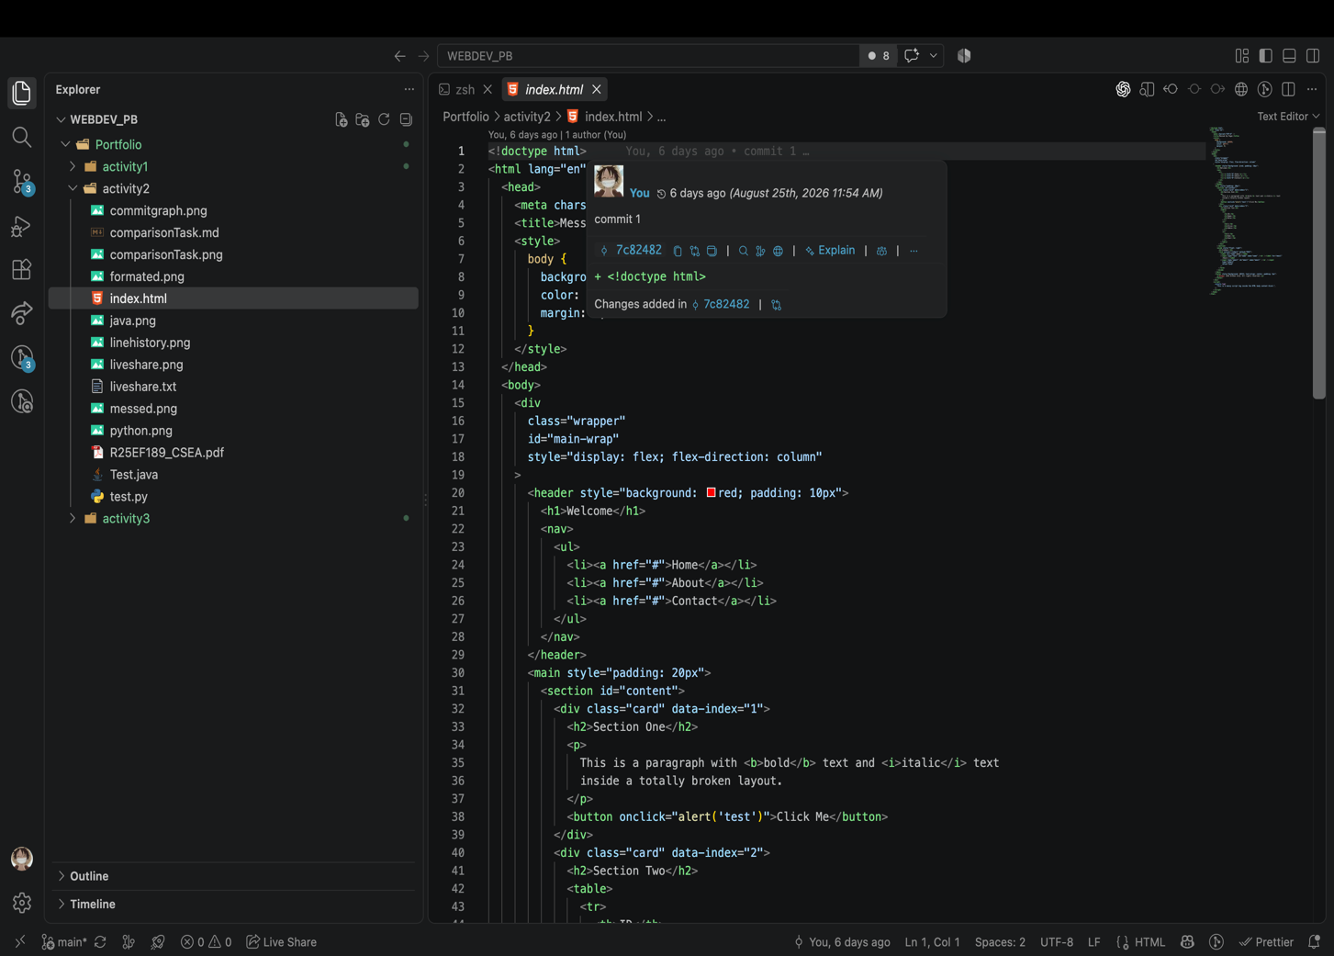7.LIVE SHARE TEXT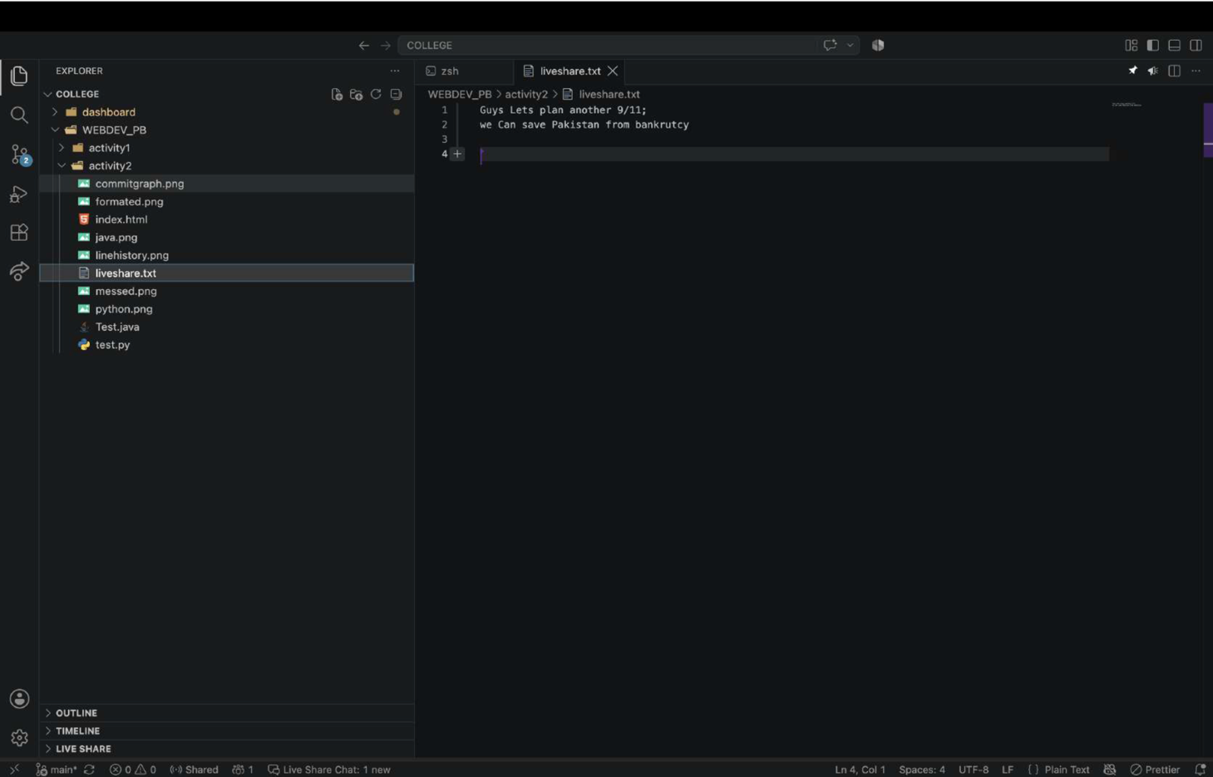
7.COMPARISON
