1.SOLUTION FOR TWO SUM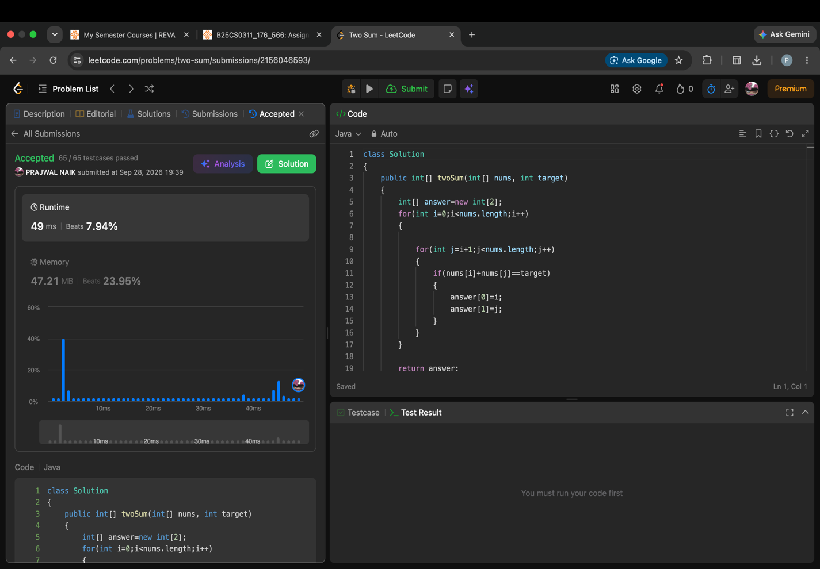2.SOLUTION FOR REVERSE STRING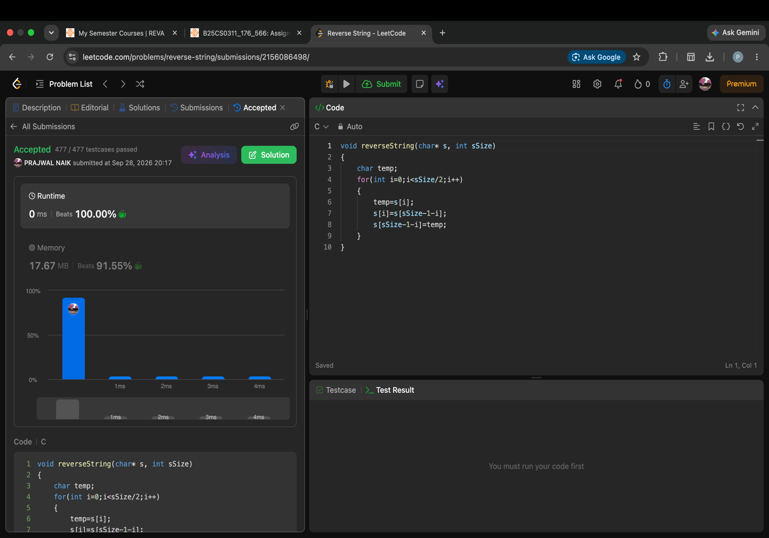
3.VALID ANAGRAM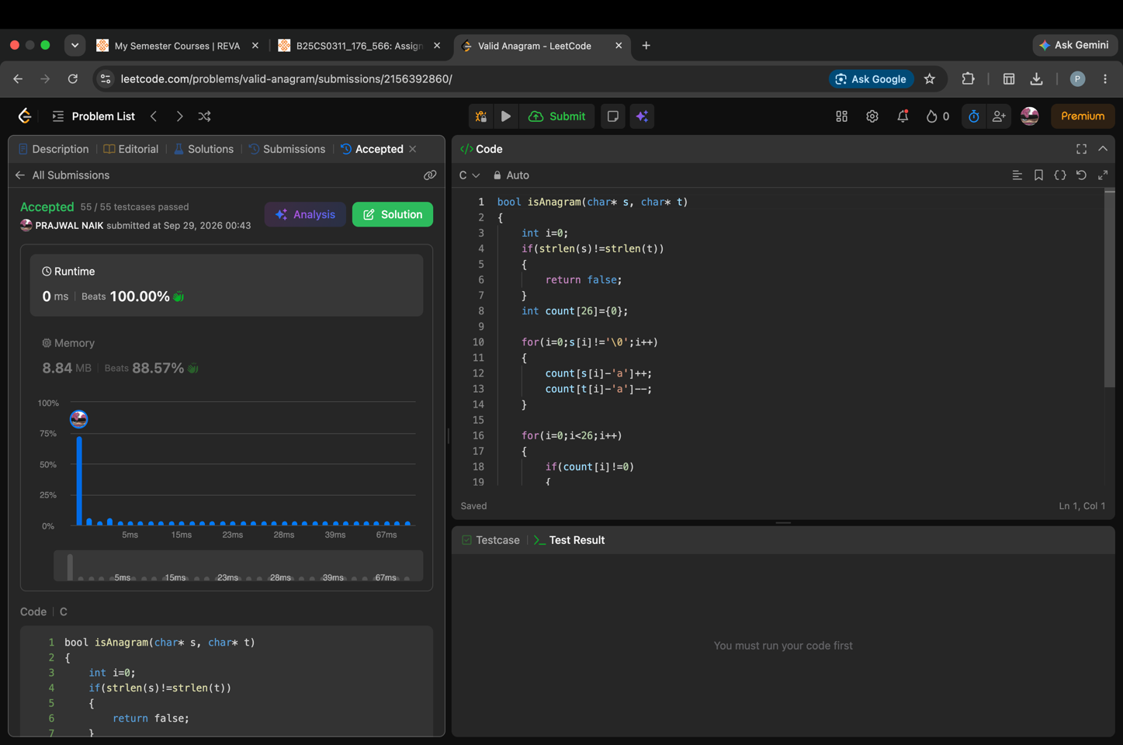4.BEST TIME TO BUY AND SELL STOCK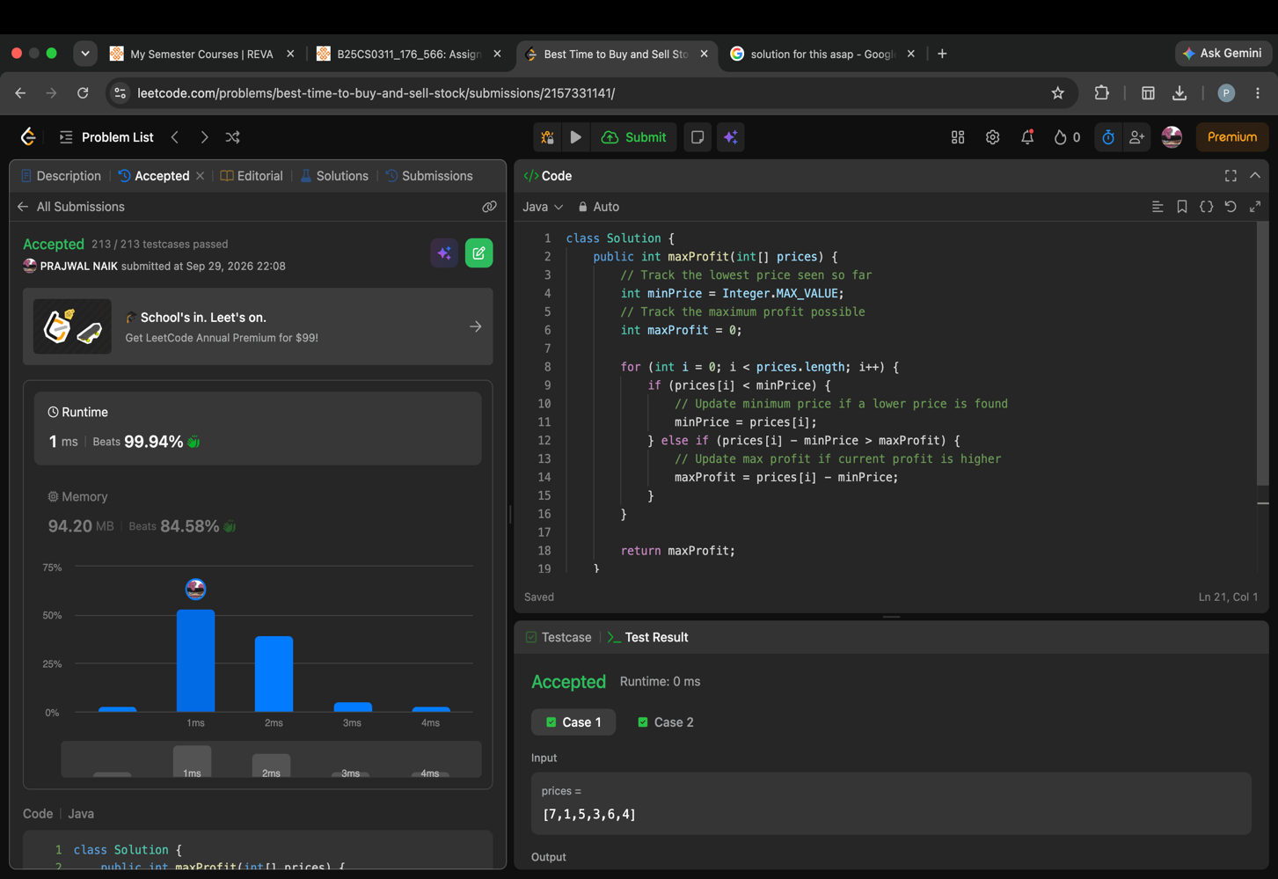
05.SOLUTION FOR LONGEST COMMON PREFIX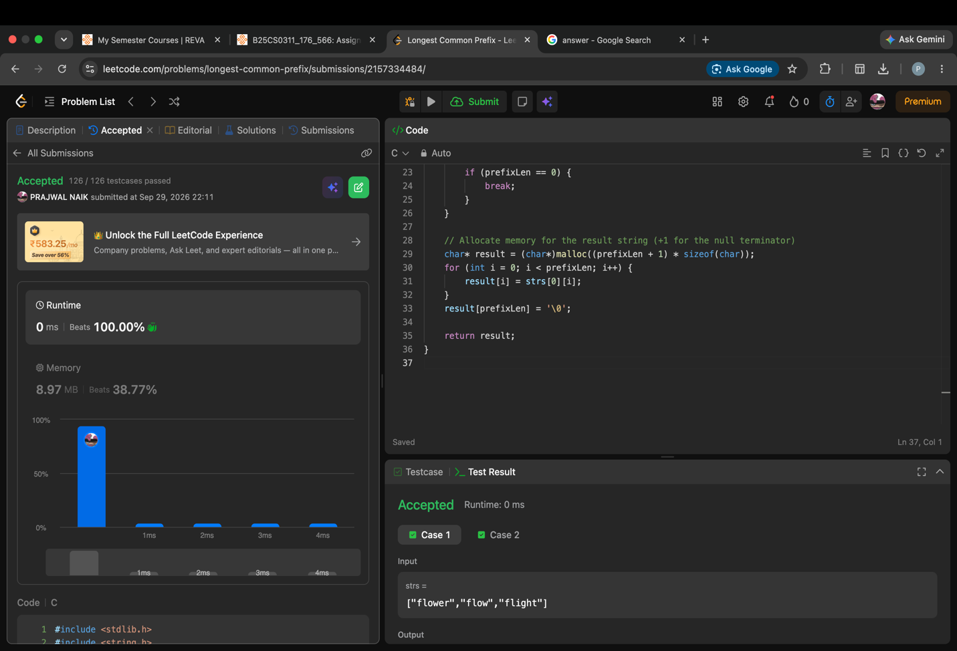06.SOLUTION FOR BINARY SEARCH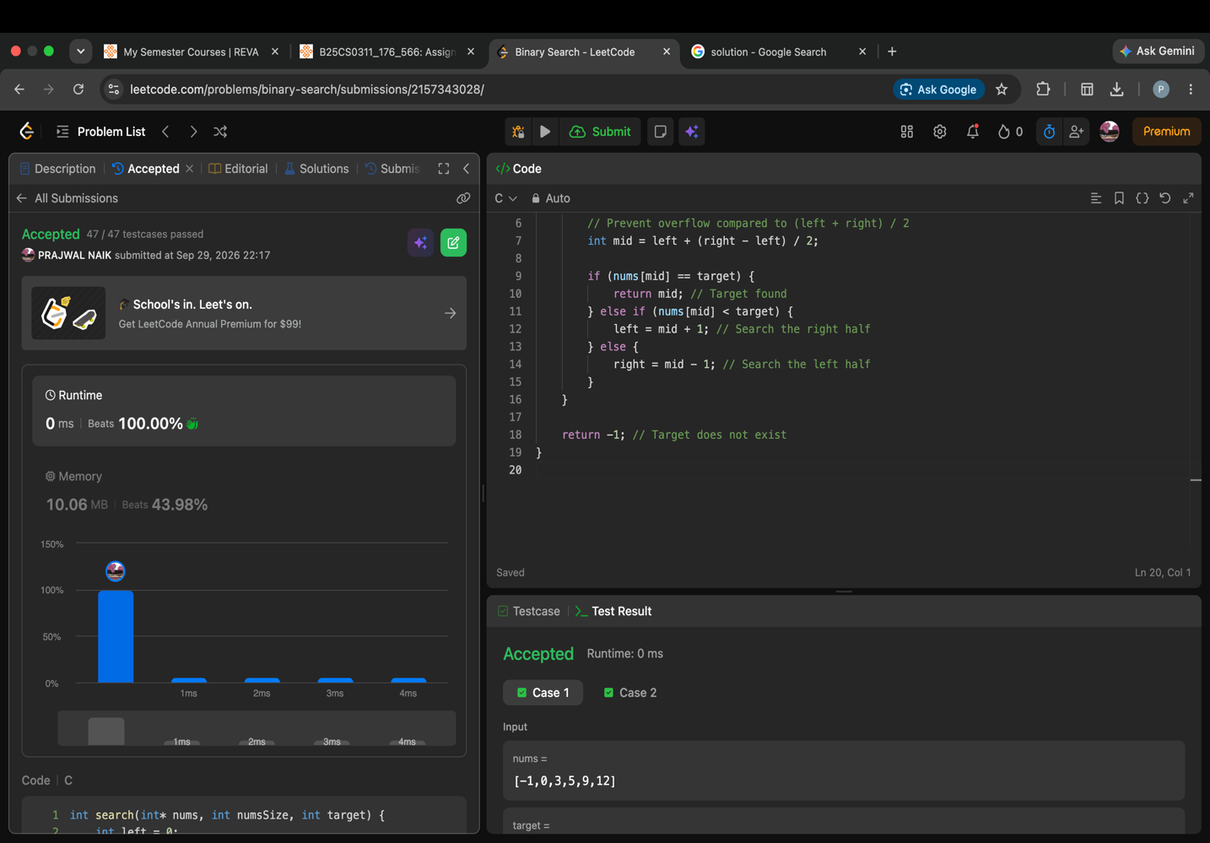
07.SOLUTION FOR MOVE ZERO
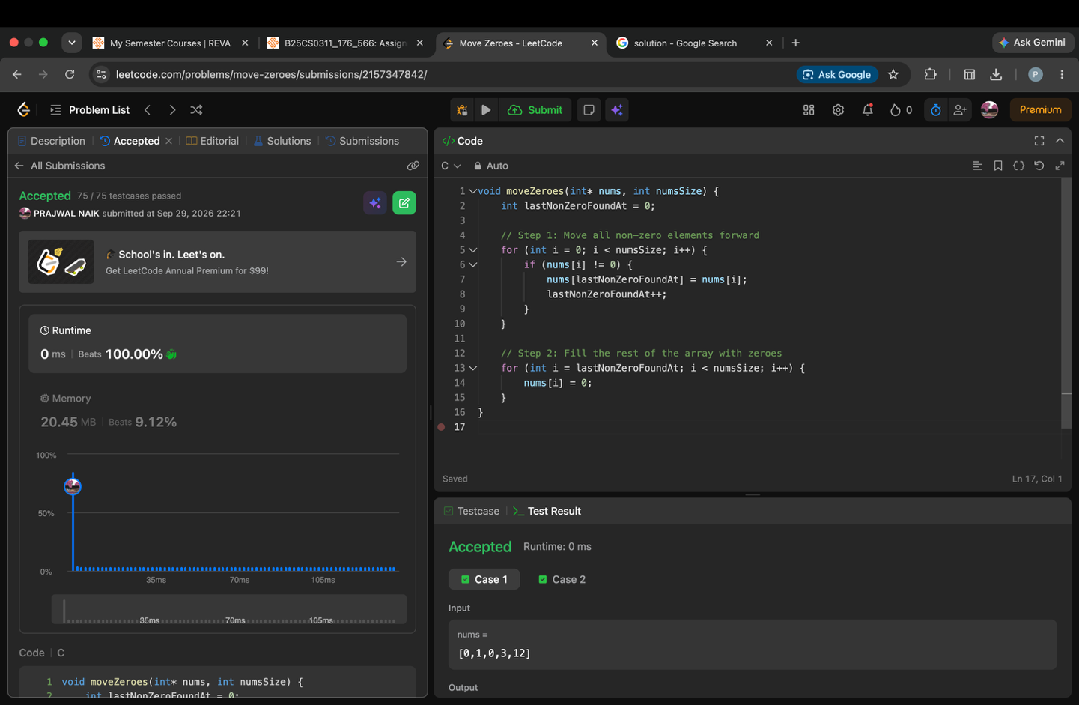08.SOLUTION FOR VALID PARENTHESES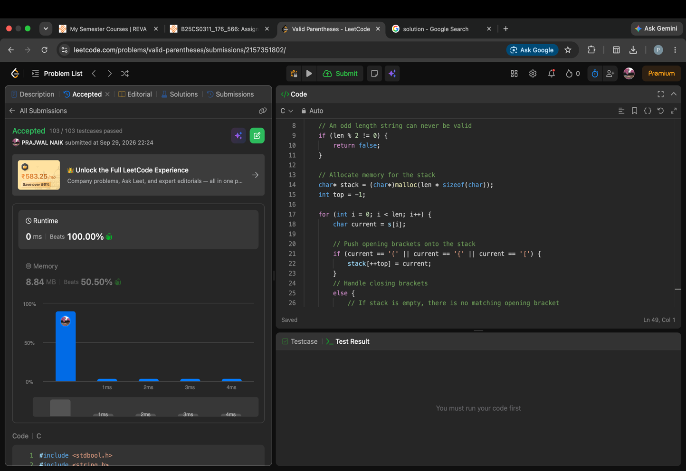
09.ALL THE MD FILES AND FOLDER STRUCTURE
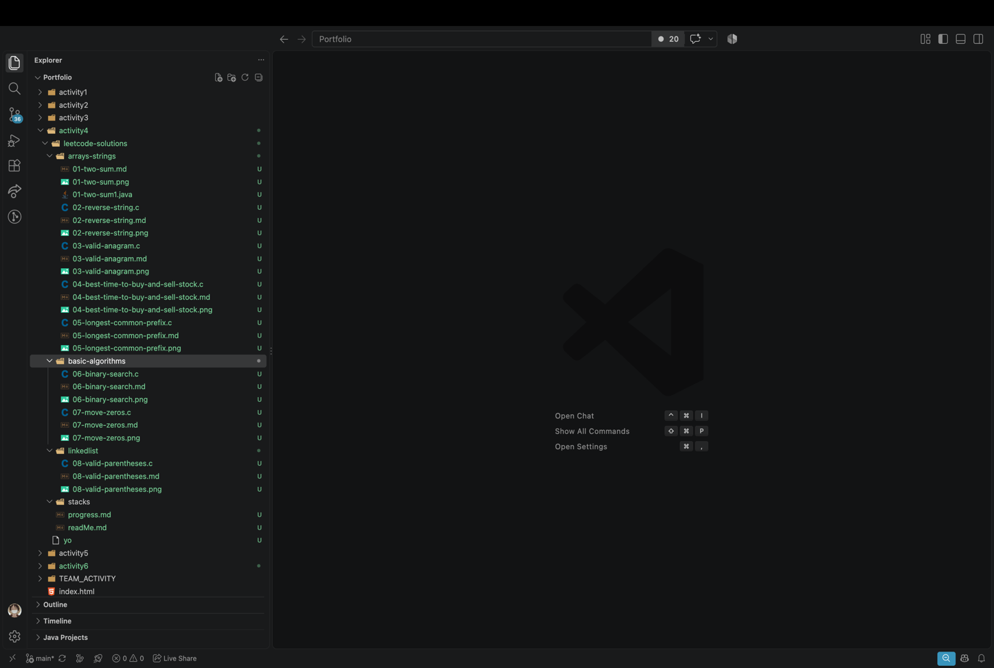10.COMMIT AND PUSH FOR LEETCODE-SOLUTIONS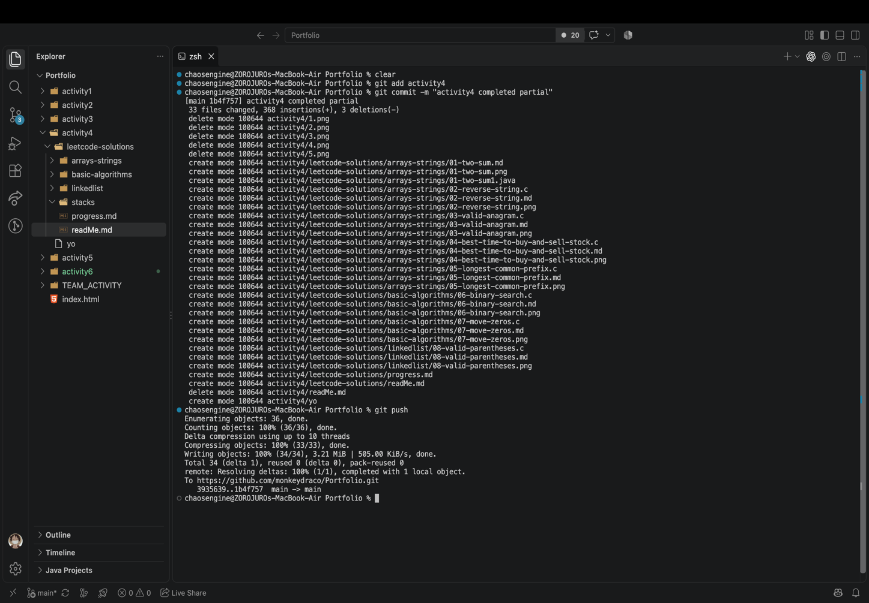
11.COMPLETION OF PROGRESS.MD FILE
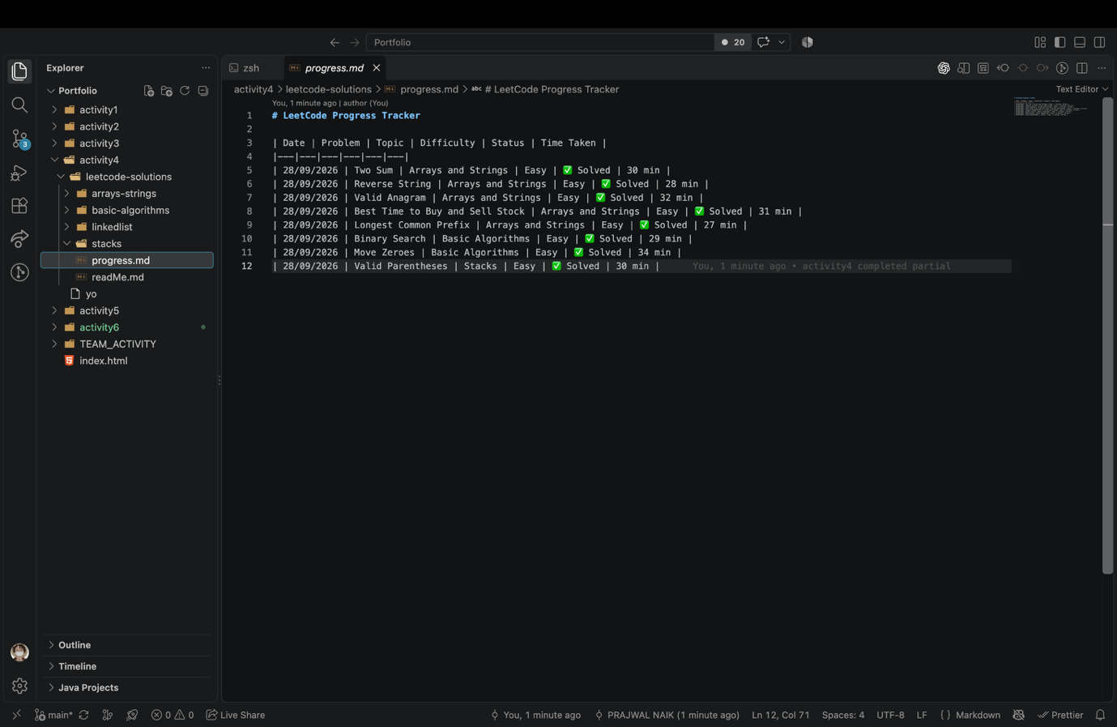

LEETCODE-SOLUTIONS GITHUB REPO LINK:
https://github.com/monkeydraco/Portfolio/tree/main/activity4/leetcode-solutions

