1.PUBLISHED REFLECTIVE POST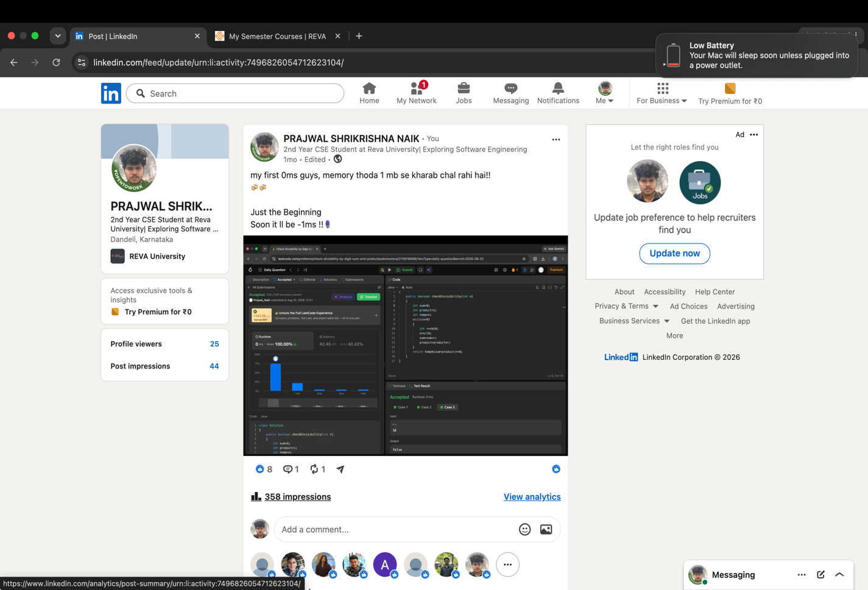2.PERSONALIZED CONNECTION REQUEST WITH NOTE 2 INDIVIDUALS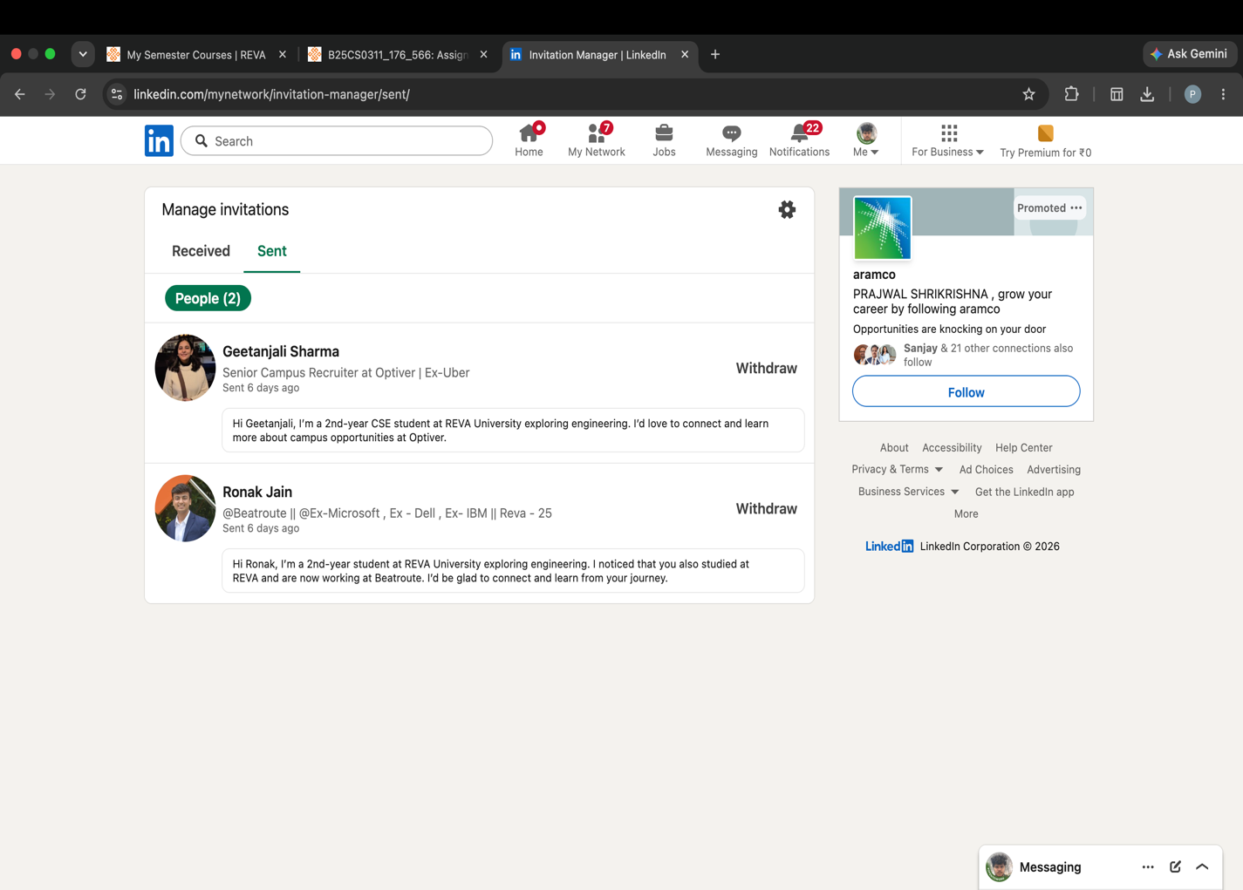
3.PROFESSIONALS FOLLWED BY ME 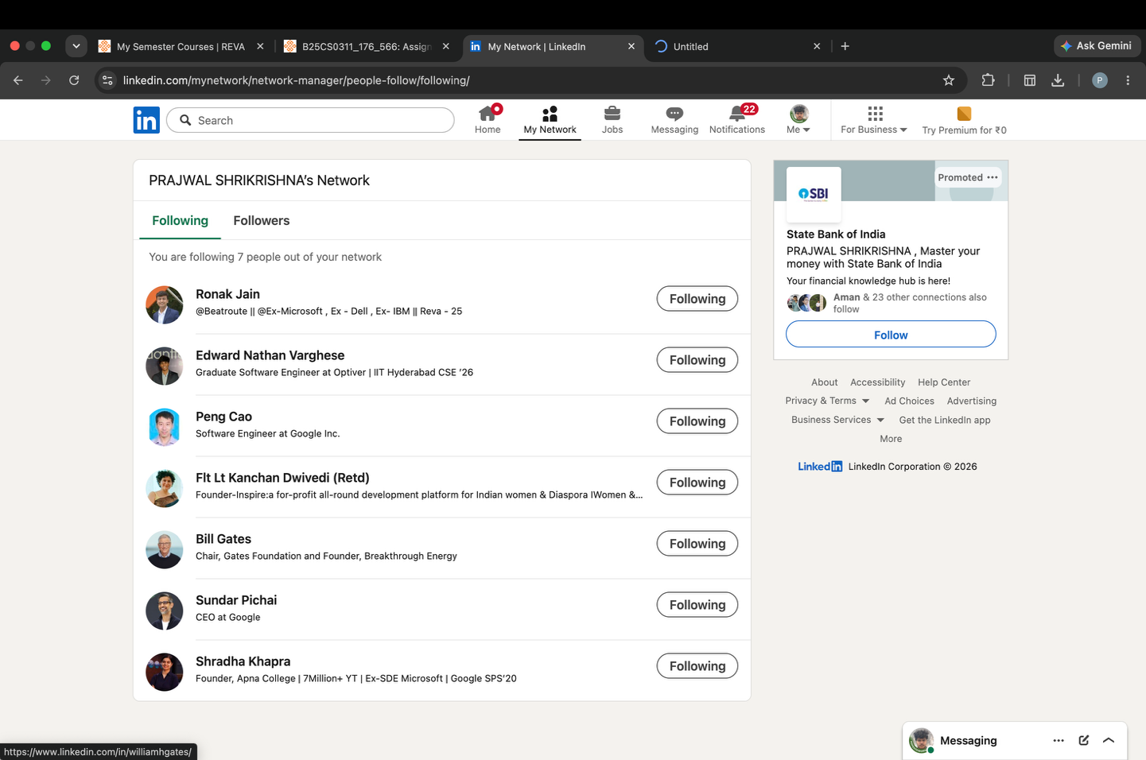4.COMPANIES FOLLOWED BY ME 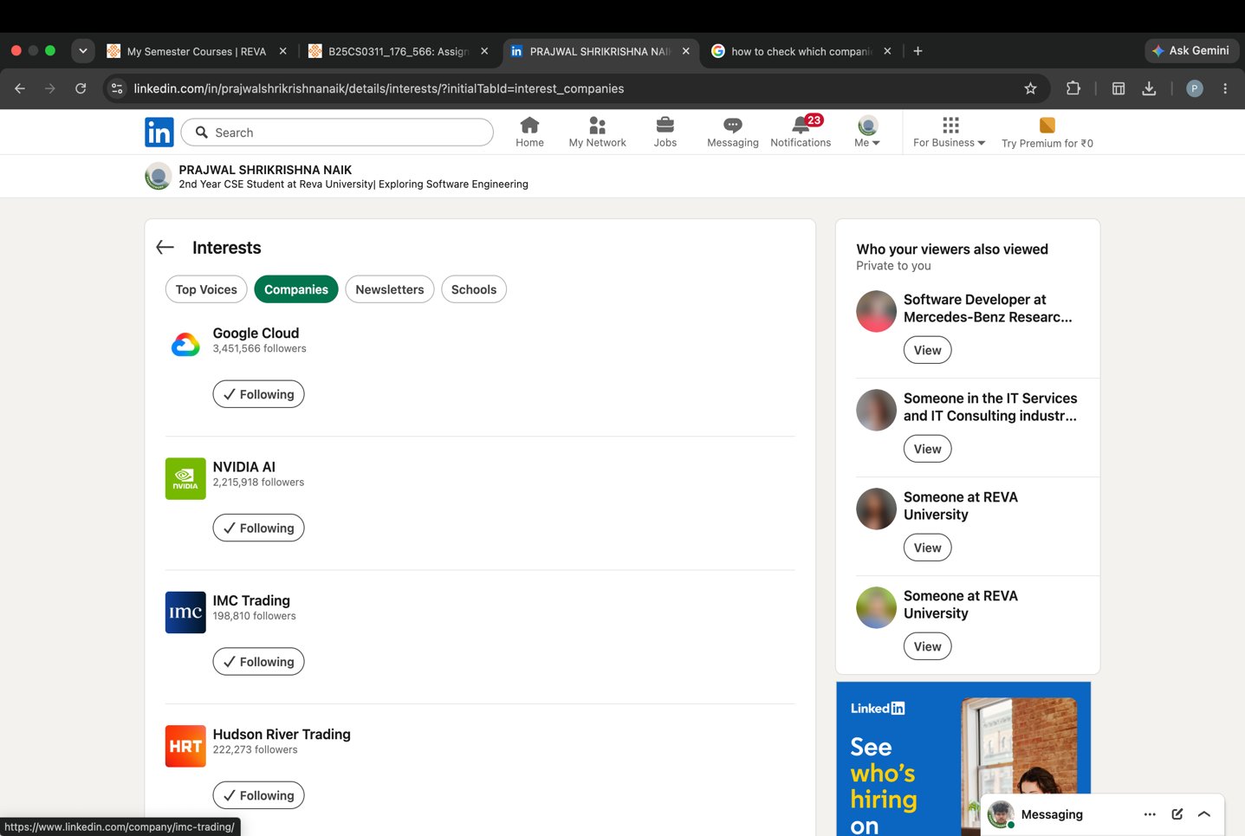

5.MEANINGFUL COMMENT OF INDIVIDUALS POST
