## SpatialOS Homework

1. Path of the homework:

The project is forked from SpatialOS/StartProject.

<https://github.com/monkeykane/UnrealGDKStarterProject.git>

1. Reference:

2.1 UE4/ShootGame: Grenade, AI behavior

2.2 SpatialOS/ThirdPersonShooter: Score board, GamePawn (Health, takedamage)

1. Homework:

3.1 Grenade:

(1) Press ‘G’ to spawn a grenade in player hand.

(2) Release ‘G’ to throw it.

(3) Grenade will explode after 5 seconds.

(4) Damage of Grenade:

Radial Damage: Damage from 300 to 0 within radius of 5 meters.

Impact Damage: Damage == 100, when first hit a pawn.

1. Use color to show Pawn’s health: White > Yellow > Red > Black. When health of pawn is 0, it will be recover after 5 seconds.

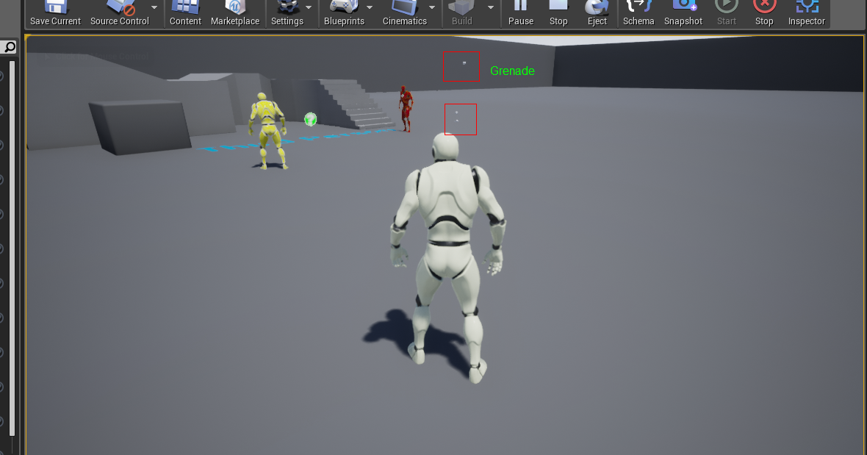

3.2 Highscore board:

3.3 AI behavior:

Behavior Tree is used for Bot. The bot will find the closest enemy and use grenade to attack it.

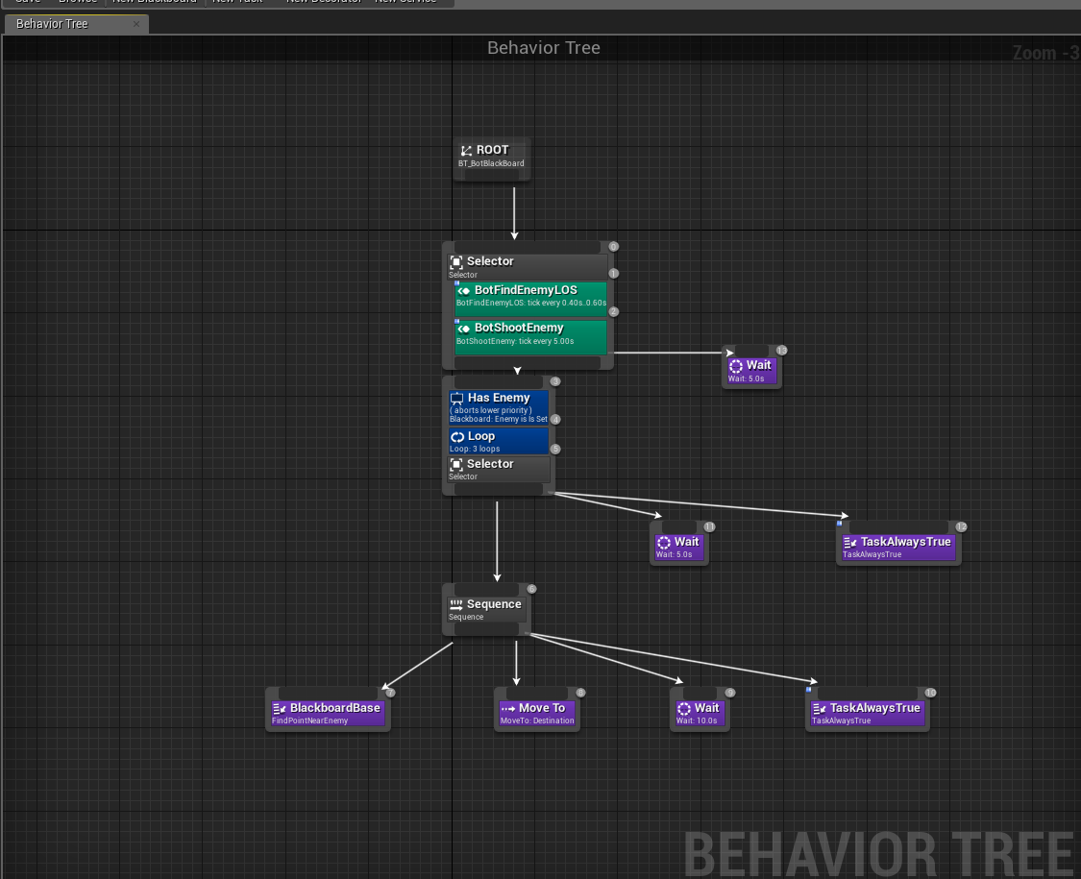

1. Issues:

AIController could not be spawned regularly when Spatial Network is on.

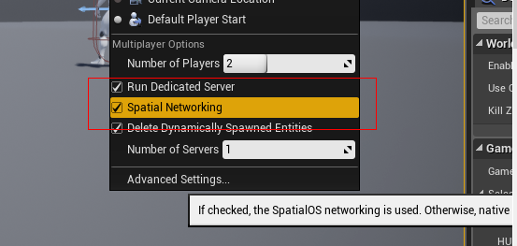

1. Place AIBot in map.
2. After game starting, AIController is not spawned and processes AIBot.
3. Shutdown Spatial Network and restart again. AIController can be spawned.

Patch codes to fix it:

