Note : For 6c, it takes me more than 2 hours to run the program and haven’t finished yet with killing my computer already(I am totally convinced that my part a) for the question must be right since I tried multiple times to verify the correctness) , so I decided to change n interval to dramatically reduce the time that need for calculation. However, the conclusion that we get should not change

n_vals = [10:10:100]; -🡪 n_vals = [10:10:50];

The result is as expected since the size of A is way too large. In this case, QR decomposition is not a good choice as discussed in class. Meanwhile, since A is large, Cholesky works too much better than QR with respect to time efficiency.

Following are some data that might want from the running result.

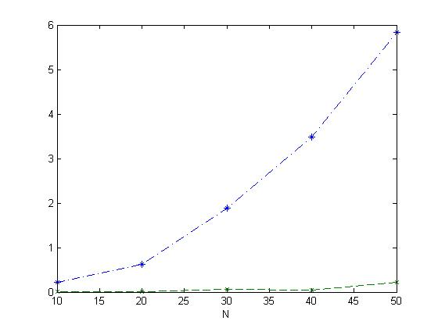

Note: Green Line represent the time that requires for Cholesky while blue line is the representation of QR.

