**Jeff Morton**

**Data Structures and Algorithms 2**

**Project 4**

**DataStructures**

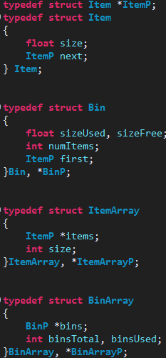

I chose to use these data structures because they made everything easy and made logical sense to me. Each item has a next pointer to make bin packing easier via integrated linkedlists. Each bin has a linkedlist of items, utilizing the next pointer in each item. There is also an ItemArray data structure, which contains the array of item nodes after the data has been read from items.txt. There is also a BinArray struct to contain an array of bins and data related to the bins.