1. Consider a grey-level image f (x, y) with histogram sketched below.

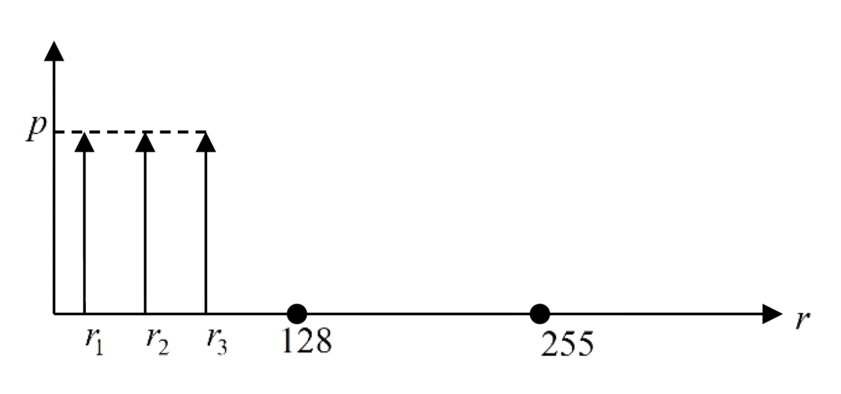

What can we say about f (x, y) and what is the value of *p*?

1. Consider the following image:

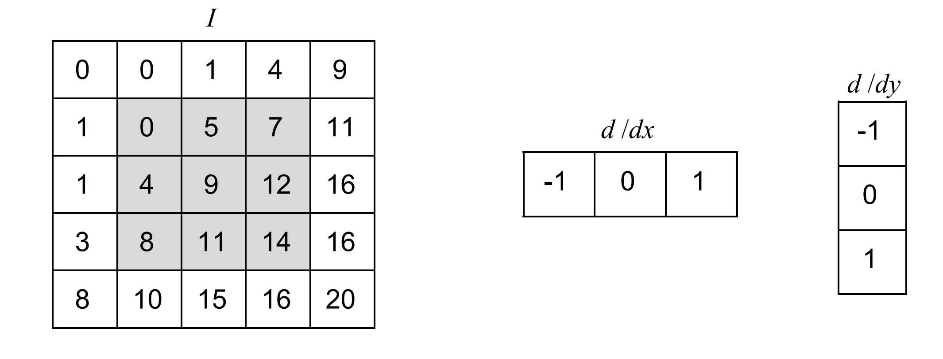

We will compute the **Harris** matrix for the 3 by 3 highlighted window. In the following formula $I_{x}=\frac{dI}{dx}, I_{y}=\frac{dI}{dy}$ and *W* is the window highlighted in the image.

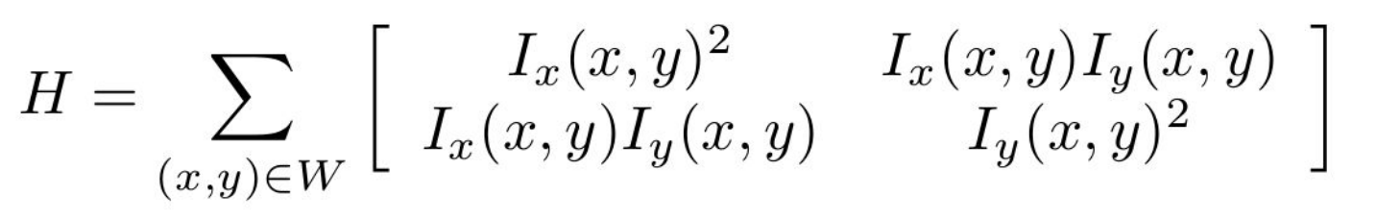

1. Compute the derivatives using the differentiation kernels shown above.

1. Compute the Harris Matrix based on the derivatives.
2. Compute the Corner Response Measure $R=\det\left(H\right)– k∙{trace\left(H\right)}^{2}$ for $k=0.04$.

Computer the value of R.